A First Project Final Report on

**Traffic Density Analysis Using Image Processing**

Submitted in Partial Fulfillment of the Requirements for

the degree of **BE Information Technology**

under Pokhara University

Submitted by:

**Kashindra Mahato, 171549**

**Rajan Paudel, 171550**

Under the Supervision of

**Dr. Roshan Chitrakar**

Date: 31st December,2019

 Department of Information Technology Engineering

**NEPAL COLLEGE OF INFORMATION**

**TECHNOLOGY**

Balkumari, Lalitpur, Nepal

**ACKNOWLEDGEMENT**On the submission of our first project report on “Traffic Density Analysis Using Image Processing”**,** we would like to extend our gratitude and sincere thanks to our supervisor Dr. Roshan Chitrakar, Department of Engineering of Information Technology for his constant motivation and support during the course of our work throughout the semester. We truly appreciate and value his esteemed guidance and encouragement from the beginning to the end of this project.

Above all we would like to thank our friends whose direct and indirect support helped us to complete our project on time. This project would have been impossible without their moral support.

# ABSTRACT

For cities like Kathmandu, traffic jam is one of the biggest problem. Technology used to control traffic is still same as it was decades ago. The system proposed in this paper includes a method to solve traffic problem using real time image processing using openCV. OpenCV provides built in functionalities such as Background Subtraction Method, Edge Detection Techniques, Filters etc. Using these functions we can count the number of vehicles and hence determine the density. Further the density calculated at various interval of time can be used to analyse the patter of traffic flow and many conclusions can be derived for more applications such as controlling the traffic light signal accordingly.

**KEYWORDS:** traffic density, openCV

TABLE OF CONTENTS

ACKNOWLEDGEMENT……………………………….…………….………………I

ABSTRACT…………………………………………………………...……………….II

LIST OF FIGURES………………………………………………….………...…...….III

LIST OF TABLES……………………………………………….……..………….….IV

1. INTRODUCTION………….;……………………………….………….………..….1

1. 1.1 PROBLEM STATEMENT…………………………………….……………..2
2. 1.2 OBJECTIVES……………………………………………….…….……..…...3
3. 1.3 SIGNIFICANCE OF THE STUDY…………………….……..…….…......…4

2. LITERATURE REVIEW ………………….….……………..……..…...………...5-6

3. METHODOLOGY……………………………………………….…..…………...7-12

4. CONCLUSION……………………………………………………...…..……….….13

5. RECOMMENDATION……………………………………………….…..……...…14

6. WORKING SCHEDULE……………………………………………………...….…15

7. REFERENCES…………………………………………….…….….…………..….16

LIST OF FIGURES

Figure1:-Flow chart……………………………………………………..………...7

Figure2:- Background Subtraction………………………….….……….….……..8

Figure3:- Result of Image thresholding………………………………….………..9

Figure4:- Result of morphological operations…………………………...……….10

Figure5:- Blob detection……………………………………………………….….11

Figure6:- Final result of detection…………………………………………………12

# LIST OF TABLES

Table1: Working Schedule………………………………………………………...15

# 1. INTRODUCTION

Traffic monitoring and controlling has always been a challenge. The exponentially increasing vehicular traffic has led to many issues ranging from traffic congestion to increase road accidents. Improved traffic density estimation would help to curb the traffic before it becomes critical problem. Vehicular traffic has various issues that make it difficult to be measured.

The implemented algorithm detects vehicles as well as other moving object in the frame. Therefore it is necessary to determine area of interest i,e. Road. Since algorithm is based on simple object detection technique and not intelligent enough to separately count vehicles while there are multiple of them congested in area of interest, we set an entry line and exit line whenever a vehicle enter the entry line the it is given a blob finding its centroid. And when it passes the exit line it is counted.

In Background Subtraction Method noise level is high. To reduce noise we use binarization, median filter, and other thresholding techniques.

# 1.1 PROBLEM STATEMENT

For Traffic analysis Frame Subtraction Method is being used. This method is used to get the presence of moving objects through difference between two consecutive images. In this method generally, it is difficult to obtain a complete outline of moving object and liable to appear the empty phenomenon so a result detection of object is not accurate. In Frame Subtraction Method accuracy is less because Reference image is changing in each and every iteration so we do not get exact amount of traffic volume.

There are limitations with real-time image processing because a static camera is used to capture video and result is based on frames i,e. Previous frame and present frame. Following are the requirements and limitations:

* 24 – hour electricity supply to the camera.
* Climatic change, fog , smog.

# 1.2 PROJECT OBJECTIVES

* + 1. The main objective of this systems are:
* To build a module which would be able to count vehicles using static camera.
* To store count in database and determine density of vehicles.
* To test the accuracy and efficiency of the module.

# 1.3 SIGNIFICANCE OF THE STUDY

Background subtraction algorithm is a very important part of Intelligent Traffic System (ITS) application for successful segmentation of objects from video sequence to control the Traffic at heavy traffic junction. Automatic Number Plate Recognition (ANPR) is an application of Traffic Analysis which use mainly for security purpose which identifies the character directly from the image from license plate.

Following may be some more applications of Traffic Analysis

* Video surveillance
* Weapon Storage Area
* Toll Plaza Management
* Security System
* Traffic Control

# **2. LITERATURE REVIEW**

## Open CV

OpenCV (Open Source Computer Vision) is a open source computer vision and machine learning software library. OpenCV was initially built to provide a common infrastructure for applications related to computer vision and to increase the use of machine perception in the commercial products. As it is a BSD-licensed product so it becomes easy for business to utilize and modify the existing code in OpenCV.

Around 3000 algorithms are currently embedded inside OpenCV library, all these algorithms being efficiently optimized. It supports real-time vision applications. These algorithms are categorized under classic algorithms, state of art computer vision algorithms and machine learning algorithms. These algorithms are easily implemented in Java, MATLAB, Python, C, C++ etc. and are well supported by operating system like Window, Mac OS, Linux and Android.

## **NumPy**

NumPy is the fundamental package for scientific computing with Python. It can be treated as an extension of the Python programming language with support for multidimensional matrices and arrays. It is open source software with many contributors. It contains among other things:

* A powerful N-dimensional array object.
* Broadcasting functions.
* Tools for integrating C/C++ and FORTRAN code.
* Useful linear algebra, Fourier transform, and random number capabilities.

Besides its obvious scientific uses, NumPy can also be used as an efficient multidimensional container of generic data.

## PYTHON VS OTHER LANGUAGES FOR OBJECT DETECTION

Object detection is a domain-specific variation of the machine learning prediction problem. Intel’s OpenCV library that is implemented in C/C++ has its interfaces available in a number of programming environment such as C#, MATLAB, Octave, R, Python etc. Some of the benefits of using Python codes over other language codes for object detection are:

* More compact and readable code.
* Python uses zero-based indexing.
* Dictionary (hashes) support is offered.
* Simple and elegant Object-oriented programming.

# 3. METHODOLOGY

Video Camera

# 

Computer vision and image

Processing

(OpenCV)

Frames

Video Capturing

# Proposed System

Apply computer vision and image processing operations

# Storage

Detecting and

Counting

Morphological

Operations

Image

Thresholding

Background Subtraction

# **Figure1:-Flow chart**

# **Background subtraction method**

Background subtraction (BS) is a common and widely used technique for generating a foreground mask (namely, a binary image containing the pixels belonging to moving objects in the scene) by using static cameras.

As the name suggests, BS calculates the foreground mask performing a subtraction between the current frame and a background model, containing the static part of the scene or, more in general, everything that can be considered as background given the characteristics of the observed scene.

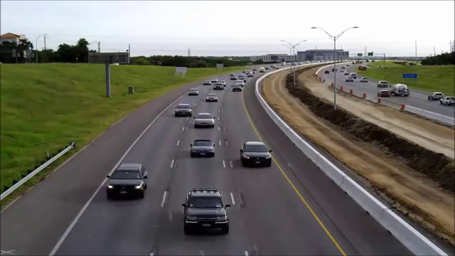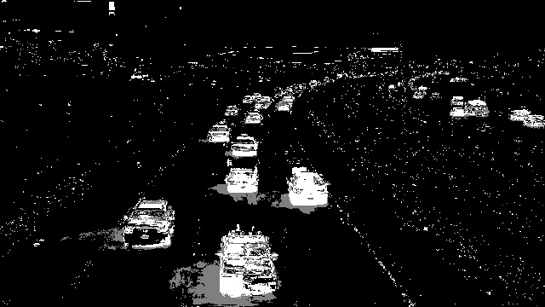

**Figure2:- Background Subtraction**

Background modeling consists of two main steps:

* Background Initialization
* Background Update.

In the first step, an initial model of the background is computed, while in the second step that model is updated in order to adapt to possible changes in the scene.

## **Image thresholding**

Image thresholding is a simple, yet effective, way of partitioning an image into a foreground and background. This image analysis technique is a type of image segmentation that isolates objects by converting grayscale images into binary images.

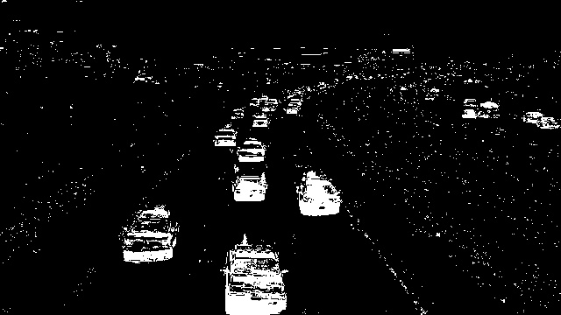

Figure3:- Result of Image thresholding

## **Morphological operation**

The most basic morphological operations are two: Erosion and Dilation. They have a wide array of uses, i.e.

* Removing noise.
* Isolation of individual elements and joining disparate elements in an image.
* Finding of intensity bumps or holes in an image.



Figure4:- Result of morphological operations

## **Contours**

Contours can be explained simply as a curve joining all the continuous points (along the boundary), having same color or intensity. The contours are a useful tool for shape analysis and object detection and recognition.

## **Blob detection**

A Blob is a group of connected pixels in an image that share some common property ( E.g grayscale value ). The goal of blob detection is to identify and mark these regions.

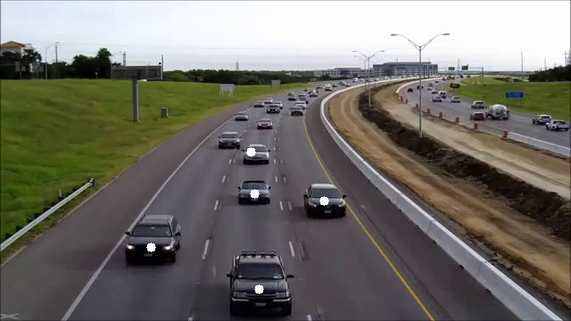

Figure5:- Blob detection

## **Bounding rectangle**

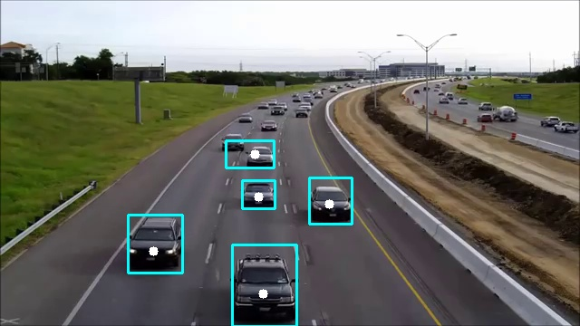

**Figure6:- Final result of detection**

# 4. CONCLUSION

In this paper, a framework for vehicle detection, tracking and counting was proposed. Its key functions are detecting vehicles which form the foreground part of a frame using Background subtraction method which gives a binary mask. This binary mask is then subjected to morphological operators.

Morphology is basically applied in order to overcome noise in binary foreground detected image. After the removal of noise, connected regions are detected using Blob Analysis. The objects having size lesser than a threshold value are ignored and and only those objects are detected which satisfies the condition. Further reference lines are drawn and once the object pass the assigned reference line count is increased.

The limitations of this paper include: non-stationary camera, greater velocity of vehicles and intense sunlight which causes reflection from car windows thus making extra objects a part of foreground. Also, the algorithm implemented can detect object only in daylight.

# **5. RECOMMENDATION**

This project was implemented through lots of ups and downs, and as a result, a perfect output wasn’t reached after all. Although this application seems to lack of more features, it still stands out to be an effective application for the anticipated users. After the overall application analysis and reporting, the authors found out that there are limited precincts to this application that can be improved in future with the help of innovative and better technologies that are in the progressive stage right now. The future scope can be done to automate the entire process or partially.

Some of the future enhancements that can be applied are as follows:

* It can be used for Automatic Number Plate Recognition.
* It can be used for vehicle classification.
* It can be used in detecting traffic rule violation.

# 6. WORKING SCHEDULE

The project schedule has been designed as per requirements and constraints involved. This project completed in about 2 months.

|  |  |  |  |  |  |  |  |  |  |
| --- | --- | --- | --- | --- | --- | --- | --- | --- | --- |
|  | 1st week | 2nd week | 3rd week | 4th week | 5th week | 6th week | 7th week | 8th week | |
| Study and Analysis | 3w, nov 1  ,2019 |  | Nov 21,2019 |  |  |  |  |  | |
| Data Collection |  | 2w, nov 7,2019 | Nov 21,2019 |  |  |  |  |  | |
| Implementation |  |  |  | 2w, nov 22,2019 | Nov 29,2019 |  |  |  | |
| Testing |  |  |  |  | 2w, nov 29,2019 | Dec 6,2019 |  |  | |
| Documentation | 7w, nov 1,  2019 |  |  |  |  |  | Dec 7,2019 |  | |
| Review |  |  |  |  |  |  |  | 1w, dec 9-15, 2019 | |
| Presentation |  |  |  |  |  |  |  |  | 2d,dec 16-18,2019 |

Table1: Working Schedule

# **REFERENCES**

[1]Nicholas A.Mandellos, Iphigenia Keramitsoglou,Chris T. Kiranoudis,

A background subtraction algorithm for detecting and tracking vehicles

[2]*Harsha H. Sanap , P. A. Ghonge,* International Journal of Science and Research (IJSR) *,*Traffic Analysis Based On Image Processing

[3]*Ashwini R. Patekar, Jaya H. Dewan, Samiksha A. Umredkar, Shruti S. Mohrir,*International Journal of Computer Applications (0975 – 8887) Volume 180 – No.42, May 2018, Traffic Density Analysis using Image Processing

[*4*]*Bhumika Gupta, PhD, Ashish Chaube, Ashish Negi, Umang Goel,* International Journal of Computer Applications (0975 – 8887) Volume 162 – No 8, March 2017, Study on Object Detection using Open CV - Python