Area:

[In **MVC (Model-View-Controller)** applications, an **area** is a **logical grouping of Controller, Models, Views, and other related folders for a module**](https://www.bing.com/ck/a?!&&p=7d8b7e10b10779dbJmltdHM9MTcxNTY0NDgwMCZpZ3VpZD0xYTkyOWM2Yi1hZGYwLTY5NTItMTM4Yi04ZTJjYWM1ZDY4NjcmaW5zaWQ9NTc5Mw&ptn=3&ver=2&hsh=3&fclid=1a929c6b-adf0-6952-138b-8e2cac5d6867&psq=what+is++area+in+mvc&u=a1aHR0cHM6Ly93d3cuY29kZXByb2plY3QuY29tL0FydGljbGVzLzcxNDM1Ni9BcmVhcy1pbi1BU1AtTkVULU1WQw&ntb=1)[**1**](https://www.bing.com/ck/a?!&&p=cbf5cf79df52af40JmltdHM9MTcxNTY0NDgwMCZpZ3VpZD0xYTkyOWM2Yi1hZGYwLTY5NTItMTM4Yi04ZTJjYWM1ZDY4NjcmaW5zaWQ9NTc5NA&ptn=3&ver=2&hsh=3&fclid=1a929c6b-adf0-6952-138b-8e2cac5d6867&psq=what+is++area+in+mvc&u=a1aHR0cHM6Ly93d3cuY29kZXByb2plY3QuY29tL0FydGljbGVzLzcxNDM1Ni9BcmVhcy1pbi1BU1AtTkVULU1WQw&ntb=1)[**2**](https://www.bing.com/ck/a?!&&p=1c3e6c1e40e2a40cJmltdHM9MTcxNTY0NDgwMCZpZ3VpZD0xYTkyOWM2Yi1hZGYwLTY5NTItMTM4Yi04ZTJjYWM1ZDY4NjcmaW5zaWQ9NTc5NQ&ptn=3&ver=2&hsh=3&fclid=1a929c6b-adf0-6952-138b-8e2cac5d6867&psq=what+is++area+in+mvc&u=a1aHR0cHM6Ly9hc3BuZXRjb3JlLnJlYWR0aGVkb2NzLmlvL2VuL3N0YWJsZS9tdmMvY29udHJvbGxlcnMvYXJlYXMuaHRtbA&ntb=1)[**3**](https://www.bing.com/ck/a?!&&p=f6ce7160cb542dddJmltdHM9MTcxNTY0NDgwMCZpZ3VpZD0xYTkyOWM2Yi1hZGYwLTY5NTItMTM4Yi04ZTJjYWM1ZDY4NjcmaW5zaWQ9NTc5Ng&ptn=3&ver=2&hsh=3&fclid=1a929c6b-adf0-6952-138b-8e2cac5d6867&psq=what+is++area+in+mvc&u=a1aHR0cHM6Ly9sZWFybi5taWNyb3NvZnQuY29tL2VuLXVzL3ByZXZpb3VzLXZlcnNpb25zL2FzcG5ldC9lZTY3MTc5Myh2PXZzLjEwMCk&ntb=1). It allows for more maintainable code by cleanly separating different modules within an application.

If we have a small web application, then the default folder structure works fine to maintain the application. But if your application becomes big, its creates a problem to maintain for example, if we have a large hospital portal, then there are various sections in it, and if we use a default folder structure, it will create a mess. In this condition, we need to use Areas for separating our application. Now we will learn areas in asp.net with a simple application..

Consider using Areas in an MVC project when:

* Your application is made of multiple high-level functional components that should be logically separated
* You want to partition your MVC project so that each functional area can be worked on independently

Area features:

* An ASP.NET MVC app can have any number of areas
* Each area has its own controllers, models, and views
* Allows you to organize large MVC projects into multiple high-level components that can be worked on independently

[ASP.NET MVC 4 pluggable application modules - Geeks with Blogs](https://geekswithblogs.net/gwbarchive/asp-net-mvc-4-pluggable-application-modules/)

Routing:

ASP.NET introduced Routing to eliminate the needs of mapping each URL with a physical file. Routing enables us to define a URL pattern that maps to the request handler. This request handler can be a file or class.

Route constraints

route constraints are the way to put some validation around the defined route

Types of Route ConstraintsThere are two types of route constraints

Predefined Route Constraints

Custom Route Constraints

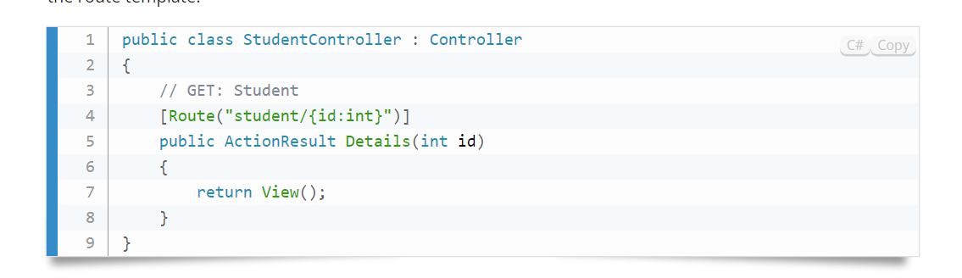

Filtering :

user is allowed to perform an action or access a resource

*Good morning. My name is Rajanbabu, and I am here to give mvc internal traning*

*I am here today to talk to you about why Target Reach Plus was created, who is benefiting from it already and how you can implement this kind of technology in your stores.*