To All,

This document will help, how this application is working currently. So please go through below snaps and along with the details. If any this is needed send an email below, that I provided at the end of this documentation.

Emp-reg-detail application snaps, these snaps will help to see how this application will works.

This code and help guide will be present in <https://github.com/rajanenu/emp-dreg-detail>

Snap1:

Once the “ng serve” command ran, we must invoke this below URL and can be seen this ui page.

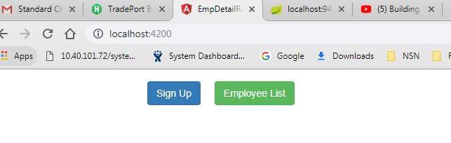

Snap2:

Click on “Sign Up” button and can be seen the employee registration form.

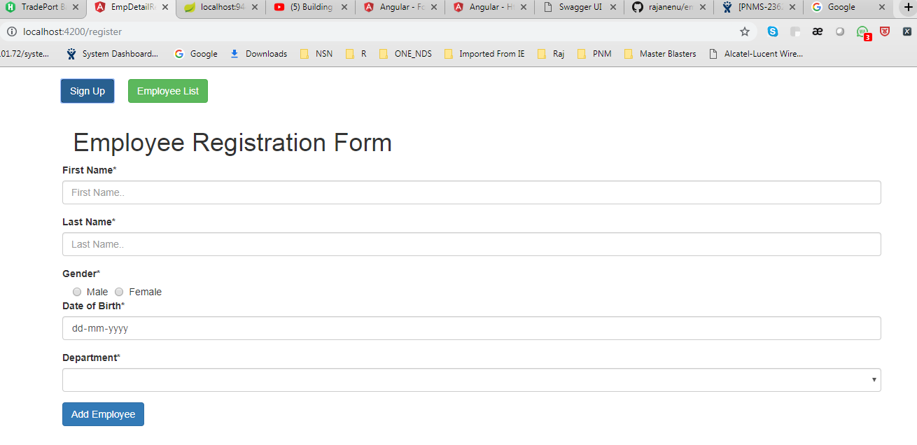

Snap3:

Click on “Employee List” button and you can see the list of employees who already registered, By default or initially there are no employees registered, so “No data found” will be shown.

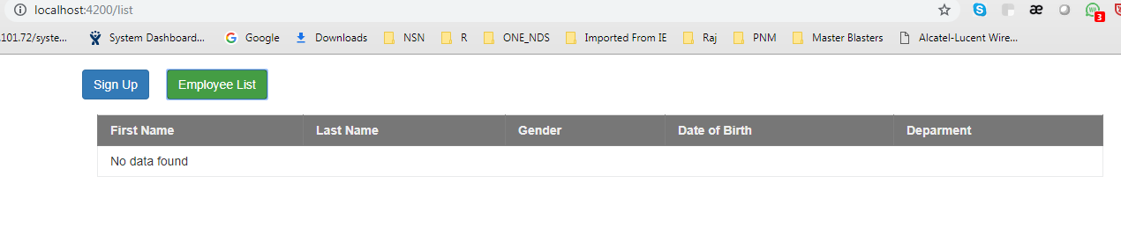

Snap4:

Lets, register an employee now and will see the information in other component like Employee List.

Before to that,

-I used radio buttons for gender differentiation.

-I used date picker for date of birth

-I used select item for departments

Let see all the above and below images one by one-

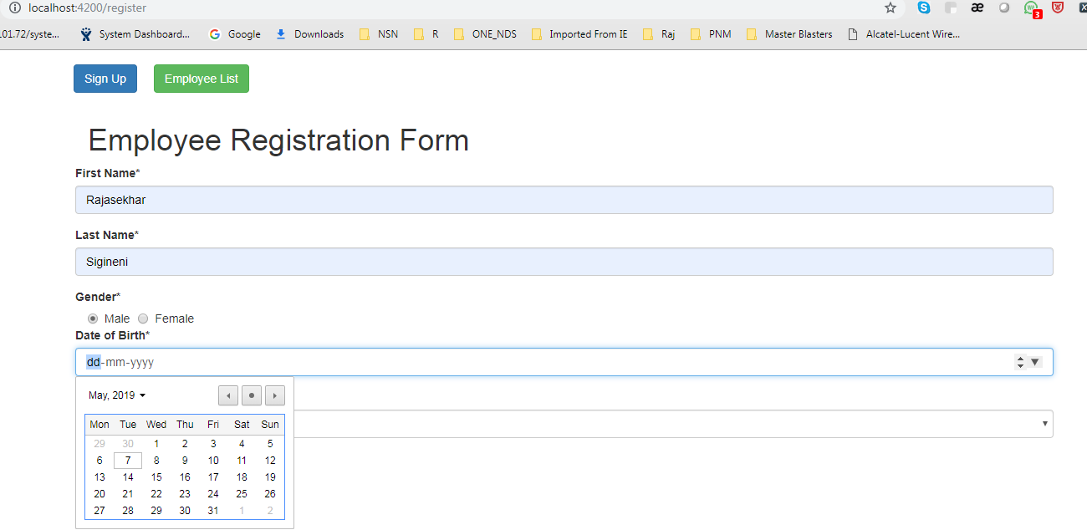

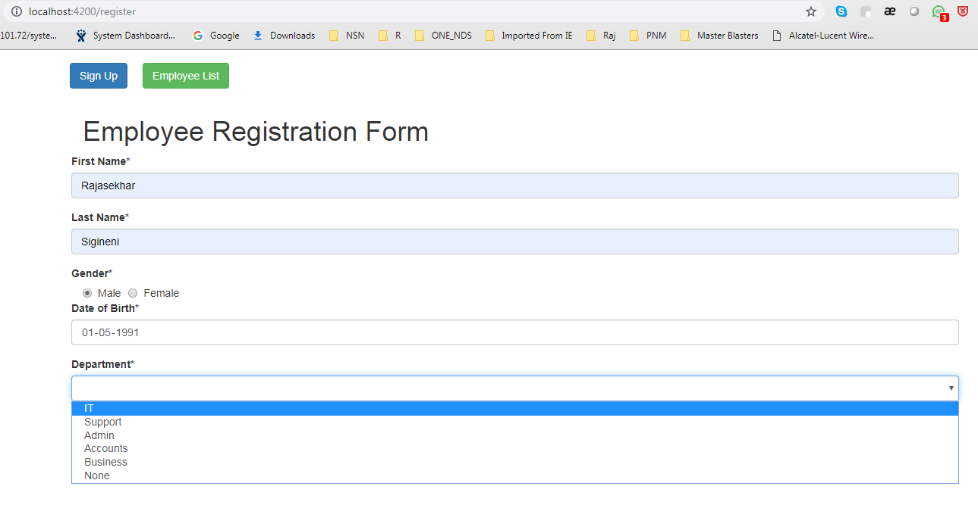

Let click on “Add Employee” button and save the above data.

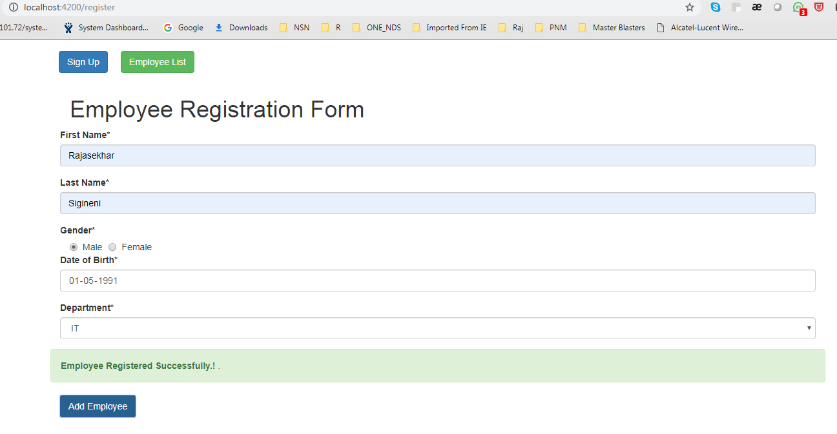Now, we will see the data in Employee List –

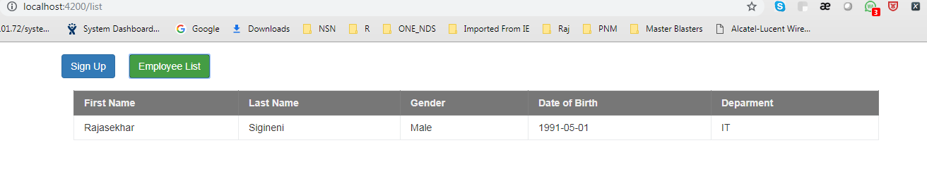Lets, register some more employees and will see the data here –

Note: We can sort the employee data with first name in ascending or descending order by using ng smart table.

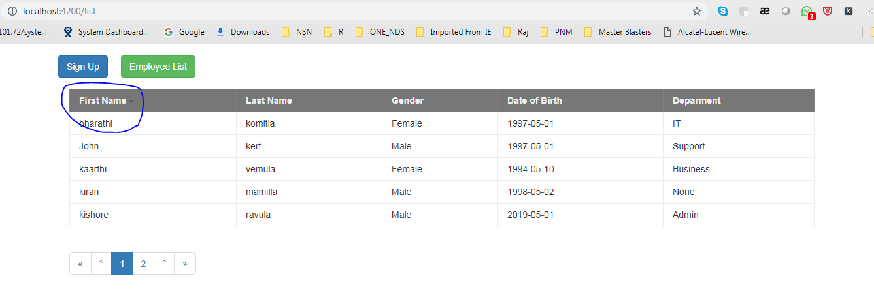

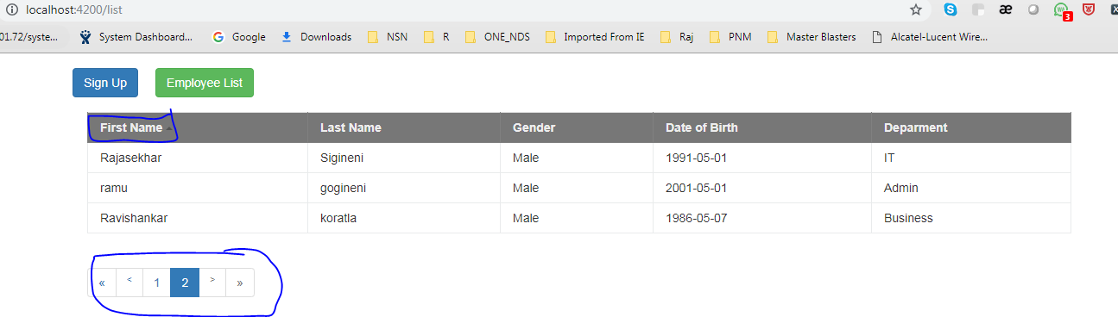

Snap5:

I want to share this swagger api to the frontend developers, based on this documentation they can call the respective service for their desired results.

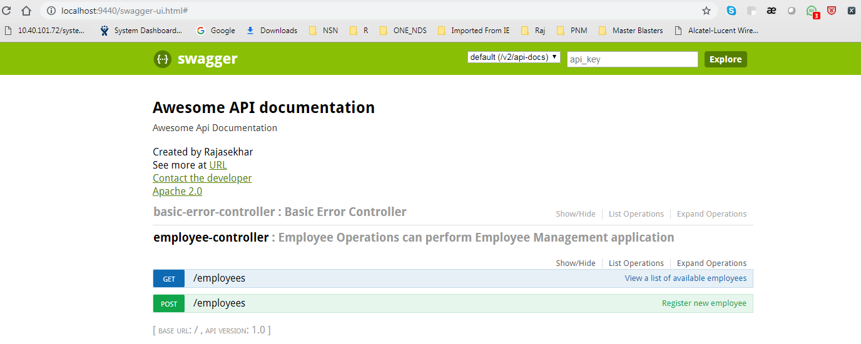

Thanks and Regards

Rajasekhar

rajanenu@gmail.com(919844221599)