All-purpose Cluster Creation in AZDB –

All-Purpose Cluster is an interactive Databricks compute used for development, exploration, and debugging in notebooks. It stays running for ad-hoc work and collaboration, but is not cost-efficient for production workloads (where job clusters are preferred).

All-Purpose clusters are not mandatory in Databricks. They are mainly for interactive development. Production workloads typically use job clusters or SQL warehouses for better cost efficiency and automation.

👉Is it Mandatory?

Compute Type | Is it mandatory? | Used for
All-Purpose Cluster | No | Development, exploration, learning
Job Cluster | No | Scheduled production jobs
SQL Warehouse | No | BI, reporting, SQL analytics
Serverless Compute | No | Auto-managed workloads

Create it when you want: Interactive notebooks; Learning Spark/PySpark; Debugging pipelines; Ad-hoc data analysis

Example use:
Explore data → test transformations → prototype logic

When you DON’T need All-Purpose Cluster?
During production pipelines All Purpose Cluster is not required
Use → Job Clusters in Production Pipelines as
They: Spin up automatically; Run workload; Terminate (save cost)

👉 Cluster Policies:

Databricks compute policies enforce governance by restricting cluster configurations to control cost, security, and performance across users.

Policy | Who uses it | Cost Control | Flexibility
Unrestricted | Admins | ❌ None | ⭐⭐⭐⭐⭐
Personal | Individuals | ✅ High | ⭐⭐
Power User | Engineers | ⚠ Medium | ⭐⭐⭐⭐
Shared | Teams | ✅ High | ⭐⭐
Legacy | Old setups | ❌ | ⭐

Best practice in real companies: Developers → Personal Compute; Heavy ETL → Power User or Job Clusters; Teams → Shared Compute; Avoid Unrestricted for normal users

👉 Performance
This Performance section controls what Spark engine + optimizations your Databricks cluster will run on.

Component | Meaning
Databricks Runtime | Databricks optimized Spark
Spark 3.5.2 | Core processing engine
Scala version | Internal Spark language version
LTS | Long Term Support (most stable)

Best practice you should use
For data engineering: ✔ Latest LTS runtime; ✔ Photon enabled; ✔ Non-ML unless needed

Simple memory trick: Runtime = Engine version; Photon = Turbo mode; ML = Data science pack; Single node = lightweight mode

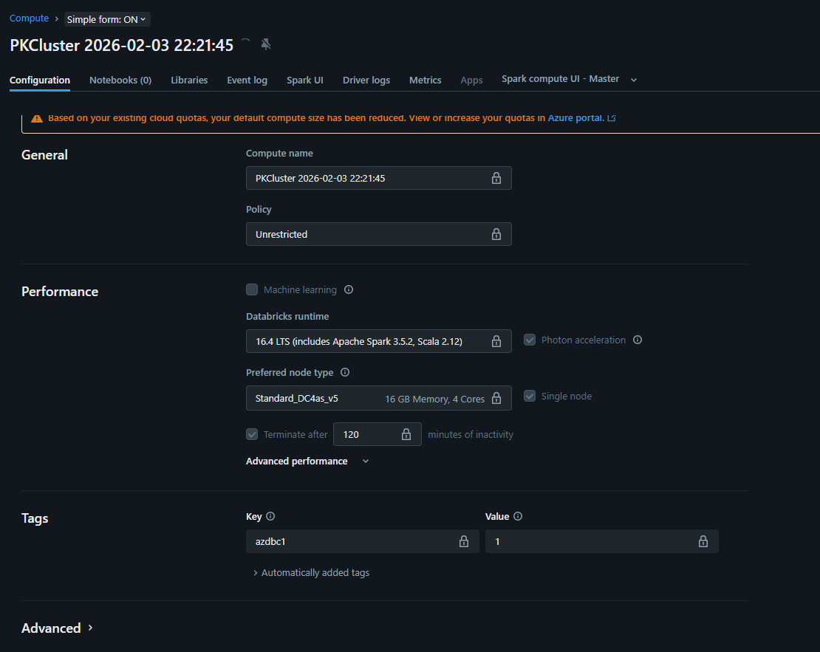

👉 Mind Mapping

