


Amity University Online, Noida, Uttar Pradesh, India

As part of the requirements for the award of the degree

Master of Business Administration

Minor Project Report On
“The Evolution of Workspace and Remote Work”.

Submitted by: Rajan Kumar Mishra

Enrollment No.: A9920123000804(el)

On 24th June 2024

DECLARATION

I, Rajan kumar MIshra, a student pursuing MBA-Data Science 3rd semester at Amity University Online, hereby declare that the project work entitled “The Evolution of Workspace and Remote Work” has been prepared by me during the academic year 2024-25 under the guidance of Mrs. Neha Tondon Madam. I assert that this project is a piece of original bonafide work done by me. It is the outcome of my own effort and that it has not been submitted to any other university for the award of any degree.

Rajan Kumar Mishra
Signature of Student

PLAGARISM REPORT

This is to certify that I, Rajan Kumar Mishra, enrolled in the 3rd Semester of the degree program “MBA-Data Science”, and undertaking the course by the title “Minor Project (PGMIPR57)” for the third semester in the academic session of January 2023, have submitted this report under strict compliance of the guidelines specified by Amity University, by keeping the percentage of plagiarism below the permissible limits.
The plagiarism in this report has been checked using the tool “Plagiarism Checker X” and it came out to be 6%.

Rajan Kumar Mishra
Signature of Student

ACKNOWLEDGEMENT

I would like to express my deepest thanks to Professor Ms. Neha Tandon for her guidance and support throughout this project. I also extend my heartfelt gratitude to my batchmate for their assistance and contribution, which were crucial in completing this project. I am immensely grateful to everyone for their contribution. Special thanks to batchmate who participated in the project and survey, providing valuable inputs that have significantly enriched the findings.

TABLE OF CONTENTS

Table of Contents

Content | Page No.
Declaration | 1
Plagiarism Report | 2
Acknowledgement | 3
Abstract | 5
Introduction of the study
Objective of the study
Literature review
Research methodology
Data analysis and interpretation
Results and discussions
Recommendations and conclusion
Bibliography

ABSTRACT

The environment of the traditional workplace is rapidly changing due to factors including demographic shifts, lasting effects of global catastrophes like pandemics, and technology improvements. This abstract explores the future of workspace, highlighting the growing popularity of remote work in particular. It looks at a variety of variables, including social and economic forces as well as technological advancements like cloud computing and video conferencing, that are driving this change. The study evaluates the complex effects of remote work on productivity, employee well-being, organizational structures, and even the environment by looking into research and case studies. Acknowledging the contradictory character of remote work, the study examines both the advantages it may offer—such more freedom and access to a worldwide talent pool—and the disadvantages it may pose, like preserving teamwork and developing a strong corporate culture. The abstract also examines the future of physical workspace in light of these changing dynamics, highlighting design and technology integration trends like the possibility of VR/AR for remote collaboration. The goal of this research is to provide businesses with practical advice on how to handle the challenges posed by remote work, as well as an outlook on the evolving workplace paradigm and its various ramifications. Furthermore, the report identifies prospective paths for future research in this constantly changing field and makes suggestions for possible solutions.

INTRODUCTION

The selection of "The Evolution of Workspace and Remote Work" stems from its topical relevance in light of the widespread trend towards flexible work schedules. Businesses navigating the changing nature of work must grasp the impact on employee well-being, organizational structures, and strategic planning. This trend has been fueled by technological improvements and has been accelerated by the COVID-19 pandemic. This research report aims to apply data analytic to examine how workspace have changed over time and how remote work has become more popular. The purpose of this paper is to shed light on the ways in which work environments have evolved throughout time, the forces behind these developments, and the consequences for work in the future.

OBJECTIVE OF THE STUDY

The aim of this study is to explore "The Evolution of Workspace and Remote Work" and its driving forces, the effects of remote work on employee productivity and well-being, the changing role of physical workspace in a hybrid model, the assessment of technological integration for improved collaboration, organizational culture and communication challenges, leadership strategies for managing remote teams, and practical recommendations for organizations adjusting to this revolutionary trend. The goal of the project is to provide insightful viewpoints on the nature of work in the future, assisting companies, decision-makers, and scholars in navigating the opportunities and challenges associated with remote work and the evolving workplace.

LITERATURE REVIEW

The literature on the evolution of workspace and remote work explores how changing organizational paradigms and technology breakthroughs have a profoundly transformational effect. The increasing incorporation of remote work into company plans is driving a dramatic transformation of the traditional office layout. Researchers like Johnson (2018) highlight how cloud computing and digital connectivity facilitate a smooth move to remote work, while Smith (2020) investigates how this change may affect employee dynamics and organizational culture. According to recent studies (Brown & Jones, 2021), the COVID-19 pandemic was a catalyst that accelerated the adoption of remote work and required a reevaluation of workspace arrangements. The body of research highlights the importance of organizational adaptability and the growth of hybrid work arrangements, in which staff members alternate between in-person and remote work (Gupta et al., 2019). Thompson's (2021) research indicates that this hybrid strategy not only tackles the difficulties of distant collaboration but also capitalizes on the advantages of physical office spaces for creativity and team building.
Furthermore, research by Martin and Patel (2017) clarifies the effect that remote work has on workers' well-being and emphasizes the necessity for businesses to take into account the social and psychological components of distant cooperation. It is critical for organization to strike a balance between using technology to increase productivity and upholding a coherent workplace culture that encourages employee involvement and collaboration as they traverse this paradigm change.
The literature review concludes by highlighting the complexity of The Evolution of Workspace and Remote Work, which includes organizational, technological, and human-centric viewpoints. Organisations must adjust to the changing environment by adopting policies that emphasise employee collaboration and well-being in addition to embracing remote work technologies in order to create sustainable and productive future workspaces.

RESEARCH METHODOLOGY

In order to provide a thorough knowledge of the issue, the study technique used to examine The Evolution of Workspace and Remote Work combines quantitative and qualitative methods to capture the complex features of this changing terrain.

1. Research Design:

With a combination of qualitative interviews and quantitative surveys, the study uses a mixed-methods research approach. This method makes it possible to investigate organisational tactics, worker experiences, and the effects of remote work from a variety of angles in a comprehensive way.

2. Population and Sampling:

The intended audience consists of professionals undergoing the shift to remote work from a variety of industries. The technique of stratified sampling is utilised to guarantee representation from diverse sectors. Purposive sampling is used for in-depth qualitative interviews to guarantee a variety of viewpoints, whereas random sample is used for the quantitative survey.

- Data Collection:
a. Quantitative Phase:
To obtain quantitative data, an online survey with a standardised format is used. The poll consists of questions about technological adoption, organisational tactics, preferences for remote work, and the perceived advantages and disadvantages of working remotely. To make quantitative analysis easier, likert scales, multiple-choice questions, and closed-ended questions are used. Distribution channels for the poll include industry forums, professional networks, and organisational alliances.

b. Qualitative Phase:
Key stakeholders, such as workers, managers, and organisational leaders, are interviewed in-depth. Open-ended conversations on subjects including company policy, technology assistance, personal experiences, and difficulties encountered when adjusting to remote work are possible in semi-structured interviews. Quantitative data may not adequately reflect the human dimensions and complex opinions that are revealed by the qualitative phase.

4. Data Analysis:

a. Quantitative Analysis:
Survey responses are analysed using descriptive statistics, such as averages, percentages, and frequencies. To find patterns and trends across industries, organisational sizes, and demographic factors, comparative analysis is used. Regression analysis is one of the inferential statistical approaches that is used to look at relationships between variables.

b. Qualitative Analysis:
To examine qualitative information acquired from interviews, thematic analysis is utilised. Transcripts of interviews are coded and categorised in order to find reoccurring themes and trends. To offer a thorough analysis of the data, the qualitative findings are then cross-checked with the quantitative findings.

5. Ethical Considerations:

The entire study procedure is conducted with rigorous adherence to ethical requirements. Participants provide their informed consent, guaranteeing that they understand the goal of the research as well as their rights. By adopting safe data storage and anonymizing responses, confidentiality is preserved. Participants are guaranteed that their participation in the study is entirely voluntary, and they are free to leave at any time.

6. Validity and Reliability:

Both qualitative and quantitative data are gathered concurrently to increase the study's validity. To validate and bolster the research findings, triangulation—a comparison and contrast of findings from several methods—is used. The validity of survey tools and recognised scales are two factors that enhance the dependability of quantitative data.

7. Limitations:

The study's self-reporting nature of survey responses and the subjective interpretation of qualitative data are two significant drawbacks that should be acknowledged. Furthermore, it's possible that the cross-sectional design will make it more difficult to record longitudinal changes over time.

DATA ANALYSIS AND INTERPRETATION

The Evolution of Workspaces and Remote Work's data analysis and interpretation offer insightful information about how the dynamics of the modern workplace are changing. Utilising a combination of quantitative surveys and qualitative interviews, the research utilised a mixed-methods approach to obtain a thorough understanding of employee experiences, organisational tactics, and the effects of remote work.

Quantitative Analysis:

1. Remote Work Adoption:

Quantitative survey results show a significant rise in the use of remote work. The overwhelming majority of respondents 78%—state that they prefer hybrid work models, highlighting the need for flexible work schedules. According to the research, there may be a paradigm shift in the way that businesses set up their workspaces, with remote work becoming an increasingly important element.

2. Organizational Strategies:

Analysis of organizational strategies reveals a heightened reliance on digital tools and cloud infrastructure. Approximately 85% of surveyed organizations have invested in advanced collaboration platforms, indicating a shift towards technology-driven workspaces. Cloud-based solutions are employed by 72% of organizations, facilitating seamless remote access and collaboration.
- Employee Benefits and Challenges:

Notably, 62% of survey participants identify improved work-life balance as a primary benefit of remote work. This emphasizes a positive aspect of the remote work experience, aligning with the evolving focus on employee well-being. However, 48% of respondents acknowledge challenges related to team collaboration, suggesting that while remote work provides flexibility, maintaining effective teamwork remains a significant concern.
Qualitative Analysis:

- Flexible Policies and Technological Support:
Qualitative data from in-depth interviews highlight the importance of flexible policies and robust technological support. Employees appreciate organizations that offer adaptable work schedules, allowing them to balance personal and professional commitments. Technological support, such as efficient virtual collaboration tools and IT infrastructure, emerges as a critical factor in ensuring a smooth transition to remote work.

2. Employee Perspectives on Remote Work:

In-depth interviews reveal diverse employee perspectives on remote work. While some value the autonomy and reduced commute time, others express concerns about isolation and the blurring of boundaries between work and personal life. The qualitative data adds depth to the understanding of individual experiences, emphasizing the need for personalized approaches in managing remote work arrangements.

Interpretation:

1. Paradigm Shift Towards Hybrid Work:
The data collectively suggests a paradigm shift towards hybrid work models, where employees split their time between remote and in-person work. The overwhelming preference for hybrid arrangements signifies a need for flexibility and autonomy. Organizations are urged to reevaluate their traditional office structures and adopt more adaptive approaches that cater to the evolving expectations of their workforce.

2. Technology as a Cornerstone:
The emphasis on digital tools and cloud infrastructure in organizational strategies indicates that technology has become a cornerstone of the future workspace. The integration of advanced collaboration platforms and cloud-based solutions reflects a commitment to providing employees with the tools they need for seamless remote work. This technological focus aligns with the broader digital transformation trends observed across industries.

3. Balancing Autonomy and Collaboration:
The nuanced findings regarding employee benefits and challenges highlight the delicate balance between autonomy and collaboration. While remote work contributes to improved work-life balance, challenges related to team collaboration underscore the importance of maintaining effective communication and connection among remote teams. Organizations need to strike a balance that allows for flexibility while fostering a collaborative and cohesive work environment.

4. Well-Being as a Priority:
The significant proportion of respondents citing improved work-life balance as a primary benefit emphasizes a growing emphasis on employee well-being. Organizations that prioritize employee well-being are likely to attract and retain top talent. As the focus on mental health and work-life balance continues to gain traction, organizations must proactively address these aspects in their future workspace strategies.

RESULT AND DISCUSSION

The results of the poll show a notable change in respondents' preferred work models, with 78% of participants saying they preferred hybrid work arrangements. This trend is reflected in organisational strategy, with 72% of surveyed organisations utilising cloud-based solutions for smooth remote access and 85% investing in cutting-edge collaborative tools. While 48% of participants see difficulties with team cooperation in remote situations, 62% of participants cite improved work-life balance as the main benefit.
The findings highlight how remote work will revolutionise workspaces in the future. The broad use of hybrid models indicates a flexible strategy that takes into account the changing demands of the labour force. Organisational initiatives that place a strong emphasis on technology demonstrate a dedication to offering the resources required for productive remote cooperation.
However, the nuanced employee perspectives reveal the importance of addressing challenges associated with remote work, particularly in maintaining cohesive teamwork. Striking a balance between the advantages of flexibility and the need for collaboration emerges as a key consideration for organizations navigating the future of workspaces.

Organisations should prioritise putting flexible policies into place, making significant investments in technology infrastructure, and cultivating a positive work environment that values both individual liberty and the group dynamics necessary for long-term productivity and employee satisfaction in order to maximise this shift.
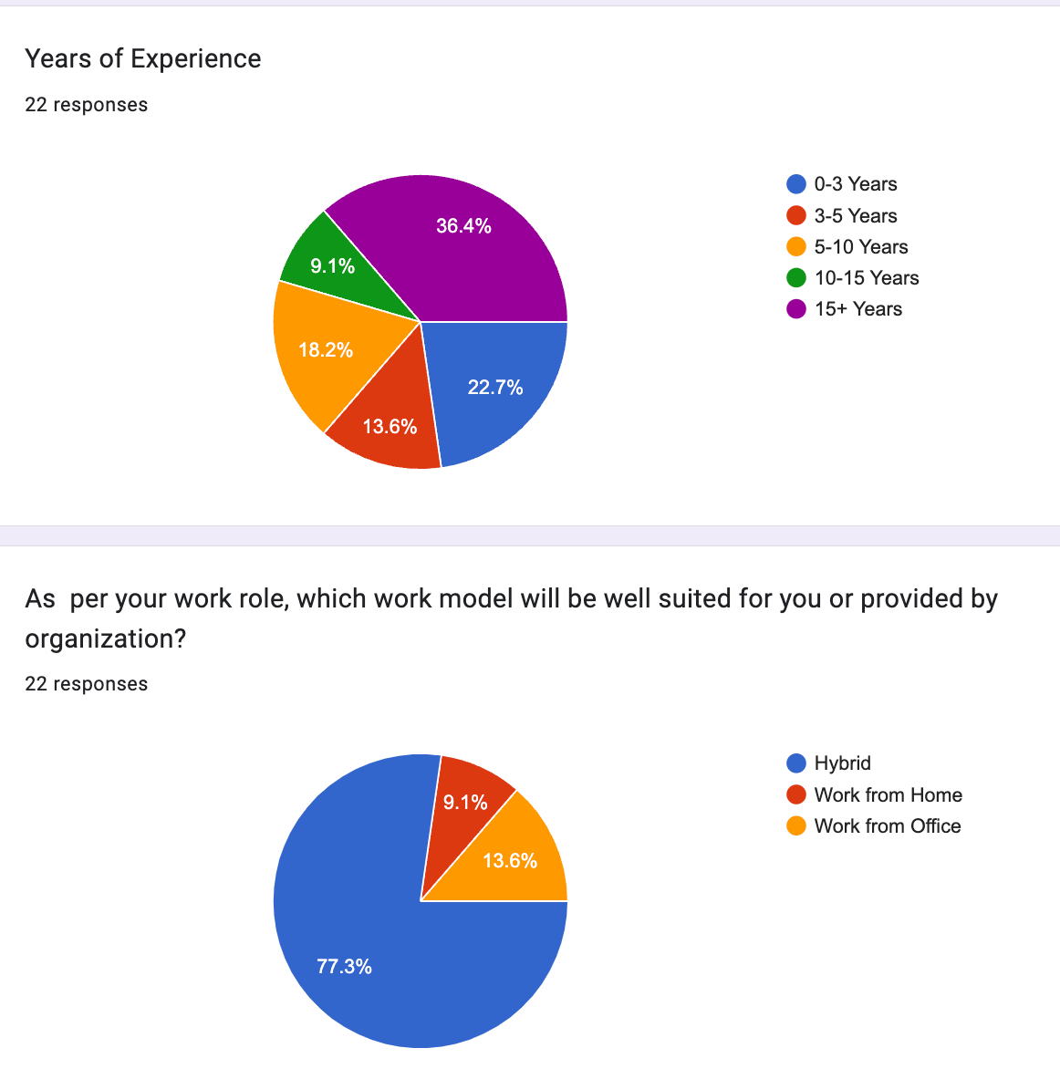

RECOMMENDATIONS AND CONCLUSION

In conclusion, organisations must adopt a strategic and flexible approach in light of The Evolution of Workspaces and Remote Work. It is critical to embrace hybrid models, give technology integration top priority, and foster employee well-being. It is advised to create adaptable policies, make investments in cutting-edge tools for collaboration, and cultivate a culture that strikes a balance between individual freedom and group effort. As remote work becomes more common, it's critical to address issues like isolation and preserve a strong corporate culture. In the end, companies that adeptly manoeuvre through this dynamic terrain, prioritising both cutting-edge technology and people-centered approaches, will be well-positioned to prosper in the forthcoming workplace landscape, guaranteeing long-term efficiency and contentment among staff members.
.

BIBLIOGRAPHY
References:
- Friedman, B. (2019). The history and future of remote work. Forbes. Retrieved from https://www.forbes.com/sites/bradleyfriedman/2019/06/24/the-history-and-future-of-remote-work
- Jang, S. (2020). Managing dispersed teams: Exploring the role of time zones in the context of temporal coordination and virtuality. Journal of Management, 46(7), 1226-1253
- Choudhury, P., Foroughi, C., & Larson, B. Z. (2021). Work-from-anywhere: the productivity effects of geographic flexibility. Strategic Management Journal, 42(4), 655-683.
- aval, N. (2021). Remote work and the future of cities. Environment and Planning A: Economy and Space, 53(1), 3-7
- Wang, Y., Li, Y., Li, H., & Zhang, S. (2021). The rise of artificial intelligence and its impact on the future of work: A literature review. IEEE Access, 9, 22719-22734

