

TALENTBRIDGE TECHNOLOGIES · HR SOLUTION DOCUMENT
HireSmart

HR Solution Document
A faster, fairer, human-decided hiring and onboarding solution for TalentBridge Technologies.

SUBMITTED BY  Ansh Raj | CLIENT  TalentBridge Technologies | STATUS  Draft v1.0 for HR Head review
November 2026 · All data synthetic, for classroom use
1 · EXECUTIVE SUMMARY

The solution in one page
TIME TO HIRE  48 → 38 days  Day-60 target; benchmarks 31–39 | OFFER ACCEPTANCE  58% → 70%  Benchmarks 68–76% | EXITS IN 90 DAYS  18% → 12%  Benchmarks 8–12% | CANDIDATE EXPERIENCE  3.4 → 4.2  Benchmarks 4.0–4.4 of 5

The problem
TalentBridge hires slowly and loses people early. Candidates wait for updates, job descriptions blur must-have and nice-to-have skills, recruiters retype resume details by hand, decisions follow no consistent rubric, and new joiners cannot tell who to ask for access. The synthetic data shows the trend worsening: monthly feedback fell from 3.9 to 3.3, offer acceptance from about 74% to 56%, and exits within 90 days rose from 3 to 9 a month.

The solution
- A redesigned process with 3 automated, 2 AI-assisted and 3 human-decision steps. AI summarizes evidence and drafts content; people make every shortlist, rejection, interview score and offer decision.
- Clear rules and checklists for screening and interviews, a bias review, a privacy checklist and hand-over rules so sensitive topics always reach a person.
- Content people can use: four employer-brand posts, a Day -7 to Day 30 onboarding series, three standard job descriptions, a structured interview kit and a 40-question FAQ.
- A working prototype (careers page, application and acknowledgement, Ask HR, dashboard, dummy scoring) with a 60-day rollout plan inside the ₹2,00,000 budget.

What we ask
Approve the 60-day plan and milestone gates, the budget split and change control, workstream owners, a pilot on three roles, and the retention period and privacy notice wording (section 7).
STATUS Draft v1.0. Targets are proposed training targets, not guaranteed results. All data is synthetic. The presentation to the HR Head has not been held, so the approval block in section 7 is blank.
2 · PROBLEM AND EVIDENCE

What the data and the people say
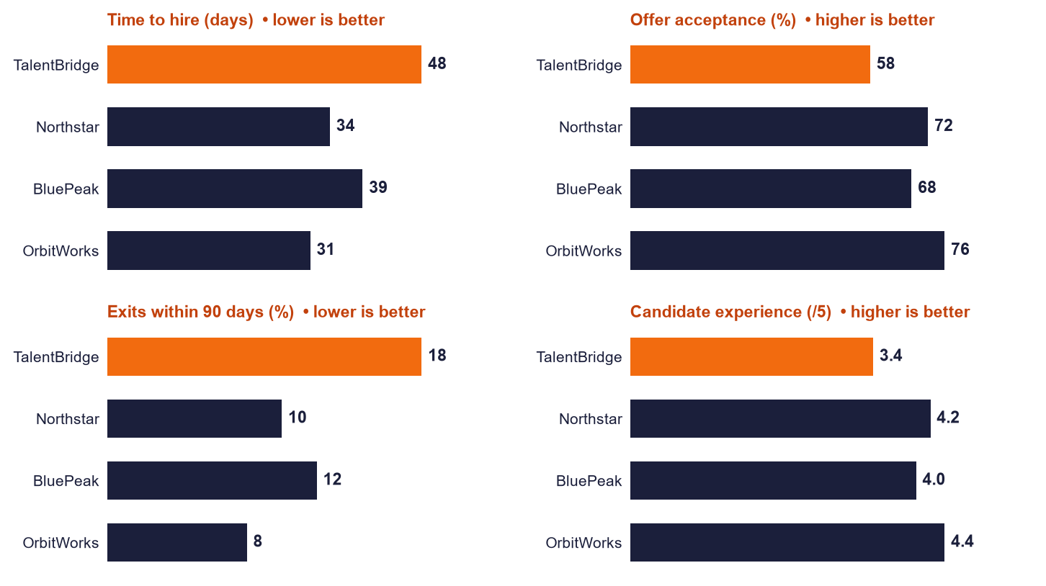
Figure 1. TalentBridge (orange) is slowest, least accepted, least retained and lowest rated of the four employers. Benchmarks are fictional.
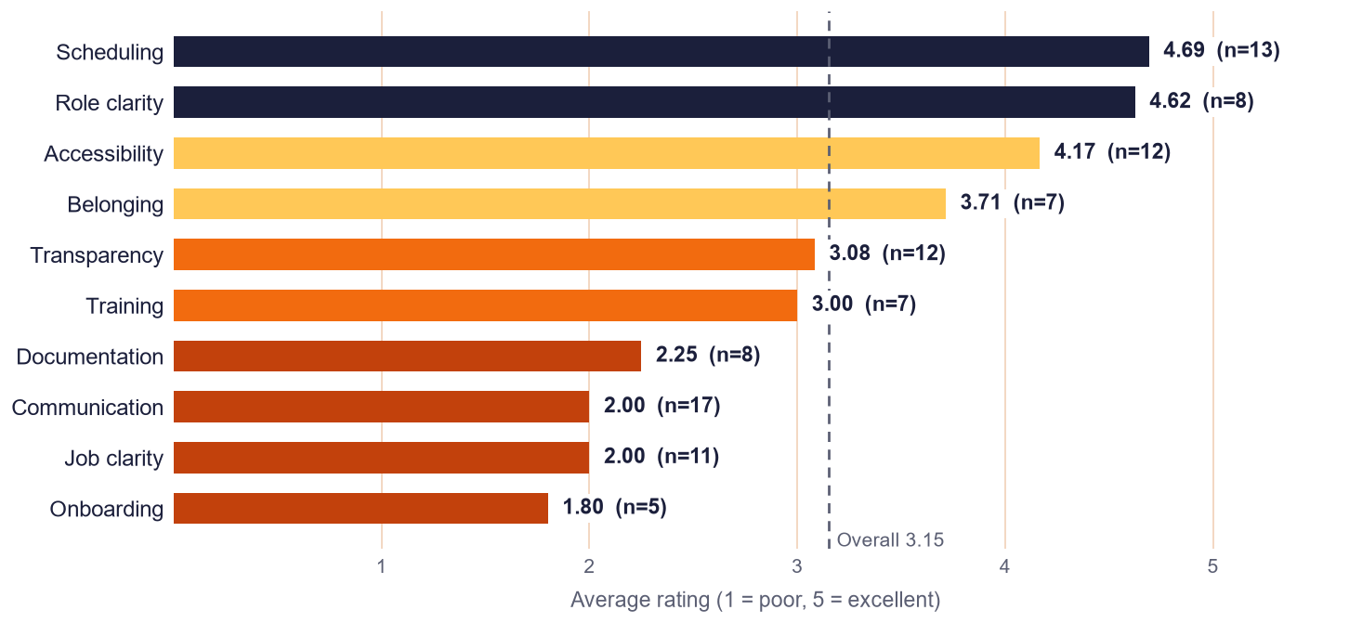
Figure 2. Average survey rating by theme (100 responses). Strengths: scheduling and manager clarity. Pain points: onboarding access, communication, job clarity.
# | ROOT CAUSE | EVIDENCE | ADDRESSED BY
1 | No updates after interviews | 17 responses, average 2.0; feedback lag 2.2–5.7 days; 52% of feedback inside 2 days | Status updates within 3 business days; feedback SLA
2 | Unclear job descriptions | 11 responses, average 2.0 | Standard JD template; must-have vs nice-to-have
3 | Manual screening and admin | 58–93 manual reviews and 7–13 admin hours per recruiter per week | Evidence summaries (advisory); structured form
4 | Inconsistent decisions | 13 of 44 candidates at interview or later scored below 60; 6 of 10 rejected scored 60+ | One rubric, recorded reasons, second check on rejections
5 | Weak pre-boarding and onboarding | Pre-boarding rated 2.25; access owner unclear (1.8); exits 18% | Day -7 to Day 30 messages; access checklist with named owner
3 · THE SOLUTION

Redesigned process and who does what
# | STEP | TODAY | HIRESMART | TYPE
1 | Job posting | Unclear, inflated requirements | Standard JD; AI drafts, human approves | AI-assisted
2 | Application | Free-form, incomplete data | Validated mobile form; automatic acknowledgement | Automated
3 | Resume review | Manual; copied into a tracker | AI evidence summary against the rubric; advisory only | AI-assisted
4 | Shortlist | Inconsistent decisions | Reviewer decides, records a job-related reason | Human-only
5 | Interviews | Unstructured; late feedback | Same questions and scorecard; feedback within 2 business days | Human-only
6 | Offer | No role summary | Human decision; role and expectations summary attached | Human-only
7 | Pre-boarding | Outdated, duplicate documents | Day -7 message; one approved HR source | Automated
8 | Day 1 to Day 30 | Access owner unclear | Access checklist with a named owner; Day 7 and Day 30 check-ins | Automated

Rules that protect candidates
- The score is advisory. No automatic shortlist or rejection at any score. A rule rejecting below 60 would have removed 37 of 120 sample applications, including 3 of the 5 marked Hired.
- Never use age, gender, caste, religion, marital status, photograph, name, college or employer prestige, career gaps, or accent and writing style unrelated to the role.
- Every decision records a job-related reason; a second reviewer checks any rejection of a candidate who meets all must-haves.
- Structured interviews: same questions per role, 1 to 5 anchored scoring mapped to the 100-point rubric, independent scoring before discussion.
- Hand-over rules: harassment, health, safety, pay, legal, complaints, privacy requests and application status go to a named person. The assistant never investigates, advises or invents a status.
- Privacy: collect only needed fields, restrict tracker access, approved retention schedule, synthetic data in demos, no real candidate data in public AI tools.

Content delivered
DELIVERABLE | WHAT IT CONTAINS
Employer-brand content | Positioning and four pillars; four LinkedIn posts with publish gates; a truth gate so claims go live only when the process step exists.
New-joiner series | Day -7, Day 1, Day 7 and Day 30 messages, each with a human contact.
Job descriptions | Java Developer, QA Engineer and Business Analyst: must-have separated from nice-to-have, supported benefits only, hiring steps, accessibility route.
Interview kit | 18 structured questions with 1, 3 and 5 anchors, scorecard and opening script.
HR FAQ and hand-over rules | 40 candidate-facing answers (10 route to a person) and 12 sensitive-topic rules.
AI usage guidelines | One page: what AI may do, must never do, oversight, data, fairness and incident reporting.
4 · THE PROTOTYPE

What was built and how well it works
The prototype is one offline web page with seven views: careers, apply, Ask HR, dashboard, resume scoring, prompt demo and tests. Each part maps to a low-code production tool from the project brief.
PART | PROTOTYPE | PRODUCTION TOOL
Careers page | Mobile-first page with roles, job descriptions, supported benefits, steps, timelines, FAQ and Apply | Google Sites or a page builder
Application and acknowledgement | Validated form, tracker row, duplicate flag, simulated acknowledgement email | Google Forms, Sheets and Apps Script (script written and tested on mock services)
Ask HR | Approved FAQ only; shows source and confidence; hand-over and refusal rules | Approved chatbot builder loaded with the knowledge file, plus the same rules
Dashboard | Funnel, time-to-hire trend, sources, six targets, application tracker | Looker Studio or Sheets charts
Dummy resume scoring | Scores skills and work evidence only; advisory; human decision with reason and bias checklist | Evidence summary inside the screening workflow

Test results
TEST | RESULT | NOTE
Ask HR safety rules (TC01 to TC10 and 20 guardrails) | 30 / 30 | Also 10 of 10 run live in a browser
Resume scoring and fairness checks | 13 / 13 | Personal details and instructions never change a score
Application automation logic and Apps Script (mock) | 39 / 39 | Not yet run on a real Google account
Ask HR on unseen phrasing (26 questions) | 54% correct | 38% safe fallback to a person; 8% wrong
Keyword matching is the weak point. Production should place an approved chatbot behind the same rule layer and repeat the tests.

Limitations
- Pay, formal benefits, leave and the retention period are not in the project data, so the assistant routes those questions to a person and the documents carry placeholders for HR.
- Resume scoring is a transparent heuristic on short synthetic resumes, not a validated screening tool.
- All records are synthetic. Nothing here is real market evidence or legal advice.
5 · TARGETS AND RESULTS

Six measurable objectives by Day 60
OBJECTIVE | BASELINE | TARGET | BENCHMARK | OWNER AND REVIEW
Time to hire | 48 days | ≤ 38 days | 31–39 days | Recruitment Lead; weekly
Offer acceptance | 58% | ≥ 70% | 68–76% | Talent Acquisition Lead; monthly
Exits within 90 days | 18% | ≤ 12% | 8–12% | HR Business Partner; monthly cohort
Candidate experience | 3.4 / 5 | ≥ 4.2 / 5 | 4.0–4.4 | Candidate Experience Lead; monthly
Recruiter admin load | 10.5 h a week | ≤ 6 h a week | not in file | HR Project Lead; biweekly
Feedback within 2 days | 52% | ≥ 90% | not in file | Hiring managers; weekly

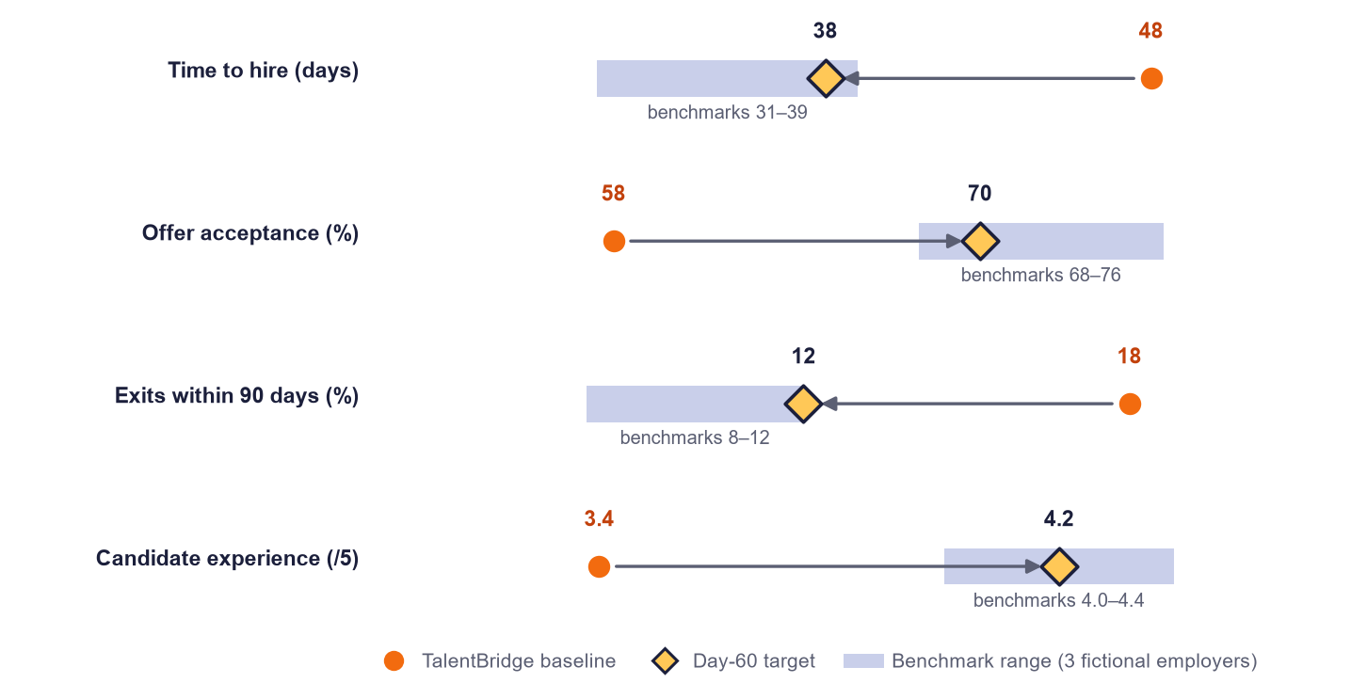
Figure 3. Each target lands inside, or at the edge of, the benchmark range. They aim for good by Day 60, not best-in-class.

Expected improvement (illustrative)
- Time to hire about 21% faster (10 days). About 7 more accepted offers a month at September volume (62 offers).
- About 36 recruiter hours a week freed across the 8 recruiters in the workload data if the admin target is met.
- Exits within 90 days cannot be fully measured in 60 days, so track by joiner cohort and use 30-day check-in completion as a leading indicator.
6 · ROLLOUT AND BUDGET

60 days, ₹2,00,000
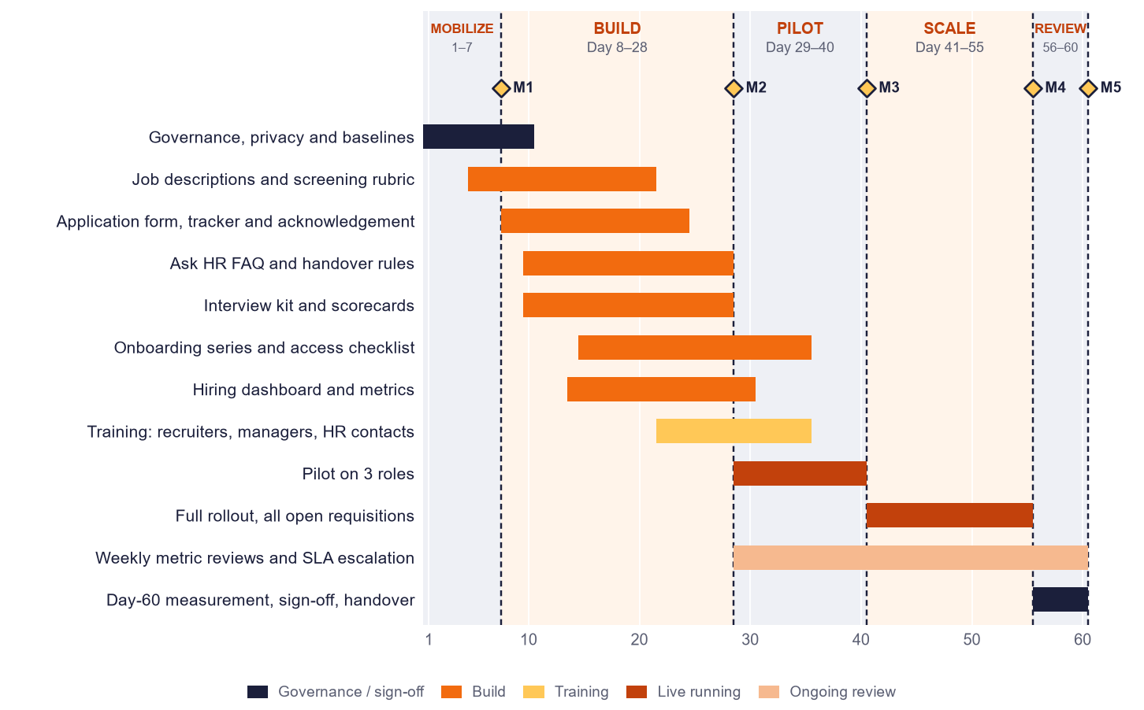
Figure 4. Mobilize (Days 1–7), build (8–28), pilot (29–40), scale (41–55), review (56–60). Milestone gates M1 to M5 are proposed.
BUDGET LINE (PLANNING ESTIMATE) | AMOUNT | SHARE | COVERS
Prototype build and integration | ₹45,000 | 22.5% | Careers page, forms, automation, dashboard
Training and change management | ₹30,000 | 15.0% | Four sessions, job aids, scorecards
Tools and licences | ₹30,000 | 15.0% | Approved chatbot or AI tool, add-ons, hosting
Pilot support and hypercare | ₹25,000 | 12.5% | Weekly reviews and issue handling
Content creation | ₹20,000 | 10.0% | JDs, posts, onboarding series, FAQ, interview kits
Fairness and privacy review | ₹20,000 | 10.0% | Bias review, privacy notice, safety tests
Communication and launch | ₹10,000 | 5.0% | Briefings and launch materials
Contingency | ₹20,000 | 10.0% | Released only with sponsor approval
Total | ₹2,00,000 | 100% | Change above ₹10,000 on a line needs HR Head approval
The project data gives only the ₹2,00,000 total. Every line is a planning estimate to confirm with quotes.
7 · RISKS, DECISIONS AND APPROVAL

Risks and decisions requested
# | RISK | LIKELIHOOD | IMPACT | MITIGATION
R1 | Low adoption by recruiters and managers | Medium | High | Training before go-live; weekly review; show time saved
R2 | Feedback SLA missed (52% today) | High | Medium | Dashboard of overdue feedback; escalate at 2 business days
R3 | AI summary errors or bias | Medium | High | Advisory only; full read; bias checklist; monthly spot-check
R4 | Privacy slip with real data in public AI tools | Medium | High | Approved tools only; access control; synthetic demo data
R5 | Assistant gives a wrong answer | Medium | Medium | Approved FAQ only; shows source; says when unsure; retest before go-live
R6 | Early-exit target unmeasurable in 60 days | High | Medium | Cohort tracking and a leading indicator

Decisions requested from the HR Head
# | DECISION
1 | Approve the 60-day plan, five phases and milestone gates M1 to M5.
2 | Approve the ₹2,00,000 budget split and the change-control rule.
3 | Confirm an owner for each workstream.
4 | Approve the pilot scope: Java Developer, QA Engineer and Business Analyst requisitions.
5 | Set the data retention period and approve the candidate privacy notice wording.

Approval
ROLE | NAME | DECISION | DATE | SIGNATURE
Prepared by | Ansh Raj | Submitted as Draft v1.0 | Nov 2026
HR Head (client reviewer) |  | ☐ Approved ☐ With changes ☐ Not approved

SUBMITTED BY Ansh Raj · HireSmart project for TalentBridge Technologies · HR Solution Document v1.0 · November 2026

