What is the best month for sales? How much earned this month?

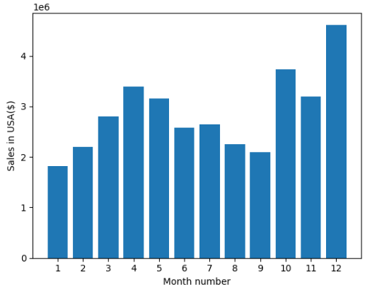

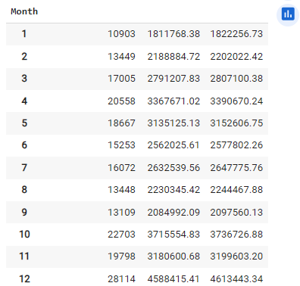

As we can see that sales first goes up in first 4 month after that gets decries. Now we can see that sales get decries for next 5 months and after that it get increases and hit the highest after 3 month .Now we can say that increase there must be some factor that by which we can see the sales rise such as Ads, marketing, offers etc. And in last month reason of sales increase must be result of holidays, traveling and end of year offers

**Which city has the higher no of sales?**

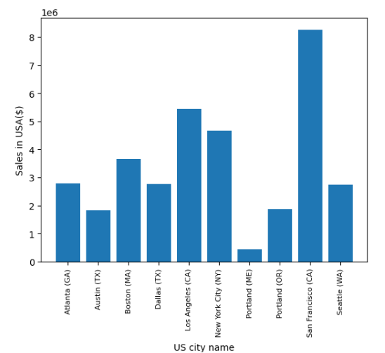

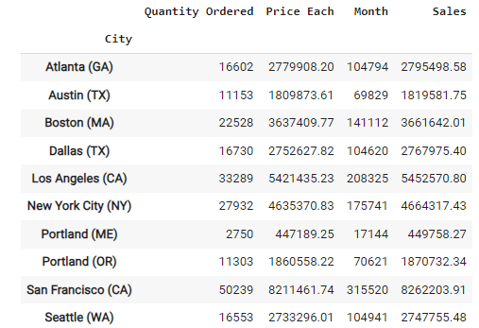

As we can see that San Francisco has the highest no of sales because of Silicon Valley needs more electronics or peoples has higher expenditure rate compare to other states .Also we can see that Portland has lowest expenditure it can cause due to low ads run on that area

## Q3 which time we should display advs. to max the customer buying product

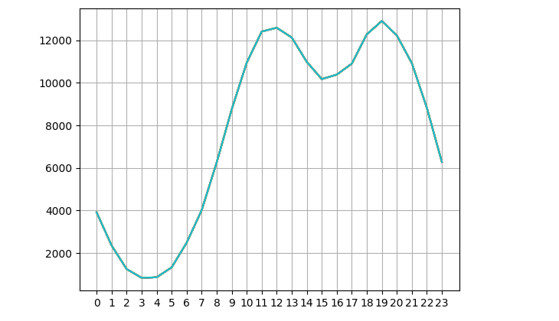

In the graph we can see that it give two pick time first pick in between 11 am to 12 pm where we get the max orders. And second peak in between 6pm to 8pm where get the max orders .So in this timing we can show Ads for max sales.

### Q4 what products are most often sold together

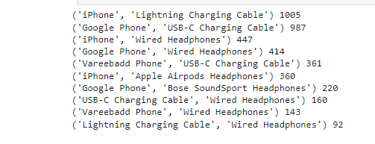

As we can see that most common items sold together are phone and cable .By this we can offer a combo deals that can attract more customers to the store that can increase the sales. And this will automatic make the customers to spend more

## Q5 what product sold the most? Why do you think it sold the most?

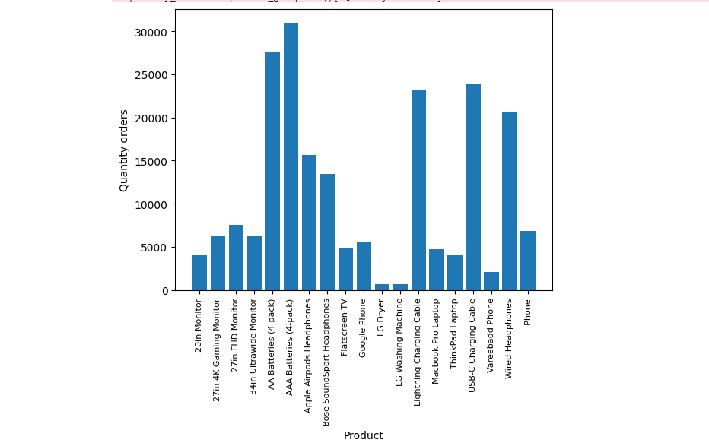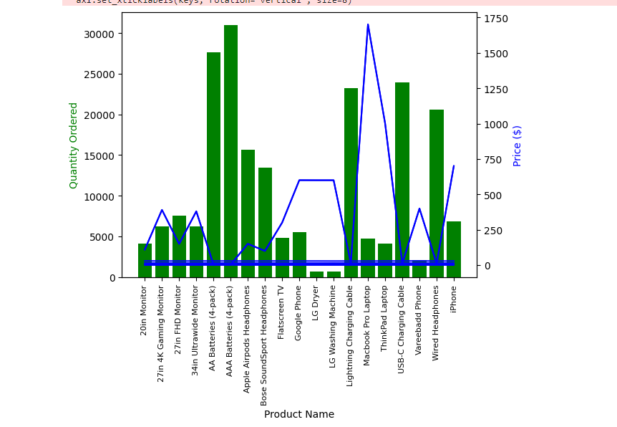

Whenever quantity orders then the prices is low .So we can see that AAA and AA batteries has a higher quantity and the lag dryer has a low quantity .Now we can say that peoples prefer less price items more or peoples byes only regular use product more