Group Project Proposal – CSC 4370/6370
IRONCLASH: Robot Arena Dashboard
Item | Details
Course | CSC 4370 Web Programming, Georgia State University
Project | Project 1: IRONCLASH, a Robot Arena Dashboard
Project folder / repository | Sharma_RobotArena
Student | Rajan Sharma (solo; Project Leader and only member)
Email | rsharma30@student.gsu.edu
Date | Sunday, 18 October 2026

1. Group Members
This is a solo project. I am the Project Leader and the only member, so I cover every role the course lists for a team.
Name | Role | Responsibilities | Email
Rajan Sharma | Project Leader (solo) | Design, HTML structure, CSS layout, CSS animation, testing (usability, responsive, accessibility), documentation, presentation and submission | rsharma30@student.gsu.edu

To keep the work organised I split it into four roles and track each as its own set of Kanban cards: UI/UX Designer (palette, CSS variables, wireframes), Layout Developer (semantic HTML, Grid and Flexbox, breakpoints), CSS Animation Specialist (keyframes, transitions, reduced-motion fallback) and QA and Accessibility Tester (widths, keyboard, contrast, links). The Team page on the site lists the same split.

2. Project Summary
Selection | Choice
Topic track | Track E: Robot Arena Dashboard (Home, arena roster, battle log and control panel pages; stat cards and status indicators built from reusable components; CSS animation sequences for power-ups and alerts; semantic HTML and a clean visual hierarchy)
Extension pack | Combat HUD Pack (status bars, alert chips and battle overlays; reusable panels for analytics and controls)
Bonus feature | Feature 4: Computer Vision Overlay Mockup, shown as "Arena Cam" on the Battle Log page (bounding boxes, detection tags with confidence and threat chips, CSS-only scan and result states; simulated, no real AI)
Hard constraint | HTML and CSS only. No JavaScript, PHP, APIs or databases.

Overview
IRONCLASH is a dashboard for a fictional robot fighting league. It has five pages: a Home page with live alerts and a featured matchup, an Arena Roster of six robots that can be filtered by type, a Battle Log with a match timeline, a results table, replay overlays and the Arena Cam bonus, a Control Panel where the visitor picks a bot, arms power-ups, chooses an arena mode and launches a match, and a Team page. Everything is styled as a combat heads-up display (HUD): dark panels with corner brackets, glowing stat bars, coloured status dots and alert chips. All interactivity is done in CSS with checkbox and radio inputs, the :has() selector, the :target selector, CSS custom properties and CSS counters.

Intended user experience
A visitor should understand the league in a few seconds on the Home page, then move through the site the way a fan or pilot would: look at the bots, check what happened in recent matches, and then set up a robot. The Control Panel is the hands-on part: every switch changes bars, numbers, alert chips and the preview straight away, so the page feels like a working console even though there is no script. Motion is used to show state (a power-up turning on, a bot locking on, a countdown) rather than for decoration, and all of it is turned off for visitors who ask for reduced motion.

Audience
- Robot-combat league fans who want to see the roster, standings and recent results.
- Pilots who want to compare bots and try out a loadout before a match.
- First-time visitors, guided by "New here?" and "Try it" hint boxes that tell them where to start.

3. Statement of Scope

In scope
- Five pages: Home (index.html), Arena Roster (roster.html), Battle Log (battle-log.html), Control Panel (control-panel.html) and Team (team.html).
- Three stylesheets: css/style.css (design system, layout, components, page styles, media queries), css/animations.css (all @keyframes) and css/arena-cam.css (the Arena Cam bonus, loaded only on the Battle Log).
- Reusable components from the Combat HUD Pack: stat cards, stat bars, status dots, alert chips, HUD panels with corner brackets, overlays and a live ticker.
- CSS-only interactions: mobile menu toggle, roster filter, power-up switches, bot and arena pickers, replay and launch overlays, flip cards, and the Arena Cam scan and result states.
- A responsive, mobile-first layout that works at phone, tablet and desktop widths.
- Accessibility basics: skip link, visible focus, labelled controls, alt text, sufficient contrast, reduced-motion support.
- Robot illustrations drawn as SVG files for this project (images/).

Deliberately out of scope
- No JavaScript, PHP, back end, API calls or database. All data on the site is static sample data written into the HTML.
- No real match data, live scores or real-time updates. The ticker, stats and "live" labels are simulated.
- No login, accounts, forms that submit, or saved settings. A Control Panel loadout resets when the page reloads.
- No real computer vision. The Arena Cam is a visual mockup; the boxes, labels and confidence values are fixed in the markup.
- No external CSS frameworks or icon libraries. The only external resource is Google Fonts.

4. Proposed Wireframe

4.1 Homepage details: introduction and navigation flow
The Home page opens with the site header (logo and main navigation), then a scrolling live alerts ticker (LIVE, ALERT, KO, POWER-UP, ARENA messages). The hero introduces the site in one line, "Build it. Power it. Clash it.", with a short lead paragraph, two call-to-action buttons ("Meet the bots" to the roster, "Open control panel" to the control panel) and a "New here?" hint that explains the suggested route. Beside it, a HUD frame shows a floating robot with a moving scan line and target tags.
Below the hero are four stat cards (bots online, matches today, average power with a bar, top bot), the featured matchup (Titan-07 vs Volt Runner with status dots and HULL and ATK bars), a three-step "How it works" list that links to the roster, control panel and battle log, and a teaser panel for the AI pilot section that deep-links to control-panel.html#ai-pilot.
Navigation flow: the header nav is identical on every page and marks the current page with aria-current="page". The intended first visit is Home, then Arena Roster, then Control Panel, with the Battle Log as the place to come back to after a match. Every page ends with the same footer (course line, Team link and a "Back to top" link).

4.2 Layout list
The site has 5 pages, all sharing one header, nav, footer and stylesheet set.
# | Page | File | Purpose
1 | Home | index.html | Introduce the league, show today's stats and the featured match, and route visitors to the other pages.
2 | Arena Roster | roster.html | Show every robot as a stat card and let visitors filter by Tank, Speed or Support.
3 | Battle Log | battle-log.html | Show recent matches, results and round-by-round replays, plus the Arena Cam bonus.
4 | Control Panel | control-panel.html | Let a pilot pick a bot, arm power-ups, pick an arena, launch a match and compare AI pilots.
5 | Team | team.html | Introduce the project leader, roles, time tracking and stand-up format.

4.3 Page content and purpose

Home (index.html)
Purpose: a fast introduction and a hub. Content: ticker, hero with CTAs and HUD visual, four stat cards in a 4-column grid on desktop, featured matchup with a pulsing "VS", three numbered steps, AI pilot teaser.
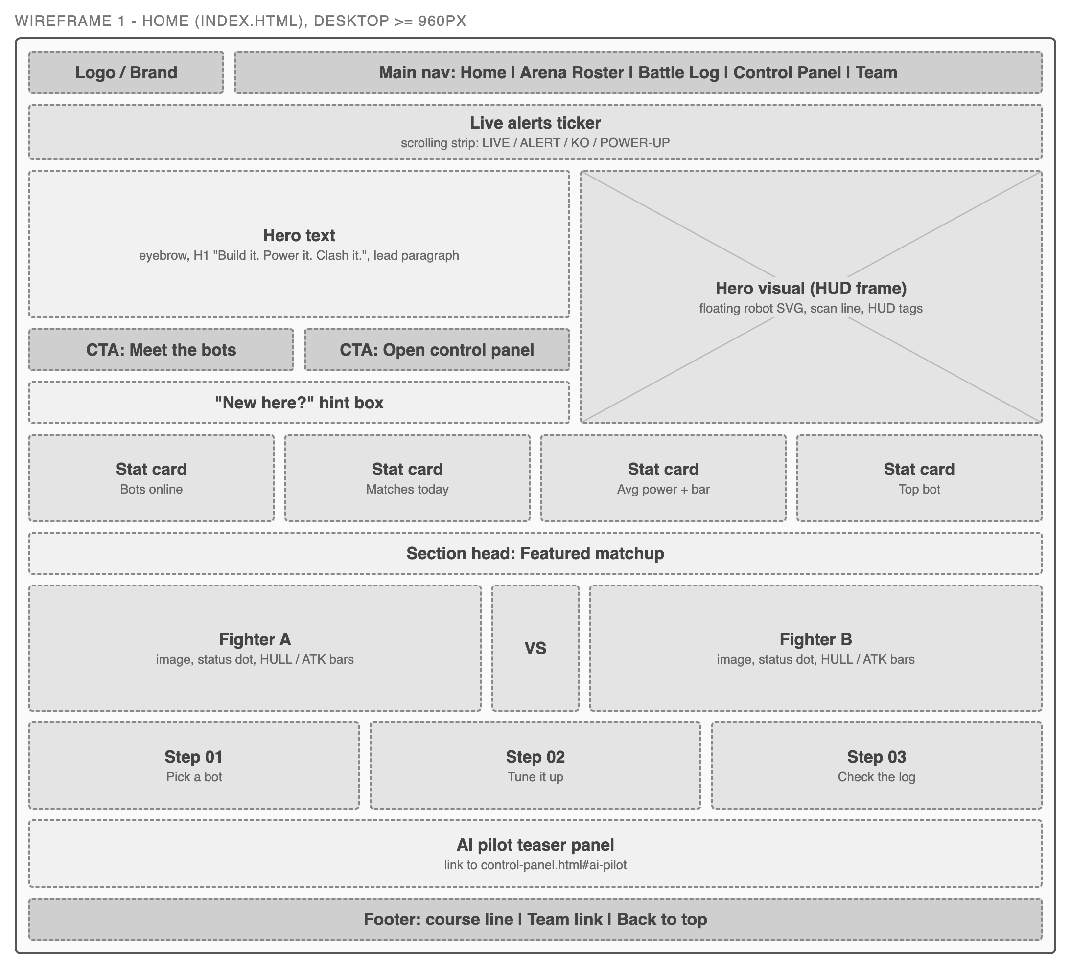
Figure 1. Home page wireframe, desktop (960px and wider).

Arena Roster (roster.html)
Purpose: compare the robots. Content: page head, a filter bar (All bots, Tank, Speed, Support), six bot cards each with a type chip, status dot (online, in repair, offline), robot image, name, one-line role and HULL, ATK and SPD bars, and a tip box linking to the Control Panel.
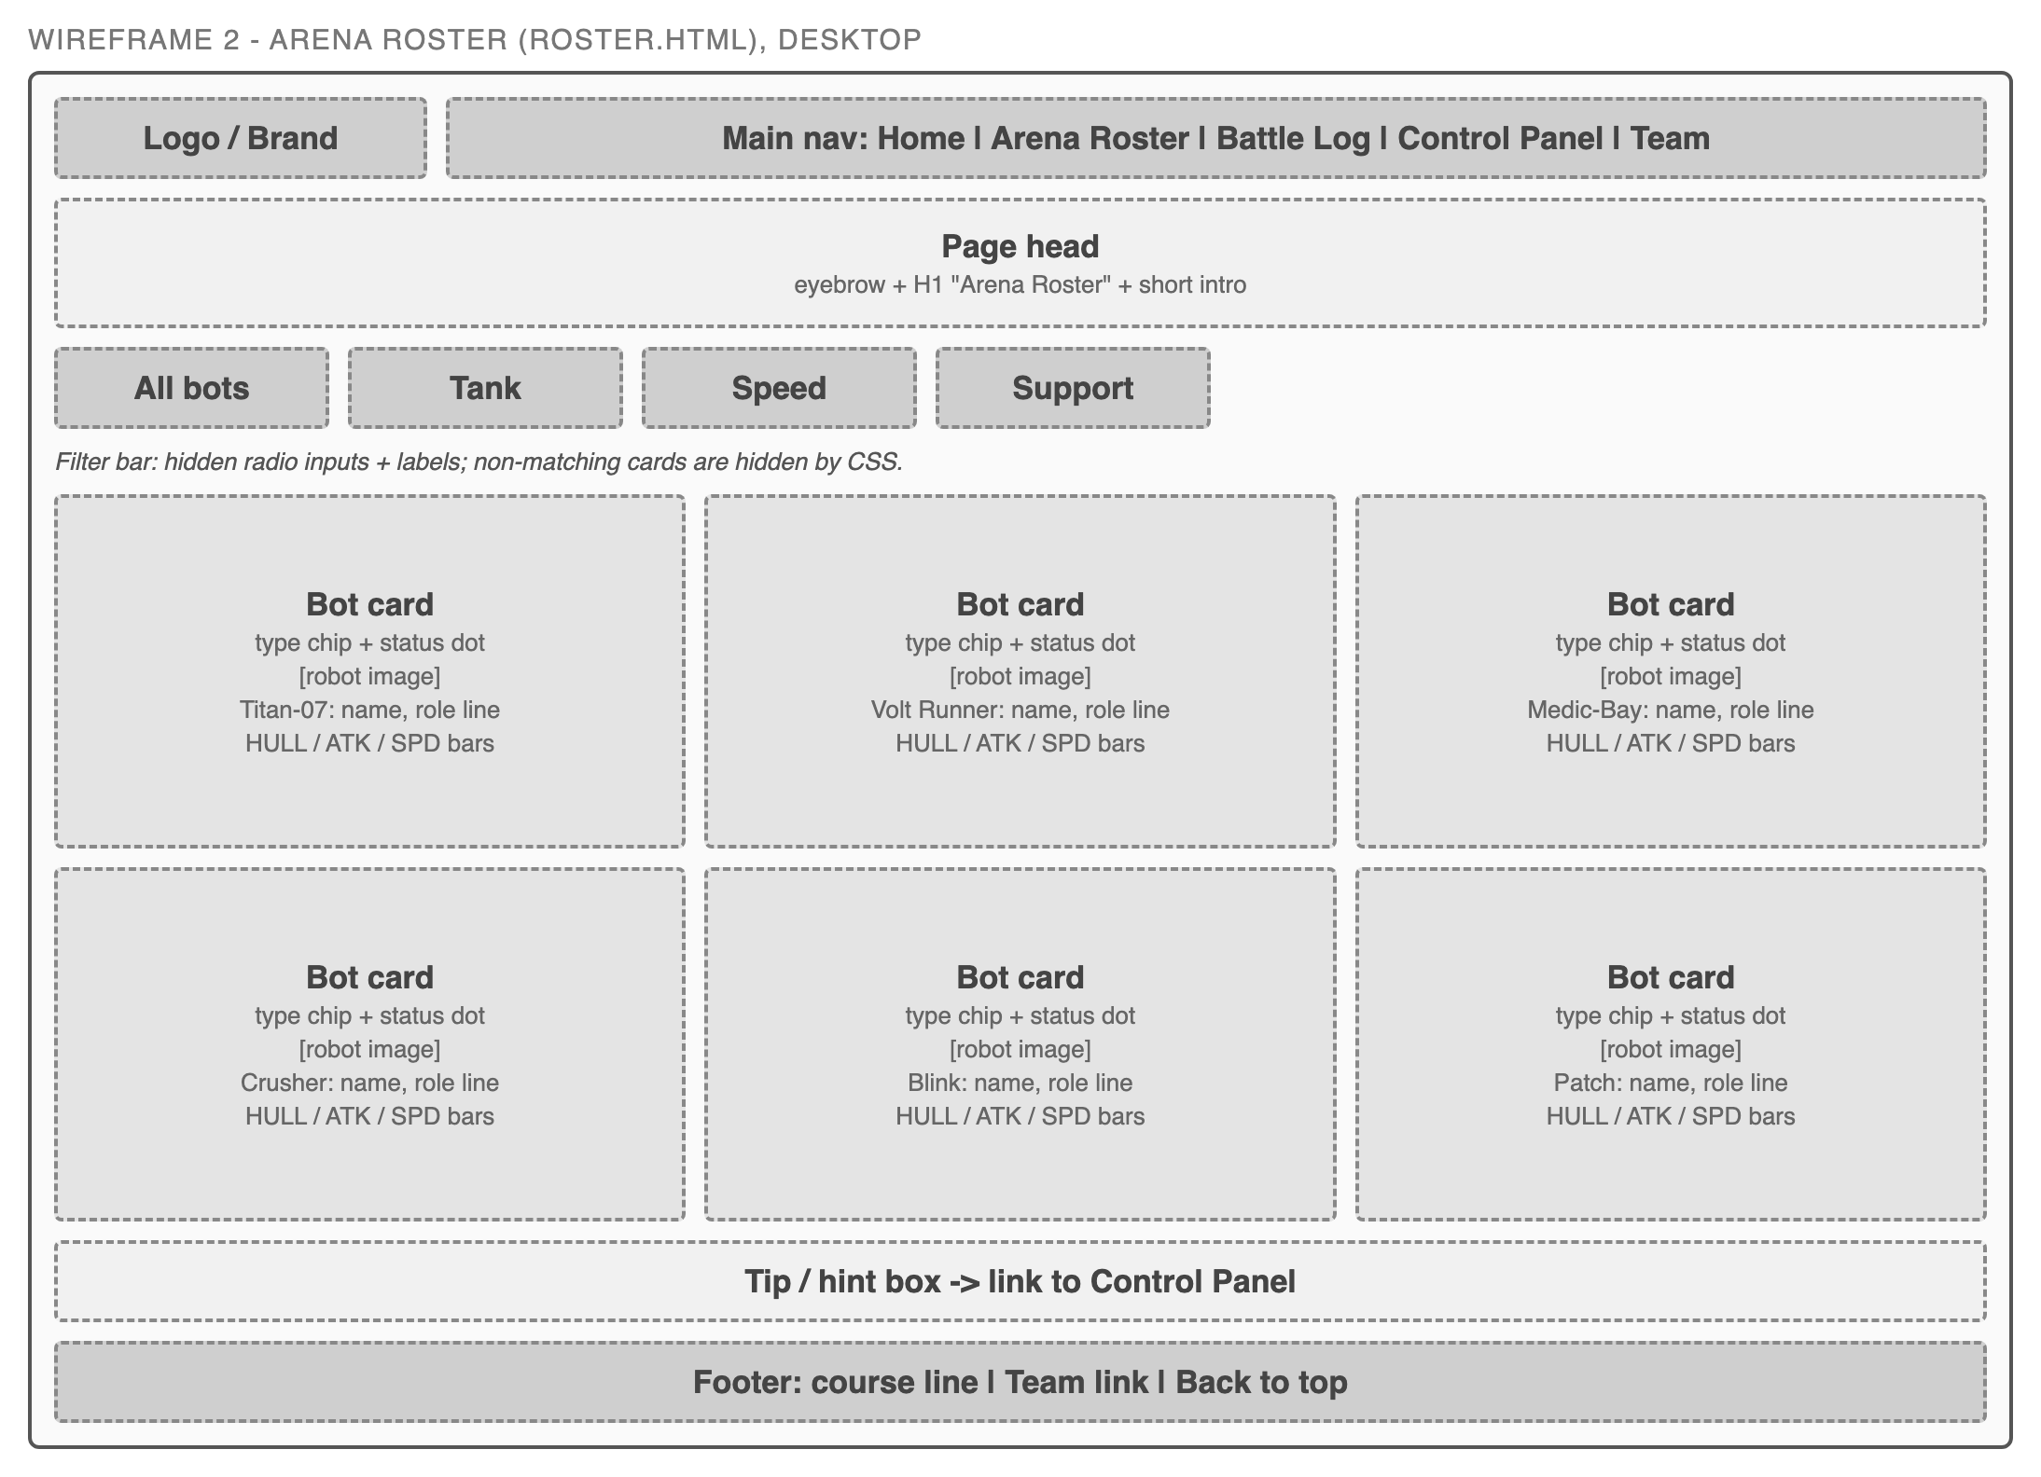
Figure 2. Arena Roster wireframe, desktop.

Battle Log (battle-log.html)
Purpose: what happened in the arena. Content: page head, season summary chips (38 matches, 14 knockouts, 5 overheats, avg 3.2 rounds), a match timeline of three log entries with result chips and "View replay" buttons, a results table of six matches, three replay overlays (#replay-1 to #replay-3) showing HULL bars per round, and the Arena Cam bonus section.
Arena Cam (bonus feature): one simulated camera frame from Titan-07 vs Volt Runner, with a clear "Simulated detection" notice. Three camera-mode buttons (01 Live feed, 02 Scan, 03 Results) are hidden radio inputs. In Live feed a red REC dot blinks. In Scan a beam sweeps the frame, the grid flickers, the robots turn grey, a progress bar fills over 2.4s and four steps explain what a detector does. In Results a bounding box snaps onto each robot one after another, each with a tag showing name, class, confidence (0.97, 0.88, 0.93) and a threat chip (high, medium, low). A fourth robot half hidden behind the pit wall gets a dashed box at 0.41, below the 0.50 cut-off, so it is flagged as uncertain and not counted. A side panel lists the same detections as text with confidence bars and a class filter (All, Tank, Speed, Support). The "Scan a frame" button on the Titan-07 vs Volt Runner log entry jumps to this section.
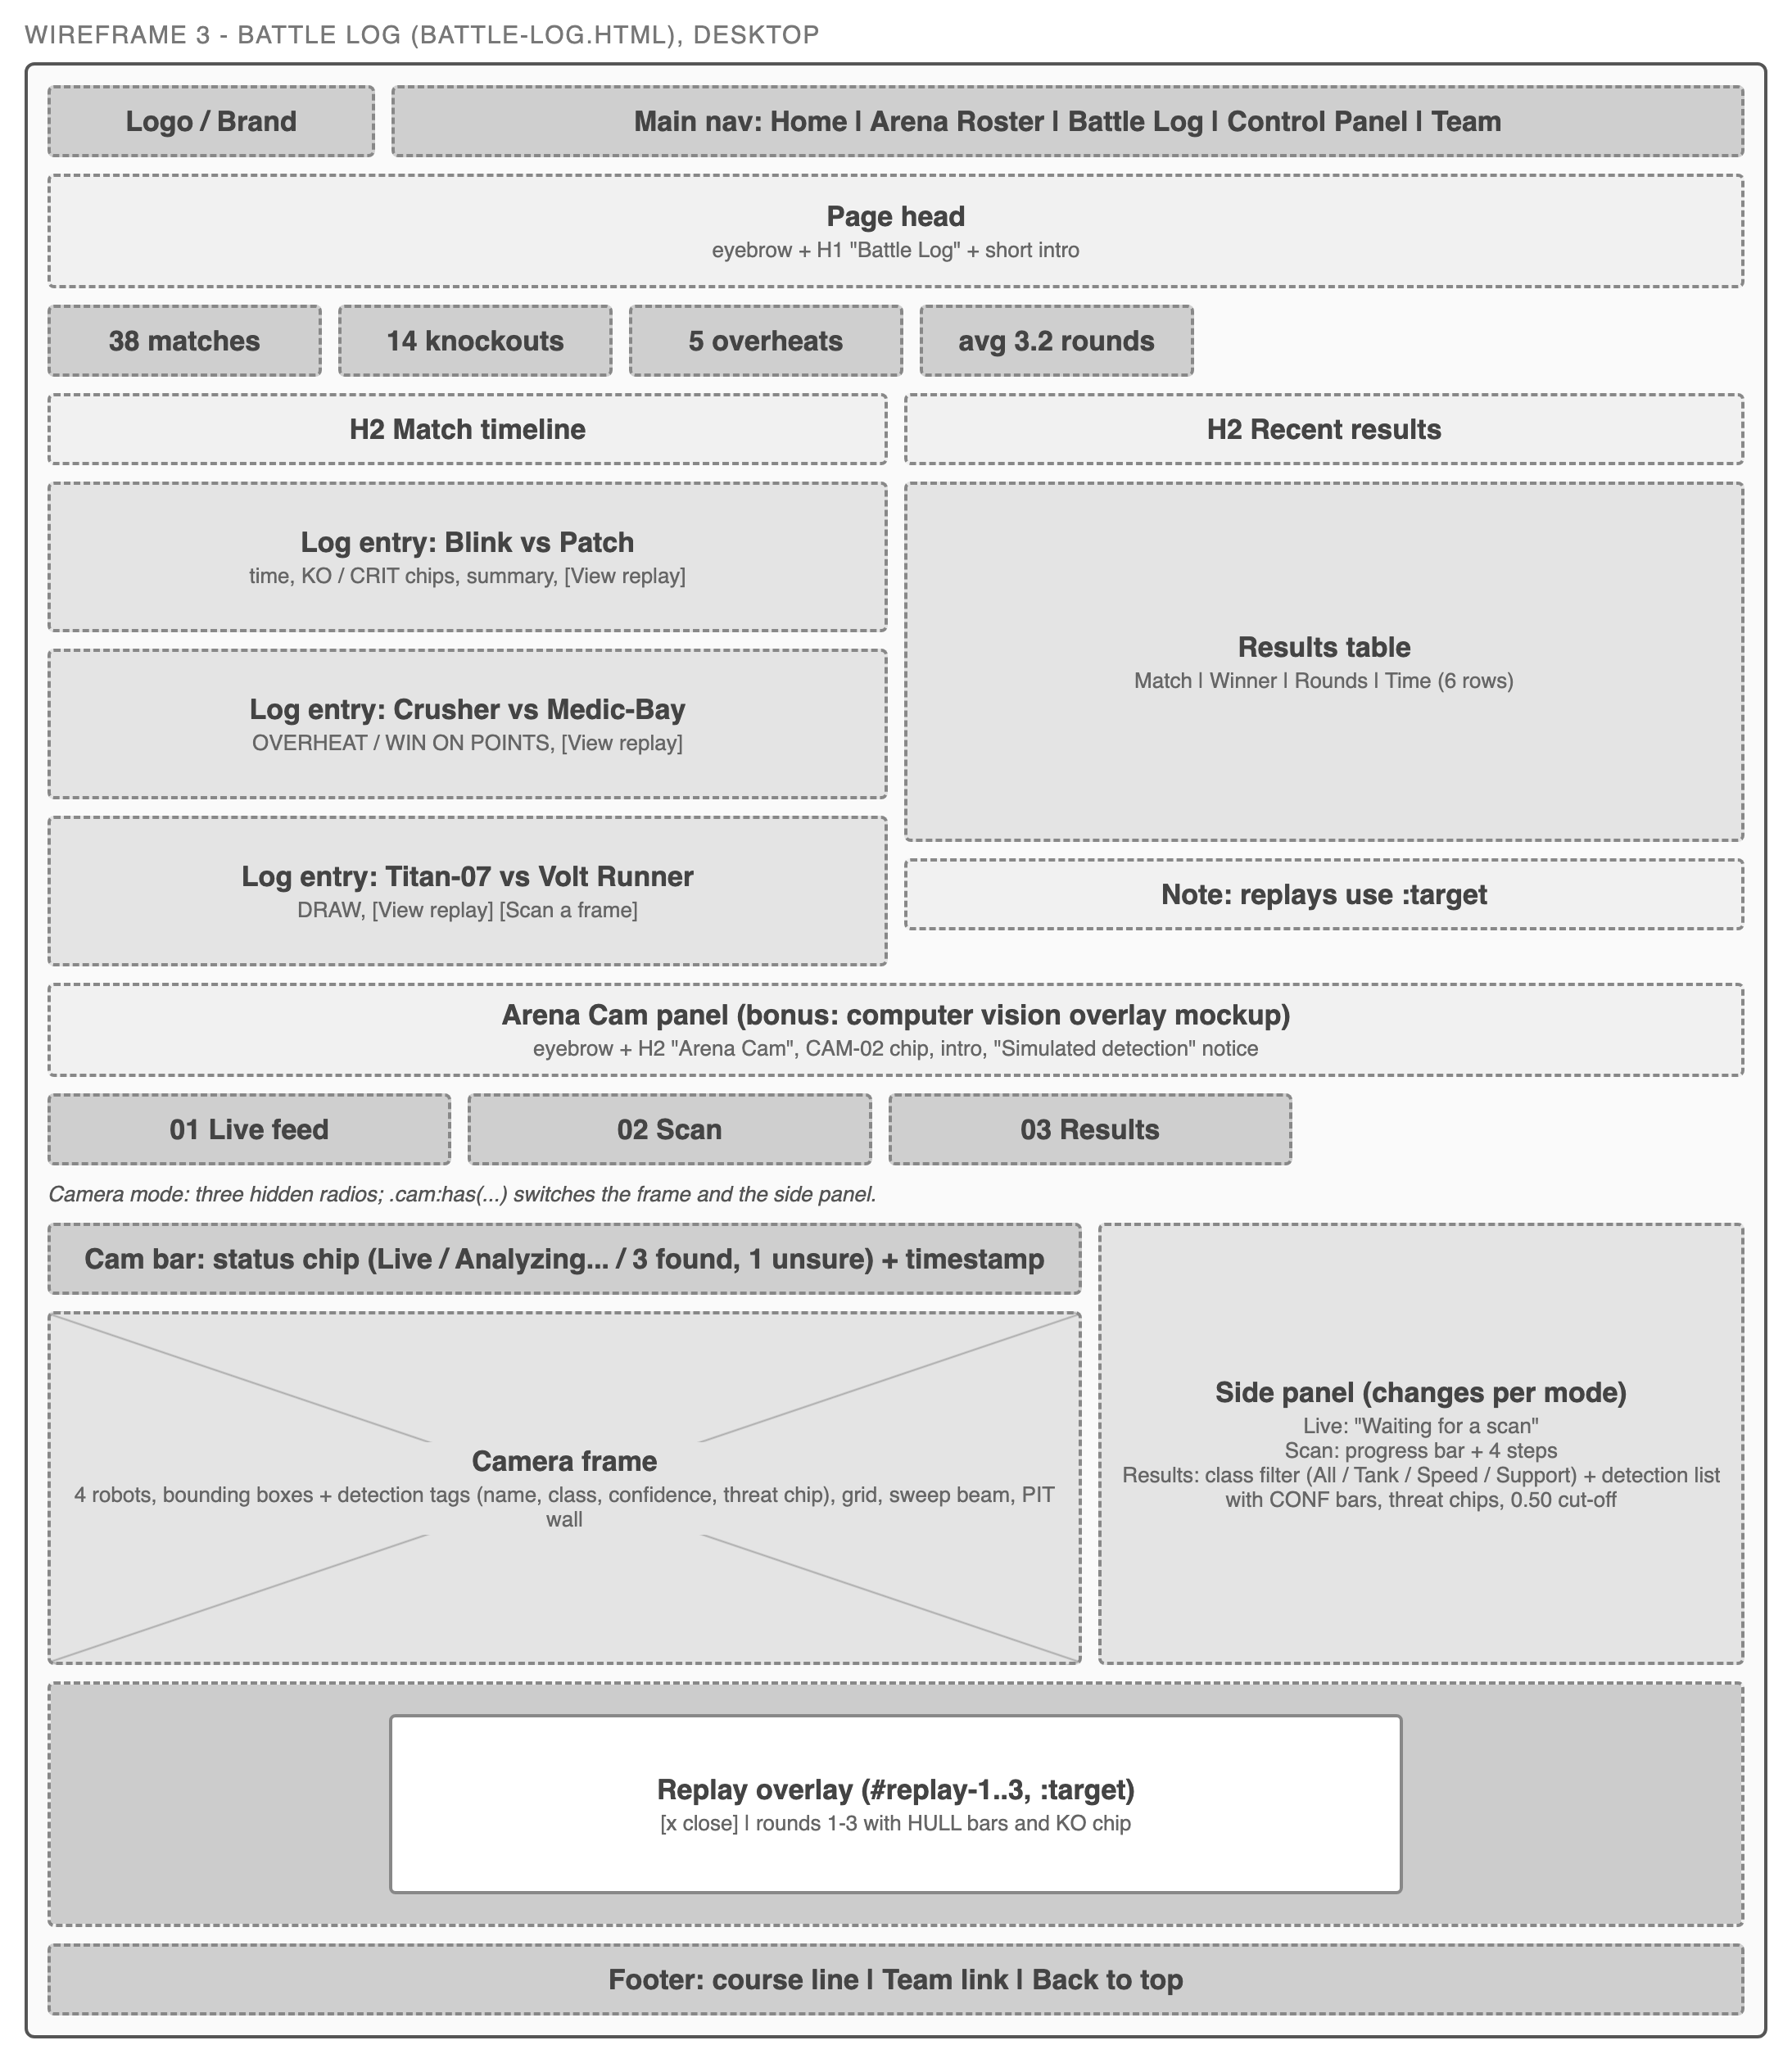
Figure 3. Battle Log wireframe, desktop, including the Arena Cam section and a replay overlay.

Control Panel (control-panel.html)
Purpose: the interactive console. Content: Step 01 bot picker (six cards), a live preview of the selected bot (scan line, HUD tags, reticle, shield bubble), Step 02 power-ups (Overdrive, Shield Boost, Repair Drone, Targeting Lock) with a live readout of HULL, SHIELD, ATK, SPD, ENERGY and HEAT bars plus alert chips, Step 03 arena mode (Standard, Lava Floor, Night Ops), Step 04 launch panel (loadout summary, radar, "Launch match" button opening a 3-2-1 countdown overlay), and a "Choose your AI pilot" row of three flip cards (Swift-3, Atlas-9, Ember Lite).
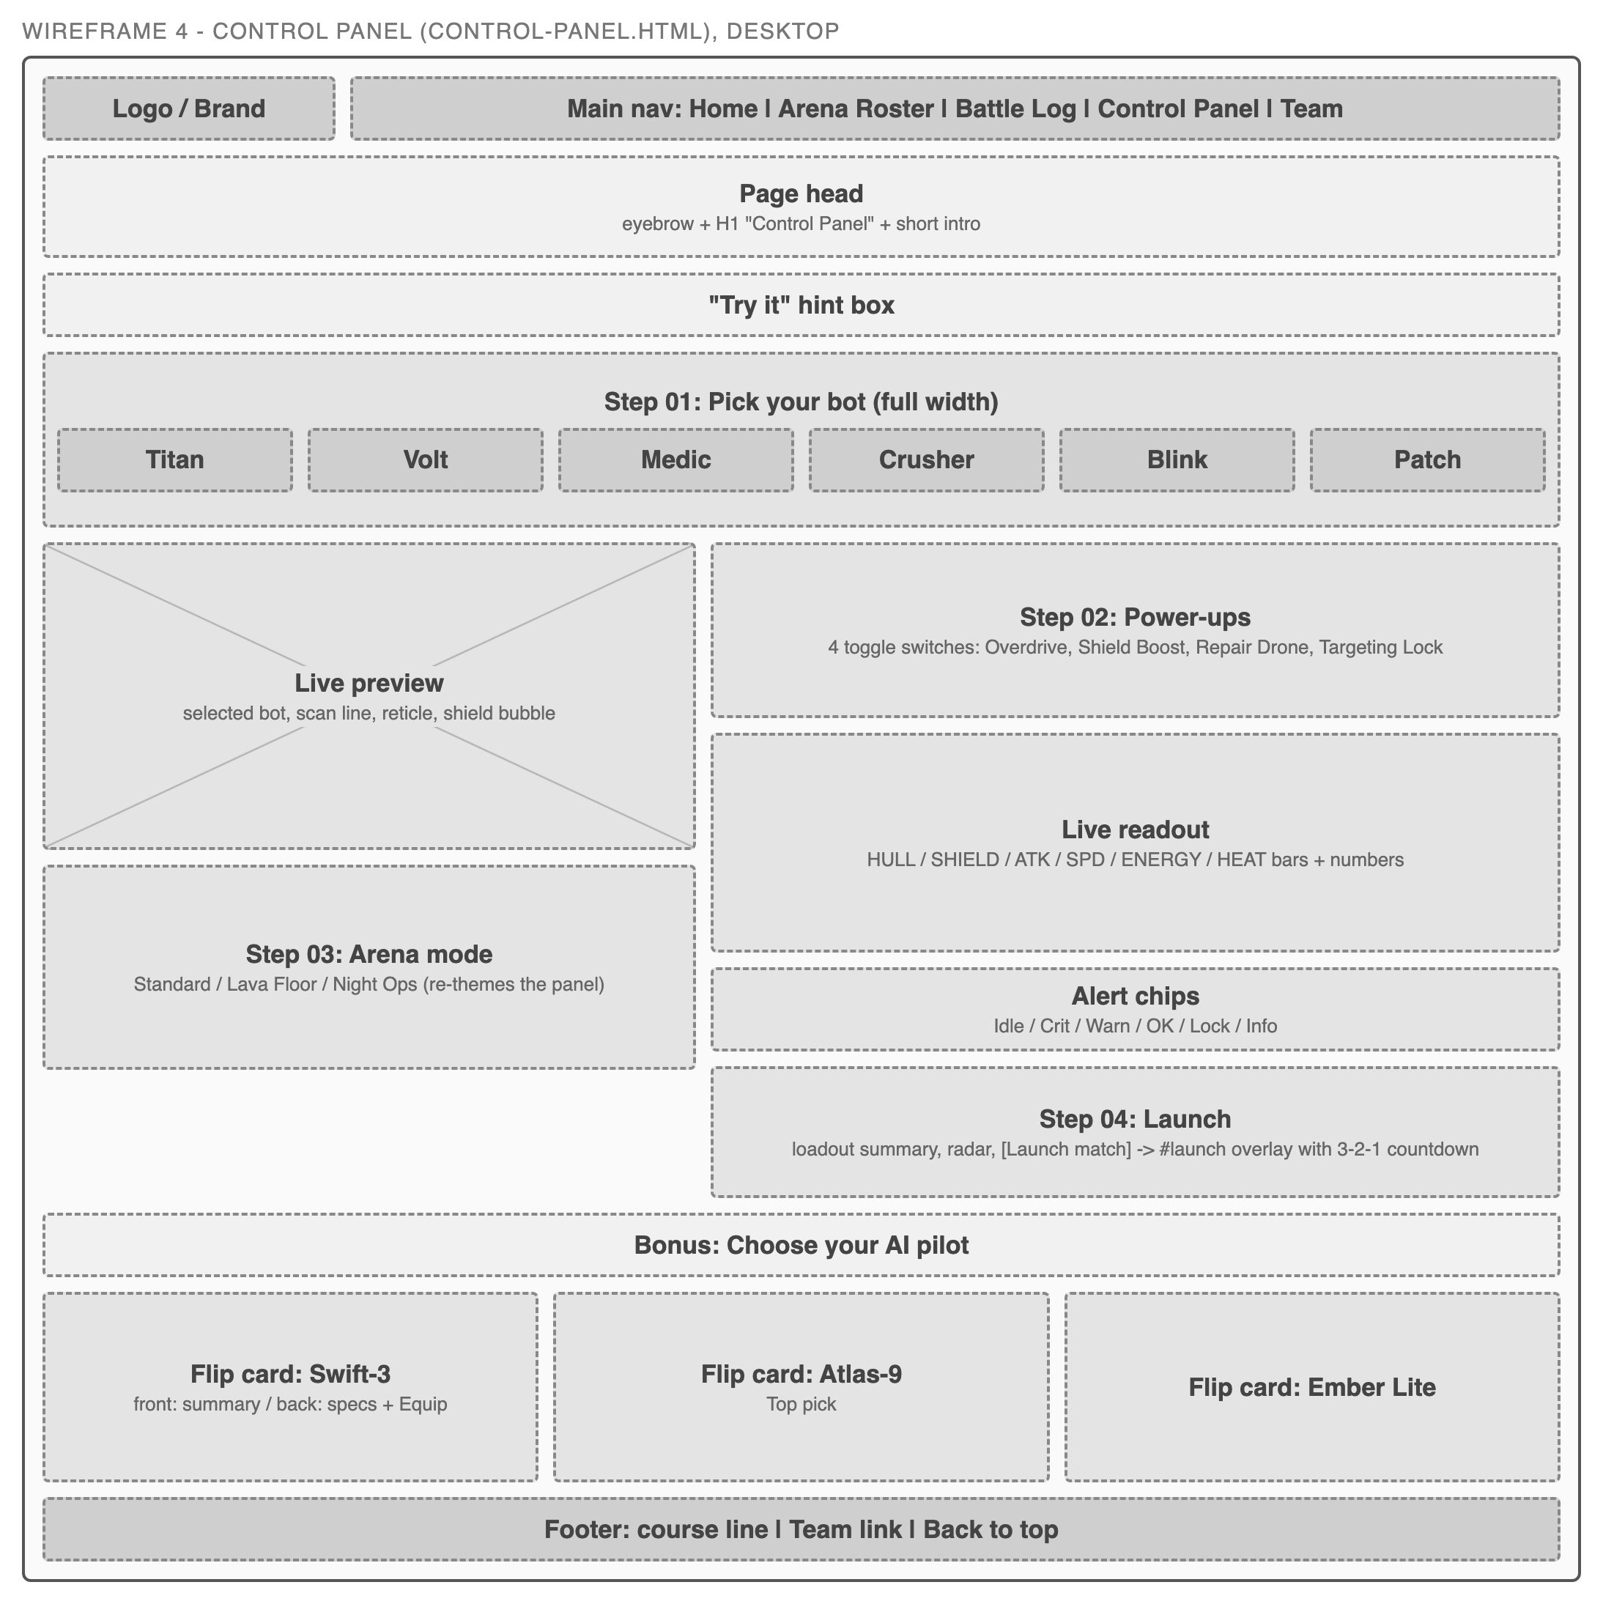
Figure 4. Control Panel wireframe, desktop.

Team (team.html)
Purpose: course team introduction. Content: page head with the project pitch and fact chips (Track E, Combat HUD Pack, Arena Cam bonus, folder name), a Project Leader panel, four duty cards (Coordination, Reporting, Technical, Submission), the four role cards, a member time tracking table by phase, and the daily stand-up format.
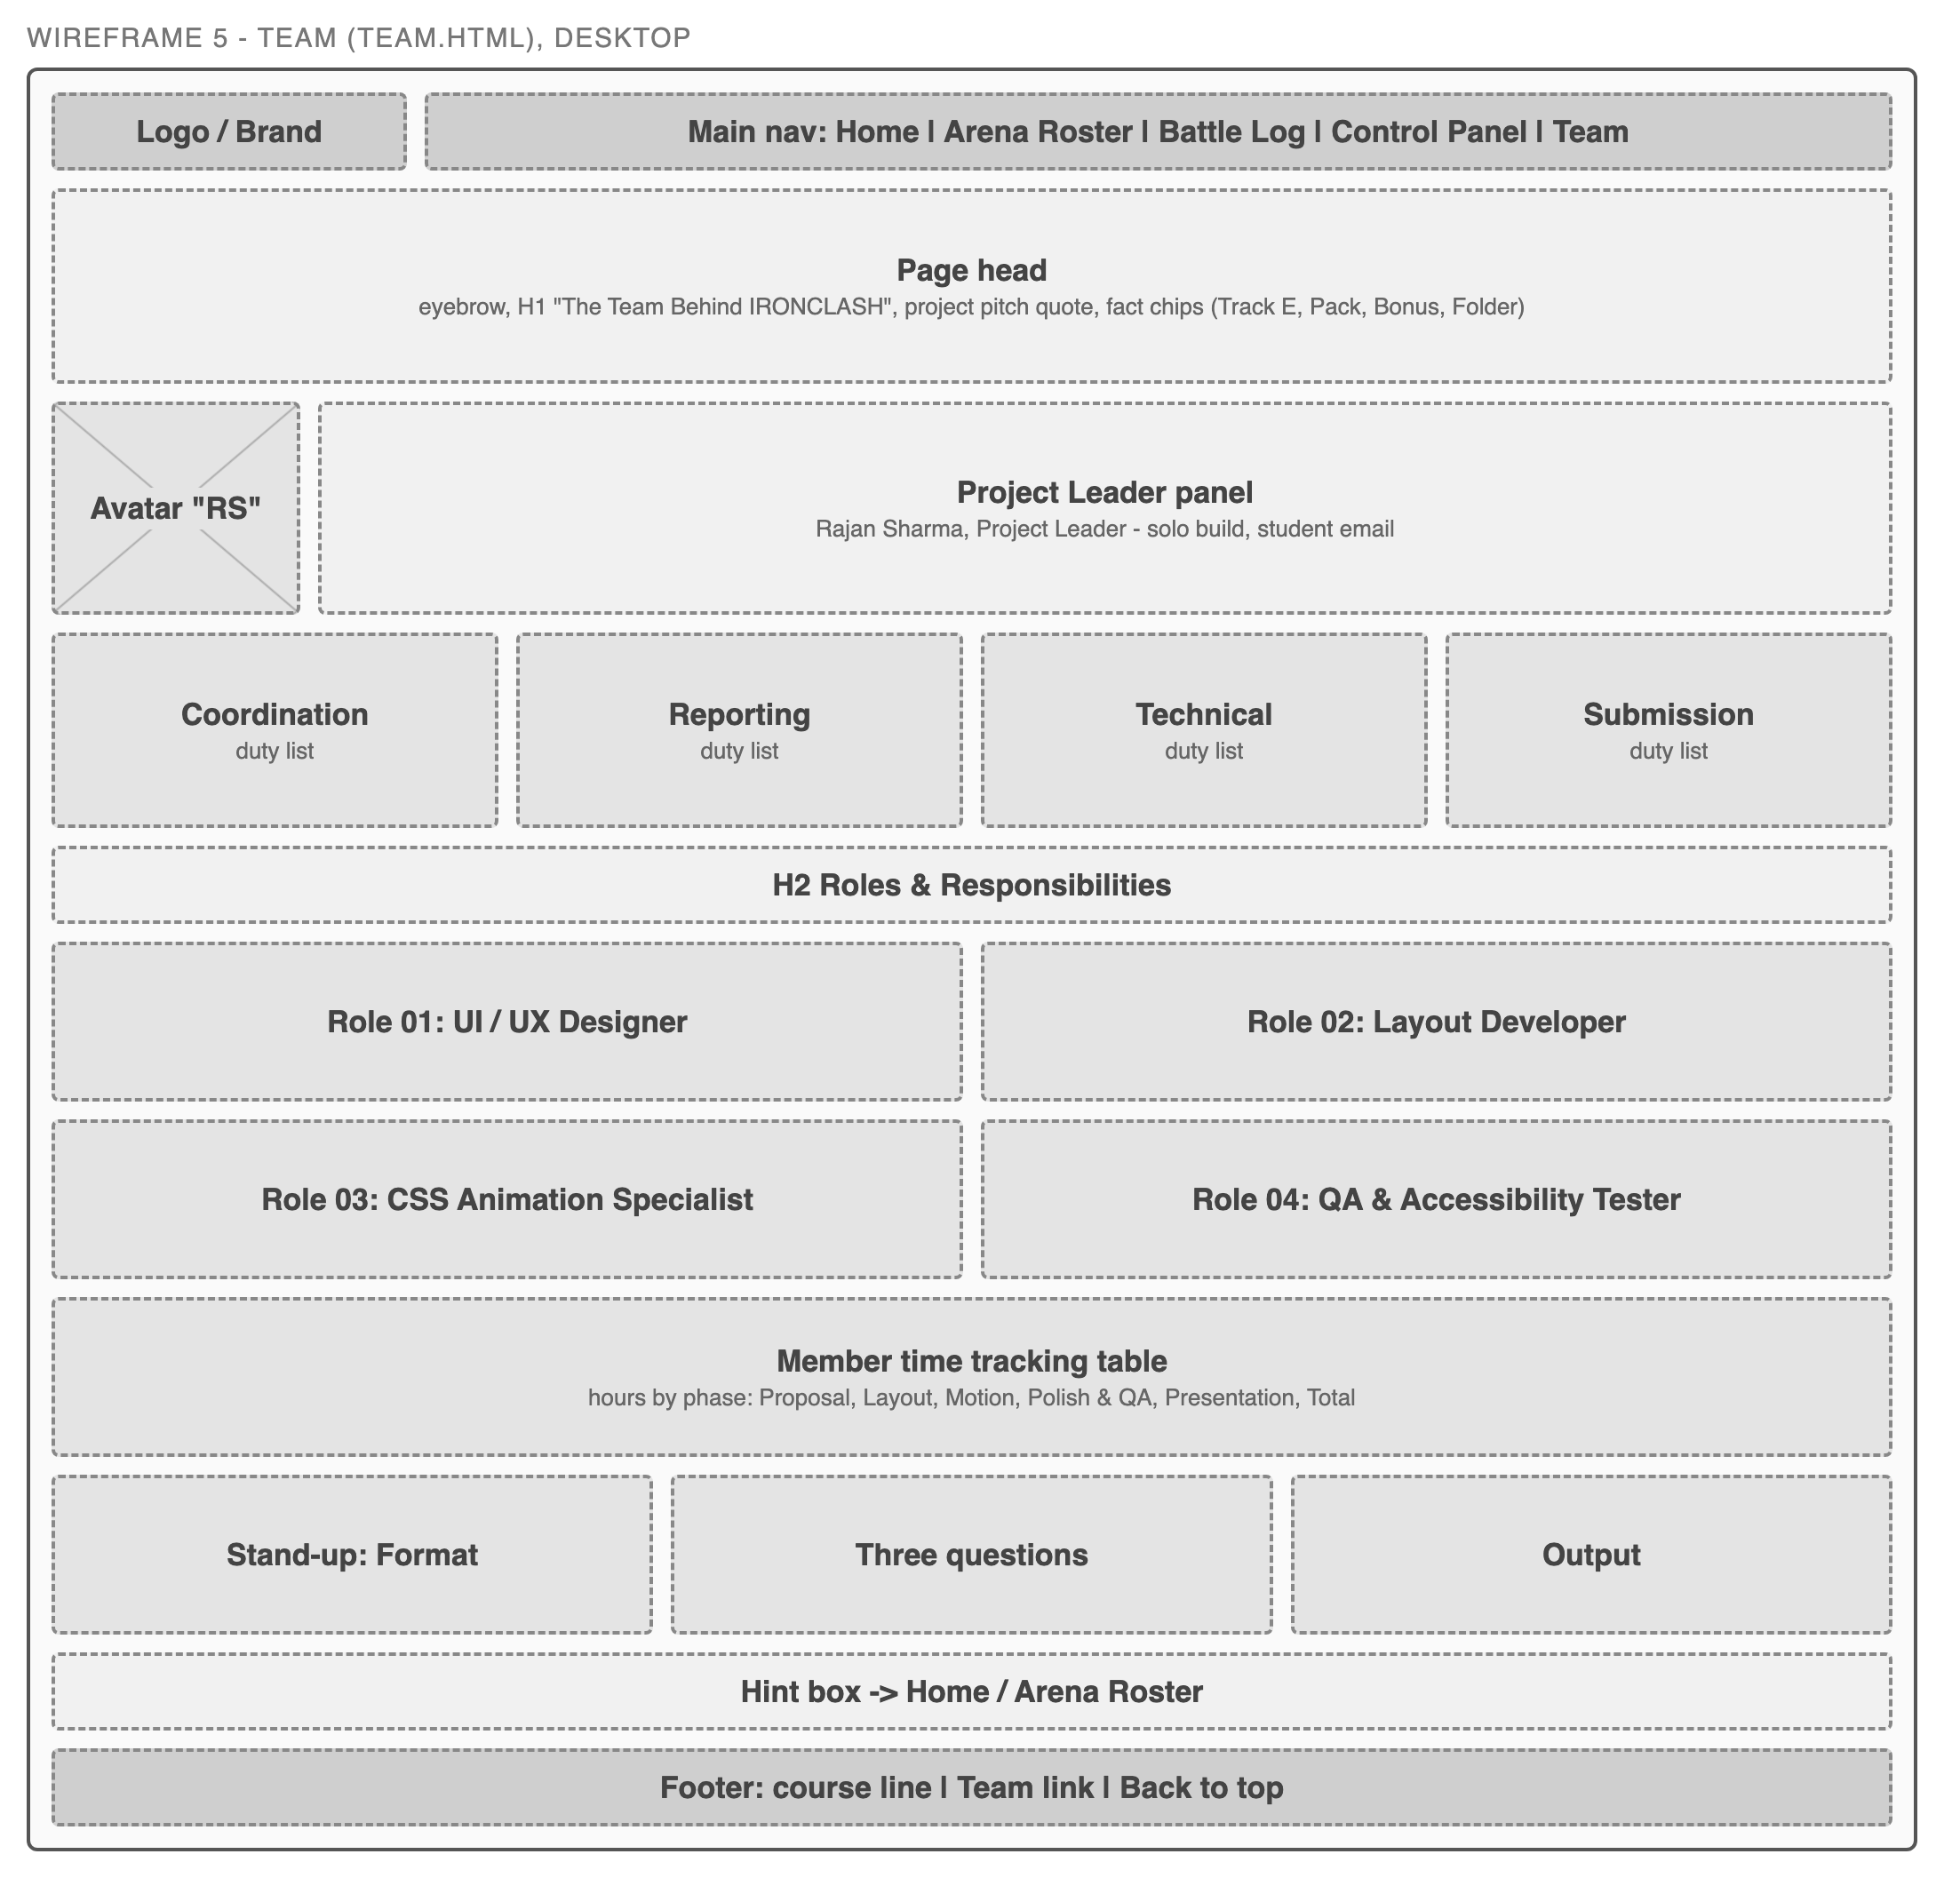
Figure 5. Team page wireframe, desktop.

Mobile layout
Below 640px every grid collapses to one column. The nav is hidden behind a "Menu" button (a checkbox and label) that opens a stacked nav drawer. From 640px most grids switch to two columns, and from 960px the full desktop layout and inline nav appear.
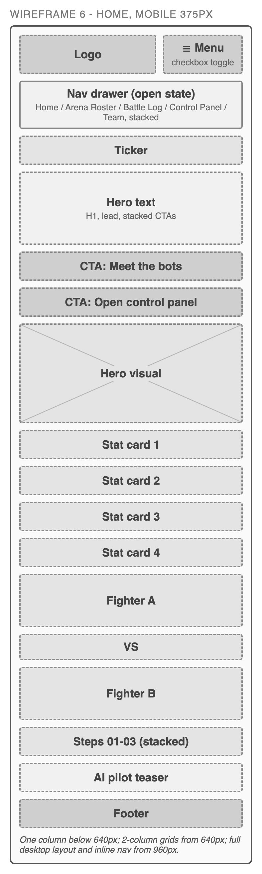
Figure 6. Home page wireframe, mobile (375px), with the nav drawer open.

5. Functionality

5.1 Screen-to-screen transition use cases
Use case | Trigger | Result
Move between pages | Header nav link (any page) | Loads the chosen page; the current page is highlighted through aria-current="page".
Open the mobile menu | Tap "Menu" (label for #nav-toggle) | Nav drawer slides open (max-height transition); burger icon turns into an X.
Start exploring | Home CTA "Meet the bots" / "Open control panel" | Goes to roster.html / control-panel.html.
Follow the guided route | "How it works" step links and hint boxes | Roster, Control Panel or Battle Log; the roster tip links on to the Control Panel.
Jump to AI pilots | Home teaser "Compare pilot models" | Opens control-panel.html#ai-pilot; scroll-margin-top keeps the heading below the header.
Watch a replay | "View replay" on a Battle Log entry | URL becomes #replay-n; .overlay:target fades in and the box scales up.
Close a replay | "x close" link or browser Back | Link goes to #timeline-title, so the overlay is no longer the target and fades out.
Scan a camera frame | "Scan a frame" on the Titan-07 vs Volt Runner entry | Jumps to #arena-cam; choosing Live feed, Scan or Results switches the camera view and side panel.
Launch a match | "Launch match" on the Control Panel | Opens the #launch overlay; the 3-2-1-Fight countdown and fuse bar run.
Abort a launch | "x abort" or "Back to setup" | Returns to #launch-panel with the loadout still set.
Return to top | Footer "Back to top" | Smooth scroll to #main (scroll-behavior: smooth, turned off for reduced motion).

5.2 Transition implementation details
Transitions use a shared timing token, --speed: 0.25s, so the whole site feels consistent.
- Buttons: transition: transform, box-shadow, background; the primary button lifts with translateY(-2px) and gains an orange glow on hover.
- Cards (stat cards, bot cards, log entries): transform, border-color, box-shadow; hover lifts the card translateY(-4px) and adds a cyan border and glow.
- Nav links: colour and background fade on hover and for the current page.
- Mobile nav drawer: max-height goes from 0 to 400px over 0.35s when #nav-toggle is checked; the burger lines rotate into an X.
- Replay and launch overlays: opacity and visibility over 0.3s, plus a transform on the inner box.
- Power-up switches: track background colour and knob position change when the hidden checkbox is checked.
- Readout bars: transition: width 0.5s ease, so bars slide to their new value when a power-up or bot changes.
- Live preview: the bot image filter (0.4s) glows during Overdrive; the shield bubble fades and scales in (0.4s); the "Locked" HUD tag fades in for Targeting Lock.
- Results table rows and toggle rows highlight on hover with a background transition.

5.3 Transformation implementation details
- translateY() lifts buttons (-2px), cards (-4px) and picker cards (-2px) on hover.
- scale() and rotate(): roster bot images grow and tilt on hover, scale(1.08) rotate(-3deg).
- scale(): overlay boxes open from scale(0.92) to scale(1); the shield bubble grows from scale(0.8) to scale(1).
- translateX(24px): the knob of each power-up switch slides to the "on" side.
- rotate(45deg) / rotate(-45deg) with translateY: the burger icon becomes an X when the menu is open.
- 3D transform on the AI pilot flip cards: perspective: 1000px, transform-style: preserve-3d, backface-visibility: hidden and rotateY(180deg) over 0.7s, triggered by :hover and :focus-within so keyboard users can flip them too.
- scaleX() is the basis of the bar-grow animation and translateX(-50%) of the ticker loop (below).

5.4 Animation implementation details
All keyframes live in css/animations.css. The table lists each one and where it is used.
@keyframes | What it does | Where it is used
pulse | Expanding green ring (box-shadow) around a dot | Online status dots on every page (1.8s, infinite)
blink | Opacity on/off | "In repair" status dot; radar blips in the launch panel
bar-grow | scaleX(0) to scaleX(1) | Every stat bar fills in on page load; the launch overlay fuse bar fills over 3s
float | Gentle up/down drift with slight rotation | Hero robot on the Home page (4s loop)
scan | Horizontal line moving top to bottom | HUD scan line in the Home hero and the Control Panel live preview
ticker | translateX(0) to translateX(-50%) | Live alerts ticker on Home (28s linear loop over duplicated content)
glitch | Brief jitter with cyan/red text shadow | The word "Clash it." in the hero heading
pulse-text | Scale and fade "breathing" | The "VS" between the two fighters in the featured matchup
fade-up | Fade in while moving up 18px | Roster cards on load, staggered 0.08s apart with nth-child delays
pop-in | Scale from 0.6 with a small overshoot | Alert chips that appear when a power-up turns on
heat | Brightness and saturation flicker | HEAT bar while Overdrive is on
spin | Full 360 degree rotation | Radar sweep in the launch panel
power-flash | Yellow text glow fading out | Readout rows affected by a power-up when it is switched on
lock-on | Reticle snaps from large and rotated to centred | Live preview when Targeting Lock is on
shield-hum | Soft pulsing cyan glow | Shield bubble when Shield Boost is on
count-step | Number zooms in, holds, fades | Launch countdown "3", "2", "1" (delays 0s, 1s, 2s via --delay)
count-go | Zooms in and stays | "Fight!" at the end of the countdown
cam-sweep | Beam moves from translateY(-100%) to translateY(100%) | Arena Cam frame in Scan mode (1.6s loop)
cam-flicker | Stepped opacity flicker | Arena Cam grid lines while the frame is "analyzed"
box-lock | Box snaps from scale(1.35) to scale(1) while fading in | Arena Cam bounding boxes in Results mode, staggered by a --d delay per robot

The countdown only receives its animation inside .overlay:target, so it restarts every time the launch overlay opens. The Arena Cam uses the same idea with :has(): animations are only attached while a mode is selected, so the scan restarts each time Scan is chosen. It also reuses existing keyframes: blink for the REC dot and the "Analyzing" cursor, bar-grow for the 2.4s scan progress bar, fade-up for the scan steps, pop-in for the detection tags (each 0.35s after its box) and pulse on the Results button once the scan bar is full.

5.5 CSS-only interaction patterns
- `:checked` with the sibling combinator `~`: the mobile menu (.nav-toggle:checked ~ .main-nav), the roster filter (four hidden radios before .filter-bar and .roster-grid; e.g. #f-tank:checked ~ .roster-grid .bot:not(.is-tank) hides the other cards) and the power-up switches.
- `:has()`: the Control Panel wraps everything in .hud. Rules such as .hud:has(#bot-crusher:checked) set the bot's base stats as custom properties, .hud:has(#pu-overdrive:checked) sets a 0/1 flag, and .pick:has(input:checked) highlights the chosen card. Two :has() in a row act as AND, e.g. Overdrive plus Shield or Repair shows the "energy low" warning. The Arena Cam works the same way: .cam:has(#cam-scan:checked) and .cam:has(#cam-results:checked) switch the status chip, frame effects and side panel, and .cam:has(#cf-tank:checked) hides the boxes and rows of other classes.
- Custom properties and `calc()`: each readout bar computes min(100, max(0, base + bonus)), where the bonus is built from the power-up flags, so the bars respond to any combination.
- CSS counters: counter-reset: stat var(--now) prints the number beside each bar, and counter-increment counts armed power-ups ("2 / 4") in the loadout summary. Bot and arena names are printed with content: var(--bot-name).
- Arena mode re-theming: Lava Floor and Night Ops override the colour variables (--accent, --panel, --line and others) on .hud, so every panel inside changes colour at once.
- `:target`: replay overlays and the launch overlay open when their id is in the URL and close when the link points elsewhere.

5.6 Design system and responsive layout
The :root block in style.css defines the design system: colours (--bg, --panel, --line, --text, --muted, --accent arena orange, --cyan HUD lines, --green, --yellow, --red), three font stacks (--font-head, --font-body, --font-mono), a type scale with clamp() for the hero and headings, spacing steps --space-1 to --space-6, radii, shadow and glow, --max-w: 1180px and --speed: 0.25s.
The layout is mobile first with CSS Grid for page sections and Flexbox for rows and controls. Breakpoints are @media (min-width: 640px) (two-column grids, three-column bot picker) and @media (min-width: 960px) (inline nav, three- and four-column grids, two-column hero, matchup and HUD, six-column bot picker). arena-cam.css uses the same two breakpoints: from 640px the mode buttons sit in one line and the detection list uses two columns, and from 960px the camera frame and side panel sit side by side (1.6fr and 1fr). A third query, @media (prefers-reduced-motion: reduce), removes motion. Bounding boxes are positioned with percentages, so they stay on the robots at any width.

6. User Experience

6.1 Proposed use case per page
Page | User goal | Use case
Home | Understand the site quickly | A first-time visitor reads the hero and stat cards, sees tonight's featured match and follows "Meet the bots" or the three steps.
Arena Roster | Find a bot that fits a play style | A pilot taps "Speed" to see only Volt Runner and Blink, compares their bars, then follows the tip to the Control Panel.
Battle Log | See what happened | A fan scans the timeline chips (KO, CRIT, OVERHEAT), opens a replay to see each round, closes it, then presses "Scan a frame", runs a scan and reads which robots the Arena Cam found and how sure it was.
Control Panel | Prepare a robot for a match | A pilot picks Crusher, sees the "hull under 25%" alert, turns on Repair Drone to clear it, switches to Lava Floor, launches and watches the countdown.
Team | Know who built it and how | The instructor or a visitor sees the project leader, roles, time by phase and the stand-up routine.

6.2 Accessibility notes
- Skip link: "Skip to content" is the first focusable element on every page and jumps to #main.
- Visible focus: one :focus-visible style (3px yellow outline) for everything; hidden inputs pass their focus to their visible label or card through :focus-visible ~ and :has(input:focus-visible) rules.
- Contrast: light text (#e8eef7) and muted text (#9aabc2) on near-black panels; accent colours are used on dark backgrounds only.
- Labels and semantics: every input has a <label>; picker groups use <fieldset> with a screen-reader <legend>; overlays use role="dialog" with aria-labelledby; the results table has a caption and scope on headers; the alert area is aria-live="polite".
- Alt text: robot images have descriptive alt text; decorative images and HUD tags use empty alt or aria-hidden="true"; duplicated ticker items are hidden from screen readers.
- Not colour alone: status dots have text (Online, In repair, Offline), alert chips pair an icon with a word (Crit, Warn, OK, Lock, Info), and stat bars show their number.
- Reduced motion: prefers-reduced-motion: reduce shortens all animations and transitions to almost zero, runs them once, turns off smooth scrolling and skips the countdown straight to "Fight!". On the Arena Cam the sweep beam is hidden and boxes and tags appear without delays.

7. Test Cases
These are the planned test cases and their expected results. I will run them in Chrome and Safari using the browser's responsive mode, and record the actual results in the QA log.
ID | Test | Steps | Expected result
TC-01 | Phone layout (375px) | Set width to 375px; open each of the 5 pages; scroll to the bottom. | Single column, no horizontal scroll, text readable, images scale down, Menu button visible.
TC-02 | Tablet layout (768px) | Set width to 768px; open each page. | Stat cards, steps and roster in 2 columns; bot picker in 3 columns; Menu button still shown.
TC-03 | Desktop layout (1280px) | Set width to 1280px; open each page. | Inline nav, 4 stat cards in a row, 3-column roster, two-column hero, matchup and Control Panel HUD; content max 1180px wide.
TC-04 | Mobile nav toggle | At 375px press "Menu", then press it again. | Drawer opens with all 5 links and the burger becomes an X; second press closes it.
TC-05 | Keyboard navigation | Use Tab / Shift+Tab / Space / Enter only on every page. | Skip link appears first; every link, switch, picker and flip card is reachable in a logical order with a visible yellow focus outline.
TC-06 | Replay overlay open/close | Battle Log: press "View replay" on each entry, then "x close"; repeat and use browser Back. | Overlay fades in with the correct match; close or Back hides it and returns to the timeline.
TC-07 | Roster filter | Choose Tank, Speed, Support, then All bots. | Only matching cards show (2 each); All shows 6; the active filter label is highlighted.
TC-08 | Power-up toggles | Control Panel: pick Titan-07; turn each power-up on and off, alone and combined. | Bars and numbers change by the stated bonus, rows flash, matching alert chips pop in, Idle chip hides; "energy low" appears for Overdrive plus Shield or Repair.
TC-09 | Bot and arena pickers | Pick each bot; switch arena to Lava Floor and Night Ops. | Preview image, info and base stats follow the bot; Crusher and Patch show the hull alert; arena modes re-colour the HUD and show their chip; loadout summary updates.
TC-10 | Launch overlay | Press "Launch match"; wait; press "x abort"; launch again. | Countdown 3, 2, 1, Fight! plays with the fuse bar; abort returns to the launch panel; it replays on every launch.
TC-11 | Arena Cam states | Battle Log: press "Scan a frame"; choose Live feed, then Scan (wait 2.4s), then Results; try each class filter. | Live shows the blinking REC chip; Scan shows the sweep, flicker, grey bots and filling progress bar; Results shows 4 boxes snapping in one by one with name, confidence and threat chips, the 0.41 box dashed and flagged; filters leave only the chosen class.
TC-12 | AI pilot flip cards | Hover each card; then Tab into each card. | Card flips to the specs side on hover and on keyboard focus; the equipped pilot is marked.
TC-13 | Reduced motion | Turn on "Reduce motion" in the OS; reload Home, Roster, Control Panel, Battle Log. | No looping motion (ticker, float, pulse, scan, cam sweep); content and states still correct; countdown shows "Fight!" at once; Arena Cam boxes appear without delay.
TC-14 | Link check | Click every nav, CTA, footer and in-page link on all pages. | No broken links or missing images; in-page anchors land on the right section.
TC-15 | HTML and CSS validation | Run each page through the W3C Markup Validator and all three stylesheets through the W3C CSS Validator. | No HTML errors; CSS errors only where the validator does not yet support newer features such as :has(), noted in the QA log.

8. Approach to Refine Improvements
Feedback goes straight into a loop of small iterations: collect it, turn each item into a card, fix it, retest it with the matching test case, and move it to Done.
- Sources of feedback: my own test runs (Section 7), peers or friends trying the site on their phones, and instructor comments on this proposal.
- Kanban board with five columns: Backlog (every idea and issue), To Do (chosen for the current work block), In Progress (at most two cards at once), Review (waiting for a retest at 375, 768 and 1280px and a keyboard pass) and Done.
- Daily journal: a short written check-in at the start of each work block (what I finished, what I am doing now, what is blocking me), plus notes on decisions and the time spent per phase.
- Priorities: anything that breaks the HTML/CSS-only rule, layout or accessibility comes first, then the required track and pack features, then polish.
- Version control: one commit per finished card with a clear message, so any change can be traced or rolled back.

9. Schedule
The project is being built in one compressed session on Sunday, 18 October 2026, the same day it is due. The phases run in this order; the times are the planned effort per phase, which I log on the Team page.
# | Phase | Date | Planned | Deliverable
1 | Proposal and plan | Sun, 18 Oct 2026 | 1.0 h | This proposal, wireframes, Kanban backlog
2 | HTML structure | Sun, 18 Oct 2026 | 2.0 h | Semantic markup for all 5 pages, shared header, nav and footer
3 | CSS layout and motion | Sun, 18 Oct 2026 | 2.0 h | Design system, Grid/Flexbox layout, breakpoints, transitions, keyframes, Arena Cam
4 | Polish and QA | Sun, 18 Oct 2026 | 1.5 h | Test cases run, fixes, validation, accessibility pass
5 | Presentation and submission | Sun, 18 Oct 2026 | 1.5 h | Recorded walkthrough, upload, final push to GitHub

10. External Assets and Credits
- Google Fonts: Chakra Petch (headings), Inter (body text) and JetBrains Mono (data and labels), loaded from fonts.googleapis.com. All three are licensed under the SIL Open Font License 1.1.
- Fallback fonts from the CSS font stacks: "Trebuchet MS", sans-serif for headings; system-ui, -apple-system, "Segoe UI", sans-serif for body text; ui-monospace, Menlo, monospace for data.
- Images: the robot illustrations (titan.svg, volt.svg, medic.svg, crusher.svg, blink.svg, patch.svg) and the logo (logo.svg) in images/ were drawn as SVG for this project.
- Code: all HTML and CSS is my own. No CSS frameworks, templates, icon fonts or JavaScript libraries are used. Icons on the site are standard Unicode characters.

11. Signed Proposal Statement
We acknowledge the conditions in this proposal, commit to active participation, and understand that individual grades may vary based on contribution and performance.
Name + Signature: Rajan Sharma ____________________
Date: Sunday, 18 October 2026

