CHAPTER III
METHODOLOGY
This chapter describes how the study was carried out: the research design and research questions, the benchmark data, the baseline system, the T-MEM modules, the memory banks, the procedure for running the experiment, the checks applied to every run, and the measures and statistical procedures. Every setting reported here was read from the source code at the commit named in the text, from the experiment's plan and manifest, or from the logs and files written during the experiment.
An earlier, narrower evaluation of the time-ranking module alone, on samples 0–1, was presented at GHTC 2026, in Boulder, Colorado, on October 8, 2026 (Yadav & Kumar, 2026); that paper has not been published. This chapter and the next report a full, end-to-end evaluation of all three T-MEM modules (time ranking, consolidation, and conflict handling), run on samples 0–3.
Research Design and Rationale
The study used a full 2 × 2 × 2 factorial design. Each of the three T-MEM modules (time ranking, T; consolidation, C; and conflict handling, H) was a factor with two levels, off and on, and all eight combinations were run. The combination with every module off is A-MEM itself (W. Xu et al., 2025), run with its own code and settings. Table 3 lists the eight setups and the names used for them in the rest of the thesis.
A factorial design was chosen over adding the modules one at a time. When modules are added in a fixed order, the measured effect of a later module depends on which modules are already present, and the effect of a module on its own is never observed. A factorial design gives three kinds of answer from the same runs: the effect of each module alone against A-MEM, the average effect of each module over all settings of the other modules, and the interactions, which show whether the effect of one module depends on whether another is on (Montgomery, 2017).
Table 3
The Eight Setups of the Factorial Design
Setup | Short name | Time ranking (T) | Consolidation (C) | Conflict handling (H) | Evaluation script
s1 | A-MEM | Off | Off | Off | A-MEM
s2 | T | On | Off | Off | T-MEM
s3 | C | Off | On | Off | A-MEM
s4 | H | Off | Off | On | A-MEM
s5 | T + C | On | On | Off | T-MEM
s6 | T + H | On | Off | On | T-MEM
s7 | C + H | Off | On | On | A-MEM
s8 | All three | On | On | On | T-MEM
Note. "A-MEM" in the last column is A-MEM's own evaluation script, test_advanced_robust.py; "T-MEM" is test_tmem_advanced_robust.py, which uses a memory class that adds the time-ranking step. Consolidation and conflict handling are optional modes of the memory system, switched on by command-line options in either script. Source: the experiment manifest.
Every setup received the same input, so that a difference between two setups could come only from the modules that separate them. Four controls kept the input the same. All setups read one shared memory bank per sample. The search words that A-MEM generates from each question were generated once per question and run, and every setup read them. The order of the two answer options in adversarial questions was fixed per question and run. Finally, A-MEM's memory, retrieval, and answering code paths, its prompts, and its answer temperatures were left unchanged. The evaluation scripts gained optional switches, off by default, for the shared search words, the fixed option order, the T-MEM modules, the bank folder, the seed, and the log name, and every setup used the switches for the shared search words and the fixed option order. With every module off, retrieval follows A-MEM's code path. Each control is described later in this chapter.
The LoCoMo conversations used are called samples 0–3. The settings of the modules were frozen in the plan before the runs, and the bank of sample 3 was built fresh for this experiment, as described under Memory Banks Used in the Experiment. Results are reported for samples 0–3 together.
Each setup was run five times, once with each of the seeds 42, 43, 44, 45, and 46, giving 40 runs. The seed selects the run's shared search words and fixes the order of the answer options in adversarial questions; it does not control the language model's sampling. Several runs were needed because the answering model samples at a non-zero temperature, so the same setup gives slightly different answers from one run to the next (Reimers & Gurevych, 2017).
The analysis was fixed before any results existed. The experiment plan, including the measures, the test families, the correction for multiple tests, and the decision rule, was committed to the project repository at 11:45 on November 7, 2026 (commit c1fcece5), together with the analysis script. The first question-answering run, a trial on one sample, began at 13:26 the same day. The analysis section of the plan and the analysis script were not changed afterwards. Every test, interval, and p-value in Chapter IV is the output of that script; the descriptive analyses added afterwards are labeled as such.
Research Questions and Hypotheses
The experiment addressed four research questions. Answerable F1 and temporal F1, the two main measures, are defined under Measures. The hypotheses are stated as null hypotheses of no difference and are tested two-sided; the tests in Chapter IV either reject them or fail to reject them.
RQ1. Each module alone. When added alone to A-MEM, does time ranking, consolidation, or conflict handling change answerable F1 or temporal F1?
H1₀: For each module, the setup with only that module switched on has the same mean answerable F1 and the same mean temporal F1 as A-MEM, and the average effect of each module over the settings of the other modules is zero.
RQ2. All modules together. Does T-MEM with every module switched on differ from A-MEM?
H2₀: The setup with every module on has the same mean answerable F1 and the same mean temporal F1 as A-MEM.
RQ3. How the modules combine. Does the effect of one module depend on whether another module is switched on?
H3₀: Every interaction effect (T × C, T × H, C × H, and T × C × H) is zero on both measures.
RQ4. Adversarial questions and scoring. Do the setups differ in how often they decline adversarial questions, and does the way those questions are scored change the comparison between setups?
RQ4 is descriptive. It is answered with the refusal rate and two overall scores, reported for every setup without significance tests.
Table 4 links each research question to the comparisons and measures that answer it.
Table 4
Research Questions, Comparisons, and Measures
Research question | Comparison | Main measures | Test family
RQ1 Each module alone | T, C, and H against A-MEM; average effect of each module | Answerable F1, temporal F1 | Main tests; factorial effects
RQ2 All modules together | All three against A-MEM | Answerable F1, temporal F1 | Main tests
RQ3 How the modules combine | Interaction effects; T + C, T + H, and C + H against A-MEM | Answerable F1, temporal F1 | Factorial effects; other setups
RQ4 Adversarial questions | All setups | Refusal rate; two overall scores | Descriptive, no tests
Note. The test families are defined under Data Analysis Plan and Statistical Procedures.
Data Source: The LoCoMo Benchmark
The data came from LoCoMo, a benchmark built to test memory over very long conversations (Maharana et al., 2024). The released file, data/locomo10.json, contains 10 conversations between pairs of speakers. Each conversation runs over many dated sessions and comes with question–answer pairs that refer back to specific turns. The file used in every run has a SHA-256 fingerprint beginning 79fa87e90f040813. Table 5 describes the four conversations used, samples 0–3. Together they contain 2,080 dialogue turns and 757 questions.
Table 5
The LoCoMo Conversations Used in This Study
Sample | Speakers | Sessions | Turns | Questions | Cat. 1 | Cat. 2 | Cat. 3 | Cat. 4 | Cat. 5
0 | Caroline & Melanie | 19 | 419 | 199 | 32 | 37 | 13 | 70 | 47
1 | Jon & Gina | 19 | 369 | 105 | 11 | 26 | 0 | 44 | 24
2 | John & Maria | 32 | 663 | 193 | 31 | 27 | 8 | 86 | 41
3 | Joanna & Nate | 29 | 629 | 260 | 37 | 40 | 11 | 111 | 61
Total |  | 99 | 2,080 | 757 | 111 | 130 | 32 | 311 | 173
Note. Counted from data/locomo10.json. Cat. = question category (see text). The sessions of sample 3 run from January 21, 2022, to November 11, 2022.
The questions fall into five categories, identified by a number in the data file. Category 2 holds temporal questions, which ask when something happened, for example "When did Caroline go to the LGBTQ support group?" Category 5 holds adversarial questions, which Maharana et al. (2024) describe as designed to trick the agent into giving a wrong answer. In these questions the stored reference answer is the plausible but wrong answer that the question invites. The A-MEM evaluation code treats these two categories separately. For category 2 it adds an instruction to use the date of the conversation. For category 5 it asks the model to choose between the stored answer and "Not mentioned in the conversation."
The data file labels the other categories only by number. Maharana et al. (2024) describe three types: single-hop questions, answered from one session; multi-hop questions, which need several sessions; and open-domain questions, which combine what a speaker said with outside knowledge. The numbers were matched to these types by the structure of the questions in samples 0–3. In category 1, 97% of the questions cite two or more evidence turns (mean 2.85), which fits multi-hop. Of the category 4 questions, 4% cite more than one turn (mean 1.04), which fits single-hop. Category 3 questions ask for inference beyond what was said, which fits open-domain.
Two properties of the data matter when reading the results. First, temporal questions are a minority: 130 of the 757 questions (17.2%). A module that helps only temporal questions can therefore move answerable F1 only a little. Second, the four samples contain only 32 open-domain questions, and sample 1 contains none, so results for category 3 rest on very few items.
Baseline System: A-MEM
A-MEM is an agentic memory system in which a language model writes, links, and revises memory notes as a conversation proceeds (W. Xu et al., 2025). This study used the "robust" implementation that the first author of A-MEM added to the project repository on March 5, 2026 (commit 0c8039f2). It asks the language model for plain text rather than structured JSON (JavaScript Object Notation) and reads the answer with section markers. The language model was gpt-4o-mini (OpenAI, 2024). All question answering, all search words, and the sample 3 bank used the exact version gpt-4o-mini-2024-07-18, and a test call to the OpenAI application programming interface (API) on the day of the runs confirmed that it served that version. The embedding model was all-MiniLM-L6-v2, a Sentence-BERT model (Reimers & Gurevych, 2019) built on MiniLM (W. Wang et al., 2020), which maps text to a normalized 384-dimensional vector.
Note Construction
Every dialogue turn became one memory note. The note's text is the turn in the form written by the evaluation code, for example "Speaker Natesays : …" (the code joins the name and "says" without a space), and its timestamp is the date and time of the session the turn belongs to. For each note the language model produced keywords, a one-sentence context, and tags. The retriever embedded a string made of the content, context, keywords, and tags. Because notes are created turn by turn, the number of raw notes in each bank equals the number of turns.
Memory Evolution and Links
When a note was added, A-MEM retrieved the five most similar existing notes and asked the language model, in up to three calls, whether the memory should evolve. The first call returned a decision. If the decision included strengthening, a second call returned links from the new note to its neighbors and revised tags. If it included updating neighbors, a third call rewrote their context and tags. Table 6 describes the raw notes of the four banks; almost every note carries links.
Table 6
Raw A-MEM Notes in the Memory Banks
Sample | Notes | Notes with links | Mean links per note | Mean keywords per note | Mean tags per note
0 | 419 | 417 | 4.07 | 3.58 | 6.75
1 | 369 | 366 | 4.17 | 3.37 | 6.01
2 | 663 | 661 | 4.13 | 3.37 | 6.18
3 | 629 | 623 | 3.93 | 3.31 | 6.02
Note. Counted from the raw notes of the shared banks used in the experiment. The A-MEM notes of sample 3 were built on November 7, 2026, by A-MEM's unchanged memory code called from the project's build script, in 2,638 seconds, with no warnings or errors.
Retrieval and Answer Generation
In A-MEM, answering a question takes two language-model calls. The first turns the question into a short list of search words. The second produces the answer. Between them, the retriever compares the search words with every note by cosine similarity and takes the 10 best notes (k = 10). For each of those notes, A-MEM then appends the notes it links to. The context passed to the answering model therefore holds the 10 retrieved notes and their linked neighbors, each shown with its session time, content, context, keywords, and tags.
The answer prompt depends on the question category. All prompts ask for a short answer. The category 2 prompt adds "Use DATE of CONVERSATION to answer with an approximate date." The category 5 prompt asks the model to select the correct answer from two options, the stored adversarial answer and "Not mentioned in the conversation." Answers are generated at temperature 0.7, except in category 5, which uses 0.5. These temperatures are A-MEM's own and were not changed.
The T-MEM Modules
T-MEM adds three modules to A-MEM. Consolidation and conflict handling do most of their work once, offline, after A-MEM has built its memory bank; at question time they decide which notes may be retrieved and what is shown with each note. Time ranking acts only at question time. Figure 1 shows where each module acts.
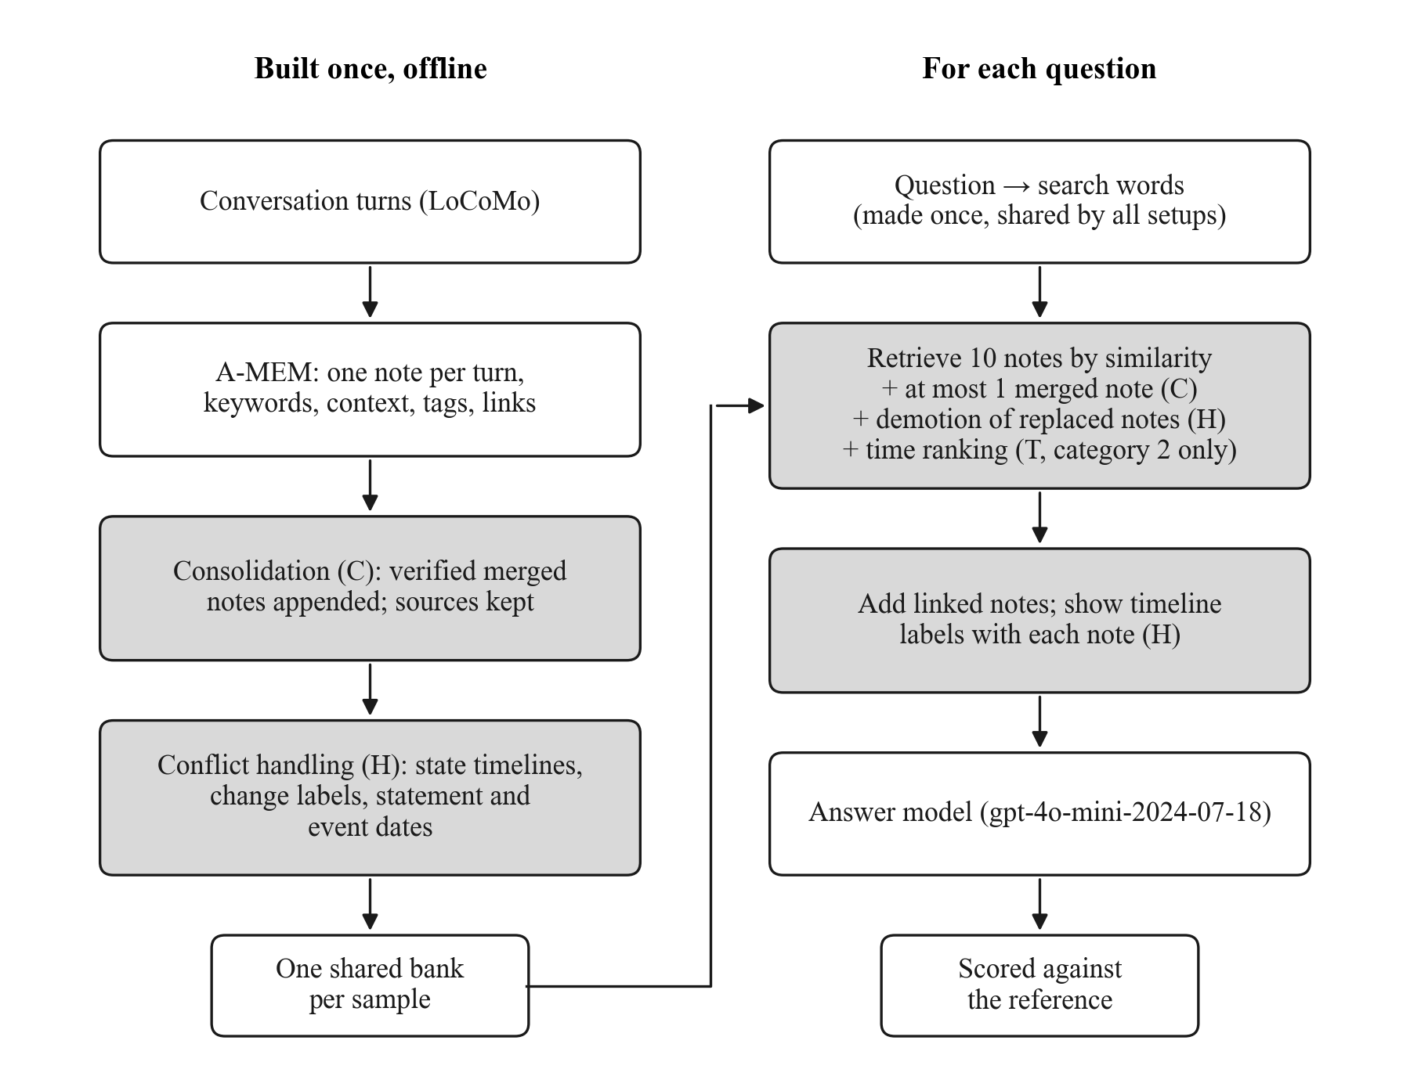
Figure 1. Where each T-MEM module acts. Shaded boxes are the steps added or changed by a T-MEM module. Each module is switched on or off independently, and with every module off the system is A-MEM.
Time Ranking (T)
A-MEM stores a timestamp on every note but does not use it when ranking. Time ranking lets recency act, but only among notes that already match the question closely. It is the semantic-first reranking of the pilot study (Yadav & Kumar, 2026). Recency is an exponential decay of a note's age:
r(m) = exp(−λ · a(m)), a(m) = (t_{ref} − t_{m}) / 30 days (1)
where t_{m} is the note's session time, t_{ref} is the latest session time in the conversation, and λ = 0.1 per 30-day period. For a question with search words q, the steps are:
1. Score every note by cosine similarity with q and sort.
2. If the best note leads the second-best by at least 0.05, return the top 10 by similarity unchanged.
3. Otherwise take the 20 most similar notes as a candidate pool.
4. Within the pool, min–max normalize the similarity scores to ŝ and the recency scores of Equation 1 to r̂, and raise the recency floor so that r̃ = 0.25 + 0.75 · r̂.
5. Rank the pool by the blend in Equation 2.
6. Keep the two most similar notes in the first places, and fill the remaining eight places from the blended ranking.
s(q, m) = α · ŝ(q, m) + (1 − α) · r̃(m), α = 0.9 (2)
Time ranking is applied only to temporal questions. The router uses the category label stored in the benchmark: for a category 2 question, time ranking orders the notes; for every other question, retrieval is the same as with time ranking off. This is an oracle router. A deployed system would have to infer from the question text whether it is temporal, so the results show the effect of time ranking when routing is perfect. Table 7 lists the settings.
Table 7
Time-Ranking Settings
Setting | Value
Decay rate λ (per 30 days) | 0.1
Weight on similarity α | 0.9
Notes reranked | Top 20 by similarity
Notes fixed in place | Top 2 by similarity
Skip when the best note leads by | 0.05 or more
Recency floor after normalization | 0.25
Questions affected | Category 2 only
Note. Defaults of TemporalRetrievalConfig in memory_layer_tmem_robust.py at commit b84b89cc.
Consolidation (C)
Long conversations repeat themselves, and each repetition becomes a separate note that competes for the same 10 retrieval slots. Consolidation merges such repetitions offline, after the base bank is built and before any question is asked. Its rule is that no checked fact or date may be lost: the original notes are kept, a merged note must contain every checked fact and date from its sources, and a merge that fails the fact and date checks is discarded.
Finding candidate groups. The content of each raw note is embedded, and every pair is compared. Pairs with cosine similarity of at least 0.80 are visited from most to least similar, and groups are grown by complete linkage: two groups are joined only if every note in one is at least 0.80 similar to every note in the other. A group holds at most five notes, all from the same speaker.
Verifying and merging. Each candidate group is shown to the language model with the date of every note, and the model chooses one label. SAME_FACT means the notes state the same fact, plan, or event. SMALL_TALK means they are greetings, thanks, praise, or encouragement with no distinct facts. DIFFERENT means they describe different things despite sounding alike; the prompt tells the model to choose DIFFERENT when unsure. DIFFERENT groups are left alone. For the other two labels, a second prompt asks for one short merged note that names the speaker, writes every date in absolute form, and keeps every name, place, and number. Both calls use temperature 0.0.
Checks. Every merged note passes four rule-based checks before it is accepted. The first lists every number, every capitalized name-like word inside a sentence, every speaker name, and every source date in the sources, and flags any of these that is missing from the merged note. The second flags relative time expressions left in the merged note, such as "next month," because the same phrase means different things when its sources were said on different dates. The third flags relative times in a source whose resolution is missing from the merged note: the resolved month or year for phrases such as "next month" or "last year," and the unit itself, such as "week" or "summer," for other phrases. The last flags a merged note that is longer than its sources. When any check fails, the merge prompt is repeated with a list of the problems, up to two more times. A group is rejected only if no attempt passes the first three checks; if the only problem left is length, the first attempt that passed those three checks is kept.
An example from sample 3 shows the result. Nate said on April 17, 2022, "Thanks! It's dairy-free and so easy. Wanna get the recipe?" and on August 14, 2022, "I've been really into making this lately - it's creamy, rich, dairy-free and a new recipe! Wanna try it? I can share the recipe with you if you'd like!" The merged note reads: "Nate has been making a creamy, rich, dairy-free recipe and is willing to share it. He mentioned this on 17 April 2022 and again on 14 August 2022." By contrast, two of Nate's statements, about winning a first video game tournament and later an international tournament, were labeled DIFFERENT and kept apart.
Storage and retrieval. Accepted merges are appended to the end of the bank, and nothing is deleted or reordered, because A-MEM's links and the retriever's rows refer to notes by position. Each merged note takes the latest timestamp of its sources, the union of their keywords and tags, and links to every source; its sources are marked as archived. At question time the primary-expand mode is used. Archived sources cannot be retrieved directly, but a retrieved merged note brings its sources back into the context through A-MEM's ordinary link expansion. At most one merged note may enter the 10 retrieved notes. Table 8 describes the merged notes in the four banks.
Table 8
Merged Notes in the Memory Banks
Measure | Sample 0 | Sample 1 | Sample 2 | Sample 3
Merged notes | 17 | 16 | 23 | 26
Source notes archived | 37 | 33 | 57 | 71
Mean source notes per merged note | 2.18 | 2.06 | 2.48 | 2.73
Notes before → after | 419 → 436 | 369 → 385 | 663 → 686 | 629 → 655
Note. Counted in the shared banks used in the experiment, whose fingerprints are recorded in the experiment manifest.
The build log of sample 3 shows each step. The model labeled the 34 candidate groups SAME_FACT (10), SMALL_TALK (16), or DIFFERENT (eight). Of the 26 groups merged, 16 were small talk; no group was rejected, and the build made 88 language-model calls. Under the length rule, 12 of the 26 merged notes are longer than their sources.
Conflict Handling (H)
Facts about a person change during a long conversation: a plan moves forward, a job is replaced, or a later statement contradicts an earlier one. A-MEM stores every statement as an equal note and keeps no record of which one is current. Conflict handling builds, offline, an ordered timeline for each changeable fact and labels how each statement relates to the earlier ones. It never adds, removes, or reorders notes; it only sets fields on existing raw notes. Merged notes are not tagged.
Tagging concrete facts. Each raw note is shown to the language model with its date and speaker, and the model decides whether it states a concrete, checkable fact about the speaker's own life that could change later, such as a job and its status, a move, a relationship status, a step in a specific plan, starting or stopping an activity, or something bought or lost. Feelings, thanks, praise, wishes, opinions, questions, and facts about other people do not count. For notes tagged as facts, the model also returns a short topic in the form "speaker's thing" and the status at that time.
Building timelines. For each speaker, the tagged topics are clustered by meaning with average-linkage clustering on the cosine distance between topic embeddings, at a similarity threshold of 0.78. Each cluster becomes a timeline with its notes in time order. Clusters whose notes all come from a single day are dropped.
Labeling and verifying changes. Within a timeline, each note is compared with each distinct earlier status. Each status is represented by its most recent mention, provided that mention comes from an earlier day. Two statuses count as the same when their embeddings have similarity of at least 0.85. For each comparison the language model chooses one of six labels: SAME, PROGRESS (the same plan moved forward), CHANGE (the old fact was replaced), CONTRADICTION (both cannot be true, and it is not a natural change), COMPATIBLE (both are true at once), or UNRELATED; the prompt tells the model to choose COMPATIBLE when unsure. CHANGE and CONTRADICTION labels are checked a second time with a stricter prompt that asks whether the older statement is no longer true and requires a quotation from the newer statement. A label is confirmed only if the answer is yes and the quotation is found in the newer note; otherwise it becomes COMPATIBLE. A confirmed CHANGE marks the older note as replaced from the newer note's date; if two confirmed changes point at the same older note, the earliest one is kept. A confirmed CONTRADICTION links the two notes without replacing either; no note in the four banks carries such a link. The calls use temperature 0.0, and their answers are cached so that a rebuild makes no new calls. Table 9 describes the timelines in the four banks.
Table 9
Timelines in the Memory Banks
Measure | Sample 0 | Sample 1 | Sample 2 | Sample 3
Raw notes | 419 | 369 | 663 | 629
Timelines | 6 | 7 | 10 | 9
Notes in timelines | 32 | 76 | 35 | 35
Replaced notes | 5 | 4 | 4 | 0
Notes linked by a contradiction | 0 | 0 | 0 | 0
Timeline notes with an event date | 9 | 10 | 5 | 11
Note. Counted in the shared banks used in the experiment. Every note with an event date belongs to a timeline.
The banks differ in a way that matters for Chapter IV. The banks of samples 0–2 mark 13 notes as replaced, and the bank of sample 3 marks none. The build log of sample 3 shows why: of its 52 notes tagged as concrete facts, every comparison was labeled PROGRESS (70) or COMPATIBLE (seven), so no label went to the verifier; the build made 706 new language-model calls. The timelines of sample 3 include, for example, Joanna's movie script (10 notes from January 23, 2022, to November 9, 2022) and Nate's video game tournament (7 notes).
Showing timelines to the model. Two mechanisms use the timeline fields at question time. The first is annotation. Every note in the context that belongs to a timeline carries one extra field. The field names the topic, the note's step number and its own dates, and the status and dates of the steps immediately before and after it. A replaced note also carries the label "OUTDATED since date: replaced by …," and a note on either side of a confirmed contradiction would carry a CONFLICTS label. The second is demotion. For questions about the present, replaced notes and the older side of any contradiction lose 0.10 from their similarity score. A question counts as being about the present if it contains a word such as "now," "currently," or "still" and none of the history words, such as "when," "before," "first," "used to," "previously," or "ago." Three questions in sample 0, two in sample 1, one in sample 2, and two in sample 3 match this rule, and one of these eight is a temporal question. Since the bank of sample 3 has no replaced notes, demotion cannot act there.
Statement date and event date. Each timeline step carries two dates: the date it was said and, if the note contains a relative time expression, the date it happened. The event date is computed by a rule-based function from the first relative expression in the note and the note's session date, with no language-model call. Table 10 lists every event date in the bank of sample 3. For example, Joanna said on March 24, 2022: "Been quite a ride - in a good way - had an audition yesterday for a writing gig." The label shown with that note in the runs reads: "Joanna's writing gig, step 1 of 2 (said on 24 March 2022; happened: 23 March 2022); after: just joined (said on 21 April 2022)."
Table 10
Event Dates in the Bank of Sample 3
Said on | First relative expression in the note | Event date written
January 23, 2022 | last Friday | the Friday before 23 January 2022
March 24, 2022 | yesterday | 23 March 2022
April 21, 2022 | next month | May 2022
May 2, 2022 | Last week | the week before 2 May 2022
August 22, 2022 | yesterday | 21 August 2022
October 6, 2022 | last week | the week before 6 October 2022
October 6, 2022 | last week | the week before 6 October 2022
October 25, 2022 | last Sunday | the Sunday before 25 October 2022
November 7, 2022 | last Saturday | the Saturday before 7 November 2022
November 7, 2022 | Last Friday | the Friday before 7 November 2022
November 9, 2022 | yesterday | 8 November 2022
Note. Read from the bank of sample 3; each event date was re-derived by running happened_around() in memory_consolidation.py at commit b84b89cc on the note and its session date. The event date is written in the form the model sees. Only the first relative expression in a note is used; notes without one show only the date said.
How the Modules Combine
When more than one module is on, they act on the same ranking. Consolidation decides which notes may be ranked (archived sources are hidden, and the number of merged notes is capped), conflict handling subtracts the demotion penalty for questions about the present, and time ranking, for temporal questions only, reorders the result. The context is then expanded through A-MEM's links, and conflict handling adds its timeline labels to the notes shown.
Keeping A-MEM Unchanged
Consolidation and conflict handling are optional modes whose default is off, and time ranking is used only when the T-MEM evaluation script is run. With every module off, retrieval calls the original A-MEM function, and only the raw notes at the start of the bank are visible. During the experiment, every run was replayed offline (check R11 below), and for every non-temporal question each setup with time ranking on was compared with its partner with time ranking off (check R10).
Memory Banks Used in the Experiment
All setups read the same bank for a given sample. Each bank holds every layer: the raw A-MEM notes at the start, the merged notes appended after them, and the timeline fields set on the raw notes. A setup with a module switched off ignores that layer: with consolidation off, retrieval sees only the raw notes, and with conflict handling off, the timeline fields are neither shown nor used. One bank can therefore serve all eight setups.
The banks of samples 0–2 were copied into the experiment folder from an earlier build, as the manifest records. The bank of sample 3 was built for this experiment on November 7, 2026, in three steps that took 47 minutes. First, the project's build script called A-MEM's unchanged memory code to build A-MEM's notes. Consolidation followed, and then conflict handling, with no cached language-model answers. Five build checks (B1–B5) were passed before the bank was used: one note per turn in turn order; raw notes identical in every A-MEM field in all three build stages; no build warnings or errors; merges and timelines logged; and event dates filled in from relative times. The SHA-256 fingerprint of every bank file was recorded in the experiment manifest and checked again before every wave of runs.
Experimental Procedure
Table 11 lists the settings fixed for every run. They were recorded in the experiment manifest before the first valid run and not changed afterwards.
Table 11
Fixed Settings of the Experiment
Setting | Value
Answering and search-word model | gpt-4o-mini-2024-07-18 (served version checked)
Embedding model | all-MiniLM-L6-v2
Notes retrieved per question (k) | 10, plus linked notes
Samples | 0, 1, 2, and 3 (757 questions)
Runs per setup | 5 (seeds 42, 43, 44, 45, 46)
Answer temperature | 0.7; 0.5 for category 5 (A-MEM's own)
Time ranking, when on | Table 7
Consolidation, when on | Primary-expand, at most 1 merged note in the top 10
Conflict handling, when on | Annotation and demotion, penalty 0.10, statement and event dates
Search words | Made once per question and run with A-MEM's prompt; shared by all setups
Option order in category 5 | Fixed per question and run from the seed
Code | Commit b84b89cc, unchanged during the runs

Shared Search Words
In A-MEM, the search words for each question come from a language-model call at temperature 0.7, so two setups asked the same question can retrieve from different search words. A difference between setups could then come from the search words rather than from the modules being compared. To remove this source of variation, one option was added to both evaluation scripts. When a search-word file is given, the script reads the search words for each question from the file instead of generating them. Without the option, the scripts behave exactly as before.
For each of the five runs, the search words for all 757 questions were generated once with A-MEM's own function, prompt, and parsing, and saved, giving 3,785 entries in all. All setups of a run read the same file. A missing entry stops the run with an error rather than falling back silently, and each question's search words are written to the log so that the checks can confirm that the file was used.
Option Order in Adversarial Questions
A-MEM places the two options of a category 5 question in random order. In this experiment the order was drawn from a random generator seeded with the run's seed, the sample number, and the question number, so the order depends only on the run and the question. Every setup therefore saw the same order for the same question in the same run. A per-question generator was used because the OpenAI client draws from Python's shared random generator when it retries a call, which could otherwise shift a shared sequence.
Running the Experiment
The 40 runs were organized in five waves, one per seed. Each wave ran the setups in two halves of four runs side by side, s1–s4 and s5–s8, with the order of the halves alternating between waves. The plan estimated that four runs at a time would use about 1,000,000 tokens per minute, half the account's limit of 2,000,000. While a half ran, the output of each run was read every 10 seconds, and any final failure of an answer would have stopped the half at once. A result file was written only at the end of a run, and a run never started if its result file already existed, so no result could be overwritten. The computer, an Apple M4 with 16 GB of memory, was kept on AC power and prevented from sleeping.
The plan set out seven stages, each closed by a gate of checks that had to pass before the next stage started; one descriptive stage was added after the analysis. Table 12 lists them.
Table 12
Stages of the Experiment and Their Gates
Stage | Work | Gate
0 | Search-word option and its tests, scripts, manifest, served-model check; plan committed | All 58 unit tests pass; plan approved
1 | Build the sample 3 bank | Build checks B1–B5
2 | Generate the search words for five runs | 757 questions per file, none empty, fingerprints recorded
3 | Trial: A-MEM on sample 0, seed 42 | All result checks pass on the trial
4 | Wave 1 (seed 42) | All result checks pass
5 | Waves 2–5 (seeds 43–46) | All result checks pass after every wave
6 | Final checks across all 40 files, analysis | All final checks pass
7 | Descriptive counts for this thesis, added after the analysis | Two runs identical; a recount by a second method agrees
Note. Stages 0–6 were planned before the runs. The trial output was never used in the analysis. Before every wave, input checks confirmed the bank and search-word fingerprints, unchanged code, free disk space, AC power, and that no result file for the seed existed.
The first attempt at wave 1 ran all eight setups side by side. It reached the tokens-per-minute limit, and 39 answers came back empty. All the runs finished, but the result checks failed, so the wave was moved to a separate folder with the reason recorded and was never used. The procedure was then changed to the two halves of four runs and the per-question option order described above, before any valid run; five unit tests were added for the change, bringing the total to 63, all passing. Wave 1 was then run again. The five waves used in this thesis, with their checks, ran from 14:11 to 16:45 on November 7, 2026; each half took between 13.4 and 15.0 minutes.
Checks on Every Run
After each wave, 10 checks were applied to each result file and its logs (R0–R8 and R11), and 2 checks covered the whole wave: R9 once, against the expected option order, and R10 for each of the 4 pairs of setups. That made 85 checks per wave. If any check failed, the whole wave would have been moved aside and the pipeline stopped. Table 13 lists the checks. After the last wave, all checks were run again across the 40 files together, with one further check that exactly the 40 planned result files existed.
Table 13
Checks Applied to Every Run
Check | What it confirms
R0 | The result file and its logs exist
R1 | 757 questions per file, in the dataset's order and the same order in all files
R2 | No empty answers
R3 | Settings stored in the file match the setup and seed
R4 | The saved overall F1 equals the mean of the per-question F1
R5 | The right bank was loaded for each sample, with no rebuild
R6 | No errors or failed answers in the log; any retried call is counted and reported
R7 | Every question's logged search words match the shared file
R8 | Timeline labels appear only with conflict handling on; merged notes only with consolidation on
R9 | Every adversarial question shows the expected option order, in all setups
R10 | For non-temporal questions, each setup with time ranking on retrieved exactly the same notes as its partner with it off
R11 | Replay: the notes in every logged context equal the notes the code gives offline from the same bank and search words

Measures
Each answer was scored against the stored reference by the evaluation code that ships with A-MEM (utils.py). Token F1 is computed exactly as in A-MEM's version of this file; the project changed only how BERTScore is loaded and added a fallback tokenizer for BLEU. The main measure was token F1. Prediction and reference are lowercased, the characters ".", ",", "!", and "?" are replaced by spaces, and each is split on white space into a set of tokens. Precision is the share of prediction tokens found in the reference, recall the share of reference tokens found in the prediction, and F1 their harmonic mean:
F1 = 2PR / (P + R), P = |T_{pred} ∩ T_{ref}| / |T_{pred}|, R = |T_{pred} ∩ T_{ref}| / |T_{ref}| (3)
In Equation 3, tokens are compared as sets, so repeated words count once. The code also computes exact match, ROUGE-L (Lin, 2004), BLEU-1 (Papineni et al., 2002), METEOR (Banerjee & Lavie, 2005), BERTScore F1 (Zhang et al., 2020), and the cosine similarity of Sentence-BERT embeddings of prediction and reference. From the per-question scores, five summary measures were computed:
1. Answerable F1: mean F1 over categories 1–4, the 584 questions that have a true answer.
2. Temporal F1: mean F1 over the 130 questions of category 2.
3. Refusal rate: the share of the 173 category 5 answers that contain the phrase "not mentioned" and do not contain at least half of the adversarial answer's words of three or more characters.
4. Overall F1 (A-MEM scoring): mean F1 over all 757 questions, with category 5 scored against the adversarial answer, as the A-MEM evaluation does. Under this scoring a correct refusal scores near zero.
5. Overall score with refusals credited: as above, except that a category 5 answer scores 1 if it is a refusal and 0 otherwise.
Answerable F1 and temporal F1 are the two main measures. The two overall scores are reported side by side because, for category 5, the scoring of the original code rewards repeating the false premise of the question.
Data Analysis Plan and Statistical Procedures
For each setup, every measure was computed per run and summarized as the mean and standard deviation over the five runs. For comparisons, each question's F1 was first averaged over the five runs, so that each question contributes one value per setup. The difference between two setups is then the mean of the per-question differences.
Factorial Effects
With s1 to s8 standing for the per-question scores of the eight setups, the average effect of time ranking is the mean of its four on-minus-off differences:
T = [(s2 − s1) + (s5 − s3) + (s6 − s4) + (s8 − s7)] / 4 (4)
The effects of consolidation and conflict handling are formed in the same way from their own four pairs. The two-way interaction T × C is the effect of T with C on minus the effect of T with C off, each averaged over the two settings of H. On this scale it equals the gain of the two modules together minus the sum of their separate gains; it is twice the interaction as scaled by Montgomery (2017):
T × C = [(s5 − s3) − (s2 − s1) + (s8 − s7) − (s6 − s4)] / 2 (5)
T × H and C × H are formed in the same way, and the three-way interaction T × C × H is the difference between the T × C contrast with H on and with H off: [(s8 − s7) − (s6 − s4)] − [(s5 − s3) − (s2 − s1)]. For a two-way interaction, a positive value means that the two modules together gain more than the sum of their separate gains.
Bootstrap Test
Every difference and effect was tested with a paired bootstrap (Efron & Tibshirani, 1993; Koehn, 2004). The per-question values were resampled with replacement 10,000 times, within each sample separately, so that every resample keeps the original number of questions per sample. The 2.5th and 97.5th percentiles of the resampled means give the 95% interval. The two-sided p-value is twice the smaller of the shares of resampled means above and below zero, plus 1/10,000. The resampling used a fixed random seed (7), so every interval and p-value can be reproduced exactly. The bootstrap makes no assumption that scores are normally distributed, which suits bounded scores with many ties (Dror et al., 2018).
Correction for Multiple Tests
The tests were grouped into three families, and the Holm (1979) procedure was applied within each family. The procedure keeps the chance of any false rejection within a family at 5%; it does not correct across families. Table 14 defines the families.
Table 14
Test Families
Family | Tests | Number of tests
Main tests | T, C, H, and all three against A-MEM, on answerable F1 and temporal F1 | 8
Other setups | T + C, T + H, and C + H against A-MEM, on the same two measures | 6
Factorial effects | T, C, H, T × C, T × H, C × H, and T × C × H, on the same two measures | 14
Note. Holm correction was applied within each family.
Decision Rule
A difference is called significant only if its Holm-adjusted p-value is below .05. The uncorrected 95% interval is reported next to every test. For the comparisons with A-MEM on samples 0–3, the number of runs, out of five, in which the setup scored higher than A-MEM is also given, and for the main tests the number of questions that improved or worsened. The trial run and the failed first attempt at wave 1 were excluded from every analysis, as the plan required.
Ethical Considerations
The study involved no human participants and collected no personal data. [TO CONFIRM BEFORE SUBMISSION: whether UTPB requires Institutional Review Board review, or a determination that this is not human-subjects research. Ask the committee chair or the IRB office, then replace this note.] The conversations in LoCoMo are not records of real people. Maharana et al. (2024) produced them with a pipeline in which language-model agents, each given a persona and a temporal event graph, held the conversations, and human annotators then verified and edited them. The speakers named in this thesis are those personas. The conversations and questions were sent to the OpenAI API during memory construction and answering, under the API's terms of use. The API key was kept out of the repository. The use of generative AI tools in preparing this thesis is described in the Disclosure of AI Tool Usage at the front of the document.
Summary
The study compared A-MEM with every combination of three T-MEM modules in a 2 × 2 × 2 factorial design on four LoCoMo samples, with 2,080 dialogue turns and 757 questions, five runs per setup, and 40 runs in all. All setups shared one memory bank per sample, the same search words, and the same option order, and A-MEM's memory, retrieval, and answering code paths, prompts, and temperatures were not changed. The runs passed 12 kinds of check (R0–R11), including an offline replay of every retrieved context. The measures, test families, correction, and decision rule were fixed and committed before any run. Chapter IV reports the results, one research question at a time.
CHAPTER IV
RESULTS AND FINDINGS
This chapter reports the results of the factorial experiment in the order of the research questions (RQ1–RQ4). As in Chapter III, T, C, and H stand for the time-ranking, consolidation, and conflict-handling modules, and s1–s8 for the eight setups of Table 3. All numbers come from the 40 result files of the experiment and their logs, the shared memory banks and search-word files, the build log of sample 3, and the data file. Every test, interval, and p-value was computed by the analysis script fixed before the runs. Two analyses were computed afterwards with separate code and are labeled as descriptive: what each module changed in the model's context, and the averages of the other measures over the runs. Values are means over the five runs unless stated otherwise. Differences are computed question by question, with each question's score first averaged over the five runs. Following the decision rule of Chapter III, a difference is called significant only when its Holm-adjusted p-value is below .05; the p-values reported are Holm-adjusted unless marked otherwise, and every 95% interval is uncorrected.
Data Screening and Run Checks
Before any comparison, every result file and its log were checked. Table 15 summarizes the outcome. All 40 runs finished, and all 30,280 answers were present and non-empty. All 85 checks of every wave passed, and when the checks were run again across the 40 files together, all 426 passed. No call to the language model failed, and no retry was logged, in any of the 40 runs.
Table 15
Completeness and Checks of the Runs
Item | Result
Runs (8 setups × 5 seeds) | 40 of 40 finished
Answers (40 runs × 757 questions) | 30,280, none empty
Checks per wave (R0–R11) | 85 of 85 passed in each of the five waves
Final checks across all 40 files | 426 of 426 passed
Errors, failed answers, and logged retries (R6) | 0 errors or failed answers and 0 retries in all runs
Contexts replayed offline (R11) | 30,280; 0 differ from the log
Non-temporal questions, time ranking on vs. off (R10) | 0 of 627 differ, in every pair and every run
Adversarial option order (R9) | 0 mismatches in 173 questions, all setups and runs
Note. R10 compares s2 with s1, s5 with s3, s6 with s4, and s8 with s7. The failed first attempt at wave 1 and the trial are not included. Source: the check files in the experiment folder (checks/).
Two of the checks bear directly on the comparisons that follow. The replay check shows that every context the answering model received is exactly the context the code produces from the shared bank and the shared search words, so no setup received a different input by accident. Check R10 shows that time ranking changed no retrieved note outside temporal questions: for all 627 non-temporal questions, in all five runs, each setup with time ranking on retrieved exactly the same notes as its partner with it off.
The run-to-run variation gives a sense of scale for the differences that follow. Across the setups, the standard deviation over the five runs ranged from 0.002 to 0.007 for answerable F1 and from 0.004 to 0.015 for temporal F1 on samples 0–3.
Overview of the Setups
Table 16 gives the scores of the eight setups on samples 0–3, and Figure 2 shows each run. Two patterns are visible before any test. The four setups with conflict handling on have the four highest temporal F1 scores, from 0.423 to 0.439, against 0.386 for A-MEM. The setups without conflict handling are within 0.010 of A-MEM on temporal F1.
Table 16
Scores of the Setups (Samples 0–3, Mean Over Five Runs)
Setup | Answerable F1 | Temporal F1 | Refusal rate | Overall F1 (A-MEM scoring) | Overall, refusals credited
A-MEM | 0.314 ± 0.003 | 0.386 ± 0.015 | 57.9% ± 2.3 | 0.337 ± 0.004 | 0.374 ± 0.007
T | 0.310 ± 0.007 | 0.388 ± 0.008 | 57.7% ± 2.4 | 0.335 ± 0.006 | 0.371 ± 0.009
C | 0.311 ± 0.005 | 0.376 ± 0.009 | 59.1% ± 1.5 | 0.332 ± 0.005 | 0.375 ± 0.004
H | 0.317 ± 0.005 | 0.423 ± 0.010 | 57.6% ± 2.7 | 0.341 ± 0.006 | 0.376 ± 0.009
T + C | 0.314 ± 0.005 | 0.380 ± 0.008 | 59.1% ± 1.6 | 0.334 ± 0.004 | 0.377 ± 0.006
T + H | 0.317 ± 0.002 | 0.429 ± 0.010 | 56.9% ± 3.7 | 0.343 ± 0.006 | 0.375 ± 0.010
C + H | 0.323 ± 0.006 | 0.435 ± 0.012 | 60.1% ± 3.7 | 0.339 ± 0.006 | 0.386 ± 0.012
All three | 0.326 ± 0.006 | 0.439 ± 0.004 | 59.7% ± 3.3 | 0.342 ± 0.003 | 0.388 ± 0.012
Note. Values after ± are standard deviations over the five runs (in percentage points for the refusal rate). Of the 757 questions, 584 are answerable (categories 1–4), of which 130 are temporal (category 2), and 173 are adversarial (category 5).
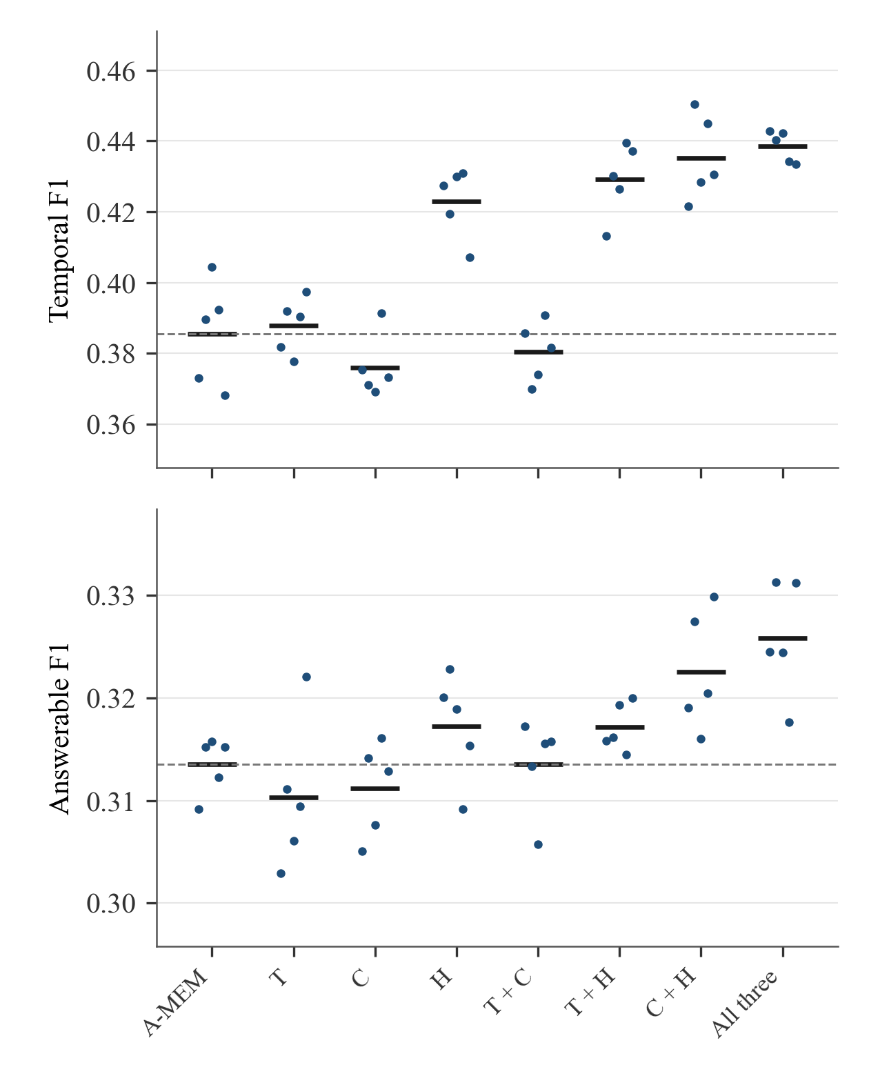
Figure 2. Temporal F1 (top) and answerable F1 (bottom) of the setups on samples 0–3. Dots are the five runs; horizontal bars are the means; the dashed line is the mean of A-MEM. Vertical scales differ between panels.
RQ1: Each Module Alone
Of the three modules, only conflict handling changed temporal F1 significantly on its own (Table 17, main tests on samples 0–3). It raised temporal F1 from 0.386 to 0.423, a difference of +0.037 (95% interval [+0.013, +0.064], p = .032), and it scored higher than A-MEM in all five runs. Time ranking alone (+0.002) and consolidation alone (−0.010) did not change temporal F1 significantly. No module alone changed answerable F1 significantly; the three differences lie between −0.003 and +0.004.
Table 17
Main Tests: Each Module Alone and All Three Against A-MEM (Samples 0–3)
Setup | Measure | Difference | 95% interval | Holm p | Significant | Runs better | Questions better / worse
T | Temporal F1 | +0.002 | [−0.016, +0.020] | 1.000 | No | 3 of 5 | 32 / 30
T | Answerable F1 | −0.003 | [−0.009, +0.002] | 1.000 | No | 1 of 5 | 146 / 166
C | Temporal F1 | −0.010 | [−0.036, +0.014] | 1.000 | No | 2 of 5 | 30 / 34
C | Answerable F1 | −0.002 | [−0.010, +0.006] | 1.000 | No | 1 of 5 | 166 / 170
H | Temporal F1 | +0.037 | [+0.013, +0.064] | .032 | Yes | 5 of 5 | 35 / 32
H | Answerable F1 | +0.004 | [−0.003, +0.011] | 1.000 | No | 4 of 5 | 154 / 165
All three | Temporal F1 | +0.053 | [+0.019, +0.086] | .025 | Yes | 5 of 5 | 47 / 29
All three | Answerable F1 | +0.012 | [+0.002, +0.023] | .089 | No | 5 of 5 | 190 / 166
Note. Family of eight tests, Holm-corrected. Temporal F1 is over 130 questions and answerable F1 over 584. Questions better or worse compare per-question F1 averaged over the five runs; the remaining questions tied.
The temporal gain of conflict handling was the net result of changes in both directions. On temporal questions, 35 questions scored higher than with A-MEM, 32 scored lower, and the remaining 63 tied.
Table 18 gives the average effect of each module over the four settings of the other two modules. The results are similar, except that the average effect of conflict handling on answerable F1 is significant, although conflict handling alone did not change answerable F1 significantly. The average effect of conflict handling was +0.049 on temporal F1 (95% interval [+0.026, +0.074], p = .001) and +0.009 on answerable F1 ([+0.003, +0.015], p = .038), both significant. The average effects of time ranking and consolidation on temporal F1 (+0.004 and +0.001) were not significant, nor were their average effects on answerable F1.
Table 18
Average Effect of Each Module Over the Other Settings
Module | Temporal F1 | 95% interval | Holm p | Answerable F1 | 95% interval | Holm p
T | +0.004 | [−0.007, +0.015] | 1.000 | +0.001 | [−0.003, +0.004] | 1.000
C | +0.001 | [−0.023, +0.022] | 1.000 | +0.004 | [−0.004, +0.011] | 1.000
H | +0.049* | [+0.026, +0.074] | .001 | +0.009* | [+0.003, +0.015] | .038
Note. Each effect is the mean of the four on-minus-off differences for that module (Equation 4 for T). Holm correction within the family of 14 factorial effects. * Significant (Holm p < .05).
What Each Module Changed in the Model's Context
To see how each module changed what the answering model saw, the retrieval of every question in every run was compared across setups, from the shared banks and search words and from the run logs. This analysis was not part of the plan fixed before the runs; it is descriptive and involves no significance test. It was run twice with identical output and recounted by a second method from the run logs, with no difference. Table 19 gives the results, counted over question-and-run cases.
Table 19
How Often Each Module Changed What the Model Was Shown
Measure | Sample 0 | Sample 1 | Sample 2 | Sample 3 | All
Temporal question-and-run cases | 185 | 130 | 135 | 200 | 650
Time ranking: same 10 notes as A-MEM | 132 (71.4%) | 97 (74.6%) | 92 (68.1%) | 150 (75.0%) | 471 (72.5%)
Time ranking skipped (best note leads by ≥ 0.05) | 26 (14.1%) | 44 (33.8%) | 31 (23.0%) | 63 (31.5%) | 164 (25.2%)
Time ranking: notes replaced per case, mean | 0.32 | 0.25 | 0.33 | 0.29 | 0.30
Conflict handling: temporal contexts with a timeline label | 87 (47.0%) | 130 (100.0%) | 135 (100.0%) | 148 (74.0%) | 500 (76.9%)
Conflict handling: temporal contexts with an event date | 76 (41.1%) | 130 (100.0%) | 31 (23.0%) | 133 (66.5%) | 370 (56.9%)
Conflict handling: contexts with an OUTDATED label, all questions | 153 (15.4%) | 301 (57.3%) | 73 (7.6%) | 0 (0.0%) | 527 (13.9%)
Questions about the present (demotion applies only to replaced notes) | 3 | 2 | 1 | 2 | 8
Consolidation: temporal contexts with a merged note | 149 (80.5%) | 111 (85.4%) | 106 (78.5%) | 181 (90.5%) | 547 (84.2%)
Consolidation: contexts with a merged note, all questions | 778 (78.2%) | 401 (76.4%) | 564 (58.4%) | 1,015 (78.1%) | 2,758 (72.9%)
Note. Each question counts once per run (five runs), except the row of questions about the present, which counts questions. Time-ranking rows compare s2 with s1; conflict-handling rows describe s4, and consolidation rows s3. Descriptive analysis, not part of the plan fixed before the runs. Source: analysis/extra.json, recounted in analysis/extra_recount.json.
Time ranking usually left the retrieved notes unchanged. In 72.5% of temporal cases it returned the same 10 notes as A-MEM, at most in a different order; these include the 25.2% of cases in which it did not act at all because the best note already led by the skip margin. On average it replaced 0.30 of the 10 notes. A change of order alone adds no new note to the context, and temporal F1 did not change significantly.
Conflict handling, by contrast, changed what the model saw in most temporal cases. In 76.9% of temporal cases the context carried at least one timeline label, and in 56.9% an event date. Demotion, the other mechanism of conflict handling, could act on very few questions: only 8 of the 757 questions are about the present, only one of them is a temporal question, and the bank of sample 3 has no replaced notes to demote. For temporal questions, therefore, conflict handling changed the retrieved notes in at most one question and otherwise changed only the annotations shown with the notes: timeline labels, event dates, and OUTDATED marks. Its effect most likely came from these annotations, although the experiment did not test which of them mattered.
Consolidation showed no significant gain, although it changed the context often: a merged note appeared in 72.9% of all contexts and in 84.2% of temporal contexts. With consolidation on, a high-scoring merged note takes one of the 10 retrieval slots and brings its sources back through link expansion. One possible explanation, not tested here, is that many merged notes add no new fact: in the build of sample 3, 16 of the 26 merged notes summarize small talk (Chapter III).
Scores by Question Category
Table 20 breaks F1 down by question category; differences by category were not tested. On multi-hop, open-domain, and single-hop questions, every setup was within 0.012 of A-MEM, and the open-domain scores rest on only 32 questions.
Table 20
F1 by Question Category (Samples 0–3, Mean Over Five Runs)
Setup | Multi-hop (cat. 1) | Temporal (cat. 2) | Open-domain (cat. 3) | Single-hop (cat. 4) | Adversarial (cat. 5)
A-MEM | 0.238 | 0.386 | 0.085 | 0.334 | 0.418
T | 0.233 | 0.388 | 0.079 | 0.329 | 0.420
C | 0.244 | 0.376 | 0.081 | 0.332 | 0.403
H | 0.226 | 0.423 | 0.084 | 0.330 | 0.423
T + C | 0.238 | 0.380 | 0.085 | 0.336 | 0.402
T + H | 0.228 | 0.429 | 0.073 | 0.327 | 0.430
C + H | 0.235 | 0.435 | 0.076 | 0.332 | 0.394
All three | 0.239 | 0.439 | 0.087 | 0.334 | 0.396
Note. Question counts: 111, 130, 32, 311, and 173. Category 5 is scored against the adversarial reference answer, as in the A-MEM evaluation, so a correct refusal scores near zero.
RQ2: All Three Together
With all three modules switched on, the all-three setup scored higher than A-MEM on both measures in all five runs (Table 17). Temporal F1 rose from 0.386 to 0.439, a difference of +0.053 (95% interval [+0.019, +0.086], p = .025), which is significant. Of the temporal questions, 47 scored higher and 29 lower. Answerable F1 was 0.326, against 0.314 for A-MEM, a difference of +0.012 (95% interval [+0.002, +0.023]). The uncorrected interval excludes zero, but after the Holm correction for the eight main tests the difference is not significant (p = .089).
On temporal questions, the gain of the all-three setup (+0.053) exceeds the gain of conflict handling alone (+0.037) by 0.016; this difference was not tested. The average effect of conflict handling (+0.049) accounts for most of the gain of the all-three setup, while the average effects of time ranking and consolidation (+0.004 and +0.001) were not significant. The all-three setup also had the smallest run-to-run spread on temporal F1 of the setups (standard deviation 0.004).
RQ3: How the Modules Combine
Table 21 gives the four interaction effects, and Figure 3 shows all seven factorial effects with their intervals. No interaction was significant on either measure after the Holm correction. The largest was between consolidation and conflict handling, whose uncorrected intervals exclude zero on both measures: +0.019 on temporal F1 ([+0.003, +0.038], p = .234) and +0.007 on answerable F1 ([+0.001, +0.012], p = .234). No interaction involving time ranking was significant.
Table 21
Interaction Effects
Interaction | Temporal F1 | 95% interval | Holm p | Answerable F1 | 95% interval | Holm p
T × C | 0.000 | [−0.019, +0.018] | 1.000 | +0.004 | [−0.001, +0.010] | 1.000
T × H | +0.001 | [−0.012, +0.016] | 1.000 | +0.002 | [−0.003, +0.007] | 1.000
C × H | +0.019 | [+0.003, +0.038] | .234 | +0.007 | [+0.001, +0.012] | .234
T × C × H | −0.005 | [−0.037, +0.024] | 1.000 | −0.002 | [−0.012, +0.008] | 1.000
Note. Interactions as defined in Chapter III (Equation 5 for T × C). For the two-way interactions, a positive value means that the two modules together gain more than the sum of their separate gains. Holm correction within the family of 14 factorial effects. * Significant (Holm p < .05).
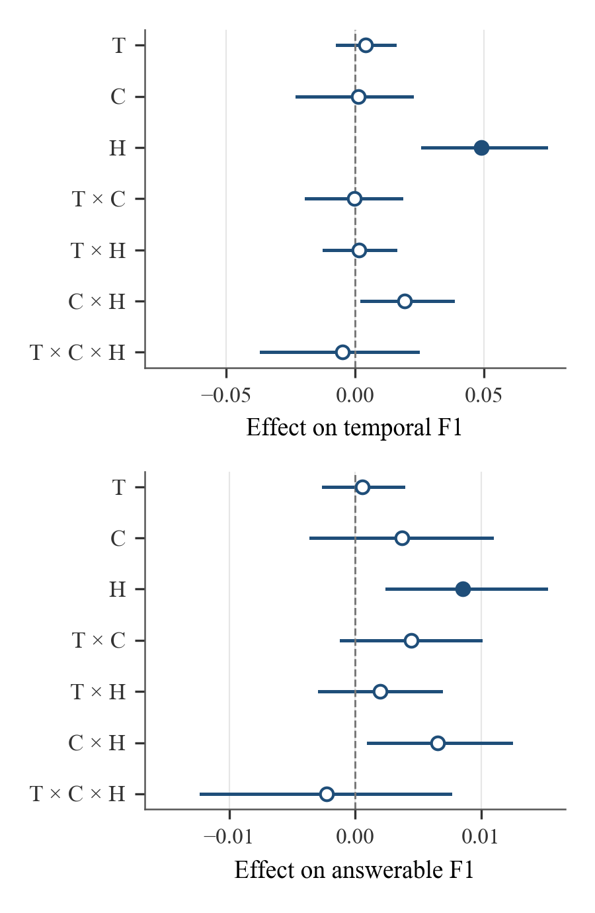
Figure 3. The seven factorial effects on temporal F1 (top) and answerable F1 (bottom), on samples 0–3. Lines are 95% bootstrap intervals; filled markers are significant after Holm correction. Horizontal scales differ between the two rows.
Table 22 compares the three two-module setups with A-MEM. Both setups that include conflict handling raised temporal F1 significantly on samples 0–3, by +0.044 (T + H, p = .017) and +0.050 (C + H, p = .026), while T + C did not differ significantly (−0.005, p = 1.000). None changed answerable F1 significantly. Comparisons of T + H and C + H with conflict handling alone were not part of the plan; on samples 0–3 their temporal gains of +0.044 and +0.050 compare with +0.037 for conflict handling alone.
Table 22
Two-Module Setups Against A-MEM (Samples 0–3)
Setup | Measure | Difference | 95% interval | Holm p | Significant | Runs better
T + C | Temporal F1 | −0.005 | [−0.035, +0.023] | 1.000 | No | 2 of 5
T + C | Answerable F1 | 0.000 | [−0.009, +0.009] | 1.000 | No | 3 of 5
T + H | Temporal F1 | +0.044 | [+0.014, +0.074] | .017 | Yes | 5 of 5
T + H | Answerable F1 | +0.004 | [−0.005, +0.012] | 1.000 | No | 5 of 5
C + H | Temporal F1 | +0.050 | [+0.014, +0.085] | .026 | Yes | 5 of 5
C + H | Answerable F1 | +0.009 | [−0.001, +0.020] | .367 | No | 5 of 5
Note. Family of six tests, Holm-corrected.
RQ4: Adversarial Questions and Scoring
Table 23 gives the refusal rate on adversarial questions and the two overall scores for every setup. The setups refused at similar rates: between 56.9% and 60.1%, against 57.9% for A-MEM. These differences were not tested, as fixed in the plan.
Table 23
Refusal Rate and the Two Overall Scores (Samples 0–3)
Setup | Refusal rate | Overall F1 (A-MEM scoring) | Overall, refusals credited
A-MEM | 57.9% ± 2.3 | 0.337 ± 0.004 | 0.374 ± 0.007
T | 57.7% ± 2.4 | 0.335 ± 0.006 | 0.371 ± 0.009
C | 59.1% ± 1.5 | 0.332 ± 0.005 | 0.375 ± 0.004
H | 57.6% ± 2.7 | 0.341 ± 0.006 | 0.376 ± 0.009
T + C | 59.1% ± 1.6 | 0.334 ± 0.004 | 0.377 ± 0.006
T + H | 56.9% ± 3.7 | 0.343 ± 0.006 | 0.375 ± 0.010
C + H | 60.1% ± 3.7 | 0.339 ± 0.006 | 0.386 ± 0.012
All three | 59.7% ± 3.3 | 0.342 ± 0.003 | 0.388 ± 0.012
Note. Samples 0–3 hold 173 adversarial questions. Means over five runs; values after ± are standard deviations (in percentage points for the refusal rate). No significance tests, as fixed in the plan.
The scoring rule changes which setup ranks first. Under A-MEM's scoring, which rewards repeating the adversarial answer, T + H had the highest overall F1 on samples 0–3 (0.343), followed by the all-three setup (0.342) and H (0.341). With refusals credited, the all-three setup ranked first (0.388), followed by C + H (0.386), and T + H had 0.375. The two setups that refused most often, C + H and the all-three setup, rank lower under A-MEM's scoring than with refusals credited. These rankings rest on gaps of less than 0.002 before rounding, below every standard deviation of these scores over the five runs (0.003 to 0.012), so they are indicative only. Because the refusal rates differ little, the scoring rule has little effect on the conclusions of this experiment; it may matter more for systems whose refusal rates differ widely.
Other Measures
Table 24 gives the other measures computed by the evaluation code, over all 757 questions with A-MEM's scoring of category 5. The plan named them as other measures to be reported without tests; their averages over the five runs were computed afterwards with separate code. ROUGE-L and METEOR broadly follow token F1: ROUGE-L is highest for the four setups with conflict handling, and METEOR for H, T + H, and the all-three setup. Exact match and BLEU-1 do not: exact match is lowest for C + H and the all-three setup (0.126), although these two setups have the highest answerable F1, and BLEU-1 is highest for A-MEM (0.293). Exact match differs by 0.011 and BLEU-1 by 0.008 between the highest and lowest setup, and BERTScore F1 is 0.903 or 0.904 for every setup.
Table 24
Other Measures, All Questions (Samples 0–3, Mean Over Five Runs)
Setup | Token F1 | Exact match | ROUGE-L | BLEU-1 | METEOR | BERTScore F1 | Sentence-BERT similarity
A-MEM | 0.337 | 0.136 | 0.339 | 0.293 | 0.259 | 0.903 | 0.495
T | 0.335 | 0.132 | 0.339 | 0.290 | 0.258 | 0.903 | 0.494
C | 0.332 | 0.127 | 0.336 | 0.286 | 0.256 | 0.903 | 0.491
H | 0.341 | 0.136 | 0.345 | 0.291 | 0.262 | 0.903 | 0.496
T + C | 0.334 | 0.128 | 0.338 | 0.287 | 0.255 | 0.903 | 0.492
T + H | 0.343 | 0.137 | 0.347 | 0.292 | 0.262 | 0.904 | 0.499
C + H | 0.339 | 0.126 | 0.343 | 0.285 | 0.258 | 0.903 | 0.492
All three | 0.342 | 0.126 | 0.345 | 0.287 | 0.261 | 0.903 | 0.495
Note. Computed by utils.py in the A-MEM evaluation; category 5 is scored against the adversarial reference answer. Named in the plan as other measures, reported without tests; averaged over the runs afterwards with separate code. Source: analysis/extra.json, recounted per question in analysis/extra_recount.json.
Summary of Findings
Table 25 summarizes the answer to each research question.
Table 25
Summary of Findings by Research Question
Research question | Finding | Null hypothesis
RQ1 Each module alone | On samples 0–3, conflict handling alone raised temporal F1 (+0.037, significant), and its average effect was significant on both measures; time ranking and consolidation had no significant effect. | Rejected for conflict handling on temporal F1 (alone and average effect) and on answerable F1 (average effect only); not rejected for conflict handling alone on answerable F1 or for time ranking or consolidation.
RQ2 All three together | On samples 0–3, temporal F1 +0.053 (significant) and answerable F1 +0.012 (not significant after correction); higher than A-MEM in all five runs on both measures. | Rejected for temporal F1. Not rejected for answerable F1.
RQ3 How the modules combine | No interaction was significant on either measure. T + H and C + H raised temporal F1 significantly; T + C did not. | Interactions: not rejected.
RQ4 Adversarial questions | Refusal rates were similar across setups (not tested). The scoring rule changes the order of the top setups, by gaps smaller than the run-to-run spread, but not the main conclusions. | Descriptive.

Several limits apply to these results and are taken up in Chapter V. The bootstrap resamples questions, not conversations, so the intervals do not cover variation between conversations, of which there are only four. Each memory bank was built once, so variation in building it is not sampled. The Holm correction controls false rejections within each family, not across the three families. The settings of the modules were chosen using samples 0–2, which make up three of the four samples reported here, so the estimates may be optimistic. Time ranking was tested with an oracle router, so its results reflect perfect routing; it showed no significant gain even so, and routing from the question text was not tested. All answers came from one model on one benchmark.
In short, conflict handling was the only module with a significant effect: it raised temporal F1. The descriptive analysis suggests that it works through the annotations it adds to each note, but the experiment did not test this mechanism. The all-three setup had the largest estimated temporal gain (+0.053), though this was not tested against conflict handling alone. Time ranking and consolidation showed no significant gain. Chapter V discusses what these results mean.

