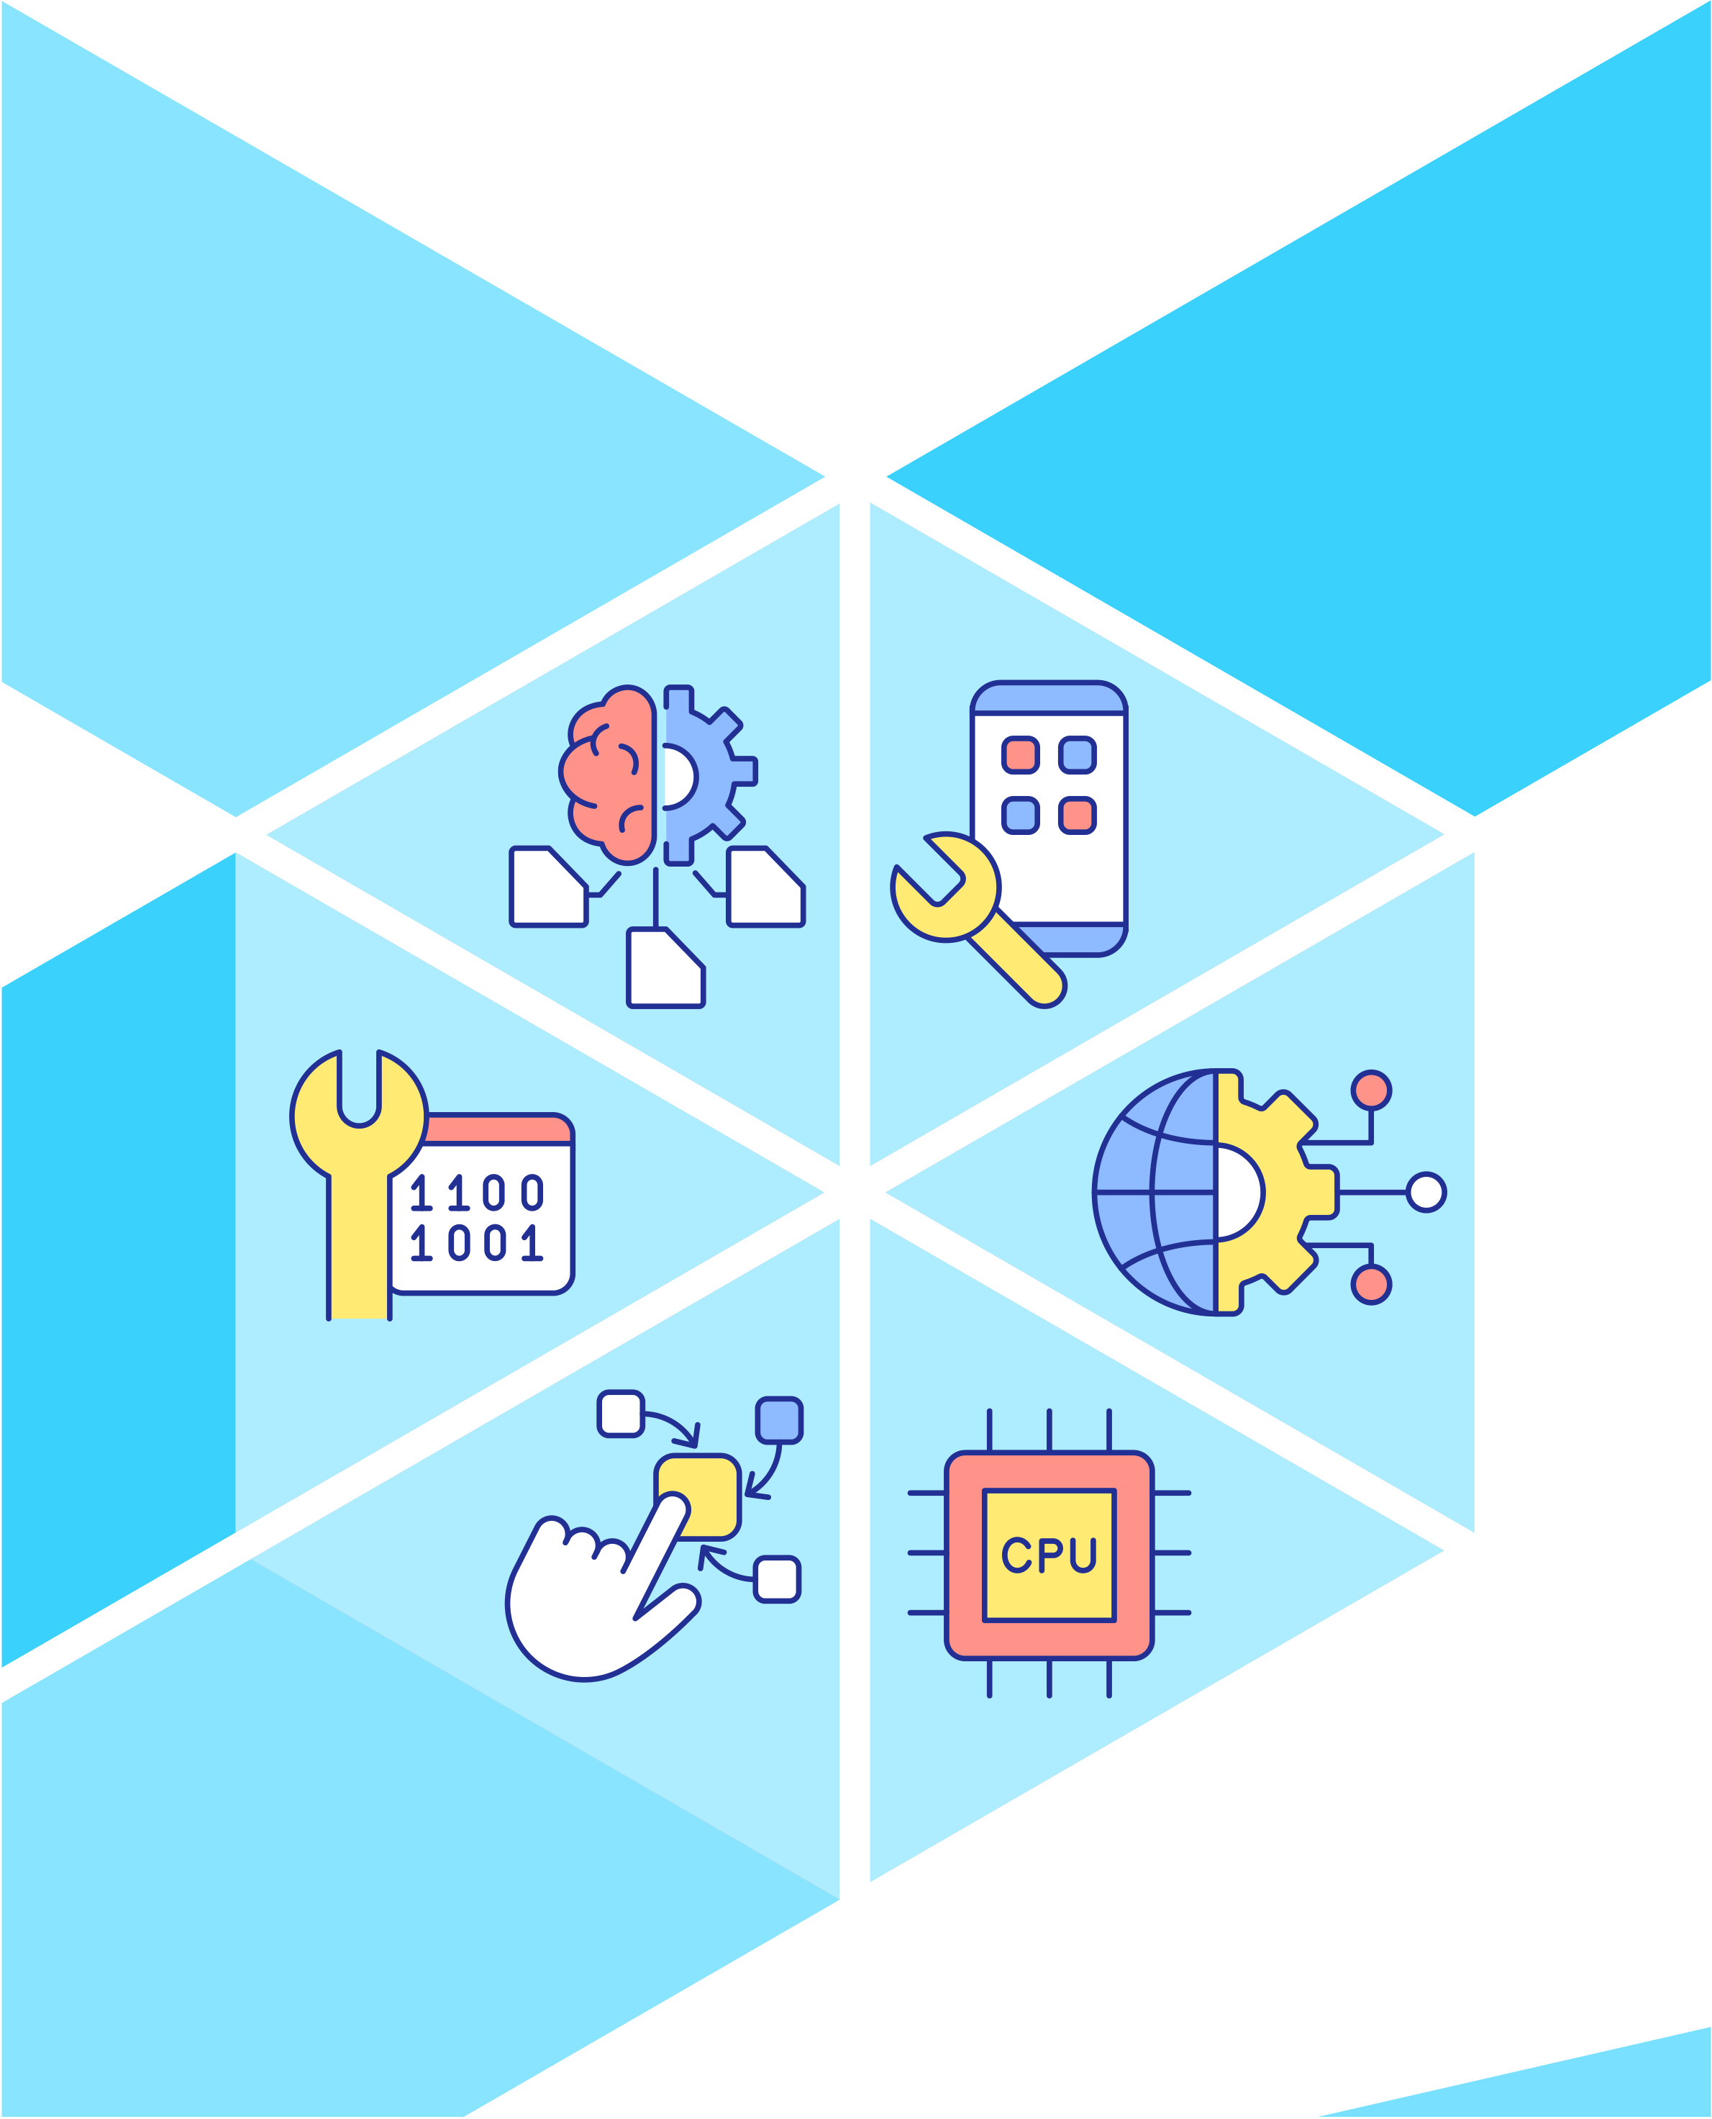

**PYTHON SELF STUDY MATERIAL**

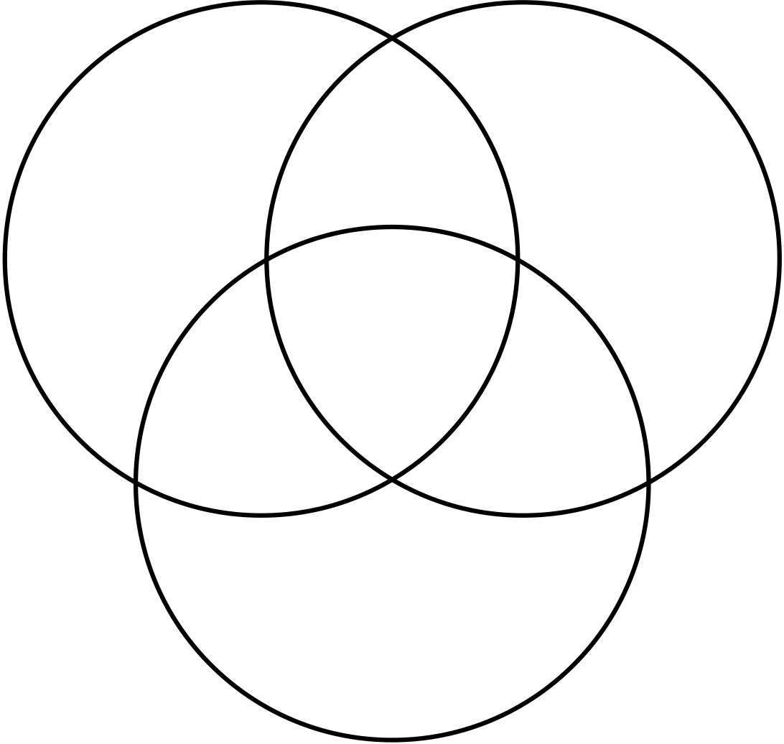

|  |
| --- |
| **Python** |

As per the latest statistics, Python is the second most used programming language for around 80% of developers use python as a main coding language. From web development to data science and artificial intelligence, Python's versatility knows no bounds, making it the ultimate tool for turning ideas into reality. So join the Python community and unlock the gateway to innovation, efficiency, and boundless creativity

Coding in Java   
public class HelloWorld {  
 public static void main(String[] args) { System.out.println("Hello");  
 }   
}

|  |  |  |  |  |
| --- | --- | --- | --- | --- |
|  | |  | | --- | | **Why Python** | | Beginner friendly | Simple and  elegant |
| Python |
|  | It's easy to learn and code |  | Great demand |
|  | Cross Platform Compatibility |
|  | Demand is High |





**Confused!! How to Start your Python Journey**

|  |
| --- |
| **Here is Python Learning Journey for you** |

|  |
| --- |
| **Core Python Concepts** |

Ensure you have a strong grasp of Python's syntax, data types, control flow, functions, classes, and modules. Understanding these fundamental concepts is crucial for writing clean, efficient, and maintainable Python code.

|  |
| --- |
| **Object-oriented programming (OOP)** |

Learn how to implement OOP principles in Python, such as encapsulation, inheritance, and polymorphism. MNCs often require developers to work with large-scale projects, and OOP is essential for designing modular and scalable code.

|  |
| --- |
| **Data structures and algorithms** |

Familiarize yourself with common data structures like lists, dictionaries, sets, and tuples, and understand their use cases and time complexity. Additionally, study algorithms such as sorting, searching, and graph algorithms, as they are frequently asked in technical interviews.

|  |
| --- |
| **Web development frameworks** |

Gain knowledge of popular Python web frameworks like Django and Flask.

Understanding these frameworks and their features, such as URL routing, templating, database integration, and security practices, will be valuable for building web applications.

|  |
| --- |
| **Database interaction** |

Learn how to interact with databases using Python, particularly with relational databases like MySQL or PostgreSQL. Familiarize yourself with concepts like SQL queries, database modeling, and ORM (Object-Relational Mapping) libraries like SQLAlchemy





|  |
| --- |
| **API integration** |

Understand how to consume and interact with APIs (Application Programming Interfaces) using Python. Learn how to make HTTP requests, handle responses, and work with popular API formats such as JSON and XML.

|  |
| --- |
| **Data analysis and visualization** |

Gain proficiency in libraries like NumPy, Pandas, and Matplotlib for data analysis,manipulation, and visualization. These tools are widely used in data-centric industries and can be valuable for roles involving data analytics or machine learning

|  |
| --- |
| **Testing and debugging** |

Learn how to write unit tests using frameworks like pytest and understand the importance of testing in software development. Familiarize yourself with debugging techniques and tools to identify and resolve issues in your code effectively.

|  |
| --- |
| **Version control** |

Become proficient in using Git, a widely adopted version control system.

Understanding Git's basic commands and workflows will enable you to collaborate effectively with other developers and contribute to team projects

|  |
| --- |
| **Job opportunities available for Python programmers** |

|  |
| --- |
| **Software Developer/Engineer** |

Python developers are in high demand for building software applications, whether it's web development, desktop applications, or enterprise systems. Python's readability and ease of use make it a popular choice for creating scalable and maintainable software.





|  |
| --- |
| **Data Scientist/Data Analyst** |

Python's rich ecosystem of libraries like NumPy, Pandas, and scikit-learn make it a go-to language for data analysis and machine learning. Data scientists and analysts extensively use Python for tasks like data manipulation, statistical analysis, predictive modeling, and building machine learning models.

|  |
| --- |
| **Machine Learning Engineer** |

Python, along with frameworks like TensorFlow and PyTorch, is widely used in machine learning development. Machine learning engineers leverage Python's libraries to develop and deploy models for tasks like natural language   
processing, computer vision, recommendation systems, and more.

|  |
| --- |
| **Web Developer** |

Python, especially with frameworks like Django and Flask, is widely used for web development. Python's simplicity and the productivity offered by these frameworks make it a popular choice for building scalable and efficient web applications.

|  |
| --- |
| **DevOps Engineer** |

Python is often used in DevOps practices due to its ability to automate tasks and integrate with other tools and systems. DevOps engineers leverage Python for tasks such as infrastructure management, deployment automation, and configuration management.

|  |
| --- |
| **Data Engineer** |

Python is frequently used in data engineering tasks, such as extracting, transforming, and loading (ETL) data from various sources. Python's versatility and libraries like Apache Spark and Apache Airflow make it ideal for handling large datasets and building data pipelines.

|  |
| --- |
| **Scientific Researcher** |

Python's extensive libraries and support for scientific computing make it popular among researchers in fields like physics, biology, chemistry, and computational sciences. Python is used for data analysis, simulation, visualization, and scientific computation in these domains

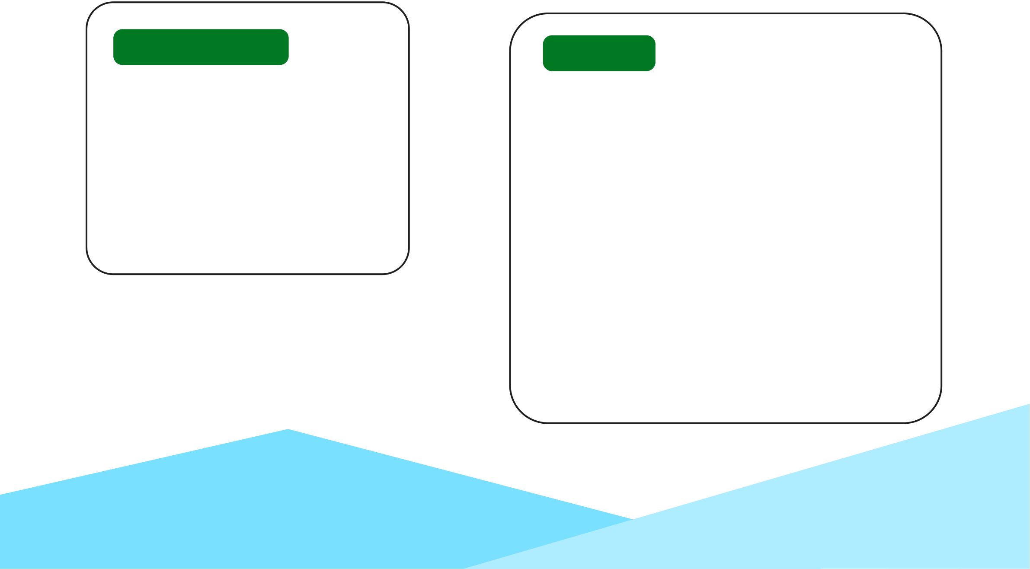

|  |
| --- |
| **Scientific Researcher** |

Python, along with frameworks like Pygame, is used in game development for tasks such as prototyping, scripting, and building game logic. While Python may not be the primary language for complex game engines, it is commonly used for smaller games and rapid development

|  |
| --- |
| **Automation Engineer** |

Python's simplicity and extensive libraries make it suitable for automation tasks. Python is used in areas like test automation, robotic process automation (RPA), and scripting for system administration and infrastructure management.

|  |  |
| --- | --- |
| **Python Cheat Sheet** | |
| **Variables and Data Types** | **Input and Output** |
| **Declare variables:** x = 5  **Data types:** int, float, string, bool | **Print:** print("Hello, World!")  **Input:** name = input("Enter your name:") |
| **Control Flow** | **Strings** |

**if-else statement:**   
if condition:   
# code block   
else:   
# code block   
**for loop:** for item in iterable: **while loop:** while condition:

**Declare a string**: my_string =   
"Hello"   
**String concatenation:** new_string = "Hello, " + name

**String methods:**   
**upper():** Converts all characters in a string to uppercase.

**lower():** Converts all characters in a string to lowercase.

**split()**: Splits a string into a list of substrings based on a specified delimiter. By default, splits on whitespace



**List**

**Declare a list:** my_list = [1, 2, 3]   
**Access elements:** my_list[0]

**List methods:**   
**append(element):** Adds an element to   
the end of the list.

**extend(iterable):** Extends the list by   
appending elements from the iterable.

**insert (index, element):** Inserts an   
element at the specified index.

**remove(element):** Removes the first   
occurrence of the specified element from   
the list.

**pop(index=-1):** Removes and returns   
the element at the specified index. If no   
index is provided, it removes and returns   
the last element.

**index (element, start=0,**   
**end=len(list)):** Returns the index of the   
first occurrence of the specified element   
within the given range.

**count(element):** Returns the number   
of occurrences of the specified element   
in the list.

**sort():** Sorts the elements of the list in   
ascending order.

**reverse():** Reverses the order of the   
elements in the list.

**copy():** Returns a shallow copy of the   
list.

**clear():** Removes all elements from the   
list.

**len(list):** Returns the number of   
elements in the list



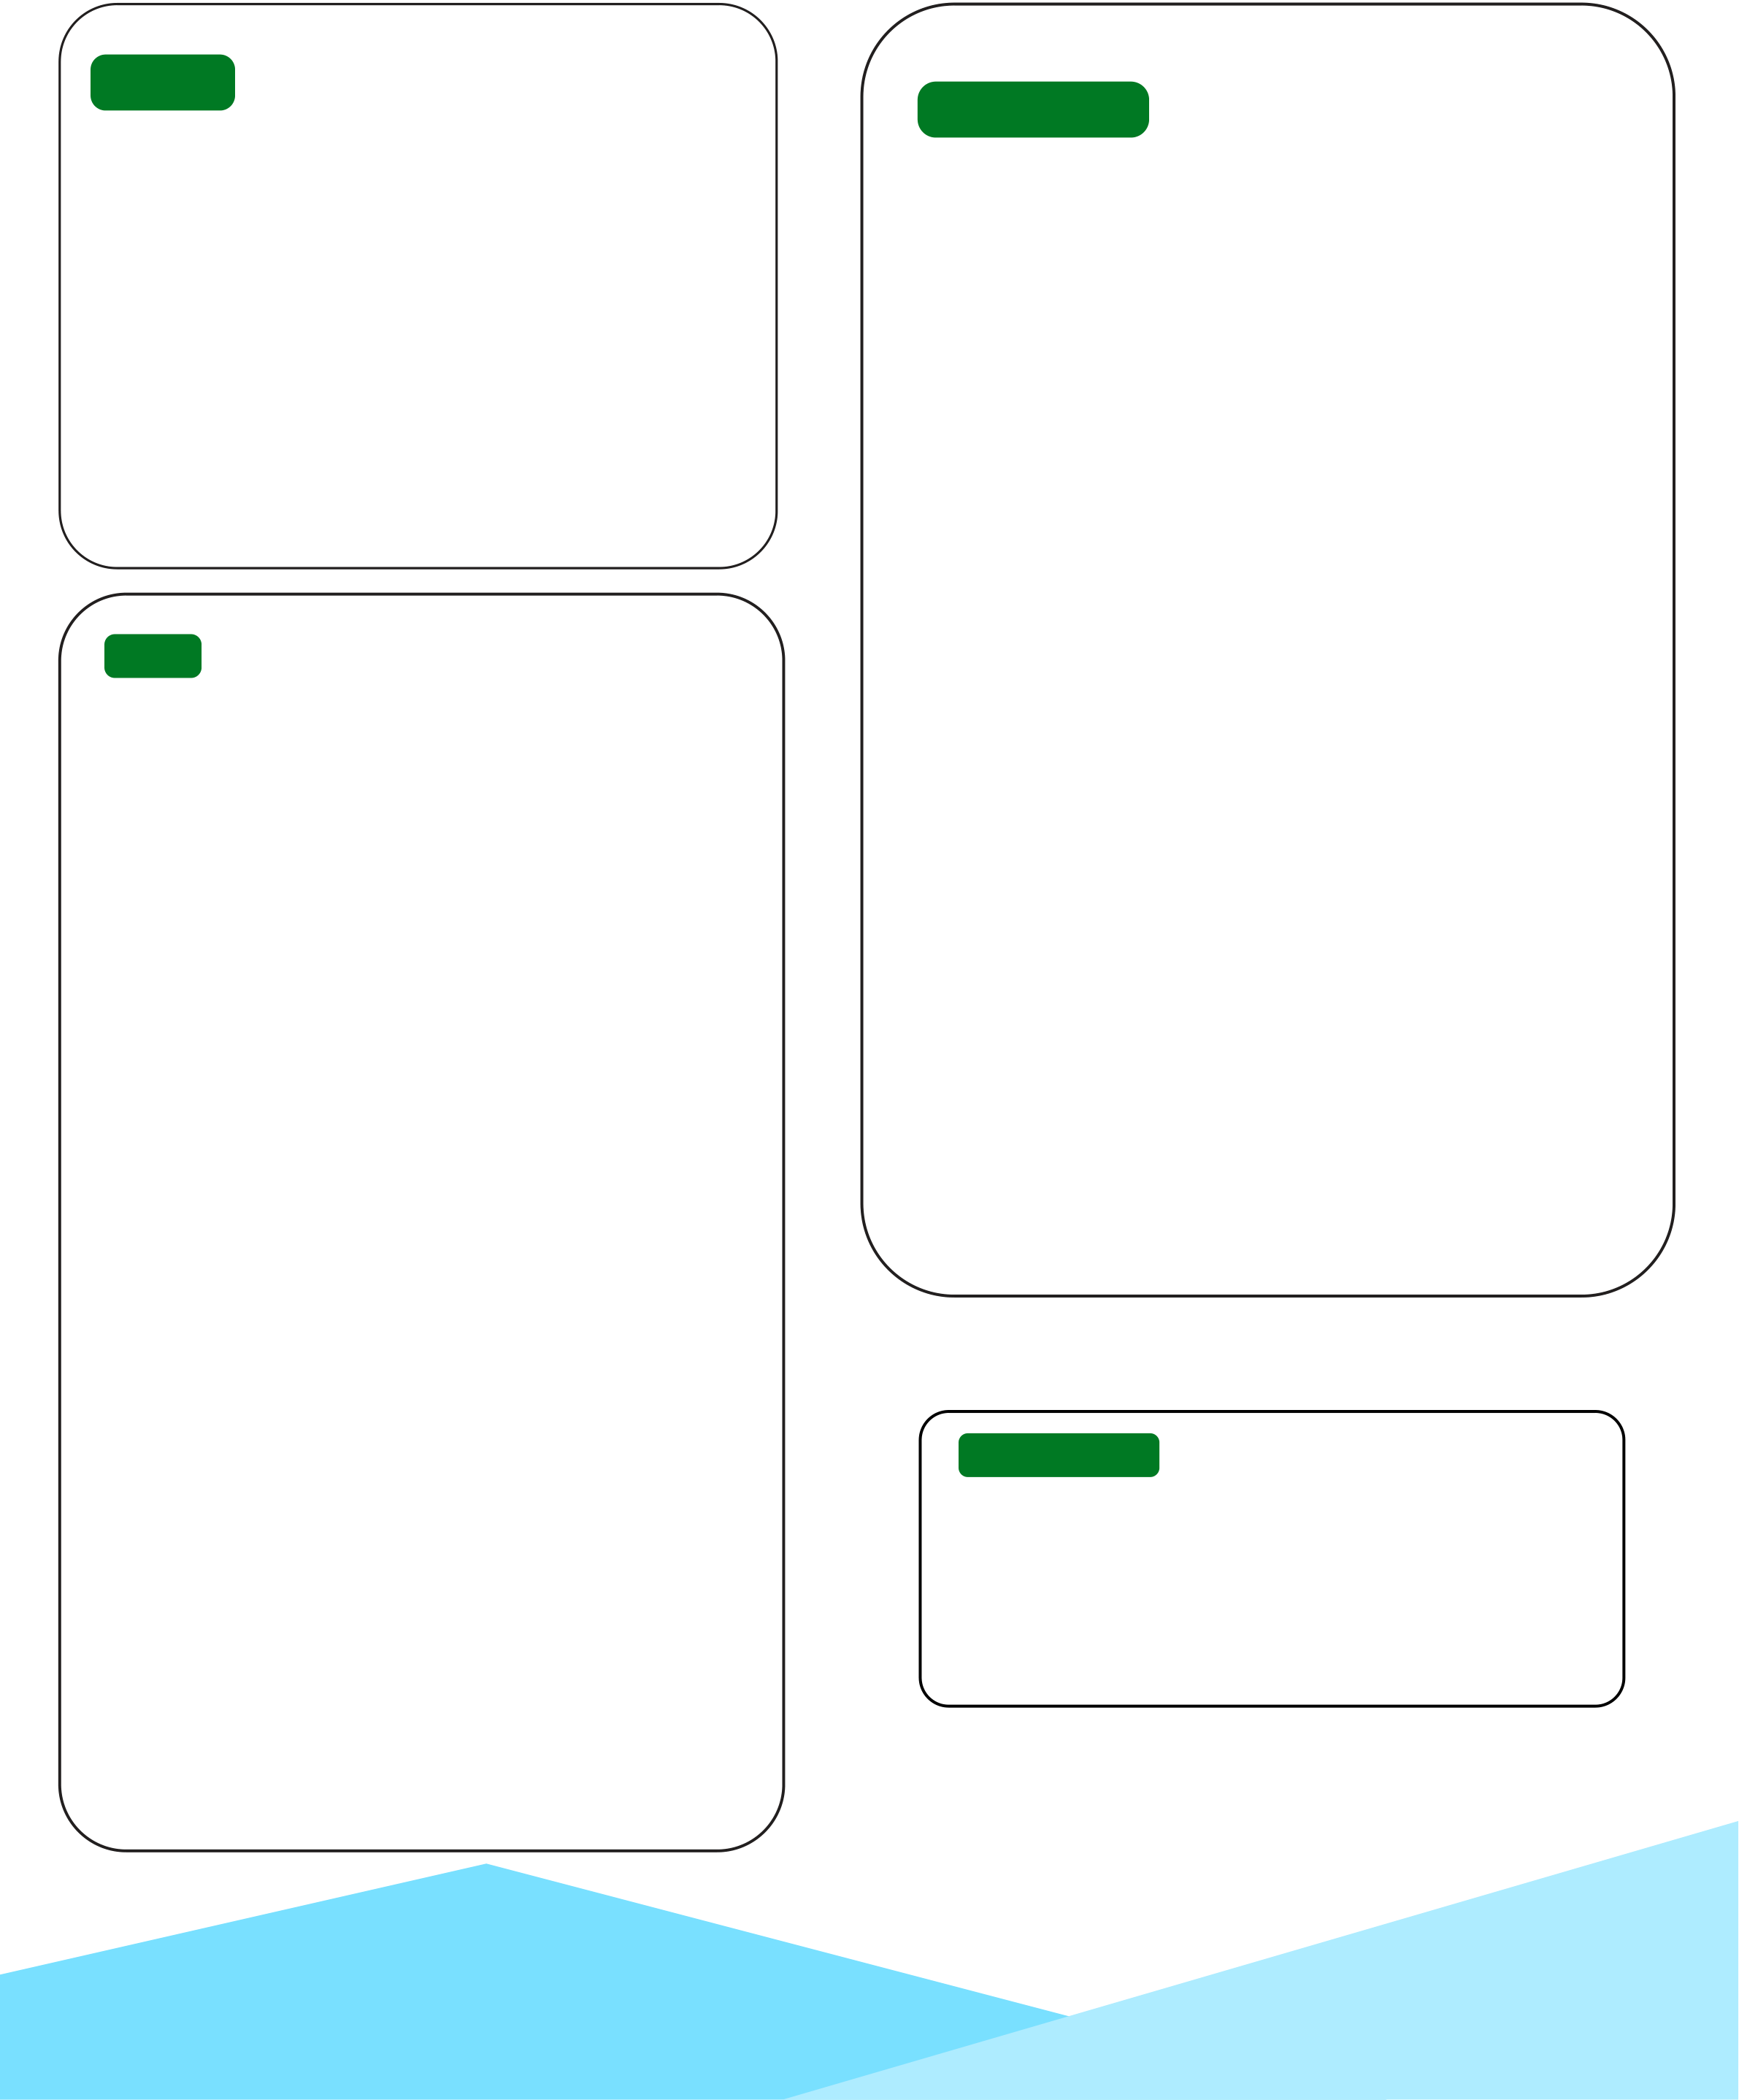

**Tuple**

**Declare a Tuple:** my_tuple = (1, 2, 3)   
**Access elements:** my_tuple[0]   
**Tuple methods:**   
**count(element):** Returns the number of occurrences of the specified element in the tuple.

i**ndex(element, start=0,**   
**end=len(tuple)):** Returns the index   
of the first occurrence of the specified element within the given range.

**Set**

**Declare a Set:** my_set = {1, 2, 3}   
**Access elements:** my_set[0]   
**Set methods:**   
**add(element):** Adds an element to the set.

**remove(element):** Removes the   
specified element from the set. Raises a KeyError if the element is not found.

**discard(element):** Removes the   
specified element from the set. Does not raise an error if the element is not found.

**pop():** Removes and returns an arbitrary element from the set.

**clear():** Removes all elements from the set.

**union(set):** Returns a new set that   
contains all elements from the set and the given set.

**intersection(set):** Returns a new set that contains common elements between the set and the given set.

**difference(set):** Returns a new set   
that contains elements present in the set but not in the given set.

**symmetric_difference(set):**   
Returns a new set that contains   
elements present in either the set or the given set, but not in both.

**Dictionary**

**Declare a Dictionary:** my_dict =   
{"key1": value1, "key2": value2, "key3": value3}   
**Access elements:** value =   
my_dict["key"]   
**List methods:**   
**keys():** Returns a list of all keys in the dictionary.

**values():** Returns a list of all values in the dictionary.

**items():** Returns a list of key-value pairs as tuples.

**get(key, default=None):** Returns the   
value associated with the specified key. If the key is not found, returns the default value.

**pop(key, default=None):** Removes   
and returns the value associated with the specified key. If the key is not found,   
returns the default value.

**popitem():** Removes and returns an arbitrary key-value pair from the dictionary.

**update(dictionary):** Updates the   
dictionary with the key-value pairs from the given dictionary.

**clear():** Removes all elements from the dictionary.

**Function**

**Declare a function:**   
def my_function(parameter):   
# code block   
return result   
Function call: my_function(argument)



**Random Numbers**

|  |  |
| --- | --- |
| **Generating Random Integers**:  random_number = random.randint(1, 10)  **Generating Random Elements**  **from a Sequence:**  sequence = [1, 2, 3, 4, 5]  random_element =  random.choice(sequence)  **Files**  **Open a file:**  file = open("filename.txt", "r") **Read content:**  content = file.read()  **Write to a file:**  file.write("Hello, World!")  **Date**  **Creating a Date Object:**  today = datetime.date.today() **Accessing Date Components:** year = today.year  month = today.month  day = today.day | **Turtle Graphics**  **Creating a Turtle:**  my_turtle = turtle.Turtle()  **Basic Turtle Movement:**  **forward(distance):** Moves the turtle forward by the specifed distance. |
| **backward(distance):** Moves the turtle backward by the specified distance.  **left(angle):** Rotates the turtle counterclockwise by the specified angle.  **right(angle):** Rotates the turtle clockwise by the specified angle.  Drawing Shapes:  **circle(radius):** Draws a circle with the specified radius.  **square(length):** Draws a square with the specified side length.  **triangle(length):** Draws an equilateral |
| triangle with the specified side length.  **Pen Control:**  **penup():** Lifts the turtle's pen off the canvas, so it doesn't draw.  **pendown():** Puts the turtle's pen back on the canvas, so it starts drawing again.  **pensize(width):** Sets the width of the turtle's pen. |
|  |

**Keywords**

**False, None, True, and, as, assert, async, await, break, class, continue, def, del, elif, else, except finally, for, from, global, if, import, in, is, lambda, nonlocal, not, or, pass, raise, return, try, while with, yield**

