**AWS EBS to deploy a sample application using AWS CLI**

**Prerequisites:**

1. Must have installed Python and AWS CLI (using pip) in your server (My case: EC2 Red Hat).

2. Create a bucket named (myapp9876) in your AWS S3.

3. Assuming we were already in the directory where our file is present.

**Steps:** <1>

1) Copy the files from your location to the S3 bucket created earlier.

2) Then we create the application version, give application a desired name, label the version, write custom description, point where the source file is, and create the application.

3) In this we create the environment for the application, by using the assigned values and using appropriate solution stack name. <4>

**Screenshots:**

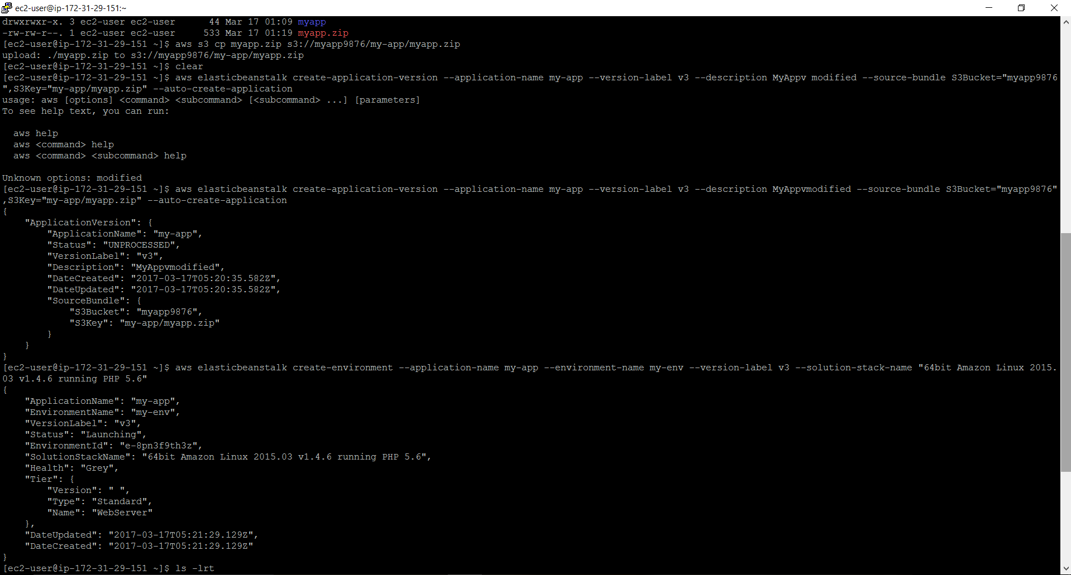

1.EBS CLI commands execution in EC2 Red Hat Server.

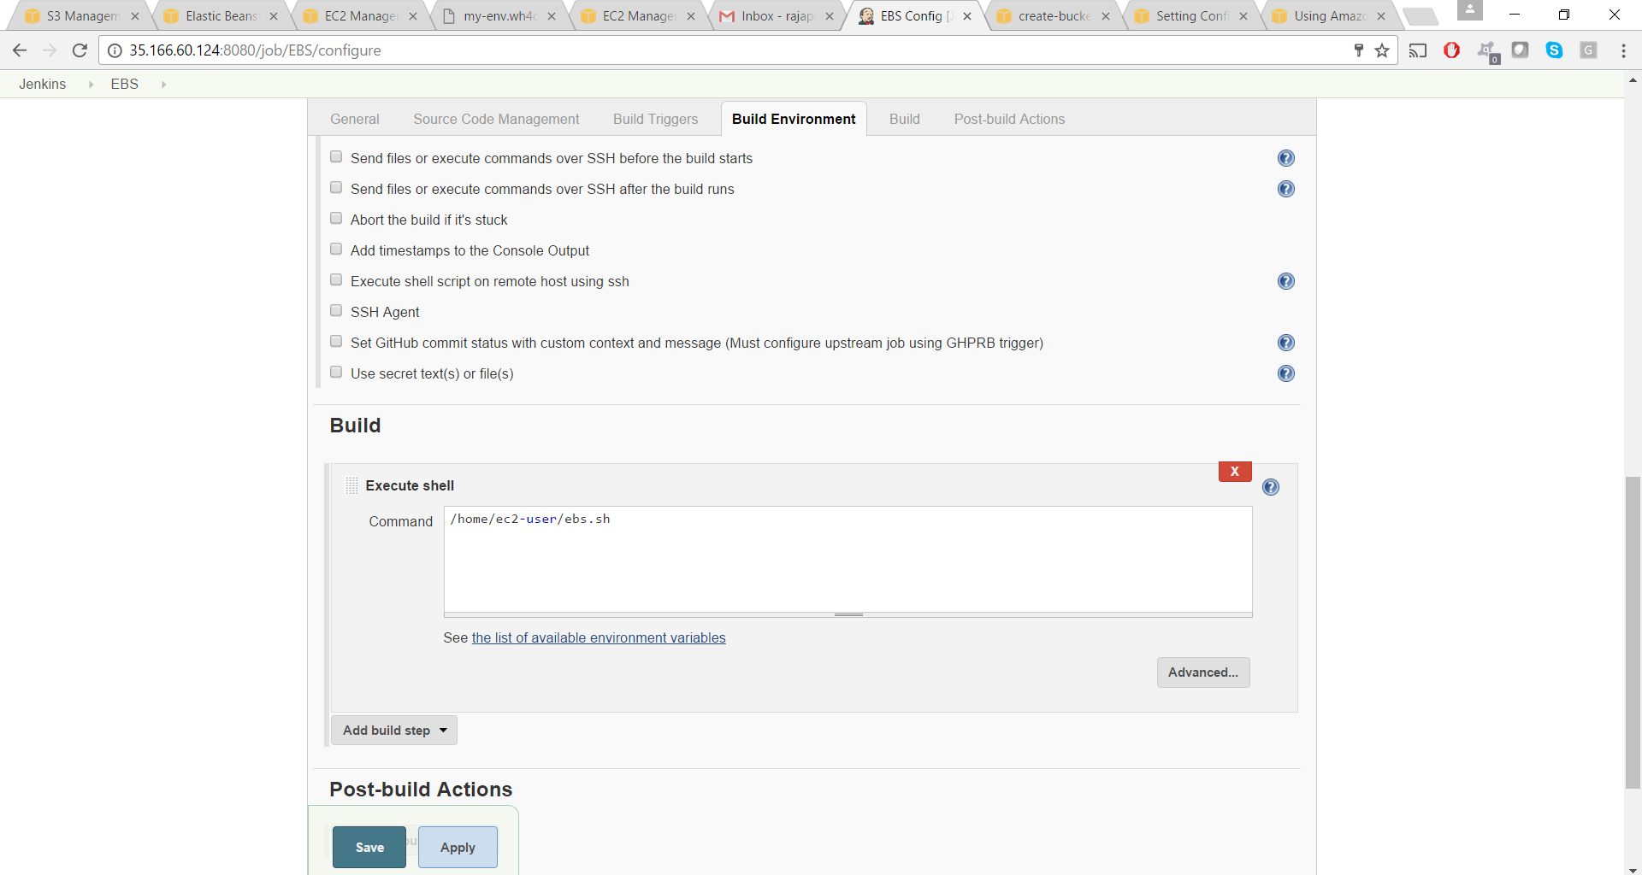

2. Jenkins Execute shell in Build where the shell script is pointed.

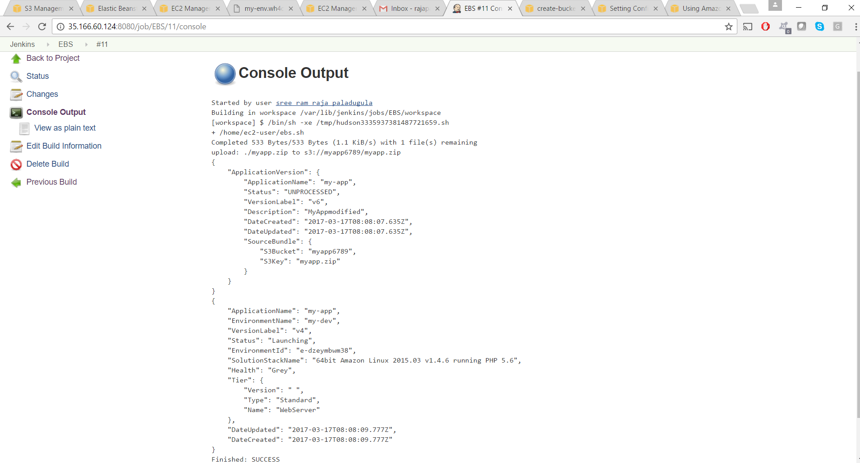

Jenkins Console Output after the build is successful and launched an application in EBS.

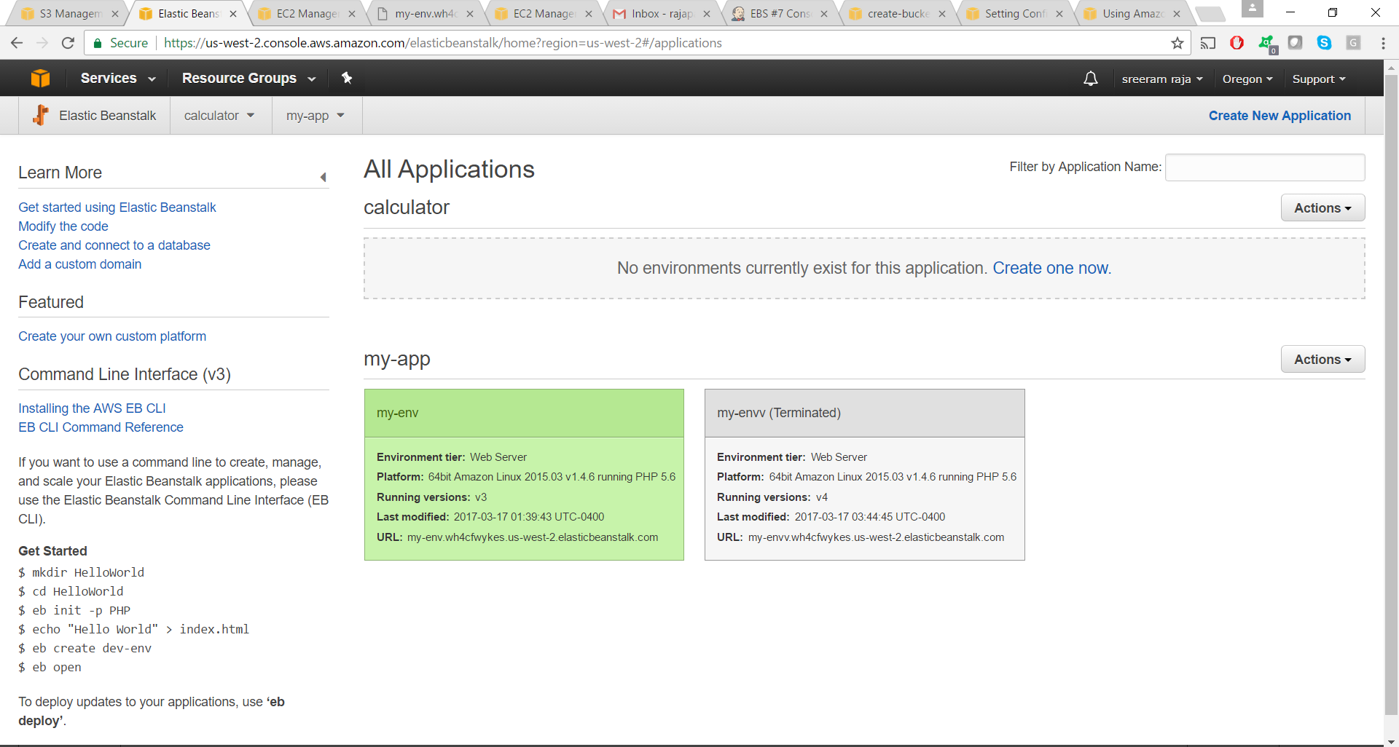

Application that is created in our AWS EBS.

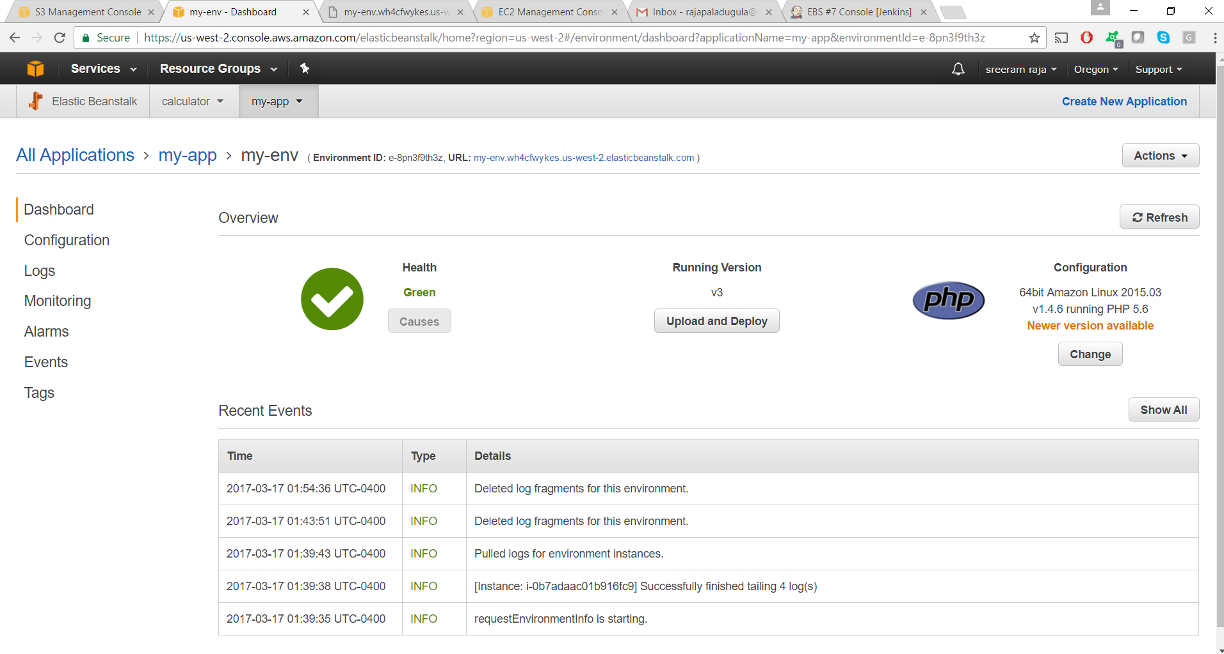

AWS EBS Application generated which we can navigate through the URL Link.

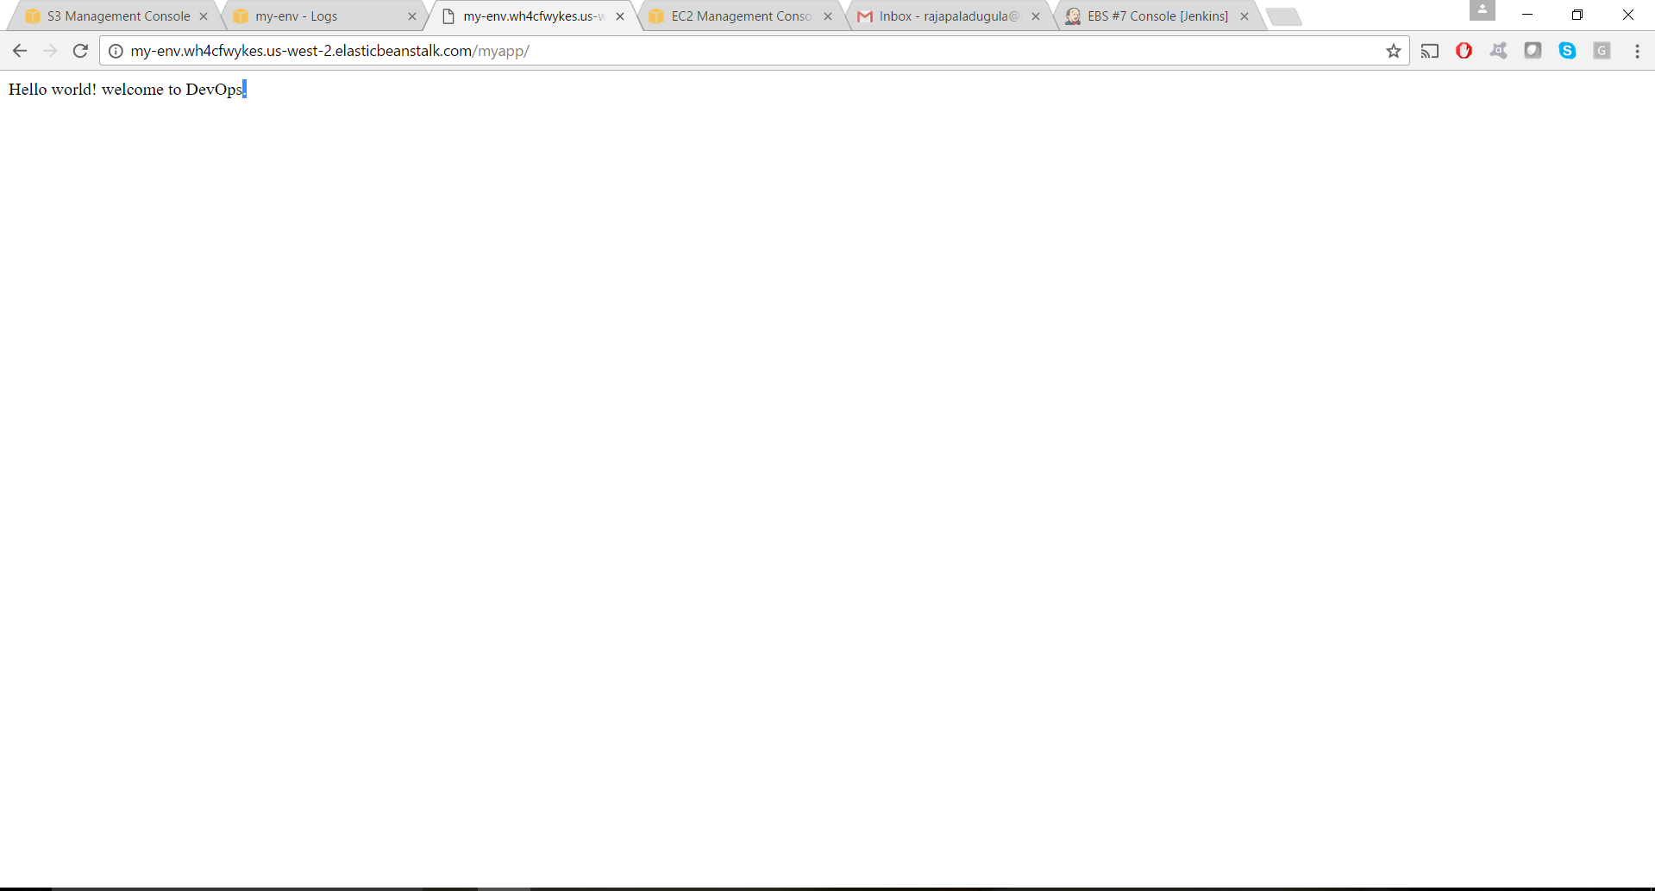

Output generated when we click the link created.

**AWS EBS Link:**

my-env.wh4cfwykes.us-west-2.elasticbeanstalk.com/myapp

**References:**

<1> <http://docs.aws.amazon.com/elasticbeanstalk/latest/dg/environment-configuration-methods-during.html>

<2> <http://docs.aws.amazon.com/elasticbeanstalk/latest/dg/environment-configuration-methods-before.html>

<3> <http://docs.aws.amazon.com/elasticbeanstalk/latest/dg/environment-configuration-methods-before.html>

<4> <http://docs.aws.amazon.com/cli/latest/reference/elasticbeanstalk/list-available-solution-stacks.html>

<5> <http://docs.aws.amazon.com/elasticbeanstalk/latest/dg/command-options.html#configuration-options-recommendedvalues>

<6> <https://github.com/ifdattic/symfony-app-deploy-to-aws-eb-article-code/blob/master/.ebextensions/misc/aws-cli-commands-used.md>

<7> <http://docs.aws.amazon.com/elasticbeanstalk/latest/dg/environments-create-awscli.html>

**Deprecated:**

<https://docs.aws.amazon.com/elasticbeanstalk/latest/dg/using-api-cli.html>

This tool, the Elastic Beanstalk API CLI, and its documentation have been replaced with the AWS CLI.