CHAPTER 1

INTRODUCTION

Motivation
The process of finding and hiring reliable building contractors for residential construction is often fraught with challenges. Customers typically face significant hurdles in accessing detailed and trustworthy information about potential contractors. This lack of transparency makes it difficult to evaluate contractors' credentials, past work, and overall reliability. Moreover, customers often struggle to obtain accurate and competitive quotes, manage billing, and maintain clear and consistent communication throughout the construction project.
These challenges can lead to stress, inefficiencies, and even disputes during construction. Many homeowners find themselves overwhelmed by the need to vet contractors, compare bids, and stay on top of financial and project management tasks. Additionally, the industry lacks a standardized, centralized system to streamline these processes, leaving customers to rely on word-of-mouth recommendations or generic online reviews that may not always reflect the contractor's current capabilities or reputation.
This project is motivated by the need to address these issues by creating a comprehensive and user-friendly web platform. The envisioned platform will serve as a one-stop solution for homeowners seeking reliable residential building contractors.
The platform aims to empower homeowners by providing them with the tools and information they need to make informed decisions and foster better collaboration with contractors. At the same t ime, it will help contractors enhance their visibility, credibility, and operational efficiency, creating a win-win situation for both parties. By simplifying and centralizing the contractor selection and project management process, this platform aspires to redefine how residential construction projects are initiated and executed.

Problem Statement
Current systems for connecting customers with contractors often fall short in addressing the core issues of transparency, access to information, and effective communication. These shortcomings create significant barriers for customers, particularly those undertaking residential construction projects, where trust, reliability, and clear communication are paramount.

Lack of Transparency:
      - Customers often find it difficult to verify contractors' credibility and reliability due to the absence of standardized vetting processes.
      - Many platforms do not provide comprehensive or verified information about contractors, such as certifications, licensing, or customer feedback, leaving customers to rely on incomplete or outdated data.

Insufficient Contractor Information:
      - Existing systems rarely offer detailed contractor profiles that showcase portfolios, specializations, or past project performance.
      - Customers may struggle to differentiate between contractors or assess their suitability for specific project requirements.

Ineffective Communication Tools:
      - Communication between customers and contractors is often fragmented, relying on emails, phone calls, or separate messaging apps.
      - This lack of a centralized communication platform can lead to misunderstandings, missed updates, and inefficiencies.

Uncertainty About Costs:
      - Obtaining accurate and competitive project quotes is often a convoluted process, with hidden fees or unclear billing structures causing customer dissatisfaction.
      - Budget management tools are rarely integrated into these systems, making it harder for customers to track expenses and avoid cost overruns.

Customer Dissatisfaction:
      - These gaps in transparency, communication, and cost management often result in delays, disputes, and overall dissatisfaction with the construction process.

Problem Objectives
This project aims to address these challenges through the development of a streamlined platform that transforms how customers connect with contractors. The platform will integrate innovative features to ensure transparency, reliability, and user convenience at every stage of the process.

Verified Contractor Profiles:
      - Contractors will undergo a robust verification process to validate their credentials, certifications, and licensing.
      - Detailed profiles will include project portfolios, customer reviews, ratings, and areas of expertise, allowing customers to make informed decisions.

Transparent Costing and Quotes:
      - A standardized system for contractors to submit detailed and itemized quotes, giving customers a
clear understanding of project costs.
      - Features to compare quotes from multiple contractors side by side, fostering competitive pricing and informed choices.

Centralized Communication Hub:
      - A built-in messaging system for real-time communication between customers and contractors, ensuring clarity and reducing delays.
      - Tools for sharing project updates, documents, and change requests within a single platform.

Integrated Billing and Payment Tools:
      - Customers can track budgets, receive invoices, and make secure payments directly through the platform.
      - Automated reminders for milestones and payments help streamline the financial aspects of the project.

Project Management Dashboard:
      - A user-friendly interface to track project timelines, milestones, and progress updates.
      - Alerts and notifications for changes in project scope or schedules, ensuring transparency and minimizing surprises.

Customer Support and Dispute Resolution:
      - Dedicated support channels to assist with any platform-related issues or disputes with contractors.
      - A mediation feature to help resolve conflicts amicably and maintain customer satisfaction.

Educational Resources:
      - Comprehensive guides, tips, and FAQs to educate customers about the construction process, contractor selection, and cost management.

  - Project Report Organization
The organization of this project report is designed systematically present the development process, findings, and outcomes of the BuildingMate project. The report is structured into the following chapters:
- Introduction
- Purpose: Streamline contractor hiring for homeowners
- Problems: Unverified contractors, unclear pricing, poor communication
- Solution: Centralized platform with verified profiles, quotes, and project tracking
- System Design
- Features:
  - Contractor verification
  - Quote comparison
  - In-app messaging
  - Payment system
- Tech: Web-based (e.g., React, Node.js, MongoDB)
- Implementation
- Built key modules:
  - User profiles
  - Bidding system
  - Project dashboard
- Challenges: Secure payments, real-time updates
- Results
- Benefits:
  - Transparent hiring
  - Better cost control
  - Improved communication
- Future: AI recommendations, mobile app
- Conclusion
Platform solves major pain points in residential construction hiring.

CHAPTER 2

LITERATURE REVIEW

Existing Work
While platforms like Houzz and Thumbtack have become popular options for connecting customers with contractors, they primarily function as directories or lead generation tools. These platforms offer basic functionalities, such as browsing contractor listings and accessing limited reviews, but they fall short in delivering the advanced tools and features needed to address the complexities of residential construction projects. Here’s a detailed analysis of their limitations and how this project aims to go beyond what these platforms offer:

Basic Contractor Directories:
      - Platforms like Houzz and Thumbtack provide searchable contractor directories, but these often focus on aesthetics (e.g., photos of completed projects) rather than in-depth, verified data about contractors.
      - Information about licensing, certifications, and compliance with local regulations is often incomplete or unverified, leaving customers unsure about the contractors' qualifications.

Limited Project Tracking:
      - These platforms typically do not provide tools for tracking a project’s progress. Customers are left to manage milestones, schedules, and updates through manual or external methods, such as spreadsheets or separate project management tools.
      - The absence of integrated timelines, task tracking, and automated updates increases the risk of miscommunication and project delays.

No Secure Billing and Payment Features:
      - While some platforms allow for basic payment exchanges, they lack robust billing management features, such as itemized invoices, secure escrow services, and automated payment reminders.
      - Customers often feel exposed to financial risks, such as overbilling, hidden fees, or disputes over payments, without a structured system to mediate or enforce agreements.

Fragmented Communication Tools:
      - Communication between customers and contractors often occurs outside the platform, through email, phone calls, or third-party apps, leading to disjointed exchanges.
      - This fragmentation increases the likelihood of missed updates, misinterpretations, and disputes, particularly during scope changes or unforeseen delays.

Lack of End-to-End Solutions:
      - These platforms stop short of offering a comprehensive experience. Once a customer hires a
contractor, the platform’s involvement typically diminishes, leaving the customer to navigate the complexities of project management, budgeting, and communication on their own.

Inconsistent Review Systems:
      - Reviews on these platforms are often subjective and prone to manipulation. They do not always provide a clear, structured representation of the contractor’s reliability, communication skills, or ability to stay within budget.

Limitations Of Existing Work

Limited Contractor Verification
      - Existing platforms often rely on self-reported contractor credentials or incomplete reviews, leaving customers uncertain about a contractor’s reliability, skills, and compliance with regulations.
      - There is no standardized vetting process to ensure contractors meet industry standards, which increases the risk of hiring unqualified individuals.

Lack of Transparent Pricing Mechanisms
      - Customers often struggle to understand how contractors arrive at quoted prices, leading to confusion, mistrust, and disputes over costs.
      - Hidden fees and vague estimates create financial unpredictability, making it challenging for customers to budget effectively.

Poor Customer-Contractor Communication Tools
      - Communication often occurs across fragmented channels like email, phone, or external messaging apps, making it difficult to maintain organized, clear, and timely exchanges.
      - Misunderstandings or missed updates can lead to project delays, rework, or dissatisfaction.

Inadequate Project Progress Tracking Capabilities
      - Customers often have little visibility into the status of their projects, leading to uncertainty and frustration.
      - Without clear tracking mechanisms, delays or scope changes may go unnoticed until they have significant impacts on timelines or costs.

CHAPTER 3

REQUIREMENT ANALYSIS

Software Requirements
- Operating System:
The platform should be compatible with Windows 10, Linux, and MacOS to ensure maximum flexibility during development and deployment. Cross-platform support ensures seamless integration with developer tools and deployment environments.

Frontend:

Framework:
    - React.js: A JavaScript library for building user interfaces, particularly single-page applications. It allows for the creation of reusable UI components.
    - Angular: A TypeScript-based open-source web application framework led by Google. It's a full-featured framework suitable for large-scale applications.
    - Vue.js: A progressive JavaScript framework for building user interfaces. Vue is designed to be incrementally adoptable, focusing on the view layer only.

Libraries:
    - D3.js: A JavaScript library for producing dynamic, interactive data visualizations in web browsers using SVG, HTML, and CSS.
    - Leaflet: An open-source JavaScript library for mobile-friendly interactive maps.
    - Google Maps API: A set of APIs from Google that allows developers to embed Google Maps on webpages and customize them with various services and layers.

Languages:
    - HTML5: The latest version of the HyperText Markup Language, the standard for creating webpages and web applications.
    - CSS3: The latest version of Cascading Style Sheets, used for describing the presentation of a document written in HTML.
    - JavaScript/TypeScript: JavaScript is the language of the web for creating interactive effects within web browsers. TypeScript is a superset of JavaScript that adds static typing, enhancing code quality and development efficiency.

Backend:

Framework:
    - Node.js with Express.js: Node.js is a JavaScript runtime built on Chrome's V8 engine, enabling server-side scripting. Express.js is a minimal and flexible Node.js web application framework providing a robust set of features for web and mobile applications.
    - Django: A high-level Python web framework that encourages rapid development and clean, pragmatic design. It includes many built-in features such as an ORM, admin interface, and authentication.
    - Flask: A lightweight WSGI web application framework in Python. It's designed with simplicity and flexibility in mind, making it easy to get started with.

Languages:
    - JavaScript: Used primarily for Node.js-based applications.
    - Python: Used for frameworks like Django and Flask.

Database:
Implement PostgreSQL or MongoDB based on data requirements:
- PostgreSQL (relational database) is ideal for structured data, offering advanced querying capabilities and data integrity features
- MongoDB (NoSQL database) is suitable for handling unstructured or semi-structured data with high flexibility and scalability.

Table 1 Software Requirements
Software Requirements | Details
Operating System | Windows 10/Linux/MacOS
Frontend | Java Script, Type Script, HTML, CSS
Backend | Java Script, Django, Python
Database | PostgreSQL/MongoDB

Hardware Requirements

Development Machines:
- Processor: Intel i5 or equivalent AMD processor or higher.
- RAM: 8 GB minimum (16 GB recommended).
- Storage: 256 GB SSD minimum (512 GB SSD recommended).

Servers:
- Processor: Multi-core Intel Xeon or equivalent AMD processor.
- RAM: 16 GB minimum (32 GB or higher recommended for handling larger datasets).
- Storage: 1 TB SSD (for database and application storage).
- Network: High-speed internet connection (1 Gbps or higher for optimal performance).

Table 2 Hardware Requirements

Hardware Requirements | Details
Processor | Intel i5 or equivalent AMD
RAM | Minimum 8GB (16GB recommended)
Storage | 256GB SSD minimum
Network | High speed internet connection

CHAPTER 4 SYSTEM DESIGN

Proposed Methods
The platform incorporates advanced algorithms to enhance the user experience and streamline decision-making processes. Two key algorithms are the Recommendation Algorithm and the Cost Estimation Algorithm, each serving a distinct yet complementary purpose.
The Recommendation Algorithm is designed to help customers identify the most suitable contractors for their projects. It leverages multiple data points, such as location, ratings, and reviews, to create personalized recommendations. The algorithm first filters contractors based on the customer’s geographical location, ensuring relevance and accessibility. It then evaluates contractor ratings, which reflect their performance across past projects, such as timeliness, quality of work, and adherence to budget. Customer reviews, analyzed using natural language processing (NLP) techniques, further refine these recommendations by considering qualitative feedback. For instance, positive mentions of specific skills or professionalism are weighted to highlight contractors with proven expertise. The algorithm also accounts for other criteria, such as project type and contractor availability, to provide a list of top matches that align with the customer’s needs. By offering tailored suggestions, this algorithm simplifies the contractor selection process, saving customers time and ensuring confidence in their choice.
The Cost Estimation Algorithm focuses on providing customers with a transparent and realistic initial quote for their projects. It operates by analyzing the project specifications submitted by the customer, such as size, materials, and complexity. Historical data from similar projects is utilized to estimate costs, creating a baseline that reflects current market conditions. The algorithm factors in regional variations in labor and material costs, ensuring that estimates are contextually accurate. Additionally, it allows contractors to input standard rates and pricing templates, which are dynamically applied based on the customer’s project details. For more precise estimates, the algorithm integrates variables like additional features (e.g., custom finishes or eco-friendly options) and timelines. The result is a detailed and itemized preliminary quote that helps customers set expectations and plan budgets effectively. This transparency builds trust and reduces the likelihood of misunderstandings or disputes later in the project.
Together, these algorithms provide a seamless and intelligent system for connecting customers with the right contractors while offering clear and accurate cost insights. They not only enhance the platform's usability but also contribute to higher satisfaction levels by addressing common pain points such as decision fatigue and cost ambiguity.

Class Diagram

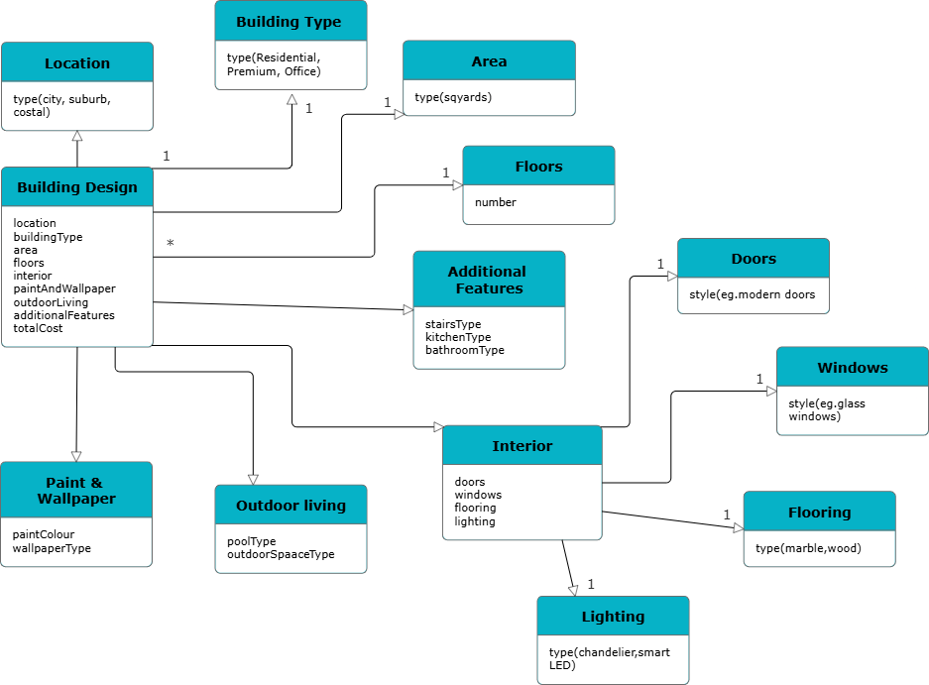

Figure 1 Class Diagram

Use Case Diagram

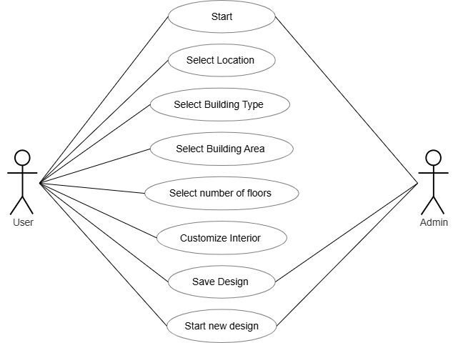

Figure 2 Use Case Diagram

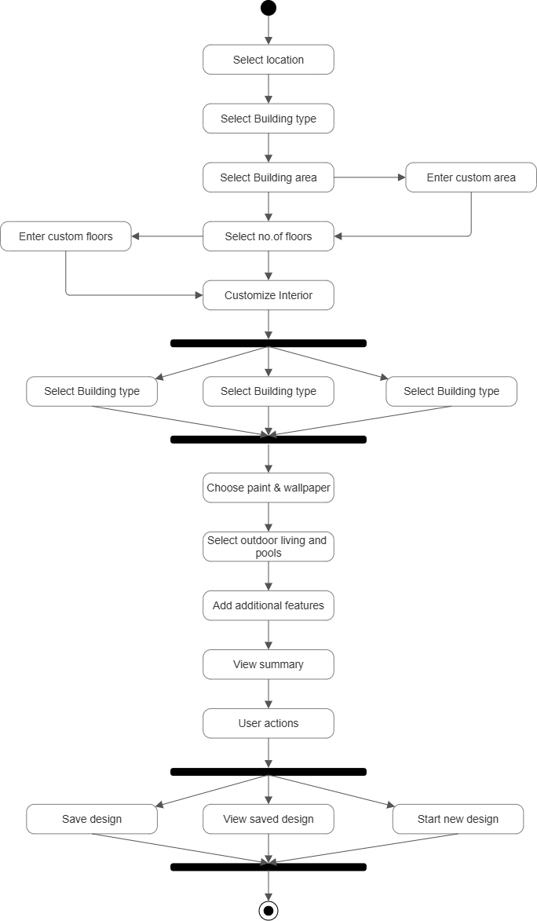
Activity Diagram

Figure 3 Activity Diagram

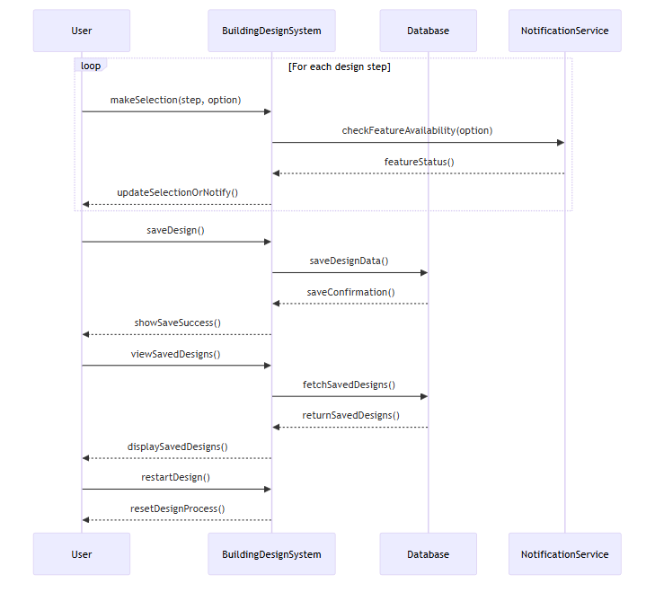
Sequence Diagram

Figure 4 Sequence Diagram

System Architecture

The system architecture is designed to provide a seamless, efficient, and secure platform for customers, contractors, and administrators. It is structured into four key components: the frontend, backend, database, and a secure payment gateway. Each component is integral to the overall functionality, ensuring smooth user interactions, reliable data processing, and robust security.

The frontend serves as the interface that directly interacts with users, including customers and contractors. It is responsible for delivering an intuitive and user-friendly experience, enabling users to navigate through contractor profiles, request quotes, and track project progress. Built using modern frameworks like React.js or Angular, the frontend ensures responsiveness across various devices, including desktops, tablets, and smartphones. It integrates features such as filtering options, dashboards, and communication tools, making it simple and efficient for users to perform their tasks.

The backend acts as the core of the system, processing user requests and implementing the business logic that powers the platform. Using frameworks like Django or Node.js, the backend ensures that customer and contractor interactions are handled smoothly and securely. This includes managing authentication, processing contractor bids, handling secure communications, and coordinating updates to the database. The backend also integrates APIs for services such as notifications, real-time updates, and the payment gateway, ensuring that all components of the system work cohesively.

The database is the storage backbone of the platform, securely maintaining all user and contractor data, including profiles, project details, and financial transactions. Relational databases like PostgreSQL are ideal for maintaining structured data integrity, while NoSQL options like MongoDB provide flexibility for handling semi-structured data. Advanced security measures, such as encryption and role-based access, protect sensitive data, ensuring that customer and contractor information is safe from unauthorized access or breaches.

The secure payment gateway is a critical component that facilitates financial transactions between customers and contractors. By integrating trusted services such as Stripe or PayPal, the platform ensures secure payment processing with features like escrow services and milestone-based payments. These gateways comply with PCI DSS standards, encrypting payment details and protecting user financial information.

Together, these components create a robust and scalable system architecture that prioritizes user experience, data security, and operational efficiency. The architecture is modular, allowing for the integration of new features and the scaling of services as the platform grows. This design ensures a reliable and secure environment for all stakeholders, fostering trust and satisfaction among users.

Technology Description

Contractor Profiles
  - Personal Information: Name, contact info, location, etc.
  - Skills and Expertise: A list of skills and areas of specialization such as web development, mobile app development, design, etc.
  - Portfolios: Links to past projects, work samples, or case studies that demonstrate their expertise.
  - Ratings and Reviews: Feedback from previous clients or employers regarding the contractor’s performance.
  - Availability: Contractor's current work schedule, including whether they are accepting new projects.
  - Pricing: Rates, whether hourly or project-based, to estimate costs for potential clients.

Customer Projects
  - Project Requirements: A detailed description of what the customer needs, including features, technologies to be used, design preferences, and other requirements.
  - Project History: This could include past project iterations, previous developers involved, issues encountered, and lessons learned.
  - Timeline: Estimated start and end dates, deadlines for different project milestones, and expected delivery times.
  - Budget: Information on how much the customer is willing to spend on the project.
  - Communication and Progress Updates: A log of updates, feedback, and collaboration notes between the customer and contractor.

CHAPTER 5 IMPLEMENTATION

Front page Screenshots
    - Login page
It contains two main sections: a Sign Up container for new users to register by providing their first name, last name, email, and password, and a Sign In container for existing users to log in with their email and password. Both sections include form validation and user-friendly input fields with icons. The page also features the company logo prominently in both sections and provides navigation buttons to switch between Sign Up and Sign In forms. The page uses external CSS for styling and includes JavaScript for authentication functionality.
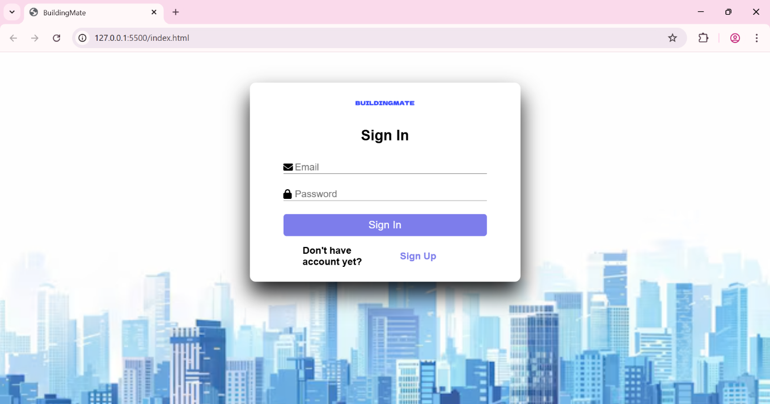

Figure 1 Screenshot of the login page

    - Section 1
This section showcases a selection of beautifully designed buildings that are ready for purchase. It includes a heading, a descriptive paragraph inviting users to explore the available designs, a gallery displaying images of different building types such as Modern Residential Buildings, Luxury Office Complexes, and Commercial Spaces, each with a caption. Additionally, there is a call-to-action button labeled "Explore Our Designs" to encourage users to browse the offerings further.
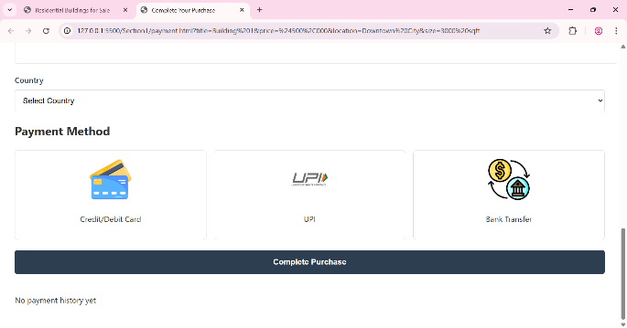
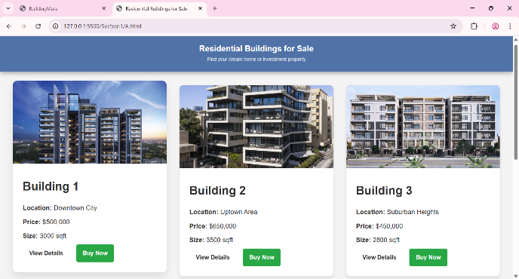
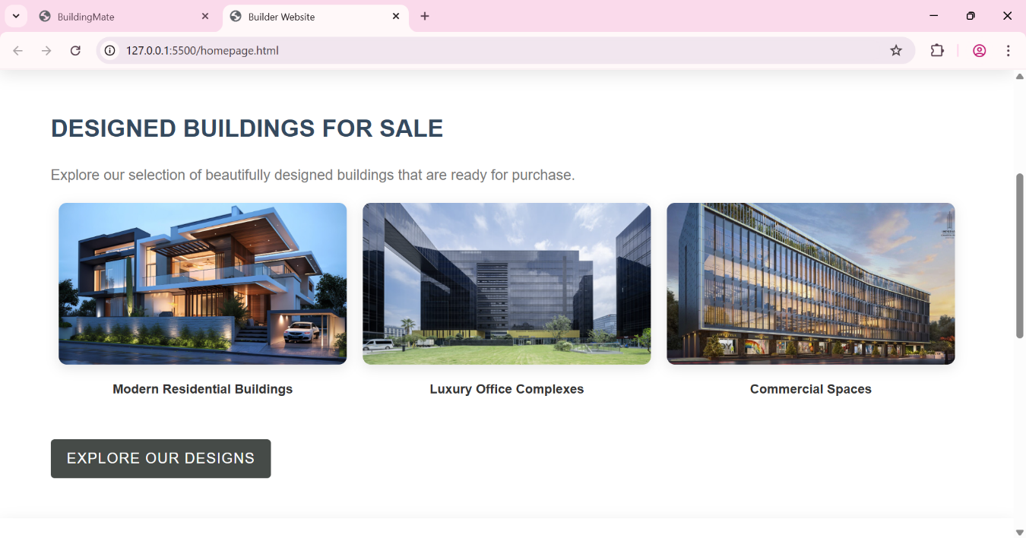

Figure 2 Screenshot of the section-1 page

    - Section 2
This section encourages users to bring their vision to life by creating custom buildings tailored to their specific needs and preferences. It features a heading, a descriptive paragraph inviting users to use the design tool, an illustrative image showcasing the design tool example, and a call-to-action button labeled "Start Designing" that links to the building design page.

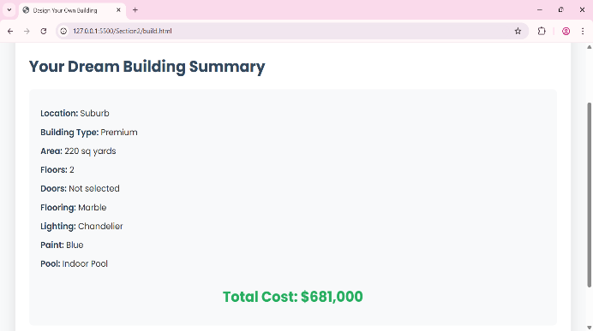
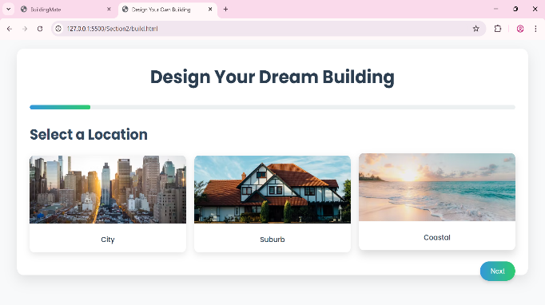
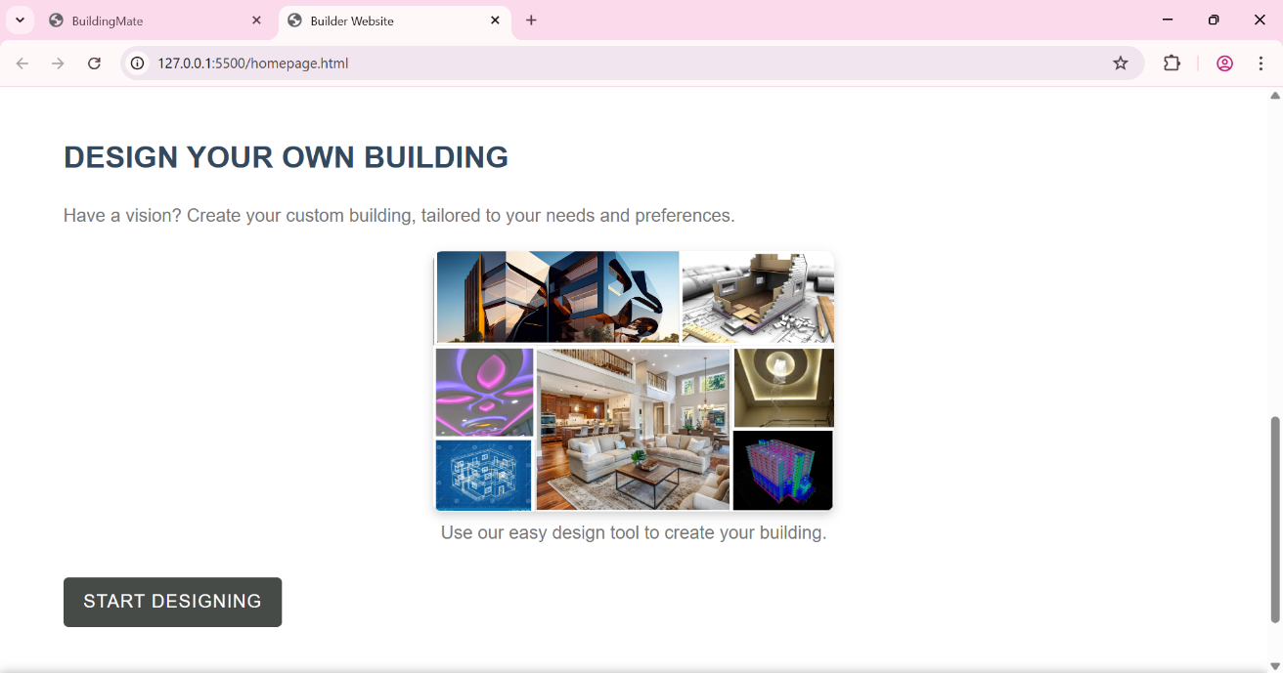

Figure 3 Screenshot of the section-2 page

Code Snippets:
Section 1:
<!-- Section 1: Designed Buildings for Sale -->
<section class="designed-buildings">
<div class="container">
<h2>Designed Buildings for Sale</h2>
<div class="gallery">
<div class="gallery-item" data-link="building1-detail.html">
<img src="Pics\building1.jpg" alt="Building 1">
<p style="font-weight: bold;">Modern Residential Buildings</p>
</div>
<div class="gallery-item" data-link="building2-detail.html">
<img src="Pics\building2.jpg" alt="Building 2">
<p style="font-weight: bold;">Luxury Office Complexes</p>
</div>
<div class="gallery-item" data-link="building3-detail.html">
<img src="Pics\building3.jpg" alt="Building 3">
<p style="font-weight: bold;">Commercial Spaces</p>
</div>
</div>

<a href="#" class="cta-button">Explore Our Designs</a>
</div>
</section>

Section 2:
<!-- Section 2: Design Your Own Building -->
<section class="design-your-own">
<div class="container">
<h2>Design Your Own Building</h2>

<div class="design-tool">
<img src="Pics\design.jpg" alt="Design Tool Example">
<p>Use our easy design tool to create your building.</p>
</div>

<a href="StartDesigning\DesignTool.html" class="cta-button">Start Designing</a>
</div>
</section>

Results and Discussions

Simplified Contractor Hiring
      - Comprehensive Contractor Profiles:
        - Contractors can create detailed profiles showcasing their skills, experience, portfolios, certifications, and ratings. This provides customers with a one-stop place to evaluate candidates based on relevant experience and credentials.
        - Filtering options allow customers to easily search contractors by specific skills, experience levels, pricing, and availability, so they can find the best match for their project needs without the need for manual vetting or interviews.
      - Easy Comparison:
        - Customers can compare multiple contractors side by side, evaluating their rates, expertise, portfolios, and reviews. This reduces the time and effort needed to manually research each potential contractor and helps customers make informed decisions faster.
      - Trust and Security:
        - Features such as ratings, reviews, and portfolios offer insights into the contractor's previous work and customer satisfaction. Positive feedback from previous clients builds trust, and customers feel more confident hiring contractors who have proven reliability.

Transparency in Project Execution
Customers can create and share detailed project specifications, including milestones, timelines, and goals, ensuring that contractors have a clear understanding of the work required.
As the project progresses, contractors can provide updates on key milestones, tasks, and challenges. This transparency keeps customers informed at all stages of the project, reducing any ambiguity about progress.
The platform can also include tools for tracking project performance against agreed- upon metrics such as deadlines, budget adherence, and quality of work.

Benefits to Both Contractors and Customers
- For Customers:
  - The platform saves customers time by allowing them to find contractors quickly based on their specific needs.
  - Transparent pricing, timelines, and project tracking provide customers with peace of mind, knowing what to expect from the start to the end of the project.

For Contractors:
  - The platform provides contractors with an opportunity to showcase their work and gain visibility, which helps them attract more customers.
  - Contractors can track their reputation through ratings and reviews, providing an incentive for high-quality work and consistent performance.

Testing
- Automated Usability Testing: Tools like heatmaps, session recording, and A/B testing can track how users interact with the platform. This data helps identify friction points or areas where users struggle, allowing the team to improve the user experience.
- Performance Monitoring: Automated performance monitoring tools track the speed, uptime, and load times of the platform, ensuring it remains responsive and reliable. Tools like New Relic or Google Analytics can provide real-time insights into the platform's performance.
- Bug Tracking and Automated Regression Testing: Automated bug tracking tools like JIRA, combined with regression testing, ensure that new updates or features don’t break existing functionality. Automated tests can run across different browsers and devices to ensure a consistent experience.
- User Reviews and Ratings: Allowing users to rate features or overall satisfaction provides continuous input on the platform's performance. This data can also be used to improve specific parts of the service based on user preferences.
- Usability Testing: Real users perform tasks such as finding a contractor, submitting a project, or tracking project progress. Observing how users navigate the platform and identifying challenges or confusion is key.
- Beta Testing: A small group of users from your target audience use the platform over a set period, testing out all features. During this period, they can provide feedback on usability, performance, and feature requests.

Validation
The platform's usability and reliability are verified through user testing and validation against project objectives. User testing involves gathering real feedback from actual users who interact with the platform, allowing the team to identify any usability issues, confusion, or points of friction. Testing can take place during different stages of development, such as beta testing or usability studies, ensuring that real users' experiences align with the intended design.
Validation against project objectives ensures that the platform meets the goals set out at the start of the project. This includes checking whether the platform effectively simplifies contractor hiring, provides transparency in project execution, and delivers a seamless user experience. Feedback is continuously collected and analyzed to ensure the platform's features and performance align with the needs of contractors and customers alike. This ongoing feedback loop ensures that the platform evolves to meet user expectations while maintaining reliability throughout.
The verification of the platform's usability and reliability is an ongoing process that relies heavily on user testing and validation against the initial project objectives. Throughout the development lifecycle, the platform must undergo several stages of testing to ensure that it provides an intuitive user experience, meets functionality requirements, and aligns with both user expectations and business goals.
User testing plays a crucial role in identifying how well users interact with the platform in real- world scenarios. By observing users as they navigate through the platform, whether they’re hiring contractors, reviewing project milestones, or managing their budgets, teams can gain direct insights into any pain points or inefficiencies that may not have been anticipated during design. This feedback directly informs iterative changes and improvements. For example, if users have difficulty finding certain features or experience confusion when submitting a project, these issues are prioritized for refinement to enhance the user experience.

CHAPTER 6

CONCLUSION&FUTURE SCOPE

Conclusion
The project successfully delivers a user-friendly platform designed to connect customers with contractors in a seamless, efficient manner. The platform emphasizes transparency, security, and efficiency, creating an experience that benefits both parties.
One of the key strengths of the platform is its focus on transparency. Customers can easily browse contractor profiles, which include detailed information on skills, past projects, pricing, and customer reviews. This transparency allows customers to make informed decisions based on reliable data, such as ratings and project histories. Additionally, the platform enables real-time tracking of project progress, offering customers visibility into milestones, deadlines, and any potential issues. This transparency fosters trust between contractors and clients, helping to avoid misunderstandings and ensuring that expectations are met.
Security is another cornerstone of the platform. By implementing robust security features, such as secure payment gateways and data encryption, the platform ensures that sensitive information—like payment details and personal data—is protected. Contractors and customers can confidently engage in projects, knowing that their interactions are safe from potential threats. Furthermore, the use of milestone-based payments, where customers pay only after specific project stages are completed, provides an added layer of financial security for both parties. This reduces the risk of fraud or disputes and ensures that payments are tied to the successful delivery of work.
Efficiency is embedded throughout the platform. The system allows customers to easily search for contractors based on specific criteria, such as skill set, availability, and budget, which accelerates the hiring process. Similarly, contractors can quickly review project requirements and begin work without unnecessary delays. Automated tools help with project management by sending reminders, tracking progress, and notifying both parties of important milestones, further enhancing the efficiency of the process.

Future Scope
    - On-the-Go Access: Users can access contractor profiles, manage projects, and receive real- time notifications directly from their mobile devices. This makes it easier for customers to track project progress and for contractors to communicate with clients, update milestones, or accept new job requests.
    - Push Notifications: Users will receive timely updates about project status, new messages, upcoming milestones, or new contractor availability, ensuring that they stay informed and engaged without needing to check their emails or desktop.
    - Improved User Experience: A mobile app can offer a more streamlined, optimized experience compared to a mobile website. With features such as mobile-friendly designs, offline capabilities, and a more intuitive user interface, the app can help users complete tasks faster and more conveniently.
    - Smart Matchmaking: AI algorithms can analyze a customer’s project description, timeline, and budget and suggest the most suitable contractors based on their skill set, availability, and past performance. This could reduce the time spent browsing through profiles and ensure that users find the right fit faster.
    - Personalized Recommendations: AI can learn from users’ preferences and past interactions, offering more tailored contractor suggestions over time. This improves the matching process by considering not just qualifications, but also factors like working style, customer feedback, and prior project success.

REFERENCES:
- https://www.nobroker.in/
- https://www.mapsofindia.com/lat_long/telangana/

