OPERATING SYSTEMS
SIMULATION BASED PROJECT

QUESTIONS: 16,17

NAME: M. RAJA RAHUL
REG. NO: 11601793
SECTION: K1615
ROLL NO: A20
EMAIL: maddula.rajarahul@gmail.com
GITHUB REPOSITORY LINK: https://github.com/rajarahul12/K1615-A20

Q.16
CODE
#include<bits/stdc++.h>
using namespace std;

struct Process{
int arrival_time;
int burst_time;
int process;
};

//Function for Sorting the Structure
bool sorting_process(Process a, Process b)
{
return a.arrival_time < b.arrival_time;
}

int main()
{
int n,i,j,k;
cout<<"Enter the number of processes : ";
cin>>n;
cout<<"\n";
Process p[n];
int burst_times[n];
//Taking Input's of Arrival Time and Burst Time
for(i=0;i<n;i++)
{
cout<<"Enter the arrival time of "<<i+1<<" Process : ";
cin>>p[i].arrival_time;
p[i].process = i+1;
}
cout<<"\n";
for(i=0;i<n;i++)
{
cout<<"Enter the burst time of "<<i+1<<" Process : ";
cin>>p[i].burst_time;
burst_times[i]=p[i].burst_time;

}

//Sorting the structure based on Arrival Times
sort(p,p+n, sorting_process);

//Displaying the Data about Processes
cout<<"\n";
cout<<"PROCESS"<<"\t"<<"ARRIVAL TIME"<<"\t"<<"BURST TIME"<<endl;
for(i=0;i<n;i++)
{
cout<<" P"<<p[i].process<<"\t "<<p[i].arrival_time<<"\t "<<p[i].burst_time<<endl;
}
cout<<"\n";

//Taking the TIMEQUANTUM and calculating the TurnAround Time and Waiting Time
int time_quantum,waiting_time=0,turnaround_time=0,time,count,remaining,flag;
cout<<"Enter Time Quantum : ";
cin>>time_quantum;
remaining=n;
cout<<"\n";
cout<<"\n\nProcess\t|Turnaround Time|Waiting Time\n\n";
for(time=0,count=0;remaining!=0;)
{
if(burst_times[count]<=time_quantum && burst_times[count]>0)
{
time+=burst_times[count];
burst_times[count]=0;
flag=1;
}

else if(burst_times[count]>0)
{
burst_times[count]=burst_times[count]-time_quantum;
time+=time_quantum;
}

if(burst_times[count]==0 && flag==1)
{
remaining--;
cout<<" P"<<count+1<<"\t|\t"<<time-p[count].arrival_time<<"\t|\t"<<time-p[count].arrival_time-p[count].burst_time<<endl;
waiting_time+=time-p[count].arrival_time-p[count].burst_time;
turnaround_time+=time-p[count].arrival_time;
flag=0;
}

if(count==n-1)
count=0;
else if(p[count+1].arrival_time<=time)
count++;
else
count=0;
}
cout<<"\nTotal Waiting Time of All Processes : "<<waiting_time<<endl;
cout<<"\nAverage Waiting Time : "<<(waiting_time*1.0)/n<<endl;
cout<<"\nTurnAround Time : "<<(turnaround_time*1.0)/n<<endl;
}

QUESTIONS:

- Description:

The problem is to schedule processes that are given a Time Quantum and if the Time Slice expires then the process should enter the ready queue again and starts executing it when it’s turn comes. The algorithm that needs to be used for this scheduler is ROUND-ROBIN algorithm.

- Algorithm:

- Taking input of number of Processes and also data about Burst Time and Arrival Time of each process.
- Storing the data in the structure and sorting the structure based on Arrival Times of the Processes this makes the work of selecting the processes easy.
- After that taking Time Quantum from the user and start scheduling the process.
- Now the processes are selected based on their arrival time and executed based on Time Quantum.
- Whenever Time Quantum expires the burst time gets updated and next process in the queue is selected.
- After the burst time becomes zero the waiting time and turnaround time are calculated for each process and then displayed.
- After the calculation of waiting time for each process they are added and that gives the Total Waiting Time of all the processes and also Average Waiting Time and Average Turn Around Time.

- Purpose of Use:
Round-Robin Algorithm is one of the algorithms employed by process and Network schedulers in computing. These are mainly used in Operating Systems and applications that serve multiple client requests.

- Code Snippet:

- Calculation of Total Waiting Time
- Calculation of Average Waiting Time
- Calculation of Average Turn Around Time

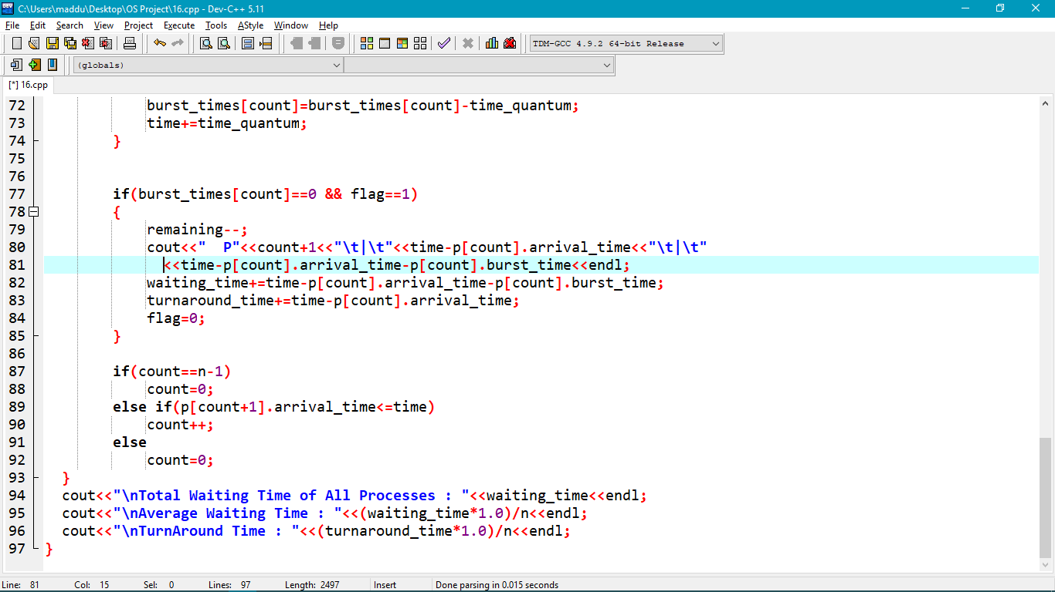

- Boundary Conditions: The main boundary condition in this algorithm execution is the Time Quantum.

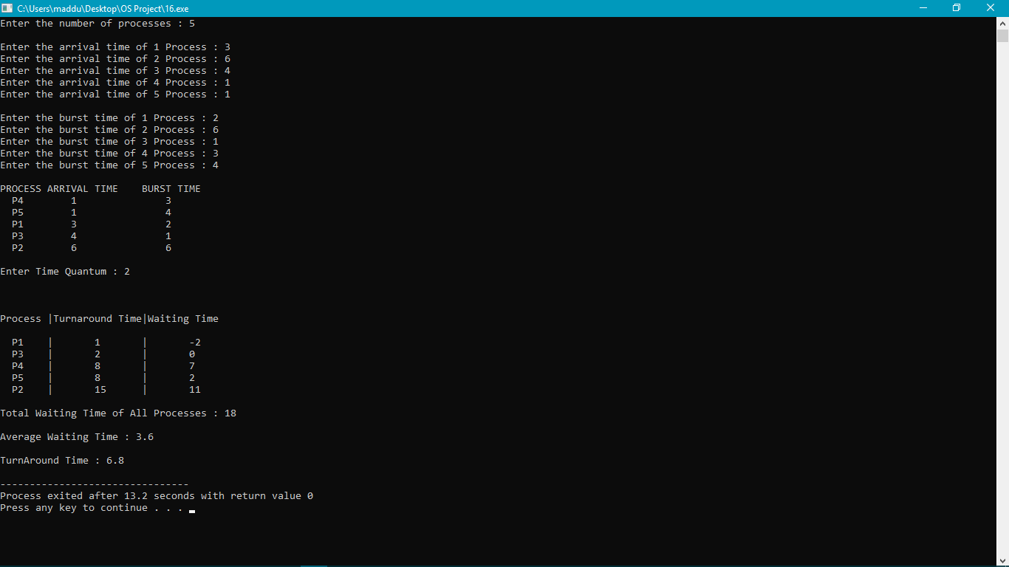

- Test Cases:

- Test Case 1

Process | Arrival Time | Burst Time
1 | 1 | 2
2 | 3 | 5
3 | 5 | 3

Time Quantum = 2

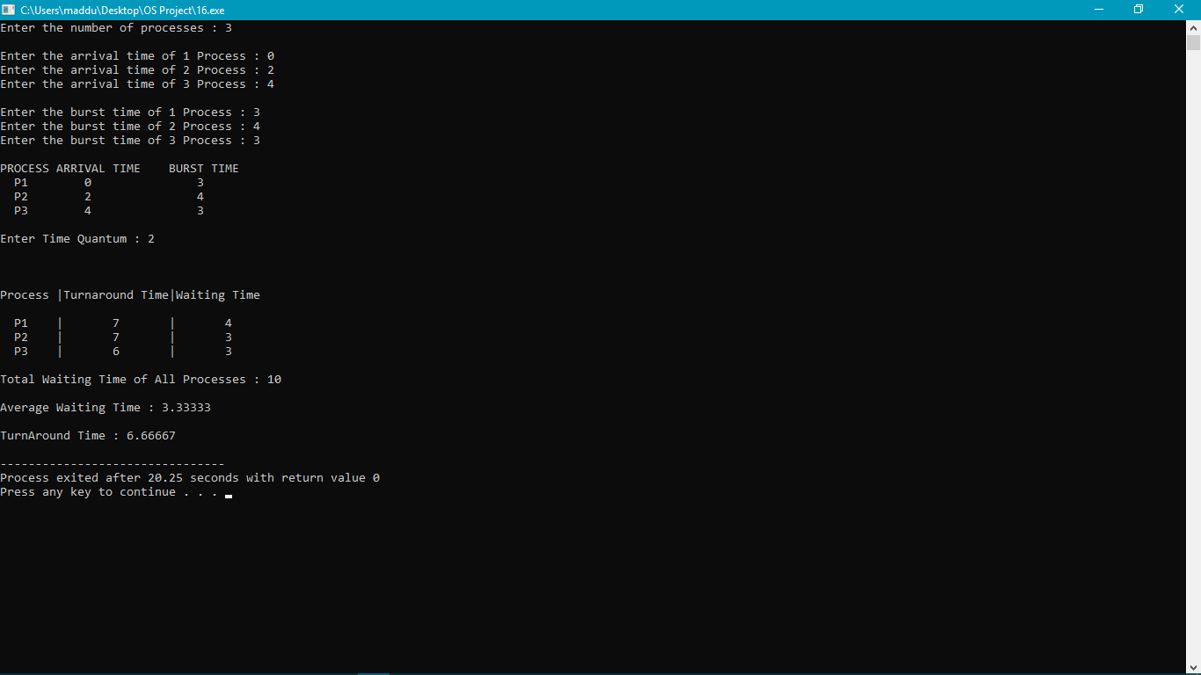

- Test Case 2
Process | Arrival Time | Burst Time
1 | 0 | 9
2 | 1 | 5
3 | 2 | 3
4 | 3 | 4

Time Quantum =5
Output:
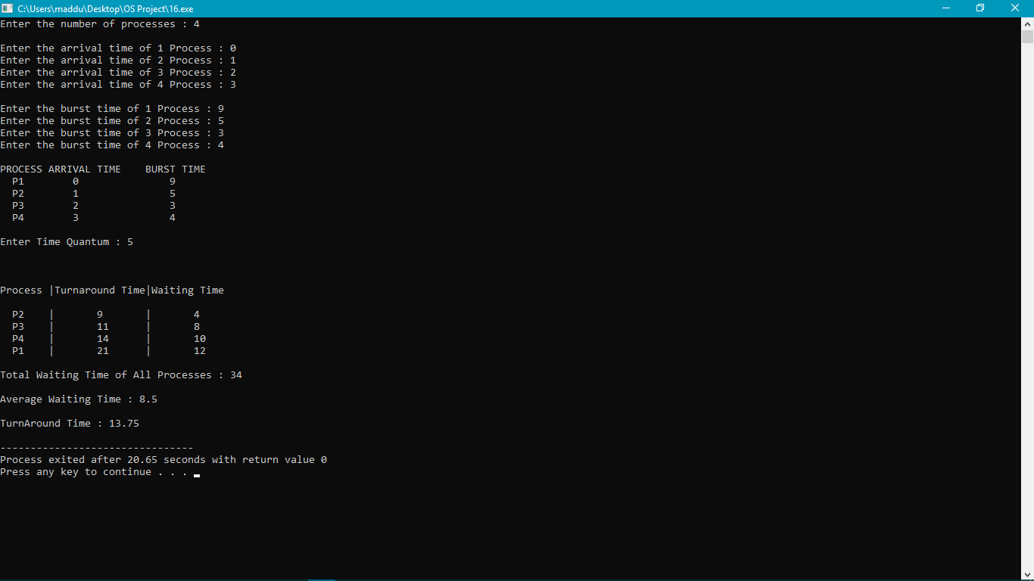

- Test Case 4:
Process | Arrival Time | Burst Time
1 | 1 | 5
2 | 2 | 5
3 | 3 | 5
4 | 4 | 5
5 | 9 | 5

Time Quantum :2

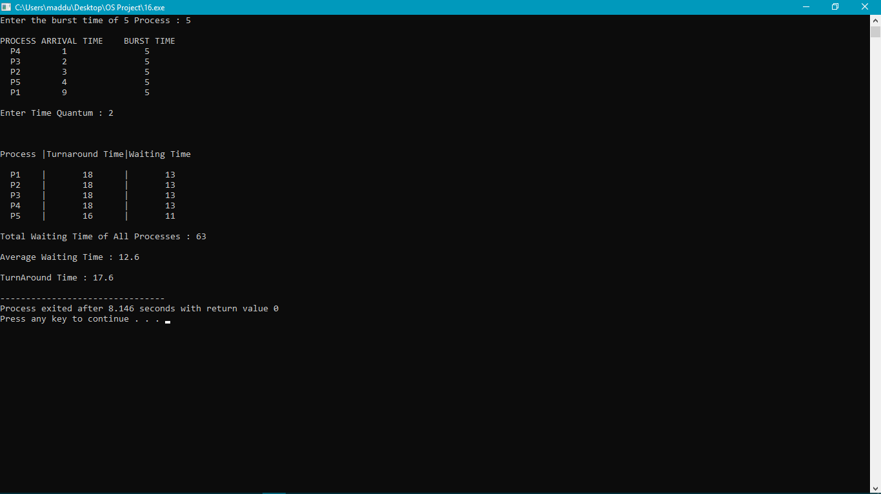

Complexity = O(nlogn)

Q.17

CODE
#include<bits/stdc++.h>
using namespace std;
struct Process{
int status;
int process;
int arrival_time,burst_time,waiting_time,turnaround_time;
};

//Sorting of Structure based on Burst Time in Descending Order
bool compareTwoProcesses(Process a,Process b){
return (a.burst_time > b.burst_time);
}

//Sorting the Structure based on Burst Time in Ascending Order
bool shortestJob(Process a,Process b){
return (a.burst_time < b.burst_time);
}

int main(){

int n,i;
cout<<"Enter the no.of processes : ";
cin>>n;
cout<<"\n";
Process p[n];
int completed_processes[n];
for(i=0;i<n;i++){
cout<<"Enter the arrival_time of "<<i+1<<" process : ";
cin>>p[i].arrival_time;
p[i].burst_time = p[i].arrival_time * 2;
p[i].status=0;
p[i].waiting_time=0;
p[i].turnaround_time=0;
p[i].process = i+1;
}

//Displaying the Entered Data
cout<<"\tProcess \t Arrival Time \t Burst Time\n";
for(i=0;i<n;i++){
cout<<"\t"<<p[i].process<<"\t\t "<<p[i].arrival_time<<"\t\t "<<p[i].burst_time<<"\n";
}

//Executing the min arrival time in the process

int minarr_loc=0,min_arrival_time=p[0].arrival_time,total_time=0;
for(i=0;i<n;i++){
if(min_arrival_time > p[i].arrival_time){
min_arrival_time = p[i].arrival_time;
minarr_loc=i;
}
}

cout<<"\nOrder of Execution based on highest Burst Time: ";
cout<<"\nP"<<p[minarr_loc].process<<" will be executed first \n";
p[minarr_loc].status=1;
total_time=total_time+p[minarr_loc].arrival_time+p[minarr_loc].burst_time;
p[minarr_loc].turnaround_time=total_time-p[minarr_loc].arrival_time;
p[minarr_loc].waiting_time=p[minarr_loc].turnaround_time-p[minarr_loc].burst_time;

//Used for Sorting of Structure
sort(p,p+n,compareTwoProcesses);

//Selecting the processes and calculating the TAT and WAT
i=0;
int count = 1;
while(count!=n){
if(p[i].status==0 && (p[i].arrival_time <= total_time)){
cout<<"\nP"<<p[i].process<<" will be executed next \n";
p[i].status=1;
total_time=total_time+p[i].burst_time;
p[i].turnaround_time=total_time-p[i].arrival_time;
p[i].waiting_time=p[i].turnaround_time-p[i].burst_time;
count++;
}
i=(i+1)%n;
}

//Calaculating Average Waiting Time and Average Turn Around Time
float waiting_time=0,turnaround_time=0;
for(i=0;i<n;i++){
waiting_time+=p[i].waiting_time;
turnaround_time+=p[i].turnaround_time;
}

cout<<"\n Average Waiting Time = "<<waiting_time/n;
cout<<"\n Average Turn Around Time = "<<turnaround_time/n;

//Execution based on Shortest Job First
for(i=0;i<n;i++){
p[i].status=0;
p[i].waiting_time=0;
p[i].turnaround_time=0;
}

//Executing the min arrival time in the process

total_time=0;
min_arrival_time=p[0].arrival_time;
minarr_loc=0;
for(i=0;i<n;i++){
if(min_arrival_time > p[i].arrival_time){
min_arrival_time = p[i].arrival_time;
minarr_loc=i;
}
}

cout<<"\n\nOrder of Execution based on Shortest Job First";
cout<<"\nP"<<p[minarr_loc].process<<" will be executed first \n";
p[minarr_loc].status=1;
total_time=total_time+p[minarr_loc].arrival_time+p[minarr_loc].burst_time;
p[minarr_loc].turnaround_time=total_time-p[minarr_loc].arrival_time;
p[minarr_loc].waiting_time=p[minarr_loc].turnaround_time-p[minarr_loc].burst_time;

//Used for Sorting of Structure
sort(p,p+n,shortestJob);

//Selecting the processes and calculating the TAT and WAT
i=0;
count = 1;
while(count!=n){
if(p[i].status==0 && (p[i].arrival_time <= total_time)){
cout<<"\nP"<<p[i].process<<" will be executed next \n";
p[i].status=1;
total_time=total_time+p[i].burst_time;
p[i].turnaround_time=total_time-p[i].arrival_time;
p[i].waiting_time=p[i].turnaround_time-p[i].burst_time;
count++;
}
i=(i+1)%n;
}

//Calaculating Average Waiting Time and Average Turn Around Time
waiting_time=0,turnaround_time=0;
for(i=0;i<n;i++){
waiting_time+=p[i].waiting_time;
turnaround_time+=p[i].turnaround_time;
}

cout<<"\n Average Waiting Time = "<<waiting_time/n;
cout<<"\n Average Turn Around Time = "<<turnaround_time/n;
}

QUESTIONS:

1.Description:

The problem is to schedule processes such that processes are executed based on their Burst Time i.e., Processes having highest Burst Time are executed first. This allows processes which requires more CPU time to be executed first but this may lead to starvation in many cases.

2.Algorithm:

- Taking input of number of Processes and also data about the Arrival Times and the burst time is double of that of Arrival Time.
- Storing the data in the structure and sorting the structure based on Burst Times of the Processes this makes the work of selecting the processes easy.
- After that processes are selected based on their Burst Times.
- A total time calculator calculates the completion time for each process and compares it with the Burst Times.
- Now the waiting time and turnaround time are calculated for each process and then displayed.
- After the calculation of waiting time for each process they are added and that gives the Total Waiting Time of all the processes and also Average Waiting Time and Average Turn Around Time.
- And after that the average waiting time of the processes are calculated based on Shortest Job First.

3.Purpose of Use:
This algorithm is mainly used in Operating Systems and applications that serve multiple client requests and requires the process with highest requirement of CPU are executed first.

4.Code Snippet:

Based on Highest Burst Time
a) Calculation of Average Waiting Time
b) Calculation of Average Turn Around Time

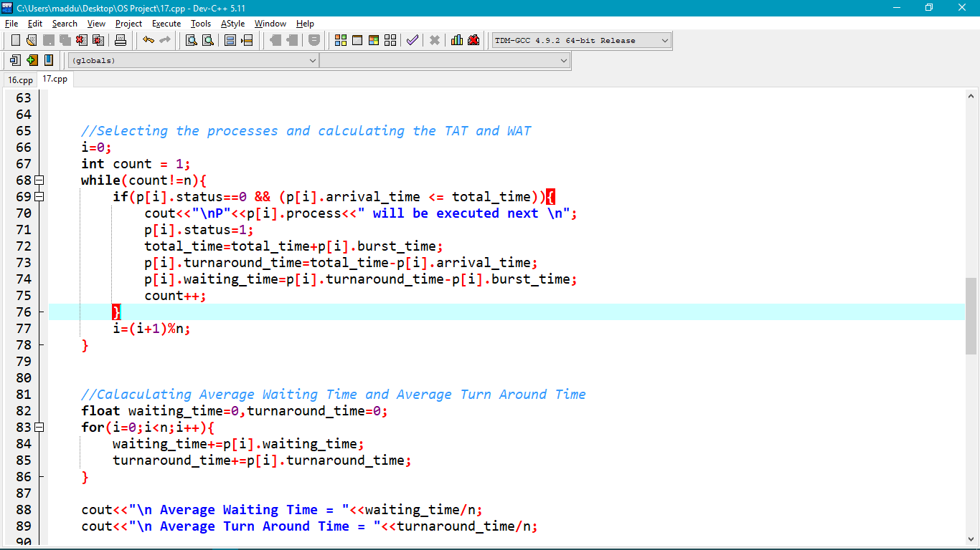

Based on Shortest Job First
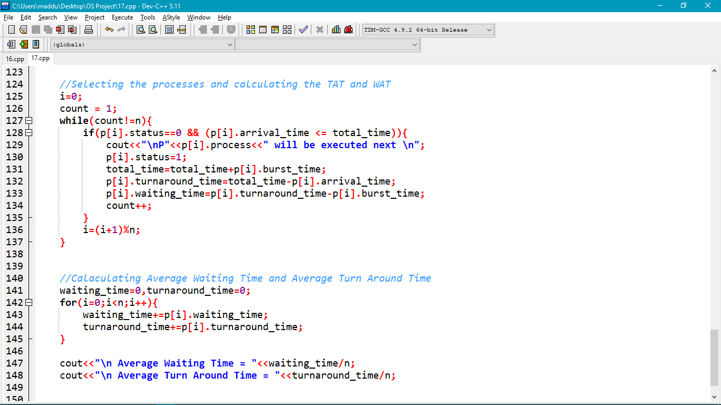

5.Test Cases:
Test Case 1
Process | Arrival Time | Burst Time
1 | 2 | 4
2 | 3 | 6
3 | 1 | 2
4 | 5 | 10

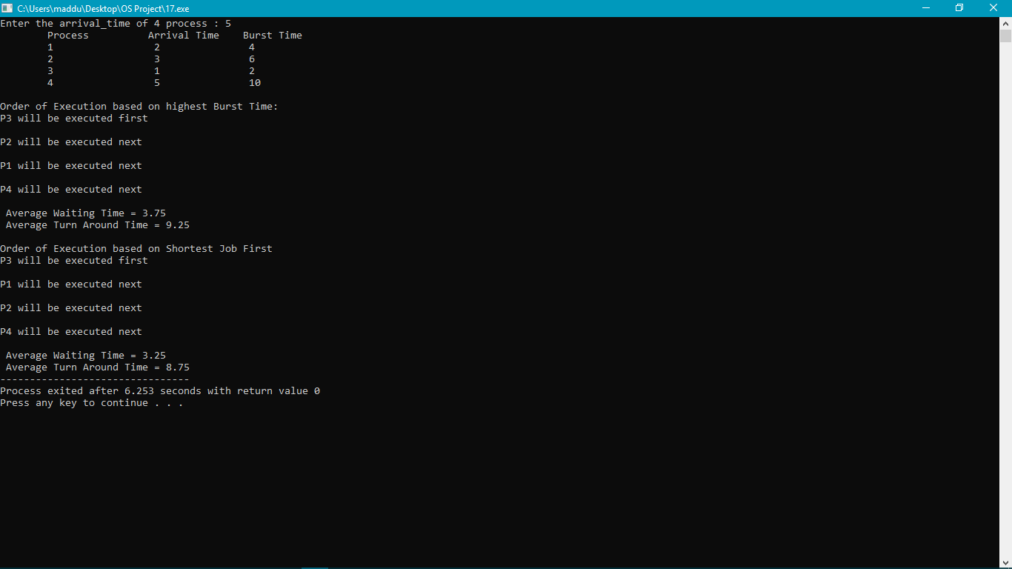

Test Case 2
Process | Arrival Time | Burst Time
1 | 2 | 4
2 | 8 | 16
3 | 6 | 12

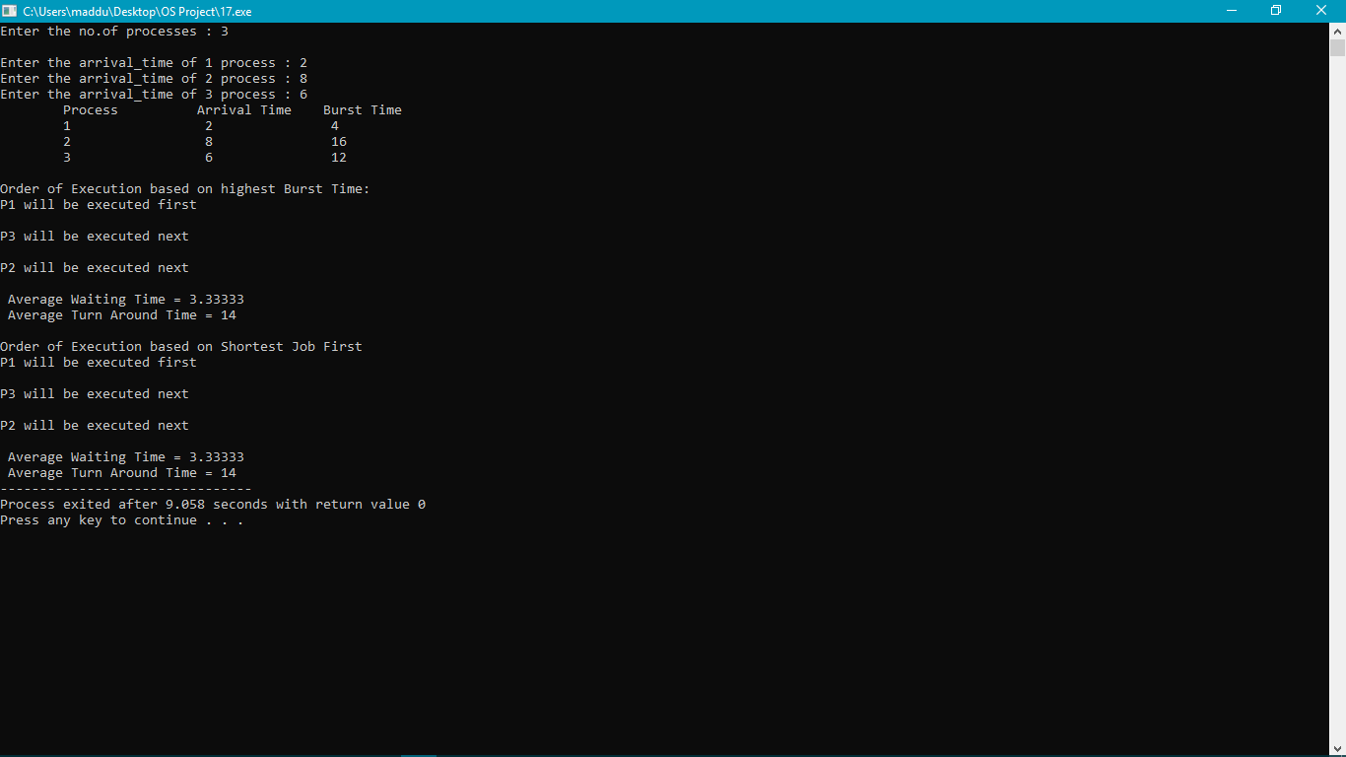

Test Case 3:
Process | Arrival Time | Burst Time
1 | 5 | 10
2 | 3 | 6
3 | 4 | 8
4 | 1 | 2
5 | 6 | 12

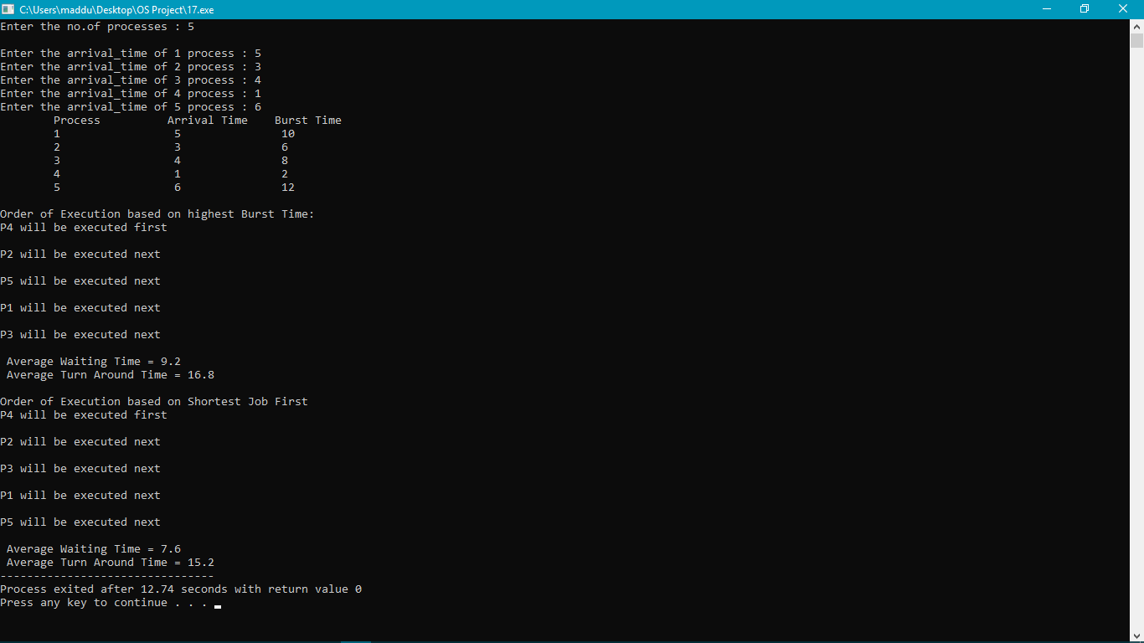

Complexity: O(nlogn)

