-- Q.1) what is the total revenue generated by male vs female customers?
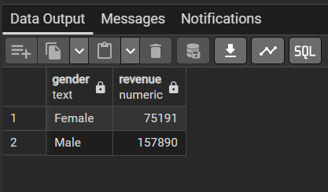
-- Q.2) which customers used a discount but still spent more than the average purchase amount?
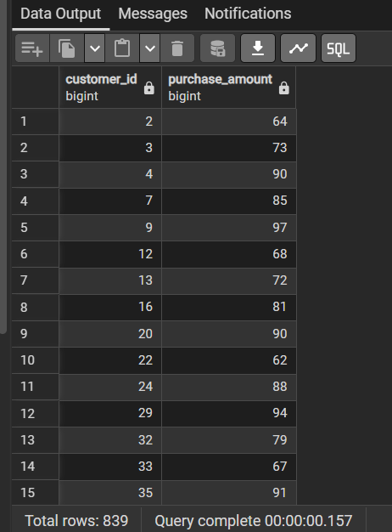

-- Q.3) Which are the top 5 product with the highest avg review rating?
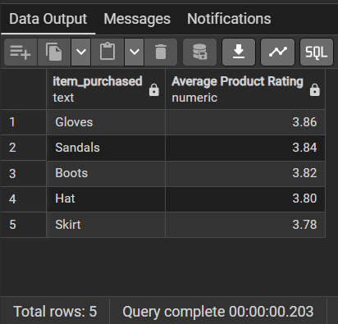
-- Q. 4) Compare the avg purchase amount btw. standard and express shipping?
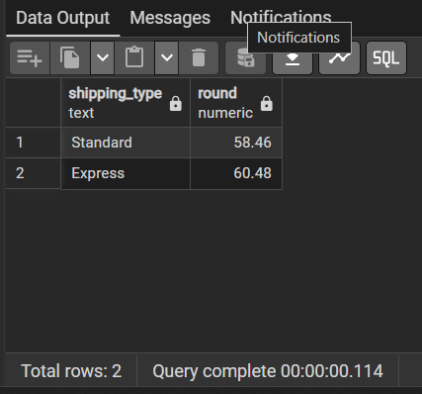

-- Q. 5) Do subscribed customer spend more? compare avg spend and total revenue btw. subscriber and non-subscriber?
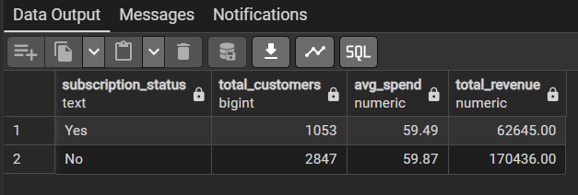

-- Q. 6) Which 5 products have the highest percentage of purchases with discounts applied?
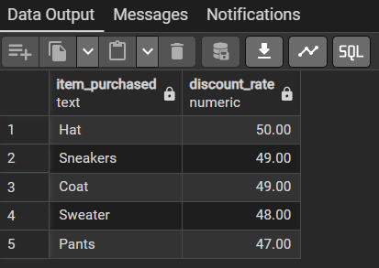

-- Q. 7) Segment customers into new, returning, and loyal based on their total no. of previous purchases, and show the count of each segment?
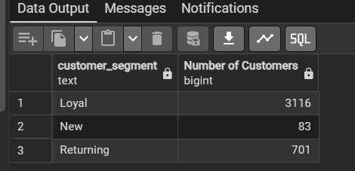
-- Q. 8) WHat are the top 3 most purchased products within each category?
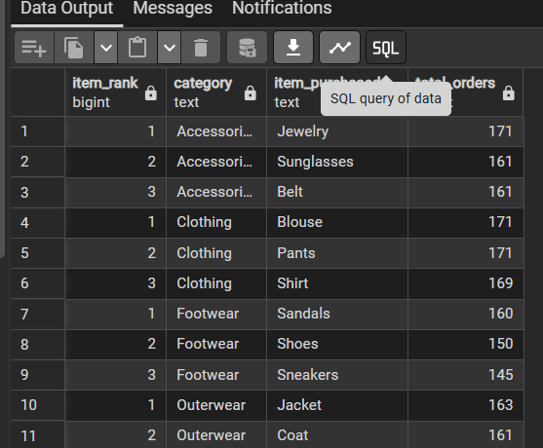

--Q. 9) Are customers who are repeat buyers (more than 5 previous purchases) also likely to subscribe?
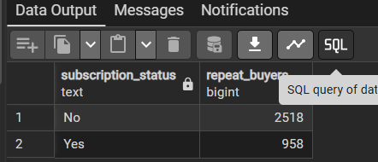
-- Q. 10) What is the revenue contribution og each age group?
