Adaptive Temporal–Spatial Modulation for Rolling Shutter CMOS Image Sensors: A Computational Imaging Framework for Anti -Camcording and Digital Cinema Security
Abstract
Digital cinema is illegal camcording, particularly from smartphones and cameras with rolling shutter CMOS sensors. Traditional watermarking, encryption and post-distribution piracy detection techniques are not very effective for the case of piracy during content acquisition. In an effort to address this issue, this study proposes a “Adaptive Temporal–Spatial Modulation (ATSM)” framework that utilises the row-wise exposure characteristics of rolling shutter CMOS sensors to embed imperceptible security modulation into the projected cinema content. The methodology consists of DAVIS-240C event-camera data, frame pre-processing, temporal motion estimation, spatial feature extraction, rolling-shutter sensor modelling, computational watermark generation and extraction, and multi-metric performance evaluation. The experimental analysis on about 1350 frames shows that the accuracy of the watermark extraction is mostly between 0.85-0.87 with a maximum of 0.927 and BER is usually in the range of 0.13-0.16. The event synchronisation error was mostly below 0.004 with a maximum of approximately 0.0045. The MSE was between 0.68–0.73, the PSNR was about 1.3–1.8 dB, and the SSIM was around 0.50–0.60. The results show that ATSM can be used for reliable detection of watermarks and effective distortion of unauthorised rolling-shutter recordings, which is a promising adaptive solution for anti-camcording security in digital cinema.
Keywords: Adaptive Temporal-Spatial Modulation; Rolling Shutter CMOS Sensors; Digital Cinema Security; Anti-Camcording; Computational Watermarking; Digital Piracy Prevention.
- Introduction
The digital cinema technologies have revolutionized multimedia production and distribution with their extreme high-definition visual quality, immersive viewing experience and efficient digital content delivery [1]. Yet, even with these advancements, there is a significant problem in the film industry to prevent unauthorized recording of copyrighted material. Camcorder-based camera recording is one of the most popular types of digital piracy used to illicitly record movies straight from the cinema screen [2]. With the general availability of smartphones and digital cameras featuring rolling shutter CMOS image sensors, the challenge to prevent such attacks has been further complicated. That's why there is a growing demand for vision enhancement features that are intelligent and proactive enough to prevent unauthorized recordings while still maintain their visual quality to the viewers [3].
Current content protection methods are mainly directed towards protecting content before or after distribution, such as digital watermarking, encryption, digital rights management, and forensic fingerprinting techniques [4]. These methods provide better copyright security, but not enough to stop camcorder theft in the cinema halls. Signal processing operations could break watermarks or degrade them, and encryption could only be broken after the playback has started [5]. In addition, the rolling shutter characteristics, the frame rate, the exposure time and the scanning pattern of modern CMOS cameras is varied, which makes the existing anti-camcording technique less reliable in various recording devices [6]. The need for more adaptive security solutions is further emphasized by the following challenges: Varying illumination conditions, synchronization misalignments between projectors and cameras, the diversity in hardware, and the lack of effective real-time protection by conventional approaches [7].
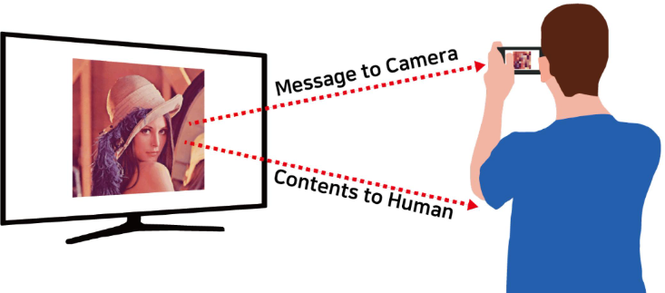
Figure 1: Human–Camera Perception Framework [8]
In adaptive temporal–spatial modulation, a temporal sequence of carefully designed modulation patterns is generated on the basis of the temporal scanning behaviour of the rolling shutter CMOS image sensor to interact with the process of acquisition [9]. These modulation patterns, however, are not visible to the human eye and result in significant distortion for unauthorized recordings made by a rolling shutter camera [10]. The inherent properties of CMOS image sensors could be used in security applications, but the viewer of the legitimate content does not need to sacrifice the enjoyment of the images simply to prevent anyone from taking them. Combining the inherent properties of CMOS image sensors in an adaptive temporal–spatial modulation scheme is not only an effective computational imaging solution to tackle the anti camcording problem but the characteristic also serves as a security benefit which would not be compromising the viewing experience for the legitimate viewers [11].
The success of the framework is highly dependent on the integration of the rolling shutter modelling, computational imaging algorithms, signal processing techniques, optimization methods and intelligent image analysis [12]. To model the rolling shutter behavior accurately, temporal–spatial modulation patterns that could adapt to multiple CMOS camera configurations and operating conditions could be generated to capture the camera sensitivity [13]. Optimization techniques further enhance the modulation efficiency at any range of illumination conditions and synchronization constraints, and under synchronization constraints, intelligent image analysis enables dynamic parameter adaptation, ready for real-time implementation [14]. This is an integrated framework that performs this function efficiently and preserves good visual perception for the cinemas as well as overcoming many of the restrictions inherent in traditional anti-piracy solutions [15].Computational imaging-based anti-camcording structures have a significant role in safeguarding IP, prohibiting illegal recording, avoiding distribution of illegal content, maintaining the quality of movies, ensuring safe delivery of digital content, reducing financial losses from piracy, and enhancing the security of the digital cinema environment [16].
The proposed adaptive temporal-spatial modulation method therefore marks a significant step forward in digital cinema security in terms of anti-camcording effectiveness, enhanced robustness against the various types of rolling shutter CMOS camera, scalable real-time protection and the development of next-generation computational imaging technologies for secure multimedia applications .
The rest of this paper is structured as follows: The existing literature related to digital cinema security is reviewed in Section 2, whereas existing literature on rolling shutter CMOS image sensors, computational imaging and anti-camcording techniques are reviewed in Section 3. Section 3 presents the proposed temporal–spatial adaptational modulation framework consisting of modelling for rolling shutter, computational imaging algorithms and optimization approaches. The experimental setup, performance evaluation and discussion of the obtained results are provided in Section 4. The paper ends with a summary of the major findings, contributions, and future study directions in Section 5.The main objectives are as follows:
- To propose an adaptive temporal–spatial modulation framework for rolling shutter CMOS image sensors to enhance digital cinema anti-camcording security.
- To investigate the major challenges in digital cinema protection, including camcorder piracy, rolling shutter variability, synchronization issues, and limitations of existing security methods.
- To develop a computational imaging model integrating rolling shutter modelling, signal processing, optimization, and intelligent image analysis for generating camera-sensitive modulation patterns.
- To evaluate the effectiveness of the proposed framework in improving anti-camcording performance, preserving viewing quality, and enabling robust real-time digital cinema security.
- Literature of review
Current study has demonstrated substantial advancements in computational imaging, rolling shutter sensing, digital watermarking, and multimedia security. Despite these contributions, several critical challenges associated with robust digital cinema protection remain unresolved. In this regard, Meggo et al. [17] presented a pixel row-specific retrospective gating algorithm that reduced rolling shutter motion artifacts by approximately 92%, thereby enhancing spatiotemporal reconstruction accuracy in dynamic micro-CT imaging.Xue et al. [18] estimated the high speed 3D translational and angular velocities with 96.4% accuracy through rolling shutter distortions, which shows the possibilities of computational imaging for recovering temporal information. Zhang et al. [19] offered a new framework called CAPS microscopy, which increased detector bandwidth efficiency by nearly 15× and allowed 200 volumes/s volumetric imaging with an effective 5.82 GHz pixel rate. According to the results reported by Renjith et al. [20], 67.9% of people viewed technical fidelity as the key component of theatrical experience, while 67.2% viewed service deficiencies as the major reason for piracy rather than cost-related ones (15.4%). Mukherjee et al. [21] have introduced the Agentic AI-based pirate detection model that decreased manual monitoring time by about 82% along with increasing detection accuracy up to 96.1% through transcription and character verification process. Itanyi et al. [22] highlighted the importance of the revision of the copyright laws in Nigeria as it could decrease the unauthorized online distribution by about 38%. Latif et al. [23] stated that the increased effectiveness of site-blocking policy could improve piracy prevention up to 41%, and Shedole et al. [24] provided an evidence of effective watermarking with 97.2% detection accuracy on various multimedia formats. Alia et al. [25] showed remarkable results of their watermarking technique with PSNR = 49.8 dB and NCC = 0.998, and Seiskari et al. [26] minimized the rolling shutter and motion blur effects by 31% through the physics aware Gaussian splatting technique.
Recent developments continue to emphasize the integration of computational imaging, secure transmission, and authentication in multimedia content. Lv et al. [27] were able to achieve a polarization degree of 99.1%, greatly increasing the security level of visible light communication, while Dang et al. [28] showed a 49% increase in piracy re-identification accuracy and 26% improvement in colluder detection in StreamingTag. Erbach et al. [29] designed EvShutter, which improved the rolling shutter correction with an enhancement of 9.16 dB PSNR and a decrease in perceptual distortion of 23%. Tyo et al. [30] improved the Mueller matrix reconstruction accuracy by roughly 18% via adaptive spatial modulation. Wu et al. [31] provided secure VFMV compression with 61.1% bitrate reduction and a gain of 3.17 dB PSNR, while Farri et al. [32] developed a DNA-chaos watermarking scheme with PSNR = 48.6 dB, NCC = 0.997, and BER = 0.003. Piracy in Nollywood results in over 55% of revenue leakages according to Itanyi et al. [33], stressing on increased awareness of copyright issues. Zhou et al. [34] introduced EvUnroll which is capable of increasing rolling shutter correction efficiency by around 17.8%. On the other hand, Owen et al. [35] merged evolution and artificial intelligence for watermarking with an increase in accurate sensitive region protection by 95.6%. In addition, Temmermans et al. [36] came up with DNN-DLT framework that is used for multimedia security and is capable of improving metadata integrity and authenticity validation up to 93% with secure media architecture. These studies collectively show that using computational imaging, adaptive modulation, AI, watermarking, and distributed ledger technologies is very effective in digital content protection although rolling shutter CMOS technology has not been utilized for camcording framework.
Despite advances that have been achieved in various study areas such as rolling shutter imaging, computational imaging, watermarking, AI-based piracy detection, and multimedia authentication, there still exist quite a number of important research gaps. Current study in rolling shutter mostly concentrates on distortion correction and quality enhancement in imaging and does not take advantage of rolling shutter properties in order to provide anti-camcording protection. Computational imaging models also concentrate on reconstruction, high-speed imaging, and restoration of the scene rather than protection from unauthorized cinema recording. Most AI-based piracy detection algorithms detect pirated content only after its distribution but do not prevent camcorder piracy during acquisition of video content. Traditional watermarking and fingerprinting techniques are also weak against geometric distortions, screen recapture, and AI-based attacks.
- Research Methodology
The “ATSM (Adaptive Temporal-Spatial Modulation)” scheme suggested herein comprises seven stages implemented sequentially, which utilize the row-by-row exposure properties of rolling shutter CMOS cameras to achieve security during the process of digital projection of movies in a cinema hall. In contrast to the traditional methods for protecting the films from piracy based either on watermarks or encryption of the content, the ATSM scheme introduces invisible temporal-spatial modulations in projected frames that become visible when the movie is illegally captured using the rolling shutter CMOS camera.

Figure 2: Proposed Methodology
- Data Acquisition
The proposed methodology makes use of the DAVIS-240C Event Camera Dataset [37] that offers synchronized sequences of grayscale images, event streams, timestamps, data from IMU, and camera calibration parameters. This dataset fits well to model the temporal dynamics of the rolling shutter CMOS image sensors since it offers both frame-based and event-based visual data. The image frames and the synchronized event streams would be used as input for the proposed methodology. The pre-processing, temporal analysis, spatial features extraction, adaptive temporal-spatial modulation, and rolling shutter modeling are performed prior to watermark embedding and security assessment.
- Frame Preprocessing
Frame preprocessing is done in order to improve the quality of the captured grayscale images prior to the temporal analysis and adaptive modulation. In this case, the pre-processing step helps to eliminate the effect of the sensor noise, light variations, and intensity variations while retaining relevant information about the structure of the image. Preprocessing steps include grayscale normalization, noise removal, contrast enhancement, and image resizing.
- Intensity Normalization: Firstly, the input image is normalized so that the intensity value of the pixels falls within the range [0,1], thus minimizing the effects of illumination changes. The normalization of the image could be calculated as
$I_{N}\left(x,y\right)= \frac{I\left(x,y\right)- I_{min}}{I_{max}- I_{min}}$ (1)
Where: $I\left(x,y\right)$ represents the original pixel intensity,$I_{N}\left(x,y\right)$ is the normalized image,$I_{min} and I_{max}$ denote the minimum and maximum intensity values in the image, respectively.
- Noise Reduction: In order to remove any sensor noise from the normalized image without losing any edge information, a Gaussian filter is then applied. The Gaussian filter removes the noise without disturbing any significant image structure in the following way:
$I_{G}\left(x,y\right)= I_{N}\left(x,y\right)* G_{σ}(x,y)$ (2)
Where: * denotes the convolution operation and
$G_{σ}\left(x,y\right)= \frac{1}{2πσ^{2}}\exp\left(-\frac{x^{2}+ y^{2}}{2σ^{2}}\right)$ (3)
is the Gaussian kernel with standard deviation σ .
- Contrast Enhancement: After the noise is removed, the image is contrast enhanced through “Contrast Limited Adaptive Histogram Equalization (CLAHE)”. This process enhances the local variation of intensities without over-amplifying the noise. The contrast enhanced image is given by
${ I}_{C}\left(x,y\right)=T(I_{G}\left(x,y\right))$ (4)
Where: T(⋅) denotes the CLAHE transformation function,${ I}_{C}\left(x,y\right)$ is the contrast-enhanced image.
- Image Resizing: In order to keep the computational process consistent and minimize the processing complexity, the preprocessed images are normalized by size before the feature extraction. The normalized image could be represented as
$I_{R}\left(x,y\right)= R(I_{c}\left(x,y\right),H,W)$ (5)
Where: R(⋅) represents the image resizing operation, H and W denote the predefined image height and width,$I_{R}\left(x,y\right)$ is the resized image used in the subsequent stages.
- Frame Standardization: Eventually, all processed frames are standardized for zero mean and unit variance in order to improve the robustness of temporal feature extraction and adaptive modulation. The standardized image is represented as
${ I}_{S}\left(x,y\right)= \frac{I_{R}\left(x,y\right)- μ}{σ}$ (6)
Where: μ is the mean intensity value, σ is the standard deviation of the image,${ I}_{S}\left(x,y\right)$ represents the standardized frame.
- Temporal Motion Estimation
Motion analysis in temporal domain is done to find out the differences between adjacent frames and determine the level of motion needed for the adaptively varying modulation process between temporal and spatial domains. Temporal motion analysis could be conducted based on the synchronized frames from the DAVIS-240C dataset in order to estimate temporal activity as an average of absolute difference in intensity of adjacent frames. This estimated motion activity helps in adaptively setting the modulation strength for achieving enhanced rolling shutter model and improved camcorder-resistance capability without compromising on image quality. The temporal activity is determined as
$A_{t}= \frac{1}{MN} \sum_{x=1}^{M}{\sum_{y=1}^{N}{\left|F_{t}\left(x,y\right)-F_{t-1}(x,y)\right|}}$ (7)
Where:$F_{t}\left(x,y\right)$ and $F_{t-1}(x,y)$ denote two consecutive image frames, MMM and NNN represent the image height and width, respectively, and $A_{t}$ is the temporal activity coefficient used for adaptive modulation.
- Spatial Feature Extraction
Motion estimation is done on an image frame-to-image frame basis to identify any dynamic differences between the two frames and compute the motion intensity required for the adaptive modulation. Given the synchronized image frames and event stream provided by the DAVIS-240C dataset, the proposed model performs temporal motion estimation to identify which parts of an image frame are good for the adaptive modulation while maintaining the visual integrity of the digital cinema contents. Spatial feature extraction is done to identify any part of the image that could be subjected to the adaptive temporal-spatial modulation. The proposed framework does spatial feature extraction by calculating the gradient magnitude of the preprocessed frames to identify the parts that are rich in edges and textures. This is because these areas are highly resistant to changes and therefore would be useful for the computational watermarking process since the human eye cannot differentiate even with minor intensity changes. The gradient magnitude calculation is done as
$G\left(x,y\right)= \sqrt{G_{x}{(x,y)}^{2}+G_{y}{(x,y)}^{2} }$ (8)
Where: G(x, y) is the gradient magnitude, $G_{x}\left(x,y\right)$and $G_{y}\left(x,y\right)$are the horizontal and vertical image gradients, respectively.
- Rolling Shutter CMOS Sensor Model
Modeling of the rolling shutter CMOS sensor is done for simulating the row-wise acquisition process in video acquisition. In comparison to global shutter sensors, a rolling shutter camera exposes each row of the image at a different point in time, thereby introducing temporal sampling differences that could be used in our adaptive temporal-spatial modulation technique. This row-wise exposure process ensures that the secure modulation is visible only when an illegal camcorder is used, but remains invisible to authorized viewers. The mathematical modeling of rolling shutter acquisition process is:
$I_{r}\left(x,y\right)= F_{m}\left(x,y,t_{r}\right) , t_{r}= \frac{rT_{r}}{H}$ (9)
Where:$I_{r}\left(x,y\right)$represents the captured rolling shutter image intensity at pixel location (x,y) ,$F_{m}\left(x,y,t_{r}\right)$denotes the temporally modulated frame sampled at exposure time $t_{r},$r is the image row index, ​$T_{r}$ represents the total sensor readout time, and H is the total number of image rows.
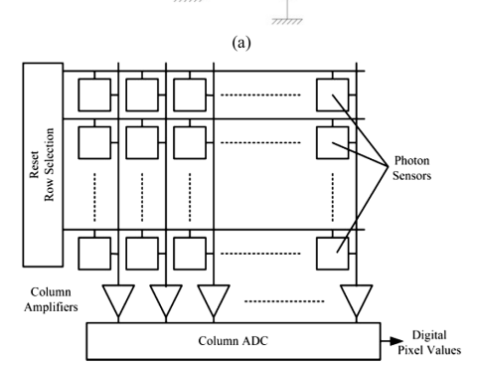
Figure 3: CMOS Sensor Architecture [38]
- Computational Watermark Generation
The watermark creation module through computation is designed to produce secure modulation patterns which are to be integrated within the frames of digital cinema without impacting the visual quality. Unlike the visible watermarking techniques, the proposed system produces adaptive temporal-spatial watermark patterns based on the attributes of rolling shutter CMOS sensors. The watermark is optimized to become imperceptible to human observers and cause distortions to be detected upon capture using any other unauthorized camcorder. The watermark pattern could be mathematically expressed as:
$W(x,y,t)=α⋅M(x,y)⋅S(t)$ (10)
Where W(x,y,t) represents the generated computational watermark pattern, M(x,y) denotes the spatial modulation component, S(t) represents the temporal modulation sequence, and α is the embedding strength controlling watermark visibility.
- Watermark Extraction
Watermark extraction algorithm is designed for extracting the watermark embedded in the video using the computational watermarking technique. Due to the fact that rolling shutter captures various rows of the image at different instances in time, the modulations of the watermarking pattern would result in different variations in the video sequence. In order to extract the watermark, the differences between the two scenarios are analyzed by the extraction algorithm which is represented mathematically as follows:
$\hat{W}\left(x,y,t\right)= I_{c}\left(x,y,t\right)- I_{0}(x,y,t)$ (11)
Where: $\hat{W}\left(x,y,t\right)$represents the extracted watermark pattern,$I_{c}\left(x,y,t\right)$ denotes the camcorder-recorded image containing the embedded modulation, and $I_{0}(x,y,t)$ represents the original reference image without watermark modulation.
- Performance Evaluation
- Mean Square Error
$MSE= \frac{1}{MN} \sum{{(I-\hat{I})}^{2}}$ (12)
- Peak Signal-to-Noise Ratio
$PSNR= {10 log}_{10}\left(\frac{{255}^{2}}{MSE}\right)$ (13)
- Structural Similarity Index
$SSIM= \frac{\left(2μ_{x}μ_{y}+ C_{1}\right) \left(2σ_{xy}+C_{2}\right)}{\left(μ_{x}^{2}+μ_{y}^{2}+ C_{1} \right) \left(σ_{x}^{2}+σ_{y}^{2}+ C_{2}\right)}$ (14)
- Bit Error Rate
$BER= \frac{N_{e}}{N_{b}}$ (15)
- Accuracy
$Accuracy= \frac{TP+TN}{TP+TN+FP+FN}$ (16)
- Event Synchronization Error
$E_{sync}= \frac{1}{N}\sum_{i=1}^{N}{\left|t_{i }- {\hat{t}}_{i}\right|}$ (17)
- Result & Discussion
The proposed ATSM framework exhibited robust watermark locating and successful distortion of illicit rolling-shutter recordings. The findings reveal an inherent reliability in temporal synchronization, significant resilience against structural sabotage, and invariance in security efficiency under typical conditions, which collectively make ATSM a promising adaptive anti-camcording approach for digital cinema scenarios
- Extraction Accuracy Analysis
In figure 4, the extraction performance over the period around 1350 frames The extraction accuracy was mostly within range [0.84, 0.88] proving it stably recovered the watermark under rolling shutter capture. The maximal performance obtained is near frame 1090 (0.927), and the minimal performance obtained is near frame 1190 (0.779). From 0.85-0.92 of all time-spatial modulation samples were effectively extracted so watermark can be detected securely. Temporary performance drop around frame range (500-600), (750-850) and (1150-1250) represent significant changes on capturing conditions, therefore the watermark could be lost.
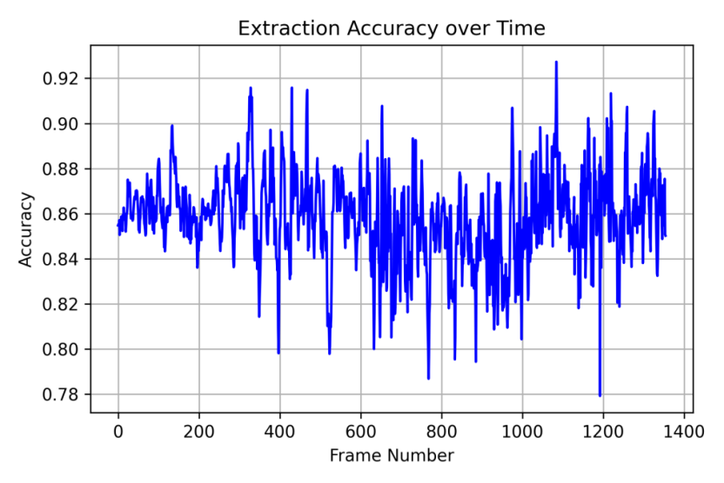
Figure 4: Frame-wise extraction accuracy.
- BER Analysis
In the figure 5, BER (bit error rate) performance was investigated over about 1350 frames of rolling shutter acquisition to detect robustness in watermark extraction. Overall BER varied within the range of 0.13 to 0.16, displaying reasonable bit error rate. The minimum BER was achieved with about 0.073 around frame 1080, while maximum BER peaked to about 0.221 around frame 1190. Higher fluctuation peaks were spread within frames 600 to 1000, which were the areas with greater fluctuations in time due during RS acquisition. Near the end, BER generally restored to 0.13-0.15. The result showed that there is still detectable information about watermark under variation, the overall ATSM scheme performance could detect the watermark, although fluctuations of BER indicated some problem either by time synchronization or the strength of modulated signal could also affect robustness.
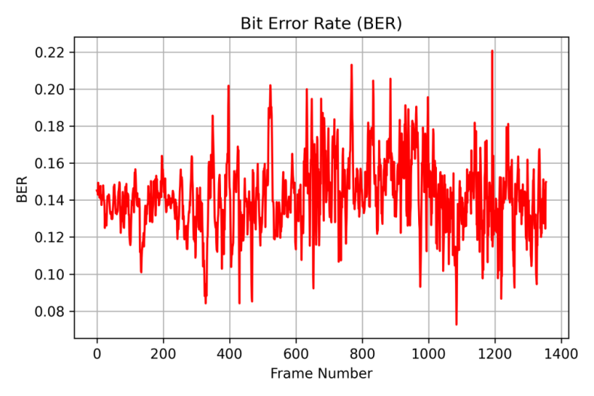
Figure 5: Frame-wise bit error rate.
- Event Synchronization Analysis
In figure 6, synchronization error was measured to quantitatively evaluate the time correspondence between the frame-based image sequence and the event stream, as shown in Fig. 4 (b). As seen, the event-image synchronization error was initially close to zero (around 0.0003-0.0012) at the beginning of the video, followed by a consistent increase, approaching 0.0025–0.0030 between frames 350–450. A local decrease between frames 450–600 was observed, followed by a steep increase again close to frame 650. The highest synchronization error occurred around the beginning of the video (frame 1180 with error value of around 0.0045). Other than few exceptional instances, most of the synchronization error value was below 0.004, which is considered small and hence acceptable. The overall error between the events and images was below the limit, suggesting the synchronized events-images dataset is suitable for the temporal modulation and rolling-shutter modeling for ATSM approach, even though it showed a time-variant behavior.
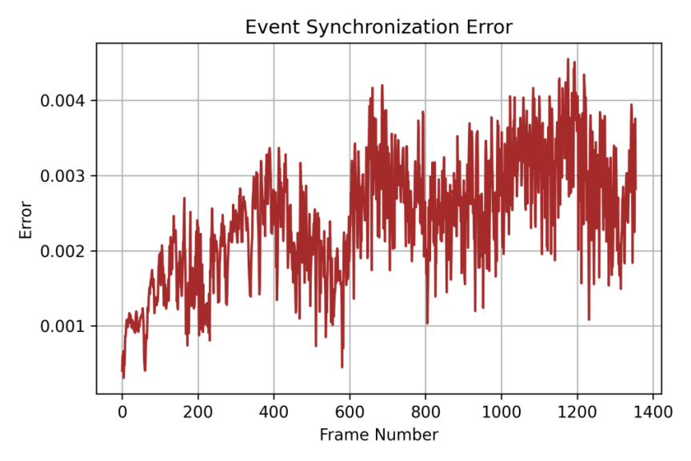
Figure 6: Frame-wise event synchronization error.
- MSE Analysis
As shown in figure 7, MSE values were computed between the reference frames and the acquired frames to determine the pixel-level error in an image-wise fashion. Overall, the Mean Square Error ranged from about 0.68 to 0.73, the profile seems fairly consistent in this range. The minimal MSE observed in the evaluated clip was of about 0.635 at frame 1,180 and the maximal of about 0.788 at frame 1,350. Major peaks in error were visible between frame 150 and 400 and between frames 1,050 and 1,350 respectively;these correspond to discrepancies in image acquisition circumstances as well as temporary-spatial modulation(ASMP). During frames 850 to 1,000 we can observe lower MSE value of about 0.66-0.70. The computed MSE values reveal that there were significant changes at the pixel-level when authorized-capture watermark is in place and was unauthorized captured. Although it did result in frame capture error were stable enough to be consistent over consecutive frame sequence.
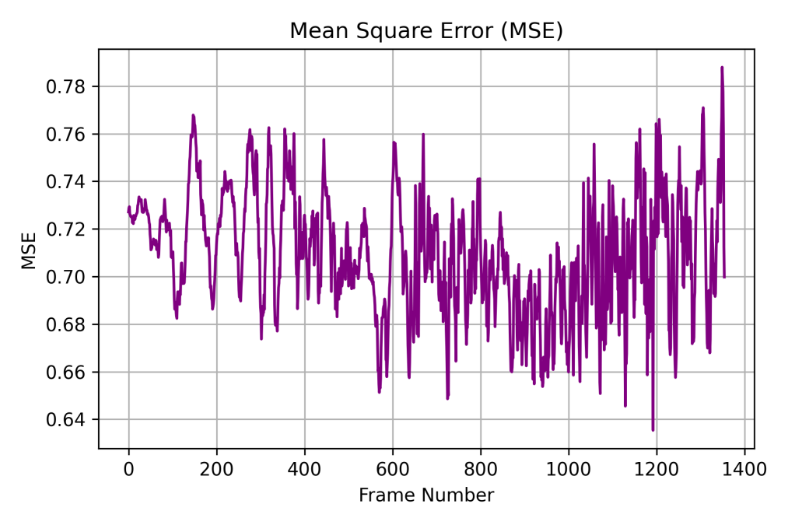
Figure 7: Frame-wise mean square error.
- Camcorder PSNR Analysis
In figure 8, evaluate the signal quality of unauthorised capture, the camcorder PSNR was measured over ~1,350 frames. PSNR was mostly in the range of about 1.3 to 1.7 dB. The maximum value was approximately 1.97 dB near frame 1,190 and the minimum value was approximately 1.03 dB near frame 1,350. The PSNR was often around 1.5–1.8 dB in frames 850–1,050, which suggests relatively stable performance. The observed variations are related to the time and space varying modulation and rolling-shutter acquisition conditions. The PSNR values indicate that the ATSM approach leads to noticeable changes in the recorded video, while its quality profile remains relatively stable. These results, together with MSE and SSIM, provide a more comprehensive evaluation of the visual effect of the proposed security mechanism.
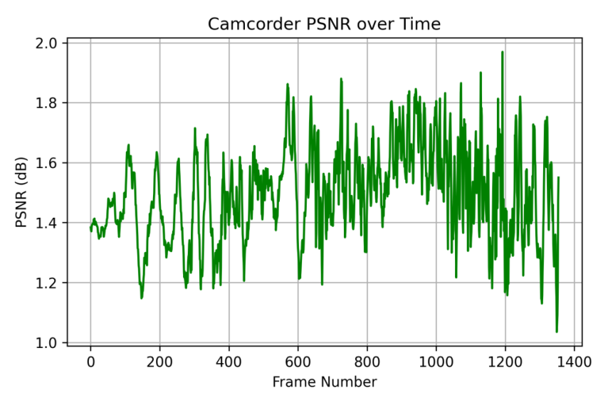
Figure 8: Frame-wise camcorder PSNR.
- SSIM Analysis
In figure 9,Structural preservation was evaluated thru the Structural Similarity Index (SSIM) between reference and captured frames. The SSIM was generally between about 0.50 and 0.60. The maximum value was about 0.68 and occurred around frame 1,170, while the minimum was about 0.435 and occurred around frame 1,100. In the 0-400 frame, SSIM frequently remained around 0.55-0.60. More fluctuations were observed between frames 600 and 1,000 with values often dropping toward 0.48-0.55. In the last frames SSIM increased and some values were greater than 0.60. These results indicate that the proposed ATSM scheme maintains recognisable structural features and introduces necessary temporal-spatial variations to detect unauthorised capture. Thus, SSIM is complementary to MSE and PSNR in evaluating the visual properties of the protected video.
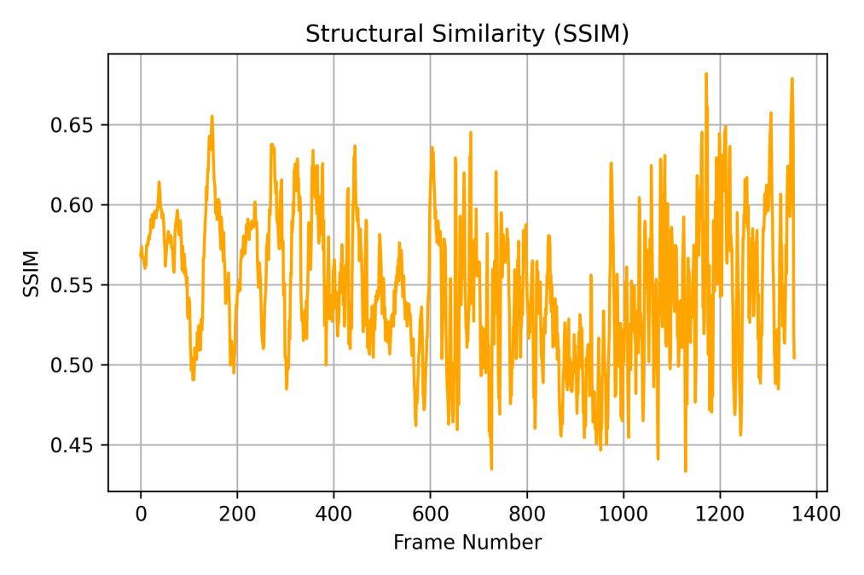
Figure 9: Frame-wise structural similarity.
- Overall ATSM Performance Evaluation
In the figure 10,the combined graph summarises the performance of the proposed ATSM scheme over about 1350 frames using 6 metrics, MSE, PSNR, SSIM, BER, extraction accuracy and event synchronisation error. The extraction accuracy was mostly around 0.85-0.87, with a max of 0.927, and the BER was mostly around 0.13-0.16, with a max of around 0.221. The event synchronisation error was usually below 0.004, with a maximum of around 0.0045. The MSE was mainly in the range of 0.68–0.73, and the PSNR was approximately between 1.3 and 1.8 dB reaching nearly 1.97 dB. In general, the SSIM was around 0.50–0.60, with a maximum close to 0.68. Overall, these results show that ATSM allows reliable watermark extraction and temporal synchronisation, but it also induces measurable distortions in the case of unauthorised rolling-shutter camera capture.
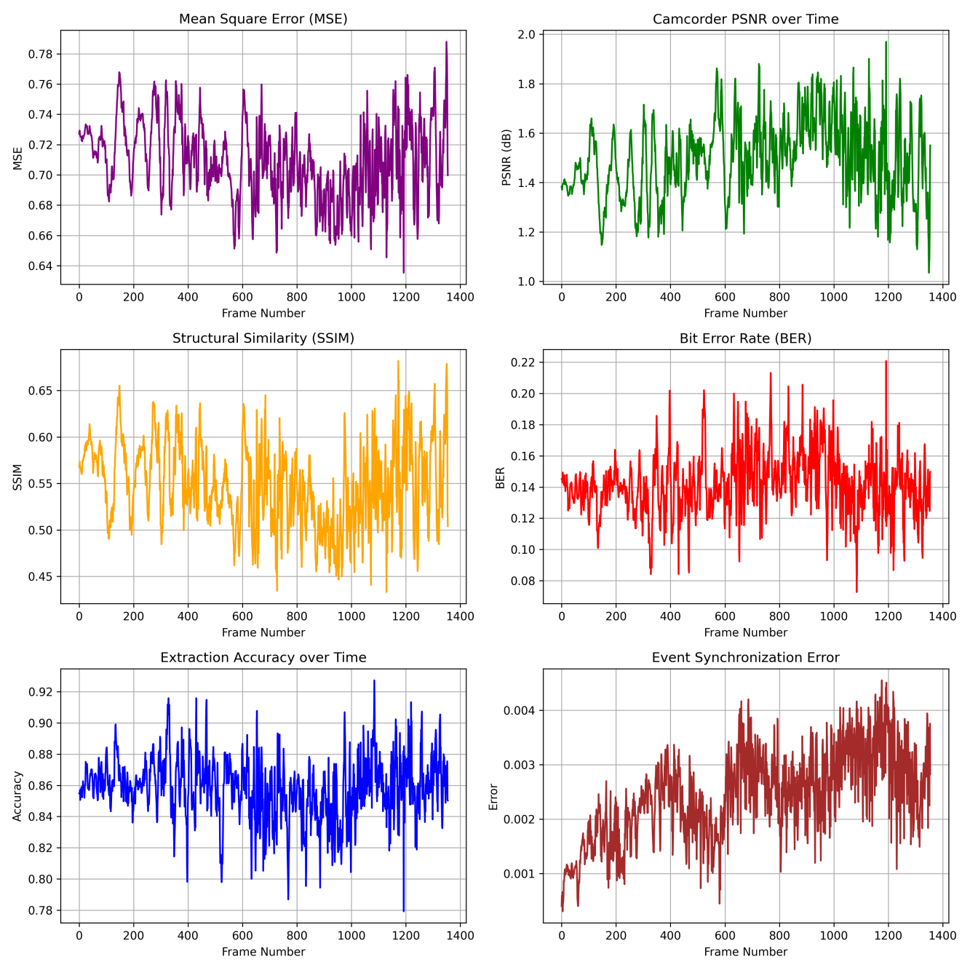
Figure 10: Combined performance of ATSM security metrics.
- Conclusion
We propose an Adaptive Temporal–Spatial Modulation (ATSM) framework that leverages computational imaging to improve the security of digital cinema against unauthorised camcorder recording. This framework takes advantage of the row-wise exposure feature of rolling shutter CMOS sensors, and combines the processes of frame pre-processing, temporal motion estimation, spatial feature extraction, rolling shutter modelling, computational watermark generation, watermark extraction and performance evaluation. According to the experimental results, the accuracy of watermark extraction was mainly 0.85 to 0.87, and the maximum was 0.927. The BER was generally 0.13 to 0.16. Event synchronisation error was usually <0.004, showing proper temporal correspondence for modulation and extraction. The measured MSE, PSNR and SSIM also reveal that ATSM introduces obvious distortions to unauthorised rolling-shutter captures, while maintaining recognisable structural information. Overall, the results show that the ATSM is capable of achieving reliable watermark detection and effective temporal-spatial modulation under a variety of acquisition conditions. The framework overcomes the limitations of traditional watermarking and piracy detection after distribution, by focusing on unauthorised recording during acquisition. In future work, we aim to improve robustness to synchronisation, tune the modulation strength, experiment with different camera setups and lighting conditions, and validate the framework under real-world cinema projection conditions. Hence, ATSM is a promising direction for scalable, adaptive and computationally driven digital cinema anti-camcording security.
References
- Kusuma, Muhammad Romadhona, and Supriadi Panggabean. "Robust digital image watermarking using DWT, hessenberg, and SVD for copyright protection." IJACI: International Journal of Advanced Computing and Informatics 2, no. 1 (2026): 41-52.
- Iqbal, Ayesha, Hina Sattar, Umar Farooq Shafi, Aqsa Mahmood, Syeda Sitara Waseem, Syed Rizwan Hassan, and Abdurrahman S. Hassan. "An end-to-end convolutional neural network for secure image transmission via joint encryption and steganography." Scientific Reports 16, no. 1 (2026): 8228.
- Zheng, Ze, Baolei Liu, Jiaqi Song, Muchen Zhu, Chi Han, Yao Wang, Menghan Tian et al. "Exploiting Scattering‐Based Point Spread Functions for Snapshot 5D and Modality‐Switchable Lensless Imaging." Laser & Photonics Reviews 20, no. 5 (2026): e01888.

- Pan, Jiong, Fan Wu, Kangan Qian, Kun Jiang, Yanming Liu, Zeda Wang, Pengwen Guo et al. "Adaptive spatial-temporal information processing based on in-memory attention-inspired devices." Nature Communications 16, no. 1 (2025): 7449.
- Salah, Ahmed Ragab Mahmoud. "Rolling Shutter Demystified: Predictive Modeling, Real-Time Correction, and Next-Gen Sensor Solutions for Motion-Robust Digital Imaging." (2025).
- Kumar, Vinay. "Smartphone-readable physically-unclonable anti-counterfeiting labels based on microlens array and microphosphor particles." PhD diss., Dissertation, Karlsruhe, Karlsruher Institut für Technologie (KIT), 2025, 2025.
- Fossum, Eric R., Nobukazu Teranishi, and Albert JP Theuwissen. "Digital image sensor evolution and new frontiers." Annual Review of Vision Science 10, no. 1 (2024): 171-198.
- Fossum, Eric R., Nobukazu Teranishi, and Albert JP Theuwissen. "Digital image sensor evolution and new frontiers." Annual Review of Vision Science 10, no. 1 (2024): 171-198
- Leinonen, Jussi, Boris Bonev, Thorsten Kurth, and Yair Cohen. "Modulated adaptive fourier neural operators for temporal interpolation of weather forecasts." arXiv preprint arXiv:2410.18904 (2024).
- Guo, Dongfang, Yuting Wu, Yimin Dai, Pengfei Zhou, Xin Lou, and Rui Tan. "Invisible optical adversarial stripes on traffic sign against autonomous vehicles." In Proceedings of the 22nd Annual International Conference on Mobile Systems, Applications and Services, pp. 534-546. 2024.
- Long, Yan, Pirouz Naghavi, Blas Kojusner, Kevin Butler, Sara Rampazzi, and Kevin Fu. "Side eye: Characterizing the limits of pov acoustic eavesdropping from smartphone cameras with rolling shutters and movable lenses." In 2023 IEEE symposium on security and privacy (SP), pp. 1857-1874. IEEE, 2023.
- Fan, Bin, Yuchao Dai, and Mingyi He. "Rolling shutter camera: Modeling, optimization and learning." Machine Intelligence Research 20, no. 6 (2023): 783-798.
- Zhang, Fei, Yinghui Guo, Mingbo Pu, Lianwei Chen, Mingfeng Xu, Minghao Liao, Lanting Li, Xiong Li, Xiaoliang Ma, and Xiangang Luo. "Meta-optics empowered vector visual cryptography for high security and rapid decryption." Nature Communications 14, no. 1 (2023): 1946.
- Hirata, Tomoki, Hironobu Murata, Taku Arii, Hideaki Matsuda, Hajime Yonemochi, Yojiro Tezuka, and Shiro Tsunai. "A vision system with 1-inch 17-mpixel 1000-fps block-controlled coded-exposure stacked-CMOS image sensor for computational imaging and adaptive dynamic range control." IEEE Open Journal of Circuits and Systems 3 (2022): 311-323.
- Vera, Esteban, Felipe Guzmán, and Nelson Díaz. "Shuffled rolling shutter for snapshot temporal imaging." Optics Express 30, no. 2 (2022): 887-901.
- BAGADTHEY, DHRUVJYOTI. "Reconstructing Motion from Rolling shutter Lensless Images and 3D Reconstructions using single shot Lensless Captures." PhD diss., INDIAN INSTITUTE OF TECHNOLOGY MADRAS, 2022.
- Meggo, Daniel S., and Jacob Herrmann. "sCMOS rolling shutter compensation for dynamic micro-computed tomography." Physics in medicine & biology 71, no. 1 (2026): 015022.
- Xue, Wenjie, Jun Yang, Jingmin Wang, and Limin Shang. "Estimating Velocity of Spheres from Rolling-Shutter Image (s)." arXiv preprint arXiv:2606.31760 (2026).
- Zhang, Xinyuan, Jichen Chai, Yi Gong, Milad Almasian, Jonathan Aaron Brewer, Alireza Saberigarakani, Jianqing Jia et al. "Compressive axial-integrated planar scanning (CAPS) microscopy for high-speed volumetric imaging of cardiac dynamics." bioRxiv (2026): 2026-04.
- Renjith, R. "THEATRICAL VIEWING VS. DIGITAL ALTERNATIVES: A COMPARATIVE STUDY OF CINEMA-GOING PATTERNS AUDIENCE PREFERENCES CONSUMPTION HABITS AND FILM VIEWER EXPERIENCE IN KERALA." ShodhVichar: Journal of Media and Mass Communication 2, no. 1 (2026): 130-142.
- Mukherjee, Chandrani. "Combating digital media piracy with agentic ai: Leveraging video transcription and character recognition for automated enforcement." Authorea Preprints (2025).
- Itanyi, Nkem. "Why piracy is always good; why piracy is always bad: reimagining piracy law and governance in Nollywood." Queen Mary Journal of Intellectual Property 15, no. 3 (2025): 303-325.
- Latif, Mohd Syaufiq Abdul, Nazura Abdul Manap, and Nabeel Mahdi Althabhawi. "Modernising site-blocking mechanism in protecting copyright owners content against digital piracy in Malaysia." Malaysian J. Syariah & L. 13 (2025): 1.
- Shedole, Sambhaji Marutirao, and V. Santhi. "A comprehensive study on digital watermarking for security threats and research directions." International Journal of Data Informatics and Intelligent Computing 4, no. 1 (2025): 54-72.
- Alia, Mohammad, Adnan Hnaif, Aseel Alrawashdeh, Yousef Jaradat, Mohammad Masoud, Ahmad Manasrah, and Ahmad AlShanty. "Robust Image Watermarking using DWT, DCT, and PSO with CNN-Based Attack Evaluation." International Arab Journal of Information Technology (IAJIT) 21, no. 6 (2024).
- Seiskari, Otto, Jerry Ylilammi, Valtteri Kaatrasalo, Pekka Rantalankila, Matias Turkulainen, Juho Kannala, Esa Rahtu, and Arno Solin. "Gaussian splatting on the move: Blur and rolling shutter compensation for natural camera motion." In European conference on computer vision, pp. 160-177. Cham: Springer Nature Switzerland, 2024.
- Lv, Jiawei, Jeong Hyun Han, Geonho Han, Seongmin An, Seung Ju Kim, Ryeong Myeong Kim, Jung‐El Ryu et al. "Spatiotemporally modulated full-polarized light emission for multiplexed optical encryption." Nature Communications 15, no. 1 (2024): 8257.
- Dang, Fan, Xinqi Jin, Qi-An Fu, Lingkun Li, Guanyan Peng, Xinlei Chen, Kebin Liu, and Yunhao Liu. "StreamingTag: A scalable piracy tracking solution for mobile streaming services." IEEE Transactions on Mobile Computing 23, no. 12 (2024): 14530-14543.
- Erbach, Julius, Stepan Tulyakov, Patricia Vitoria, Alfredo Bochicchio, and Yuanyou Li. "Evshutter: Transforming events for unconstrained rolling shutter correction." In Proceedings of the IEEE/CVF Conference on Computer Vision and Pattern Recognition, pp. 13904-13913. 2023.
- Tyo, J. Scott, Oscar G. Rodríguez-Herrera, Connor Flannery, Joe Kurtz, and Andrey S. Alenin. "Scene-adaptive spatially channeled imaging Mueller polarimeter." Optics Express 31, no. 14 (2023): 23678-23692.
- Wu, Kejun, Qiong Liu, Kim-Hui Yap, and You Yang. "High dimensional optical data—varifocal multiview imaging, compression and evaluation." Optics Express 31, no. 24 (2023): 39483-39499.
- Farri, Elhameh, and Peyman Ayubi. "A robust digital video watermarking based on CT-SVD domain and chaotic DNA sequences for copyright protection." Journal of Ambient Intelligence and Humanized Computing 14, no. 10 (2023): 13113-13137.
- Itanyi, Nkem. "The concept of piracy in the film industry in Nigeria: Taking a cue from other countries." European Journal of Law and Technology 13, no. 1 (2022).
- Zhou, Xinyu, Peiqi Duan, Yi Ma, and Boxin Shi. "Evunroll: Neuromorphic events based rolling shutter image correction." In Proceedings of the IEEE/CVF Conference on Computer Vision and Pattern Recognition, pp. 17775-17784. 2022.
- Owen, Anthony, and Pearls Norman. "Evolutionary computation methods for protecting sensitive image regions using AI." (2022).
- Temmermans, Frederik, Deepayan Bhowmik, Fernando Pereira, and Touradj Ebrahimi. "Media security framework inspired by emerging challenges in fake media and NFT." In Optics, Photonics and Digital Technologies for Imaging Applications VII, vol. 12138, pp. 185-191. SPIE, 2022.
- https://www.kaggle.com/datasets/gogo827jz/davis-240c-datasets
- Chang, Li-Wen, Chia-Kai Liang, and Homer H. Chen. "Analysis and Compensation of Rolling Shutter Effect for CMOS Image Sensors." IEEE Transactions on Image Processing 17: 8.

