MACHINE LEARNING FOR BIG DATA REPORT

AIM: The aim of the project was to predict the Geld_ausgegeben based on other variarbles provides in the 'Einkaufsstatistik.csv' file.
DATA PRE-PROCESSING: The Data was pre-processed to make it better suited for machine learning. Initially all the shape of the dataset, the value attributes of individual variable was computed to get a brief overview of the statistics. Later each variable was tuned in a way suitable for feeding into the model. The alphabet 'P' from the ProduktID was removed to make the value as consistent: All the 'NaN' values in Produkt_Kategorie_2 and Produkt_Kategorie_2 are replaced with zeroes. The value '4+' under Anzahl_Jahre_in_aktueller_Stadt is replaced with '4'. The values of Geschlecht are hot encoded to '0' amd '1', further the parameter Alter and Stadtkategorie are hot encoded by using the dummies method. The processed dataset is stored as a csv file and a heatmap is generated to get an idea about the correlation between different parameters and with respect to Geld_ausgegeben. Following are the correlation values with respect to it and the Heatmap along with the correlation parameters. In the generatioin of a heatmap the variables ProduktID and Anzahl_Jahre_in_aktueller_Stadt are neglected, hence we get 15 features.
CORRELATION VALUES
Serial No. | Feature | Geld_ausgegeben
 | KaeuferID | 0.005
 | Geschlecht | 0.06
 | Berufskategorie | 0.02
 | Familienstand | -0.0002
 | Produkt_Kategorie_1 | -0.3
 | Produkt_Kategorie_2 | 0.05
 | Produkt_Kategorie_3 | 0.3
 | 0-17 | -0.01
 | 18-25 | -0.009
 | 26-35 | -0.002
 | 36-45 | 0.007
 | 46-50 | -0.003
 | 50-55 | 0.01
 | A | -0.04
 | B | -0.02

HEATMAP
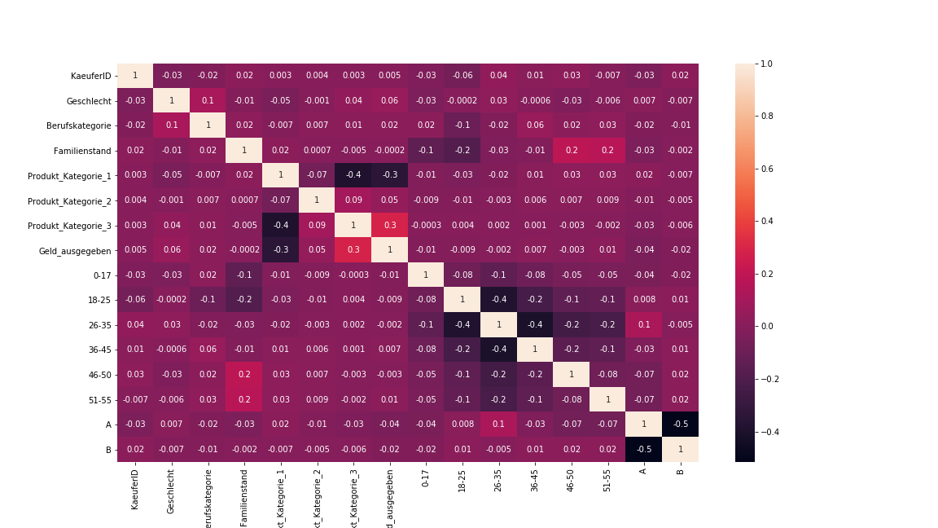

Based on the information incurred from the correlation values of the heatmap, five different categories of variables where grouped to train the model and make an analysis based on it. Below is the category table, the first category contains all the variables, the second category consists of only variables with correlation between -0.01 to 0.01, the third category consists of the two pvariable which are highly correlated to Geld_ausgegeben, the fourth category consists variable with two decimal precision in correlation and finally the fifth category consists of variables with the least correlation.
Category 1:  All features | Category 2:  Selected features | Category 3:  Produkt_Kategorie_1 and 3 | Category 4:  Second Tier | Category 5:  Third Tier
KaeuferID  ProduktID  Geschlecht  Berufskategorie  Anzahl_Jahre_in_aktueller_Stadt  Familienstand  Produkt_Kategorie_1  Produkt_Kategorie_2  Produkt_Kategorie_3  0-17  18-25  26-35  36-45  46-50  50-55  A  B | Geschlecht  Berufskategorie  Produkt_Kategorie_1  Produkt_Kategorie_2  Produkt_Kategorie_3  0-17  50-55  A  B | Produkt_Kategorie_1  Produkt_Kategorie_3 | Geschlecht  Berufskategorie  Produkt_Kategorie_2  0-17  50-55  A  B | KaeuferID  Familienstand  18-25  26-35  36-45  46-50
17 Features | 9 Features | 2 Features | 7 Features | 6 Features

MODEL TRAINING: A total of seven regression algorithms were considered in the study, namely Linear Regression, Random Forest, Decision Tree, Extra Tree, ElasticNet, Deep Neural Network and Convolutional Neural Network. These algorithms were trained for each category and their performance metrics were calculated. Further the performance of Convolutional Neural Network for various number of layers was also analysed.
DISCUSSION: The metrics show that the model belonging to Category 1 which consists of all the variables, performs better with respect to the other categories with the highest R2_Score of 0.7056 and lowest of 0.1382. Its performance is followed by Category 2 and then by Category 3. An exception in the case of Decision Tree and Exttra Tree occurs where Category 3 comprising of just two varaiable performance better than others with an R2_score of 0.6400 and 0.6419, followed by Category 2 with 0.6350 and 0.6355. we can see that Category 2 always performs above average and consistent in its performance with respect to others.
Category 1 performs well most of the times, it can be attributed to providing the model with more information to learn from. Category 2 and 3 also peform fairly well but with a reduced set of variable with Category 3 containing just two. The performance of Category 4 and 5 are always less as they are not well correlated to the prediction variable.
Model-wise Random Forest provides the highest performance of MSE: 7422953.9209 and R2_Score: 0.7056 with Category 1 dataset, followed by Deep Neural Network with MSE: 8403692.2094 and R2_Score: 0.6685 and Decision Tree with MSE: 14206308.4465 and R2_Score: 0.6400. The least performing model is ElasticNet with its maximum R2_score of 0.1382. The Convolutional Neural Network model performs a bit better than ElasticNet but doesnt learn better even with an increase in the number of layers. The Linear Regression model doesnt perform well as it works good with less amount of data and is not suitable for huge amounts of complex data.
CONCLUSION: The dataset of Category 1 gives the best performance most of the times followed by Category 2 and 3. The Random Forest model learns better than Neural Networks and provides the best performance followed by Deep Neural Network and Decision Tree. The analysis shows that Decision Tree and Extra Tree learns the best with a limited set of fairly correlated data. In conclusion, the learning can be improved by providing more variables with high correlation to the prediction variable.

