Comparative Study of Machine Learning Algorithms for Fraud Detection in Blockchain

Fraud transaction effect economy of any country in the world and Blockchain consider secured against any attack due to its proof of work and transaction validation via hash code but the user who is involving Blockchain transaction cannot be trusted and he may perform fraud transaction and to predict such user transaction author of this paper is using various machine learning algorithms called Logistic Regression, MLP, SVM, Decision Tree and many more than evaluating performance of this algorithms in terms of accuracy.

To implement this paper author has used Blockchain fraud transaction dataset which contains user and transaction details and then we extracted all transaction details and then process dataset to normalize value and then replace missing values with 0 and then remove all non-numeric data.

Below screen showing dataset details

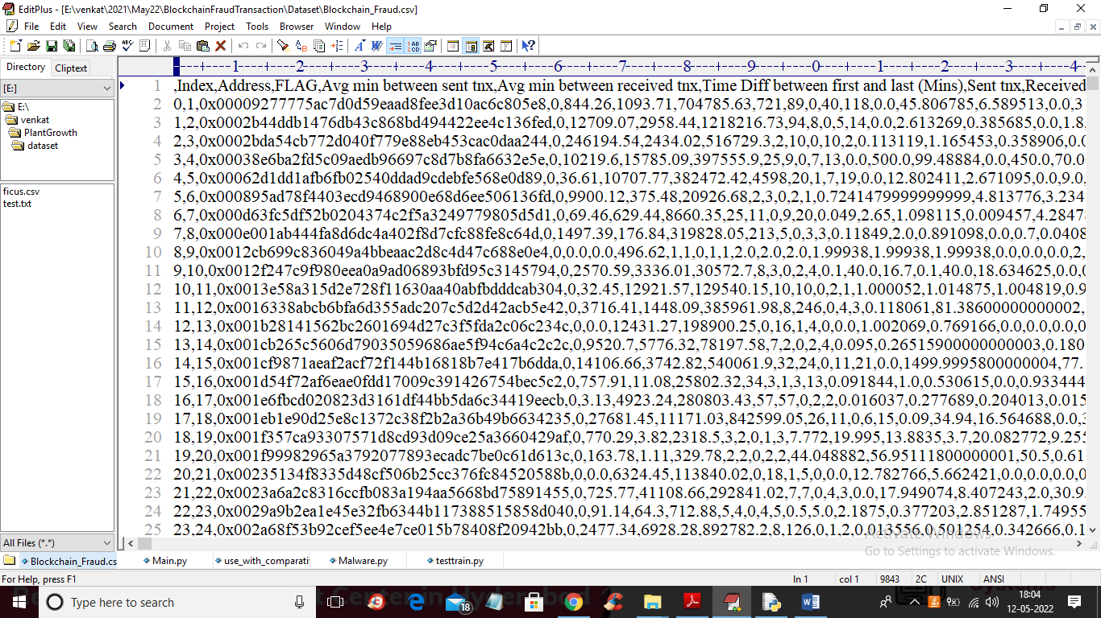

In above screen first row contains dataset column names and remaining rows contains dataset values and in dataset we have column called FLAG which contains values as 0 and 1 where 0 means Normal transaction and 1 means fraud transaction

SCREEN SHOTS

To run project double click on ‘run.bat’ file to get below screen

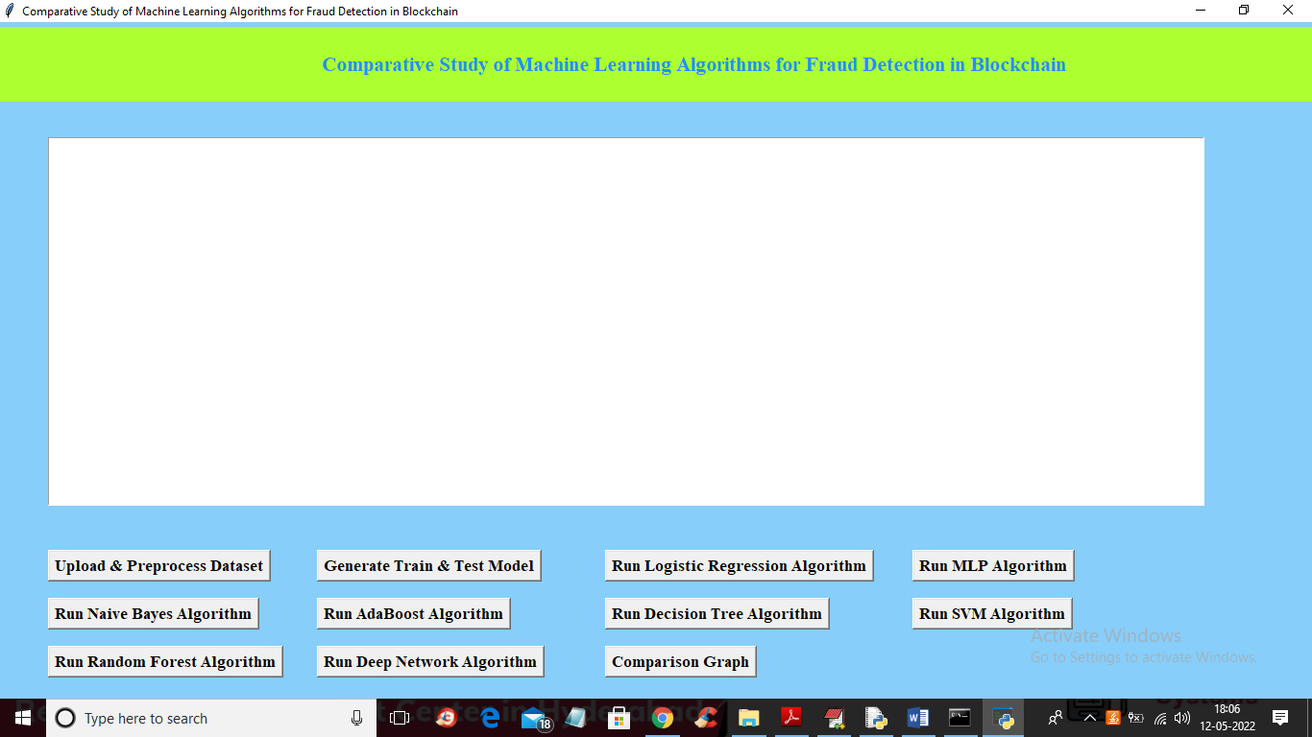

In above screen click on ‘Upload & Preprocess Dataset’ button to upload and read dataset and then remove missing values

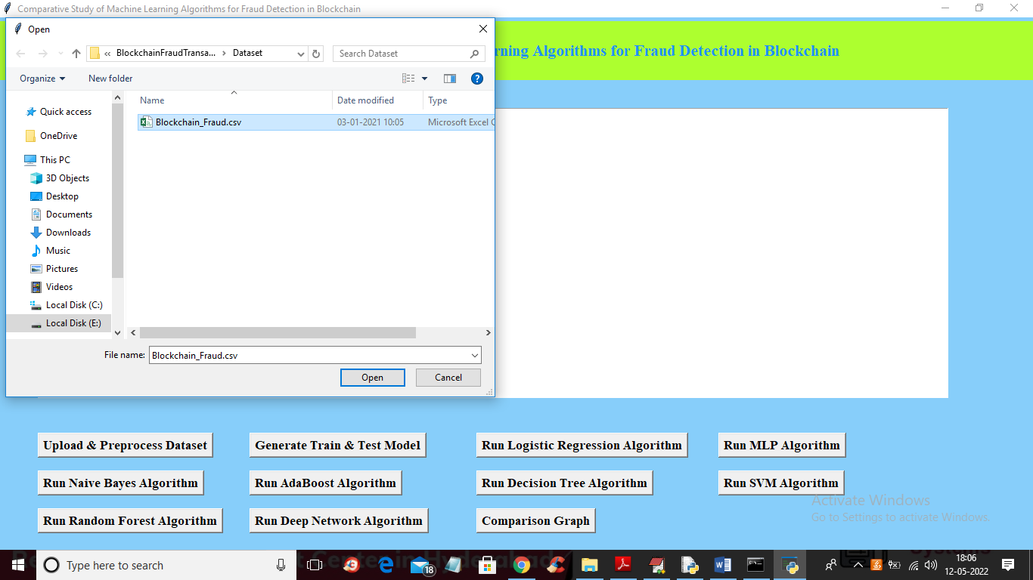

In above screen selecting and uploading dataset and then click on ‘Open’ button to load dataset and get below output

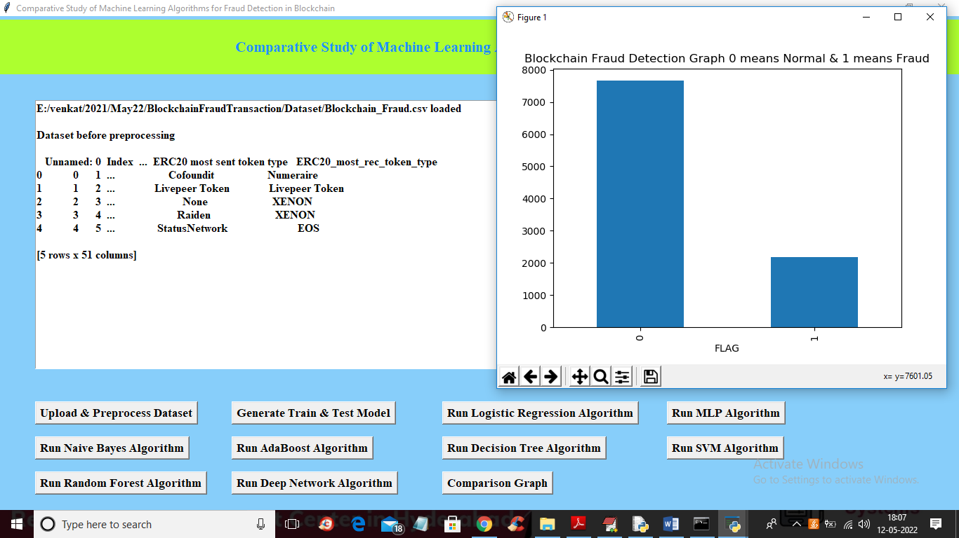

In above screen dataset loaded and dataset contains some non-numeric data and ML algorithms will not take such data so we need to remove and graph x-axis contains type of transaction and y-axis contains number of records and now close above graph and then click on ‘Generate Train & Test Model’ button to get below output

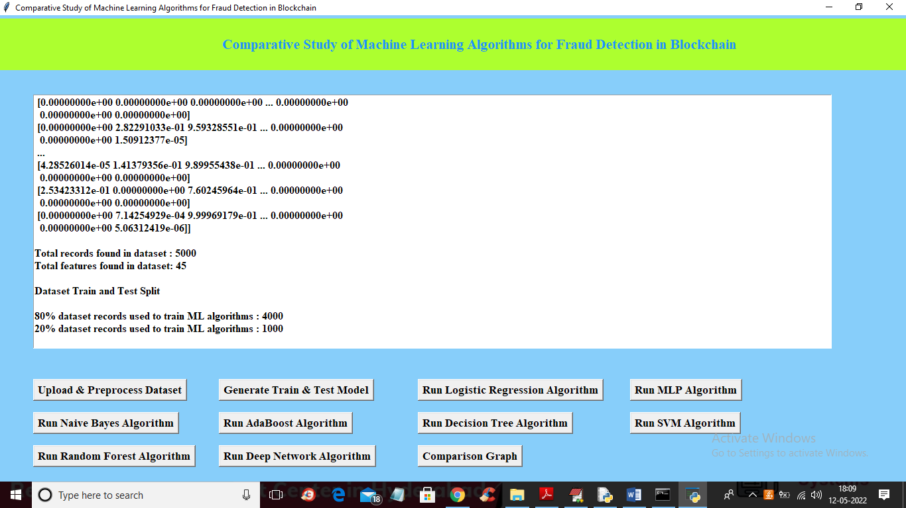

In above screen we can see all data converted to numeric format and we can see total records found in dataset with total columns and then split dataset into train and test and now train and test data is ready and now click on each button to run all algorithms and get below output

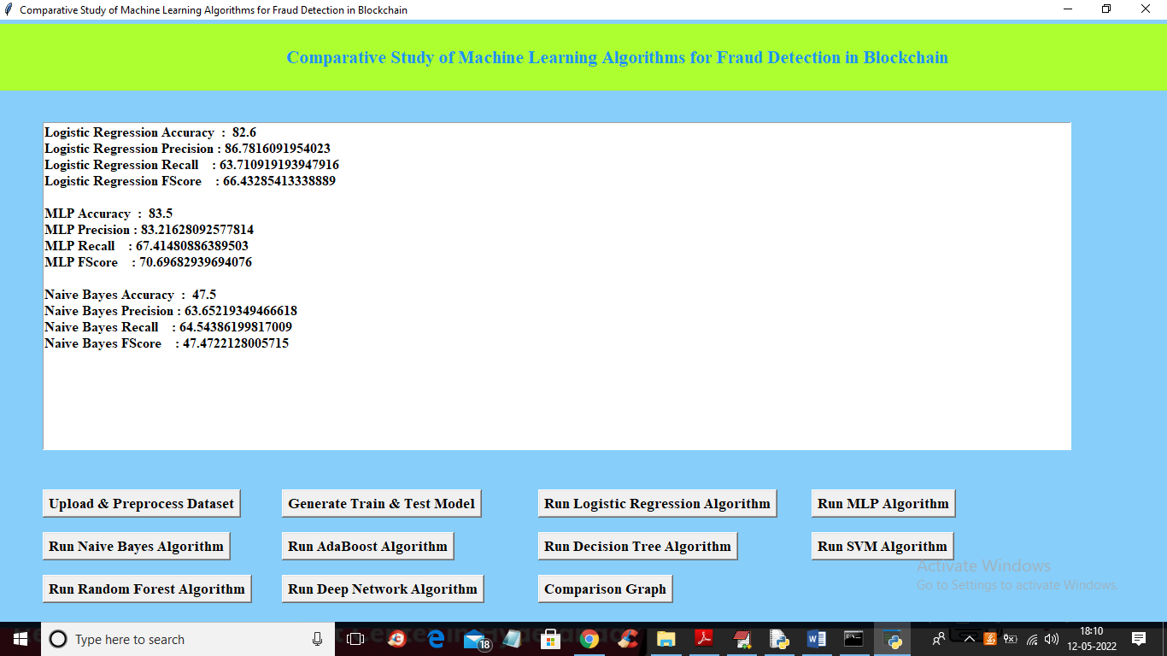

In above screen we can see the performance or accuracy of each algorithm and below is the remaining algorithm accuracy

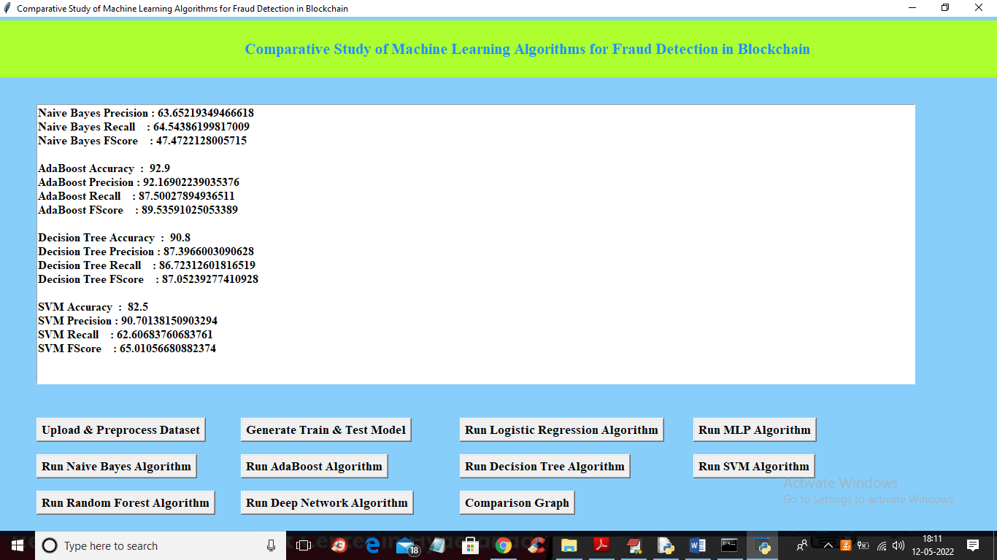

In above screen we can see accuracy of AdaBoost, Decision Tree and SVM and below is the accuracy of remaining algorithms

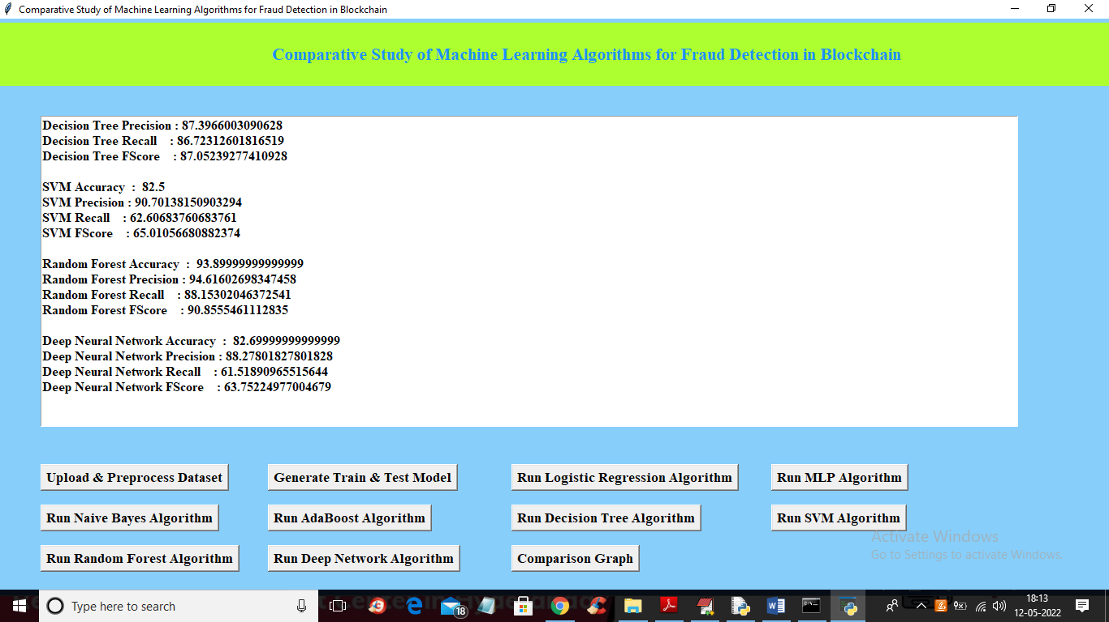

In above screen we can see random forest and Deep neural accuracy and in all algorithms Random Forest is giving better accuracy. Now click on ‘Comparison Graph’ button to get below output

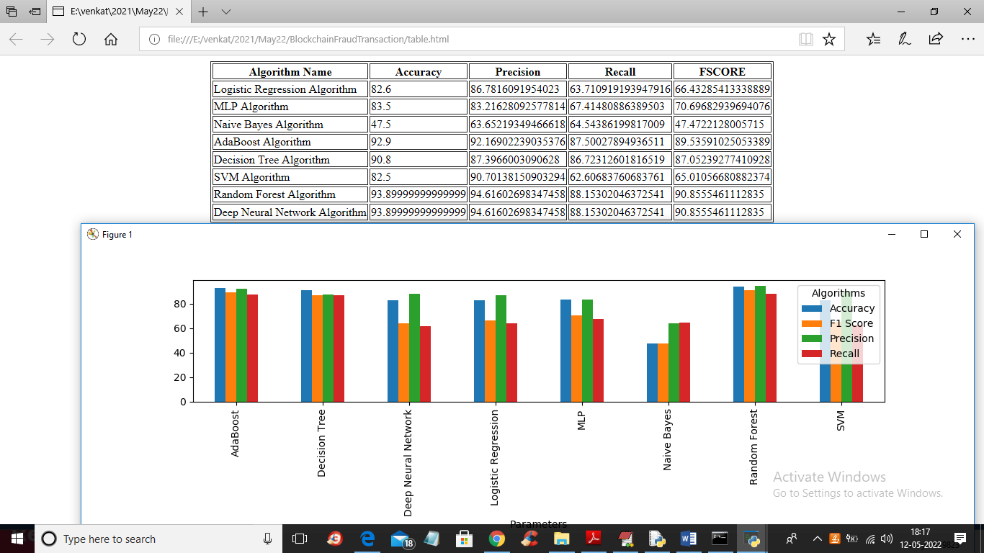

In above screen we can see the accuracy, precision, recall and FSCORE of each algorithm in graph and tabular format and in all algorithms Random Forest giving better result