Demo Project in mvc

15

GYMONE GUIDE

**Saineshwar Bageri**

Project GYMONE Guide

Project Name: - **GYMONE**

I had provided entire **GYMONE project to download** with **Sql server Script** which contains tables and store procedures which are used.

Please read Text files **ReadMe_First**.txt file first.

In this Application there are 2 Types of Users one will be **Admin** and other will be **System User**.

**Project System User Process:-**

This project aims complete on GYM process. The Process starts with Membership when Member is newly joining GYM he is been registered in GYM Software by System User while registering he will ask to Member for which type of Scheme he will like to take (GYM+CARDIO OR GYM) and for how much period he will be joining GYM (Quarterly, Half Yearly, Yearly) According to this the Fees of GYM will be decided. After registering The Member is given a Receipt and Declaration form. the Receipt is sign be System User and Declaration form is been sign by Member who is joining the GYM along with this Member is told to provide legal Document proof of Address and Photo Identity. Now the Member can use GYM facilities till Period has paid for Services after completion of service he need to renew Membership it from System User for next Period ( Quarterly , Half Yearly , Yearly) and pay Fee to System User for that Period.

The System user also has a Rights to check How much Amount has been Collected this month by seeing Month wise (Month wise Report Download) Report and if he want to check how much Amount has been collected this year than he can view Year wise Report (Year wise Report Download) and Finally he can also check which user renewal is upcoming to notify him about his renewal of Membership by viewing renewal Report.

**Admin System User Process:-**

The Role of Admin is to Create and Delete System User and also assign roles (Admin , System User ) to them . He also has rights for Adding Scheme ( GYM+CARDIO OR GYM etc ) and Plan ( Quarterly , Half Yearly , Yearly) he can view All Reports Month wise collection Report and Year wise collection Report , Renewal Report according to this he can plan scheme for getting more Member to his GYM.

Platform Used

**About Platform Used:-**

I had developed this Application using Microsoft Visual Studio Ultimate 2012 with Microsoft SQL server 2008 and Reporting is done using Crystal Report Version (13.0.2000.0).

Project is Created using **ASP.NET MVC 4** and Language Used is **C#** and **ORM Dapper** with **Repository Pattern**.

**Microsoft Visual Studio Ultimate 2012.**

Link to download Trial Microsoft Visual Studio Ultimate 2012.

<http://www.microsoft.com/en-in/download/details.aspx?id=30678>

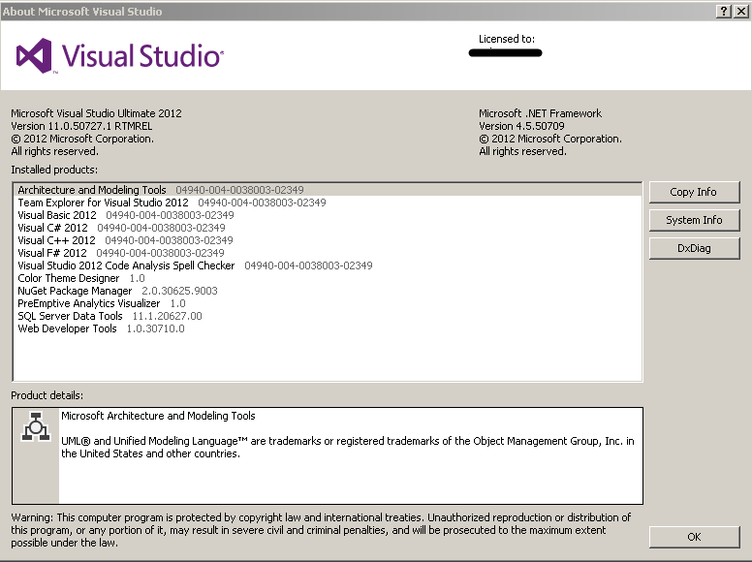

**Microsoft SQL server 2008**

Link to download Trial Microsoft Visual Microsoft SQL server 2008.

URL: - <http://www.microsoft.com/en-in/download/details.aspx?id=1695>

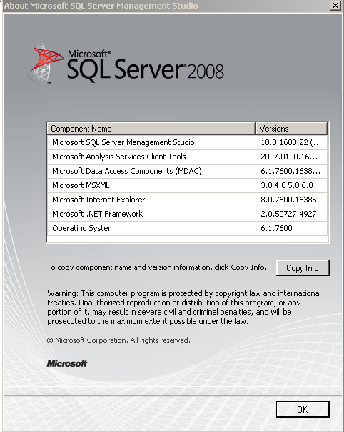

**SAP Crystal Report Version (13.0.2000.0)**



Link to download Trial Crystal report Viewer 2011.

URL: - <http://downloads.businessobjects.com/akdlm/crystalviewer/51043407.ZIP>

**Database Details.**

Finally after Understanding Process let check out which are the tables we had used in this Application.

Please read Text files **ReadMe_First**.txt file first in this file entire process of database creation and Login details of file exists.

I have created database with Name **GYMONEDBMVC** inside this all this tables are present.

Let’s start with **Asp.net Membership tables** first we have five table of it.

1. Users
2. webpages_Membership
3. webpages_OAuthMembership
4. webpages_Roles
5. webpages_UsersInRoles

**User Table**

This table contains User Details with UserID.

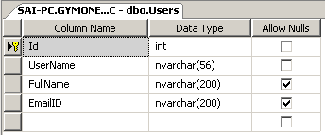

**webpages_Membership**

This table contains User Password Details

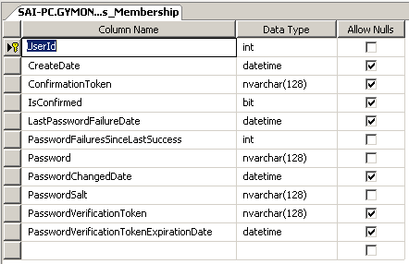

**webpages_OAuthMembership**

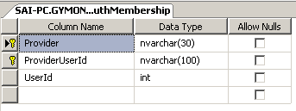

**webpages_Roles**

This Table Contains Roles .

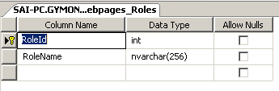

**webpages_UsersInRoles**

This table contains Roles assign to User.

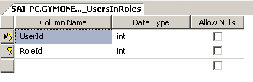

After completing with all Membership Table now lets start with other tables.

1. SchemeMaster
2. PlanMaster
3. MemberRegistration
4. PaymentDetails
5. RecepitTB
6. Fiscalyear

**SchemeMaster**

Table contains all Scheme Details in it. E.g. ( GYM+CARDIO OR GYM )

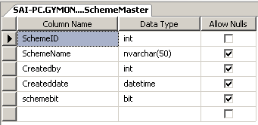

**Plan Master**

Table contains all Plan Name in it also a Foreign key SchemeID

E.g. ( Quarterly , Half Yearly , Yearly)

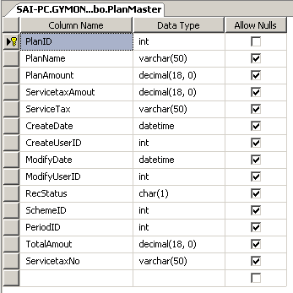

**MemberRegistration**

Table Contains all Member Details and it is a Master table.

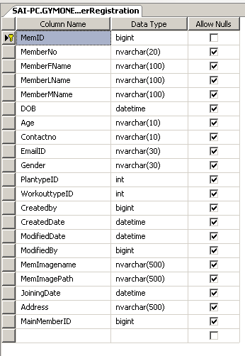

**PaymentDetails**

Table Contains all Payment Details of Member in it . MemberID is Foreign key in this table.

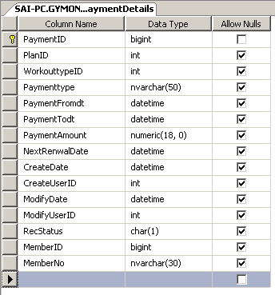

**ReceiptDetails**

Table contains details of who and how many Receipt has been downloaded

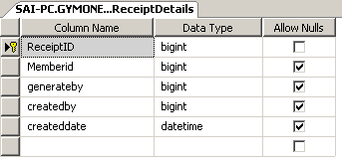

**Fiscalyear**

Table contains all Fiscal year details.

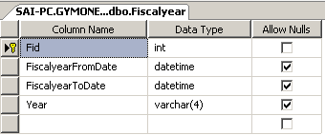

After Completing Database Details Now let’s have look on Project structure in Visual studio.

The Project Name is GYMONE.

You can see basic folder structure provide by MVC.

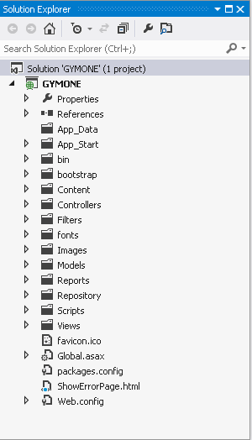

**External packages which are be used in this Project.**

I have also added some packages from NuGet here they listed below.

1. Bootstrap
2. Dapper dot net
3. Grid.MVC
4. PagedList.MVC
5. JQuery UI

**Let’s have look at folder and there details.**

**Bootstrap folder** contains all files of .js and .css .

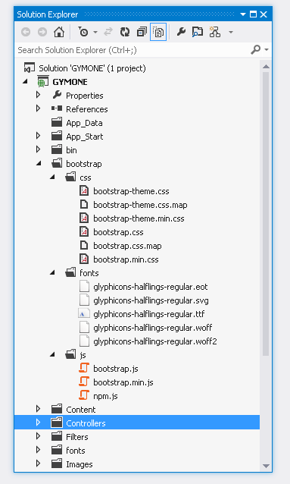

**Controller Folder** contains all Controller created in this application.

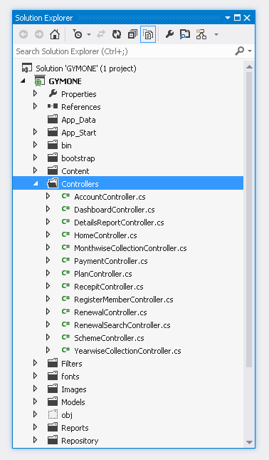

**Model Folder** contains all **Model** created in this application.

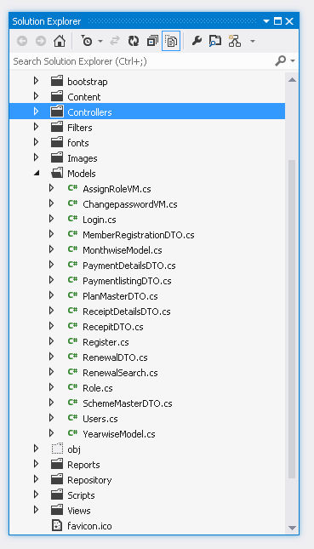

**View Folder** contains all **view** created in this application.

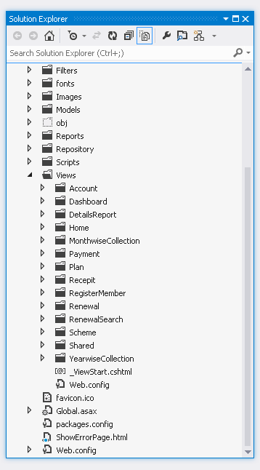

**Repository Folder**

This folder contains Interface and there implementation.

E.g. IPlanMaster (Interface) and PlanMaster Implementation.

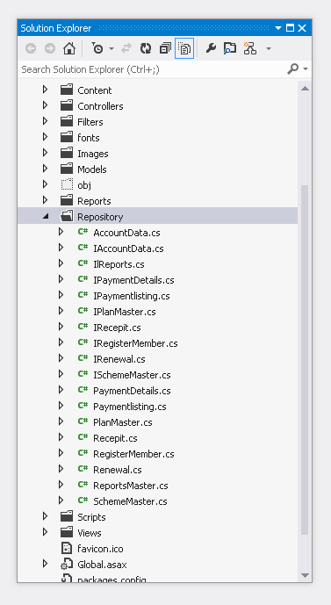

**Reports Folder**

This folder contains Crystal report which have been develop in this application.

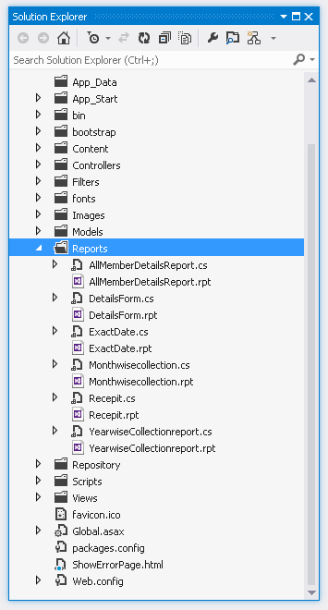

Finally we had completed having look on folder structure now let’s check out our screens.

Starting with Login Screen.

**Login Screen**

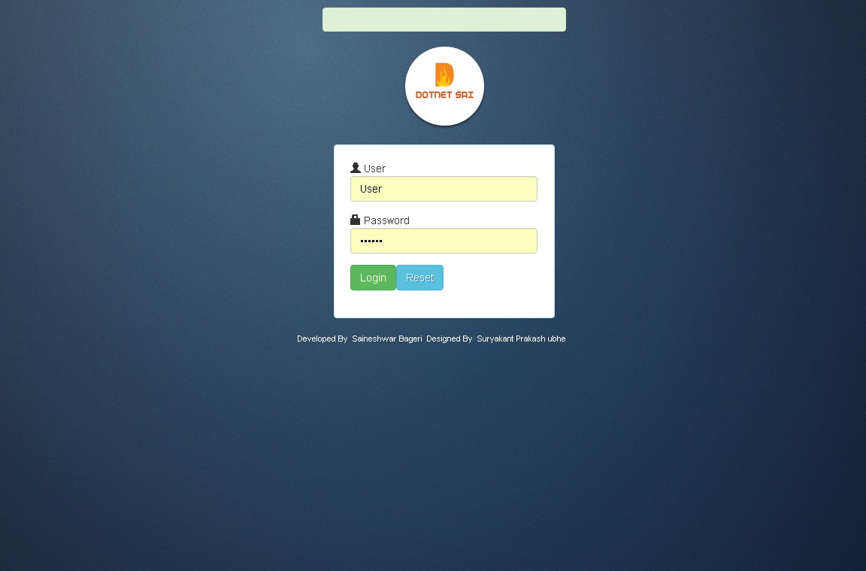

After login screen now let’s check System User Screen.

**System User Section**

**User Dashboard**

After login user will see this User Dashboardscreen in which he will able to see all page which he can access.

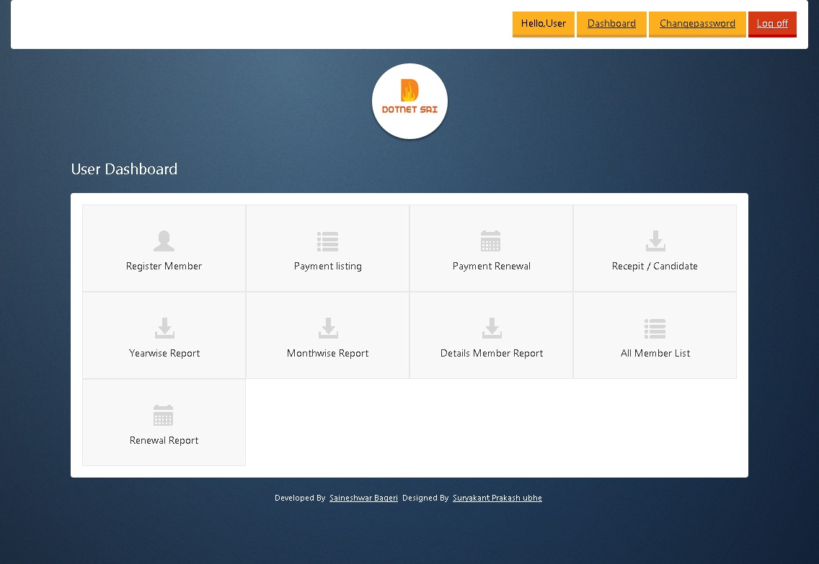

Now let’s open first link of User Dashboard Register Member Master.

**Register Member Master [Create]**

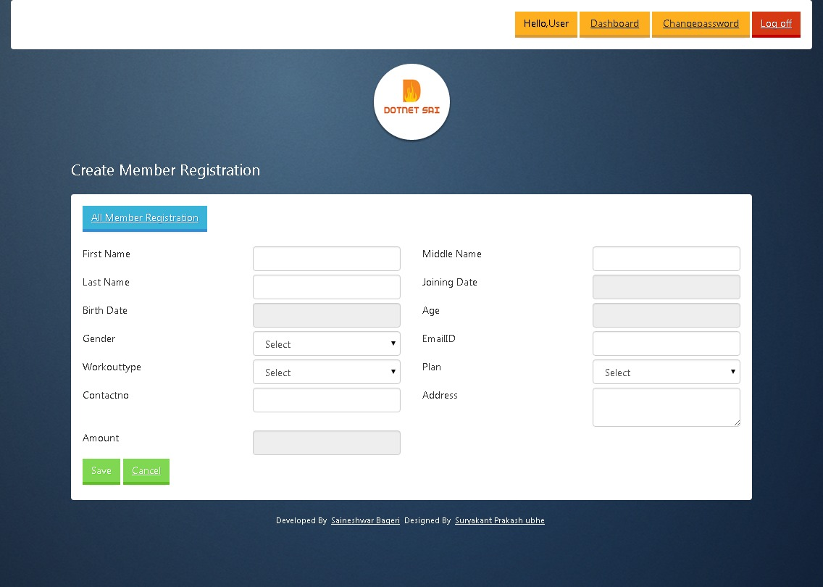

**Register Member Master [Listing]** 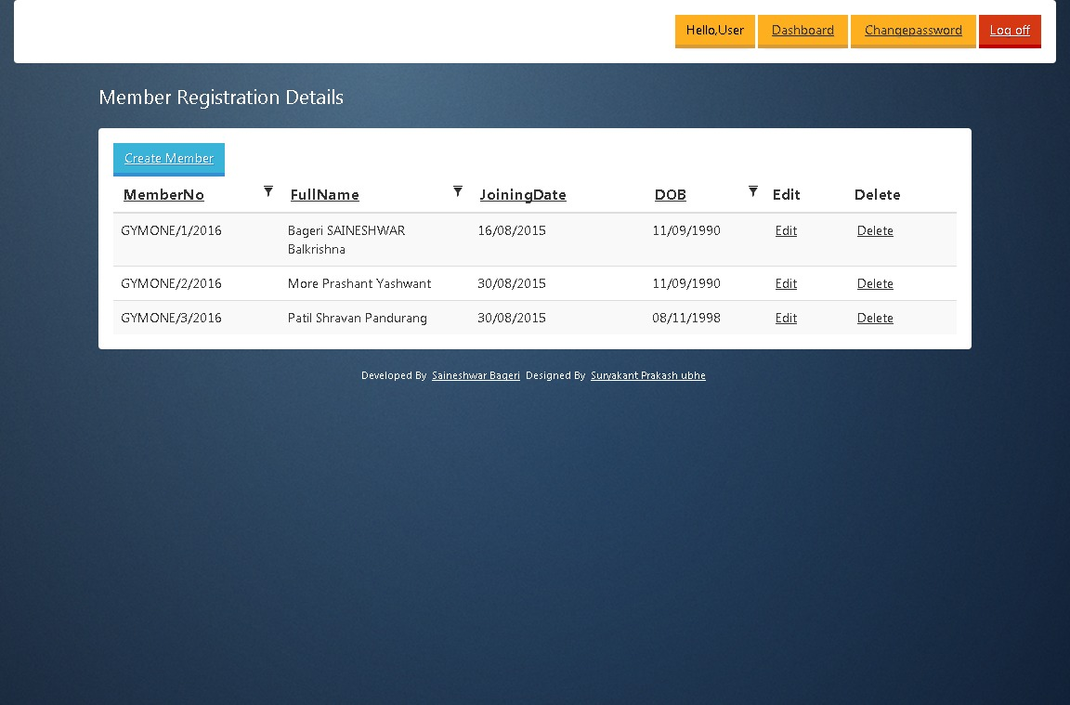

**Register Member Master [Edit / Update]**

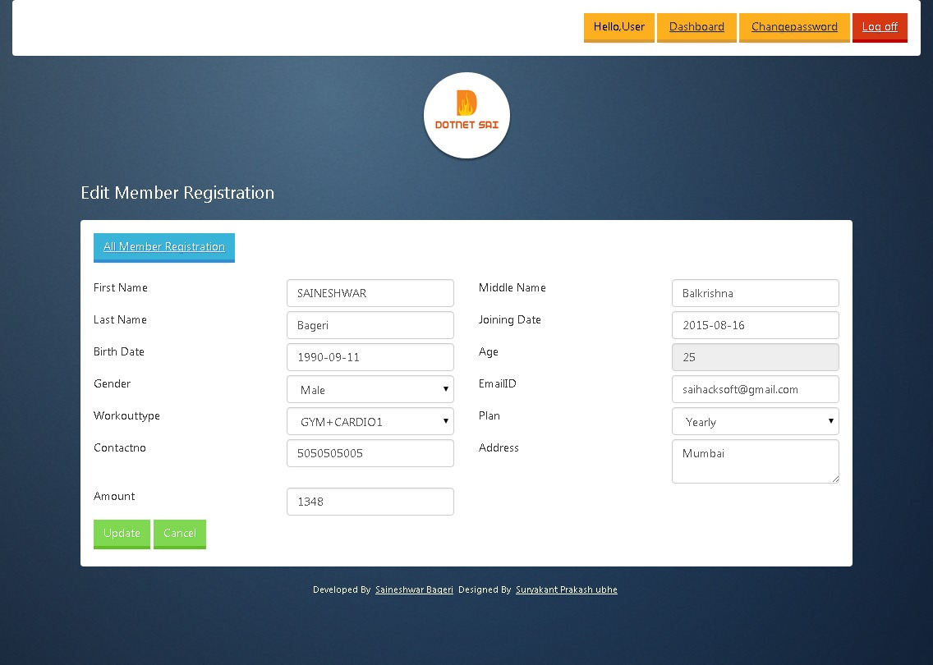

**Receipt Download**

In this page we can download Candidate Receipt.

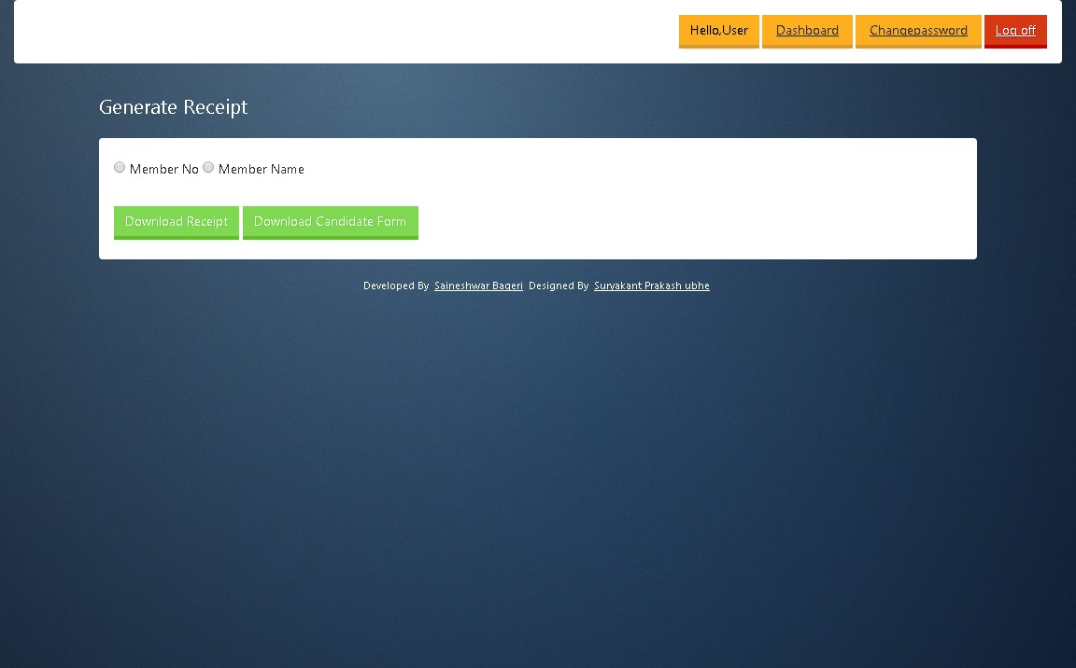

**Candidate Form Download**

In this page we can download Candidate Declaration Form.

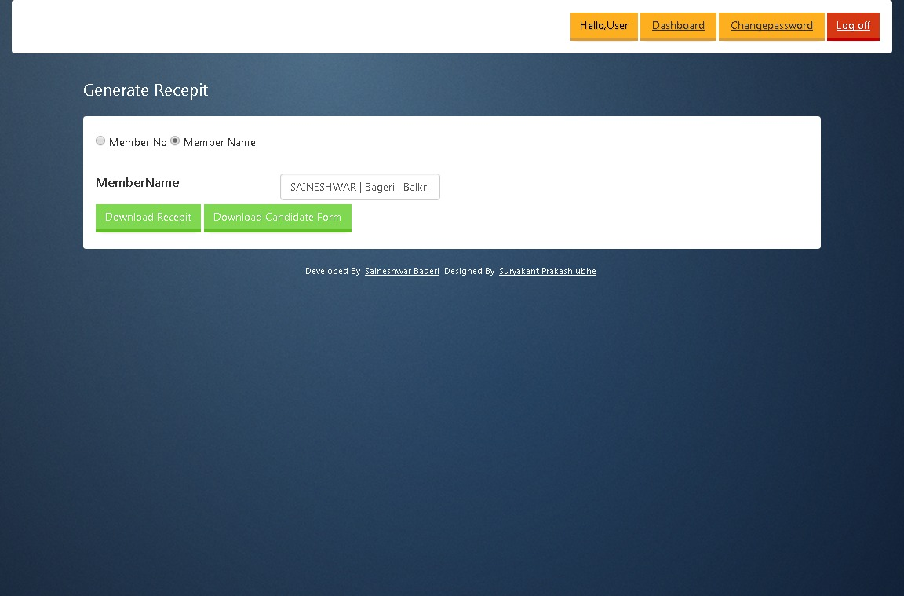

**Payment Listing**

In this page we can check out details of Member Payment and Renewal according to Member No or Member Name.

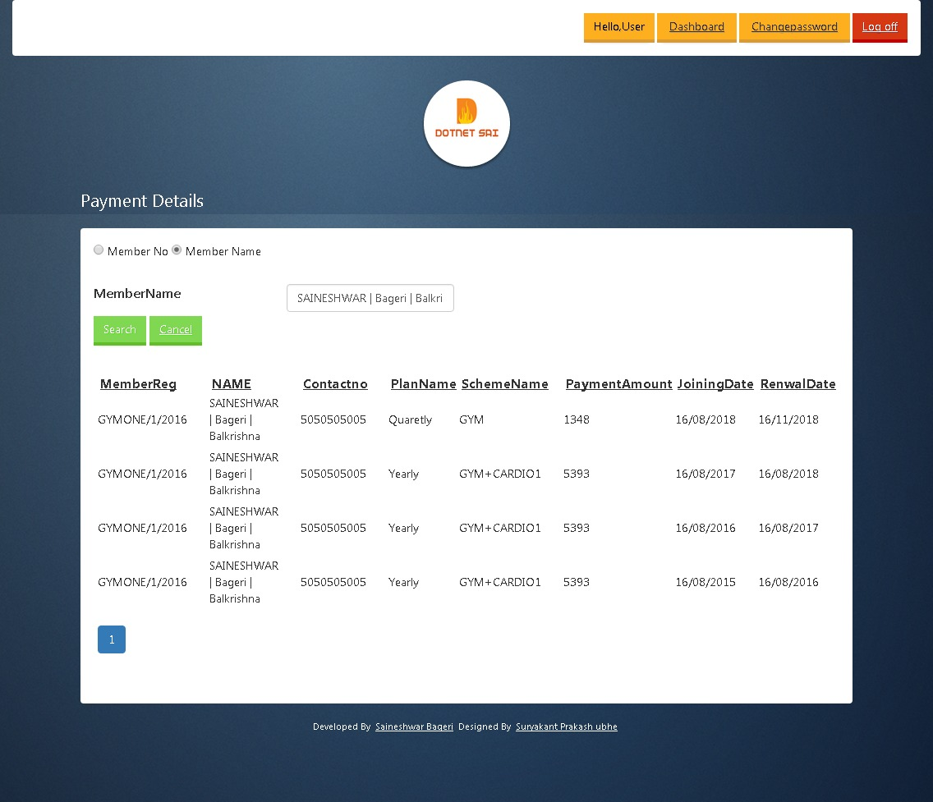

**Renewal Details**

In this page we can renew All Members Membership.

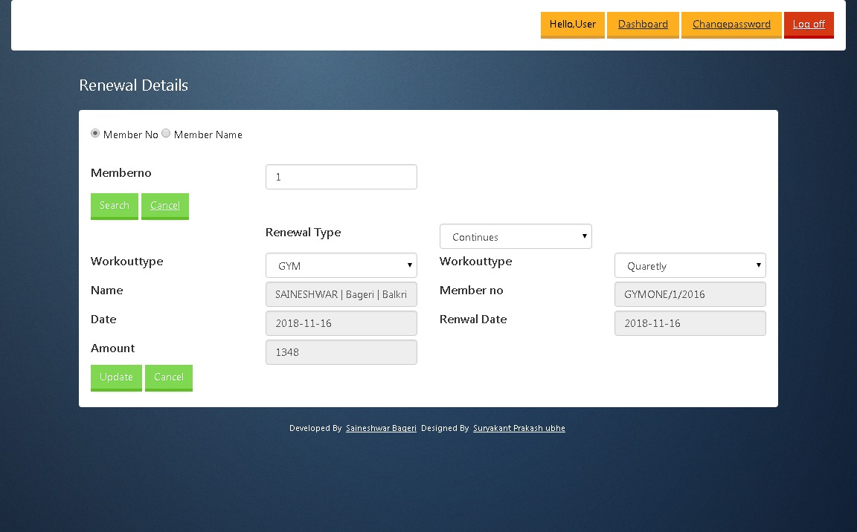

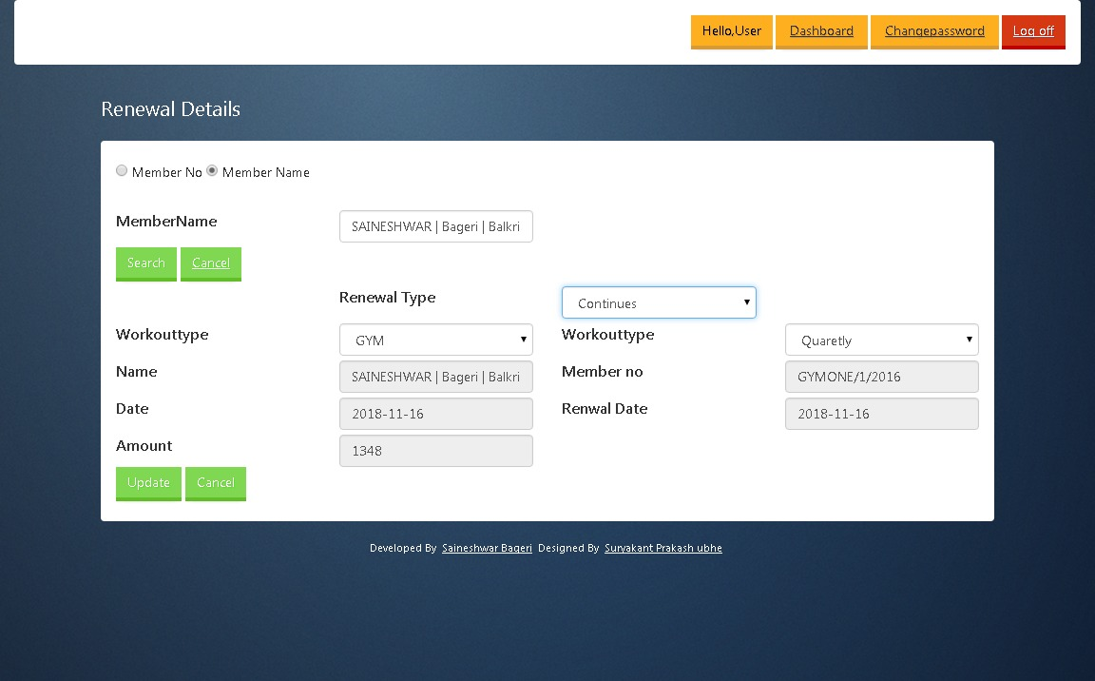

**All Member List**

In this page we can see All Members List which are Registered.

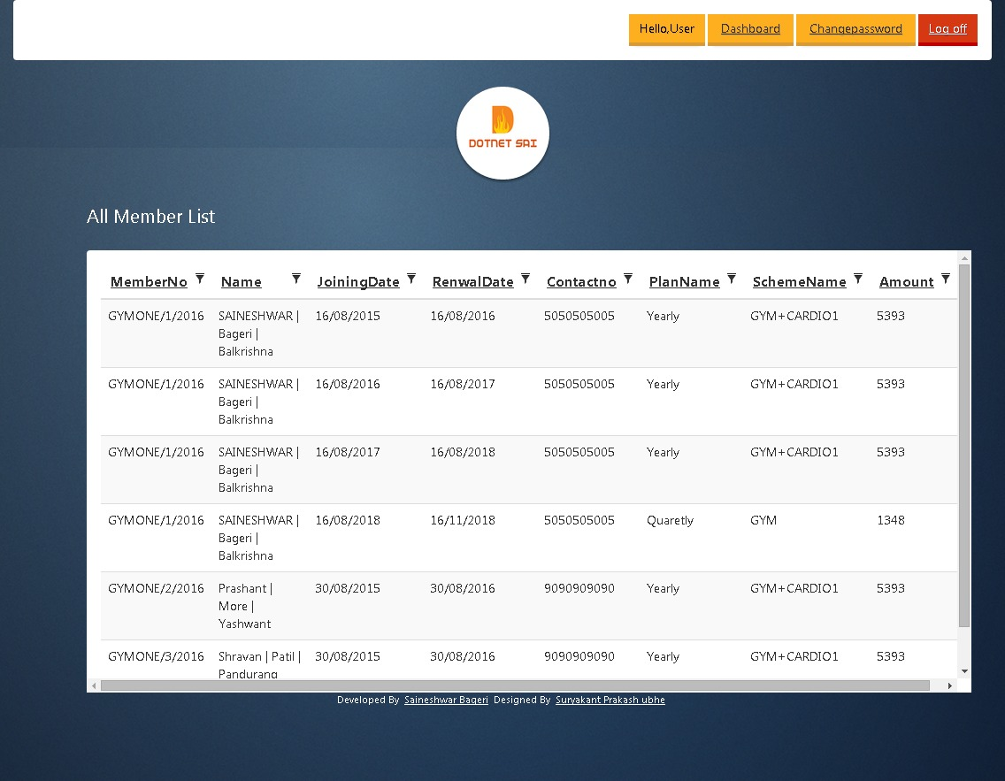

**Year wise Report Download**

In this page we can download Year wise Report of Fee Collection.

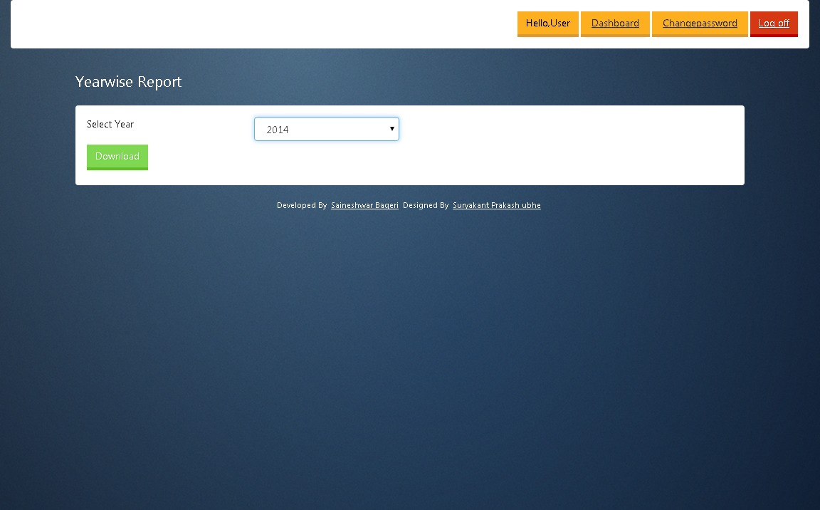

**Month wise Report Download**

In this page we can download Month wise Report of Fee Collection.

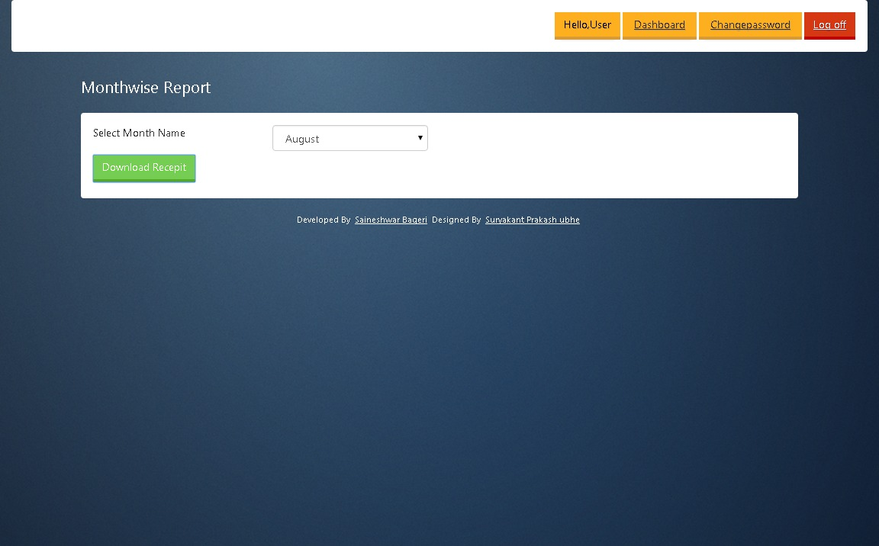

**Detailed Renewal Report Download**

In this page we can download Detailed Renewal Reportof all Members.

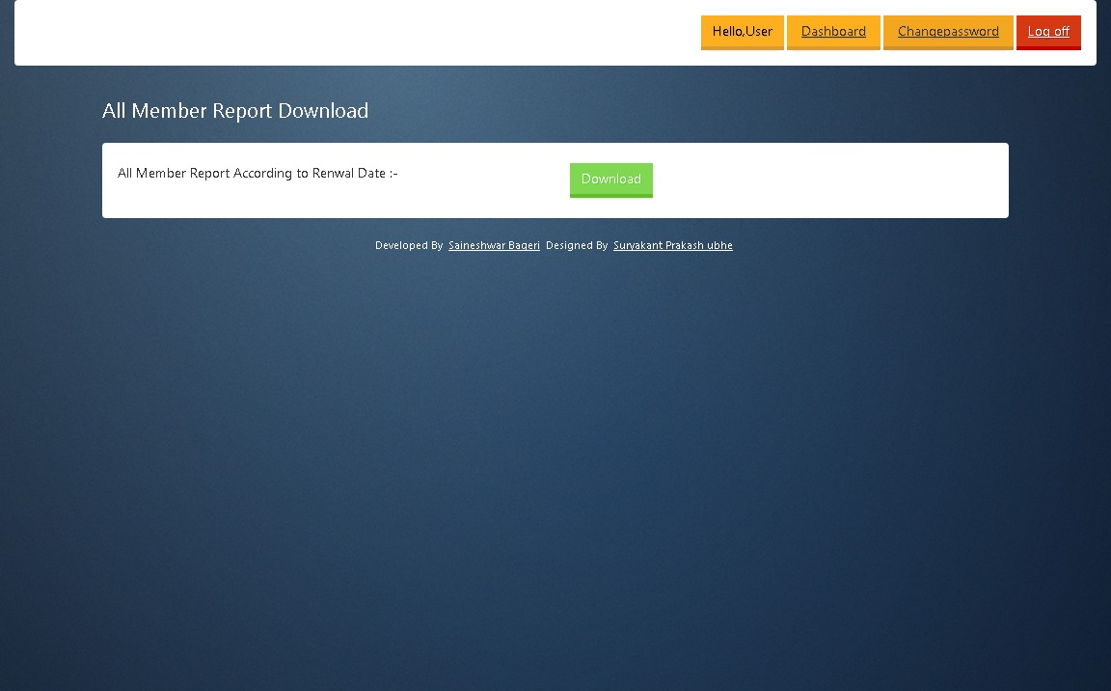

**Detailed Date wise Renewal Report Download [Exact Date]**

In this page we can download Detailed Renewal Reportof all Members according to Date.

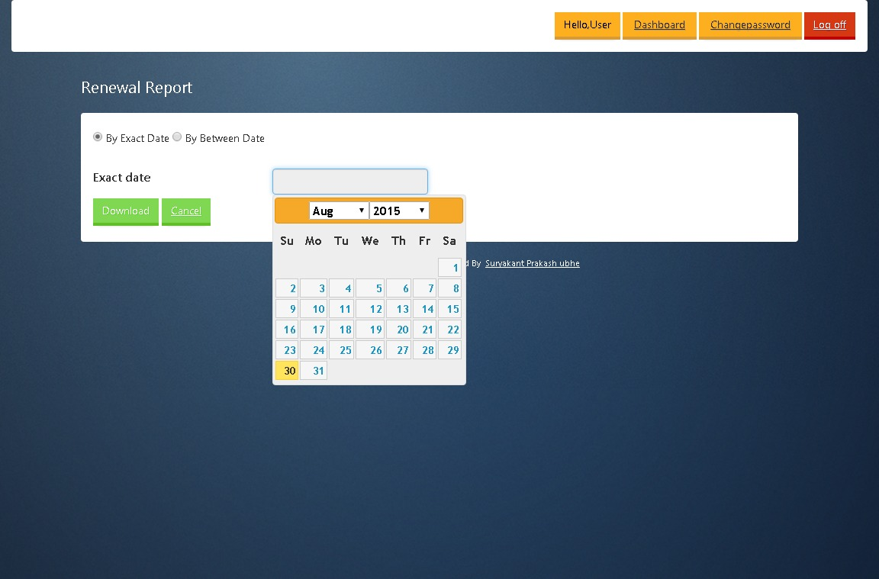

**Detailed Date wise Renewal Report Download [Between Dates]**

In this page we can download Detailed Renewal Reportof all Members according to Date.

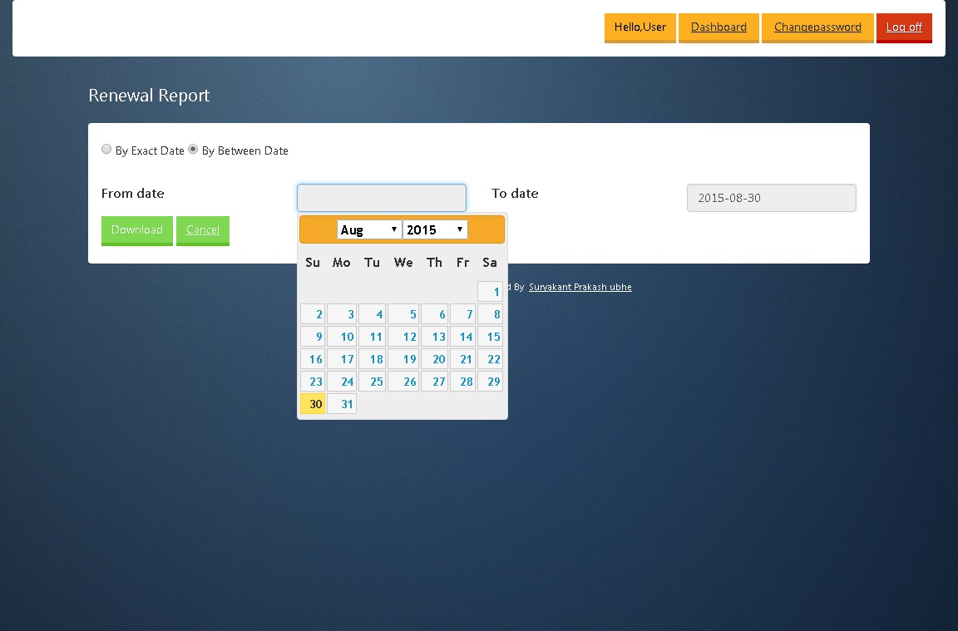

After completing with viewing System User Page now let’s move forward to have look on Admin

Dashboard and Pages.

It is coded simple you can just have look on it and learn it.

**Account Section**

The first thing we are going to look is Admin dashboard.

Reports here will be similar to what System User Reports.

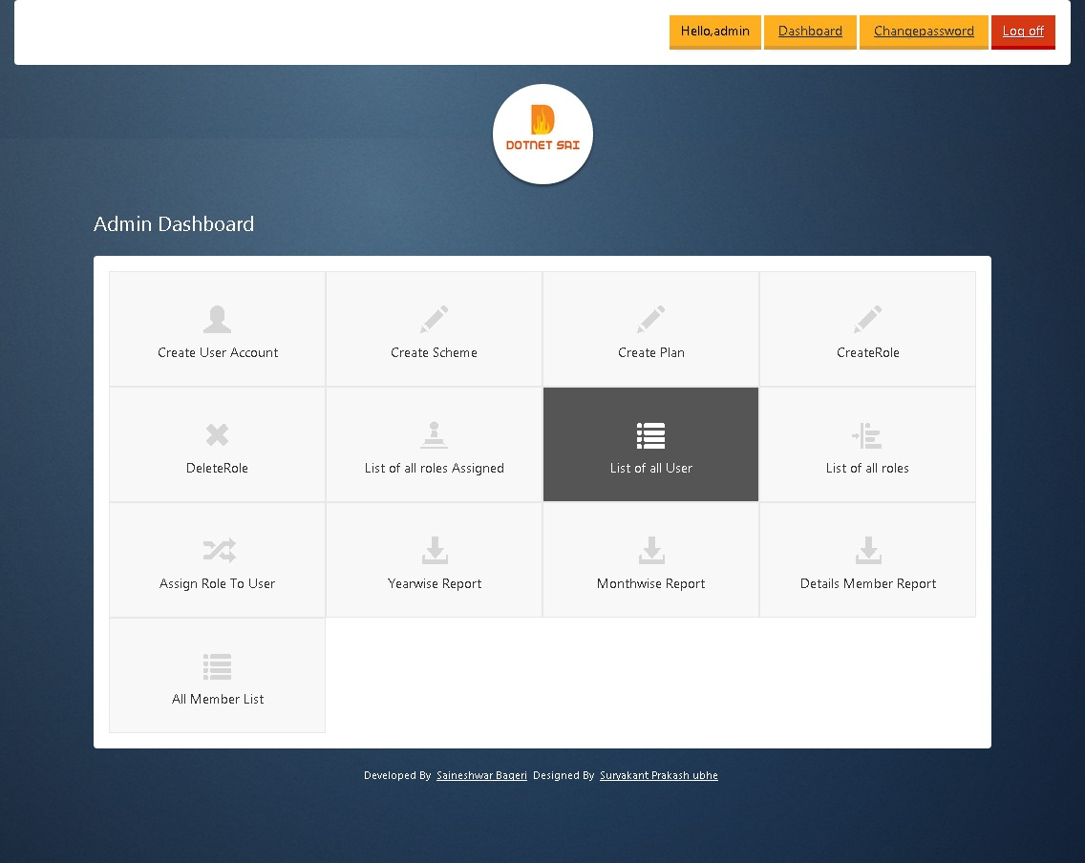

After seeing dashboard now we are going to see is how to Create Role.

**Create Role [Create]**

The first thinking in admin section is to Create Role and it is One time entry .

In this system I have created only 2 roles [Admin , SystemUser] if any one want to add another role then he need to add ([Authorize(Roles = "NewRoleName")]) attribute to controller in system.

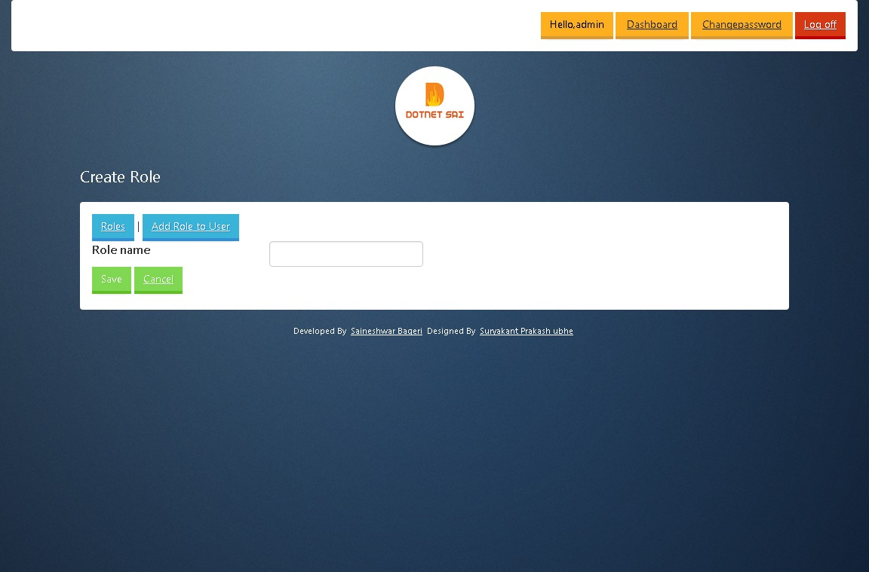

**Role Listing [Listing / Delete Role]**

In this page I am displaying all roles which admin has added.

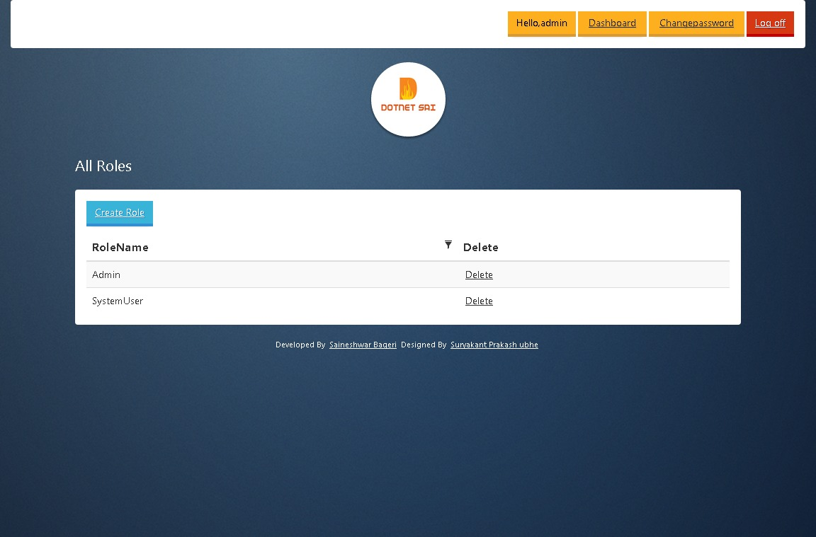

After adding roles now let move towards Creating System User Account.

**Create User Account**

In this page I am going to Register “ SystemUser or Admin ” which are going to use system.

And here are the details which are going enter for creating Account.

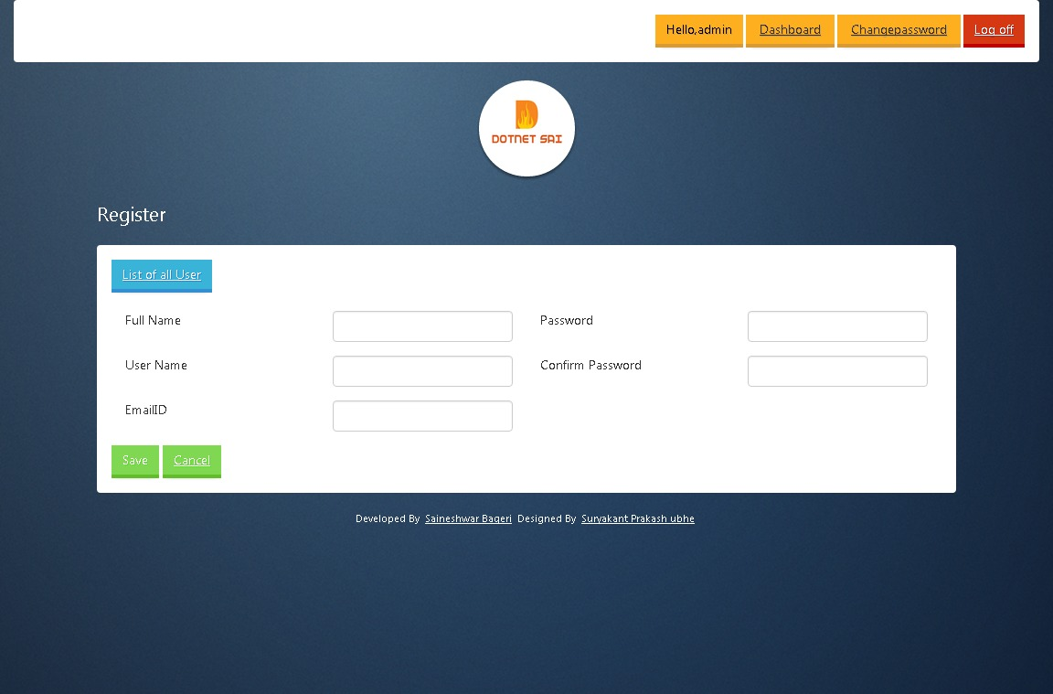

After Creating Account first thinking we are going to do is assigning role to user which we have created.

**Assign Role to User**

In this page I am going show how to assign role to User which are created.

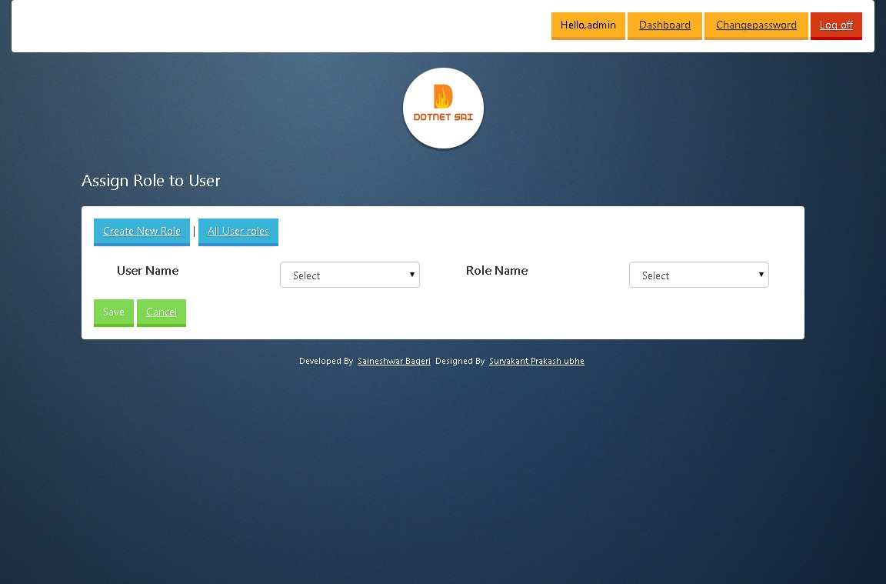

After assigning role now let’s Move towards Listing of Roles assign to User.

**Display All SystemUser Assign Roles.**

In this Page I am displaying all roles with Username to whom it is assign.

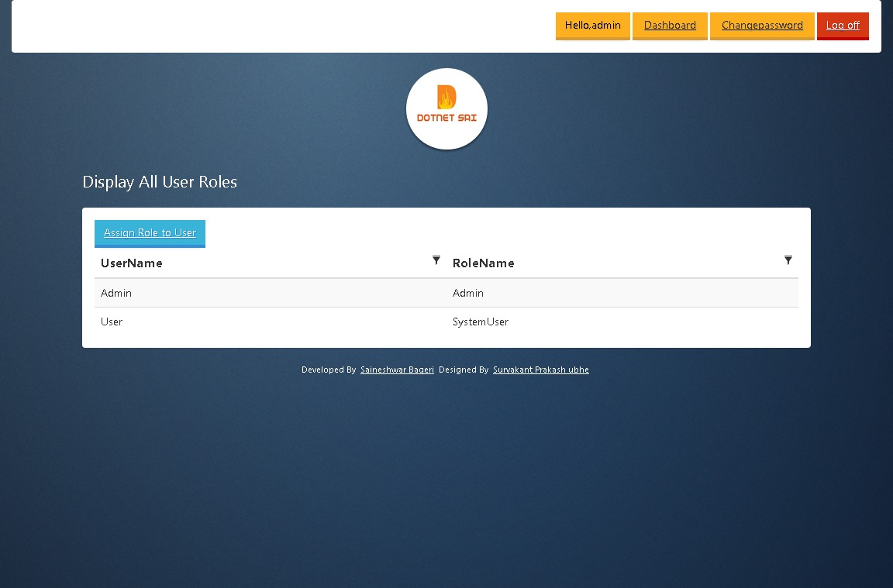

**Remove Role from User**

In this page I am showing how remove role of User which we have already assigned role.

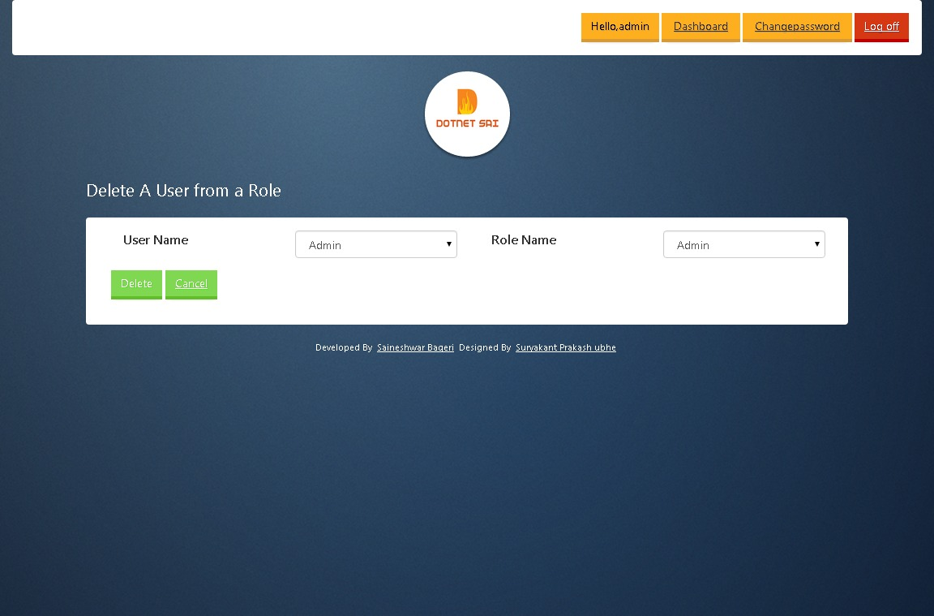

**All Registered User Details**

In this page I am displaying all Registered User Details.

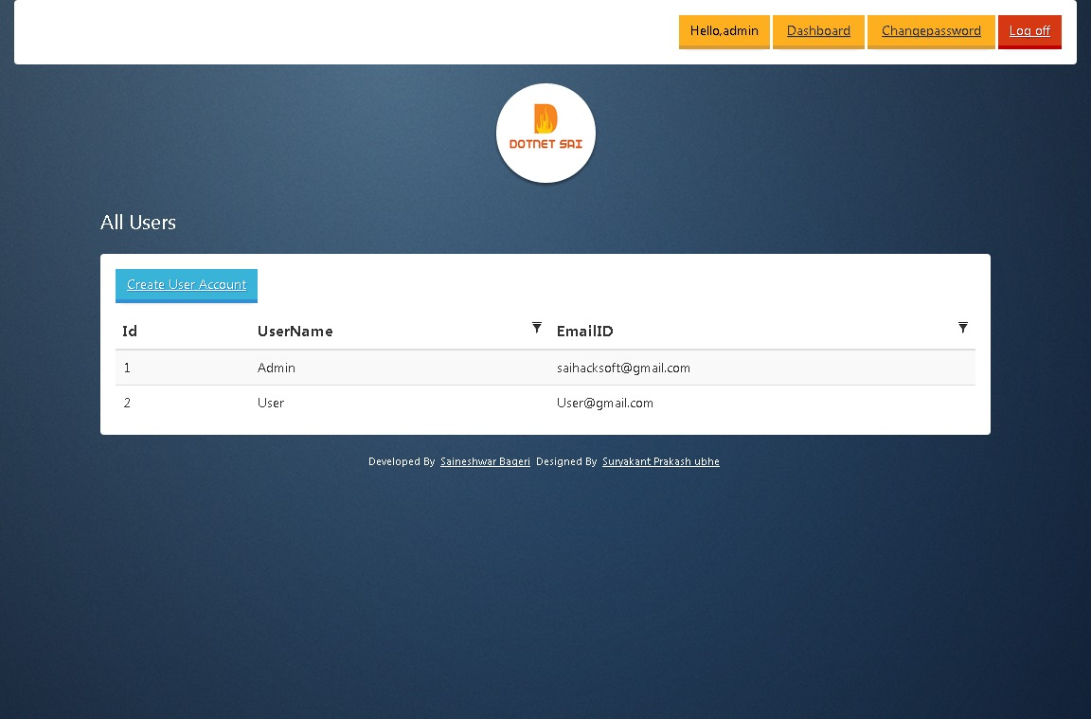

After viewing all Registered User Details now lets Add Scheme to Member from Scheme Master.

**Create Scheme Master [Create]**

In this page I am going show how to Create Scheme.

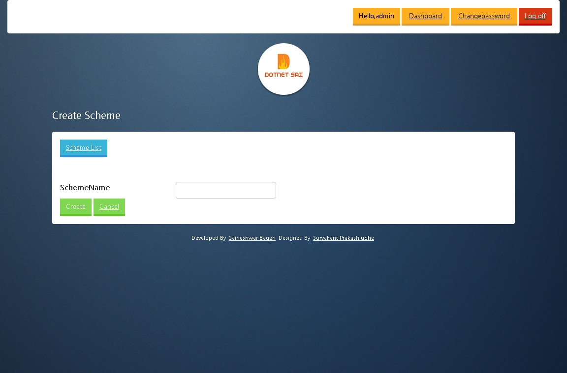

**Scheme Master [Listing]**

In this page I am going displaying all Scheme.

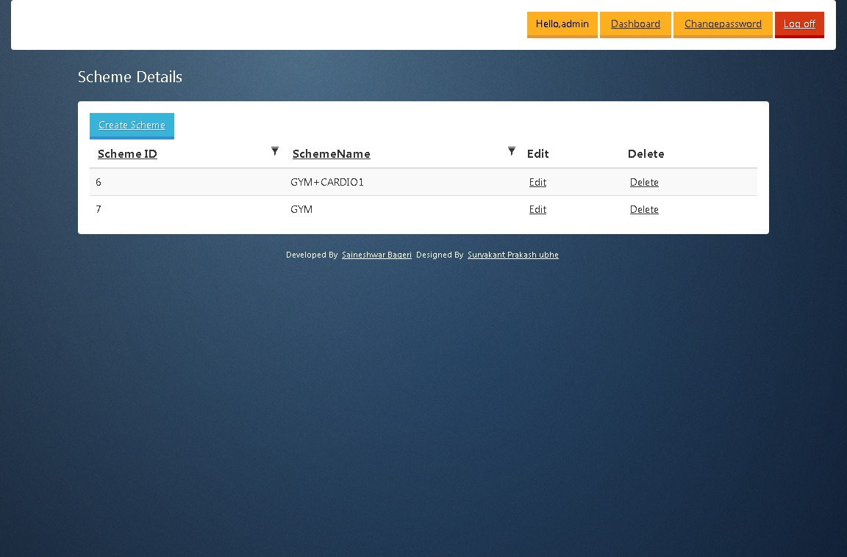

**Scheme Master [Edit]**

In this page I am going show how to Edit Scheme.

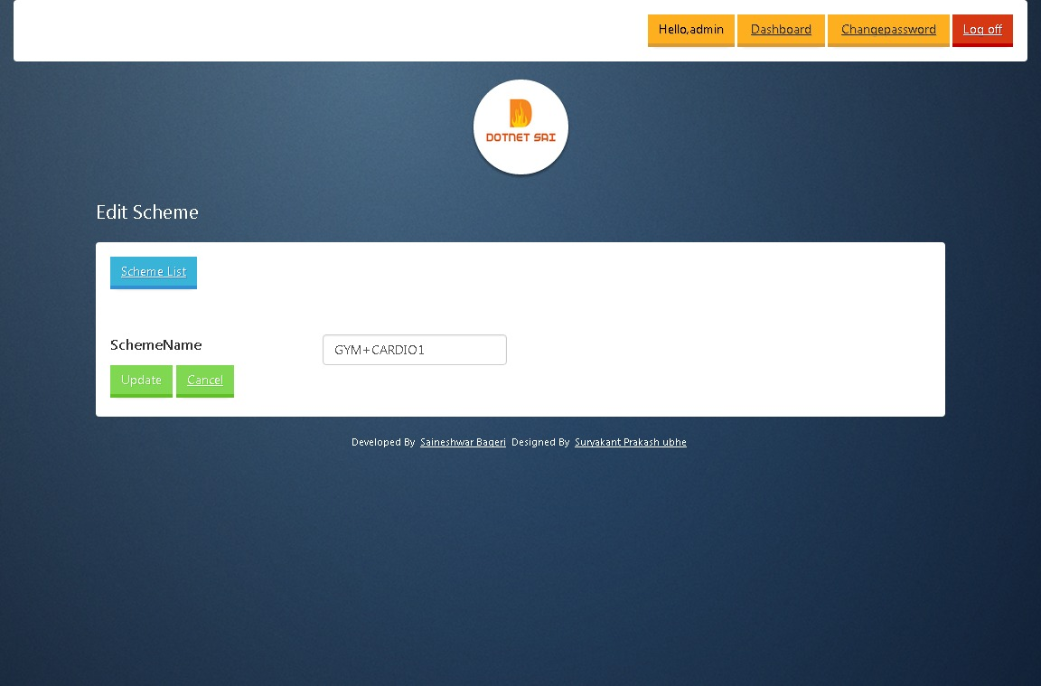

**Create Plan Master [Create]**

In this page I am going show how to Create Plan.

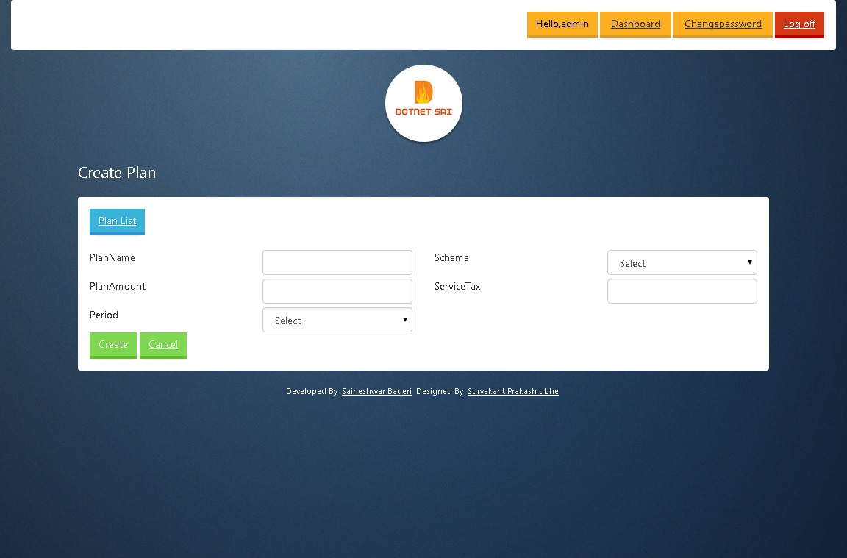

**Plan Master [Listing]**

In this page I am going displaying all Entered Plan.

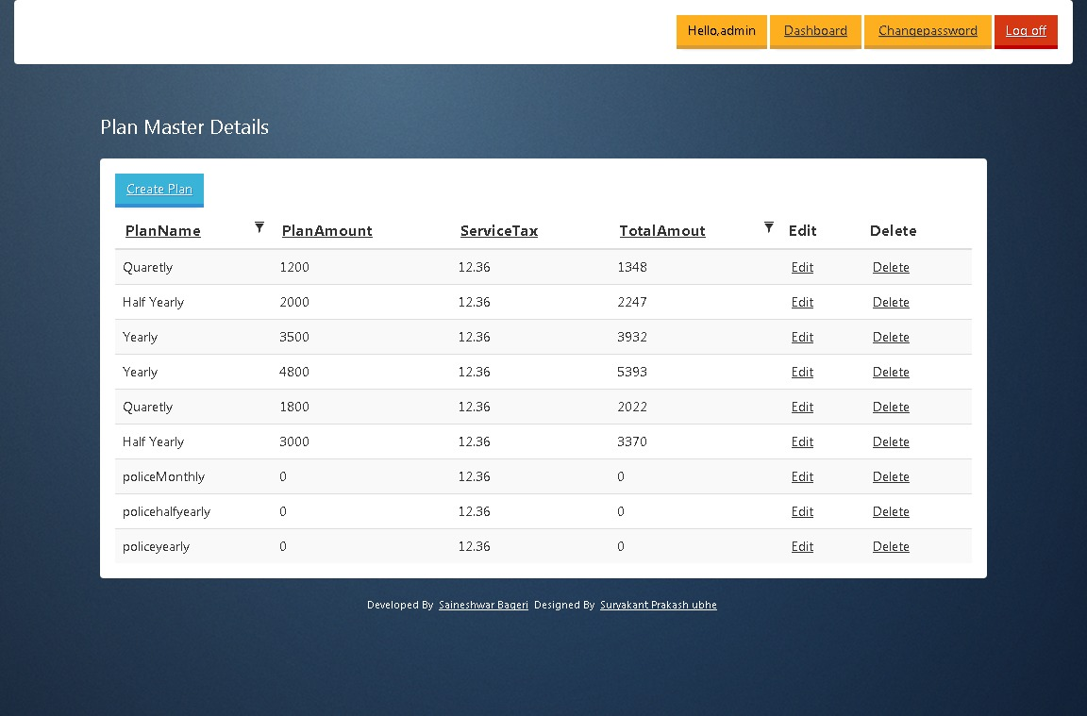

**Plan Master [Edit]**

In this page I am going show how to Edit Plan.

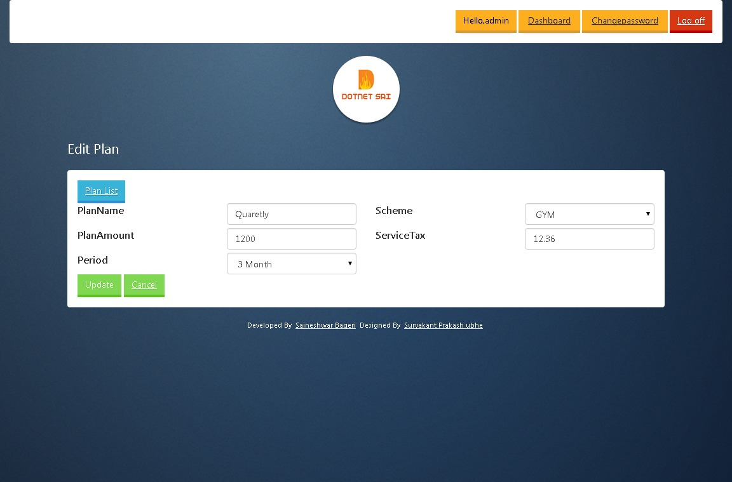

Finally after Completing all View now let’s move towards report to have look on it.

**Month wise Report**

The first report which we are going to see is **Month wise Report** In this report we are going to display all Fee collected in particular month.

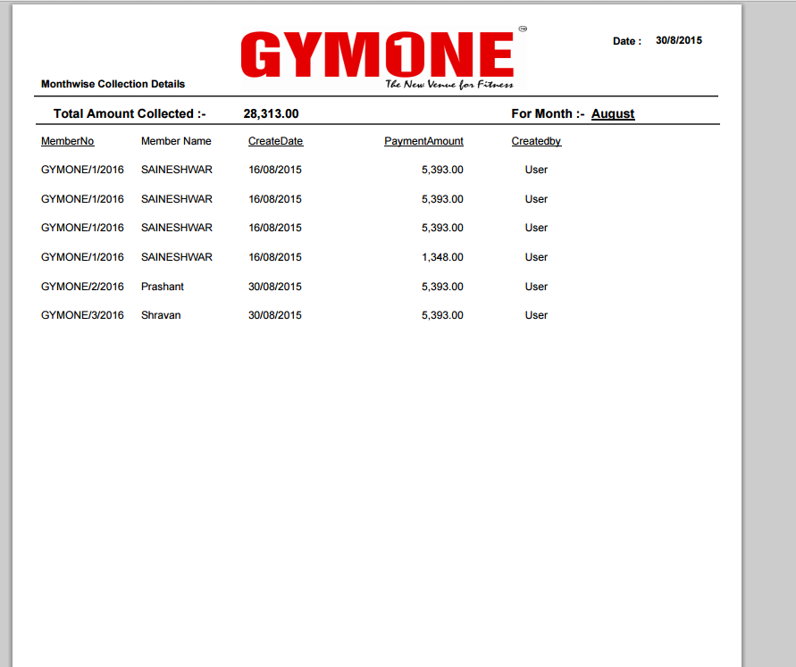

**Year wise Report**

The second report which we are going to see is **Year** **wise Report** In this report we are going to display all Fee collected in particular Year.

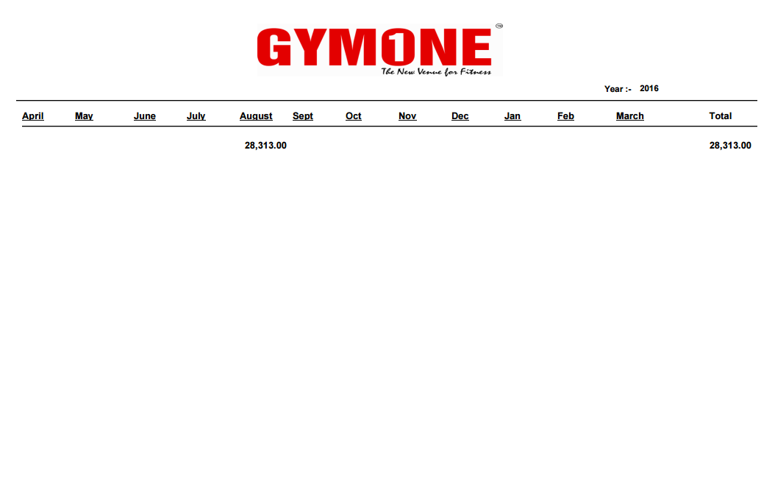

**Details Report**

The Third report which we are going to see is **Details Member Report** in this report we are going to display all Members which are registered in GYM.

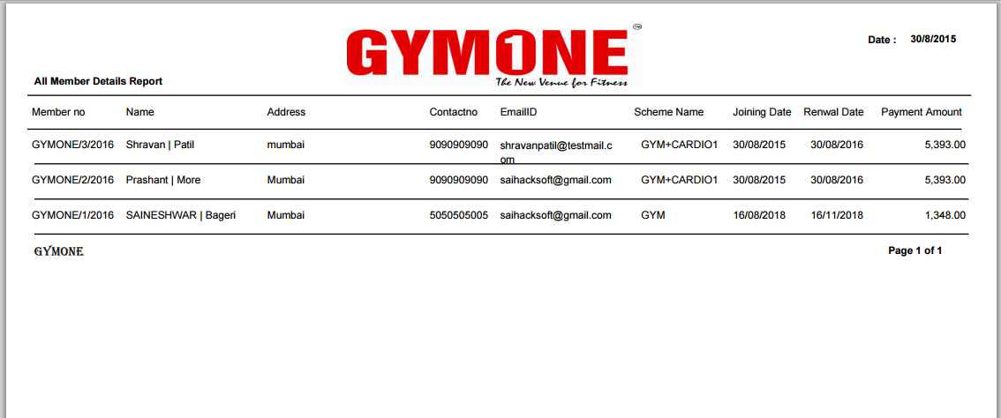

**Payment Receipt**

The Fourth report which we are going to see is **Payment Receipt.**

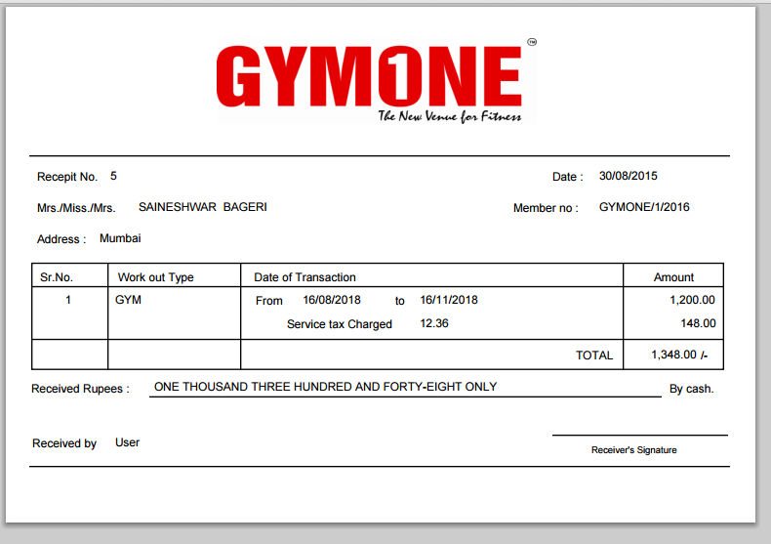

**Declaration Form**

The Fifth report which we are going to see is **Declaration Form.**

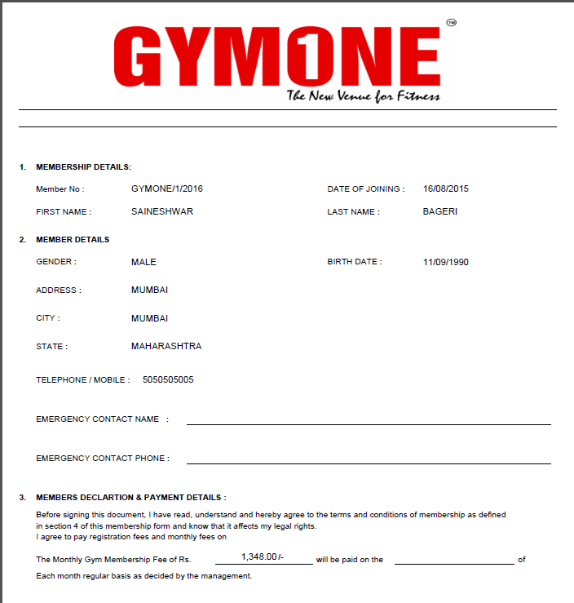

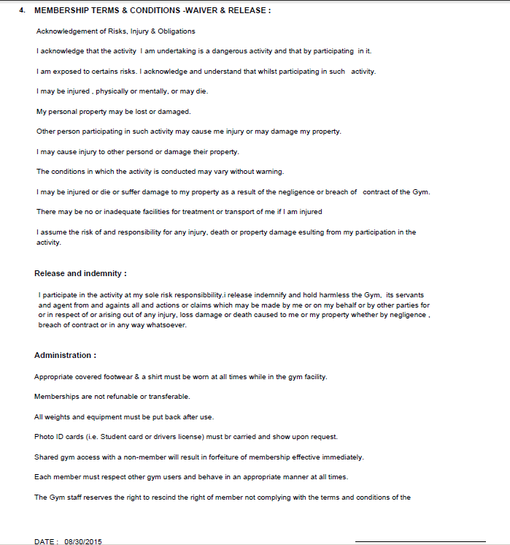

Finally we have completed Project Successfully and I think that people who are new to MVC have learnt a lot from this project.



Name :- Saineshwar Bageri

Bio

I am Software Developer and MVP from c-sharpcorner working on .Net Web Technology ( Asp.net , C# , Sqlserver , MVC , Windows ,Console Application, javascript , jquery , json , ORM Dapper) and also freelance developer.

Connect me on c-sharpcorner.

<http://www.c-sharpcorner.com/Authors/4d9083/saineshwar-bageri.aspx>

Connect me on Facebook.

<https://web.facebook.com/saineshwar.bageri>

Connect me on LinkedIn.

<https://in.linkedin.com/pub/saineshwar-bageri/40/4/352>

Connect me on twitter.

<https://twitter.com/saihacksoft>

Connect me on Blogger.

<http://dotnet-sai.blogspot.in/>