**CSE 5344 COMPUTER NETWORKS**

PROJECT – 1

Web Proxy Server - Caching

STUDENT ID : 1001165700

NAME: RAJARAMAN GOVINDASAMY

1. Calculate and Display RTT for the client request.Do you see variation in time when object was cached?Yes/No give reasons.(2.5 points)

Yes. The variation is seen and observed less when fetched from cache.

1. (b) Print the relevant server details on client side The examples could be Host Name of the server, socket family, socket type, protocol, timeout

Capured in LOG FILE.

1. Print the relevant client details on server side The examples could be Host Name of the client, socket family, socket type, protocol, timeout

Captured in LOG FILE.

SCREENSHOT BEFORE STARTING THE PROGRAM:

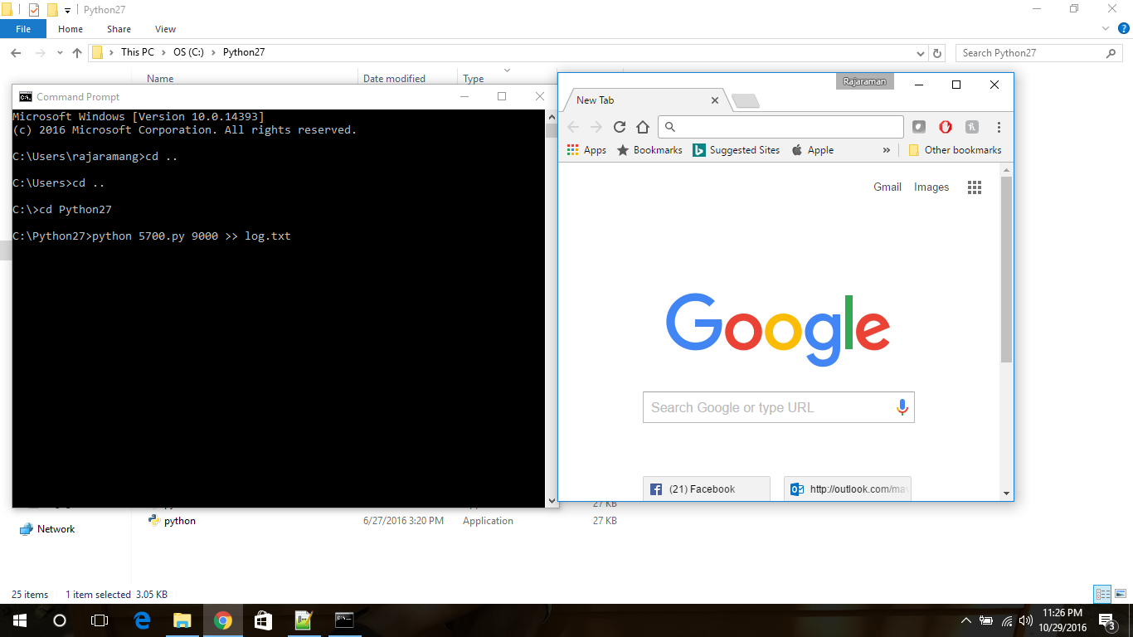

SCREENSHOT 1:

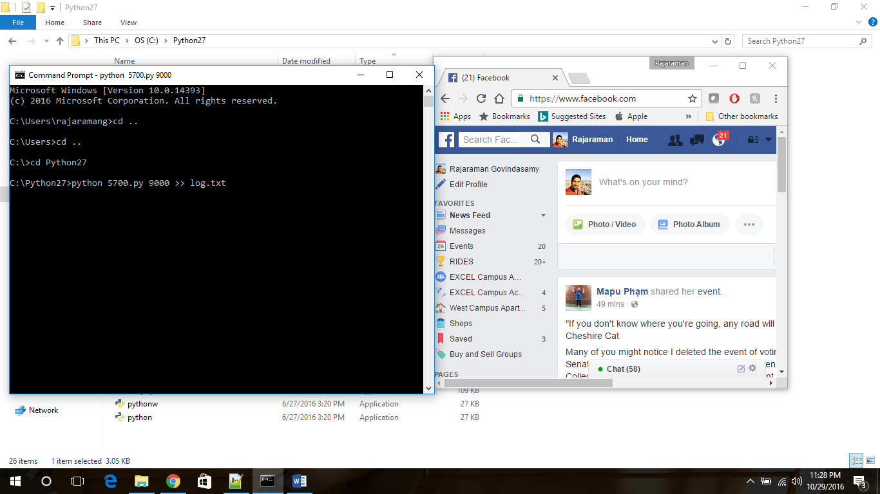

SCREENSHOT 2:

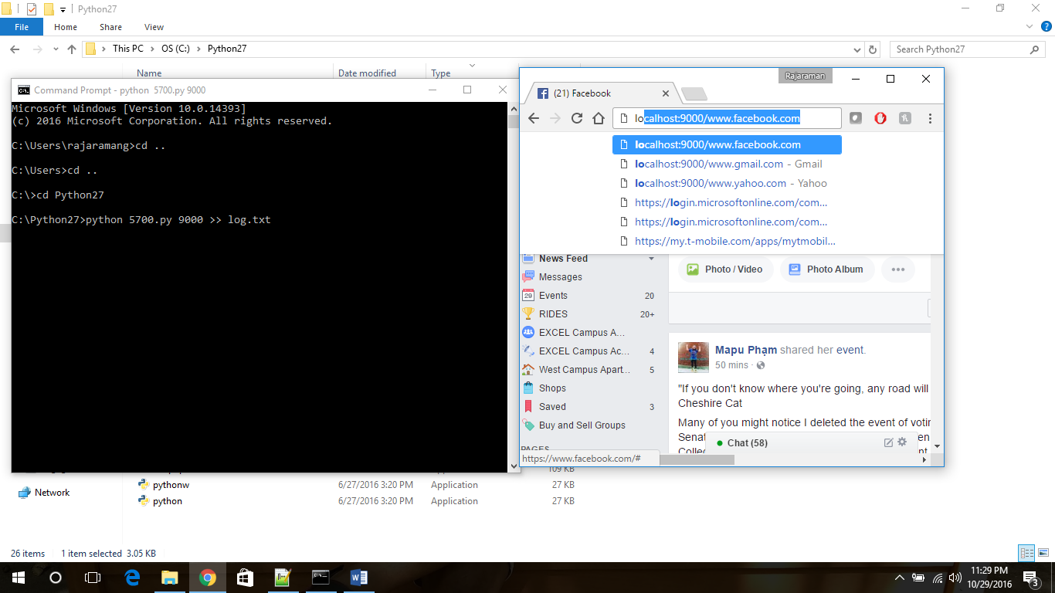

SCREENSHOT 3:

