Agentic AI Actuarial Application Platform
Reference architecture, model creation data flow and Claude tooling
Draft for review · November 2026
Contents
1. Summary 2
Key design decisions 2
What reviewers need to decide 2
2. Reference architecture 3
Platform zones 3
Architecture principles 3
3. Use case: create an actuarial model 5
Process steps 5
Human checkpoints 5
Data stores 6
4. Claude tooling 8
Options not used 8
Bedrock limits and platform answers 8
Models 8
5. Open items 10
Appendix: terms 11

1. Summary
This document describes a proposed platform for actuarial work using Claude-based AI agents on AWS, and asks reviewers to confirm its design and resolve the open items in Section 5. It is written for architecture, security, actuarial and model risk reviewers.
The platform lets actuaries build, validate and report on models with AI assistance, while keeping each business unit (BU) isolated and leaving calculation, approval and sign-off where they belong. It is described in three views:
- Reference architecture (Section 2): what the platform is made of.
- Create an actuarial model (Section 3): how data moves from a model change request to a signed-off model.
- Claude tooling (Section 4): which Claude tool runs where, and what each can reach.

Key design decisions
Decision | Rationale
Claude Code is used to write code, not to run production agents | Keeps developer tooling separate from governed runtime processes.
Runtime agents use the Anthropic SDK and Tool Runner, hosted on Amazon Bedrock AgentCore | The platform controls tools, approvals and audit logging, which model risk review needs.
Claude Agent SDK runs only in CI | Provides automated PR review and documentation drafts, with no access to data.
All Claude traffic passes through one LLM Gateway to Amazon Bedrock | Gives one point for quotas, PII filtering, cost metering and logging.
Agents act only through MCP servers | Access is BU-scoped, uses short-lived credentials and is audited on every call.
AXIS remains the calculation engine | Claude prepares, monitors and explains runs. It does not calculate results, so they stay deterministic and reproducible.
Managed Agents is not used | It is not available on Bedrock, and its default sandbox runs outside the BU accounts.

What reviewers need to decide
Three open items affect the design most: how far Claude Code can reach into data, whether Claude Desktop stays, and how AXIS grid computing runs in the target architecture. Section 5 lists these and the other open items, each with a recommendation.

2. Reference architecture
Figure 1 shows the whole platform. Each BU has its own workspace account, created from a standard blueprint by a shared Control Plane. Agents in a workspace reach enterprise data only through MCP servers scoped to that BU.

Platform zones
Zone | Purpose | Main components
1. Actuarial User Access | How people reach the platform and stay in control | Claude Code, Claude Desktop, project context, enterprise identity provider, human-in-the-loop approvals
2. Control Plane Account | Shared services across all BUs | Workspace provisioning, guardrails, LLM Gateway, HashiCorp Vault, observability and audit, platform registry, FinOps, Model Risk Evidence Store, network hub
3. BU Workspace Account | Isolated environment for each BU, such as Life, Annuity or Group | AgentCore runtime and agents, domain services, SageMaker, React Actuarial Portal, Step Functions / Batch, MCP servers, BU storage
4. Enterprise Data Platform | Analytics and systems of record, over private connectivity | Snowflake Bronze, Silver and Gold layers, Cortex AI, SQL Server (GGY AXIS), Oracle Exadata, CDC and batch ingestion
5. Enterprise Engineering Tools | Source control, delivery and documentation | GitHub, security scanning, Jira, Confluence, SharePoint, artifact registry
6. Reporting and BI | Governed reporting from Snowflake | Sigma, Power BI, MicroStrategy

Architecture principles
- BU isolation: separate account, KMS keys, Snowflake roles and MCP scopes per BU.
- Agents act only through MCP; no direct database credentials on laptops.
- Snowflake is the agent query surface; OLTP is read-mostly via MCP, written only through validated domain APIs.
- Short-lived, Vault-issued credentials bound to the user's identity.
- All LLM traffic goes through the LLM Gateway (quotas, PII filters, cost metering).
- Every prompt, tool call and data change is logged and retained as model-risk evidence.
- Human approval for writes, run submissions and published results.
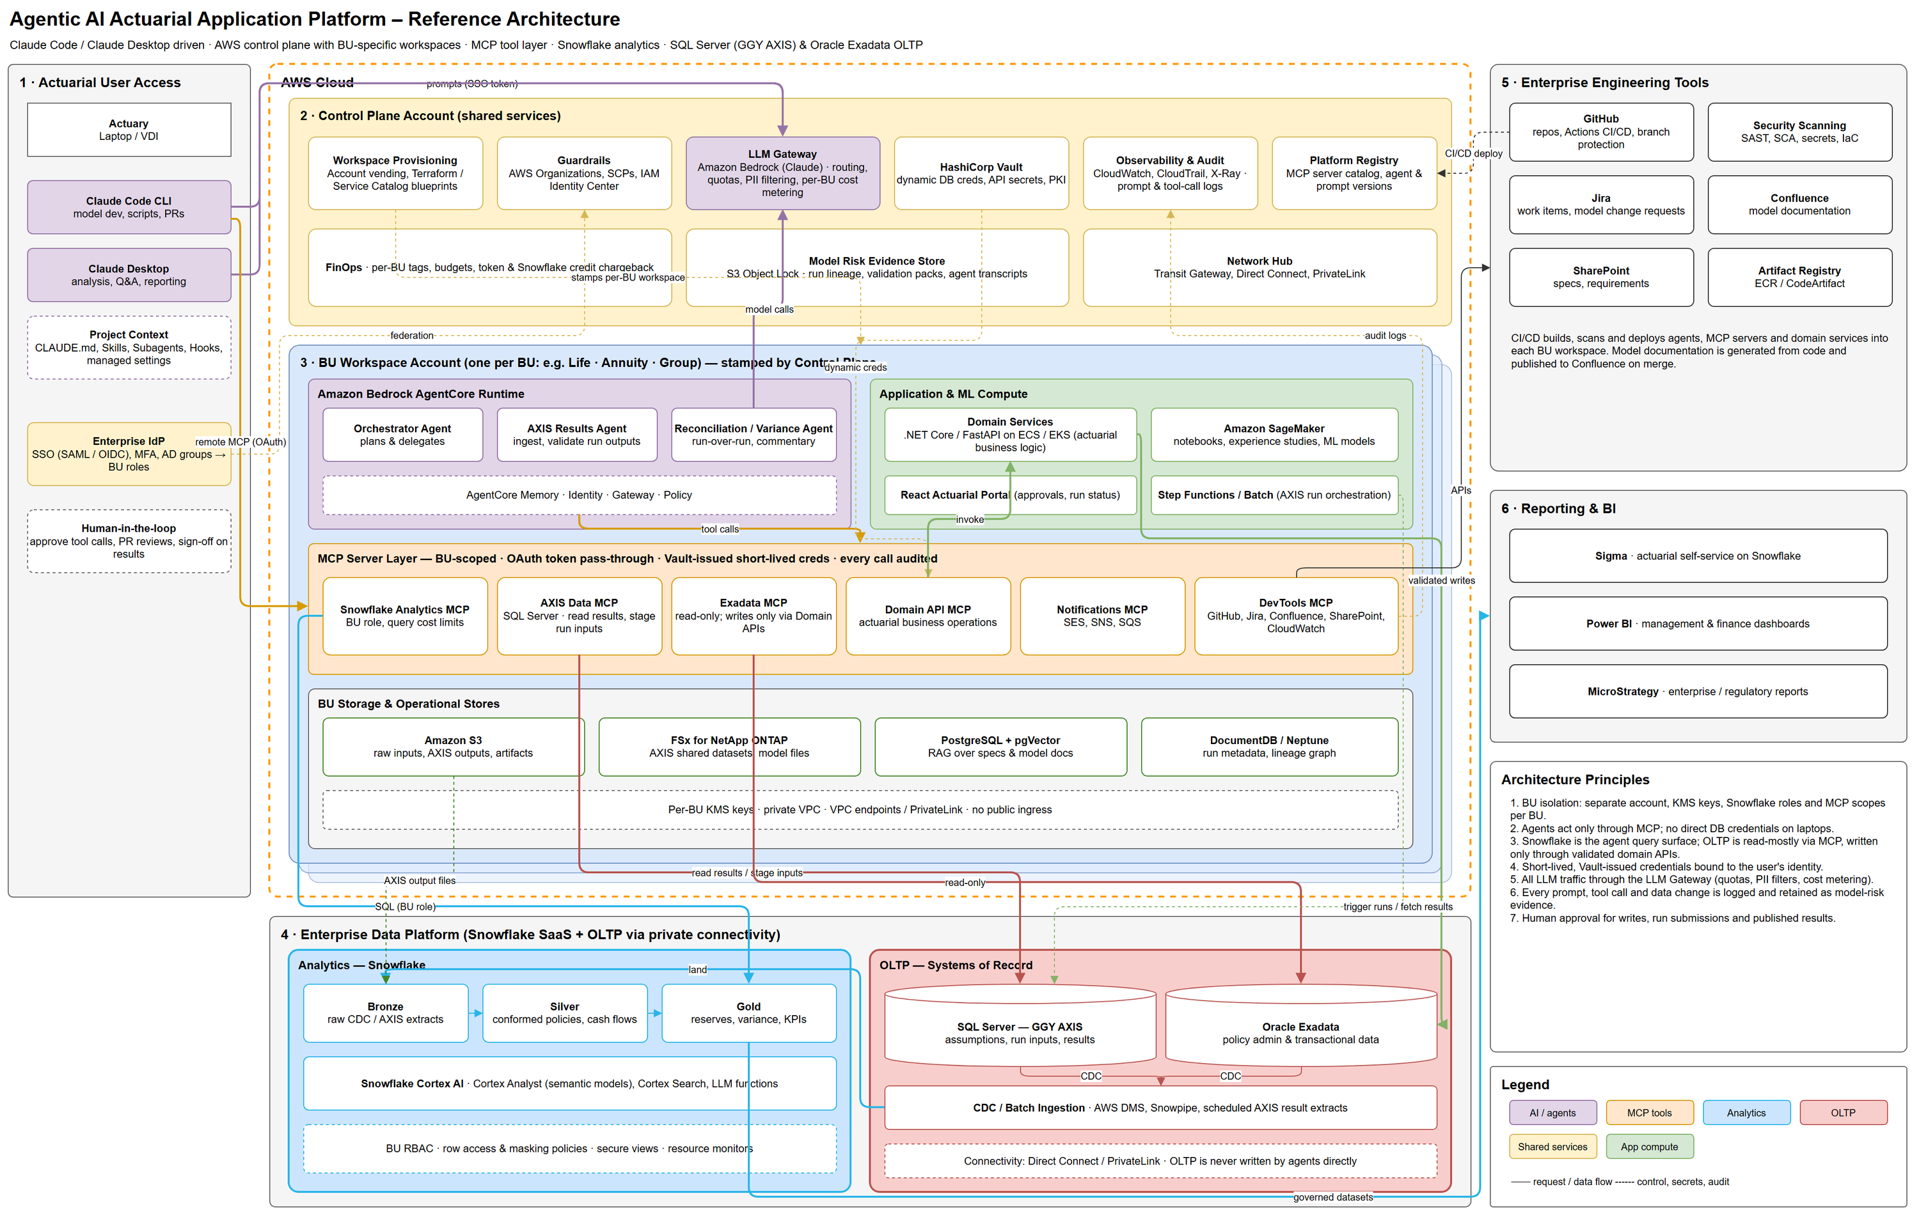
Figure 1. Platform reference architecture

3. Use case: create an actuarial model
Figure 2 traces one model from an approved model change request in Jira to a versioned, documented and independently signed-off model. For this document, a "model" means a package of model code, assumption tables, AXIS run configuration and tests.
The flow crosses three trust boundaries: dev-time, CI-time and runtime. Runtime here is a test environment. Production data and production writes stay out of scope until sign-off, and the approved version then moves to production through the same CI/CD path.

Process steps
Step | Activity | Performed by | Result
1 | Capture requirements | Claude Code, with the actuary | Scope, regulatory basis, acceptance tests
2 | Design model | Claude Code, with the actuary | Proposed structure and assumptions, based on masked data
3 | Generate model package | Claude Code, with the actuary | Feature branch and pull request
4 | Build, test, scan | GitHub Actions | Unit test and security scan results
5 | Review PR, draft docs | Claude Agent SDK | Review findings and draft model documentation
6 | Approve, merge, release | Peer reviewer, GitHub Actions | Release candidate; documentation published on merge
7 | Orchestrate validation | Orchestrator Agent | Test run plan and run submission
8 | Execute model run | Domain Services, Step Functions / Batch | AXIS results (see Section 5, item 3)
9 | Validate results | AXIS Results Agent | Completeness and control checks
10 | Reconcile to baseline | Reconciliation / Variance Agent | Variance explanations and draft commentary
11 | Review and sign off | Model Risk Approver, in the React Actuarial Portal | Sign-off, lineage and validation pack stored as evidence

Human checkpoints
- Actuary (steps 1 to 3): sets intent and approves tool calls and edits.
- Peer reviewer (step 6): a second actuary approves the pull request. Branch protection enforces this, and review comments return to step 3.
- Model Risk Approver (step 11): independently signs off before any production release.

Data stores
ID | Data store | Contents
D1 | Requirements (Jira, SharePoint) | Model change requests and specifications
D2 | Snowflake Sandbox | Masked, non-production data
D3 | GitHub Repository | Feature branch and pull request
D4 | Confluence | Model documentation
D5 | Artifact Registry | Versioned release candidate
D6 | SQL Server, GGY AXIS | Test instance: run inputs and results
D7 | Amazon S3 | AXIS output files
D8 | Snowflake Validation Schema | New results and approved baseline
D9 | Model Risk Evidence Store | Immutable lineage, validation packs, sign-offs and agent transcripts

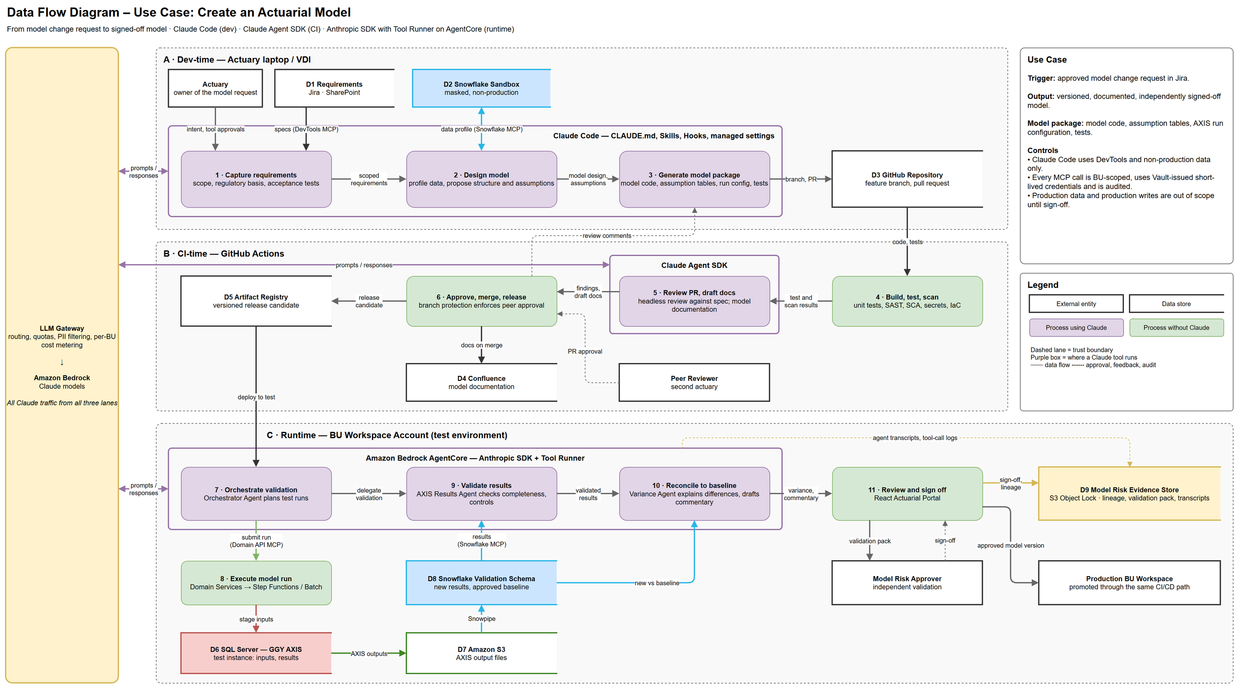
Figure 2. Data flow for creating an actuarial model

4. Claude tooling
Figure 3 shows the three Claude tools side by side. They run at different times and never interact in a single sequence, so each has its own lane, access scope and block list. All three reach Claude only through the LLM Gateway.
Lane | Claude tool | Started by | Can reach | Blocked
Dev-time | Claude Code | Actuary or engineer | DevTools MCP; Snowflake Analytics MCP (non-production scope) | Production Snowflake, AXIS, Exadata and Domain API MCPs
CI-time | Claude Agent SDK | Pull request event | DevTools MCP | Data MCPs, production access, merge rights
Runtime | Anthropic SDK with Tool Runner, on AgentCore | Actuary through the portal, or a schedule | Snowflake, AXIS Data, Exadata (read-only), Domain API and Notifications MCPs | Writes, run submissions and published results need human approval

Options not used
- Managed Agents: not available on Bedrock. Its default sandbox runs on Anthropic infrastructure, which conflicts with per-BU account and private-VPC isolation.
- Claude Platform on AWS: held in reserve for features Bedrock lacks. Anthropic operates it, so it needs its own data-governance review.
- Claude Desktop: not shown in Figure 3, because the decision is pending (Section 5, item 2).

Bedrock limits and platform answers
Not available on Bedrock | Platform answer
Message Batches | Own queue with Step Functions
Hosted code execution | SageMaker or own compute
MCP connector | Agents call MCP servers from their own code
Server-side fallbacks | SDK client-side fallback for refusals
Task budgets | Token limits in the LLM Gateway
Files API, API-side Agent Skills, web tools | Not used
Based on Anthropic’s October 2026 reference; confirm against the live documentation.

Models
- Default: Claude Opus 5.5 for agents and hard coding work.
- To test: Sonnet 5.5 or Haiku 5.5 on high-volume steps, compared on cost per completed task.
- To confirm: availability in the Bedrock regions the platform will use.
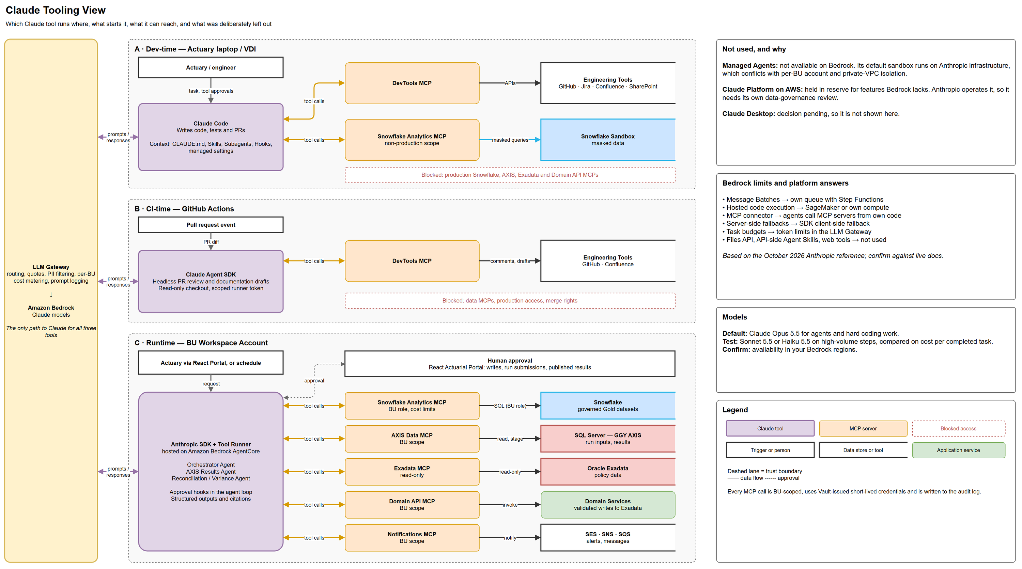
Figure 3. Claude tooling view

5. Open items
The three views are not yet fully consistent. The items below need a decision or confirmation before the architecture is finalized.
# | Item | Why it matters | Recommendation
1 | Claude Code data access | Figure 1 connects Claude Code to the whole MCP layer. Figures 2 and 3 limit it to DevTools and non-production data. | Narrow the Figure 1 connection to match, which also supports principle 2.
2 | Claude Desktop | Figure 1 includes it for analysis and reporting, but it is not in Figures 2 or 3. Routing it through Bedrock and the LLM Gateway is unconfirmed. | Either apply the same gateway and audit controls, or move this work to the React Actuarial Portal.
3 | AXIS grid execution | No figure shows the compute layer. Large runs need grid-scale parallel computing, and Step Functions / Batch only orchestrates them. | Add an AXIS grid layer. Assess Moody's Enterprise GridLink first, then GlaaS (Grid Link as a Service) or AXIS Cloud, keeping any on-premises grid as an interim step.
4 | AXIS on AWS | Moody's public material emphasizes Azure and does not confirm AWS for Enterprise GridLink. Another cloud would add networking, data transfer and egress controls. | Confirm AWS support, licensing and sizing with Moody's, and benchmark with real models.
5 | Policyholder data | A Moody's-managed option may move this data outside the BU accounts. | Complete a data-governance review before choosing an option.
6 | AXIS output path | Figure 2 shows outputs moving from SQL Server to S3 and then Snowflake. | Confirm how the chosen AXIS deployment writes results.
7 | Test environment | The Snowflake Sandbox, Validation Schema and AXIS test instance appear in Figure 2 only. | Confirm they exist or plan them, then add them to Figure 1.
8 | Agent SDK in CI | Figure 1 does not show the Claude Agent SDK. Read-only checkout, a scoped runner token and no merge rights are recommended settings, not agreed design. | Add it under zone 5 with its LLM traffic through the gateway, and adopt the settings as CI policy.
9 | Agent evaluation | No figure shows how agents are tested before prompt or model changes are released. | Add an evaluation step and keep the results in the Model Risk Evidence Store.
10 | Scope and roles | The definition of a "model" is an assumption, and Peer Reviewer and Model Risk Approver are placeholder roles. | Confirm the scope and replace the placeholders with actual roles. A SageMaker or experience-study model would change steps 8 to 10.

Appendix: terms
Term | Meaning
AXIS | GGY AXIS, the actuarial modeling system used for run calculations.
BU | Business unit, such as Life, Annuity or Group.
CDC | Change data capture: copying data changes from source systems as they happen.
CI/CD | Automated build, test and deployment of software.
LLM Gateway | The shared service that all Claude traffic passes through.
MCP | Model Context Protocol: the standard way agents call tools and data sources.
OLTP | Transactional systems of record, here SQL Server and Oracle Exadata.
PR | Pull request: a proposed code change submitted for review.
Tool Runner | A part of the Anthropic SDK that runs the agent loop over tools the platform defines.

