REFERENCE ARCHITECTURE

Power Automate → FSx for ONTAP
How a Power Automate flow's file-system action reaches an SMB share on Amazon FSx for NetApp ONTAP — relayed through an on-premises data gateway running inside the VPC, which authenticates to Active Directory on both ends of the hop.

Architecture Overview
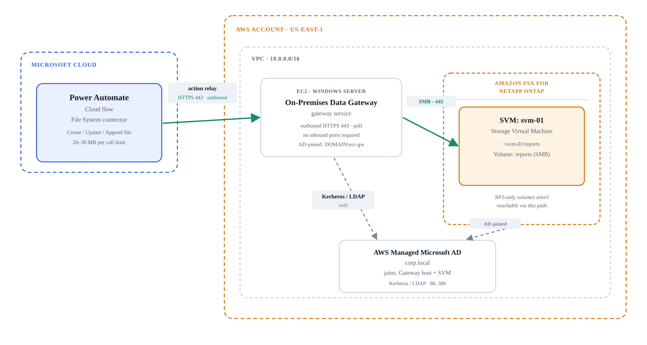
- Data path — file write over SMB (teal, solid)
- Auth path — Kerberos / LDAP to Active Directory (grey, dashed)
The flow's file-system action doesn't reach AWS directly — the gateway service polls Microsoft's cloud over an outbound-only HTTPS connection, receives the action, then executes the file write locally over SMB against the ONTAP storage virtual machine. Names shown (svm-01, corp.local, DOMAIN\svc-gw) are illustrative placeholders.

Ports, Protocols, and Limits
Cloud ↔ gateway | Outbound HTTPS 443, gateway-initiated poll — no inbound firewall rule needed on the VPC side.
Gateway ↔ storage | SMB over TCP 445, addressed as a UNC path such as \\svm-01\reports.
Authentication | Kerberos/LDAP against Active Directory; the gateway connection stores a DOMAIN\user credential pair.
Protocol requirement | The SVM must expose the target volume as an SMB share — NFS-only exports aren't reachable through this connector.
Per-call size limits | 20 MB on Create file, 30 MB on Update file (File System connector ceiling).
Throttling | ~100 calls / 60s and 1000 MB / 60s, enforced per gateway connection.
Gateway placement | A domain-joined Windows host with network access to the SVM — typically an EC2 instance in the same VPC, or reachable via peering / Direct Connect.
Connection scope | Gateway connections aren't shareable — each flow author configures their own against the registered gateway.

Installing the Gateway Service on an EC2 Instance
1. Provision the EC2 instance. Use a Windows Server AMI (2019, 2022, or 2025 — not Server Core, and not a domain controller). Microsoft's baseline is 8 vCPU / 8 GB RAM with SSD-backed storage for good throughput. Place it in a subnet with a route to your FSx for ONTAP SVM and outbound internet access via an internet gateway or NAT gateway — the gateway only calls out to Microsoft, never in.
2. Domain-join the instance. Since the File System connector authenticates to the SVM via Kerberos, this EC2 host must be joined to the same Active Directory as the SVM — AWS Managed Microsoft AD or self-managed AD, whichever the SVM uses. Do this via the standard domain-join workflow, or AWS Directory Service's seamless EC2 join if using Managed AD.
3. Open outbound firewall / security-group rules. Allow outbound TCP 443 and 80 (auth, download, connectivity checks), 5671–5672 (AMQP messaging), and 9350–9354 (Azure Relay), directed at *.servicebus.windows.net and the Microsoft login/download domains. No inbound rule is needed for the gateway itself — only a temporary, IP-scoped inbound RDP (3389) rule for the install.
4. RDP in and run the installer as a local admin. Download the standard gateway installer from Microsoft, keep the default install path, accept the terms, and install.
5. Sign in with a Microsoft work/school account. Use an account in your organization's Microsoft Entra ID tenant — the same tenant your Power Automate environment belongs to — not a personal Microsoft account.
6. Register the gateway. Choose “Register a new gateway on this computer,” give it a tenant-unique name, and set the region. Store the recovery key issued at this step in Secrets Manager or a password vault — Microsoft cannot recover it if lost, and it's required to add a second gateway to the same cluster later.
7. Assign gateway admins. In the Power Platform admin center, add whoever needs to manage the gateway or create connections through it — connections themselves aren't shareable, so each flow author configures their own.
8. (Optional) Add a second gateway for HA. Repeat steps 1–6 on a second EC2 instance, choosing “Add to an existing gateway cluster” and supplying the first gateway's recovery key — this removes the single point of failure.
Note for reusable-pattern documentation: Microsoft recommends against installing the gateway on a machine that is frequently turned off, asleep, or disconnected. If this becomes a standard pattern, exclude the gateway host from any scheduled stop/start instance automation.

Sources
Install an on-premises data gateway — Microsoft Learn: https://learn.microsoft.com/en-us/data-integration/gateway/service-gateway-install
Adjust communication settings for the on-premises data gateway — Microsoft Learn: https://learn.microsoft.com/en-us/data-integration/gateway/service-gateway-communication
File System connector reference — Microsoft Learn: https://learn.microsoft.com/en-us/connectors/filesystem/
Managing FSx for ONTAP resources using NetApp applications — AWS Docs: https://docs.aws.amazon.com/fsx/latest/ONTAPGuide/managing-resources-ontap-apps.html

