Before going to actual test plan, when I go through the given requirements I understood the requirement in 2 different ways.

1. One is to test the given apis with different combinations of query parameters and take care of different validations, etc. I followed this finally because of the points I mentioned in #2 below.
2. Second is, as per my understanding an end user who consumes the said APIs will have a form to accept the parameters, they prepare a fully-qualified URL and pass to get direct so there is a chance we get invalid URL without replacing blanks or special characters , wrong key-value pairs, etc.   
   Example valid URL we get from user is  <https://itunes.apple.com/search?term=jack+johnson>  
   This URL works fine when we hit from browser. But I see we get empty response when I pass it like below from RestAssured. So I choose requirement as #1 as mentioned above.

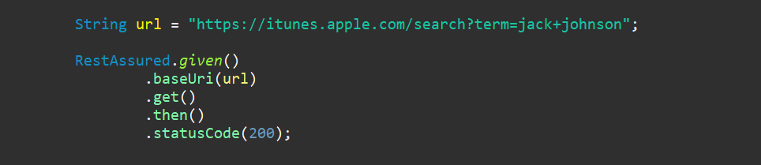

**Test Plan for iTunes Search API**

**Introduction:**

The Search and Lookup APIs allows developers to integrate search functionality for content within the Store, App Store, iBooks Store, and Mac App Store into their websites or applications. This test plan includes the approach for testing the functionality of the Search and Lookup APIs using automated API tests written in Java, TestNG, and Maven.

**Objectives:**

The primary objectives of this test plan are as follows:

1. To ensure the Search API works correct
2. To ensure the Lookup API works correct
3. To ensure the API returns search results based on various query parameters combinations
4. To ensure specifications and requirements as provided in the documentation are met

**Test Scope:**

The scope of testing Search and Lookup APIs includes:

1. API functionality with different combinations of query parameters
2. Response validation for valid, invalid data
3. Error handling and verification of status codes

**Test Environment:**

1. Programming Language: Java
2. Test Framework: TestNG
3. Build Automation: Maven
4. Test Data: Various test cases with different parameters using DataProvider
5. Automation using: RestAssured

**Test Strategy:**

The test strategy for the Search and Lookup APIs includes the following phases:

1. Test Case Preparation
   * Identify and create test cases including positive and negative cases
   * Identify and create test cases for invalid data and verify proper status codes are returned
   * Document the expected results
2. Test Data Preparation
   * Prepare test data with different combinations of search parameters
   * Include test data for different media types, countries, etc.
3. Test Automation
   * Develop Java-based automated tests using TestNG and Maven
   * Implement test cases to send API requests and validate responses
4. Test Execution
   * Execute the automated tests using the Search and Lookup APIs
   * Record test execution results, including pass/fail status and any deviations from expectations
5. Performance and Load Testing
   * Out of scope
6. Reporting
   * For now we depend on testing report. We can enhance with Extent reports in future
   * Document any defects or issues

**Test Cases**

**Search API:** Below are few sample test cases

1. Search API should return valid response when search is performed with valid artist
2. Search API should return valid response when search is performed with valid artist and language
3. Search API should return valid response when search is performed with valid artist and country
4. Verify API returns data based on given parameters only
5. API should return bad request when term is not provided
6. API should return bad request when invalid language provided
7. API should return bad request when invalid country provided
8. API should return bad request when invalid entity provided
9. etc

**Lookup API:** Similar tests with different combinations for Lookup API

**Test Deliverables**

The following deliverables will be produced during and after testing:

1. Test Plan Document
2. Automated test scripts written in Java using TestNG and Maven
3. Test execution reports with detailed test results
4. Defect reports

**Conclusion**

This is the detailed outline of the approach to test the Search and Lookup APIs using automated API tests. Aim is to ensure the APIs are reliable, correct, and are complying with the requirements documents given.