**EX.NO:**

**DATE:**

**ZOHO WORKERLY**

**AIM:** To design scheduler and personal information management using zoho workerly.

**ALGORITHM:**

**STEP 1:** Open the browser and login zoho.com.

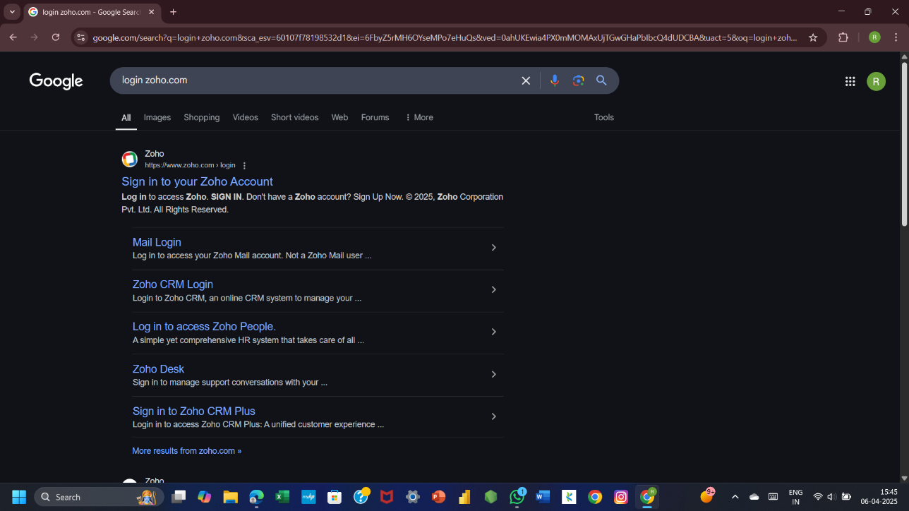

**STEP 2:** Click CRM in home page.



**3:** Enter the company name and phone number in the dialog box.

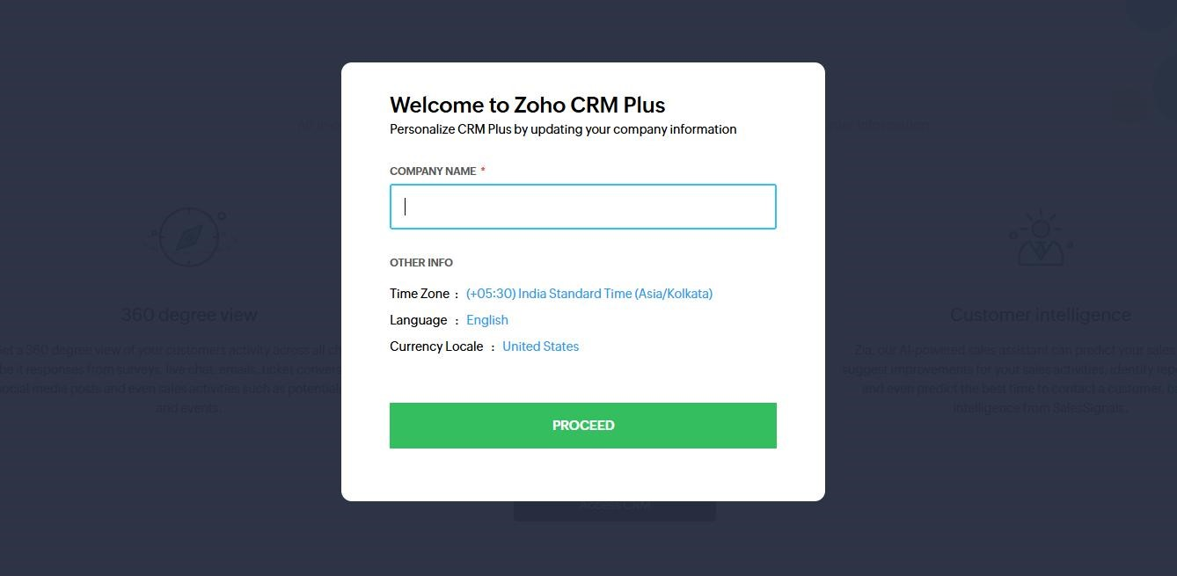

**STEP 4:** Home page is opened. Click the contents on the top.

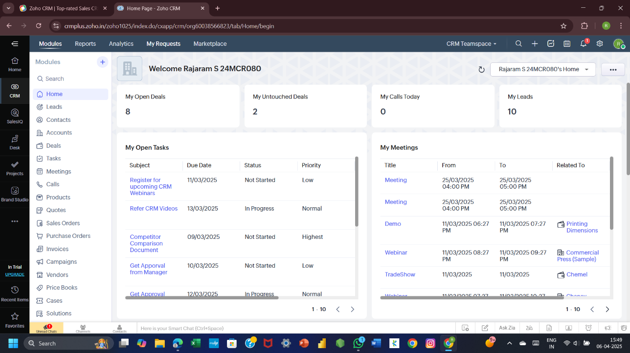

**5:** create button in the window.

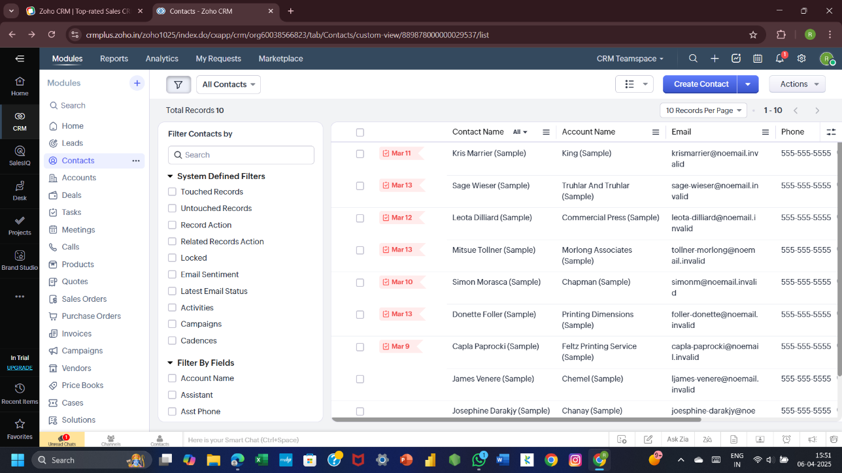

**STEP 6:** Enter the details and contact information click and save.

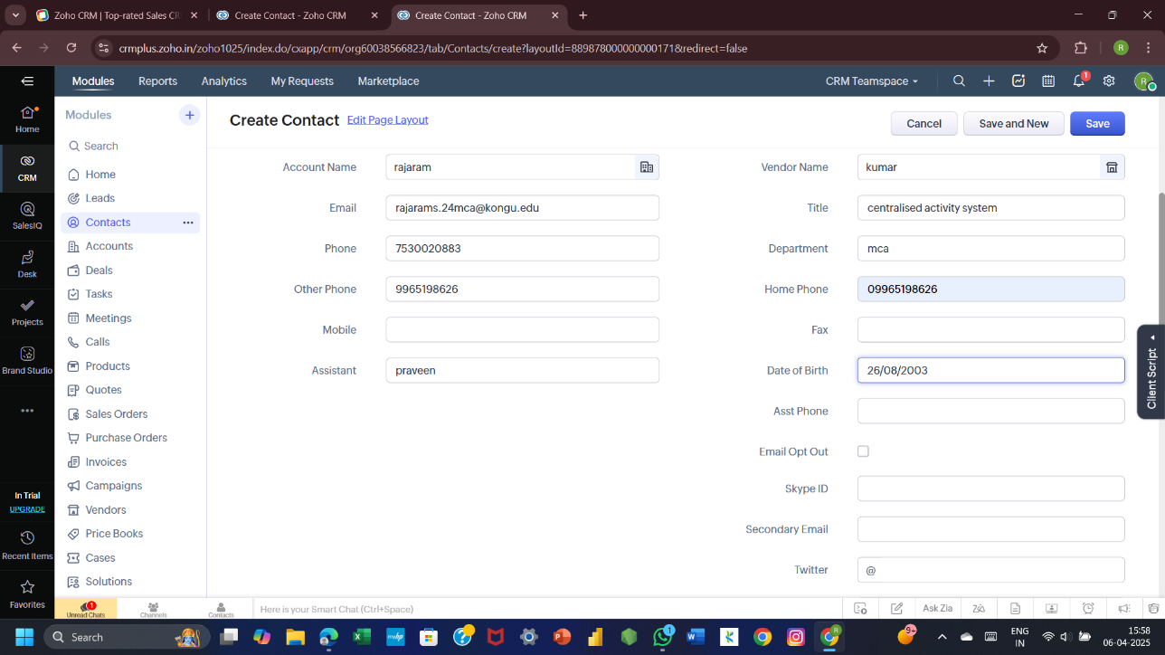

STEP **7:** task option in top.

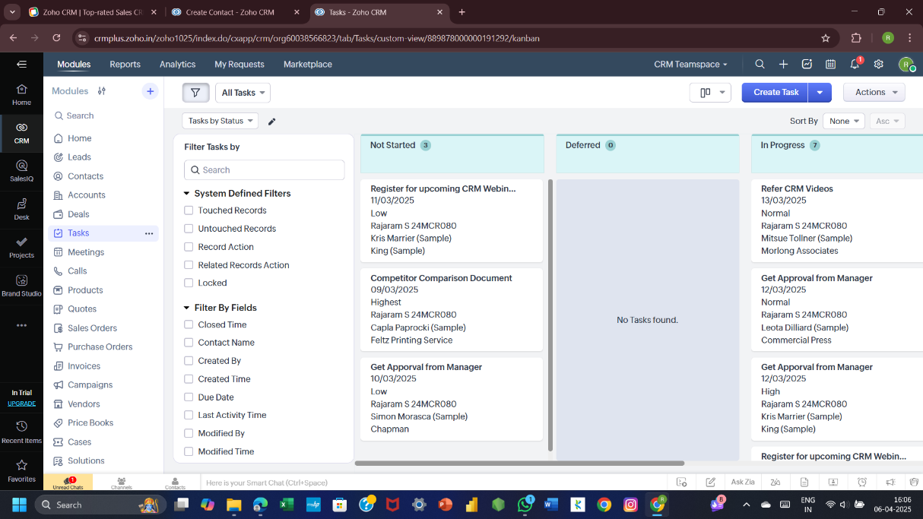

**STEP 8:** Click create task and enter details then click save.

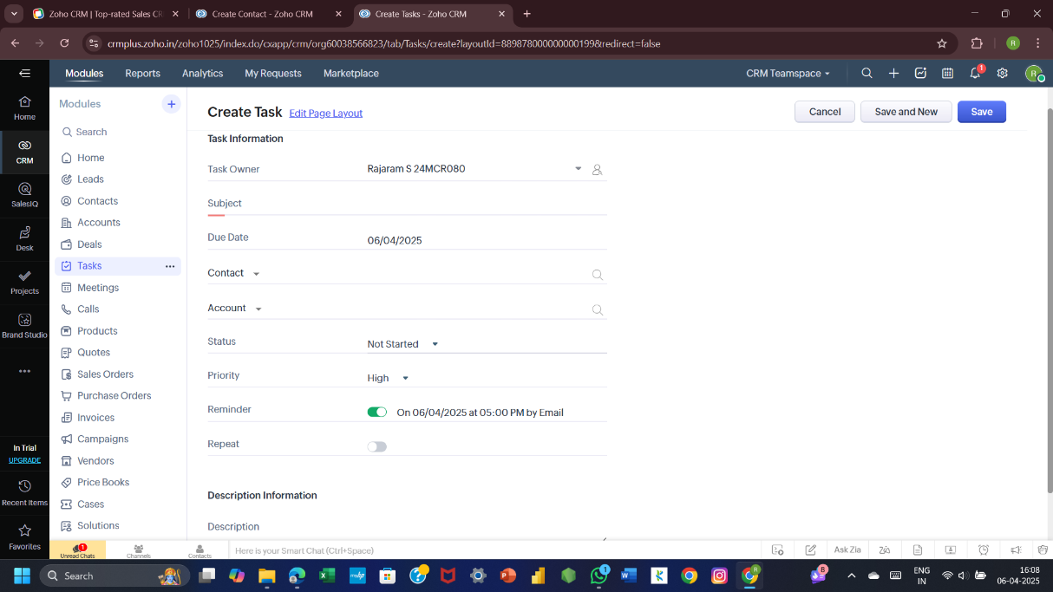

**STEP 9:** meeting option on top.

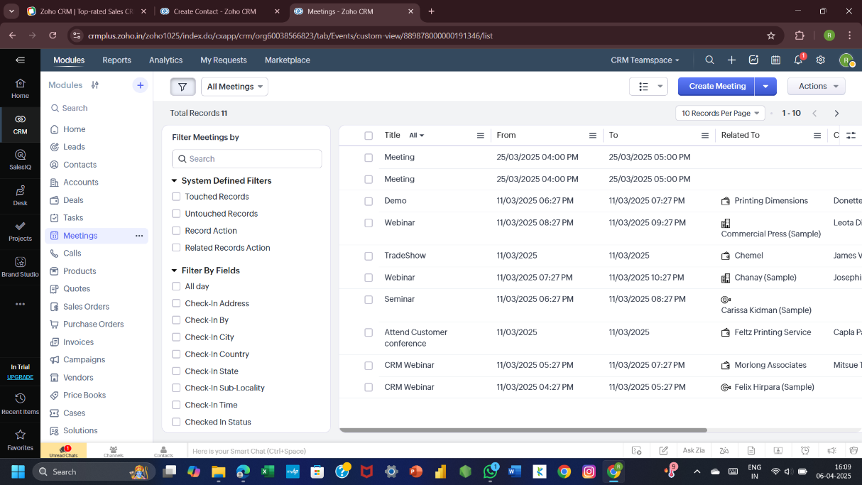

**STEP 10:** Fill details and click save.

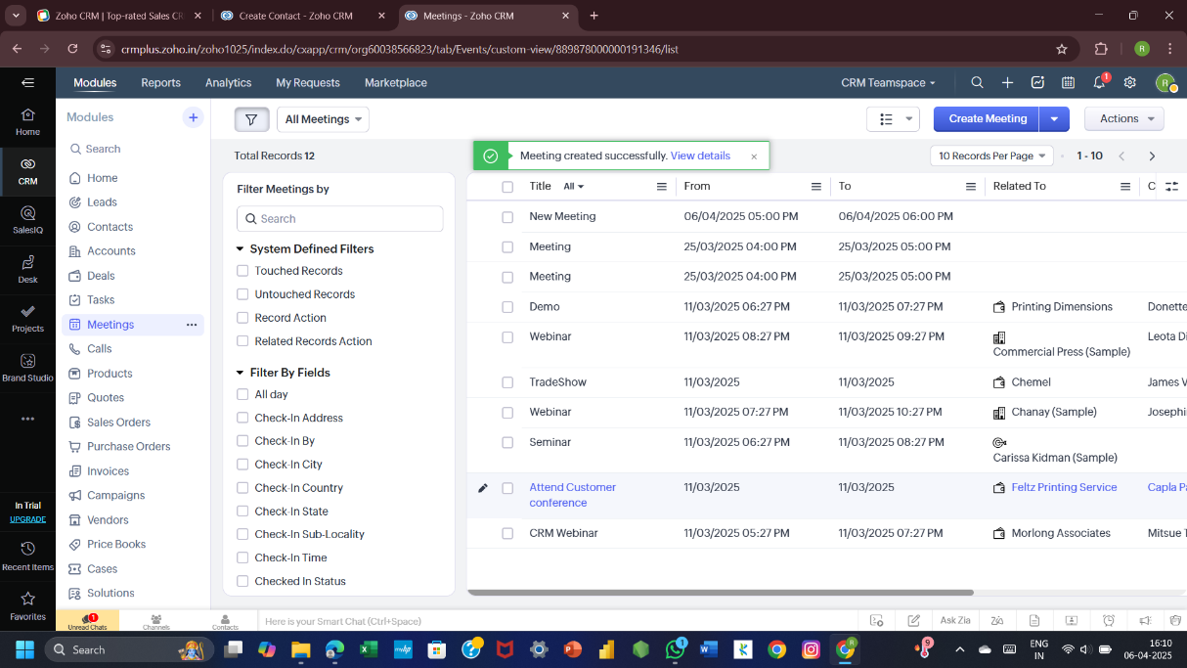

|  |  |
| --- | --- |
| COE (30) |  |
| RECORD (20) |  |
| VIVA (10) |  |
| TOTAL (60) |  |

**RESULT:**

Use Zoho Workerly to automate scheduling and manage personal info.