# **BOOTCAMP SETUP MANUAL**

## **Setup of R tools/Packages:**

1. **Tools Installation**

The following installations are required: R, RStudio (ide for R), Python, Jupyter notebook(ide for python).

1. Steps to install R:
2. Click the link : <https://cran.r-project.org/bin/windows/base/>
3. Select Download R as below:

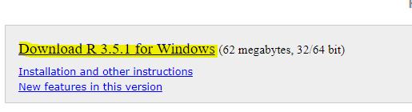

1. Run the .exe file:

In the setup wizard accept the default options and keep clicking on next, until the installation finishes. After it is completed the below windows appears, click on finish as below:

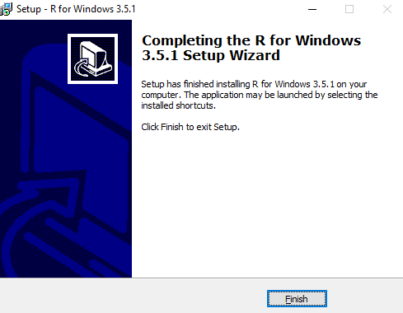

### Steps to install RStudio (IDE for R):

1. Click on the link : <https://www.rstudio.com/products/rstudio/download/>.
2. Click on download for RstudioDesktop as below:

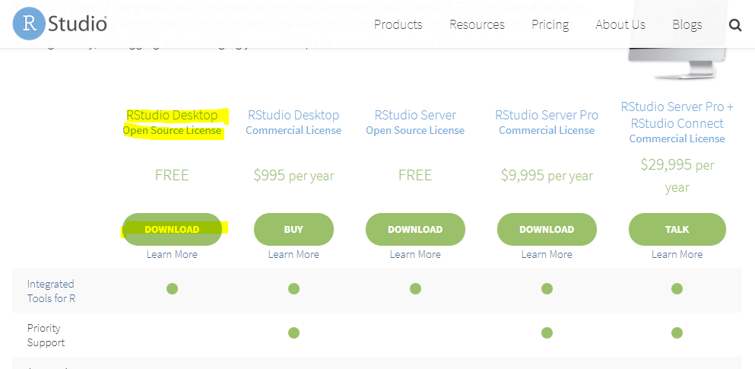

1. Select the preferred platform:

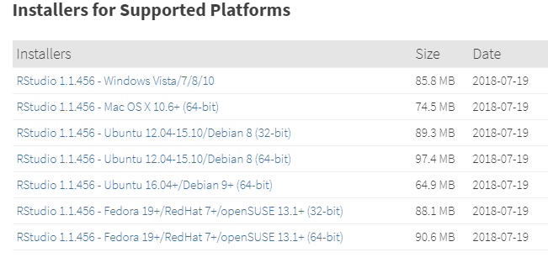

1. Run the downloaded .exe file:

In the setup wizard accept the default options and keep clicking on next, until the installation finishes.

## **Packages Installation:**

### Steps in R:

1. Open Rstudio.
2. To install package, execute the following command – install.packages(“**<package name>**”)
3. Install the following packages:

e1071   
lubridate   
lubridate   
reshape2   
magrittr   
dplyr

caret   
sampling   
randomForest

## **Setup of Python:**

## **1) Tools Installation**

### Steps to install python(v 3.6.1) :

1. Click on the link : <https://www.python.org/downloads/release/python-361/>
2. Click on windows x86-64 executable installer:

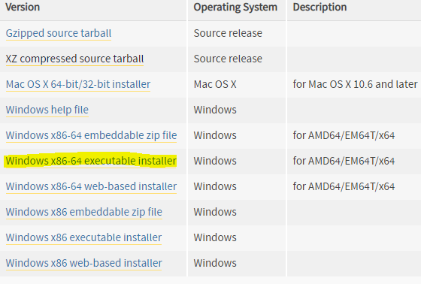

1. Open the downloaded exe, check add python to path and install now:

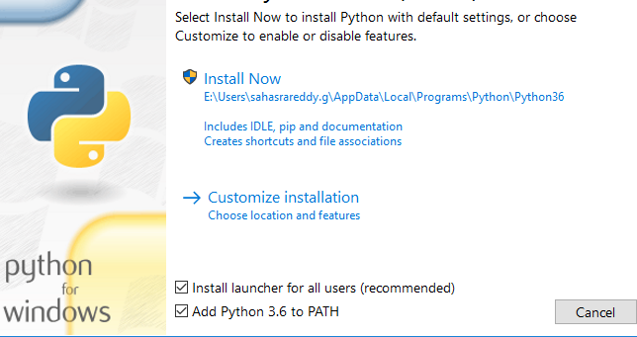

1. Finish installation with default options.

### Steps to install jupyter notebook:

Open command prompt and type the following commands:

* 1. python -m pip install --upgrade pip
  2. python –m pip install jupyter

## **2) Packages Installation:**

## A. Steps in Python:

1. From command prompt type:
   1. Pip install tensorflow
   2. pip install keras

**Pre-Reading Reference Material:**

Please find the below Pre-Reading reference material for ML Boot Camp.

Machine Learning:

[https://towardsdatascience.com/machine-learning-for-beginners-d247a9420dab](https://apac01.safelinks.protection.outlook.com/?url=https%3A%2F%2Ftowardsdatascience.com%2Fmachine-learning-for-beginners-d247a9420dab&data=02%7C01%7Csrinivasarao.v%40hcl.com%7C0dd1edcd7de8430ea17708d6332d5ca7%7C189de737c93a4f5a8b686f4ca9941912%7C0%7C0%7C636752667243950072&sdata=7LTAXhfYZvdbZ9HmeLM4ke2Jy5alITlUqPYwZf4FN8c%3D&reserved=0)

[https://towardsdatascience.com/introduction-to-machine-learning-algorithms-linear-regression-14c4e325882a](https://apac01.safelinks.protection.outlook.com/?url=https%3A%2F%2Ftowardsdatascience.com%2Fintroduction-to-machine-learning-algorithms-linear-regression-14c4e325882a&data=02%7C01%7Csrinivasarao.v%40hcl.com%7C0dd1edcd7de8430ea17708d6332d5ca7%7C189de737c93a4f5a8b686f4ca9941912%7C0%7C0%7C636752667243960085&sdata=F%2F%2Bmldls6%2Fv%2FH34SA4oQqBL9fvRaBUTuBvJ9p3NPuO4%3D&reserved=0)

[https://www.analyticsvidhya.com/blog/2017/09/common-machine-learning-algorithms/](https://apac01.safelinks.protection.outlook.com/?url=https%3A%2F%2Fwww.analyticsvidhya.com%2Fblog%2F2017%2F09%2Fcommon-machine-learning-algorithms%2F&data=02%7C01%7Csrinivasarao.v%40hcl.com%7C0dd1edcd7de8430ea17708d6332d5ca7%7C189de737c93a4f5a8b686f4ca9941912%7C0%7C0%7C636752667243980099&sdata=glhHcanSdtR9FbnHx3Ek62IKkAxC2sq9OaBkkVlHUFk%3D&reserved=0)

Neural Networks:

[https://towardsdatascience.com/a-gentle-introduction-to-neural-networks-series-part-1-2b90b87795bc](https://apac01.safelinks.protection.outlook.com/?url=https%3A%2F%2Ftowardsdatascience.com%2Fa-gentle-introduction-to-neural-networks-series-part-1-2b90b87795bc&data=02%7C01%7Csrinivasarao.v%40hcl.com%7C0dd1edcd7de8430ea17708d6332d5ca7%7C189de737c93a4f5a8b686f4ca9941912%7C0%7C0%7C636752667243990108&sdata=zzxVlNe7Y0HnFQyuTVavWS7MT0XqigHxkIoWiRHiP1c%3D&reserved=0)

[https://adeshpande3.github.io/A-Beginner%27s-Guide-To-Understanding-Convolutional-Neural-Networks/](https://apac01.safelinks.protection.outlook.com/?url=https%3A%2F%2Fadeshpande3.github.io%2FA-Beginner%2527s-Guide-To-Understanding-Convolutional-Neural-Networks%2F&data=02%7C01%7Csrinivasarao.v%40hcl.com%7C0dd1edcd7de8430ea17708d6332d5ca7%7C189de737c93a4f5a8b686f4ca9941912%7C0%7C0%7C636752667244010126&sdata=rxcQDk1VcNFvnZFesM4sLsRgTCPr9eIDo0VqlDM9KVk%3D&reserved=0)

[http://www.wildml.com/2015/09/recurrent-neural-networks-tutorial-part-1-introduction-to-rnns/](https://apac01.safelinks.protection.outlook.com/?url=http%3A%2F%2Fwww.wildml.com%2F2015%2F09%2Frecurrent-neural-networks-tutorial-part-1-introduction-to-rnns%2F&data=02%7C01%7Csrinivasarao.v%40hcl.com%7C0dd1edcd7de8430ea17708d6332d5ca7%7C189de737c93a4f5a8b686f4ca9941912%7C0%7C0%7C636752667244020135&sdata=5Y8aIR%2BzBPH8rH4gE6%2Bx9D59zkVlqaKnm%2BgORWeMOSw%3D&reserved=0)

**Google Colab GPU Tutorial:**

<https://medium.com/deep-learning-turkey/google-colab-free-gpu-tutorial-e113627b9f5d>

<http://cs231n.github.io/convolutional-networks/>

[**https://www.learnopencv.com/image-classification-using-convolutional-neural-networks-in-keras/**](https://www.learnopencv.com/image-classification-using-convolutional-neural-networks-in-keras/)

[**https://www.learnopencv.com/understanding-feedforward-neural-networks/**](https://www.learnopencv.com/understanding-feedforward-neural-networks/)