THREE PHASE 3-LEVEL T-Type ISOLATED BIDIRECTIONAL AC-DC CONVERTER FOR EV CHARGING
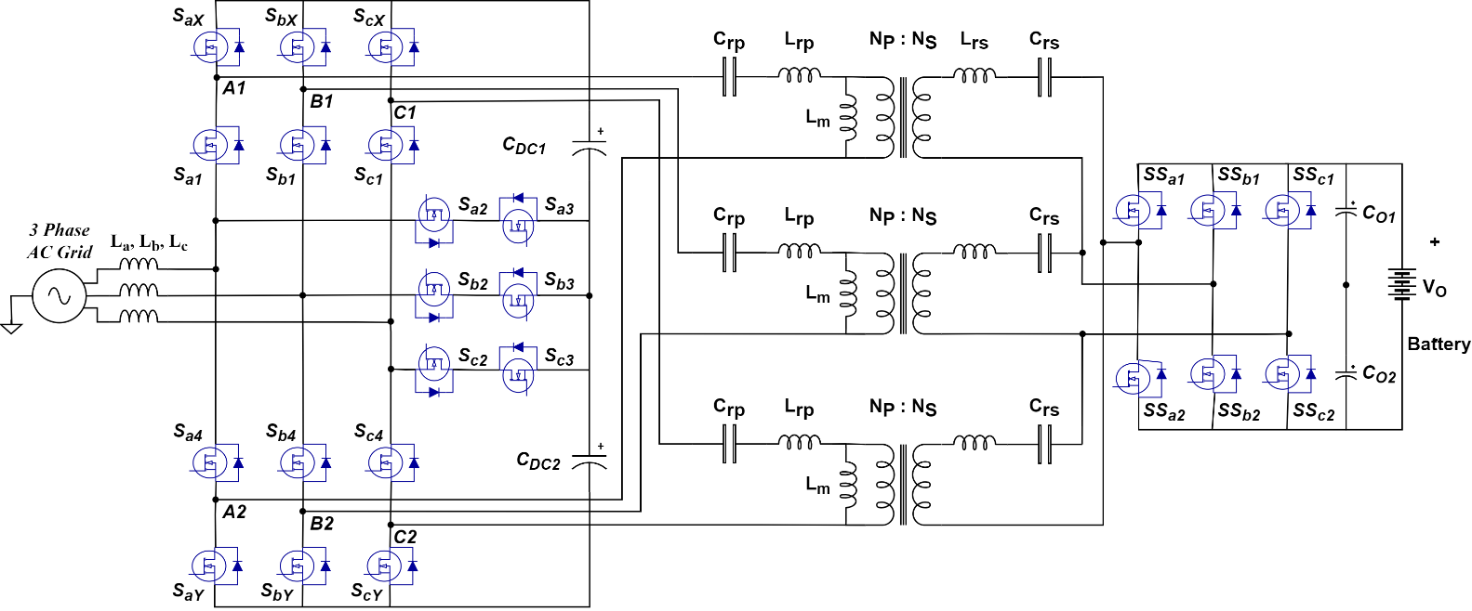
Fig.1 Three Phase 3-level T-TYPE Isolated Bidirectional Converter
PARAMETERS
PARAMETERS | SPECIFICATIONS
Peak Power Rating | 6.6 kW
Switching Frequency | 120 kHz(AC to DC)
Input AC Voltages | 300-415 V, 50 Hz
DC Link Voltages | 900-1100 V
Battery Voltages | 600-800V
Primary side bridge duty ratio | 0.6
Secondary side bridge duty ratio | 0.5
Input AC Inductances | 0.8 mH
Turns Ratio | 55:80
HF Transformer magnetizing inductance | 103.5 µH
Primary and Secondary Side Resonant Inductance | 78.8 µH
Primary and Secondary Side Resonant Capacitance | 32.145 nF
Split DC Link Capacitances | 660 µF
Output Split DC Capacitances | 440 µF
d-Current Controller | 5 + 1000/s
q-Current Controller | 5 + 1000/s
DC-link Voltage Controller | 0.1 + 10/s
Output Current Controller | 0.05 + 10/s
MODULATION INDEX OF THE UPPER SWITCH
$$V_{AB1}=0.707m_{a}\left(m-1\right)E$$
Where $V_{AB1,MAX}=input rms line voltage$
$m_{a}=modulation index$
$m=number of voltage levels$
$E=voltage of each level$
$$V_{AB1}=415 V$$
$$m=3$$
$$E=\frac{V_{DC}}{2}=450 to 550V$$
This implies that
$m_{a}=0.53 to 0.65$

SWITCHING FREQUENCY
- Switching frequency is selected between 100 kHz to 150 kHz.
- Most off-line AC/DC applications require a switching frequency below 150 kHz for normal operation, and usually between 100 and 150 kHz as a rule of thumb.
- This is usually because conducting EMI testing starts at 150 kHz. Maintaining the switching frequency below the EMI test’s lower boundary helps the application pass the test.
- At high frequencies, the parameter of the resonant inductor and capacitor will be lower.

FILTER INDUCTOR
$$∆I_{rip_max}=\frac{V_{DC}}{2{\left(N-1\right)}^{2}f_{S}L_{1}}$$
Where $N$ is the number of voltage levels.
$f_{S}$ is switching frequency.
$L_{1}$ is filter inductance.
$V_{DC}$ is DC Link Voltage.
$∆I_{rip_max}$ is the maximum ripple in the input line current.
$∆I_{rip_max}$ is taken as 10% of the rated peak current.
This implies that,
$L_{1}=882 μH$

CAPACITOR CALCULATION
$$C_{O}≥\frac{P_{OUT}}{4πfV_{O}{∆V}_{O}}$$
- ${∆V}_{O}$ is the Voltage ripple taken as 10% of DC Voltage.
- $f$ is the line frequency.
This implies,
$$C_{DC}≥129.68 μF$$
$$C_{O}≥291.78 μF$$
We took,
$$C_{DC}=292.5 μF$$
$$C_{O}=390 μF$$
The rms ripple current passing through the capacitor is given by
$$I_{cap\left(rms\right)}=I_{ph\left(rms\right)}\sqrt{\left[2M\left\{\frac{\sqrt{3}}{4π}+\left(\frac{\sqrt{3}}{π}-\frac{9M}{16}\right)\cos^{2}∅\right\}\right]}$$
For DC Link Capacitor,
$$I_{cap\left(rms\right)}=5.9421 A$$
RESONANT CONVERTER PARAMETERS
The primary side and secondary side bridge voltages are given by
$$V_{ph}=\frac{V_{DC}\left[j\sin\left(2πhD_{i}\right)+\left(1-\cos\left(2πD_{i}\right)\right)\right]}{\sqrt{2}hπ}$$
$V_{sh}=\frac{V_{bst}\left[-\sin\left(2πh\left(D_{o}+\frac{1}{3}\right)\right)+\sin\left(2πh\left(\frac{1}{3}\right)\right)+1-\cos\left(2πhD_{o}\right)+\cos\left(2πh\left(D_{o}+\frac{1}{3}\right)\right)-\cos\left(2πh\left(\frac{1}{3}\right)\right)+j\sin\left(2πhD_{o}\right)\right]}{\sqrt{2}hπ}$

The final expressions for primary- and secondary-side bridge voltages can be drawn as
$$V_{p}\left(h\right)=V_{ph}, V_{s}\left(h\right)=V_{sh}e^{jhγ}, γ=λ+ϕ, λ=∠V_{p1}-∠V_{s1}$$

MODULATION SCHEME
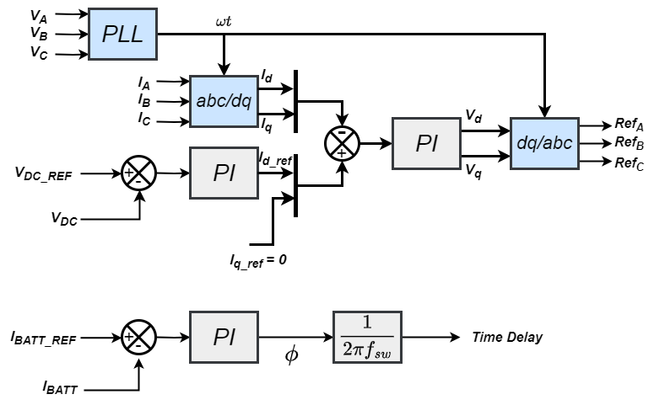
FIG. : CLOSED-LOOP CONTROL BLOCK DIAGRAM
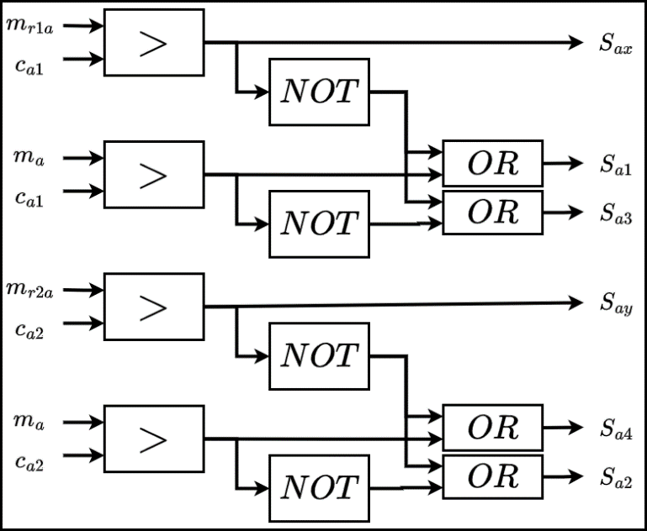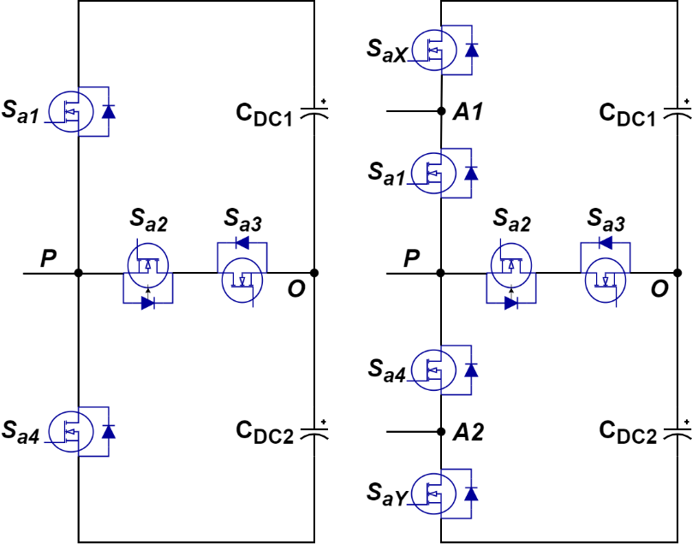

SIMULATION RESULTS
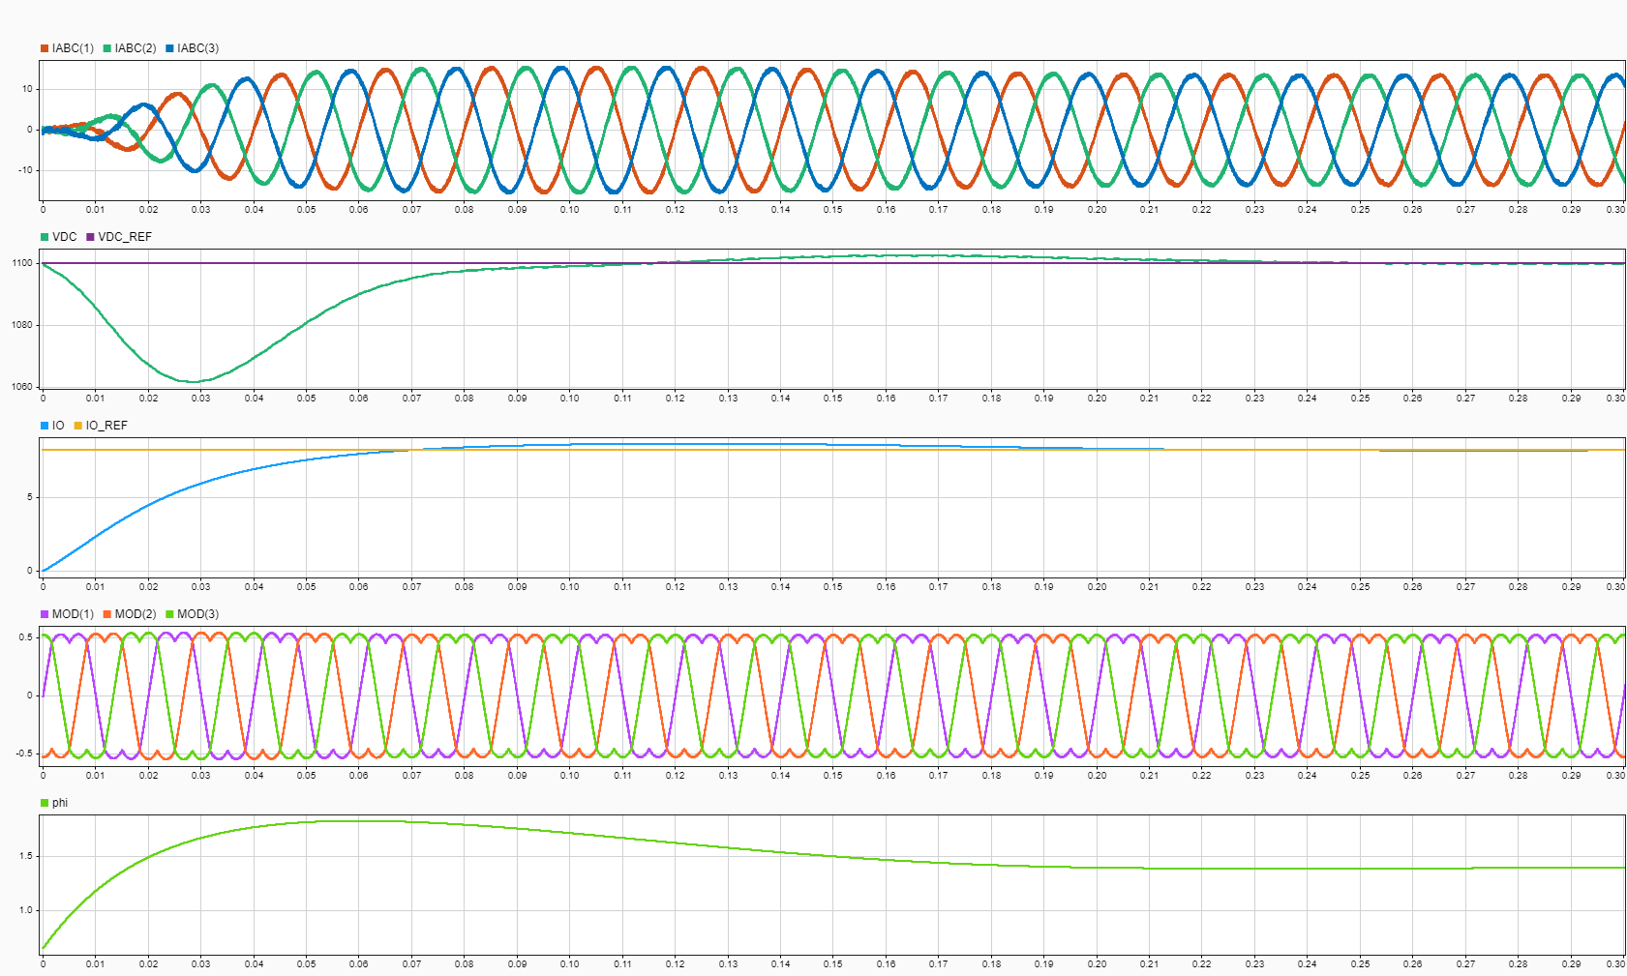
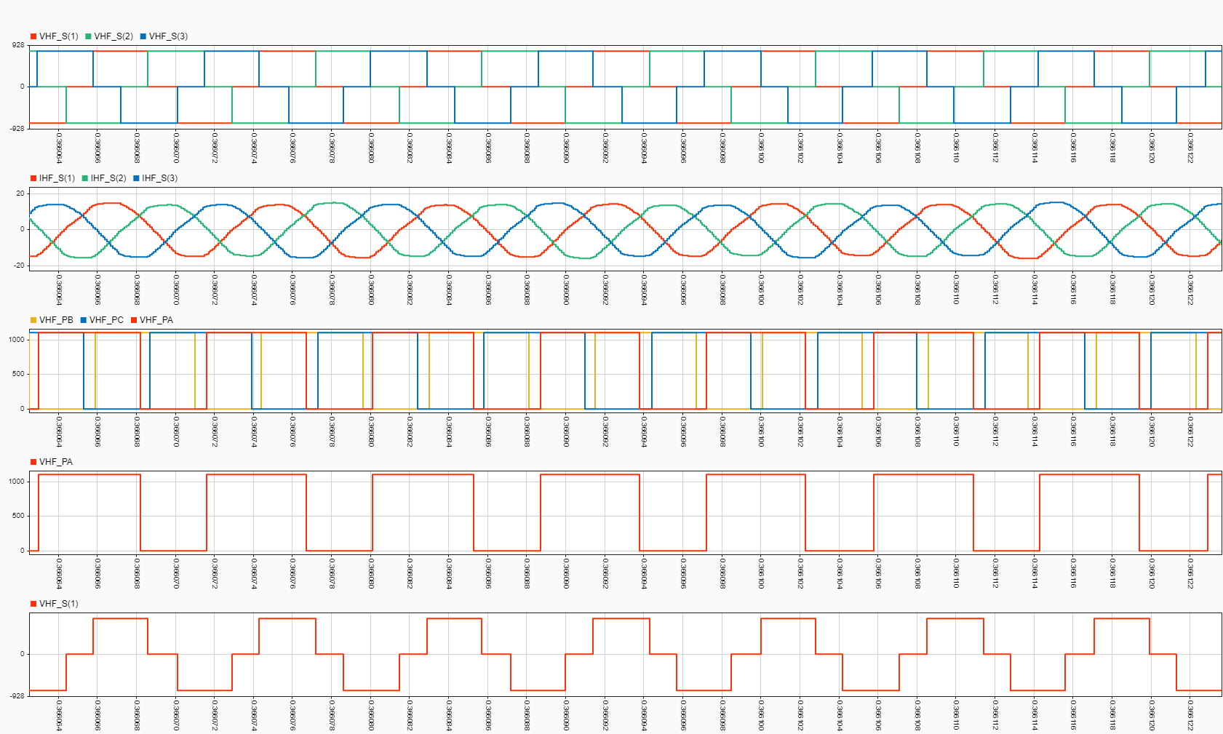
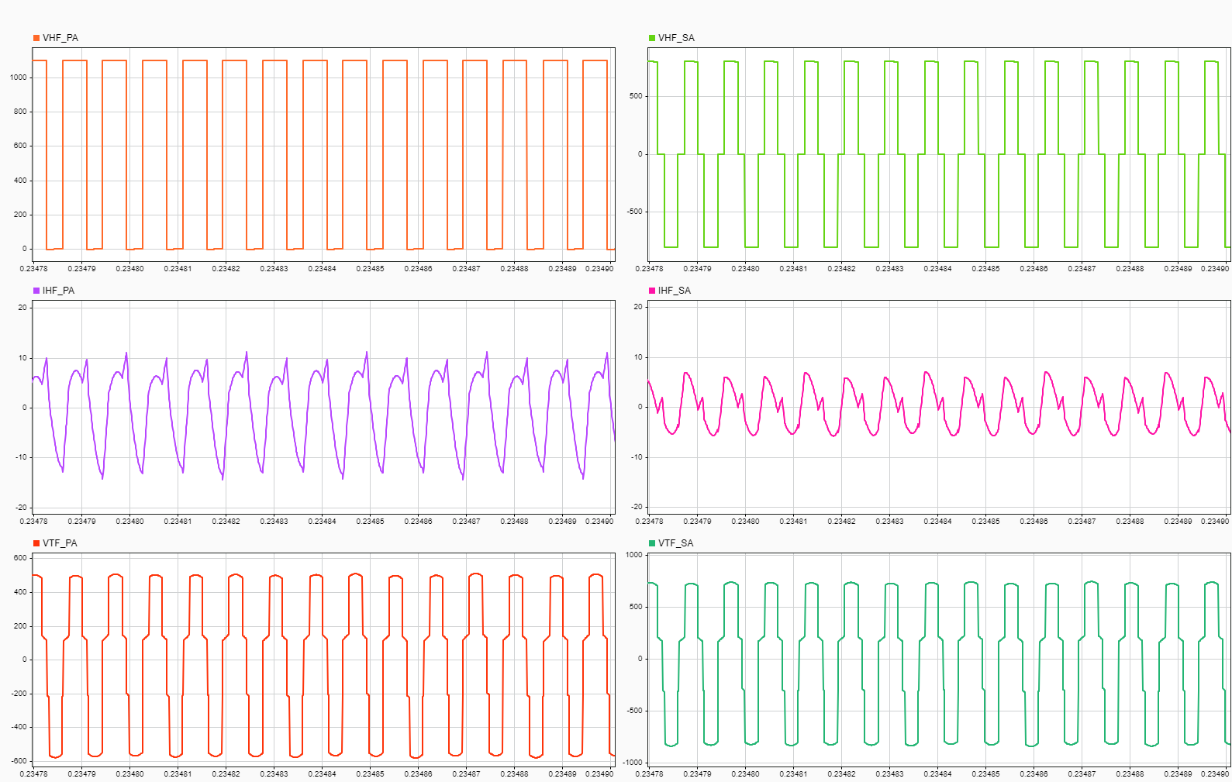
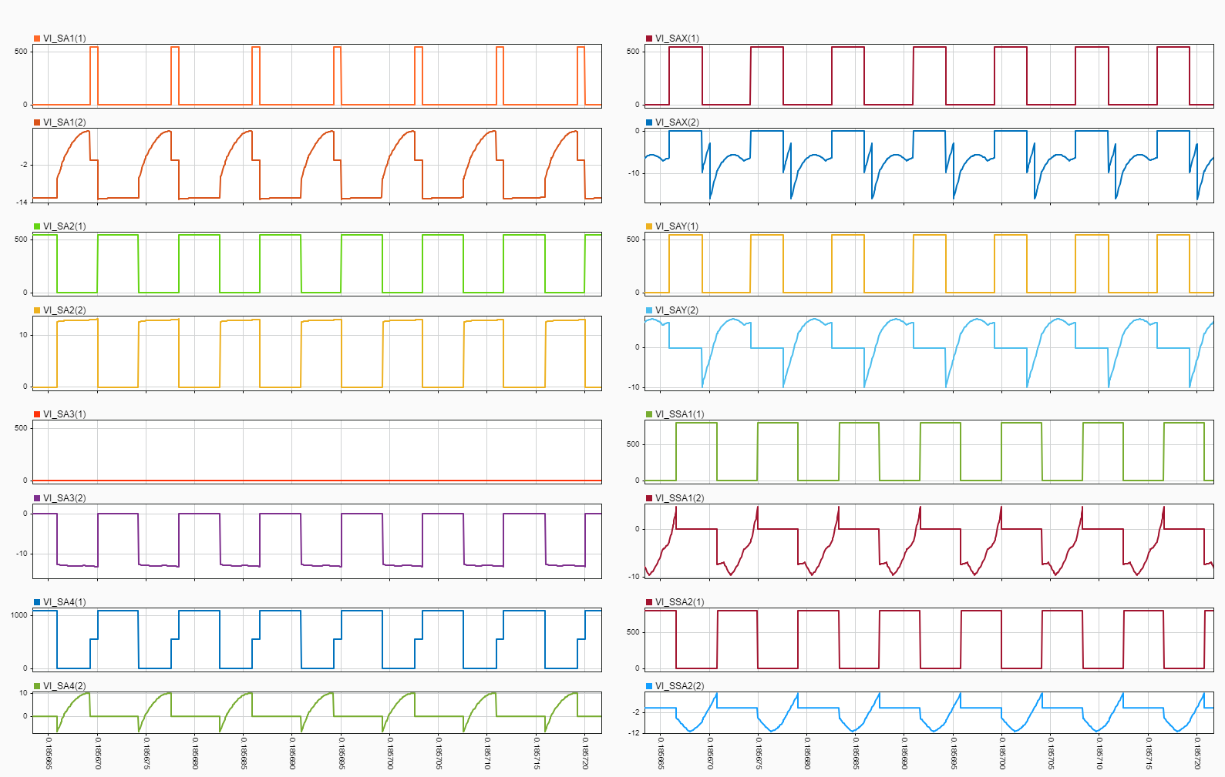

SWITCH SELECTION
FORMULA USED FOR CALCULATION OF CONDUCTION AND SWITCHING LOSS:
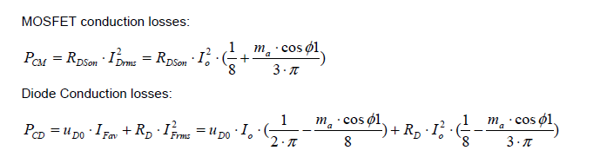
Ud0 = Vsd ( source to drain voltage) when drain current is zero
Io = Peak value of current
Ma =modulation index
Rdson = drain to source resistance
Rd= diode resistance
$\cos{∅1}$= power factor
MOSFET switching losses:
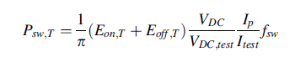
DIODE switching losses:
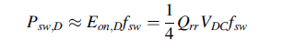
Eon= turn on loss
Eoff=turn off loss
Vdc= input voltage
Ip= input current
Qrr= reverse recovery charge
Switch Model Number | Manufacturer | Conduction Loss (IN Watt) | Switching Loss (in Watt) | Total Loss (in Watt)
G3R40MT12K | GENESIC | 3.733 W | 8.3071 W | 12.041 W
IMZA120R040M1H | INFINEON | 4.357 W | 11.47 W | 15.825 W
IMZ1Z0R030M1H | INFINEON | 5.048 W | 16.5 W | 21.548 W
NVH4L030N120M3S | ONSEMI | 6.71 W | 11.835 W | 18.545 W
SCT4036KRHR | ROHM | 5.605 W | 11.63 | 17.235
SWITCH SELECTED: G3R40MT12K
GATE DRIVER
ACPL W346 is selected as it is suitable for SiC MOSFET and the recommended gate voltage of the switch.
$$R_{DS\left(ON\right)}=40 mΩ$$
$$R_{g}≥\frac{\left(V_{CC}-V_{EE}\right)}{I_{OLPEAK}}-R_{DSON}$$

Where $V_{EE}= -5 V$, $V_{CC}= 15 V$, $I_{OLPEAK}=2.5 A$.

$$R_{g}≥7.96 Ω$$

POWER SUPPLY GATE DRIVER
MGJ2D051505BSC with 2W power and output voltage of 15/-5V is selected.

DC LINK and OUTPUT CAPACITOR
$$C_{O}≥\frac{P_{OUT}}{4πfV_{O}{∆V}_{O}}$$
- ${∆V}_{O}$ is the Voltage ripple taken as 10% of DC Voltage.
- $f$ is the line frequency.
This implies,
$$C_{DC}≥129.68 μF$$
$$C_{O}≥291.78 μF$$
We took,
$$C_{DC}=315 μF$$
$$C_{O}=420 μF$$

$$I_{cap(rms)}=I_{ph(rms)}\sqrt{\left[2M\left\{\frac{\sqrt{3}}{4π}+\left(\frac{\sqrt{3}}{π}-\frac{9M}{16}\right)\cos^{2}∅\right\}\right]}$$
For DC Link Capacitor,
$$I_{cap(rms)}=5.9421 A$$

The capacitor taken is an Aluminium Electrolytic Capacitor with a value of 420uF and a current rating of 2.96 A with 420V. The series combination of 4 capacitors with 3 parallel lines will give the suitable capacitance.
The capacitor selected is EKHJ421VSN421MR51M.
Similarly, series combination of 3 capacitors and 3 parallel lines will give suitable capacitance for the output capacitor.

SNUBBER CAPACITOR
R53BI31505000K WITH 0.15uF.

RESONANT CAPACITANCE
Cr1=32.145nF, 1000V
R76UN233050H4J is selected for the purpose. Its rating is 33nF and 1000V. The combination of 2 series and 4 parallel lines for each terminal will give equivalent Cr1. The current rating of each capacitor is 4.6 A. So, it is suitable for the resonant current.
R76QI218050H4J is selected for the purpose. Its rating is 18nF and 1000V. The combination of 2 series and 4 parallel lines for each terminal will give equivalent Cr2. The current rating of each capacitor is 2.93 A. So, it is suitable for the resonant current.
HEAT SINK
- Power Loss in one switch is 12.041W.
- We will place 3 switches in one heat sink.
- Total power loss will be 3*12.041=36.123 W.
- Ambient temperature $T_{A}$is taken as 35°C.
- Junction temperature $T_{J}$is taken as 150°C.
- Heat flow equation is $P_{LOSS}=\frac{T_{J}-T_{A}}{R_{JA}}$
- $R_{JA}$ is the equivalent thermal resistance between the junction and the ambient.
- We must calculate $R_{JH}$.
- Junction to heatsink thermal resistance $R_{JH}$ of MOSFET is 0.66 k/w.
- Equivalent $R_{JA}$ is 4.77535 K/W.
- Equivalent Junction to Heatsink thermal resistance $R_{JH}$ is calculated by the equivalent parallel of all the thermal resistances of MOSFET.
- It is calculated as 0.22 K/W.
- Equivalent Heatsink to Ambient Thermal Resistance $R_{HA}$ = 4.77535-0.22 = 4.55535 K/W.
- CR-201-75E has been selected. It has a thermal resistance of 2.6 K/W.
AC PFC INDUCTOR
- The calculated value of inductance is$882 μH$.
- The current rating should be more than 1.5 times the peak line current.
- The selected inductor is B82747S6313N061.
- It is a power line choke with 3 winding on a single toroid core.
- The rating is 950uH, 31A, 250VAC.

Point to discuss:
- Loop Inductance of Gate Signal
- Heat sink
- DC Link Capacitor

SCHEMATIC DIAGRAMS
GATE DRIVER
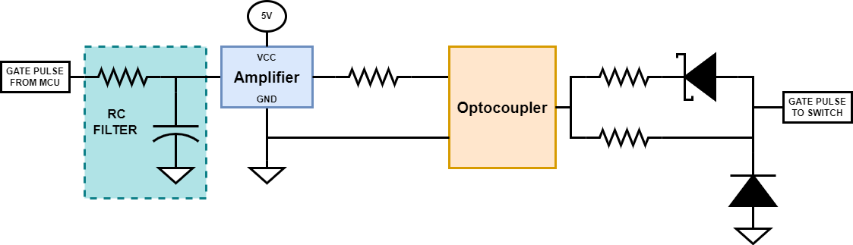
- Reference from Texas Instruments.
- The track length between the Optocoupler and the Gate terminal is 15 mm.
- MCU generates a Gate Pulse of 0/3V.
- RC filter is used to filter the noise.
- An amplifier generates 0/5V and is compatible with an optocoupler.
- Optocoupler ACPL-W346 is used which is compatible with SiC-MOSFET.
- Gate Resistance for the forward path is taken as 15 ohms.
- 20 ohms resistance in series with antiparallel Schottky diode is taken. It will make a net backward gate resistance of 8.57 ohms.
- An antiparallel Zener diode is connected between the gate and the ground to avoid over-voltage across the gate.
- A DC/DC converter MGJ2D051505BSC with 2W, 5V to 15V/-5V supplies the optocoupler.
- A PCB consists of 6 gate driver circuits to provide gate pulses for each leg.
AC VOLTAGE SENSOR
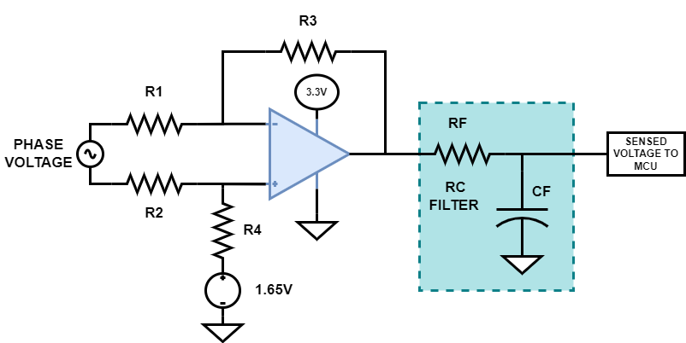
- Differential Gain OPAMP Circuit is used to sense the phase voltages.
- Phase Voltage is fed to the resistor divider circuit to step down the voltage.
- A offset of 1.65V will make the voltage within the range of MCU.
- The gain of the sensor circuit is R3/R1.
- Here, R1=R2 and R3=R4.
- A PCB will consist of sensor circuit for all three phases.
- High voltage side is placed on MAIN BOARD.
- Low voltage side is placed on AC VOLTAGE SENSOR PCB.
DC VOLTAGE SENSOR
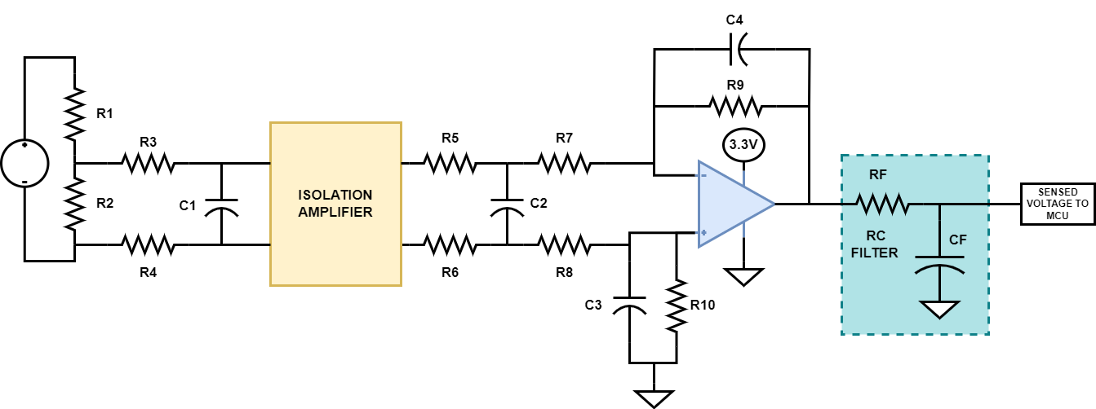
- R1 and R2 form the resistor divider circuit.
- R3, R4 and C1 forms RC filter circuit.
- An isolation amplifier AMC 1311 isolates the DC Link side from MCU ground.
- Opamp amplifies the signal to the required range of 0/3V.
- Signal is filtered using an RC circuit and fed into MCU.
- The cutoff frequency of filter 1 is 200kHz.
- The cutoff frequency of filter 2 is 1.7 kHz.
- The cutoff frequency of filter 3 is 15 kHz.
CURRENT SENSOR
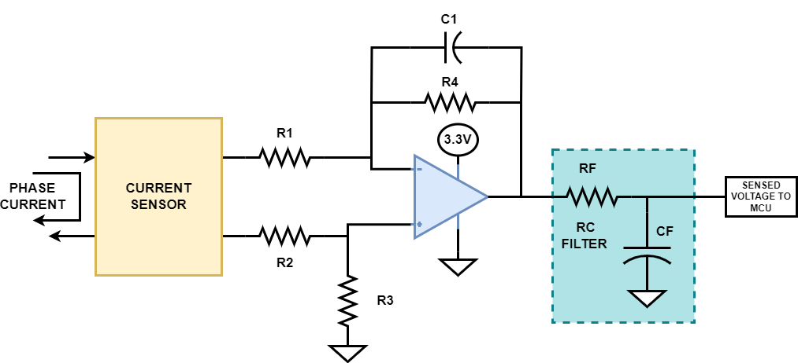
- Hall effect-based Current Sensor is used.
- Sensor IC connects in series with phase track.
- The output voltage corresponds to the input current generated by the sensor.
- The voltage is filtered out and clamped up to make it in the range MCU.
AUXILIARY POWER SUPPLY
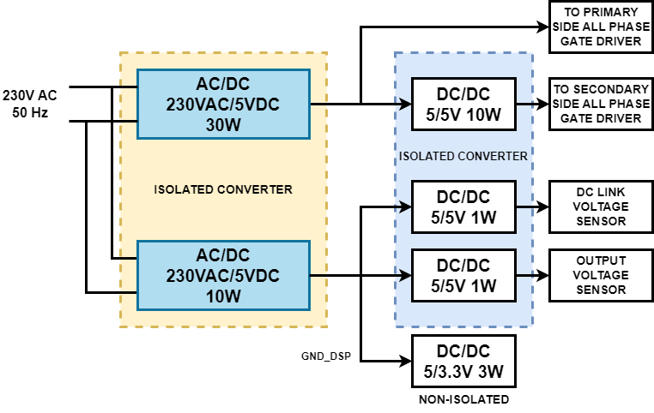
- RACM30-055K/277W is used to provide 230VAC to 5V with 30W rating.
- RAC10E-05SK/277 is used to provide 230VAC to 5V with 10W rating.
- This 5V will supply all the sensors with respect to GND_DSP.
- A non-isolated DC/DC converter will generate the 3.3V required by the sensors.
- The 5V terminal has isolated ground and will supply every gate driver's secondary circuit.

PCB FOOTPRINT
AC VOLTAGE SENSOR
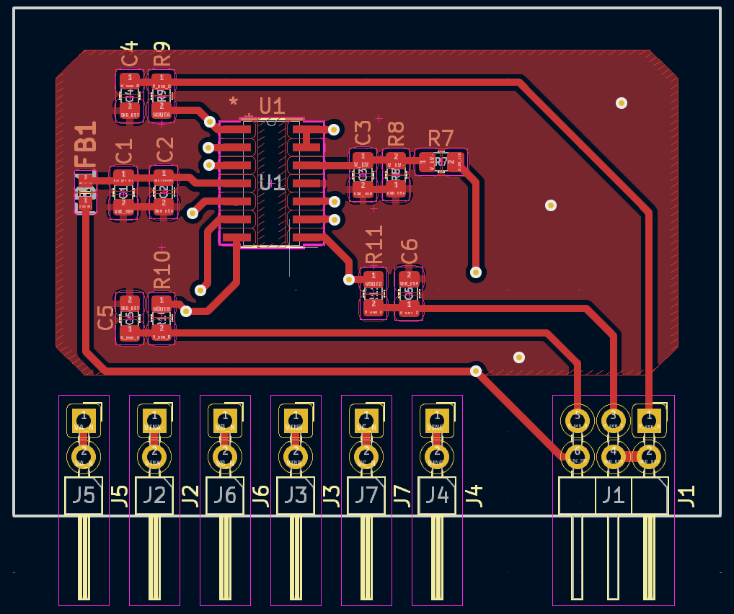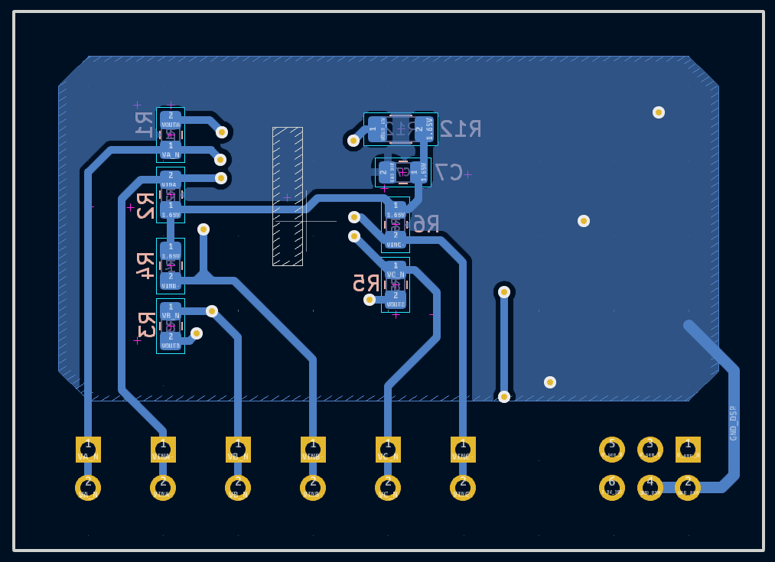
DIMENSION: 50MM*36MM
TERMINAL DISTANCE: 5MM

DC VOLTAGE SENSOR
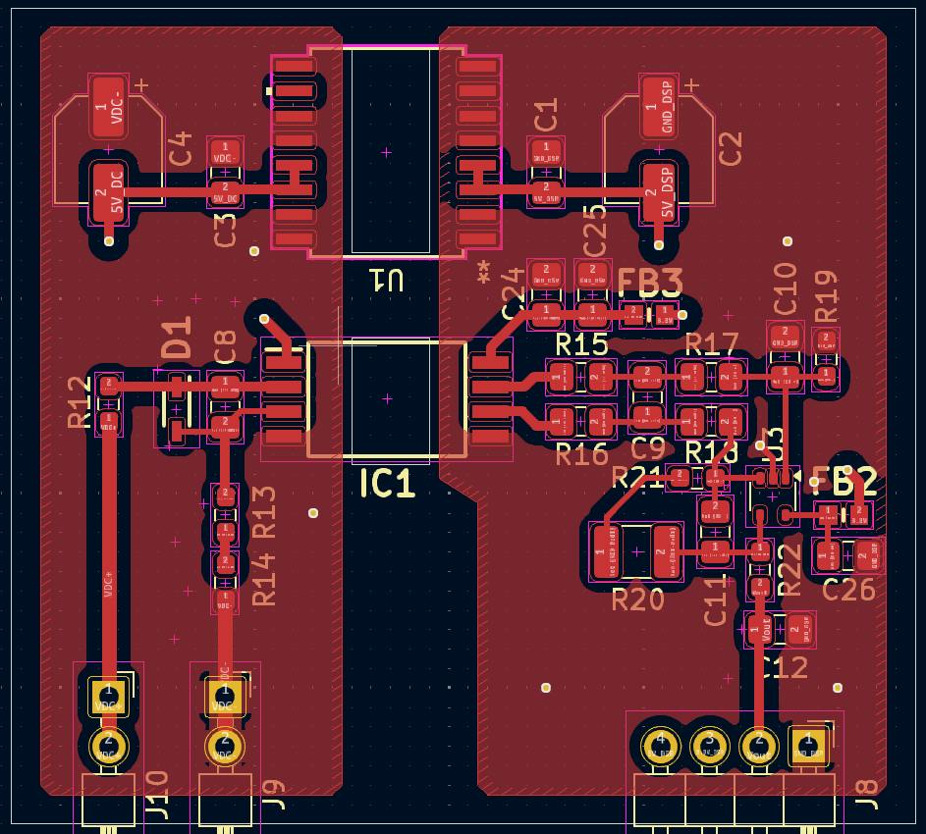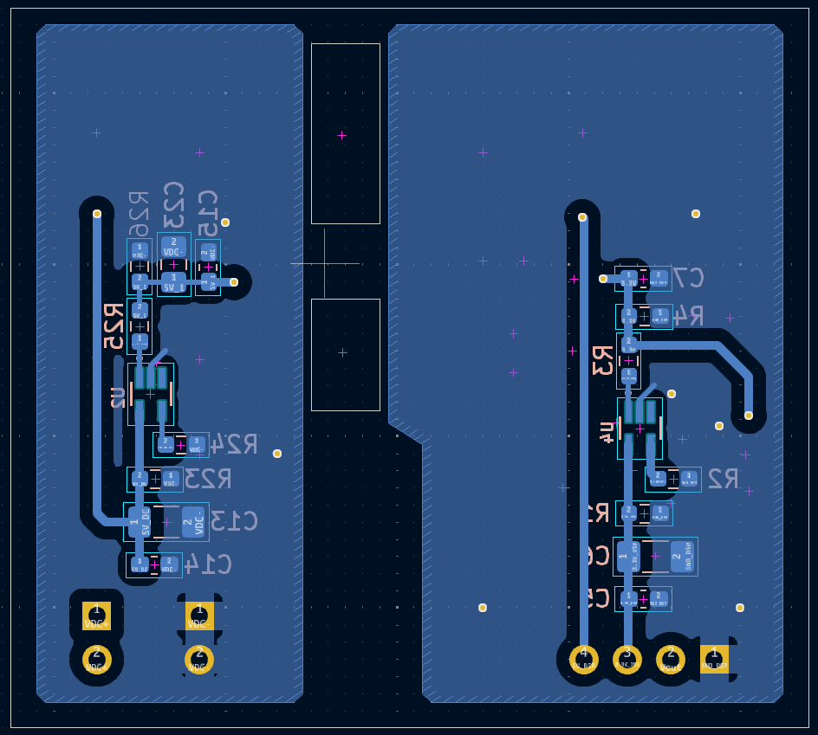
DIMENSION: 49MM*52MM
TERMINAL DISTANCE: 10MM

GATE DRIVER
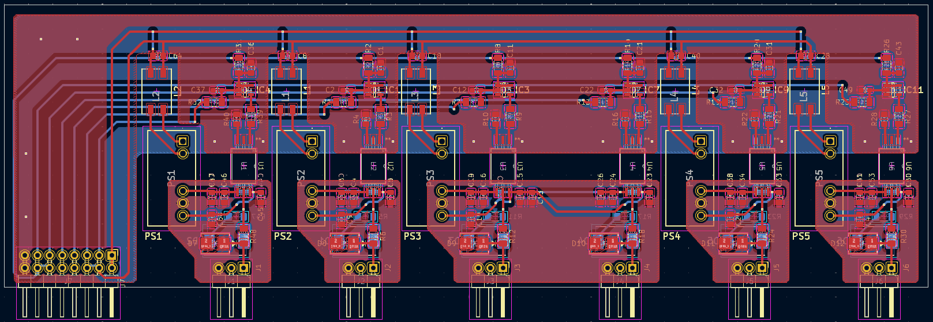
DIMENSION: 189MM*58MM
TERMINAL DISTANCE: 26.5MM
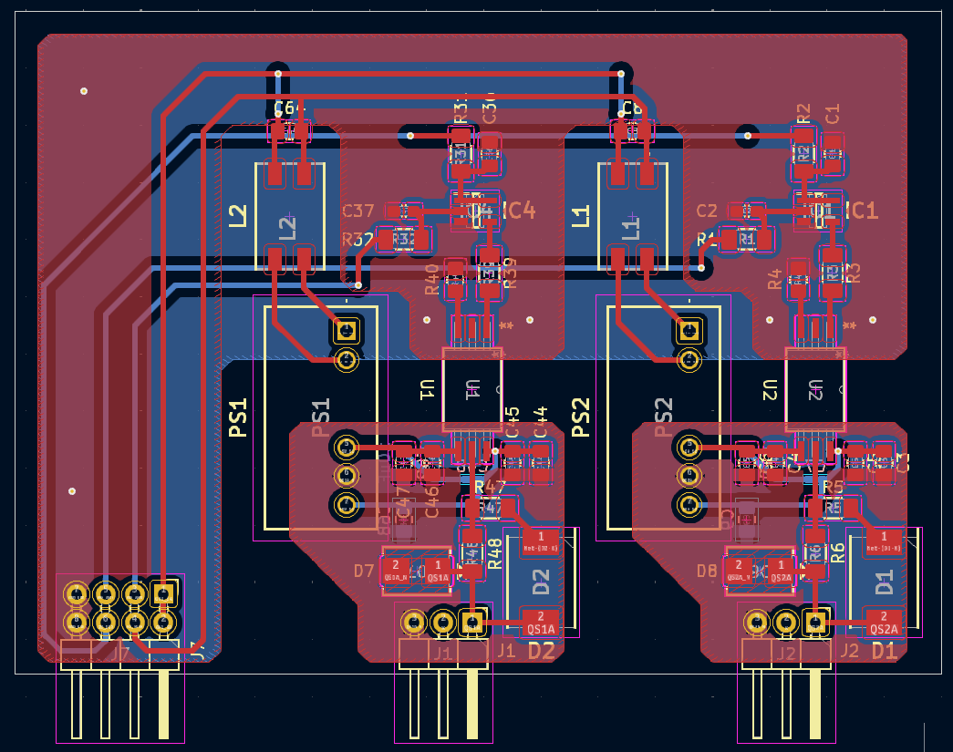
DIMENSION: 81MM*58MM

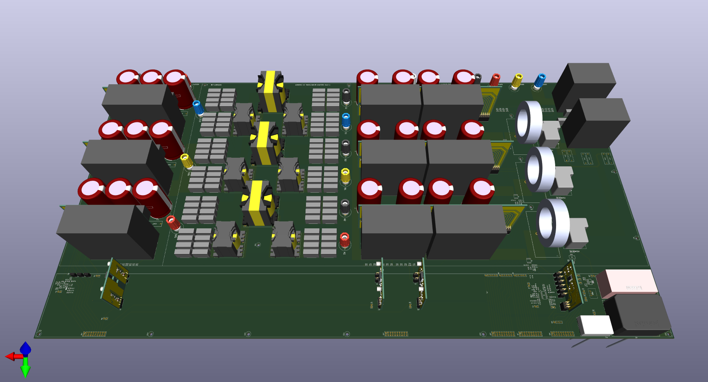

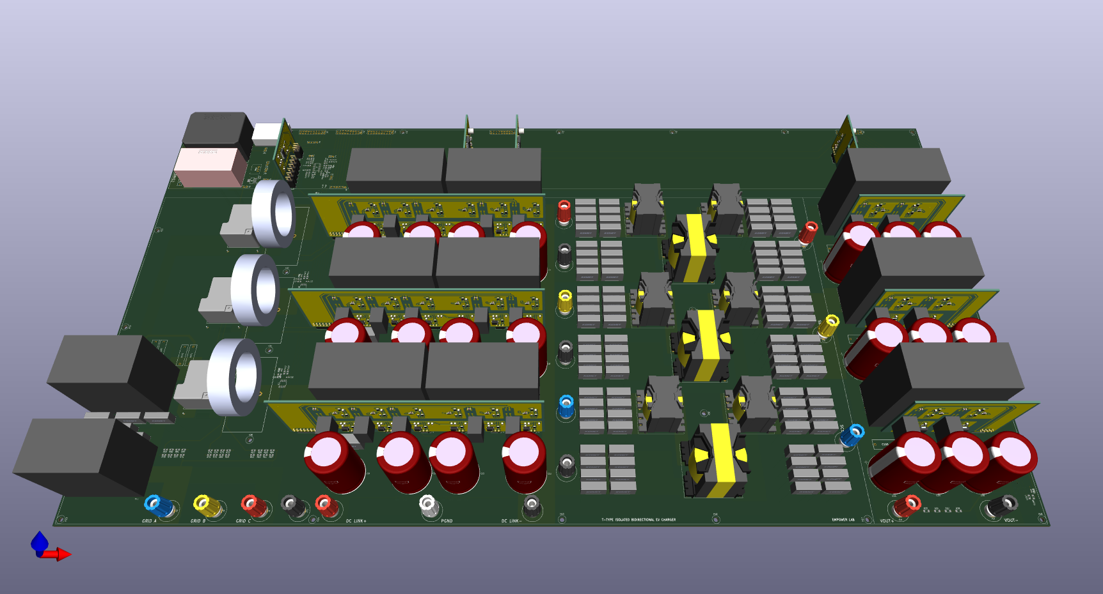

Discussion Points:
- EMI filter placement on the Main Board.
- HF transformer terminal.
- RC filter in ADC terminal
- Simulation done in the LTSpice.
- Output is coming correct with the suitable RC filter.
- FRC cable placement.
- CCS coding.

