1>

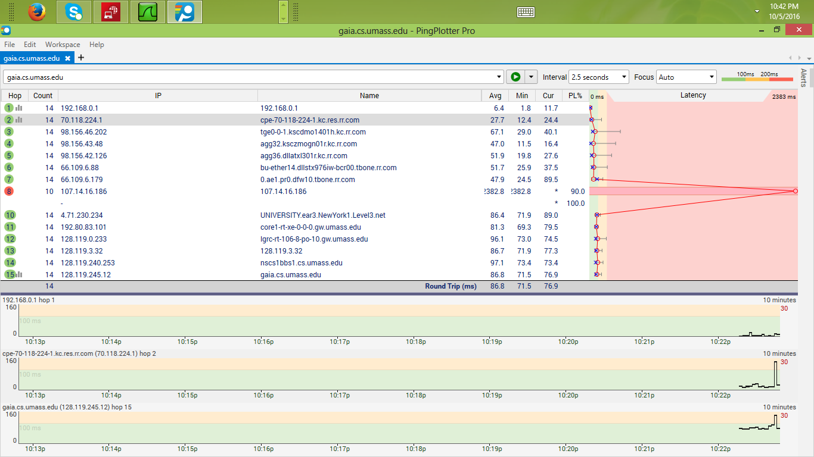

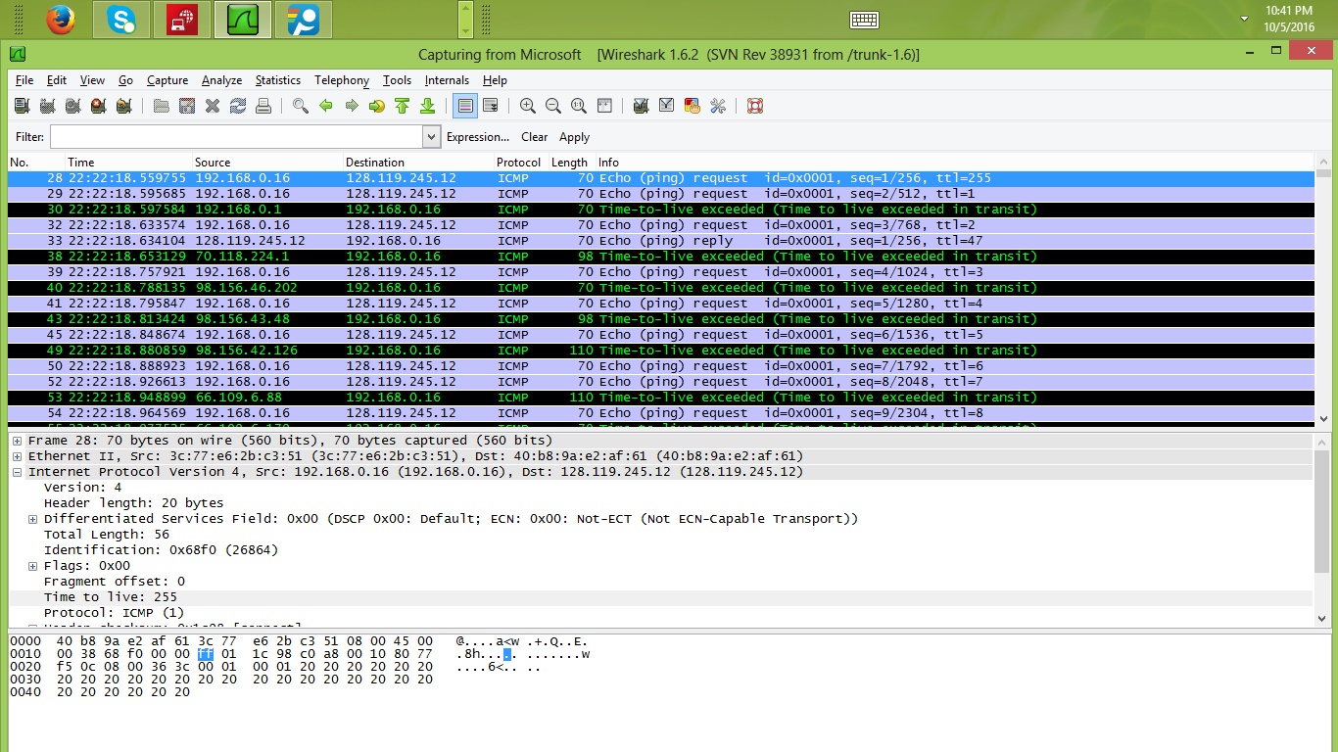

The ip address of my computer is 192.168.0.16.

2>



The value in upper layer protocol field is ICMP(1).

3> The header length is 20 bytes.

Payload length=56-20 bytes

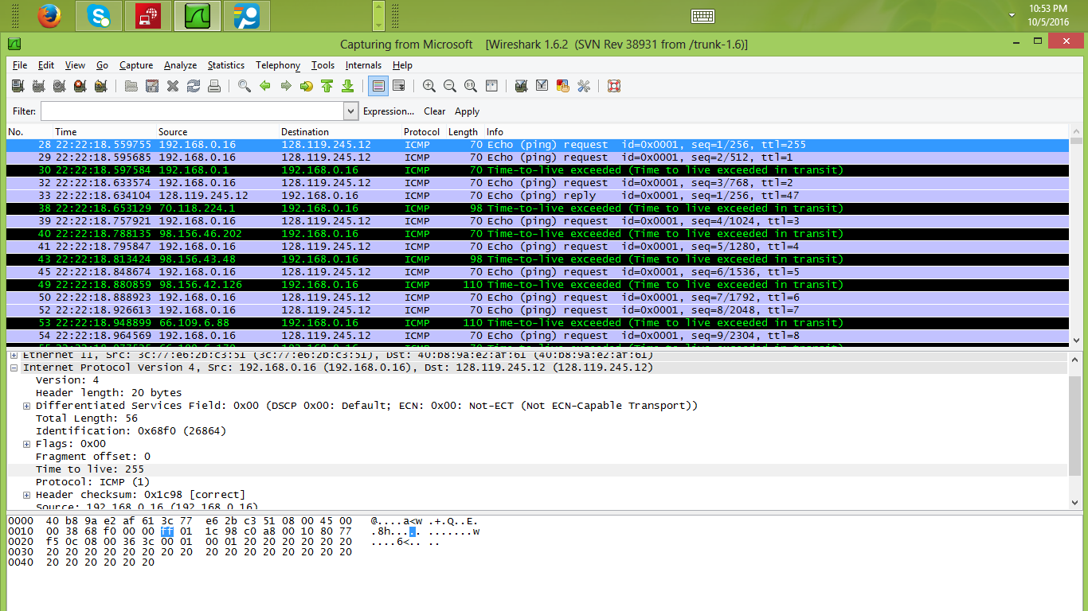

4> tyuuuvfvyhynhnhnhnhnhnhello I am rajarshiththethe ZZcgghghfhgfhgfhfhftdresefdyhhiopopopopopopopopopopopopopopopopopopopocfdrdtrytfgdrstrdtdytdtrdrtdtrdtrdrssrsrsrsrsrsrsrsrsrsrsaewzxfgcgfdrtsdtrd



T

This ip

Th

h