ANA 515 Week5 activity

Rajas Purohit

2023-06-26

Being endorsed by AOC has historically been an indicator of Primary success, looking at the 2020 elections. The following visualization helps summarize candidates’ success with their endorsement status. A lot of the skewness can be explained by the lack of data (presence of N/As)

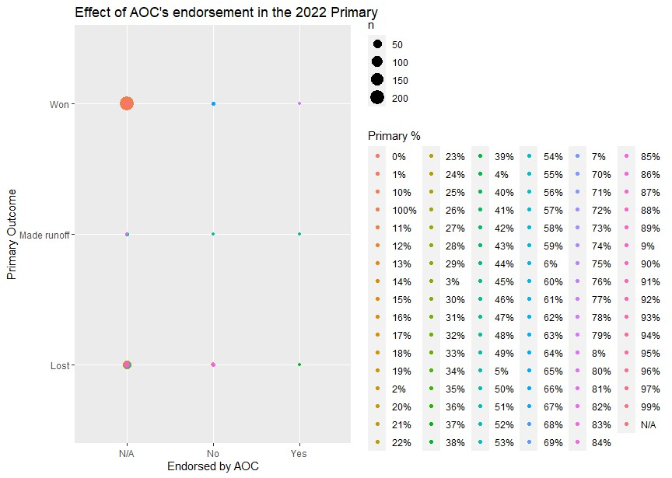

To say that the 2020 election was a controversial one, would be an understatement. As the outgoing President made unfounded claims about the election being “rigged” against them, a question was asked to Republican electoral nominees at various levels of candidacy. Here are the results on what their opinions were, and whether it cost them the election:

