**Math Problem Solving – Combinations and Geometry**

This assessment evaluates quantitative reasoning skills through problems involving counting principles and geometric measurements. The questions test the ability to calculate combinations using the fundamental counting principle and to determine dimensions using spatial reasoning in 3D geometry.

**Question:** A sports store sells 5 styles of jerseys and 3 types of shorts. Each jersey is available in 2 colors, and each short is available in 3 colors. How many unique outfit combinations (1 jersey + 1 short) are possible?

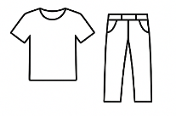

**Instruction:** Select the correct answer from the options below.

**Difficulty:** easy

**Order:** 1

(A) 15

(B) 30

**(C) 90**

(D) 45

**Explanation:**  
The number of jersey choices is 5*2=10 (styles × colors).  
The number of short choices is 3*3 =9 (types × colors).  
Total combinations = 10*9=90

**Subject:** Quantitative

**Unit**: Problem Solving

**Topic**: Combinations

**Mark**: 1

**Question:** A cylindrical container holds 8 identical spheres arranged in a single vertical column. If each sphere has a radius of 5 cm, which of the following is the closest total height of the container (including both top and bottom clearance of 2 cm each)?

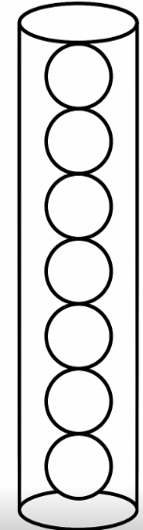

**Instruction:** Select the correct answer from the options below.

**Difficulty:** moderate

**Order:** 2

(A) 80 cm

(B) 84 cm

**(C) 74 cm**

(D) 88 cm

**Explanation:**  
The diameter of each sphere is 2*5 = 10 cm. For 7 spheres, total height without clearance = 7*10 = 70 cm. Adding 2 cm clearance at both top and bottom = 70+2+2= 74 cm.

**Subject:** Quantitative

**Unit:** Geometry and Measurement

**Topic**: Solid Figures (Volume of Cylinders)

**Mark:** 1