AWS CloudFront – CDN Service
Content Delivery Network | Edge Locations | Performance Testing | Distribution Setup
Hands-On Project Documentation

Project Overview
Amazon CloudFront is a Content Delivery Network (CDN) that dramatically improves website performance by caching your content at edge locations worldwide. Instead of every user connecting to your origin server in a single AWS region, they are automatically served from the nearest CloudFront edge location — resulting in significantly lower latency.
In this hands-on project, we measure baseline website performance, set up a CloudFront distribution, and then measure performance again to prove the improvement. The results show a dramatic reduction in load time for geographically distant users.

Without CloudFront: User in distant region → directly hits origin server → high latency
With CloudFront: User in distant region → nearest edge location serves cached content → low latency
Performance tool: https://tools.pingdom.com — tests load time from different global locations

Section 1 – How CloudFront Works
When a user requests your website, CloudFront checks if the requested content is already cached at the nearest edge location. If it is (a cache hit), CloudFront serves it instantly from there. If it is not (a cache miss), CloudFront fetches it from your origin server, caches it at the edge, and then serves it to the user. All future requests from that region are served from the cache.

Origin: Your source server — an EC2 instance, Load Balancer, or S3 bucket
Edge Location: AWS data centres globally — 400+ locations — where content is cached
Distribution: Your CloudFront configuration — defines origin, cache behaviour, and settings
Cache Hit: Content already in edge cache — served instantly, no trip to origin
Cache Miss: Content not in cache — fetched from origin, then cached for future requests
TTL: Time To Live — how long content stays cached before CloudFront checks origin for updates

CloudFront Coverage Options
US and Europe only: Basic coverage — lowest cost option
US, Europe, Asia, Middle East and Africa: Expanded coverage — good balance of cost and reach
All Edge Locations: Maximum global coverage — best performance, highest cost

Key Benefits of CloudFront
Performance: Serves content from the edge closest to the user — dramatically reduces load time
Cost savings: Reduces data transfer costs from origin — CloudFront pricing is cheaper than EC2 data transfer
Security: Built-in DDoS protection via AWS Shield, HTTPS/SSL support
Compression: Automatically compresses files — reduces page size and transfer time
Origin protection: Origin server only receives cache miss requests — much lower load

Section 2 – Baseline Performance Test (Before CloudFront)
Before setting up CloudFront, we measure the current load time of the website using Pingdom. Testing from a distant location (like Sydney, Australia) shows how slow the experience is for users far from the origin server in the US.

Test tool: https://tools.pingdom.com
Test location: Pacific — Australia — Sydney (simulates distant user)
What is tested: Direct Load Balancer or EC2 public DNS URL

Step 1 – Run Pingdom Test on Origin URL
Paste your Load Balancer DNS or EC2 public IP into Pingdom, select Sydney as the test location, and click Start Test. Record the load time — this is the baseline before CloudFront.
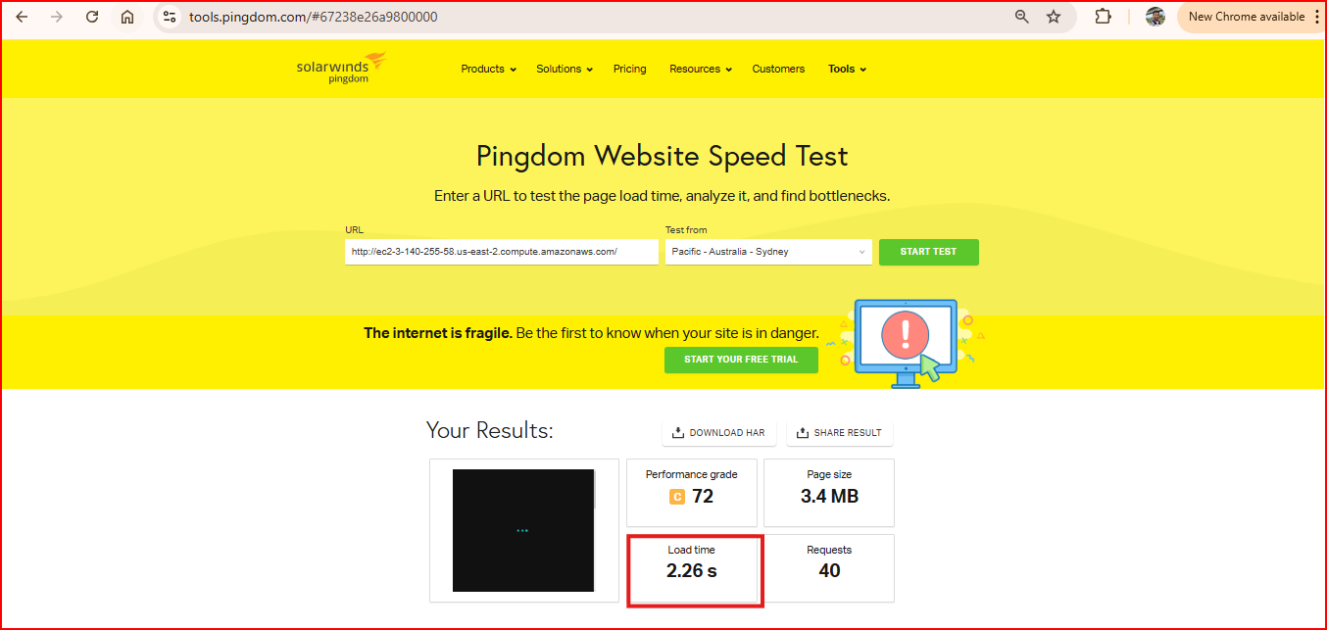
Result before CloudFront (Test 1): Load time: 2.26 seconds
Section 3 – Create CloudFront Distribution
Now we create a CloudFront distribution pointing to our origin server. CloudFront will start caching our content at edge locations worldwide. Once deployed, users will be served from the nearest edge instead of the distant origin.

Step 1 – Navigate to CloudFront and Create Distribution
Go to AWS Console → Services → CloudFront → Create Distribution. CloudFront distributions define where content comes from (origin) and how it should be cached and delivered.
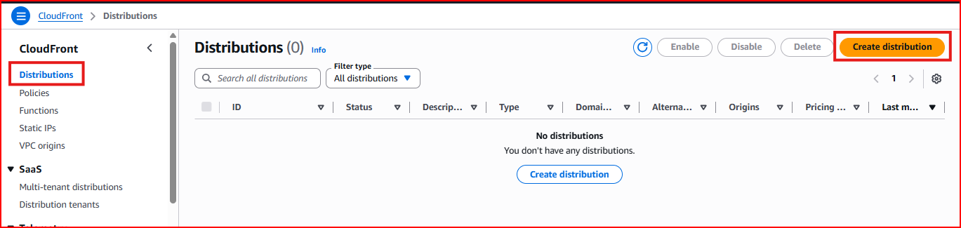
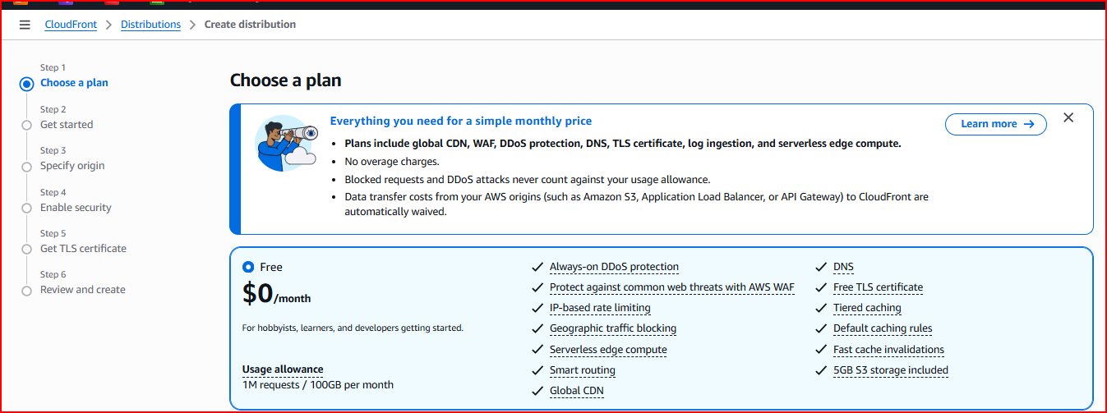
Step 2 – Configure Origin Settings
The origin is where CloudFront fetches content when it does not have a cached copy. Select your Load Balancer or EC2 instance as the origin domain. Set the origin protocol policy based on whether your server uses HTTP or HTTPS.
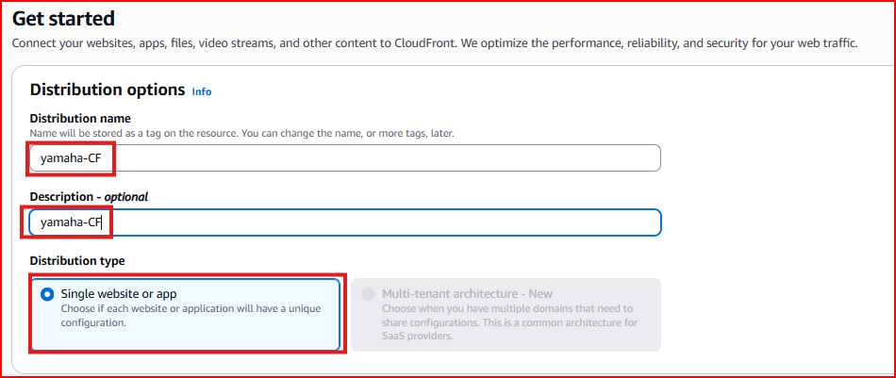
Origin Domain: Select your Application Load Balancer or paste EC2 public DNS
Origin Protocol: HTTP Only (if your server runs HTTP) or Match Viewer
Origin Path: Leave blank — serves content from root of origin
Step 3 – Configure Cache Behaviour
Cache behaviour settings control how CloudFront handles requests. Set the viewer protocol policy and allowed HTTP methods based on your application needs.
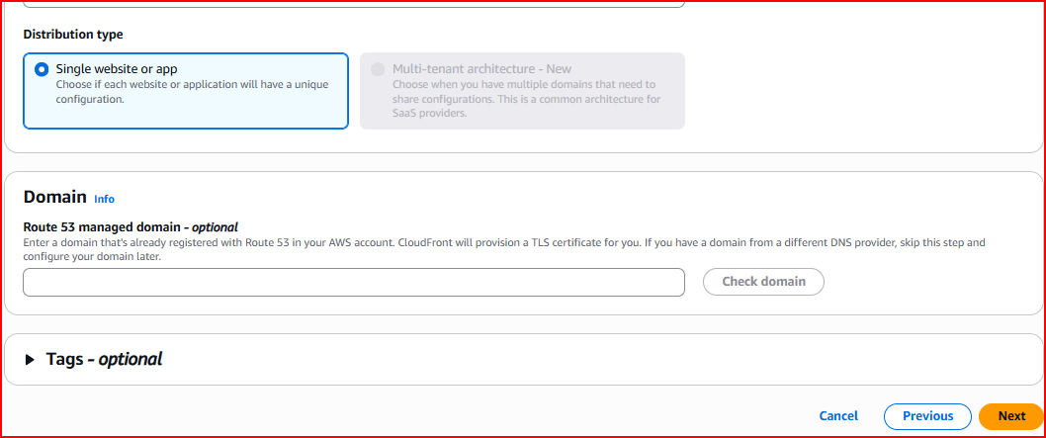
Viewer Protocol Policy: HTTP and HTTPS — allows both during testing
Allowed Methods: GET, HEAD — sufficient for static websites
Cache Policy: Caching Optimized — best for static HTML, CSS, JS, images
Step 4 – Distribution Settings and Price Class
Choose the Price Class which determines which edge locations CloudFront uses. More edge locations means better performance globally but higher cost.
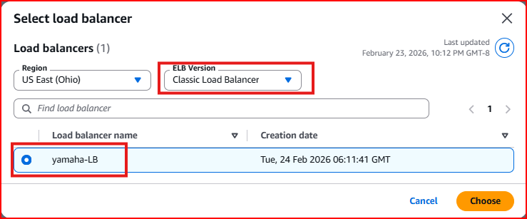
Price Class selected: Use North America, Europe, Asia, Middle East and Africa
Tip: For a global audience always select all edge locations. For cost-conscious projects use North America and Europe only
Step 5 – Review and Create Distribution
Review all settings and click Create Distribution. CloudFront will begin deploying your distribution across all selected edge locations globally.
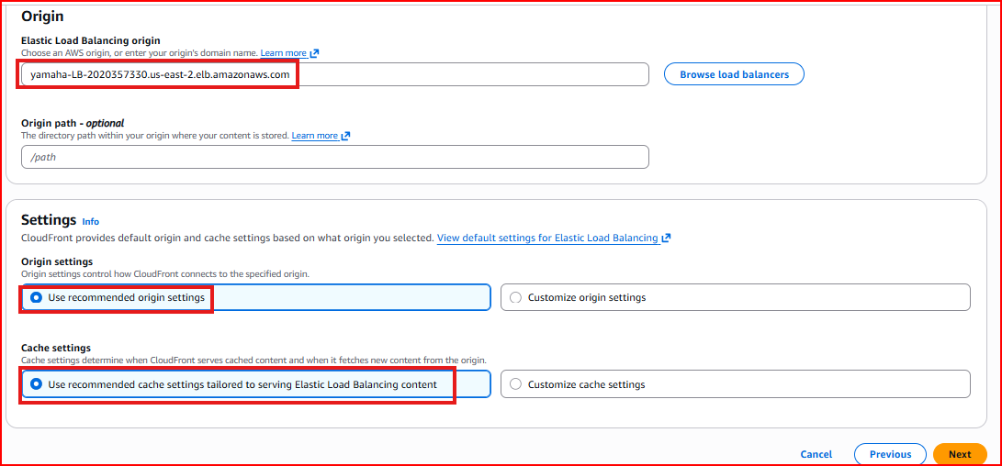
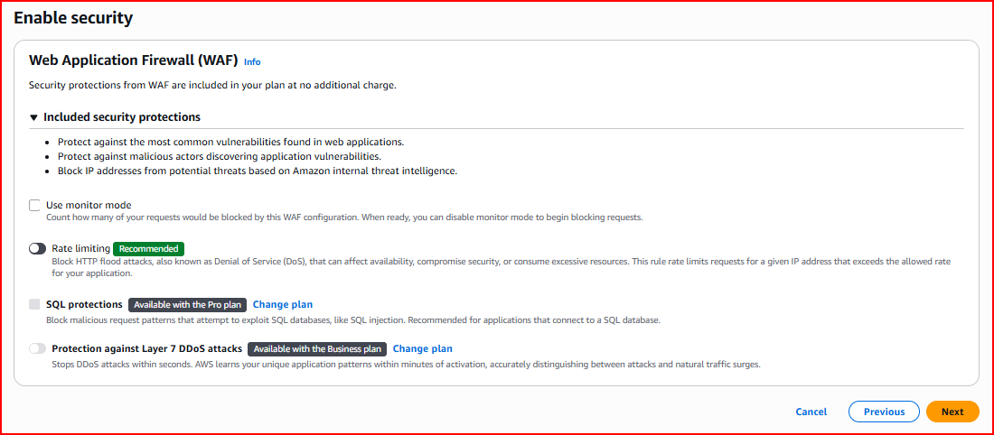
Wait time: CloudFront deployment takes 10-15 minutes — the status shows 'In Progress' then changes to 'Deployed'. Do NOT test until status is Deployed

Section 4 – Performance Test After CloudFront
Once the CloudFront distribution status shows 'Deployed', copy the CloudFront domain name (e.g., d1234abcdef.cloudfront.net) and run the same Pingdom test again from Sydney. The improvement will be dramatic.

Step 1 – Copy CloudFront Domain Name
In the CloudFront console, find your distribution and copy the Domain Name. This is the URL users will use — or you can point your custom domain to it using Route 53.
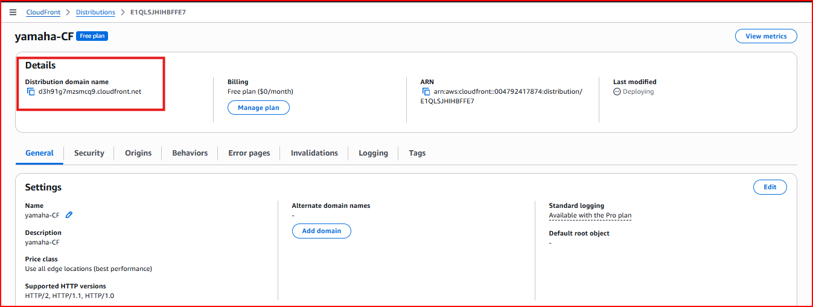
Step 2 – Run Pingdom Test on CloudFront URL
Paste the CloudFront domain name into Pingdom, select the same Sydney test location, and run the test again. Compare the result with the baseline.
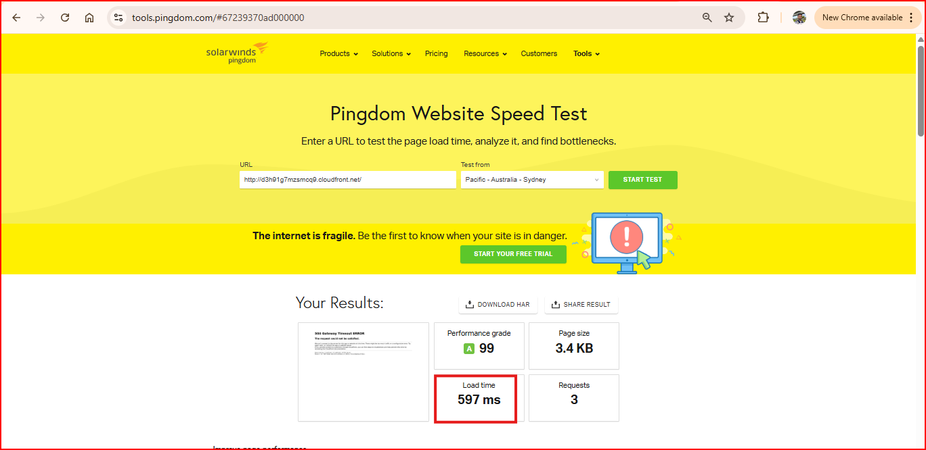
Result (Test 2): Load time: 597ms
Result after CloudFront: Significantly lower load time — content served from nearest edge location
Typical improvement: 60-85% faster for users geographically distant from the origin server
Page size: Often smaller too — CloudFront automatically compresses content
Project Summary
✅ Understood how CloudFront works — origin, edge locations, cache hit/miss, TTL
✅ Ran baseline Pingdom performance test from Sydney on the origin URL — recorded load time
✅ Created CloudFront distribution with Load Balancer as the origin
✅ Configured cache behaviour, viewer protocol policy and price class
✅ Waited for distribution status to change from 'In Progress' to 'Deployed'
✅ Re-ran Pingdom test using CloudFront domain — confirmed dramatic performance improvement
✅ Proved that CDN caching at edge locations reduces latency for distant users by 60-85%
Interview Questions & Answers

Q1: What is CloudFront and what problem does it solve?
CloudFront is AWS's Content Delivery Network. It solves the latency problem for users who are geographically far from your origin server. Without CloudFront, every user — regardless of location — connects directly to your origin server in a single AWS region, resulting in high latency for distant users. CloudFront caches your content at 400+ edge locations worldwide so users are served from the nearest edge instead of the distant origin. I proved this with a Pingdom test — the load time dropped significantly when accessed through CloudFront from Sydney.

Q2: What is the difference between an origin and an edge location in CloudFront?
The origin is your actual source server — an EC2 instance, Application Load Balancer, or S3 bucket. It holds the original content and CloudFront fetches from it on a cache miss. An edge location is one of CloudFront's 400+ globally distributed data centres where content is cached. When a user requests your website, they connect to the nearest edge location. If the content is cached there it is served instantly. If not, CloudFront fetches it from the origin, caches it at the edge, and serves it — all future requests from that region are then served from cache.

Q3: What is a cache hit and a cache miss in CloudFront?
A cache hit means the requested content is already stored at the edge location — CloudFront serves it immediately without contacting the origin server. This is fast and cheap. A cache miss means the content is not in the edge cache — CloudFront has to fetch it from the origin, which takes longer. After fetching it, CloudFront caches it at the edge so the next request for the same content is a cache hit. The goal is to maximize cache hit rate by setting appropriate TTL values and caching static content aggressively.

Q4: How long does it take to deploy a CloudFront distribution and why?
It takes approximately 10 to 15 minutes for CloudFront to fully deploy. This is because AWS needs to propagate the distribution configuration to all 400+ edge locations worldwide simultaneously. Until deployment is complete the status shows 'In Progress'. You should always wait for 'Deployed' status before testing — otherwise you may be hitting edge locations that have not yet received the configuration and won't serve cached content correctly.

Q5: What is TTL in CloudFront and why does it matter?
TTL stands for Time To Live — it controls how long CloudFront caches content at an edge location before checking the origin for an updated version. A longer TTL means better performance and lower origin load since content is served from cache more often. A shorter TTL means content stays more up to date but requires more origin fetches. For static content like images, CSS and JS files I set a long TTL. For dynamic content that changes frequently I use a shorter TTL or set Cache-Control headers on the origin to control caching behaviour.

