AWS Route 53 – DNS Service
Domain Registration | Hosted Zones | DNS Records | Routing Policies
Hands-On Project Documentation

Project Overview
Route 53 is Amazon's DNS (Domain Name System) service. DNS is the internet's address book — it translates human-readable domain names like example.com into IP addresses like 54.23.10.5 that computers use to route traffic. Route 53 is named after the DNS port number: port 53.
In this hands-on project we register a domain, create a hosted zone, create DNS records to map the domain to an EC2 instance, adjust TTL, and verify the domain resolves correctly — both by IP and by domain name.

Port: 53 — the standard DNS port, hence the name Route 53
Key functions: Domain registration, DNS routing, health checks, traffic management
Hosted Zone: A container for DNS records for a specific domain in Route 53

Section 1 – DNS Record Types
DNS records are instructions stored in Route 53 that tell the internet how to handle requests for your domain. Each record type serves a different purpose.

A Record (Address Record): Maps a domain name to an IPv4 address — e.g., example.com → 192.168.1.1. This is the most common record type used to point a domain to an EC2 instance
PTR Record (Pointer Record): Reverse of A record — maps an IP address back to a domain name — e.g., 192.168.1.1 → example.com. Used for reverse DNS lookups
CNAME Record (Canonical Name): Maps one domain name to another domain name — e.g., www.example.com → myloadbalancer.elb.amazonaws.com. Used to point a domain to a Load Balancer DNS
MX Record (Mail Exchange): Specifies which mail server handles email for the domain — required for email routing and delivery
NS Record (Name Server): Identifies the authoritative name servers for the domain — Route 53 provides 4 NS records when you create a hosted zone
SOA Record (Start of Authority): Contains administrative information about the domain — automatically created by Route 53 with every hosted zone

IANA: Internet Assigned Numbers Authority manages global IP addresses and domain names ensuring every domain is unique on the internet

Section 2 – Hands-On: Register Domain and Create DNS Records
Step 1 – Register a Domain in Route 53
Go to AWS Console → Route 53 → Registered Domains → Register Domain. Search for your desired domain name, add it to the cart, complete the contact details, and purchase. AWS will register the domain and automatically create a Hosted Zone for it.
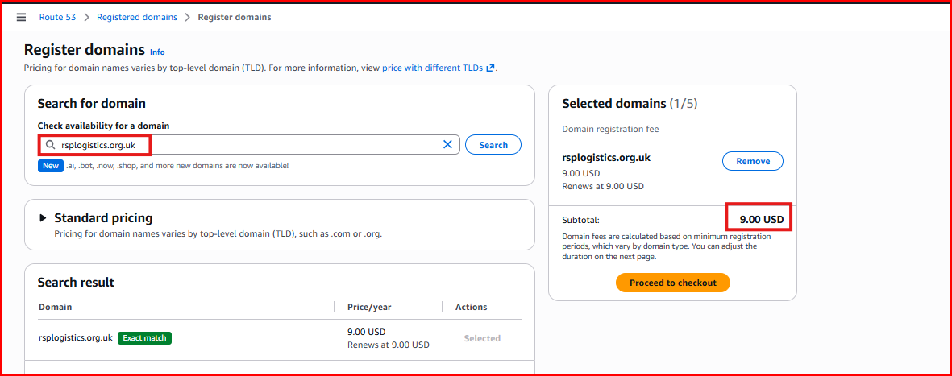
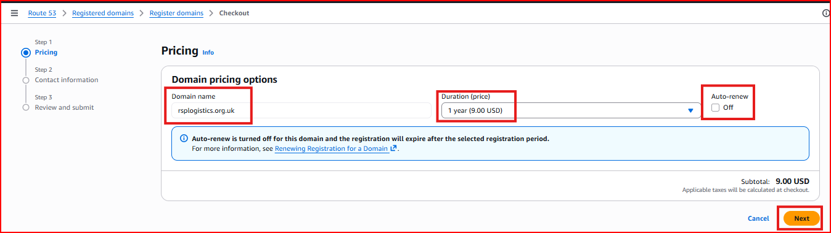
Cost: Domain prices vary — .com is typically ~$12/year
Alternative: You can also buy a domain from GoDaddy or Namecheap and point it to Route 53 by updating the name servers

Step 2 – Hosted Zone is Created Automatically
After domain registration, Route 53 automatically creates a Hosted Zone for your domain. A Hosted Zone is a container for all the DNS records for your domain. It comes pre-populated with two records: an NS record (4 name servers) and an SOA record.
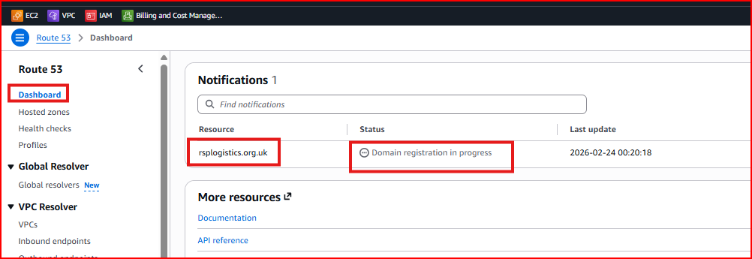
NS Record: 4 Route 53 name servers — these tell the internet that Route 53 is authoritative for your domain
SOA Record: Start of Authority — administrative details about the zone, created automatically

Step 3 – Create an A Record to Point Domain to EC2 Instance
Create an A Record to map your domain name to the public IP address of your EC2 instance. This is what allows users to access your website by typing the domain name instead of the IP address.
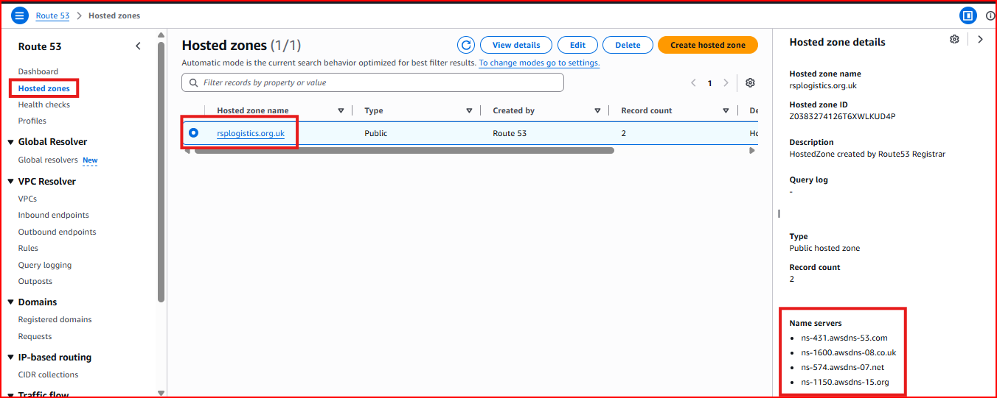
Record name: Leave blank for root domain (example.com) or enter 'www' for www.example.com
Record type: A — Routes traffic to an IPv4 address
Value: Enter the EC2 instance's public IP address
Routing policy: Simple routing

Step 4 – Change TTL (Time To Live)
TTL controls how long DNS resolvers around the world cache your DNS record before checking Route 53 for updates. A lower TTL means DNS changes propagate faster but increases the number of DNS queries. A higher TTL reduces queries but means changes take longer to take effect globally.
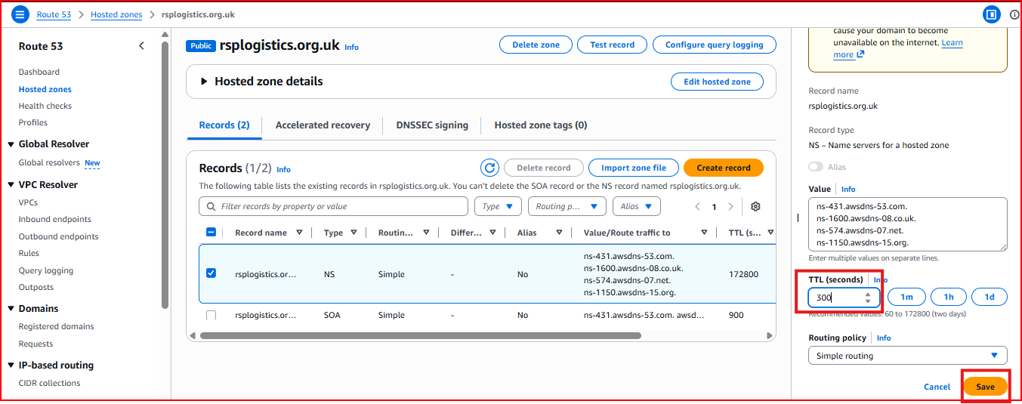
Default TTL: 300 seconds (5 minutes)
Lower TTL: 60 seconds — good when you need fast DNS changes e.g. before migrating servers
Higher TTL: 3600 seconds (1 hour) — reduces DNS query cost for stable records
Best practice: Lower TTL before making changes to DNS records so propagation is faster, then raise it back afterwards

Step 5 – Add IP Address to the Record
Enter the public IP address of your EC2 instance in the Value field of the A Record. This is the IP address that Route 53 will return when anyone queries your domain name.
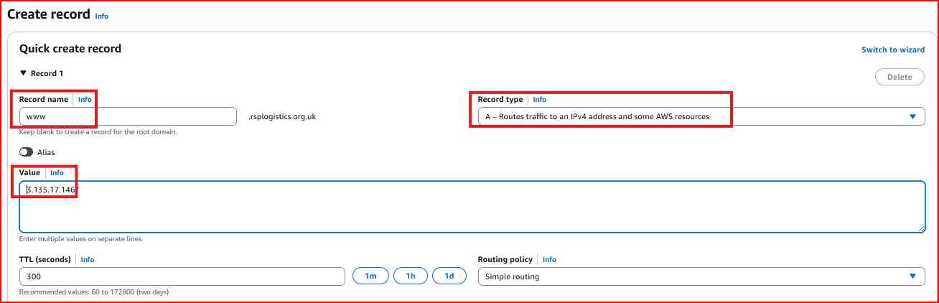
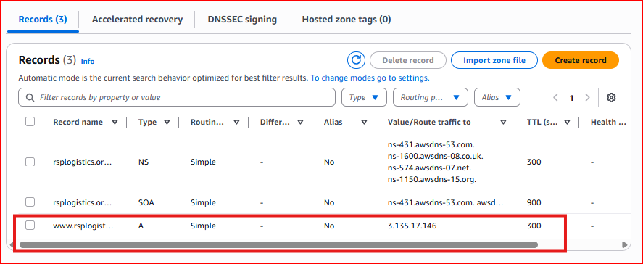

Step 6 – Test with IP Address (Before DNS)
First verify the website is accessible via the direct EC2 public IP address. This confirms the web server is running correctly before testing DNS resolution.
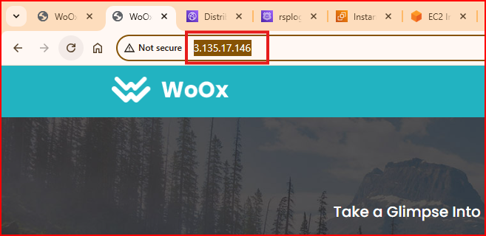
Test: Open browser and navigate to http://EC2-public-IP — website should load

Step 7 – Test with Domain Name (After DNS)
Now test using your registered domain name. Open the browser and navigate to your domain. If the A Record is configured correctly and DNS has propagated, the same website should load — but now through your domain name instead of the IP address.
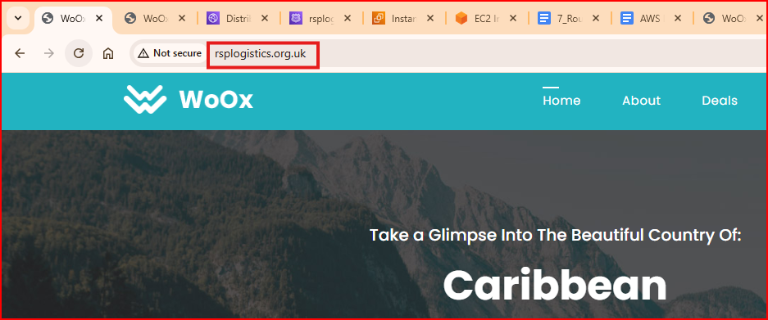
Test: Open browser and navigate to http://yourdomain.com — same website loads via domain name
Propagation time: DNS changes can take a few minutes to a few hours to propagate worldwide depending on TTL

Section 3 – Other DNS Record Use Cases
CNAME Record – Point Domain to Load Balancer
A CNAME record maps your domain to another domain name. This is used to point your custom domain to a Load Balancer DNS name. For example, www.example.com → my-lb-123456789.us-east-1.elb.amazonaws.com.
Record name: www (creates www.example.com)
Record type: CNAME
Value: Paste your Load Balancer DNS name
Limitation: CNAME cannot be used at the root domain (example.com) — only subdomains. Use Alias record for root domain

Alias Record – Recommended for AWS Resources
An Alias record is an AWS-specific extension that works like a CNAME but can also be used at the root domain. It natively integrates with AWS services and there is no additional charge for Route 53 queries to alias records.
Record type: A (with Alias toggle ON)
Route traffic to: Alias to Application and Classic Load Balancer → select region → select LB
Advantage over CNAME: Works at root domain, free queries, automatic health checking, native AWS integration

Subdomains
Subdomains are prefixes added to your domain. Each subdomain needs its own DNS record. For example Google uses mail.google.com, drive.google.com, and docs.google.com — each is a separate subdomain pointing to different servers.
Example: blog.example.com → A record pointing to blog server IP
Example: api.example.com → A record pointing to API server IP
Wildcard: *.example.com SSL certificate covers ALL subdomains with one certificate

Section 4 – Route 53 Routing Policies
Route 53 supports 8 routing policies that control how traffic is distributed to your resources. Choosing the right policy depends on your use case — high availability, performance, geographic targeting, or gradual rollouts.

1. Simple Routing
Routes all traffic to a single resource. Used when you have one website or server and no special routing requirements.
Use case: Single server, basic website hosting
2. Weighted Routing
Distributes traffic across multiple resources according to assigned weights. For example, send 80% of traffic to Server A and 20% to Server B.
Use case: A/B testing new deployments, gradually shifting traffic from old to new server version
Example: Weight 80 → Production server, Weight 20 → New version server
3. Latency Routing
Routes users to the AWS region that provides the lowest network latency for them. AWS measures latency between users and your resources and automatically sends each user to the fastest option.
Use case: Global applications where performance matters — users get routed to the fastest region
4. Failover Routing
Sends traffic to a primary resource and automatically switches to a secondary resource if the primary fails health checks. Essential for disaster recovery.
Use case: High availability — if primary server goes down, Route 53 automatically routes to backup
Requires: Health checks enabled on the primary endpoint
5. Geolocation Routing
Routes traffic based on the geographic location of the user making the DNS query. Users in different countries are directed to different servers.
Use case: Serving region-specific content, complying with data residency laws, language-specific sites
Example: Users in India → India servers, Users in US → US servers
6. Geoproximity Routing
Routes traffic based on geographic distance between users and resources, with an optional bias adjustment that makes a resource appear closer or farther than it actually is.
Positive bias (+): Makes resource appear closer — attracts MORE traffic to that resource
Negative bias (-): Makes resource appear farther — reduces traffic to that resource
Formula: Biased distance = actual distance × [1 - (bias/100)]
7. Multi-Value Answer Routing
Returns up to 8 healthy IP addresses in response to DNS queries. Acts as a simple load balancer — DNS randomly selects from the healthy IPs returned.
Use case: Simple load distribution across multiple healthy servers without a dedicated load balancer
Requires: Health checks enabled — unhealthy endpoints are automatically removed from responses
8. IP-Based Routing
Routes traffic based on the source IP address of the user making the DNS query. Useful for routing corporate network traffic to specific endpoints.
Use case: Corporate networks, network segmentation, routing specific ISP traffic to specific servers

Project Summary
✅ Registered a domain in Route 53 — hosted zone automatically created with NS and SOA records
✅ Created an A Record mapping domain name to EC2 instance public IP address
✅ Configured TTL — understood how it controls DNS propagation speed
✅ Tested website via direct IP address first to confirm server is working
✅ Tested website via domain name — confirmed DNS resolution working correctly
✅ Understood all DNS record types: A, PTR, CNAME, MX, NS, SOA and their use cases
✅ Understood all 8 Route 53 routing policies and when to use each
Interview Questions & Answers

Q1: What is Route 53 and what are its main features?
Route 53 is AWS's DNS (Domain Name System) service named after DNS port 53. Its main features are domain registration — you can buy and manage domains directly in AWS, DNS routing — translating domain names to IP addresses using various routing policies, health checks — monitoring endpoint availability and automatically routing around failures, and traffic management — controlling how traffic is distributed across multiple resources using 8 different routing policies.

Q2: What is the difference between an A Record, CNAME Record, and Alias Record?
An A Record maps a domain name directly to an IPv4 address — I use it to point example.com to an EC2 instance IP. A CNAME maps one domain name to another domain name — I use it to point www.example.com to a Load Balancer DNS name, but CNAME cannot be used at the root domain. An Alias record is AWS-specific — it works like a CNAME but can be used at the root domain, it natively integrates with AWS resources like Load Balancers and CloudFront, and Route 53 doesn't charge for Alias record queries. Best practice is always to use Alias when pointing to AWS resources.

Q3: What is TTL in Route 53 and why does it matter?
TTL stands for Time To Live — it controls how long DNS resolvers around the world cache a DNS record before checking Route 53 for an update. The default is 300 seconds. A lower TTL means DNS changes propagate faster worldwide but increases the number of DNS queries and cost. A higher TTL reduces queries but means changes take longer to take effect. My best practice is to lower TTL to 60 seconds before making any DNS changes, wait for the old TTL to expire, make the change, then raise TTL back to 3600 seconds.

Q4: What is the difference between Failover and Weighted routing policies?
Failover routing is for high availability — all traffic goes to the primary endpoint and Route 53 only switches to the secondary if the primary fails a health check. It is binary: either primary or backup. Weighted routing is for traffic splitting — you assign percentage weights to multiple endpoints and traffic is continuously distributed between them based on those weights. For example 90% to production and 10% to a new version for gradual rollout testing.

Q5: How do you migrate DNS from another provider like GoDaddy to Route 53?
The process has four steps. First create a Hosted Zone in Route 53 for the domain. Second recreate all existing DNS records from the old provider in Route 53 — A records, MX records, CNAME records and so on. Third lower the TTL on all records at the old provider to 60 seconds and wait for the old TTL to expire. Fourth copy the 4 NS record values that Route 53 provides and update the name servers at your domain registrar (GoDaddy, Namecheap etc.) to point to Route 53. DNS traffic will gradually shift to Route 53 as caches expire.

Q6: What is Geolocation routing and how is it different from Latency routing?
Geolocation routing directs users to specific servers based on their country or continent — for example all users in India go to the India server regardless of whether a closer server might be faster. This is used for compliance with data residency laws or serving region-specific content. Latency routing automatically routes each user to whichever AWS region gives them the lowest latency — it measures actual network performance and picks the fastest option. Use Geolocation when you need strict regional control, and Latency when you just want the best performance for every user.

