AWS RDS – Relational Database Service
MySQL Setup | Read Replicas | Snapshots | Multi-AZ | PHP App | Failover Testing
Hands-On Project Documentation

Project Overview
Amazon RDS (Relational Database Service) is a fully managed Platform-as-a-Service database that handles all the heavy lifting — patching, backups, replication, and failover — so you can focus entirely on your application. You never need to SSH into the database server or manage the OS.
This document covers two hands-on projects: Part 1 is creating a basic MySQL RDS database, connecting to it from EC2, and exploring Read Replicas and Snapshots. Part 2 is a full enterprise-grade Multi-AZ architecture with two web servers running a PHP login application connected to a highly available RDS database — with Load Balancer, Route 53, and failover testing.

Supported engines: MySQL, PostgreSQL, MariaDB, Oracle, SQL Server, Amazon Aurora, IBM Db2
Key benefit: AWS manages OS, patches, backups, replication — you only manage the database itself
Port: MySQL/Aurora uses port 3306

PART 1 – Creating and Connecting to a MySQL RDS Database

Step 1 – Create the RDS Database
Go to AWS Console → RDS → Create Database → Standard Create. This gives full control over all configuration options. Select MySQL as the engine type.
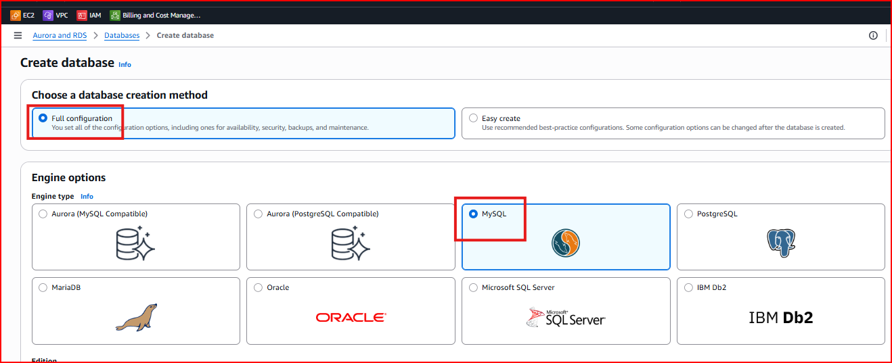
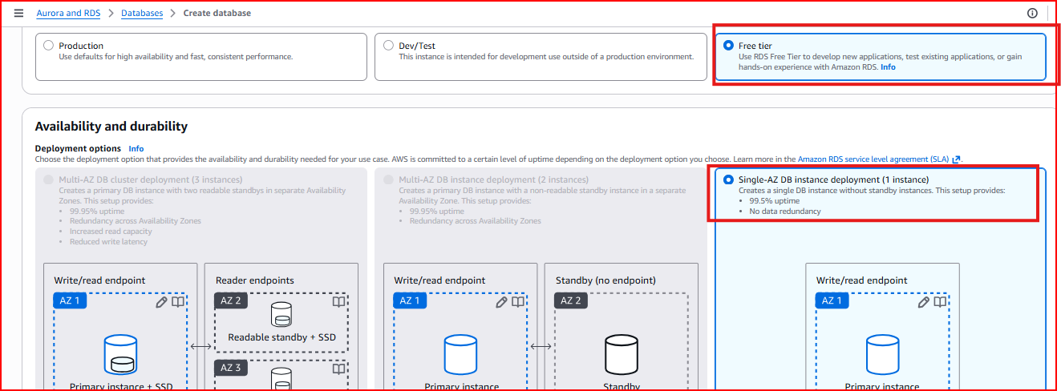
Creation method: Standard Create — gives full configuration control
Engine: MySQL
Template: Free Tier — for learning and testing (Dev/Test for Multi-AZ)

Database Settings
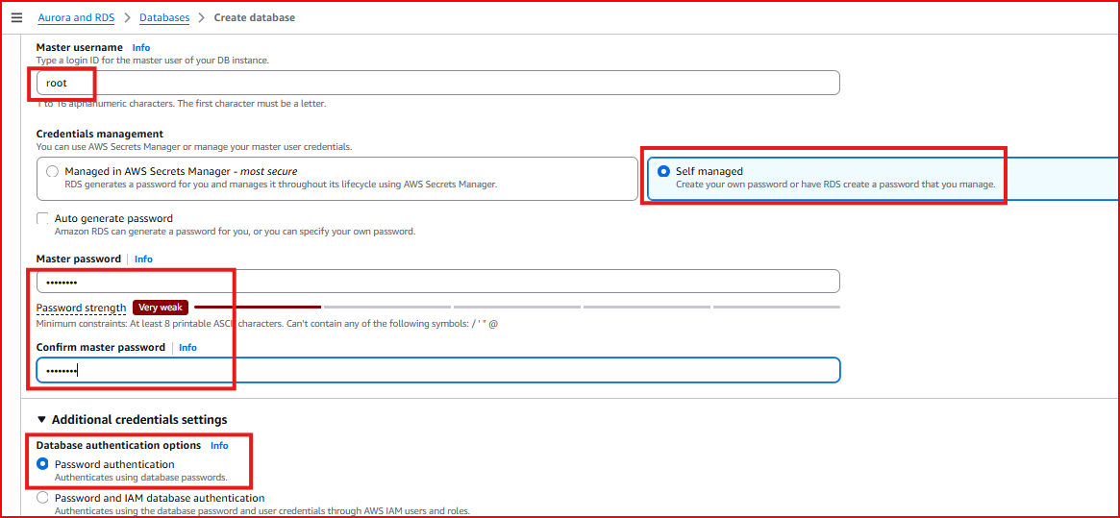
DB Instance Identifier: Unique name for your database instance — e.g., fb-db
Master Username: root — the administrator login
Master Password: Strong password, minimum 8 characters
Instance class: db.t3.micro — Free Tier eligible, suitable for testing
Storage type: General Purpose SSD (gp3) — 20 GiB minimum
Storage autoscaling: Enable — automatically expands storage when needed

Connectivity — Critical Security Settings
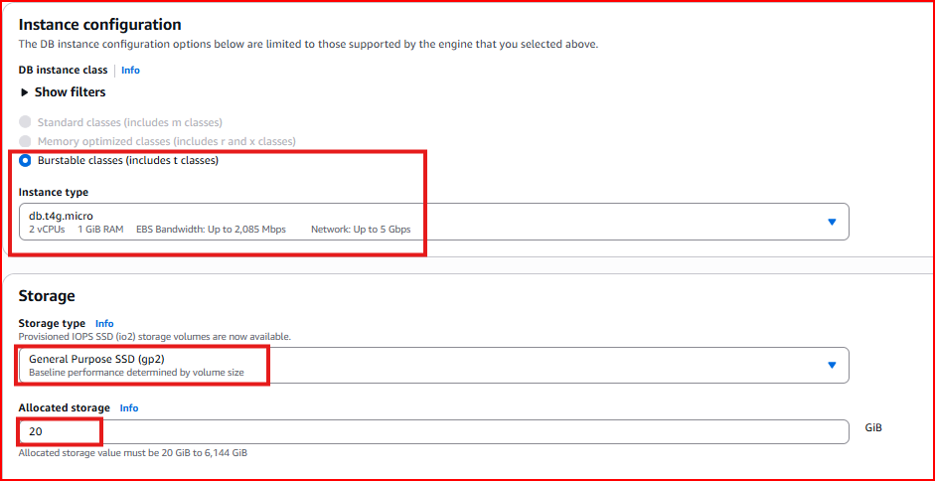
VPC: Select your VPC
Public access: No for production — Yes temporarily for direct testing only
Critical: Add inbound rule in security group — MySQL/Aurora, TCP, Port 3306. Without this rule the connection will be refused even if the database is running

Additional Configuration
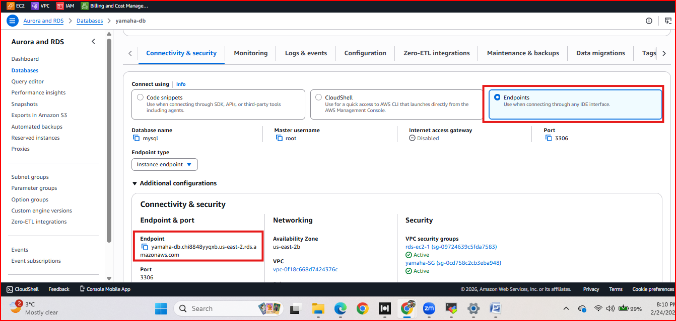
Initial database name: fbdb — creates this database automatically on first launch
Automated backups: Enable — retained for 7 days by default
Backup window: Choose off-peak hours for your application
Encryption: Enable for production — protects data at rest using AWS KMS

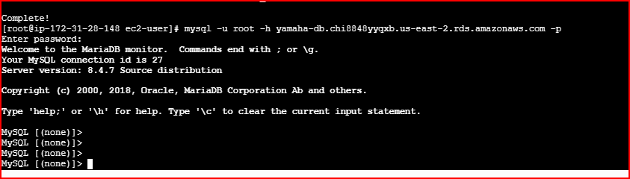
Wait time: RDS takes 5-10 minutes to become Available after creation — do not attempt to connect until status shows Available

Step 2 – Connect to the Database from EC2
RDS databases are not directly accessible from your laptop by default — they live inside a VPC. You connect through an EC2 instance in the same VPC using the MySQL client.

Install MySQL Client on EC2
yum install mariadb* -y # Install MySQL-compatible client
yum install mariadb* -y --skip-broken # Use if conflicts occur

Get the RDS Endpoint
In the RDS Console click on your database instance and copy the Endpoint address. This is the hostname your application uses to connect — it never changes even if the underlying server changes.
Endpoint example: fb-db.cfcpfm2bhmtb.us-west-2.rds.amazonaws.com

Connect and Verify
mysql -u root -h <your-rds-endpoint> -p
show databases;
Expected output shows: information_schema, fbdb, mysql, performance_schema — confirming successful connection to the RDS instance.

Section 1.2 – Read Replicas
A Read Replica is an asynchronous read-only copy of your primary database. It receives a continuous stream of changes from the primary and stays nearly up to date. You direct all read-heavy queries (SELECT) to the replica and write operations (INSERT, UPDATE, DELETE) to the primary — reducing load on the primary database.

Replication type: Asynchronous — slight lag possible between primary and replica
Max replicas: Up to 5 read replicas per source database
Location: Same region or cross-region — put replicas close to users globally
Promotion: A Read Replica can be manually promoted to a standalone database for disaster recovery
Use case: Reporting, analytics, read-heavy workloads — offload reads from primary

Create a Read Replica
In RDS Console select your database → Actions → Create Read Replica. Give it a unique identifier, choose the destination region, and configure the instance class.
Identifier: e.g., mysql-database-1-replica
Region: Same region for local read scaling, different region for global distribution
Important: Read Replicas use a separate endpoint — your application must be configured to send reads to the replica endpoint and writes to the primary endpoint

Section 1.3 – Database Snapshots
Snapshots are point-in-time backups of your entire RDS database stored in Amazon S3. They capture everything — schema, data, configuration. You can restore a snapshot to create a brand new RDS instance at any point in time.

Automated snapshots: Created daily during backup window — retained 0-35 days — deleted when DB is deleted
Manual snapshots: Created on demand by you — kept until you explicitly delete them
Restore: Creates a NEW database instance from the snapshot — original DB is unchanged
Use case: Before major schema changes, before deploying new code, disaster recovery baseline

Create a Manual Snapshot
RDS Console → Snapshots → Take Snapshot. Select the source database, give the snapshot a descriptive name with the date, and click Take Snapshot. Status changes from Creating to Available in a few minutes.
Naming tip: Use format: db-name-backup-YYYY-MM-DD so you can identify it quickly later

Section 1.4 – Parameter Groups and Option Groups
Parameter Groups
A Parameter Group is a container for database engine configuration values. Instead of configuring each database individually you create one Parameter Group and apply it to multiple databases — they all share the same settings.
Common MySQL parameters: max_connections (concurrent connections), innodb_buffer_pool_size (memory cache), slow_query_log (log slow queries)
How to apply: Create group → modify parameters → assign to database instance → reboot if static parameter

Option Groups
Option Groups enable additional features and plugins for specific database engines. For example MySQL can have MEMCACHED (in-memory caching) or MARIADB_AUDIT_PLUGIN (audit logging) enabled through an Option Group.

PART 2 – Multi-AZ RDS with PHP Application

Section 2.1 – What is Multi-AZ?
Multi-AZ (Multi-Availability Zone) deployment automatically maintains a synchronous standby replica of your database in a different Availability Zone. If the primary database fails for any reason — hardware failure, AZ outage, maintenance — RDS automatically fails over to the standby with no manual intervention.

Replication type: Synchronous — every write to primary is instantly confirmed on standby before success is returned. Zero data loss guaranteed
Failover time: 60-120 seconds — DNS automatically redirects to standby
Same endpoint: Application uses the same connection string before and after failover — no config changes needed
Standby reads: Standby is NOT used for reads — it exists only for failover (this is the key difference from Read Replica)

Multi-AZ vs Read Replica: Multi-AZ = high availability (automatic failover, synchronous). Read Replica = read scalability (manual promotion, asynchronous)

Section 2.2 – Project Architecture
This project builds a complete production-grade architecture: a PHP login application running on two EC2 web servers, backed by a Multi-AZ MySQL RDS database in private subnets, fronted by a Classic Load Balancer, with a custom domain via Route 53.

Web servers: Web-Server-1 (AZ-a) + Web-Server-2 (AZ-b) — both run identical PHP application
Database: Multi-AZ MySQL RDS in private subnets — primary in AZ-a, standby in AZ-b
Load Balancer: Distributes HTTP traffic between both web servers
Route 53: Custom domain (www.yourdomain.com) points to Load Balancer via Alias record
Application: PHP MySQL Login System — user registration and login stored in RDS

Step 1 – Create VPC with 4 Subnets
Create a custom VPC with four subnets — two public for web servers and two private for the database, spread across two Availability Zones. This isolation ensures the database is never directly accessible from the internet.
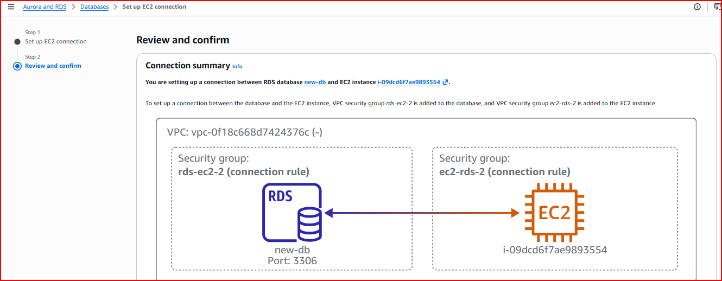
VPC CIDR: 10.0.0.0/16
Public-Subnet-1-Web: 10.0.1.0/24 — AZ-a — web servers, auto-assign public IP enabled
Public-Subnet-2-Web: 10.0.2.0/24 — AZ-b — web servers, auto-assign public IP enabled
Private-Subnet-1-DB: 10.0.3.0/24 — AZ-a — database, NO public IP
Private-Subnet-2-DB: 10.0.4.0/24 — AZ-b — database, NO public IP

Create an Internet Gateway (Production-IGW), attach it to the VPC, and add route 0.0.0.0/0 → IGW to the route table. Associate ONLY the two public subnets — never the private DB subnets.
Security rule: Private subnets must NOT be associated with the public route table — database must never have internet access

Step 2 – Create RDS Subnet Group
An RDS Subnet Group tells RDS which subnets it is allowed to place database instances in. By creating a subnet group containing only the two private subnets, you guarantee the database is always created in private subnets regardless of settings.
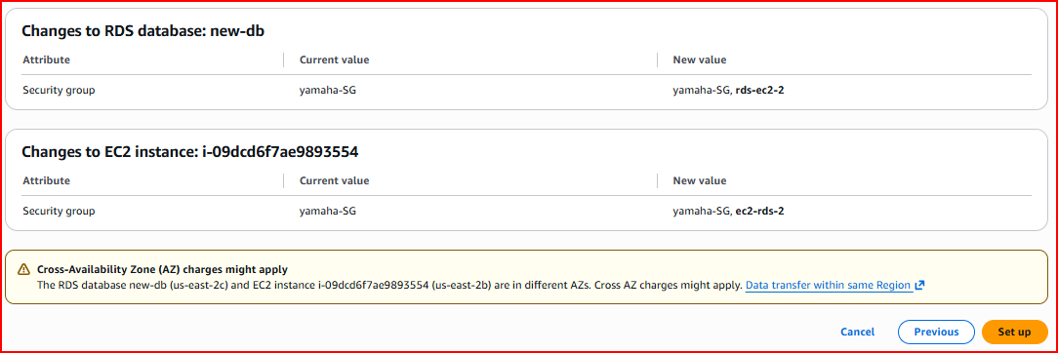
Name: production-db-subnet-group
VPC: Production-VPC
Subnets: Private-Subnet-1-DB (AZ-a) + Private-Subnet-2-DB (AZ-b)
Why this matters: Without a custom subnet group RDS might be created in a public subnet by mistake. The subnet group prevents this

Step 3 – Create Security Group for RDS
Create a dedicated security group for the RDS instance. The inbound rule allows MySQL traffic on port 3306 only from the web server security group — not from the internet or any other source.
SG Name: RDS-MySQL-SG
Inbound rule: MySQL/Aurora, TCP, Port 3306, Source: Web-Server-SG
Why source = Web-Server-SG: Only EC2 instances in the web server security group can connect — all other traffic is blocked

Step 4 – Create Multi-AZ RDS Database
Create the MySQL RDS database, selecting the production-db-subnet-group to place it in private subnets, and enabling Multi-AZ deployment for automatic failover capability.

Engine: MySQL 8.0
Template: Dev/Test — enables Multi-AZ option
DB Identifier: production-mysql-db
Instance class: db.t3.micro for testing
Subnet group: production-db-subnet-group — places DB in private subnets
Public access: No — database is never internet-accessible
Security group: RDS-MySQL-SG
Initial DB name: fbdb
Multi-AZ: ENABLED — creates synchronous standby in second AZ

Wait time: Multi-AZ RDS takes 10-15 minutes to become Available — it is provisioning two database servers simultaneously

Step 5 – Launch Two EC2 Web Servers
Launch two EC2 instances — one in each public subnet across different AZs. Both servers will run identical PHP applications. When one AZ goes down the Load Balancer automatically routes all traffic to the healthy server in the other AZ.
Web-Server-1: Amazon Linux 2023, t2.micro, Public-Subnet-1-Web (AZ-a), public IP enabled
Web-Server-2: Amazon Linux 2023, t2.micro, Public-Subnet-2-Web (AZ-b), public IP enabled
Security group: Allow HTTP port 80, HTTPS port 443, SSH port 22

Step 6 – Install and Configure PHP Application
Connect to both web servers via SSH and install Apache, PHP, and the MySQL client. Then create the PHP application files that connect to the RDS database.

Install Required Packages on Both Servers
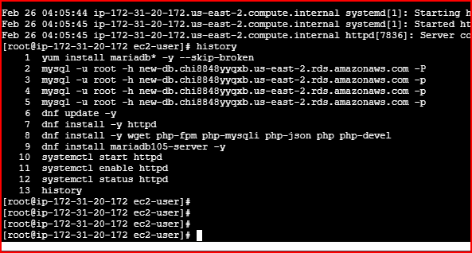
dnf update -y
dnf install -y httpd
dnf install -y wget php-fpm php-mysqli php-json php php-devel
yum install mariadb* -y
systemctl start httpd && systemctl enable httpd

Connect to RDS and Create Database Table
Get the RDS endpoint from the console. Connect from the web server using the MySQL client and create the users table that the PHP login application needs.
mysql -u root -h <rds-endpoint> -p
use fbdb;
CREATE TABLE users (
id INT NOT NULL PRIMARY KEY AUTO_INCREMENT,
username VARCHAR(50) NOT NULL UNIQUE,
password VARCHAR(255) NOT NULL,
created_at DATETIME DEFAULT CURRENT_TIMESTAMP
);
show tables;
describe users;

Create PHP Database Configuration File
Create the config.php file on both web servers with the RDS endpoint and database credentials. This file is shared by all PHP pages to establish the database connection.
cd /var/www/html
vi config.php

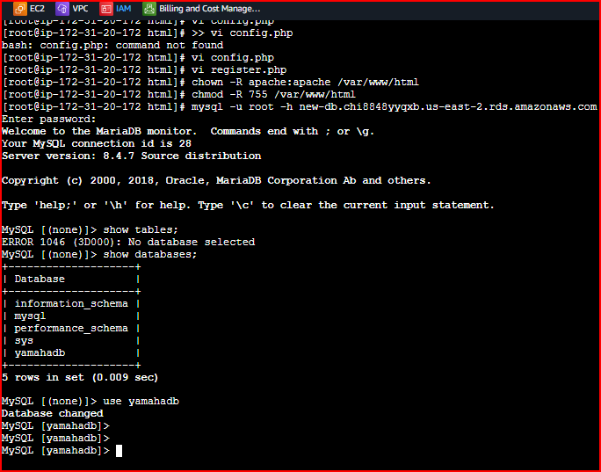
<?php
define('DB_SERVER', 'your-rds-endpoint.rds.amazonaws.com');
define('DB_USERNAME', 'root');
define('DB_PASSWORD', 'YourPassword');
define('DB_NAME', 'fbdb');
$link = mysqli_connect(DB_SERVER, DB_USERNAME, DB_PASSWORD, DB_NAME);
if($link === false){
die('ERROR: Could not connect. ' . mysqli_connect_error());
}
?>

Create Registration Page and Set Permissions
Create register.php from the PHP MySQL Login System tutorial. Set correct file ownership so Apache can serve the files.
vi register.php # Add PHP registration form code
chown -R apache:apache /var/www/html
chmod -R 755 /var/www/html

Test locally: http://<EC2-public-IP>/register.php — verify page loads and registration works

Step 7 – Create Load Balancer and Route 53 Record
Create a Classic Load Balancer that distributes traffic between both web servers. Then create a Route 53 Alias record pointing your custom domain to the Load Balancer.

LB health check path: /register.php — LB checks this page to confirm each server is healthy
Health check interval: 30 seconds, Unhealthy threshold: 2, Healthy threshold: 10
Route 53 record: A record with Alias ON → Alias to Classic Load Balancer → select region → select LB
Record name: www — creates www.yourdomain.com

Step 8 – Test the Complete Architecture
Test User Registration via Domain
Open a browser and navigate to http://www.yourdomain.com/register.php. Fill in the registration form. The request goes through: Route 53 → Load Balancer → Web Server → RDS Database.

Verify Data Stored in RDS
Connect to the RDS database from either web server and confirm the registered user is stored correctly.
mysql -u root -h <rds-endpoint> -p
use fbdb;
select * from users;
You should see the registered user with their hashed password and timestamp — confirming the full application stack is working correctly end to end.

Test Multi-AZ Failover
To prove Multi-AZ failover works, trigger a manual failover by rebooting the database with failover enabled. The standby in AZ-b gets promoted to primary. The application automatically reconnects using the same endpoint — users experience only 60-120 seconds of brief interruption.
RDS Console → Select database → Actions → Reboot → 'Reboot with failover' → Confirm
After failover: Standby promoted to primary — new standby created in original AZ — same endpoint works
Zero data loss: Because replication is synchronous every write confirmed before failover is fully preserved on the new primary

Section 2.3 – Database Migration Service (DMS)
AWS DMS (Database Migration Service) helps you migrate databases to AWS with minimal downtime. It continuously replicates from source to target so the application can keep running during migration — you only switch over when ready.

Homogeneous migration: Same engine to same engine — e.g., MySQL on-premises to MySQL RDS
Heterogeneous migration: Different engines — e.g., Oracle to PostgreSQL, SQL Server to MySQL
Schema Conversion Tool (SCT): Automatically converts schema and stored procedures for heterogeneous migrations
Steps: Assess source → create replication instance → define source/target endpoints → create task → run migration → cutover

Project Summary
✅ Created MySQL RDS database with correct security group, port 3306, initial database name
✅ Connected to RDS from EC2 using MySQL client — verified databases with 'show databases'
✅ Understood Read Replicas — async read-only copies for scaling reads, up to 5 per DB
✅ Created manual snapshot for point-in-time backup and understood restore process
✅ Built full Multi-AZ architecture: VPC, 4 subnets, IGW, RDS subnet group, security groups
✅ Created Multi-AZ RDS database — primary in AZ-a, synchronous standby in AZ-b
✅ Installed Apache + PHP on two EC2 web servers, created config.php pointing to RDS endpoint
✅ Created users table in RDS and connected PHP login application successfully
✅ Set up Load Balancer across both web servers and Route 53 Alias record for custom domain
✅ Tested failover by rebooting with failover — application reconnected automatically, zero data loss
Interview Questions & Answers

Q1: What is Amazon RDS and what are its key benefits over managing your own database on EC2?
Amazon RDS is a fully managed relational database service. The key benefits over self-managed EC2 databases are that AWS handles all the operational tasks — OS patching, database software updates, automated backups, multi-AZ replication, and failover — so you focus entirely on your application and data. RDS also provides automated backups with point-in-time recovery, one-click Read Replicas, and Multi-AZ high availability that would take significant engineering effort to build yourself on EC2.

Q2: What is the difference between Multi-AZ and Read Replicas?
Multi-AZ is for high availability — it maintains a synchronous standby in a different AZ and automatically fails over to it if the primary fails. The standby is not used for reads — it exists only for disaster recovery. There is zero data loss because replication is synchronous. Read Replicas are for read scalability — they use asynchronous replication so there may be slight lag. You direct read-heavy queries to replicas to reduce primary load. Replicas have their own endpoints and can be promoted to primary manually but failover is not automatic.

Q3: How does RDS Multi-AZ failover work and how long does it take?
When the primary database fails a health check — due to hardware failure, AZ outage, or manual reboot with failover — RDS automatically updates the DNS record for the database endpoint to point to the standby in the other AZ. The standby is promoted to primary and a new standby is provisioned in the original AZ. The entire process takes 60 to 120 seconds. Because replication is synchronous — every write is confirmed on the standby before returning success to the application — there is zero data loss. The application reconnects automatically using the same endpoint.

Q4: How do you secure an RDS database?
I apply multiple layers of security. First, I place the RDS instance in private subnets with no public access — it is never directly reachable from the internet. Second, I use a VPC security group that only allows MySQL port 3306 connections from the web server security group — no other source can connect. Third, I enable encryption at rest using AWS KMS to protect stored data. Fourth, I use strong master passwords and ideally IAM database authentication instead of static passwords. Finally, I enable automated backups with encryption and use parameter groups to enforce security settings like requiring SSL connections.

Q5: What is an RDS Subnet Group and why is it important?
An RDS Subnet Group is a collection of subnets within a VPC that you define for RDS to use when deploying database instances. It is important because it ensures the database is always created in the correct subnets — specifically your private subnets. Without a custom subnet group pointing to private subnets, you risk accidentally placing the database in a public subnet. For Multi-AZ deployments the subnet group must include subnets in at least two different Availability Zones so RDS can place the primary and standby in separate AZs.

Q6: What is the difference between automated backups and manual snapshots in RDS?
Automated backups are created daily by RDS during a configured backup window and are retained for 0 to 35 days. They enable point-in-time recovery — you can restore to any second within the retention period. They are automatically deleted when you delete the database instance. Manual snapshots are triggered by you and are retained indefinitely until you explicitly delete them. They are not affected by database deletion. I use manual snapshots before major changes — like schema migrations or deployments — as a safety net, and rely on automated backups for day-to-day point-in-time recovery.

