AWS CloudWatch Project
Auto-Stop EC2 Instance When CPU Utilization Falls Below 30%
Hands-On Project Documentation

Project Overview
This project demonstrates how to automatically stop an EC2 instance when it is not being actively used — specifically when the CPU utilization drops below 30% for a sustained period. The solution uses three core AWS services working together: Amazon EC2, Amazon SNS (Simple Notification Service), and Amazon CloudWatch Alarms with an IAM Role.
This is a cost-saving automation technique. Instead of leaving idle EC2 instances running and incurring charges, CloudWatch monitors CPU usage and triggers an automatic shutdown when the instance becomes idle.
Architecture Flow
CloudWatch continuously monitors the EC2 instance CPU metrics → When CPU stays below 30%, the alarm triggers → SNS sends an email notification → CloudWatch (via IAM Role) automatically stops the EC2 instance.

Step 1: Launch EC2 Instance
The first step is to create an EC2 instance that will be monitored. This is the virtual server we want to automatically stop when it becomes idle.
What was done: A new EC2 instance was launched in the AWS Console. The instance type, AMI (Amazon Machine Image), and key pair were selected. The instance was started and its Instance ID was noted — this ID will be used when creating the CloudWatch alarm.
Why this step: We need a running EC2 instance to monitor. CloudWatch needs a target resource to collect CPU metrics from.
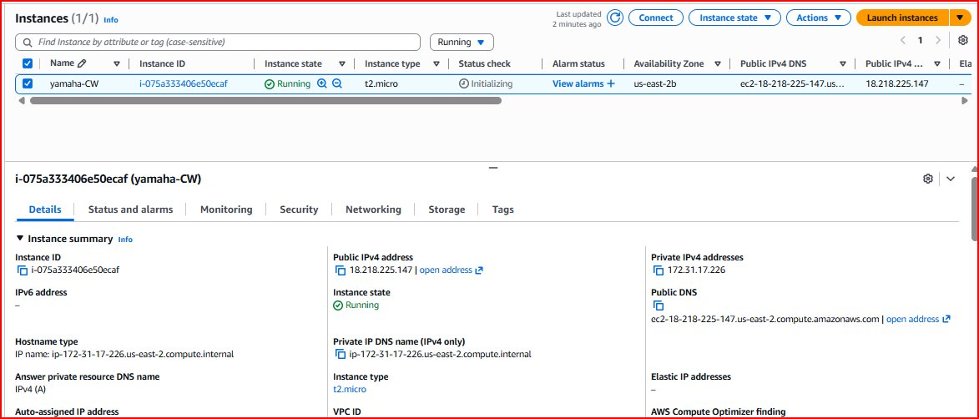
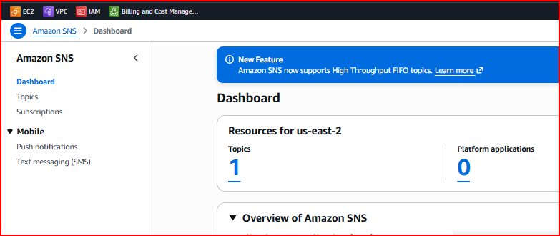

Step 2: Create SNS Topic & Email Subscription
Amazon Simple Notification Service (SNS) is used to send alert notifications. Before creating the CloudWatch alarm, we set up SNS so that we (and the alarm) have a notification channel ready.
What was done: A new SNS Topic was created in the AWS Console. An email subscription was added to the topic using a valid email address. AWS sent a confirmation email to that address, which had to be confirmed by clicking the link inside.
Why this step: When CloudWatch detects that CPU is low, it needs somewhere to send the alert. SNS acts as the notification hub — it can email you, trigger Lambda functions, or integrate with other services. Confirming the email subscription is mandatory; without it, SNS cannot deliver notifications.
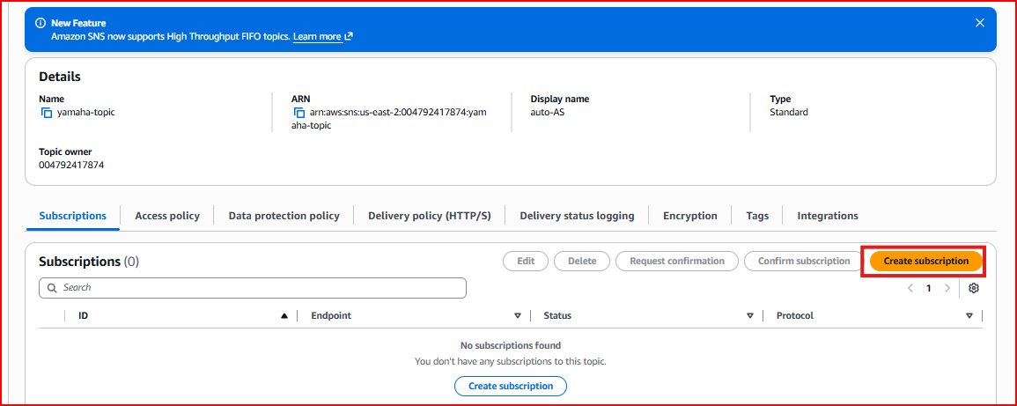
Email Subscription Confirmation
After creating the SNS subscription, AWS sends a confirmation email to the provided address. The user must click 'Confirm subscription' in that email to activate it. This is a security measure by AWS to prevent unauthorized subscriptions.
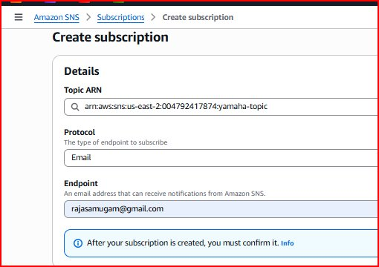
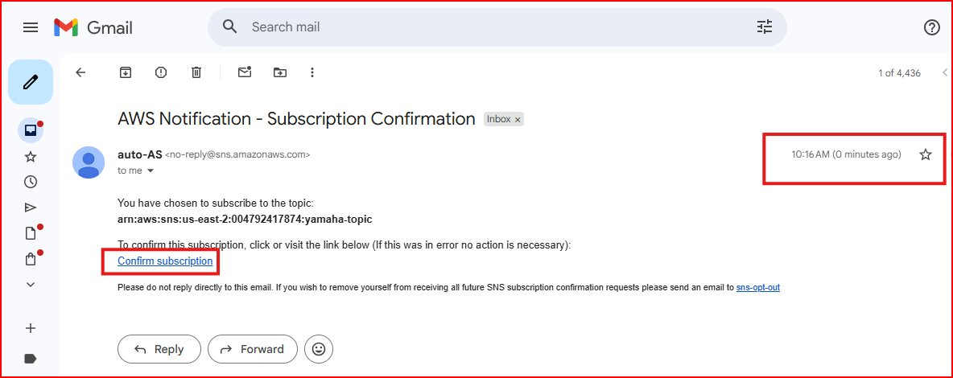
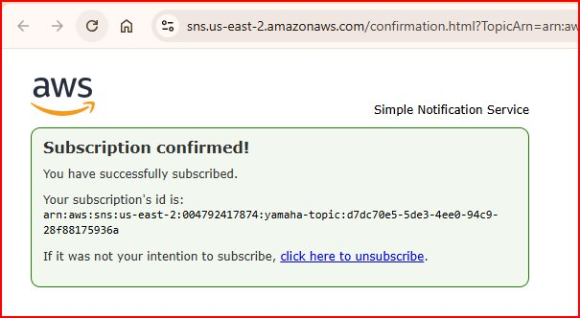
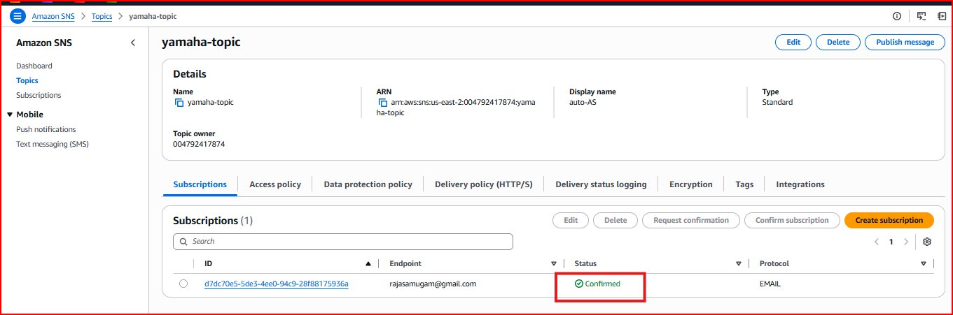

Step 3: Create IAM Role for CloudWatch
For CloudWatch to be able to stop an EC2 instance, it needs permission. In AWS, permissions are managed through IAM (Identity and Access Management) Roles and Policies.
What was done: An IAM Role was created with the EC2 Stop Instances permission policy attached. This role was then associated with the CloudWatch alarm action so that when the alarm fires, it has the authority to stop the instance.
Why this step: AWS services cannot perform actions on other services without explicit permission. Without this IAM role, CloudWatch can detect the CPU breach but cannot actually stop the instance. This is a core AWS security principle — least privilege access.

Step 4: Create CloudWatch Alarm
This is the core step of the project. The CloudWatch Alarm is configured to watch the CPU utilization metric of the EC2 instance and take action when it falls below the defined threshold.
Metric monitored: EC2 CPU Utilization (CPUUtilization)
Condition: CPU less than 30% for a defined number of evaluation periods
Actions configured: 1) Send notification to the SNS topic (email alert), 2) Stop the EC2 instance using the IAM role
Why this step: CloudWatch is the brain of this automation. It continuously pulls CPU metrics every minute from EC2 and evaluates them against the threshold you define. When the condition is met (CPU < 30%), it automatically executes both actions — notifying you and shutting down the instance to save costs.
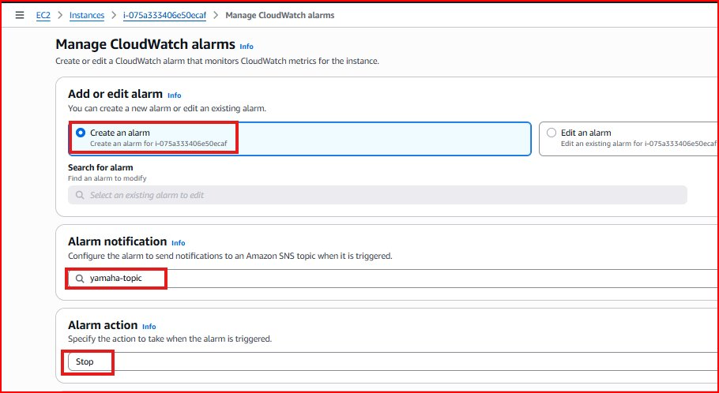
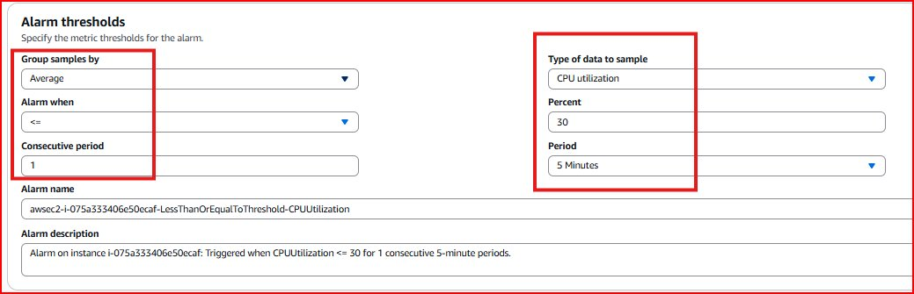

Step 5: Result — Alarm Triggers & Instance Stops
Once the CloudWatch alarm was set up and the EC2 instance remained idle (CPU below 30%), the alarm entered the ALARM state and executed both configured actions.
What happened: CloudWatch detected CPU utilization stayed below 30%. The alarm state changed from OK to ALARM. SNS sent an email notification to the subscribed email address. CloudWatch stopped the EC2 instance automatically.
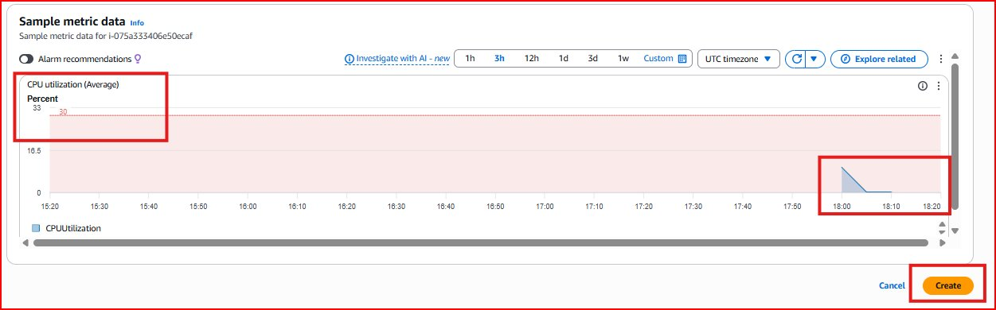

Step 6: Before & After — Instance State
The screenshots below show the EC2 instance state before and after the CloudWatch alarm triggered. This confirms the automation worked successfully.
Before (Instance Running)
The EC2 instance was in 'running' state before the CloudWatch alarm fired.
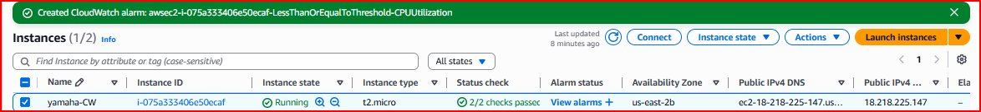
After (Instance Stopped)
After CloudWatch detected low CPU and triggered the alarm, the instance state changed to 'stopped' — automatically, without any manual intervention.
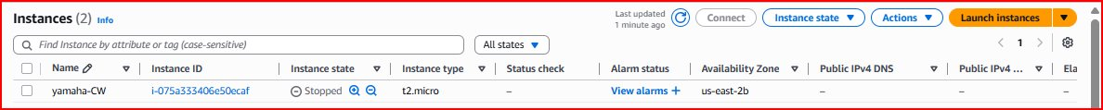

Project Summary
This project successfully demonstrates a real-world cloud cost optimization use case using native AWS services. By combining EC2, SNS, IAM, and CloudWatch, we built a fully automated system that:
- Monitors EC2 CPU usage in real time
- Sends email alerts when the instance becomes idle
- Automatically stops the instance to save costs
- Requires zero manual intervention once configured
This pattern is widely used in production environments to manage development/test instances, reduce AWS bills, and enforce resource governance policies.

Interview Questions & Answers
Q1: What is the purpose of this CloudWatch project?
The project automates EC2 cost savings by stopping idle instances. CloudWatch monitors CPU utilization and when it drops below 30% for a sustained period, it triggers an alarm that sends an SNS email notification and automatically stops the EC2 instance — eliminating the need for manual monitoring.
Q2: Why do you need an IAM Role for this project?
AWS follows the principle of least privilege — services cannot perform actions on other services without explicit permission. CloudWatch needs an IAM Role with EC2 Stop Instances permission attached so that when the alarm triggers, it has the authority to actually stop the instance. Without this role, CloudWatch can detect the threshold breach but cannot execute the stop action.
Q3: What is SNS and why is it used here?
SNS (Simple Notification Service) is AWS's managed messaging service. In this project it acts as the notification channel — when the CloudWatch alarm fires, it sends a message to the SNS topic, which delivers an email to all confirmed subscribers. Confirming the email subscription is mandatory before SNS can send notifications to that address.
Q4: What happens step by step when the alarm triggers?
When CPU stays below 30%: (1) CloudWatch evaluates the metric and moves from OK to ALARM state, (2) SNS sends an email notification to the subscribed address alerting that the instance is idle, (3) CloudWatch uses the IAM role to call the EC2 StopInstances API, (4) The EC2 instance transitions from Running to Stopped state automatically.
Q5: How is this useful in a real production environment?
Development and test EC2 instances are often left running overnight or over weekends when no one is using them, accumulating unnecessary AWS charges. This CloudWatch automation ensures those instances shut down automatically when idle, significantly reducing costs. The same pattern can be extended to use scheduled alarms, auto-scaling policies, or Lambda functions for more complex shutdown logic.

