AWS CloudWatch Log Collection from EC2
Collect /var/log from EC2 Instance using CloudWatch Agent

EC2 Instance → CloudWatch Agent → CloudWatch Log Groups → View Logs in Console
AWS Services Used: Amazon EC2 | AWS IAM | Amazon CloudWatch | CloudWatch Agent

Project Overview
This project demonstrates how to collect system logs from an EC2 instance and send them to AWS CloudWatch for centralized monitoring and analysis. The CloudWatch Agent is installed on the EC2 instance and configured to collect log files from /var/log directory and stream them to CloudWatch Log Groups in real time.
This is a standard DevOps practice in production environments — instead of SSH-ing into each server to check logs manually, CloudWatch gives a single centralized place to view, search and set alerts on all server logs.

Step 1: Create IAM Role for EC2
💡 Why this step: The EC2 instance needs permission to send logs to CloudWatch. In AWS, services cannot interact with other services without explicit IAM permissions. We create a role and attach it to the EC2 instance so the CloudWatch Agent can write logs to CloudWatch on behalf of the instance.
Step 1a — Select Trusted Entity
Navigate to: AWS Console → IAM → Roles → Create Role
On the Select trusted entity page:
- Trusted entity type: AWS service
- Use case: EC2
- This allows EC2 instances to call AWS services on your behalf
- Click Next to proceed to Add permissions
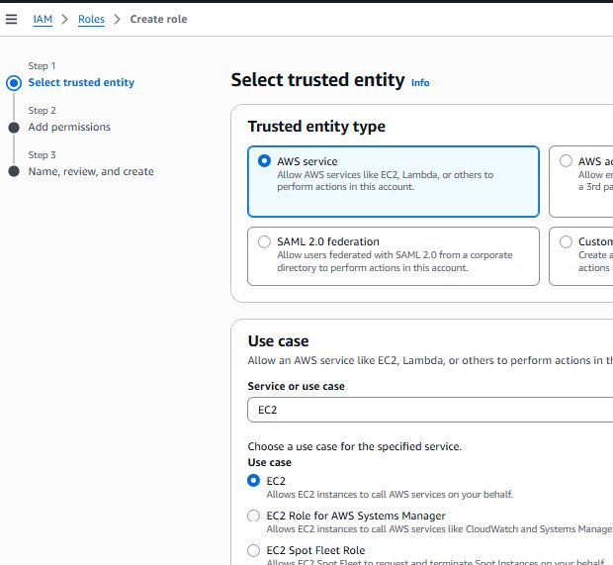
📸 IAM → Create Role → Select Trusted Entity: AWS Service → EC2
Step 1b — Add Permissions Policy
On the Add permissions page:
- Search for: CloudWatchAgentServerPolicy
- Select the checkbox next to CloudWatchAgentServerPolicy
- This policy gives the EC2 instance permission to write logs and metrics to CloudWatch
- Click Next to proceed
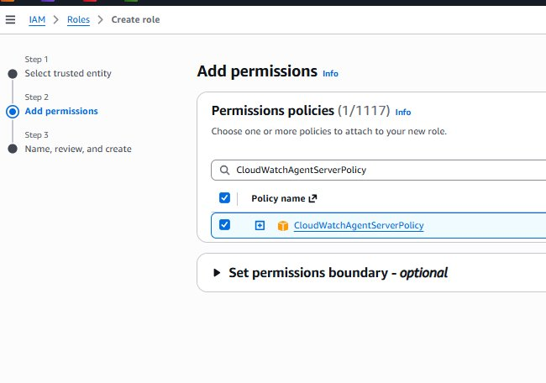
📸 Add Permissions → Search and select CloudWatchAgentServerPolicy
Step 1c — Name and Create the Role
On the Name, review, and create page:
- Role name: EC2-CloudWatch-Role
- Review the Trust policy — it shows ec2.amazonaws.com as the trusted service
- Review the Permissions policy summary — CloudWatchAgentServerPolicy is attached
- Click Create role
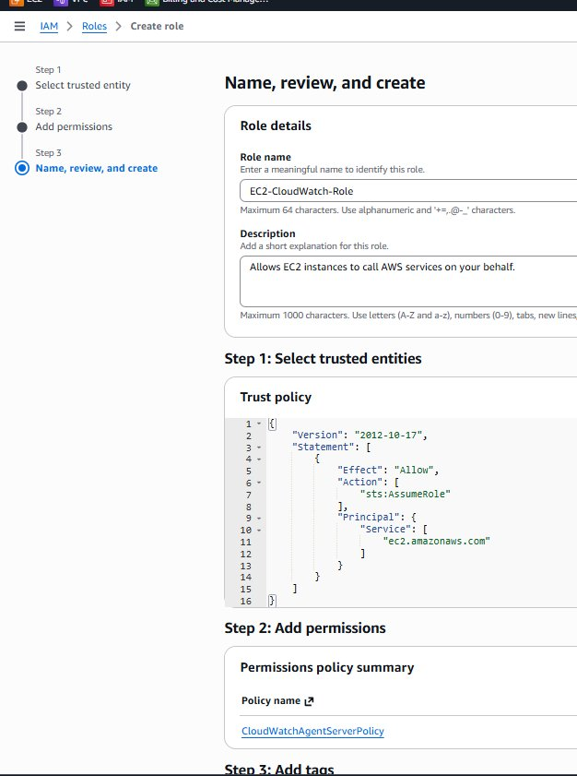
📸 Name the role EC2-CloudWatch-Role and review Trust Policy and Permissions
✅ Note: The Trust Policy with "ec2.amazonaws.com" means only EC2 instances can assume this role. The CloudWatchAgentServerPolicy allows the agent to put log events, create log groups and log streams in CloudWatch.
Step 1d — Verify Role Created Successfully
After creating the role, verify it appears in the IAM Roles list:
- Go to IAM → Roles and search for "ec2"
- You should see EC2-CloudWatch-Role listed
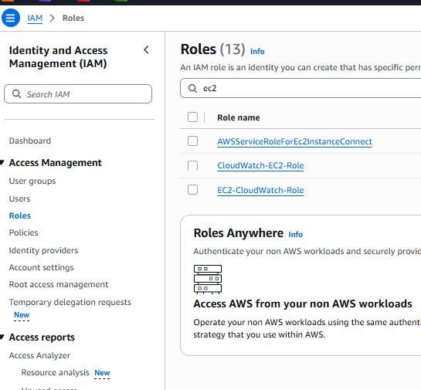
📸 IAM Roles list showing EC2-CloudWatch-Role created successfully

Step 2: Attach IAM Role to EC2 Instance
💡 Why this step: Creating the IAM role is not enough — we must attach it to the specific EC2 instance. This tells AWS that this particular EC2 instance is allowed to assume the role and use its permissions to send logs to CloudWatch.
Navigate to: EC2 → Instances → select your running instance
- Select the instance: rsp logistics-r53 (Running, t2.micro)
- The yamaha-CW instance is Stopped — make sure to select the Running instance
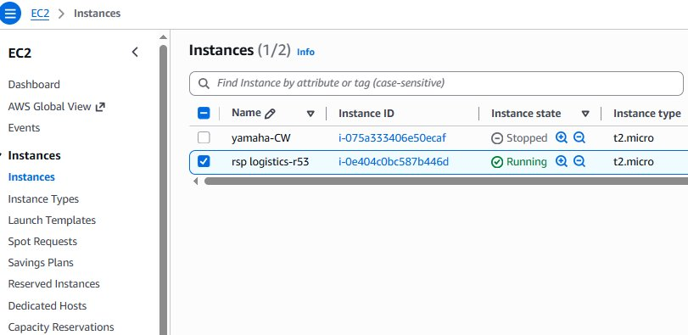
📸 EC2 Instances list — select the running instance rsp logistics-r53
Attach the IAM role:
- With the instance selected click: Actions → Security → Modify IAM Role
- In the IAM role dropdown select: EC2-CloudWatch-Role
- Click Update IAM Role
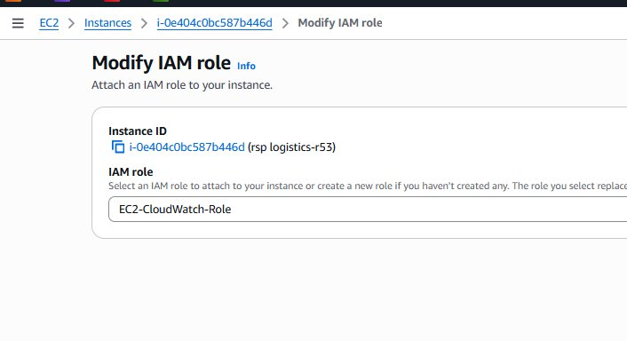
📸 Modify IAM Role — attach EC2-CloudWatch-Role to instance i-0e404c0bc587b446d
✅ Note: Once the IAM role is attached the EC2 instance immediately gains permission to send logs to CloudWatch. No restart is required. The CloudWatch Agent will use this role automatically when it runs.

Step 3: Install CloudWatch Agent and Create Config File
💡 Why this step: The CloudWatch Agent is a software program that runs on the EC2 instance. It reads log files from /var/log and streams them to CloudWatch. Without the agent installed and configured, no logs will be collected — the IAM role alone is not sufficient.
Step 3a — Install CloudWatch Agent
SSH into your EC2 instance and run:
sudo yum install -y amazon-cloudwatch-agent
Step 3b — Create the Config Directory
sudo mkdir -p /opt/aws/amazon-cloudwatch-agent/etc
Step 3c — Create the Agent Configuration File
The config file tells the agent WHICH log files to collect and WHERE to send them in CloudWatch:
sudo tee /opt/aws/amazon-cloudwatch-agent/etc/amazon-cloudwatch-agent.json > /dev/null << 'EOF'
{
"logs": {
"logs_collected": {
"files": {
"collect_list": [
{
"file_path": "/var/log/messages",
"log_group_name": "/ec2/var/log/messages",
"log_stream_name": "{instance_id}",
"timezone": "UTC"
},
{
"file_path": "/var/log/secure",
"log_group_name": "/ec2/var/log/secure",
"log_stream_name": "{instance_id}",
"timezone": "UTC"
}
]
}
}
}
}
EOF
Config file explanation:
- file_path — the log file on the EC2 instance to collect from
- log_group_name — the name of the Log Group that will be created in CloudWatch
- log_stream_name — {instance_id} automatically uses your EC2 instance ID as the stream name
- timezone — UTC ensures consistent timestamps across regions
Step 3d — Start the CloudWatch Agent
Load the config and start the agent:
sudo /opt/aws/amazon-cloudwatch-agent/bin/amazon-cloudwatch-agent-ctl \
-a fetch-config \
-m ec2 \
-c file:/opt/aws/amazon-cloudwatch-agent/etc/amazon-cloudwatch-agent.json \
-s
Verify the agent is running:
sudo /opt/aws/amazon-cloudwatch-agent/bin/amazon-cloudwatch-agent-ctl -a status
Expected output:
{
"status": "running",
"starttime": "2026-03-04T03:36:04+00:00",
"configstatus": "configured",
"version": "1.300064.1"
}
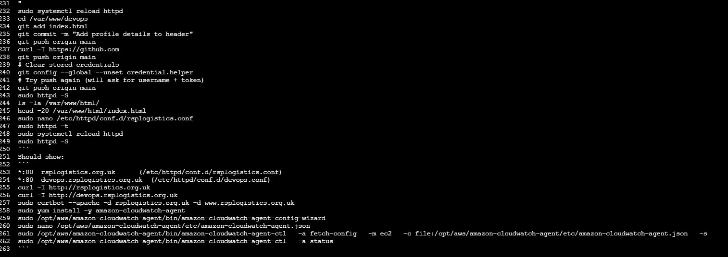
📸 Terminal showing CloudWatch Agent commands and status: running
Step 3e — Enable Agent to Start on Reboot
Make sure the agent restarts automatically if the instance is rebooted:
sudo systemctl enable amazon-cloudwatch-agent
sudo systemctl start amazon-cloudwatch-agent
✅ Note: Status "running" confirms the agent is actively collecting logs from /var/log/messages and /var/log/secure and sending them to CloudWatch. The configstatus "configured" confirms the config file was loaded successfully.

Step 4: Verify Logs in AWS CloudWatch Console
💡 Why this step: After the agent starts, CloudWatch automatically creates Log Groups and Log Streams and begins receiving log data from the EC2 instance. We verify this in the AWS Console to confirm the entire setup is working end to end.
Navigate to: AWS Console → CloudWatch → Logs → Log Management
- You will see Log Groups created automatically by the agent
- Log Group: /ec2/var/log/messages — contains system messages from the EC2 instance
- Click on the log group to see the Log Stream named with your instance ID
- Click the log stream to see the actual log entries flowing in from /var/log/messages
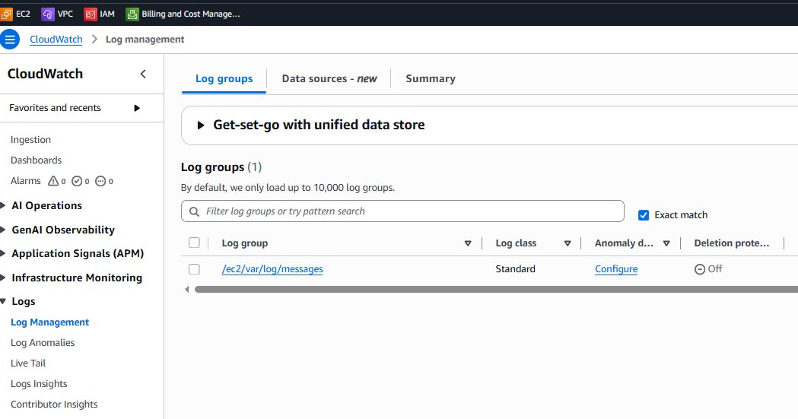
📸 CloudWatch Log Management showing /ec2/var/log/messages Log Group created successfully
✅ Note: Log Groups (1) confirms the log group /ec2/var/log/messages was created automatically. Log class Standard means logs are stored in the standard CloudWatch Logs tier. The agent is successfully streaming /var/log/messages from the EC2 instance to CloudWatch.

Project Summary
This project successfully demonstrates centralized log collection from an EC2 instance using the AWS CloudWatch Agent. The complete setup involved four main stages:
Step | What Was Done | Result
1 | Created IAM Role (EC2-CloudWatch-Role) with CloudWatchAgentServerPolicy | EC2 has permission to write logs to CloudWatch
2 | Attached IAM Role to the running EC2 instance rsp logistics-r53 | Instance can now authenticate to CloudWatch
3 | Installed CloudWatch Agent, created config file, started the agent | Agent running — collecting /var/log/messages and /var/log/secure
4 | Verified Log Groups in CloudWatch Console — /ec2/var/log/messages visible | Logs flowing from EC2 to CloudWatch in real time

Real World Use Cases for CloudWatch Log Collection
- Monitor application errors across multiple servers from one place without SSH-ing into each
- Set CloudWatch Alarms to alert on specific error patterns in logs
- Use CloudWatch Logs Insights to run queries across all log data
- Retain logs centrally for compliance and audit requirements
- Debug production issues faster by searching logs across all instances simultaneously

AWS CloudWatch Log Collection — Task Completed Successfully ✅

