AWS SECURITY & MONITORING SERVICES
CloudTrail | NACL | Trusted Advisor | ACM (SSL) | KMS

CloudTrail | NACL | Trusted Advisor | ACM/SSL | KMS
Audit Logging | Subnet Firewall | Best Practices | SSL Certificates | Encryption Keys

AWS Account: Raja (0047-9241-7874) | Region: US East (Ohio) | March 2026

1. AWS CloudTrail
1.1 What is CloudTrail?
AWS CloudTrail is a security and auditing service that records every action taken in your AWS account. Think of it as a security camera for your entire AWS infrastructure — every API call, login, resource creation, or deletion is logged as an event with full details including who did it, when, and from where.
Key features:
- Tracks all API calls and user activity across every AWS service
- Provides 90 days of event history by default — even without creating a trail
- Stores logs in S3 for long-term retention and compliance requirements
- Integrates with CloudWatch for real-time alerting on suspicious activity
- Essential for security audits, compliance (HIPAA, PCI-DSS), and incident investigation
1.2 CloudTrail Event Types
Event Type | What it Tracks | Example
Management Events | Changes to AWS resources (create/delete) | CreateEC2, DeleteS3Bucket
Data Events | Actions inside resources | S3 GetObject, Lambda Invoke
Insights Events | Unusual API activity patterns | Sudden spike in API calls
Network Activity Events | VPC network traffic and connections | VPC endpoint activity

1.3 Practical: Creating a CloudTrail
Step 1 — Navigate to CloudTrail in the AWS Console. The home page shows the "Create a trail" button:
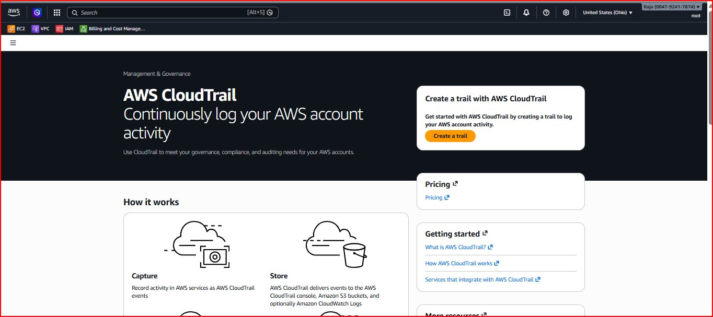
Figure 1: AWS CloudTrail home page — "Continuously log your AWS account activity"
Step 2 — Configure trail attributes. Enter trail name "my-audit-trail", select "Create new S3 bucket", and enable Log file validation:
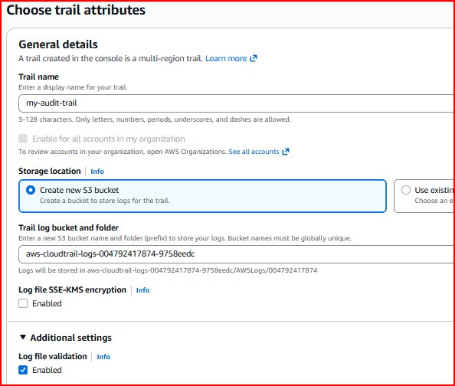
Figure 2: Trail configuration — name "my-audit-trail", new S3 bucket auto-generated, log validation enabled
Step 3 — Additional settings page with CloudWatch Logs integration (optional) and Tags:
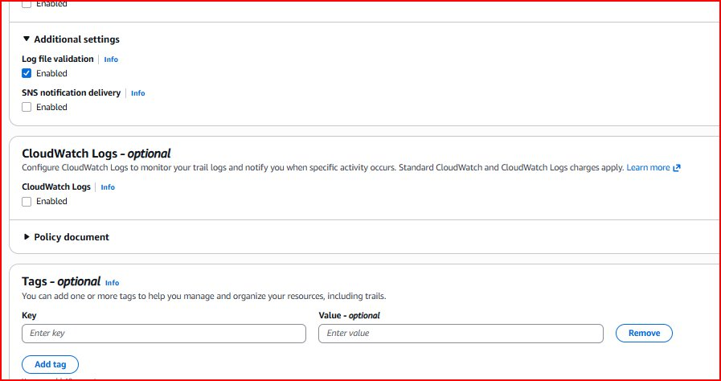
Figure 3: Additional settings — Log file validation enabled, SNS notification optional
Step 4 — Choose log events. Select Management Events with Read and Write API activity:
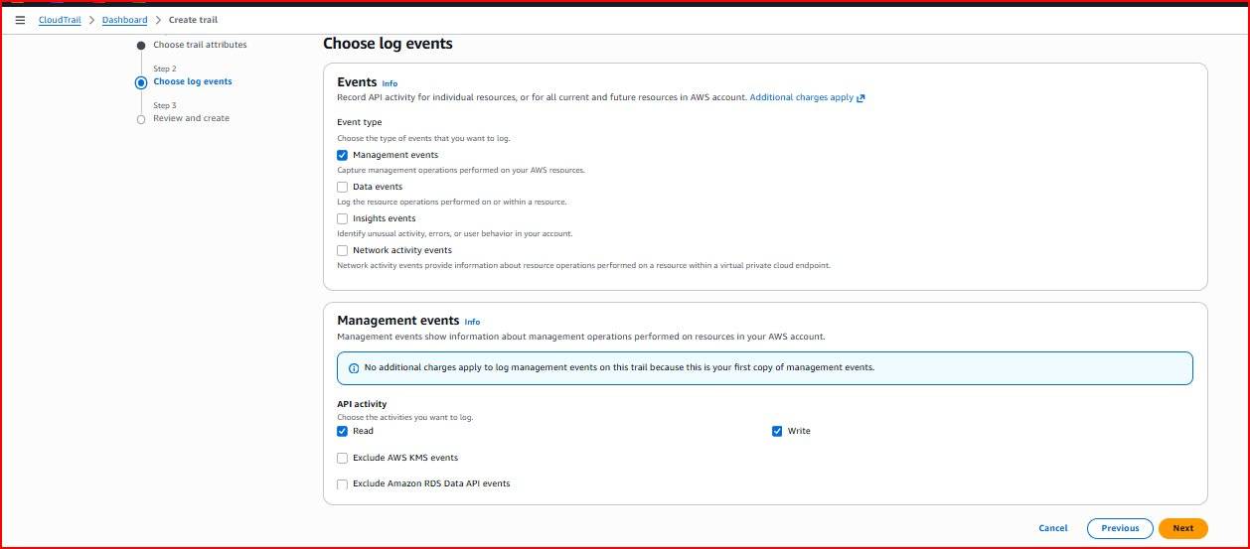
Figure 4: Log events — Management Events selected, Read & Write API activity enabled (no extra charge for first copy)
Note: Management Events are free for the first copy per region. Data Events and Insights Events have additional charges.
Step 5 — Review all settings before creating the trail:
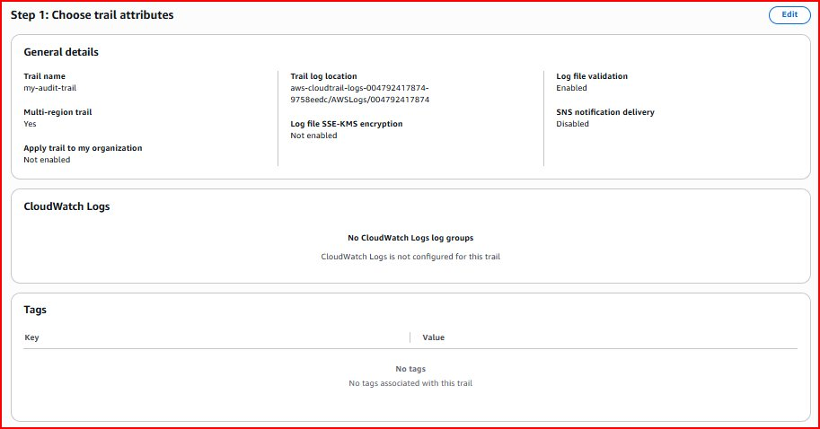
Figure 5: Review Step 1 — Trail name, S3 bucket location, Multi-region trail: Yes, Log validation: Enabled
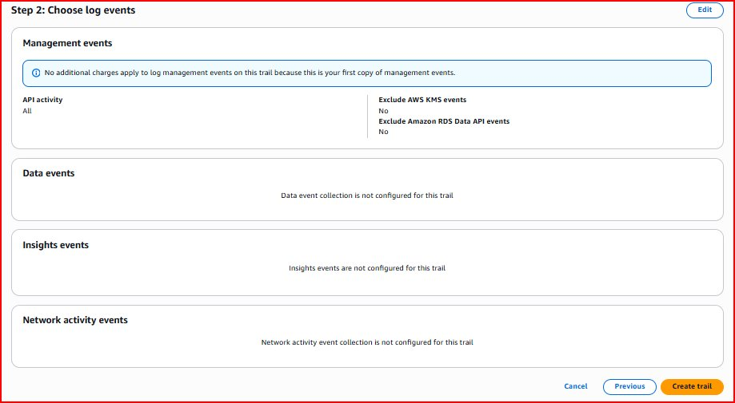
Figure 6: Review Step 2 — Management Events with All API activity, Data/Insights/Network events not configured
Step 6 — Trail created successfully. Status shows "Logging" confirming it is actively recording events:
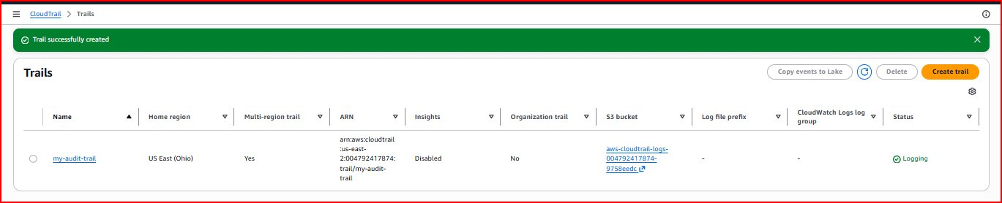
Figure 7: Trail "my-audit-trail" created successfully — Status: Logging, Region: US East (Ohio), Multi-region: Yes
1.4 Viewing CloudTrail Event History
Navigate to Event History in the left sidebar. This shows all AWS API calls made in the last 90 days. Events appear immediately after trail creation:
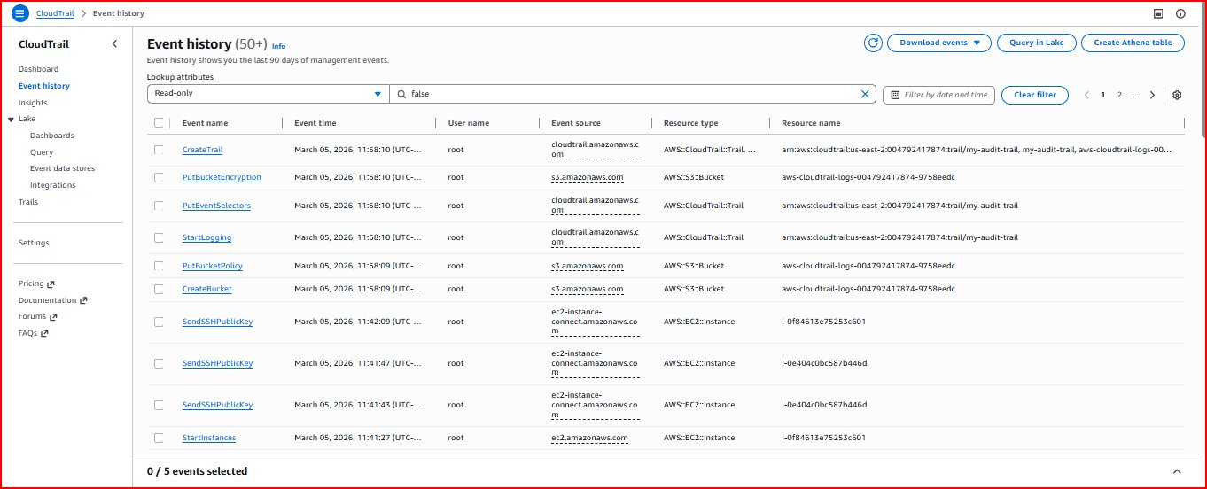
Figure 8: Event History (50+ events) — CreateTrail, StartLogging, CreateBucket, SendSSHPublicKey, StartInstances all recorded
Note: Every action is recorded. The screenshot shows CreateTrail (just created), StartLogging, CreateBucket (S3 auto-created), and even SSH connections and EC2 startups from the previous monitoring lab session!
1.5 CloudTrail Log Structure
Field | Description
eventTime | When the event occurred (UTC timestamp)
eventName | API call performed (e.g., CreateTrail, TerminateInstances)
userIdentity | Who performed the action (IAM user, role, or AWS service)
sourceIPAddress | IP address where the request originated
requestParameters | Details of the API call (e.g., instance ID, bucket name)
errorCode | Error code if the action failed (e.g., AccessDenied)

2. Network Access Control Lists (NACL)
2.1 What is a NACL?
A Network Access Control List (NACL) is an optional security layer for your AWS VPC that acts as a firewall at the subnet level. While Security Groups protect individual EC2 instances, NACLs protect entire subnets — every instance in the subnet is subject to NACL rules.
Key characteristics:
- Stateless — inbound and outbound rules are evaluated independently; return traffic must be explicitly allowed
- Subnet level — applies to ALL instances within the associated subnet, not just specific ones
- Rule priority — rules are evaluated in order starting from the lowest rule number
- First match wins — once a rule matches, evaluation stops immediately and the action is taken
- Default deny — if no rules match, traffic is denied by the catch-all rule (*)
- Supports both Allow and Deny rules — unlike Security Groups which only support Allow rules
2.2 NACL vs Security Groups
Feature | Security Group | NACL
Level | Instance level | Subnet level
State | Stateful — return traffic auto-allowed | Stateless — must explicitly allow return traffic
Rules | Allow rules only | Allow AND Deny rules
Rule Evaluation | All rules evaluated together | Rules evaluated in order (lowest # first)
Applies To | Specific instances only | All instances in the subnet

2.3 Practical: Configuring a Custom NACL
Step 1 — Navigate to VPC > Security > Network ACLs. The default NACL already exists for the VPC:
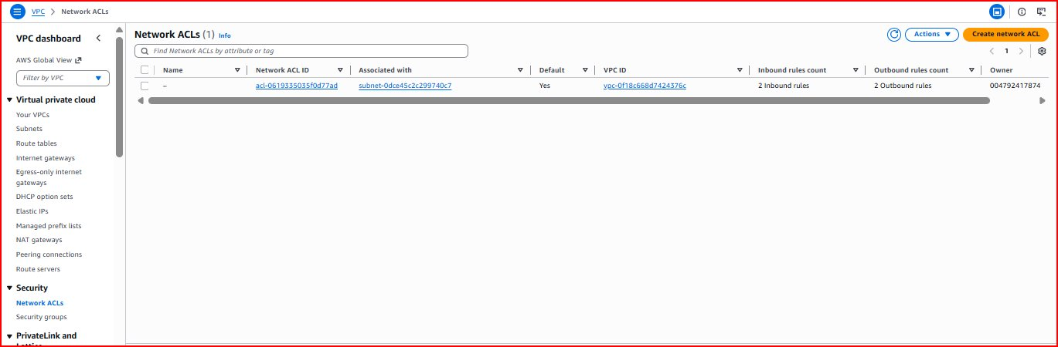
Figure 9: Network ACLs page — default NACL with 2 inbound and 2 outbound rules, associated with subnet
Step 2 — Click "Create network ACL", enter name "my-custom-nacl" and select the VPC:
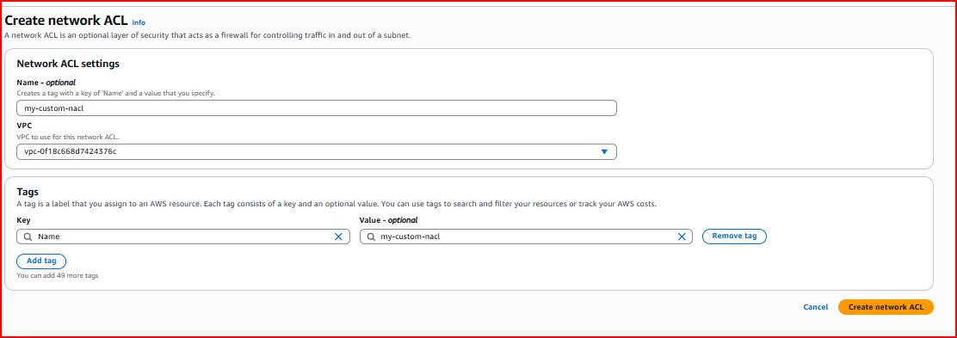
Figure 10: Create Network ACL form — name "my-custom-nacl", VPC vpc-0f18c668d7424376c selected
Step 3 — Custom NACL created alongside the default NACL:
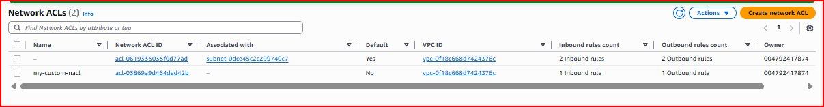
Figure 11: Two NACLs — default NACL (Default: Yes) and my-custom-nacl (Default: No) in the same VPC
2.4 Configuring Inbound Rules
Inbound rules control traffic coming INTO the subnet. Click the "Inbound rules" tab, then "Edit inbound rules" and add rules:
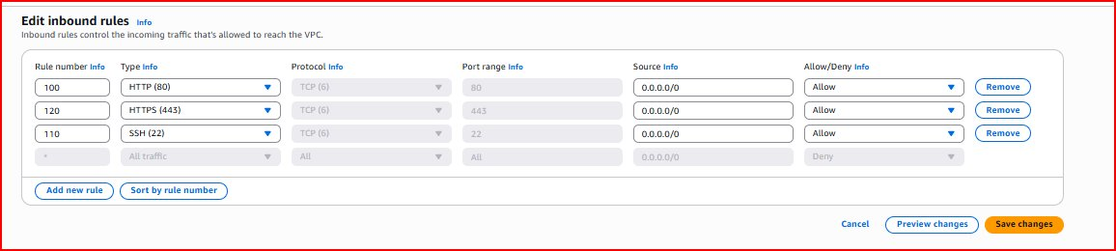
Figure 12: Editing inbound rules — adding Rule 100 (HTTP/80), Rule 110 (SSH/22), Rule 120 (HTTPS/443)
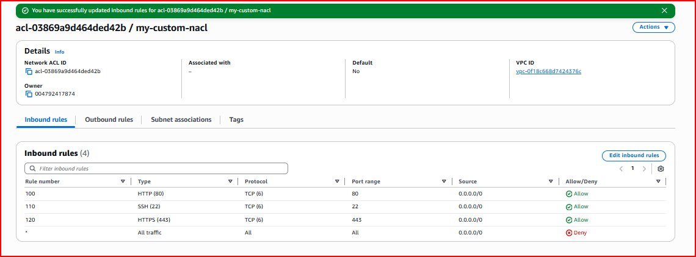
Figure 13: Saved inbound rules — HTTP, SSH, HTTPS all Allow; default rule * is Deny
Rule # | Type | Protocol | Port | Source | Action
100 | HTTP | TCP (6) | 80 | 0.0.0.0/0 | ALLOW
110 | SSH | TCP (6) | 22 | 0.0.0.0/0 | ALLOW
120 | HTTPS | TCP (6) | 443 | 0.0.0.0/0 | ALLOW
* | All Traffic | All | All | 0.0.0.0/0 | DENY

2.5 Configuring Outbound Rules
Outbound rules control traffic leaving the subnet. Because NACL is stateless, response traffic on ephemeral ports (1024-65535) must be explicitly allowed:
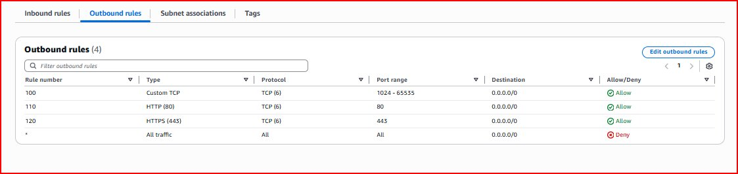
Figure 14: Saved outbound rules — Custom TCP (1024-65535), HTTP (80), HTTPS (443) all Allow
Note: Ephemeral ports 1024-65535 must be allowed outbound. When a browser connects on port 80, the server responds on a random high port. Since NACL is stateless (unlike Security Groups), this return traffic must be explicitly permitted in the outbound rules.
2.6 Subnet Association
The NACL must be associated with a subnet to take effect. Click "Subnet associations" tab then "Edit subnet associations":
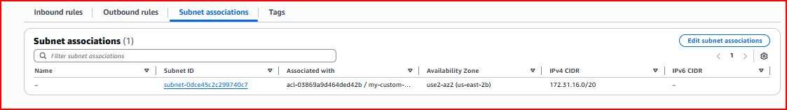
Figure 15: Subnet subnet-0dce45c2c299740c7 associated with my-custom-nacl (us-east-2b, CIDR 172.31.16.0/20)

3. AWS Trusted Advisor
3.1 What is Trusted Advisor?
AWS Trusted Advisor is an automated best practices tool that continuously analyzes your AWS account and provides real-time recommendations. Think of it as a personal AWS consultant available 24/7 — it checks hundreds of criteria and flags issues before they become problems.
Key benefits:
- Automatically identifies unused or idle resources that are wasting money
- Detects security vulnerabilities like publicly exposed S3 buckets or unrestricted port access
- Warns when you are approaching AWS service limits (quotas) before they cause outages
- Recommends architecture improvements for better performance and fault tolerance
- Free security and service limit checks available on all AWS accounts
3.2 Trusted Advisor Dashboard
Navigate to Trusted Advisor from the AWS Console search bar. The Recommendations dashboard shows a summary across all 6 categories:
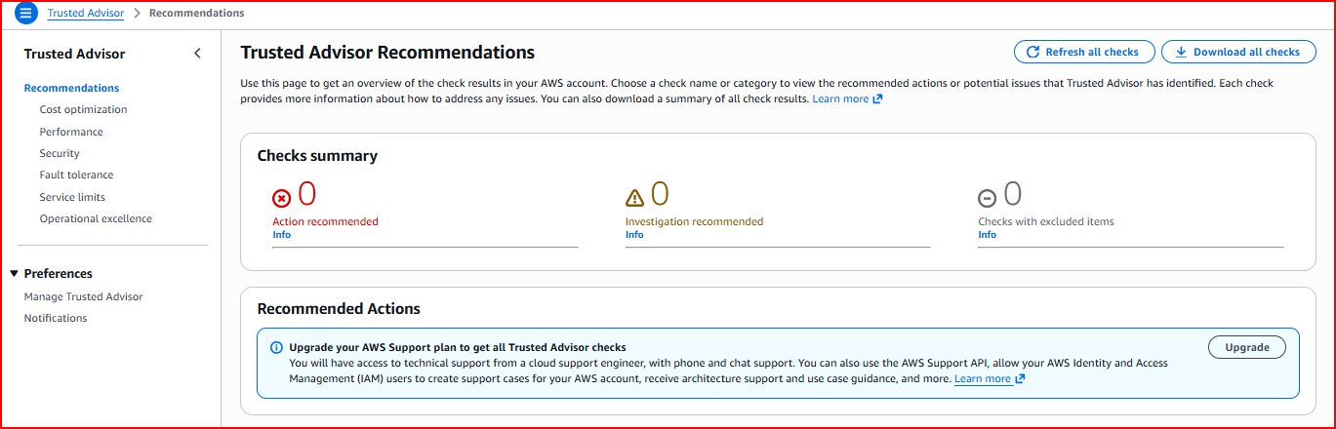
Figure 16: Trusted Advisor Recommendations dashboard — Checks summary showing Action recommended, Investigation recommended, and Excluded items
3.3 The Six Categories
Category 1 — Cost Optimization: Identifies unused resources and recommends ways to reduce your AWS bill:
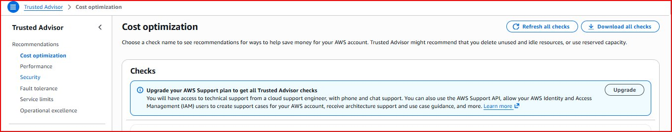
Figure 17: Cost Optimization — checks for idle EC2 instances, unused Elastic IPs, underutilized RDS (requires Support plan)
Category 2 — Performance: Detects bottlenecks and recommends improvements for speed and efficiency:
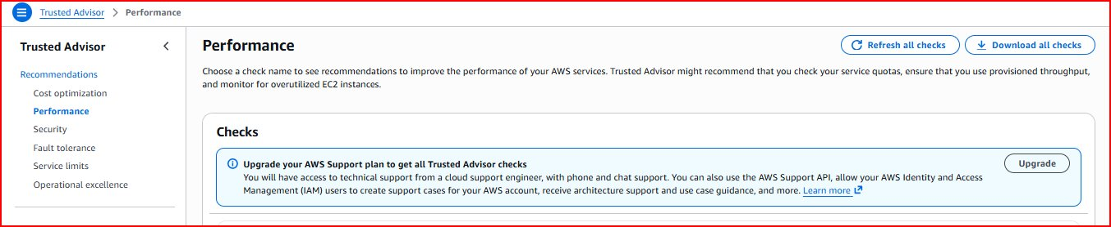
Figure 18: Performance — checks for overutilized EC2 instances and service quota bottlenecks
Category 3 — Security: Identifies vulnerabilities. Free checks are available including EBS and RDS snapshot visibility:
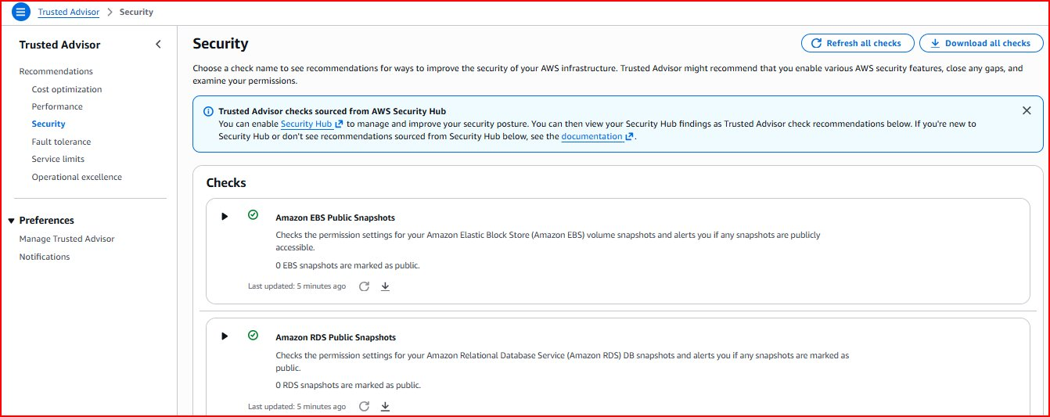
Figure 19: Security — Amazon EBS Public Snapshots: 0 public (PASS), Amazon RDS Public Snapshots: 0 public (PASS)
Note: The security checks confirm 0 EBS snapshots and 0 RDS snapshots are publicly accessible. This is the desired state — no sensitive data is accidentally exposed to the public internet.
Category 4 — Fault Tolerance: Ensures high availability by identifying single points of failure:
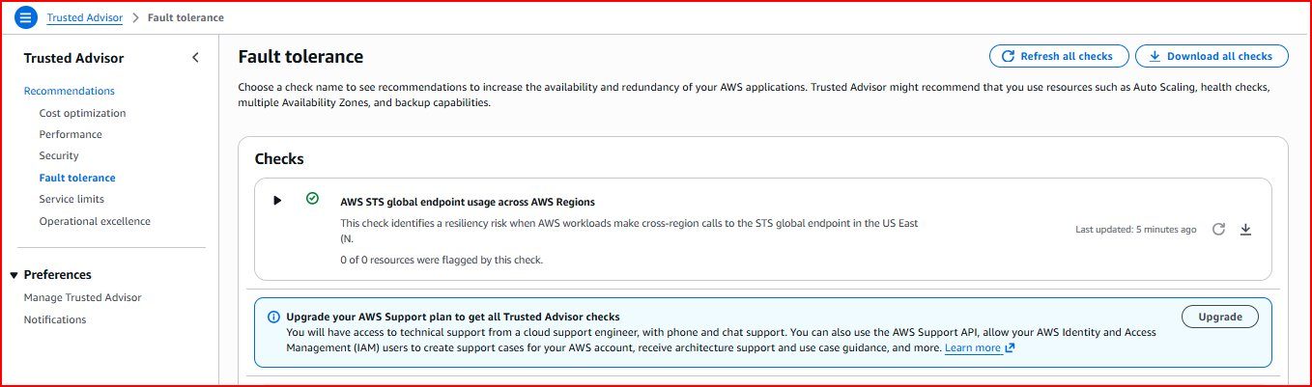
Figure 20: Fault Tolerance — AWS STS global endpoint usage check passed (0 of 0 resources flagged)
Category 5 — Service Limits: Monitors resource usage against AWS quotas and warns at 80% usage:
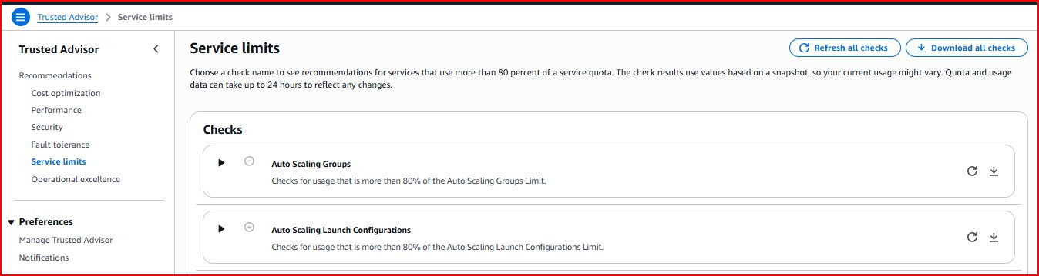
Figure 21: Service Limits — Auto Scaling Groups and Launch Configurations usage checks visible
Category 6 — Operational Excellence: Ensures operational readiness through automation and monitoring:
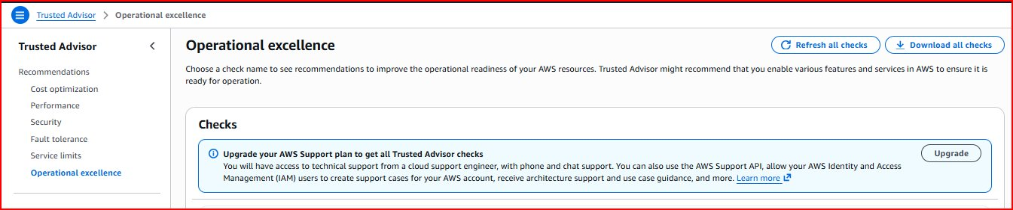
Figure 22: Operational Excellence — checks for CloudTrail enabled, MFA on root (requires Support plan for full access)
3.4 Categories Summary
Category | Purpose | Example Checks | Free?
Cost Optimization | Reduce cloud spending | Idle EC2, unused Elastic IPs | Partial
Performance | Improve speed & efficiency | High-utilization EC2 instances | Partial
Security | Protect against vulnerabilities | Public S3 buckets, open ports | Yes
Fault Tolerance | Ensure high availability | Multi-AZ RDS, EBS snapshots | Partial
Service Limits | Prevent quota outages | EC2 limits, VPC count | Yes
Operational Excellence | Maintain reliable operations | CloudTrail enabled, MFA on root | Partial

4. AWS Certificate Manager (ACM)
4.1 What is ACM?
AWS Certificate Manager (ACM) is a service that provisions, manages, and deploys SSL/TLS certificates for use with AWS services. SSL certificates enable the padlock icon in browsers and encrypt all data between users and your website using HTTPS, protecting sensitive information like passwords and payment data.
Key features:
- Free public SSL/TLS certificates for use with AWS services (ALB, CloudFront, API Gateway)
- Automatic certificate renewal — ACM renews certificates before expiry, no manual work needed
- DNS and Email validation — two methods to prove you own the domain
- Wildcard certificates — one certificate covers all subdomains (*.domain.com)
- Seamless Route 53 integration for one-click DNS validation
4.2 Certificate Types
Type | Format | Coverage | Use Case
Domain Specific | www.example.com | Single specific domain | Single website
Wildcard | *.example.com | All subdomains of domain | mail., drive., app. etc.
Multi-domain (SAN) | site1.com, site2.com | Multiple different domains | Multiple websites

4.3 ACM Home Page
Navigate to Certificate Manager from the AWS Console. Three options are available:
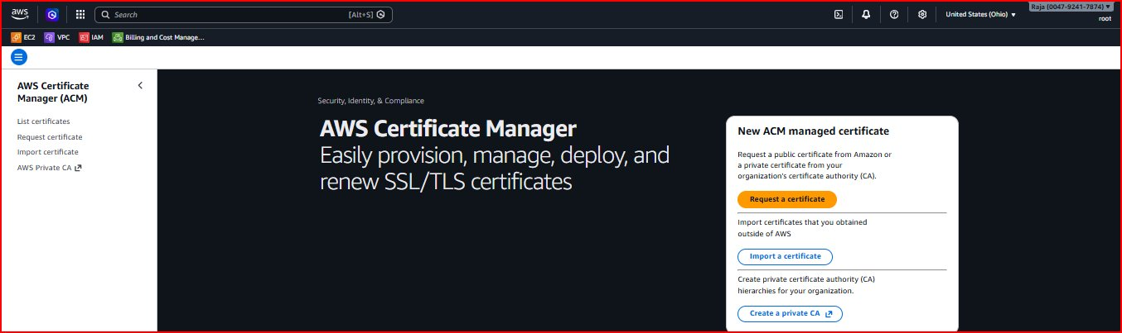
Figure 23: AWS Certificate Manager home — Request a certificate, Import a certificate, or Create a Private CA
4.4 Practical: Requesting a Public Certificate
Step 1 — Click "Request a certificate" then configure the domain name and validation method. DNS validation is recommended as it is automated with Route 53:
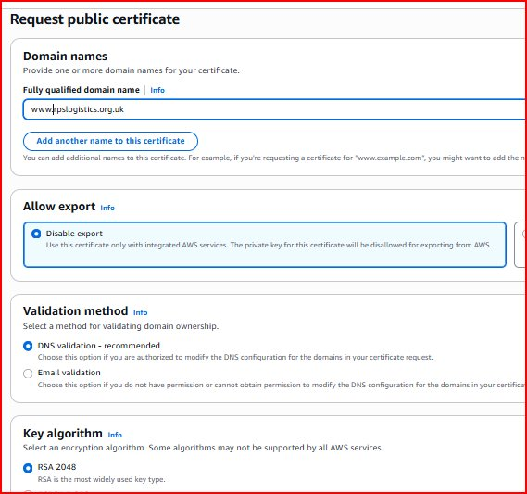
Figure 24: Certificate request — domain www.rsplogistics.org.uk, DNS validation (recommended), RSA 2048 key algorithm
Step 2 — After clicking "Request", the certificate shows "Pending validation". AWS generates a CNAME record that must be added to the domain DNS to prove ownership:
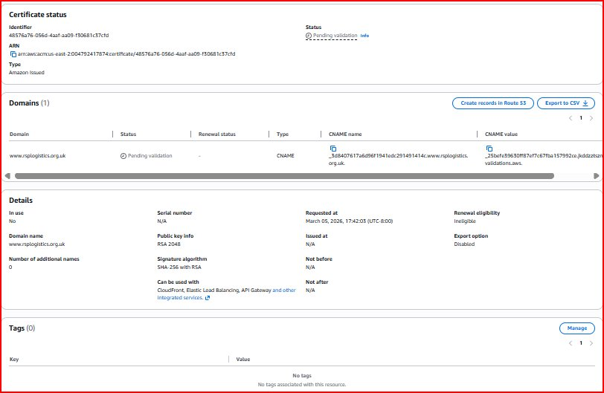
Figure 25: Certificate status "Pending validation" for www.rsplogistics.org.uk — CNAME record details shown for DNS validation
Note: Status shows "Pending validation" because AWS needs to verify ownership of rsplogistics.org.uk. Add the CNAME record shown to your DNS provider. Once added, AWS automatically validates and issues the certificate — status changes from "Pending validation" to "Issued" within minutes.
4.5 DNS Validation Process
Validation Flow:

1. Request certificate in ACM for www.rsplogistics.org.uk
2. ACM generates a unique CNAME record (validation token)
3. Add CNAME record to DNS provider (or use Route 53 auto-create)
4. AWS verifies the CNAME record exists in DNS
5. Certificate status: Pending validation -> Issued
6. Attach certificate to Load Balancer / CloudFront distribution
7. HTTPS enabled! Browser shows padlock icon.

4.6 Using ACM with Application Load Balancer
Once issued, the certificate is attached to a Load Balancer to enable HTTPS:
- Navigate to EC2 > Load Balancers > Create Application Load Balancer
- Add HTTPS Listener on port 443 in the Listeners and Routing section
- In Secure listener settings, select "From ACM" and choose your certificate
- Create Route 53 A record (Alias) pointing to the Load Balancer DNS name
- Test by visiting https://www.rsplogistics.org.uk — padlock icon confirms HTTPS is active

5. AWS Key Management Service (KMS)
5.1 What is KMS?
AWS Key Management Service (KMS) is a managed service that makes it easy to create and control cryptographic keys used to encrypt your data across AWS services and applications. KMS uses FIPS 140-2 validated hardware security modules (HSMs) — the same security standard used by banks and government agencies.
Key features:
- Integrated with 100+ AWS services — encrypt S3, EBS, RDS, Secrets Manager with one click
- Fine-grained access control — IAM policies and key policies define who can use each key
- Automatic key rotation — annual rotation of key material with zero application downtime
- CloudTrail integration — every single key usage is logged for complete compliance audit trail
- FIPS 140-2 Level 2 validated — meets government, healthcare, and financial compliance requirements
5.2 KMS Key Types
Key Type | Description | Cost | Control Level
AWS Managed Keys | Auto-created by AWS services (e.g., aws/s3) | Free | AWS manages
Customer Managed Keys (CMK) | Created and fully managed by you | $1/month/key | Full control
AWS Owned Keys | Used across multiple AWS accounts internally | Free | AWS only
Custom Key Stores | Backed by your own AWS CloudHSM cluster | HSM pricing | Highest control

5.3 KMS Home Page
Navigate to Key Management Service from the AWS Console. The left sidebar shows AWS managed keys, Customer managed keys, and Custom key stores:
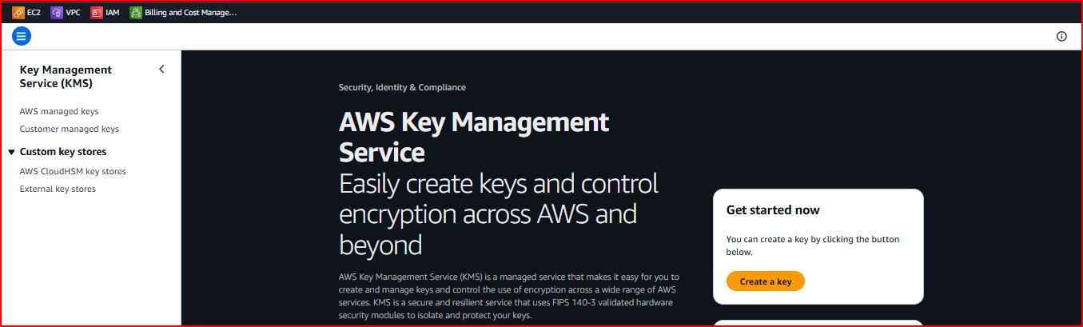
Figure 26: AWS KMS home page — "Easily create keys and control encryption across AWS and beyond"
5.4 Practical: Creating a Customer Managed Key
Step 1 — Click "Create a key". Configure key type as Symmetric (single key for both encrypt and decrypt) with "Encrypt and decrypt" usage:
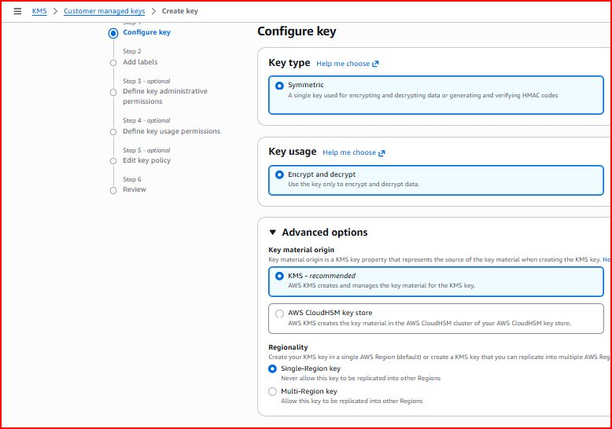
Figure 27: Configure key — Symmetric type selected, Encrypt and decrypt usage, KMS key material origin, Single-Region key
Note: A Symmetric key uses the same key for both encryption AND decryption — this is the most common type used for data encryption. Asymmetric keys (public/private key pairs) are used for digital signatures or when external parties need to encrypt data for you.
Step 2 — Add a friendly alias name and description to identify the key:
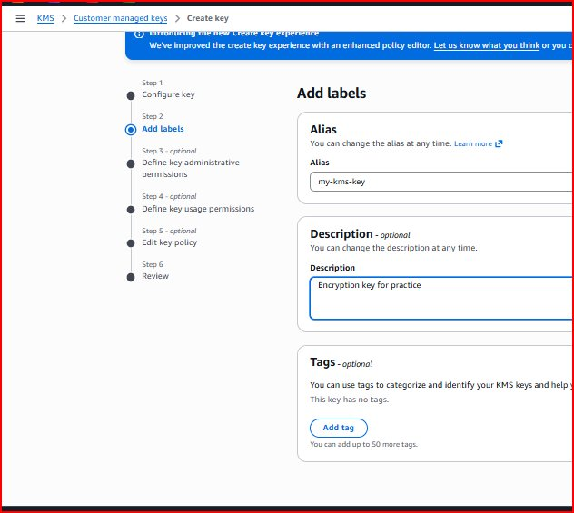
Figure 28: Add labels — Alias "my-kms-key", Description "Encryption key for practice"
Step 3 — After completing Steps 3-5 (administrative permissions, usage permissions, key policy review), click "Finish". Key is created with Enabled status:
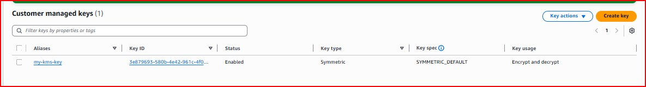
Figure 29: Customer managed key "my-kms-key" — Status: Enabled, Type: Symmetric, Key spec: SYMMETRIC_DEFAULT, Usage: Encrypt and decrypt
5.5 Practical: Encrypting & Decrypting Files via AWS CLI
Step 1 — Configure AWS CLI on the EC2 instance with your IAM credentials:
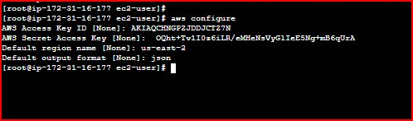
Figure 30: AWS CLI configured — Access Key, Secret Key, region us-east-2, output format json
Step 2 — Create a file and encrypt/decrypt it using the KMS key:
echo "this is my secret file" > myfile.txt
→ Creates a plain text file myfile.txt with sample content that we will encrypt using KMS
cat myfile.txt
→ Reads and displays the file — shows original readable text "this is my secret file" before encryption
aws kms encrypt --key-id alias/my-kms-key --plaintext fileb://myfile.txt --output text --query CiphertextBlob | base64 --decode > myfile_encrypted.txt
→ Encrypts myfile.txt using our KMS key. --key-id identifies our key, fileb:// reads the file as binary, CiphertextBlob extracts the encrypted output, base64 --decode converts from base64 to binary. Output saved as myfile_encrypted.txt — content will appear as unreadable binary gibberish
cat myfile_encrypted.txt
→ Tries to read the encrypted file — output will be scrambled unreadable binary data, proving the content is encrypted and protected
aws kms decrypt --ciphertext-blob fileb://myfile_encrypted.txt --output text --query Plaintext | base64 --decode > myfile_decrypted.txt
→ Decrypts the encrypted file back to readable text. KMS automatically identifies which key encrypted the data — Plaintext extracts the decrypted content, base64 --decode converts it back to plain text
cat myfile_decrypted.txt
→ Reads the decrypted file — should show "this is my secret file", confirming the full encrypt/decrypt cycle completed successfully
5.6 Encryption Flow
ENCRYPT:
myfile.txt ("this is my secret file")
--> [aws kms encrypt --key-id alias/my-kms-key]
--> myfile_encrypted.txt (unreadable binary ciphertext)

DECRYPT:
myfile_encrypted.txt (unreadable binary ciphertext)
--> [aws kms decrypt]
--> myfile_decrypted.txt ("this is my secret file")

Security guarantee: Without access to the KMS key,
the encrypted file CANNOT be decrypted by anyone.

5.7 KMS Integration with AWS Services
AWS Service | How KMS Encrypts | Where to Configure
Amazon S3 | Encrypts all objects in a bucket | S3 Bucket > Properties > Default Encryption > SSE-KMS
Amazon EBS | Encrypts EC2 disk volumes at rest | EC2 > Volumes > Create Volume > Enable Encryption
Amazon RDS | Encrypts database storage and backups | RDS > Create Database > Additional Config > Encryption
Secrets Manager | Encrypts passwords and API keys | Secrets Manager > Store secret > Encryption key
6. Summary
This document covered five essential AWS security and monitoring services. Together they form a comprehensive security foundation for any AWS environment:

Service | Purpose | What We Did | Key Concept
CloudTrail | Audit & compliance logging | Created "my-audit-trail", viewed 50+ events in Event History | Every AWS action is permanently recorded
NACL | Subnet-level firewall | Created custom NACL with inbound/outbound rules, subnet association | Stateless — must allow return traffic explicitly
Trusted Advisor | Best practices recommendations | Explored all 6 categories, verified 0 public snapshots | Security and Service Limits checks are free
ACM | SSL/TLS certificate management | Requested certificate for www.rsplogistics.org.uk | Free certs for AWS-integrated services
KMS | Encryption key management | Created "my-kms-key", encrypted/decrypted file via CLI | FIPS 140-2 validated — bank-grade security

Next Steps:
- Enable CloudTrail log file integrity validation and configure CloudWatch alarms for suspicious events
- Associate NACL with production subnets and test blocking specific IP addresses with DENY rules
- Upgrade to AWS Business Support to unlock all Trusted Advisor checks across all categories
- Complete ACM DNS validation to get the certificate issued for rsplogistics.org.uk
- Enable KMS encryption on S3 buckets, EBS volumes, and RDS databases
- Set up automatic KMS key rotation (annual) for compliance with security policies

