AWS: CloudFormation, IAM, Lambda
& Migration Services

CloudFormation | IAM | Elastic Beanstalk | Lambda | Migration
Infrastructure as Code | Access Management | PaaS Deployment | Serverless Compute | VM & DB Migration

1. AWS CloudFormation — Infrastructure as Code
1.1 What is CloudFormation?
AWS CloudFormation is an Infrastructure as Code (IaC) service that allows you to model, provision, and manage AWS resources by writing template files in YAML or JSON. Instead of manually clicking through the AWS Console, you define your entire infrastructure in a single file and CloudFormation builds it automatically and consistently.
- Consistency — same template always creates identical infrastructure, eliminating human error
- Speed — deploy hundreds of resources in minutes with a single submit
- Version control — templates can be stored in Git, enabling rollbacks and history
- Reusability — one template creates dev, staging, and production environments
- Free service — you only pay for the AWS resources created, not CloudFormation itself

1.2 CloudFormation YAML Template
AWSTemplateFormatVersion: 2010-09-09

Resources:
MyEC2Instance:
Type: AWS::EC2::Instance
Properties:
ImageId: ami-081fdcaf00ef62151 # Amazon Linux AMI
InstanceType: t2.micro
KeyName: jaguar-key
SecurityGroupIds:
- sg-0ad2e5d870c727cfd

Note: The AMI ID and Security Group ID are region-specific. Use IDs that exist in your AWS account and region.
1.3 Practical: Creating EC2 with CloudFormation
Step 1 — Navigate to CloudFormation > Stacks > Create Stack. Select "Build from Infrastructure Composer" for the visual editor:
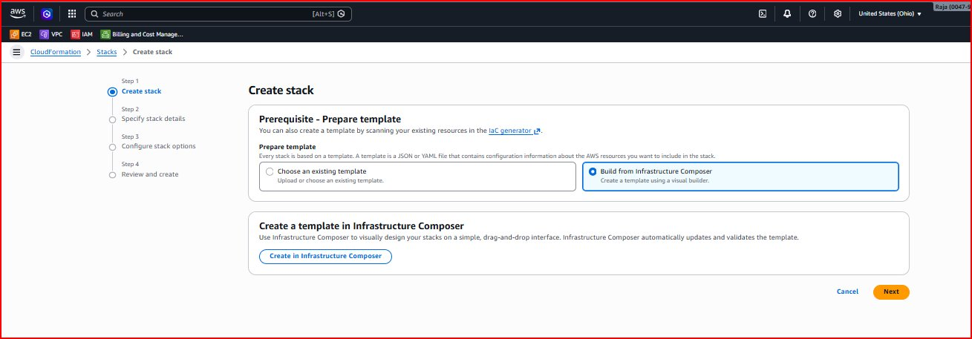
Figure 1: Create Stack — "Build from Infrastructure Composer" selected to visually design and write the template
Step 2 — In Infrastructure Composer, click the Template tab and paste the YAML. Click Validate then Create template:
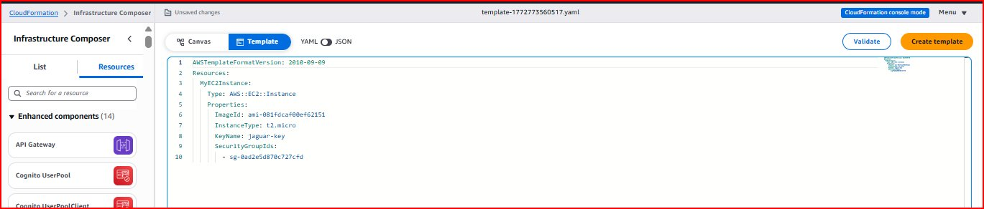
Figure 2: Infrastructure Composer YAML editor — MyEC2Instance resource with t2.micro, AMI ID, key pair, and security group
Step 3 — Enter Stack name "my-ec2-stack" on the Specify stack details page:
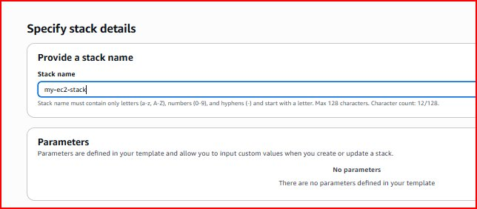
Figure 3: Specify stack details — Stack name "my-ec2-stack", no parameters defined in this template
Step 4 — Configure stack options (tags, IAM role, failure behavior) — leave defaults:
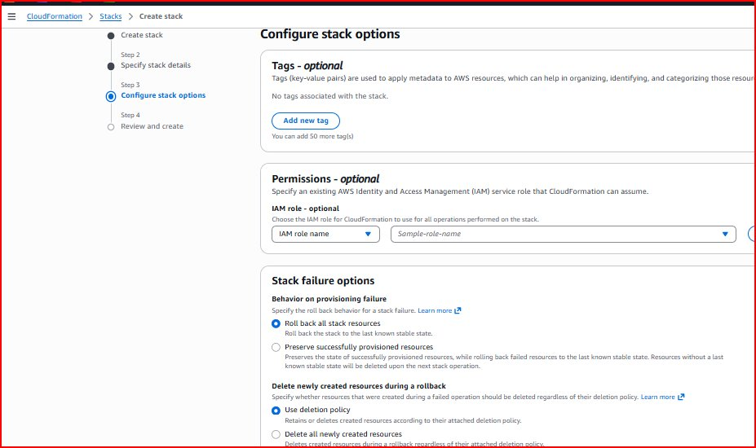
Figure 4: Configure stack options — default settings with "Roll back all stack resources" on failure
Step 5 — After reviewing and clicking Submit, stack creation begins with CREATE_IN_PROGRESS status:
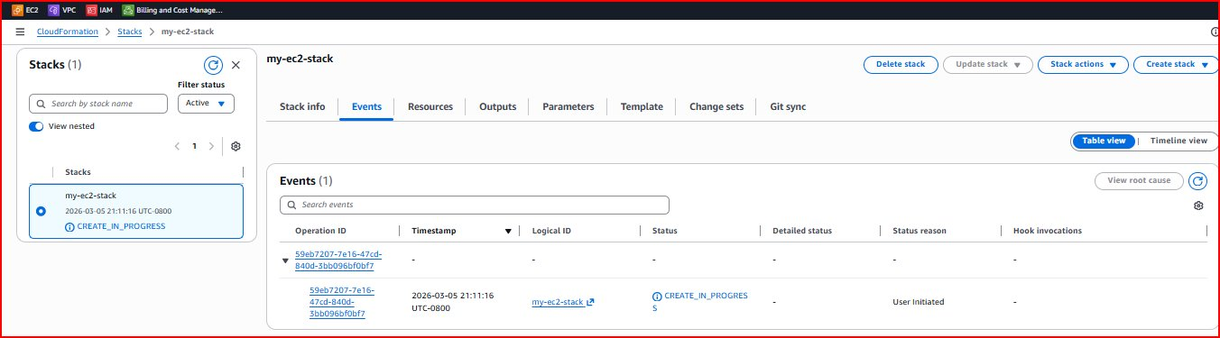
Figure 5: Stack "my-ec2-stack" with status CREATE_IN_PROGRESS — EC2 instance being provisioned automatically
Note: CloudFormation shows real-time events for each resource. Once CREATE_COMPLETE, the EC2 instance appears in the EC2 dashboard automatically — no manual steps needed.

1.4 CloudFormation vs Manual Setup
Aspect | Manual (Console) | CloudFormation (IaC)
Speed | Slow — many manual steps | Fast — one template does everything
Consistency | Human errors possible | Always identical results
Reproducibility | Hard to recreate | Re-run template any time
Documentation | Separate effort required | Template IS the documentation
Version Control | Not possible | Full Git history of changes

2. AWS IAM — Identity and Access Management
2.1 What is IAM?
AWS IAM is a free service that controls who can access your AWS account and what they are allowed to do. It is the security foundation of every AWS account — answering "Who are you?" (authentication) and "What are you allowed to do?" (authorization).
- Users — individual people or applications needing AWS access
- Groups — collections of users sharing the same permissions (Admins, Developers, ReadOnly)
- Policies — JSON documents defining exactly which actions are allowed or denied
- Roles — temporary permissions that AWS services (EC2, Lambda) assume automatically
- MFA — Multi-Factor Authentication adding a second security layer beyond passwords

2.2 IAM Best Practices
Principle | Description | Example
Least Privilege | Grant only permissions actually needed | Read-only user can view but not create
Groups over Users | Attach policies to groups not individual users | Developers group gets S3 access
Roles for Services | AWS services use roles not access keys | EC2 assumes role to access S3
Enable MFA | Always use MFA for privileged accounts | Root and admin accounts must have MFA
Rotate Credentials | Regularly rotate keys and passwords | 90-day password expiration policy

2.3 Practical 1: Creating Groups
Step 1 — Navigate to IAM > User groups > Create group. Create "Administrators" group with AdministratorAccess policy:
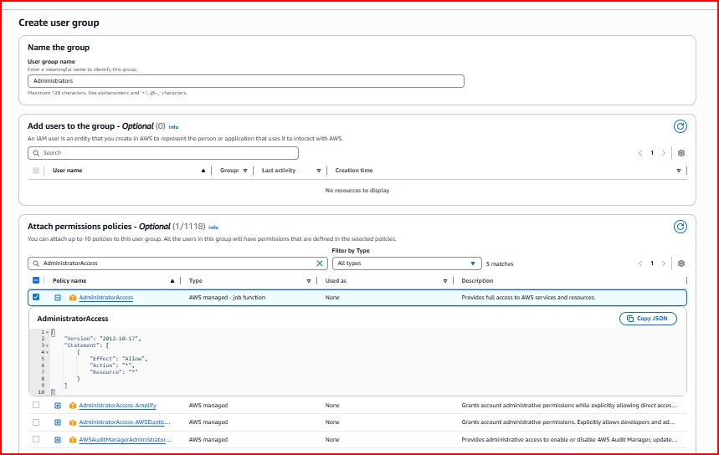
Figure 6: Create user group "Administrators" — AdministratorAccess policy selected (full AWS access)
Step 2 — Both groups created. Administrators has AdministratorAccess; ReadOnlyUsers has AmazonEC2ReadOnlyAccess:
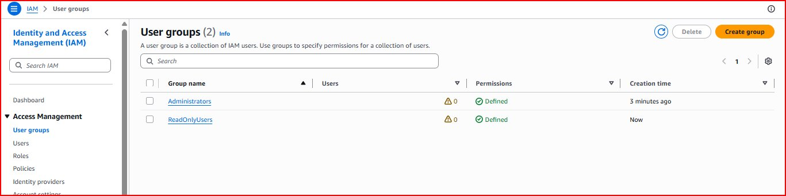
Figure 7: Two IAM groups — Administrators (full access) and ReadOnlyUsers (view-only access), both with Defined permissions
2.4 Practical 2: Creating Users
Step 3 — Create admin user "Raja" with console access and custom password:
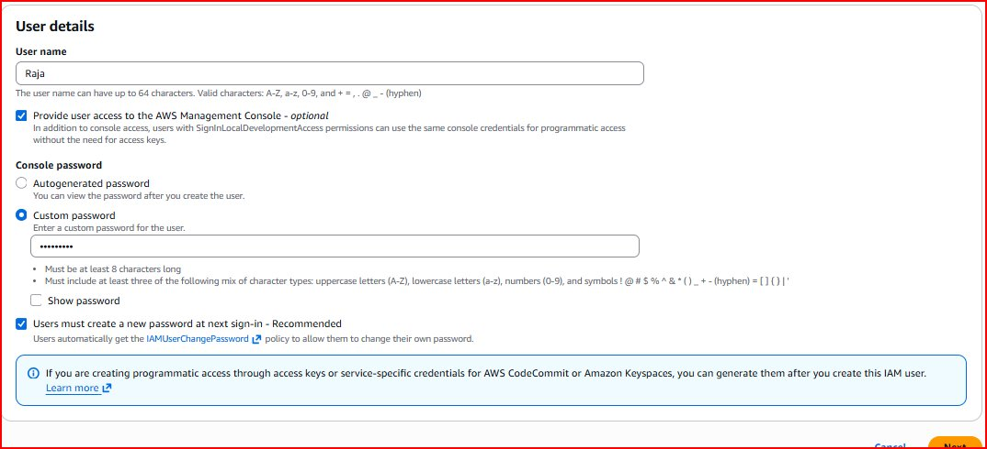
Figure 8: Create user "Raja" — console access enabled, custom password, password reset required at first sign-in
Step 4 — Add Raja to Administrators group:
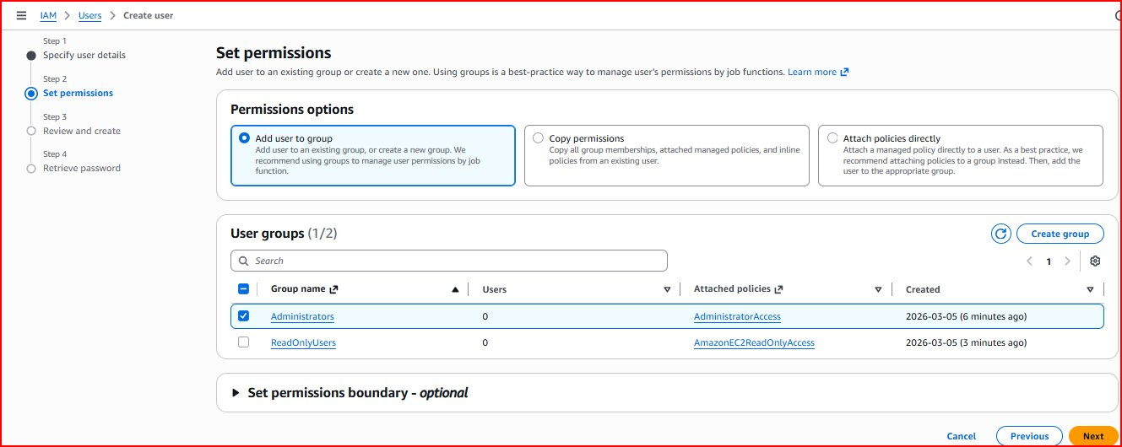
Figure 9: Set permissions — Administrators group selected for user Raja (AdministratorAccess policy)
Step 5 — Admin user created with console sign-in URL:
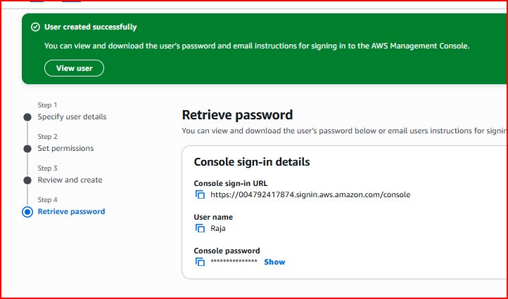
Figure 10: User "Raja" created — sign-in URL: https://004792417874.signin.aws.amazon.com/console
Step 6 — Create read-only user "raja_readonly_access":
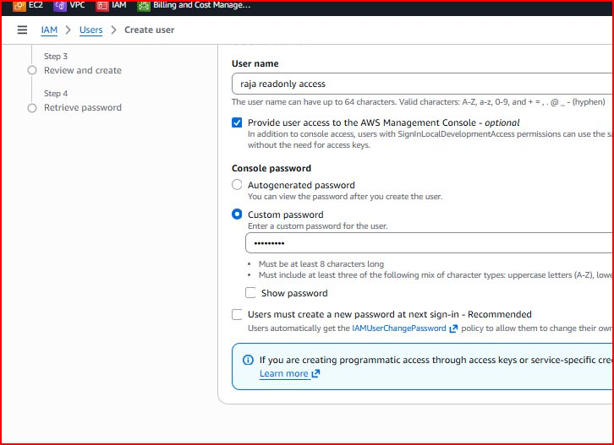
Figure 11: Create user "raja_readonly_access" — console access enabled, custom password
Step 7 — Add readonly user to ReadOnlyUsers group:
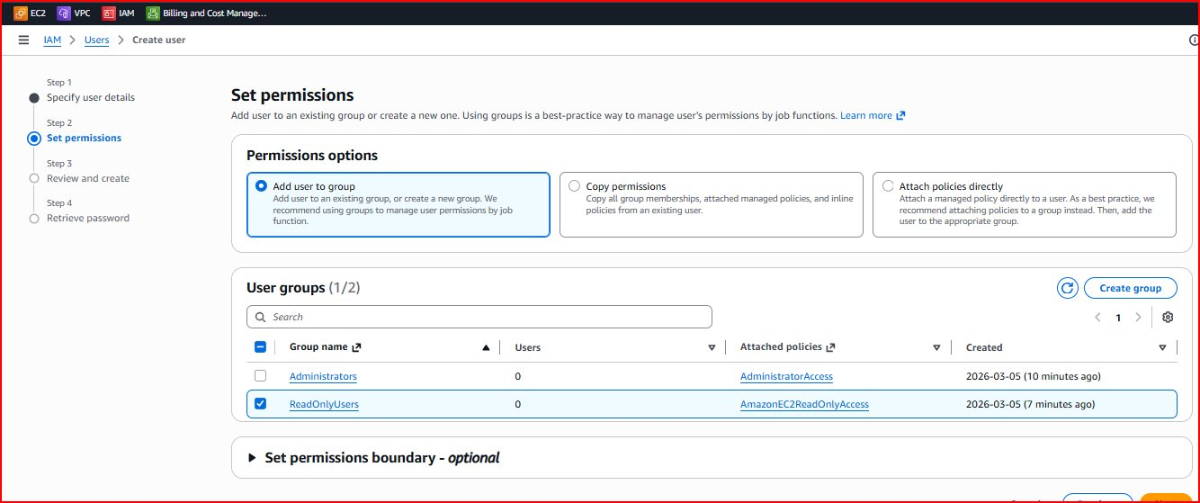
Figure 12: Set permissions — ReadOnlyUsers group selected (AmazonEC2ReadOnlyAccess policy)
Step 8 — Readonly user created successfully:
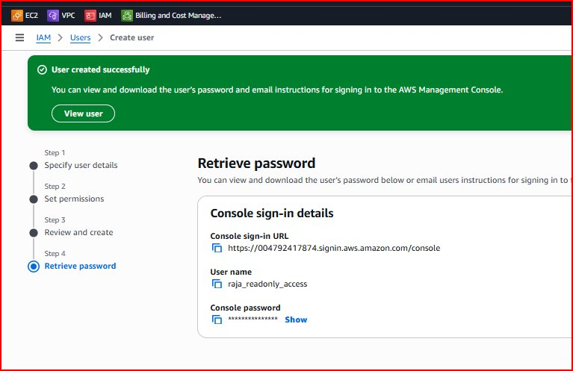
Figure 13: User "raja_readonly_access" created with ReadOnlyUsers group membership
2.5 Practical 3: Testing User Permissions
Step 9 — Sign in as admin user "Raja" at the IAM sign-in URL:
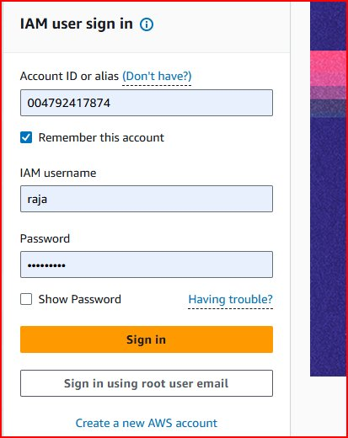
Figure 14: IAM sign-in — Account 004792417874, username "raja"
Step 10 — Password reset required on first login (as configured during user creation):
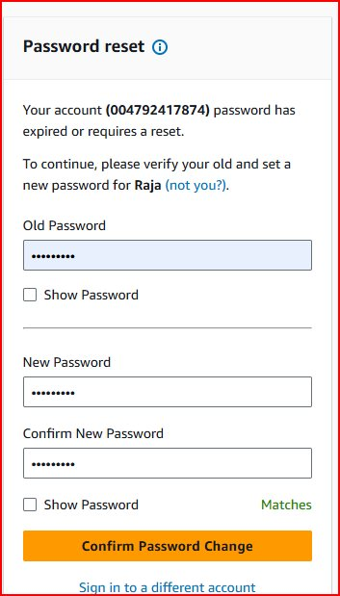
Figure 15: Password reset required — user must change password on first sign-in for security
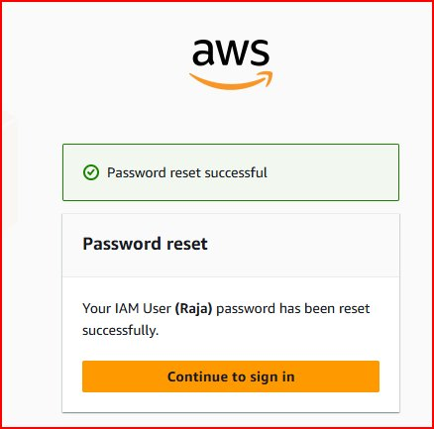
Figure 16: Password reset successful for IAM user Raja
Step 11 — Sign in as the read-only user to test restricted access:
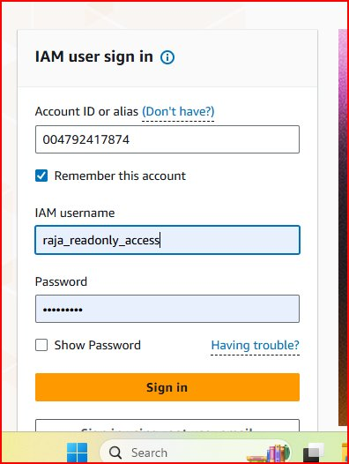
Figure 17: IAM sign-in as "raja_readonly_access"
Step 12 — Readonly user console shows Access Denied errors — confirming permissions are correctly restricted:
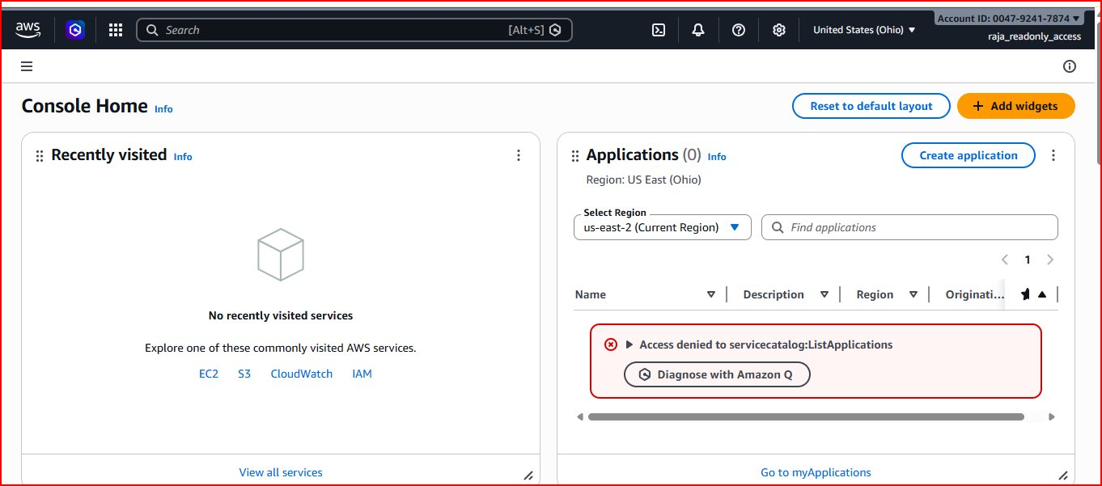
Figure 18: Readonly user — "Access denied to servicecatalog:ListApplications" confirms restricted permissions work correctly
Note: The Access Denied error is the EXPECTED and CORRECT behavior. It proves the read-only user cannot perform privileged actions. This is the Principle of Least Privilege in action.
Step 13 — Admin user "Raja" console shows full unrestricted access:
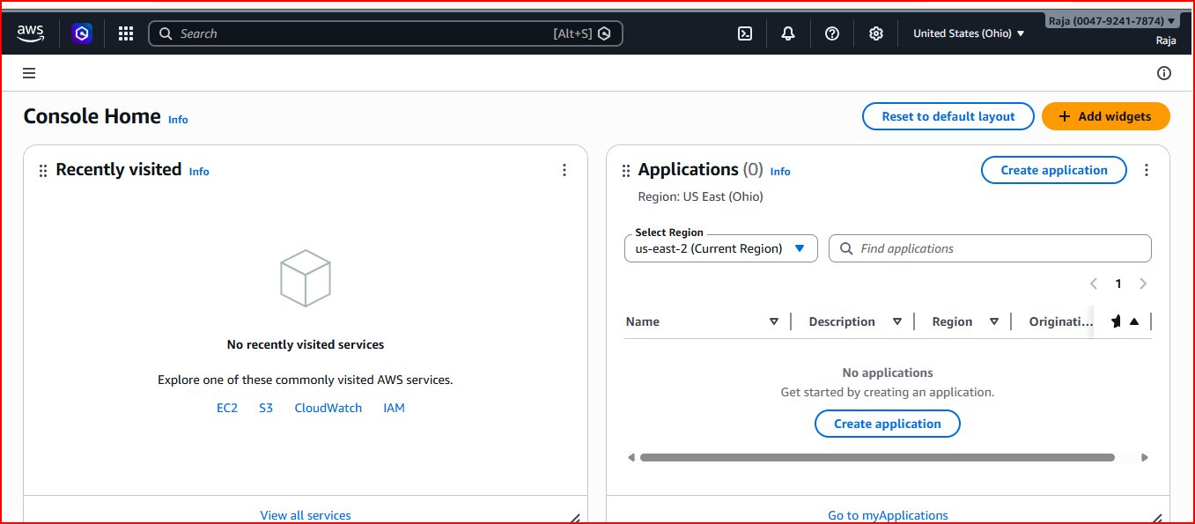
Figure 19: Admin user "Raja" console — full access, no denied errors, all AWS services available
2.6 Practical 4: IAM Roles for EC2
Roles allow EC2 instances to call AWS services without storing access keys on the instance — more secure and easier to manage.

Step 1 — Create role. Navigate to IAM > Roles > Create role. Select AWS service with EC2 use case:
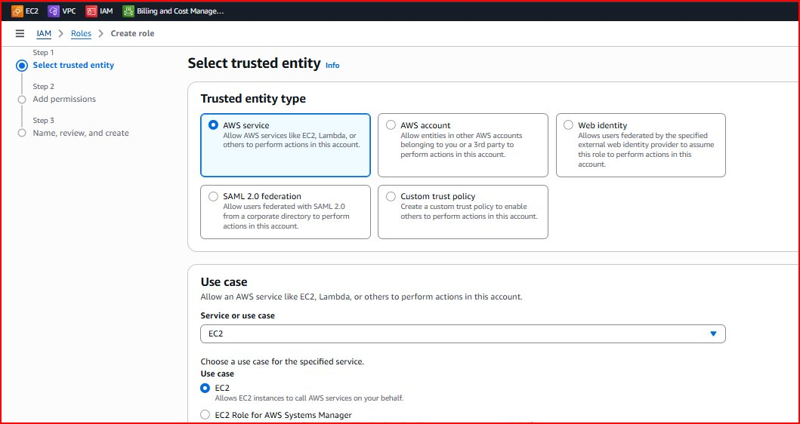
Figure 20: Select trusted entity — AWS service, EC2 use case (allows EC2 instances to call AWS APIs on your behalf)
Step 2 — Attach AdministratorAccess policy to the role:
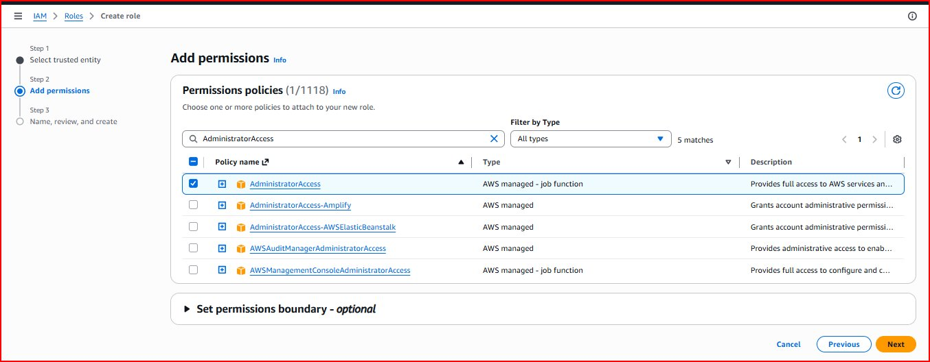
Figure 21: Add permissions — AdministratorAccess selected for EC2-Admin-Role
Step 3 — Name the role "EC2-Admin-Role":
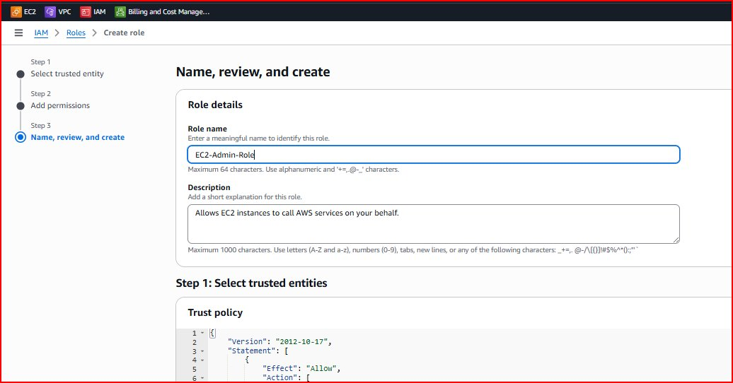
Figure 22: Role name "EC2-Admin-Role" — auto-generated trust policy shown allowing EC2 service to assume this role
Step 4 — Attach the role to an existing EC2 instance via Actions > Security > Modify IAM role:
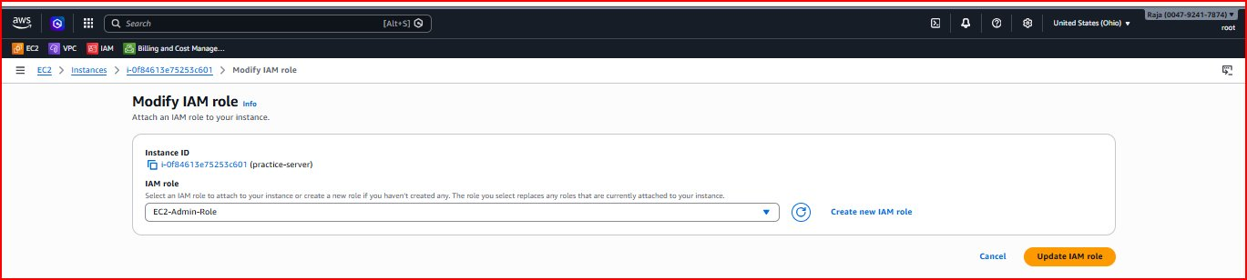
Figure 23: Modify IAM role on EC2 "practice-server" — EC2-Admin-Role selected, click "Update IAM role" to apply
Note: Once the role is attached, the EC2 instance automatically receives temporary AWS credentials. Running "aws s3 ls" or "aws ec2 describe-instances" on the instance works without any aws configure setup.

3. AWS Elastic Beanstalk — PaaS Application Deployment
3.1 What is Elastic Beanstalk?
AWS Elastic Beanstalk is a Platform as a Service (PaaS) that handles deployment, capacity provisioning, load balancing, auto-scaling, and health monitoring automatically. You upload your application code and Beanstalk manages all the underlying infrastructure.
- Auto-provisions EC2 instances, load balancers, and security groups for your app
- Managed platform updates — OS patches and runtime upgrades handled by AWS
- Built-in auto-scaling — scales instances based on traffic automatically
- Health dashboard — real-time application status and metrics
- Ideal for developers who want to focus on code, not infrastructure

Platform | Common Framework | Example Use Case
Python | Flask, Django | REST APIs, web applications
Node.js | Express.js | Real-time apps, APIs
Java | Spring Boot | Enterprise applications
PHP | Laravel | WordPress, e-commerce
Docker | Any container | Microservices architecture
.NET | ASP.NET Core | Windows applications

3.2 Deployment Steps
1. Search for Elastic Beanstalk > Create application > enter name (e.g., my-web-app)
2. Select Platform (e.g., Python 3.11) and Platform branch/version
3. Upload code: choose "Sample application" for demo, or upload your own ZIP file
4. Configure IAM: select or create Service role and EC2 instance profile
5. Click Submit and wait 5-10 minutes for environment creation
6. When status shows green "Ok", click the environment URL to access your live application
Note: Beanstalk creates a complete infrastructure stack including EC2, Auto Scaling Group, Application Load Balancer, and CloudWatch alarms — all from a single application upload.

4. AWS Lambda — Serverless Compute
4.1 What is Lambda?
AWS Lambda is a serverless compute service that runs your code in response to events without requiring you to manage any servers. You write the function code, define the trigger, and Lambda handles scaling, patching, and availability automatically.
- Serverless — no EC2 instances to provision, patch, or manage
- Event-driven — triggered by S3 uploads, API calls, schedules, DynamoDB changes, etc.
- Pay-per-use — charged only for the milliseconds your code actually runs
- Auto-scaling — handles 1 request or 1 million requests simultaneously
- Multiple languages — Python, Node.js, Java, Go, C#, Ruby, PowerShell

Limit | Value | Notes
Max execution time | 15 minutes | Default 3s — increase in Configuration tab
Memory | 128MB to 10,240MB | More memory = more CPU automatically
Deployment package | 50MB zipped / 250MB unzipped | Use Lambda Layers for large dependencies
Concurrent executions | 1,000 per region | Request increase from AWS Support

4.2 Practical 1: Creating Lambda IAM Policy
Step 1 — Navigate to IAM > Policies > Create policy > JSON tab. Paste the EC2 start/stop policy:
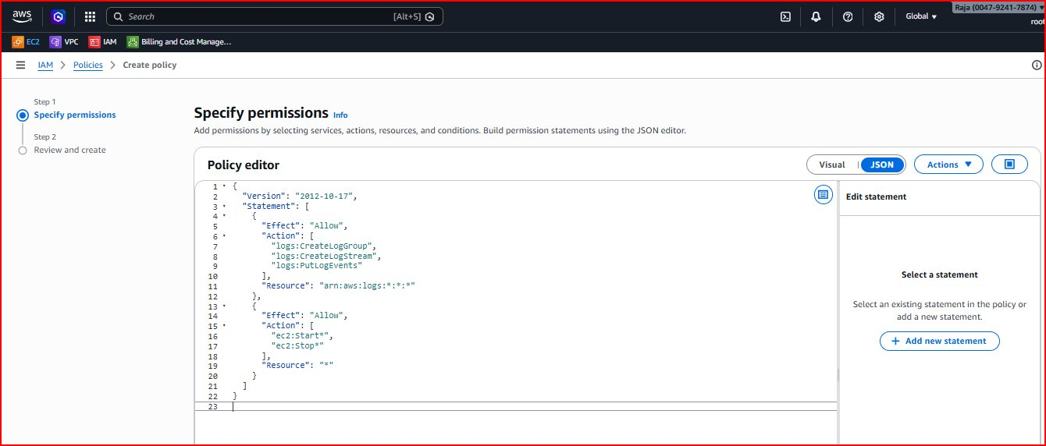
Figure 24: Lambda policy JSON — CloudWatch Logs permissions (lines 7-9) and EC2 Start/Stop permissions (lines 15-17)
{
"Version": "2012-10-17",
"Statement": [
{
"Effect": "Allow",
"Action": [
"logs:CreateLogGroup",
"logs:CreateLogStream",
"logs:PutLogEvents"
],
"Resource": "arn:aws:logs:*:*:*"
},
{
"Effect": "Allow",
"Action": ["ec2:Start*", "ec2:Stop*"],
"Resource": "*"
}
]
}

Note: The ec2:Start* wildcard covers StartInstances. ec2:Stop* covers StopInstances. The logs permissions allow Lambda to write execution output to CloudWatch Logs for debugging.
Step 2 — Name the policy "Lambda-EC2-Start-Stop-Policy":
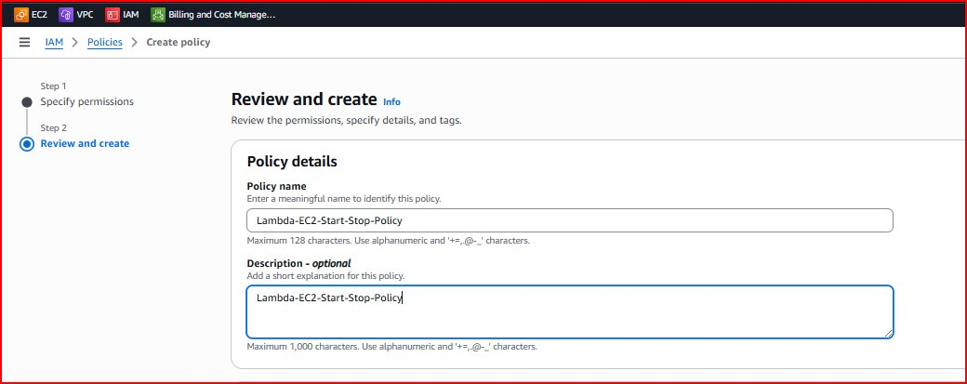
Figure 25: Policy name "Lambda-EC2-Start-Stop-Policy" with matching description — click Create policy
4.3 Practical 2: Creating Lambda IAM Role
Step 3 — Navigate to IAM > Roles > Create role. Select AWS service with Lambda use case:
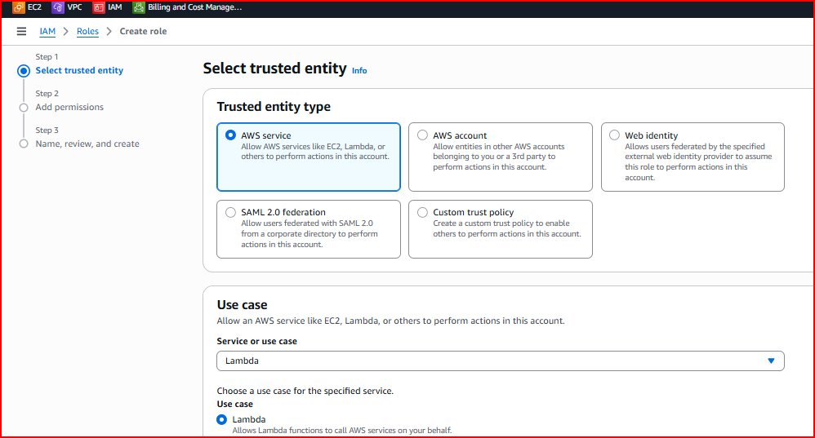
Figure 26: Trusted entity — AWS service, Lambda use case (allows Lambda functions to call AWS services)
Step 4 — Attach the custom Lambda-EC2-Start-Stop-Policy:
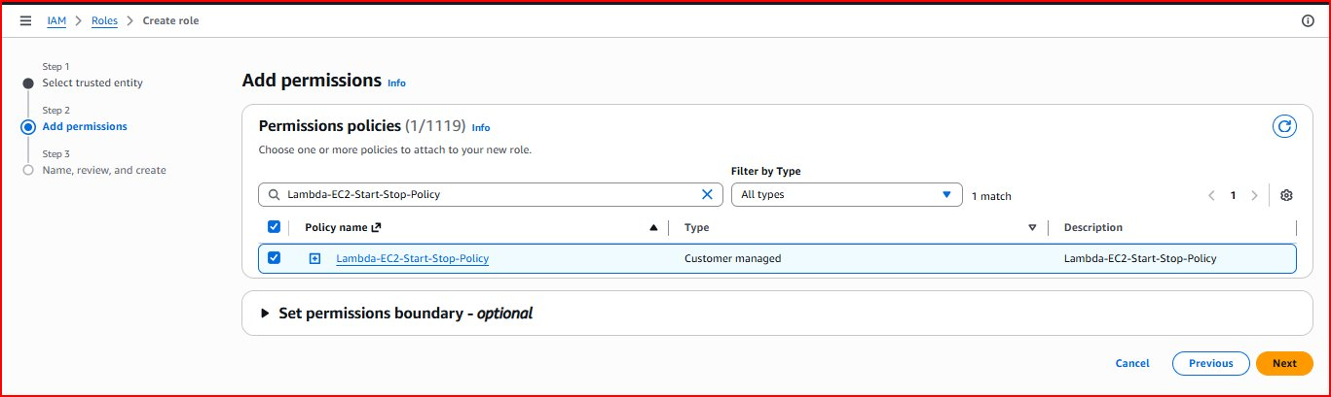
Figure 27: Add permissions — Lambda-EC2-Start-Stop-Policy (Customer managed) selected for the Lambda role
Step 5 — Name the role "Lambda-EC2-Control-Role":
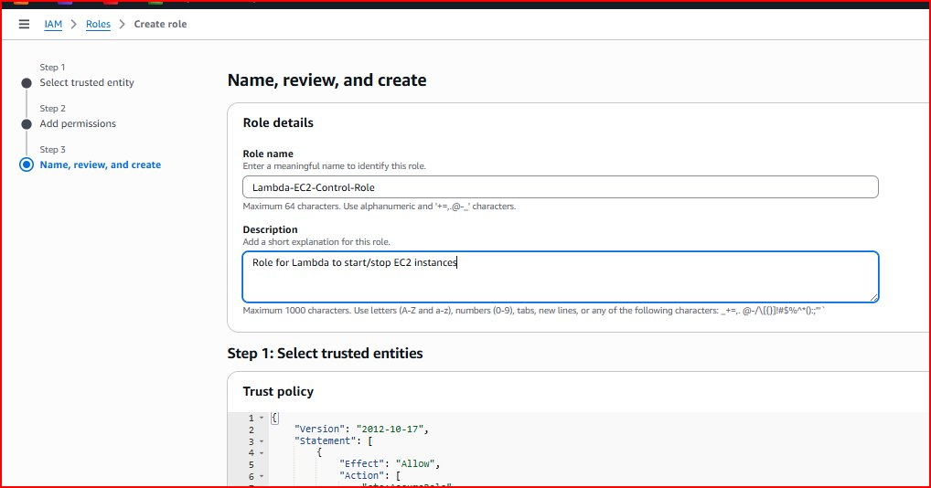
Figure 28: Role name "Lambda-EC2-Control-Role", description "Role for Lambda to start/stop EC2 instances"
4.4 Practical 3: Creating the Lambda Function
Step 6 — Navigate to Lambda > Create function. Author from scratch, name "StartEC2Instances", Python 3.14, use Lambda-EC2-Control-Role:
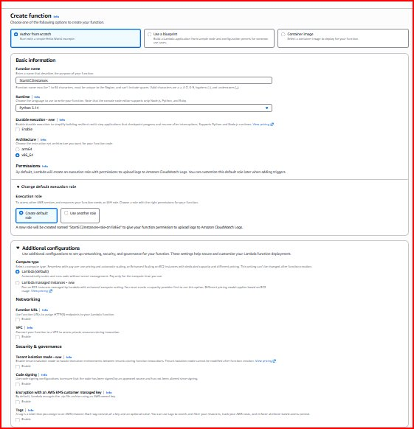
Figure 29: Create function — StartEC2Instances, Python 3.14, x86_64, Lambda-EC2-Control-Role execution role
Step 7 — Function created. Function overview shows the ARN and architecture:
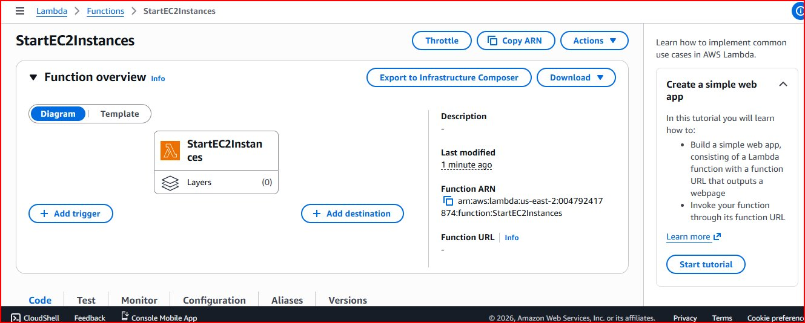
Figure 30: StartEC2Instances function — ARN: arn:aws:lambda:us-east-2:004792417874:function:StartEC2Instances
Step 8 — Replace default code with the EC2 start function and create a TestEvent:
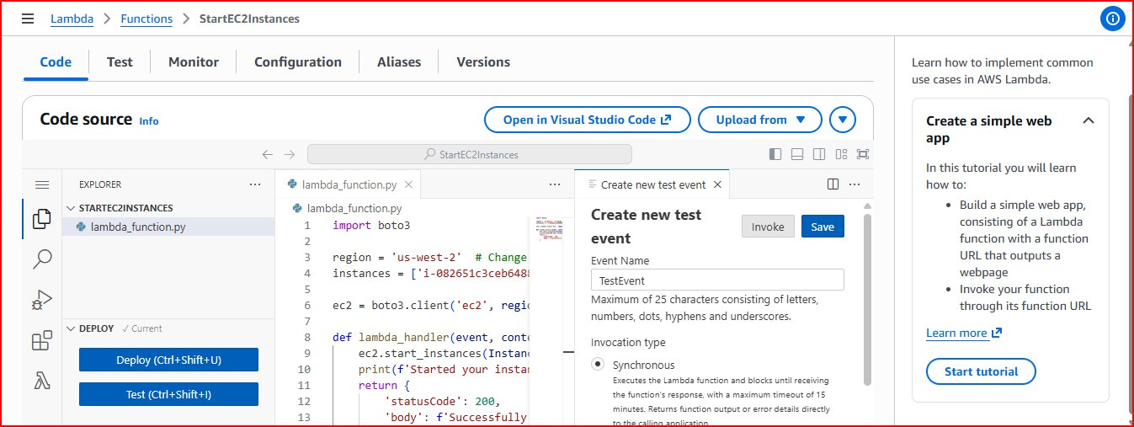
Figure 31: Lambda code editor — boto3 Python code deployed, TestEvent created, ready to invoke
import boto3

region = 'us-east-2' # Your AWS region
instances = ['i-0f84613e75253c601'] # Replace with your instance ID
ec2 = boto3.client('ec2', region_name=region)

def lambda_handler(event, context):
ec2.start_instances(InstanceIds=instances)
print(f'Started your instances: {instances}')
return {
'statusCode': 200,
'body': f'Successfully started instances: {instances}'
}

EC2 instances showing Stopped state before Lambda invocation:
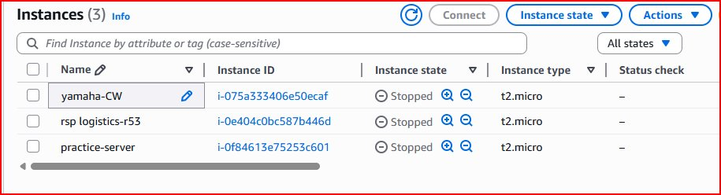
Figure 32: EC2 instances — yamaha-CW, rsp logistics-r53, practice-server all Stopped before Lambda test
Note: After clicking Deploy then Test in the Lambda console, the function runs and the target EC2 instance changes from Stopped to Running. Check the EC2 console to verify.
4.5 Practical 4: Scheduling Lambda with EventBridge
EventBridge schedules automate Lambda invocations — like a cloud cron job. Use it to start instances at 9 AM and stop them at 6 PM to save costs.

Step 9 — Navigate to EventBridge > Schedules > Create schedule. Enter name and description:
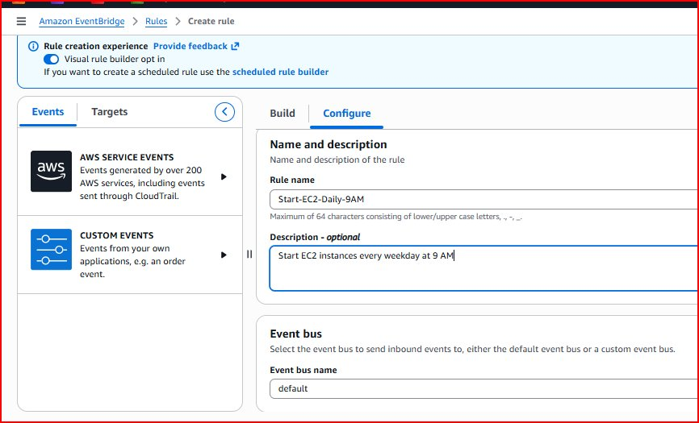
Figure 33: EventBridge rule — name "Start-EC2-Daily-9AM", description "Start EC2 instances every weekday at 9 AM"
Step 10 — Configure cron expression schedule:
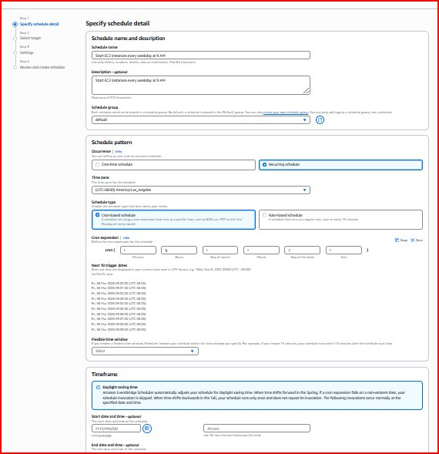
Figure 34: Schedule pattern — Recurring, Cron-based schedule showing next 10 trigger dates for verification
Cron Format: cron(minute hour day-of-month month day-of-week year)

cron(0 9 * * ? *) -> Every day at 9:00 AM UTC
cron(0 18 * * ? *) -> Every day at 6:00 PM UTC
cron(0 9 ? * MON-FRI *) -> Weekdays only at 9:00 AM
cron(*/5 * * * ? *) -> Every 5 minutes

Step 11 — Select target: choose "AWS Lambda — Invoke" from Templated targets:
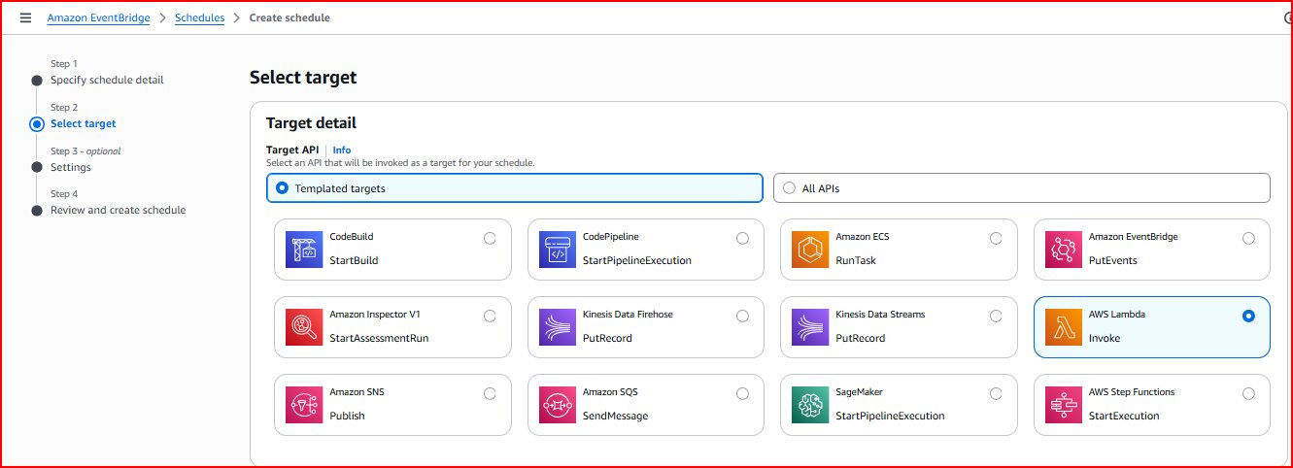
Figure 35: Select target — AWS Lambda Invoke option selected from available templated targets
Step 12 — Select "StartEC2Instances" as the Lambda function to trigger on schedule:
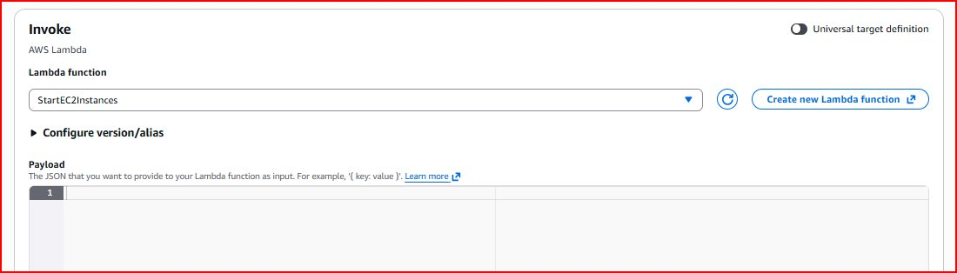
Figure 36: Lambda target — StartEC2Instances function selected, will be invoked automatically per cron schedule
Note: To also stop instances automatically: create a second Lambda function "StopEC2Instances" using ec2.stop_instances(), then create another EventBridge schedule with cron(0 18 * * ? *) pointing to it.

5. AWS Migration Services
5.1 Migration Services Overview
Migration Type | AWS Service | Use Case
Server/VM Migration | AWS Application Migration Service | Lift-and-shift servers to EC2
Database Migration | AWS Database Migration Service (DMS) | Migrate databases with minimal downtime
Large Data Transfer | AWS DataSync | Move petabytes of data efficiently
File Transfer | AWS Transfer Family | SFTP/FTPS transfers to S3 or EFS
VM Import/Export | EC2 VM Import/Export | Convert VMware VMs to EC2 AMIs
Schema Conversion | AWS SCT | Convert DB schemas between engines

5.2 VM Migration — Practical Steps
This demonstrates migrating a VMware virtual machine to AWS EC2 using VM Import/Export.

Phase 1 — Prepare the source VM:
yum remove vmware-tools
-> Remove VMware Tools before export to prevent driver conflicts in AWS
useradd test && passwd test
-> Create a user account for SSH access after migration is complete
yum -y install openssh-server && systemctl enable sshd && systemctl start sshd
-> Install SSH server so you can connect to the instance after migration
shutdown -h now
-> Cleanly shut down VM before export to ensure filesystem consistency
Phase 2 — Export from VMware: Right-click VM > File > Export > Export OVF Template > Single file OVA format

Phase 3 — Upload OVA to S3:
aws configure
-> Configure AWS CLI with Access Key, Secret Key, region us-east-2, output json
aws s3 mb s3://my-vm-migration-bucket
-> Create S3 bucket to store the OVA file during the import process
aws s3 cp C:\AWS\my-linux.ova s3://my-vm-migration-bucket/
-> Upload the OVA file to S3 (may take 10-60 mins depending on file size)
Phase 4 — Create IAM role and start import:
aws iam create-role --role-name vmimport --assume-role-policy-document file://trust-policy.json
-> Create the vmimport role allowing VM Import service to access your S3 bucket
aws ec2 import-image --description "My Linux Server" --disk-containers file://containers.json
-> Start the VM import — AWS converts the OVA to an AMI (takes 15-45 minutes)
aws ec2 describe-import-image-tasks --import-task-ids import-ami-05500c68df176dfb7
-> Check import status — repeat until status shows "completed"
Phase 5 — Launch from imported AMI: EC2 > AMIs > find imported AMI > Launch instance from AMI

5.3 Database Migration with AWS DMS
Approach | Tools | Best For | Downtime
Homogeneous | AWS DMS only | Same DB engine (MySQL to MySQL) | Minimal
Heterogeneous | AWS SCT + DMS | Different engines (Oracle to PostgreSQL) | Planned window
Physical Replication | Oracle Data Guard | Large Oracle databases | Near zero

DMS Migration Steps: Assessment > Schema Conversion (SCT) > Create Replication Instance > Configure Source and Target Endpoints > Create Migration Task (Full Load + CDC) > Validate > Cutover

