AWS EC2 – Linux Instance
Launch, Secure & Connect to a Linux EC2 Instance
Hands-On Project Documentation

Project Overview
This project documents the complete process of setting up an AWS account, creating a Linux EC2 virtual machine, securing it with a Security Group, and connecting to it remotely using MobaXterm via SSH.
Amazon EC2 (Elastic Compute Cloud) is a core AWS service that lets you rent virtual servers (instances) in the cloud. In this hands-on project, we go through every step from account creation to a successful server login.
Project Flow
AWS Account Creation → Security Group Creation → EC2 Instance Launch → Key Pair Download → MobaXterm Installation → SSH Login → Server Validation

Part 1: Creating an AWS Account
Before launching any AWS resource, you need an active AWS account. The account creation process involves email verification, identity confirmation, and payment setup.
Step 1 – Visit the AWS Signup Page
Open a browser and go to: https://portal.aws.amazon.com/billing/signup
Step 2 – Enter Email & Account Name
Provide a valid email address and choose a unique AWS account name. This email will be the root user login.
Step 3 – Verify Email
AWS sends a verification code to your email. Enter the code to confirm your email address.
Step 4 – Set a Strong Password
Create a strong password for the root account. Keep it secure and never share it.
Step 5 – Provide Contact Information
Enter your full name, phone number, and billing address.
Step 6 – Add Payment Information
Add a valid credit or debit card. AWS will charge a small verification amount (which is refunded).
Important: You will not be charged unless you use services beyond the free tier limits.
Step 7 – Identity Verification
Choose phone verification via voice call or SMS. Enter the code received.
Step 8 – Select Support Plan
For learning, select the Basic Support plan which is completely free.
- Basic Support: Free — recommended for learning
- Developer Support: $29/month
- Business Support: $100/month
- Enterprise Support: Custom pricing
Step 9 – Complete Setup
Review and accept the AWS Terms of Service. Your account is now active.

Part 2: Creating a Security Group
A Security Group acts as a virtual firewall for your EC2 instance. It controls which network traffic is allowed in (inbound) and out (outbound) of your server.
Why create Security Group first: AWS best practice is to define your firewall rules before launching the instance so it is secured from the moment it starts.
Step 1 – Navigate to Security Groups
In the AWS Console, go to EC2 → Network & Security → Security Groups, then click 'Create Security Group'.
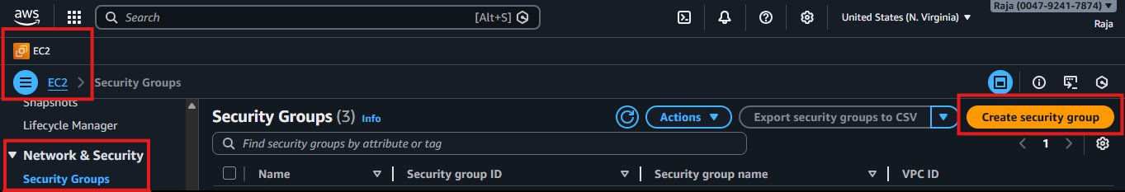
Step 2 – Set Security Group Name and Description
Provide a meaningful name (e.g., 'linux-sg') and a description. Select the default VPC for learning.
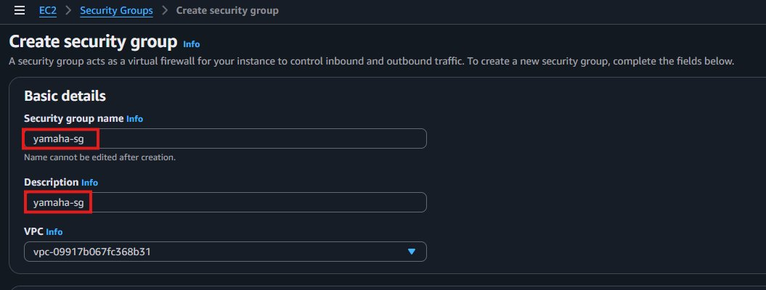
Step 3 – Add Inbound Rules
Inbound rules control what traffic is allowed to reach your EC2 instance:
SSH (Port 22): Allows remote login using MobaXterm or terminal
HTTP (Port 80): Allows web traffic so websites can be accessed
Source: Set to 0.0.0.0/0 (anywhere) for learning — restrict in production
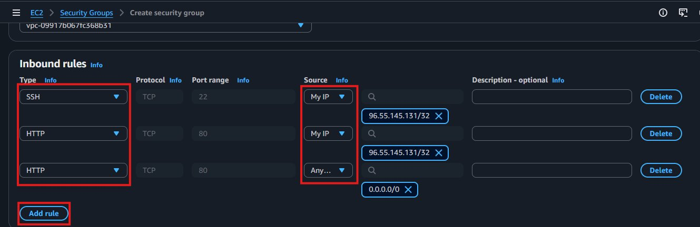
Step 4 – Review and Create
Review all rules and click 'Create Security Group' to finalize.
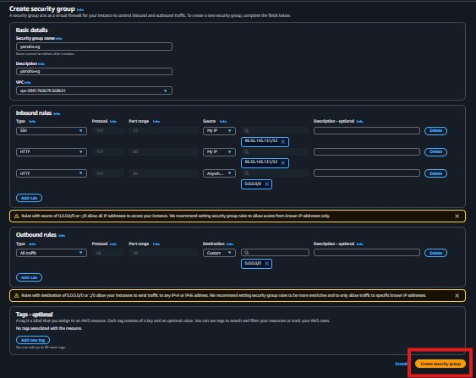
Step 5 – Confirm Security Group Created
The security group now appears in the list with a Security Group ID.
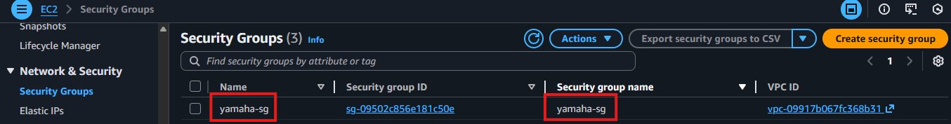

Part 3: Launching the Linux EC2 Instance
With the security group ready, we can now launch the EC2 instance.
Step 1 – Navigate to EC2 and Click Launch Instance
In the AWS Console, go to EC2 → Instances → click 'Launch Instances'.
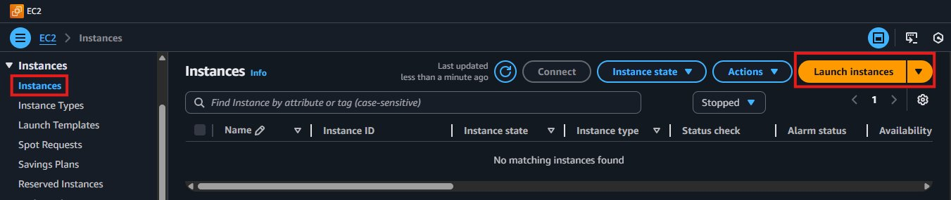
Step 2 – Set Instance Name
Provide a clear, meaningful name (e.g., 'dev-linux-server-01').
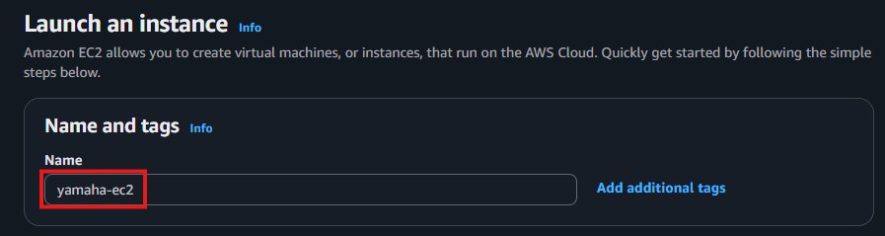
Step 3 – Select the Operating System (AMI)
Choose Amazon Linux 2 as the AMI. It is free tier eligible and optimized for AWS.
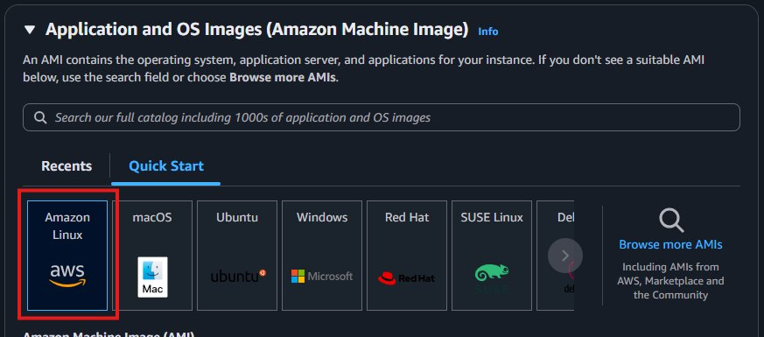
Step 4 – Select Instance Type (CPU & Memory)
Select t2.micro which provides 1 vCPU and 1GB RAM — sufficient for learning.
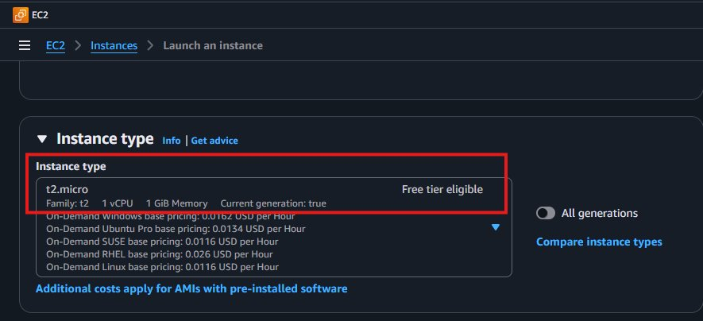
t2.micro: 1 vCPU, 1GB RAM — Free Tier eligible
To scale up: Simply stop the instance, change the instance type, and restart
Step 5 – Create & Download Key Pair
Select 'Create new key pair', give it a name, and click 'Create'. The .pem file will automatically download.
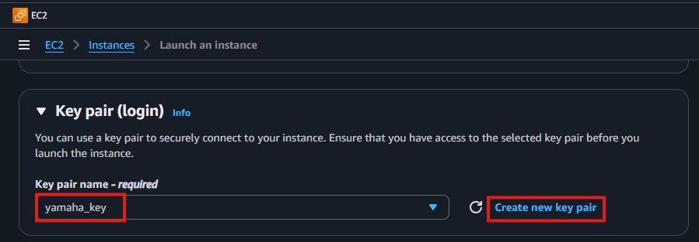
Critical: The .pem file is your password to connect to the server. Store it safely — AWS will NOT let you download it again.
Step 6 – Verify Key Pair Downloaded
Check your Downloads folder to confirm the .pem file is there.
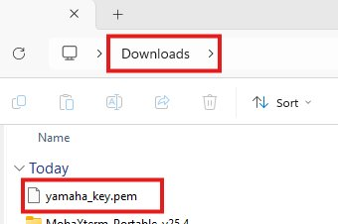
Step 7 – Attach the Security Group
In 'Network settings', select 'Select existing security group' and choose the one you created.
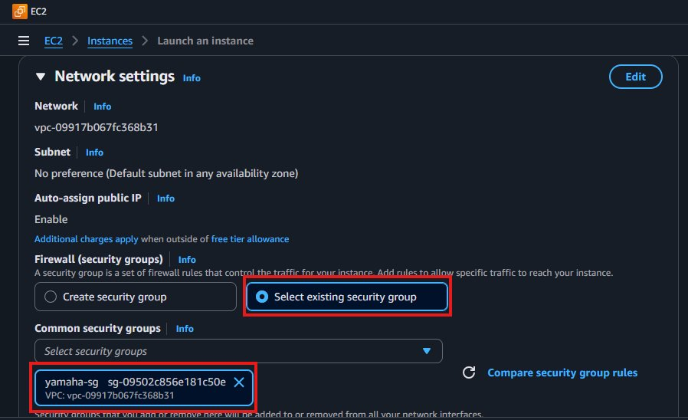
Step 8 – Configure Storage
The default is 8GB for Amazon Linux which is sufficient for learning.
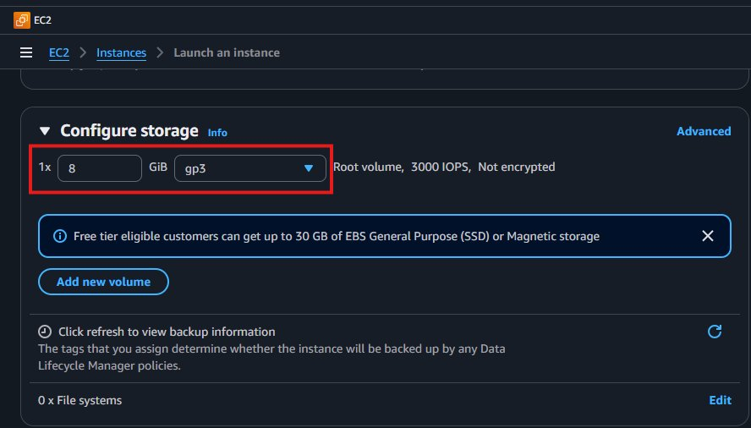
Step 9 – Review Summary and Launch
Review all settings then click 'Launch Instance'.
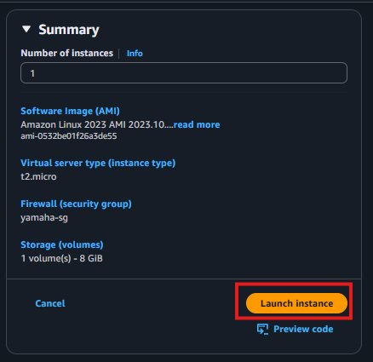
Step 10 – Confirm Instance is Running
Confirm your instance has status 'Running' and passes both status checks.
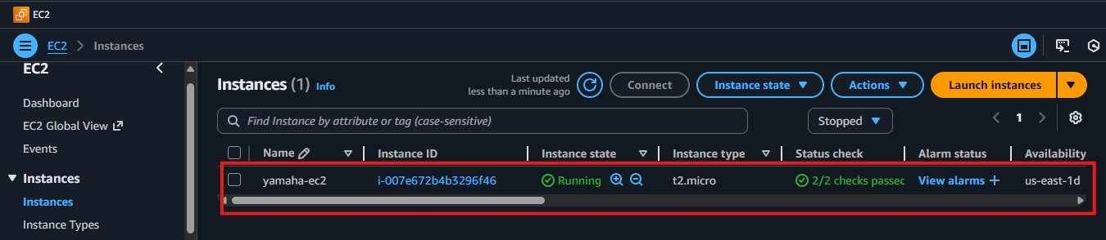

Part 4: Connecting via MobaXterm (SSH)
MobaXterm is a free Windows application providing SSH connectivity to Linux servers.
Step 1 – Download MobaXterm
Download from: https://mobaxterm.mobatek.net/download.html — select the Installer Edition.
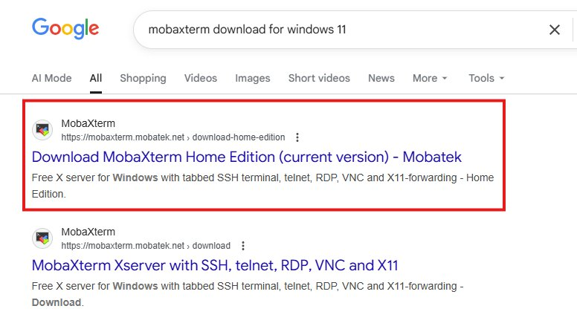
Step 2 – Install MobaXterm
Run the installer from your Downloads folder and follow the setup steps.
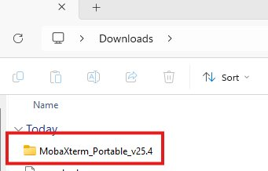
Step 3 – Copy the EC2 Public IP Address
Go to AWS EC2 Console, select your running instance, and copy the Public IPv4 Address.
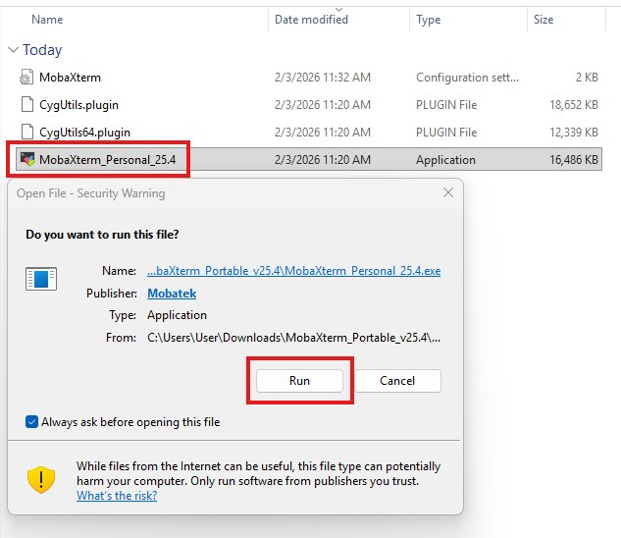
Step 4 – Create SSH Session in MobaXterm
In MobaXterm, click 'Session' → 'SSH' and fill in:
Remote Host: Paste the EC2 Public IP Address
Username: ec2-user (default for Amazon Linux)
Use private key: Check this box and browse to select your .pem file
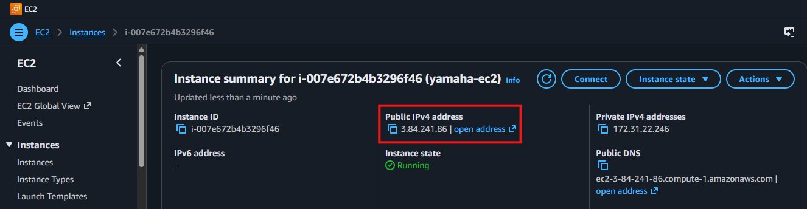
Mac Users: chmod 400 your-key.pem then ssh -i your-key.pem ec2-user@<public-ip>
Step 5 – Successful Login & Server Validation
Once connected, run these commands to verify:
uptime # How long the server has been running
uname -a # Kernel and OS version
df -h # Disk space usage
free -m # RAM usage
ifconfig # Network interface details
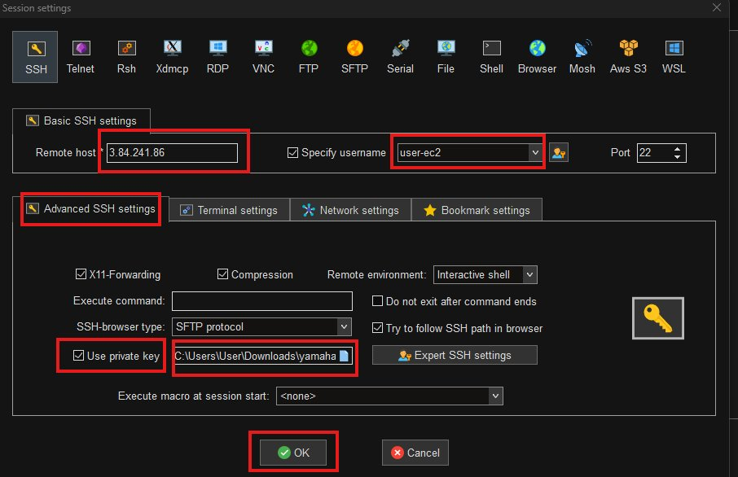
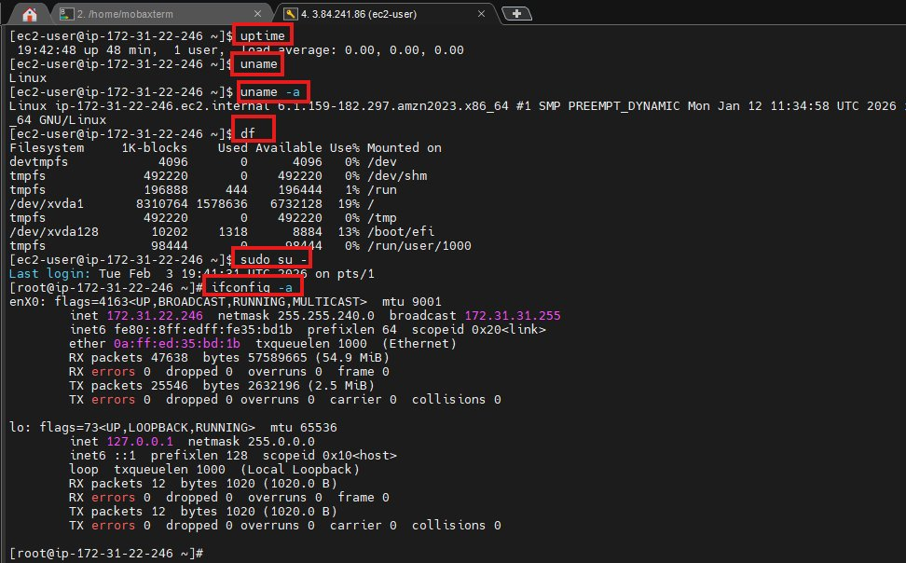

Project Summary
This project successfully demonstrates the end-to-end process of launching and connecting to a Linux EC2 instance on AWS.
- Created an AWS account with full verification and billing setup
- Created a Security Group with SSH (port 22) and HTTP (port 80) inbound rules
- Launched an Amazon Linux EC2 instance with correct AMI, instance type, and storage
- Generated and safely stored a Key Pair (.pem file) for secure authentication
- Installed MobaXterm and established a successful SSH connection
- Validated the server with basic Linux commands post-login

Interview Questions & Answers
Q1: Walk me through how you launched and connected to an EC2 instance.
I started by creating an AWS account, then created a Security Group with SSH on port 22 and HTTP on port 80. Next I launched an Amazon Linux EC2 instance, selected t2.micro, created a key pair and downloaded the .pem file, and attached my security group. Once running, I installed MobaXterm, used the EC2 public IP with ec2-user and the .pem key to SSH in, and verified the server with commands like uptime and df -h.
Q2: Why do you create the Security Group before the instance?
It's AWS best practice to define your firewall rules first so the instance is protected from the moment it launches.
Q3: What happens if you lose the .pem file?
If the .pem key is lost, you can no longer connect using that key. The solution is to pre-create OS-level users with password authentication, or stop the instance and attach its root volume to another instance to add a new key.
Q4: What is a Security Group and how does it work?
A Security Group is a virtual firewall that controls inbound and outbound traffic to an EC2 instance. It uses allow rules only — if a rule is not defined, traffic is blocked by default.

