AWS EC2 – Website Hosting
Host Websites on Linux (Apache) and Windows (IIS) EC2 Instances
Hands-On Project Documentation

Project Overview
This project covers hosting websites on both Linux and Windows EC2 instances. On Linux, we use Apache (httpd). On Windows, we use IIS (Internet Information Services) — Microsoft's built-in web server.
Linux Web Server: Apache HTTP Server (httpd) — open source, widely used
Windows Web Server: IIS (Internet Information Services) — Microsoft's built-in web server

Part 1: Hosting a Website on Linux EC2 (Apache)
Apache (httpd) is the most widely used open-source web server. It can be installed with a single command and serves web pages from the /var/www/html directory by default.
Step 1 – Login to EC2 via MobaXterm
Open MobaXterm and SSH into the Linux EC2 instance using the public IP, ec2-user username, and .pem key file.
Step 2 – Switch to Root User
Switch to the root account using sudo -i to install software and modify system files.
sudo -i # Switch to root/admin user
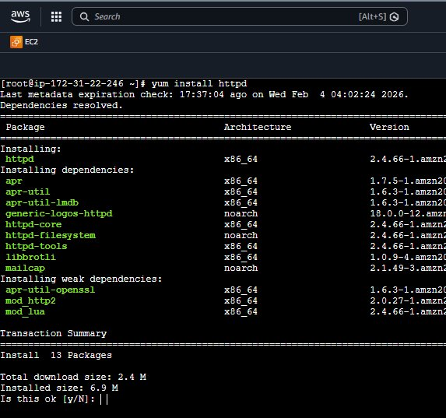
Step 3 – Install Apache Web Server
Install the Apache HTTP server using the yum package manager.
yum install httpd -y # Install Apache web server
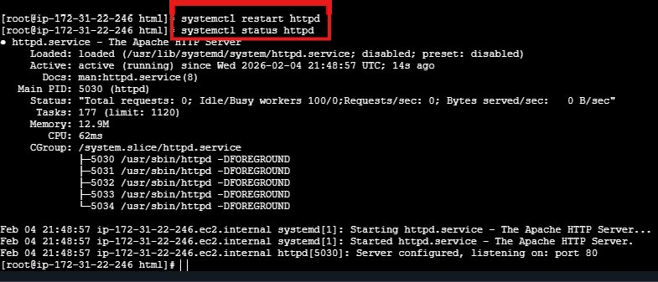
Step 4 – Navigate to the Web Root Folder
Navigate into the web root folder where all website files must be placed.
cd /var/www/html # Go to Apache's default web folder
Important: Any file placed in /var/www/html is automatically served by Apache to the internet
Step 5 – Create a Web Page Using vi Editor
Create an HTML file called index.html using the vi text editor.
vi index.html # Create and open the HTML file
i # Enter insert/edit mode
Esc # Exit insert mode
Esc + :wq! # Save and quit vi editor

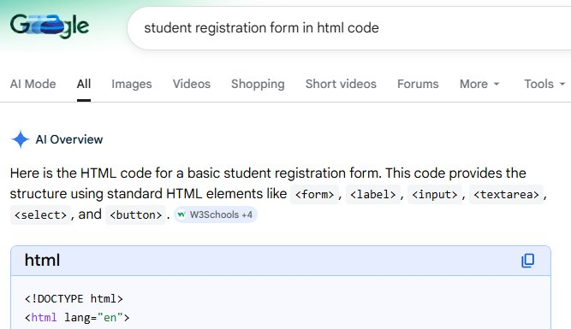
Step 6 – Restart Apache to Apply Changes
systemctl restart httpd # Restart Apache service
systemctl enable httpd # Auto-start Apache on reboot
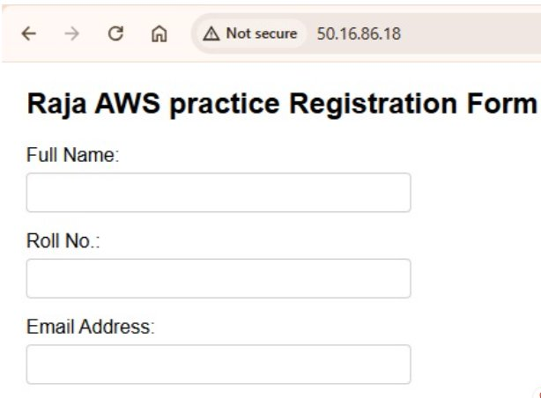
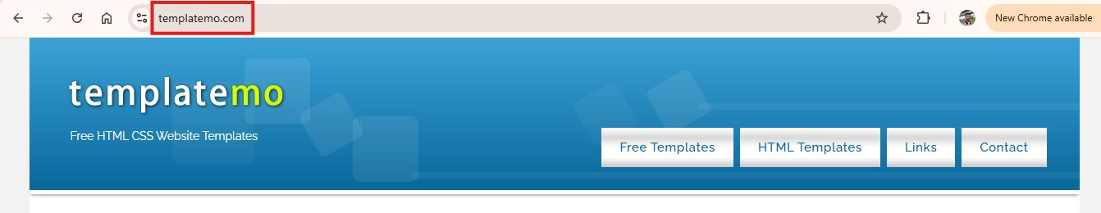
Open a browser and visit your EC2 instance's Public IP — your website will now be visible!

Part 2: Hosting a Professional Website Template (Linux)
Instead of writing HTML from scratch, download a ready-made professional template using wget and deploy it on Apache in minutes.
Step 1 – Find and Copy a Template Download Link
Visit templatemo.com, find a template you like, and copy its direct download URL.
Template used: templatemo_580_woox_travel from templatemo.com
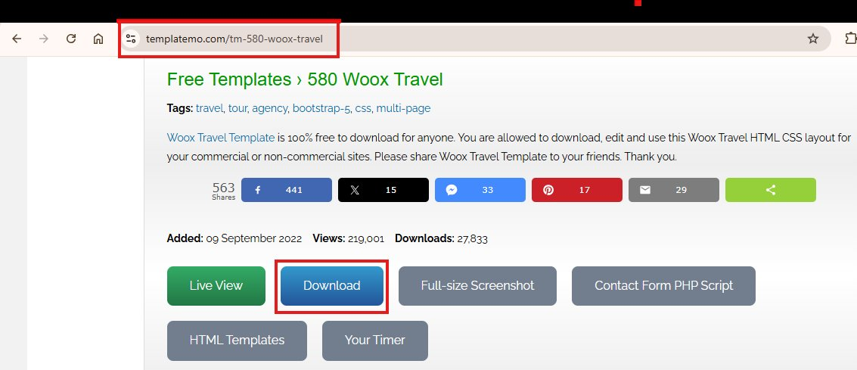
Step 2 – Download the Template Using wget
wget https://templatemo.com/download/templatemo_580_woox_travel
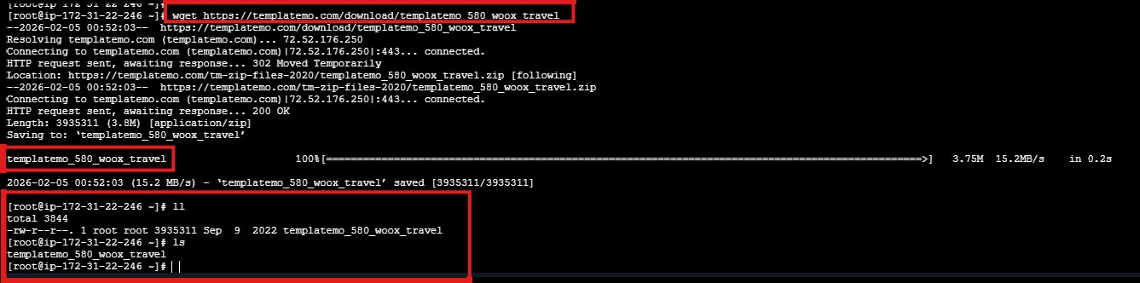
Step 3 – Rename the Downloaded File to .zip
mv templatemo_580_woox_travel templatemo_580_woox_travel.zip
Step 4 – Verify the File
ls # List files in current directory
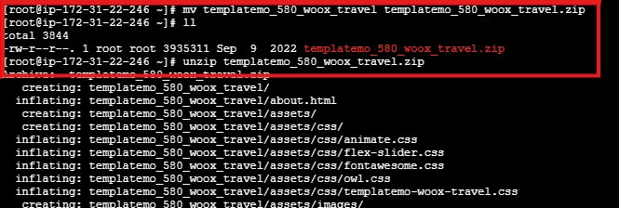
Step 5 – Unzip the Template
unzip templatemo_580_woox_travel.zip
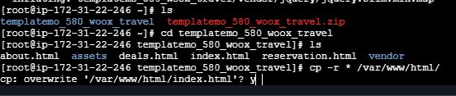
Step 6 – Navigate into the Extracted Folder
cd templatemo_580_woox_travel
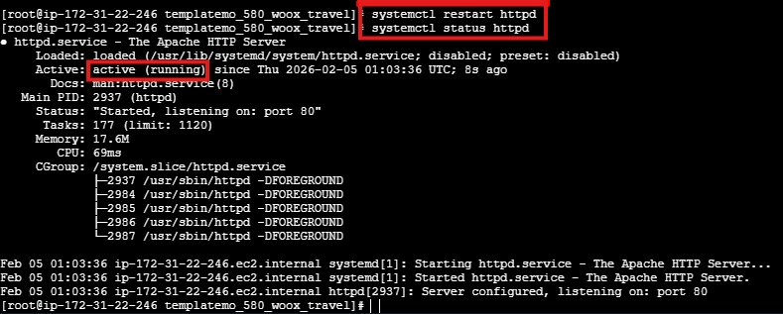
Step 7 – Copy All Files to the Apache Web Root
cp -r * /var/www/html # Copy all files to Apache web root
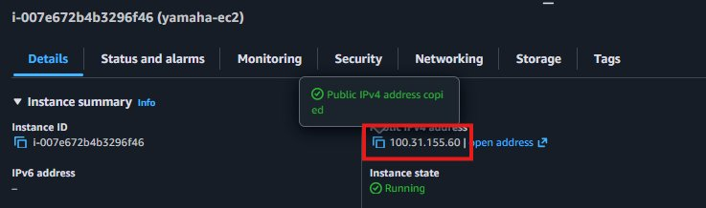
Step 8 – Restart Apache and View the Website
systemctl restart httpd # Restart Apache
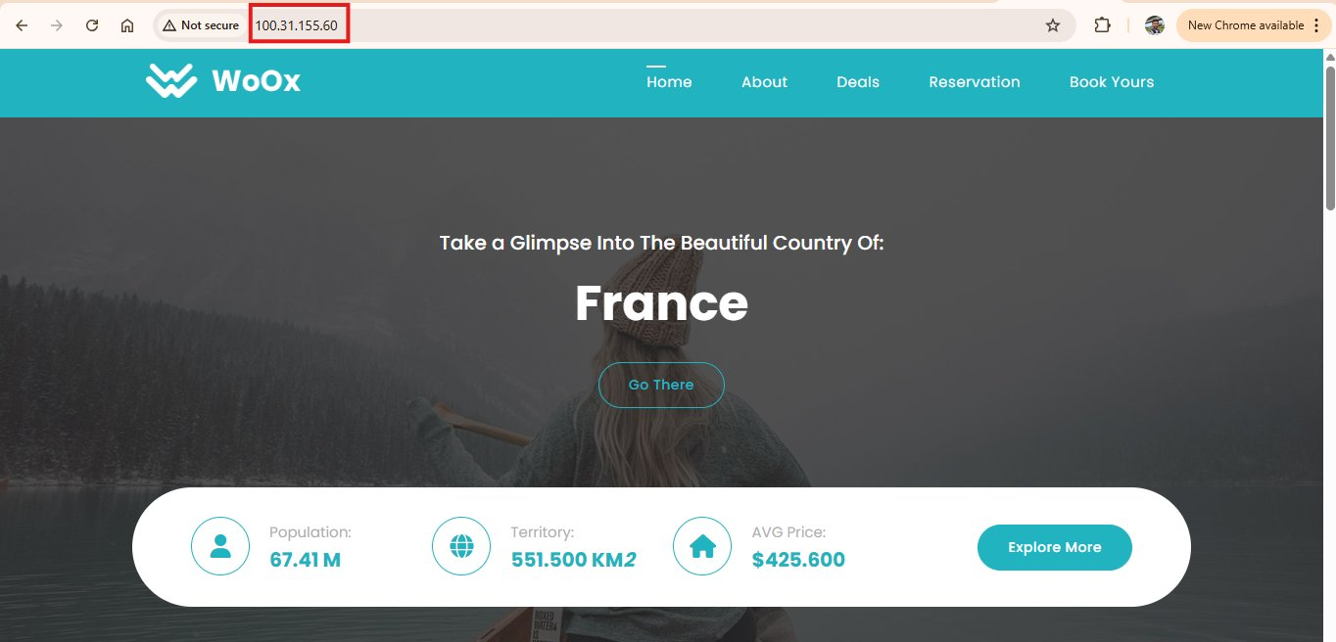
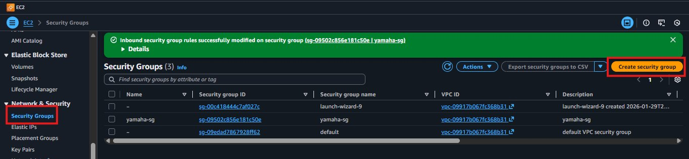
The full professional website is now live and accessible from any browser!

Part 3: Hosting a Website on Windows EC2 (IIS)
IIS (Internet Information Services) is Microsoft's built-in web server. It serves web pages from C:\inetpub\wwwroot by default.
Step 1 – Connect to Windows EC2 via Remote Desktop (RDP)
Windows EC2 instances are accessed using RDP. Select the Windows instance in AWS Console and click Connect.
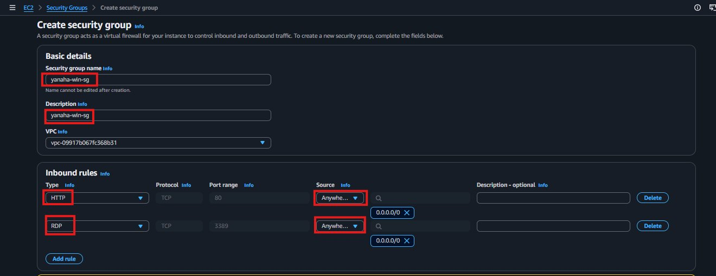
Step 2 – Get the Windows Password
Click 'Get Password', upload your .pem file, and AWS will decrypt and display the Administrator password.
Important: Store this decrypted password safely — you will need it every time you connect via RDP
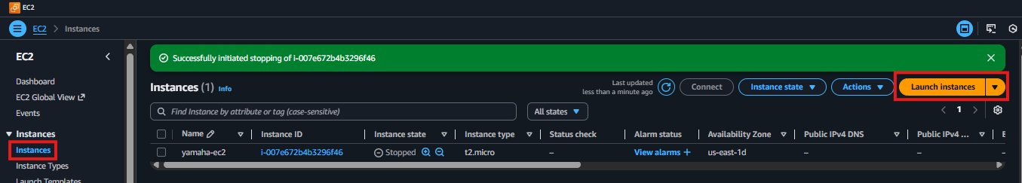
Step 3 – Connect Using Remote Desktop (RDP)
Open Remote Desktop Connection, enter the EC2 public IP, then use 'Administrator' and the decrypted password.
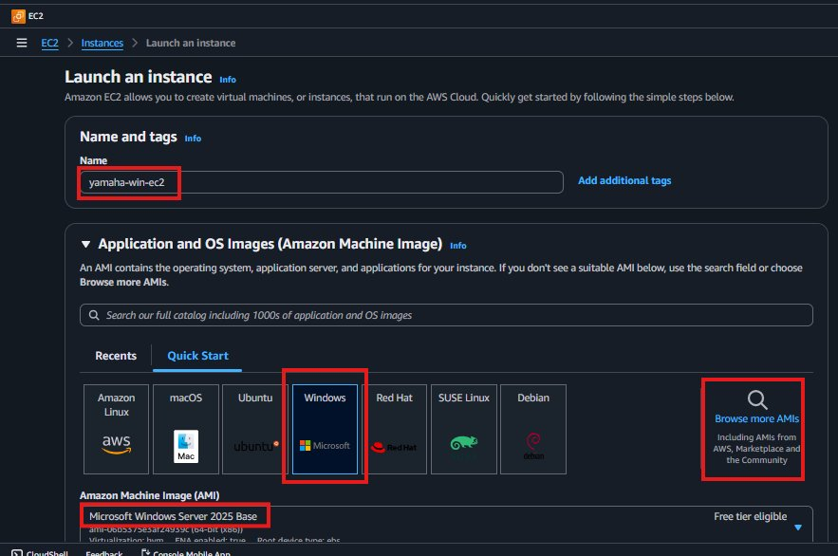
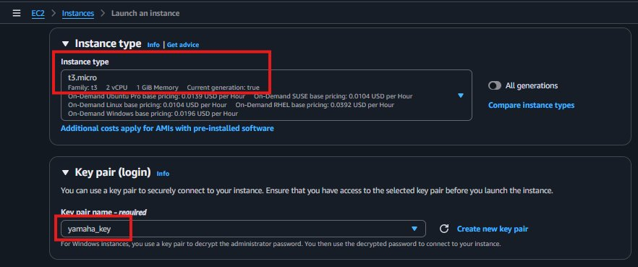
Step 4 – Windows Server Desktop Opens
Once authenticated, the full Windows Server desktop loads inside the Remote Desktop window.
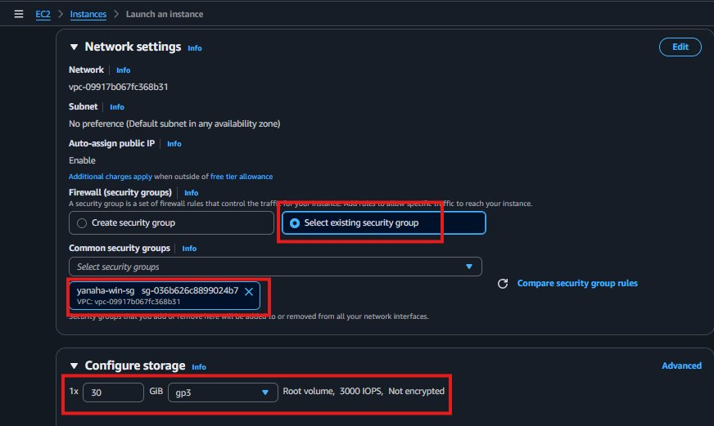
Step 5 – Open Server Manager
Server Manager opens automatically on login. From here we will install the IIS web server role.
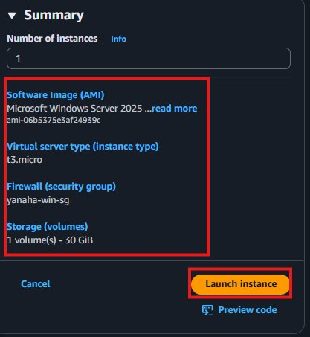
Step 6 – Add Roles and Features (Install IIS)
Click 'Add roles and features' and follow the wizard to 'Server Roles'.
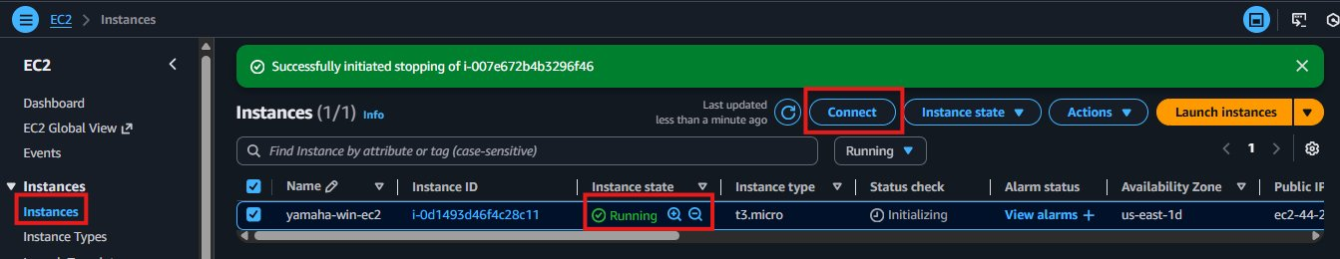
Step 7 – Select Web Server (IIS) Role
Check 'Web Server (IIS)', click 'Add Features', and continue through the wizard.
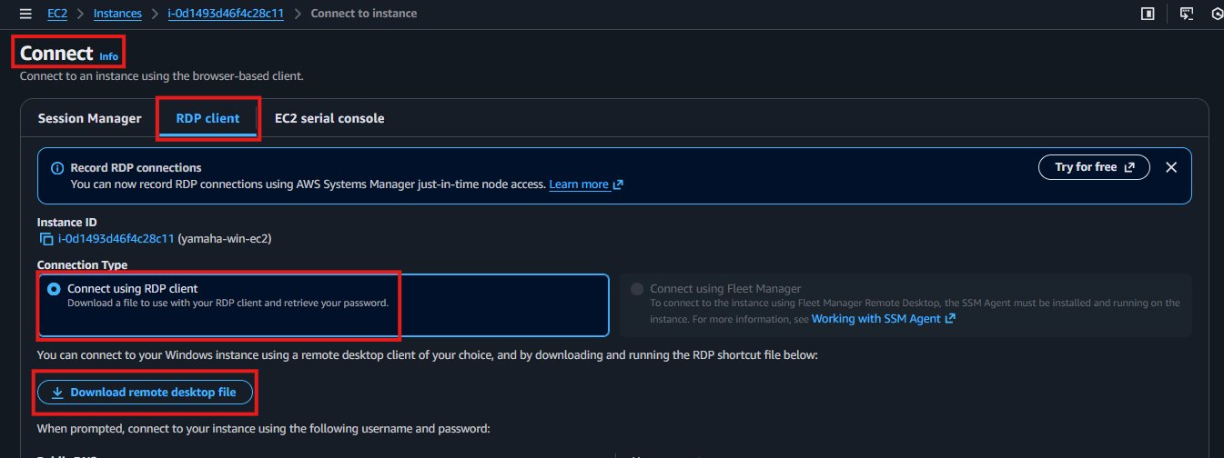
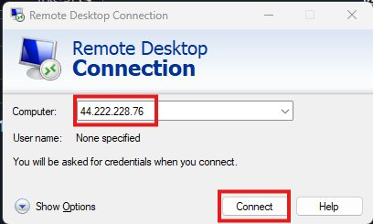
Step 8 – Complete IIS Installation
Click 'Install'. The progress bar runs and IIS is installed automatically.
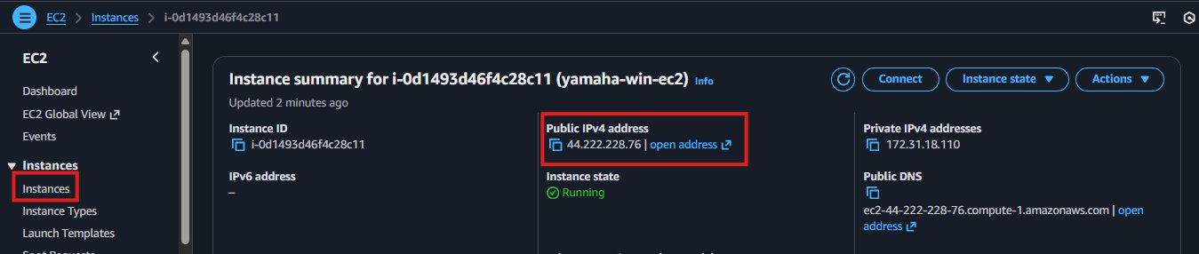
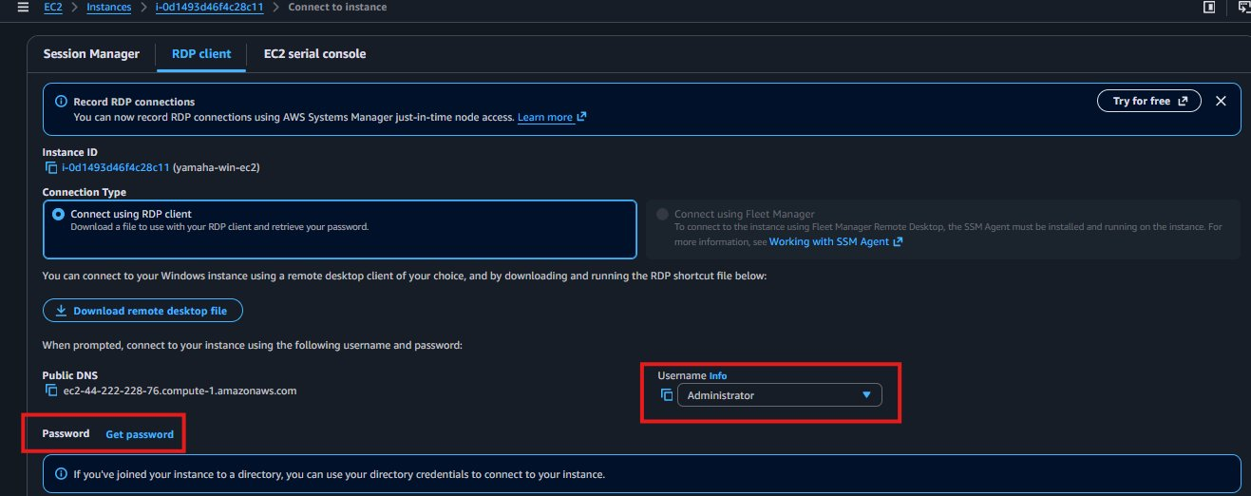
Step 9 – Navigate to IIS Web Root Folder
C:\inetpub\wwwroot\
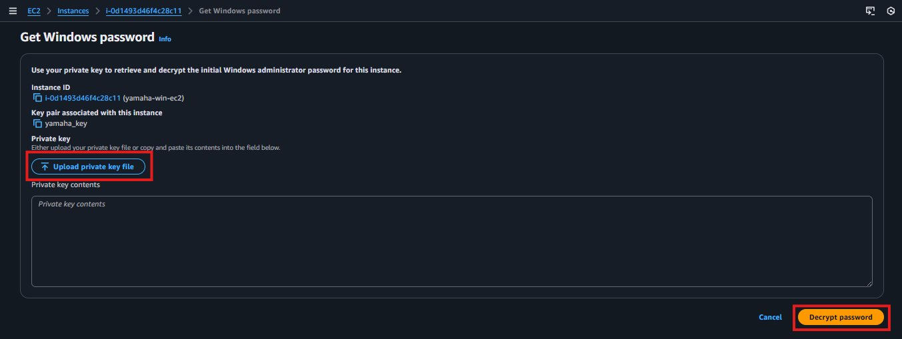
Step 10 – Edit the Default Website Page
Right-click iisstart.htm and open with Notepad to edit and customize the website.
Default web root path: C:\inetpub\wwwroot\
Default home page file: iisstart.htm (edit this to change the website)
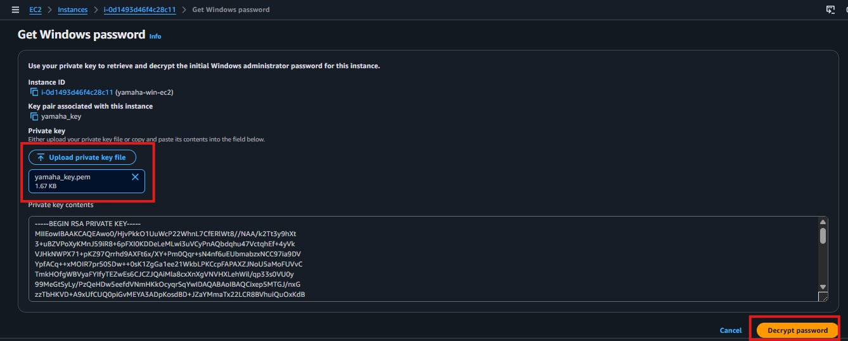
Step 11 – Restart IIS and View the Website
Restart IIS through Server Manager or IIS Manager to apply changes.
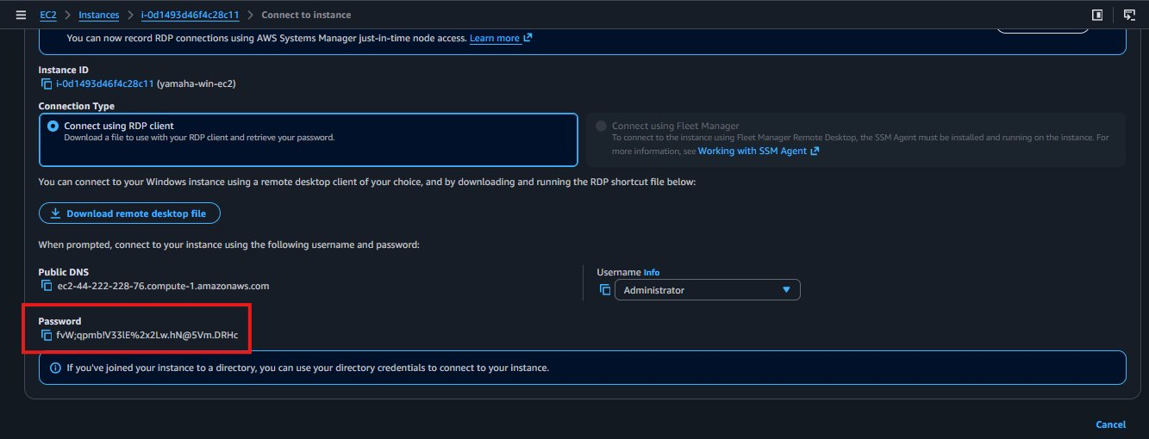
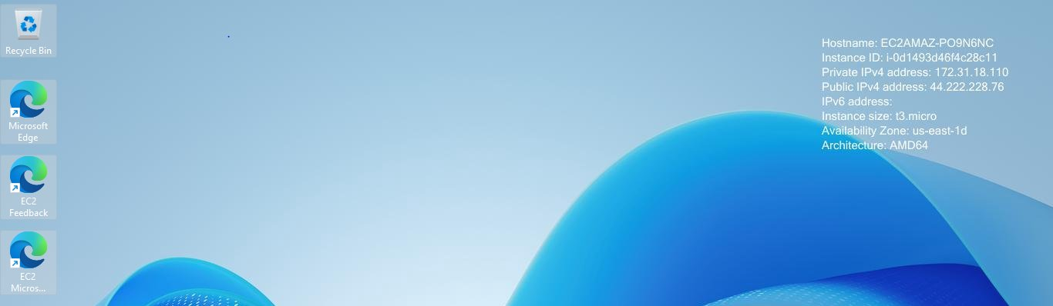
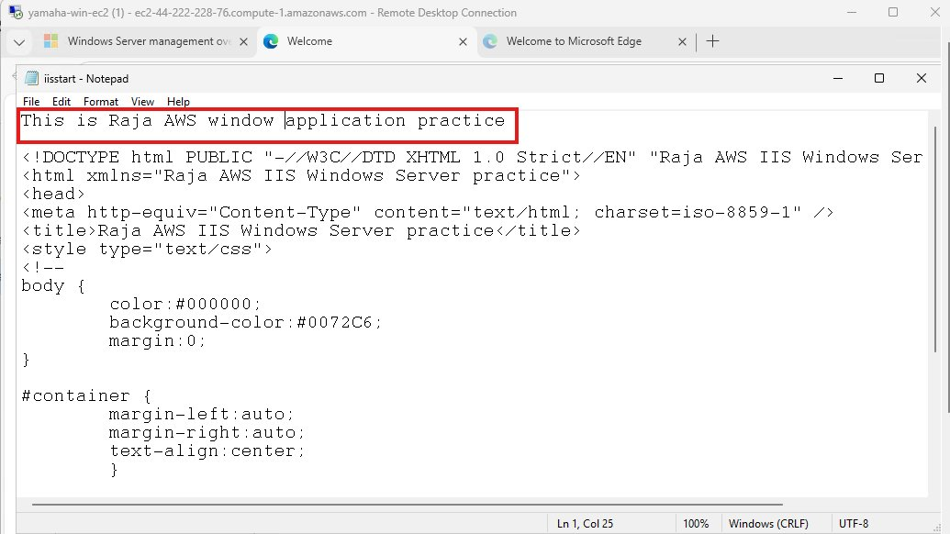
Open a browser and visit the EC2 public IP — your Windows-hosted website is live!

Project Summary
This project successfully demonstrates website hosting on both Linux and Windows EC2 instances.
- Installed Apache (httpd) on Linux EC2 and served a custom HTML page
- Downloaded and deployed a professional website template using wget
- Connected to Windows EC2 via Remote Desktop (RDP)
- Installed IIS web server through Windows Server Manager
- Customized the default IIS web page and verified website is live

Interview Questions & Answers
Q1: How do you host a website on a Linux EC2 instance?
Install Apache using 'yum install httpd -y', place HTML files in /var/www/html, run 'systemctl restart httpd' and 'systemctl enable httpd'. The website is then accessible via the EC2 public IP on port 80.
Q2: What is the difference between Apache and IIS?
Apache is an open-source web server for Linux. IIS is Microsoft's web server built into Windows Server. Both serve web pages over HTTP on port 80, but Apache uses command-line tools while IIS uses a graphical interface.
Q3: A website is not loading after setup. What do you check?
Check the Security Group to ensure port 80 is open. Verify the web service is running — 'systemctl status httpd' on Linux or IIS Manager on Windows. Confirm HTML files are in the correct web root and the EC2 instance is running.
Q4: How do you connect to a Windows EC2 instance?
Use Remote Desktop Protocol (RDP). In AWS Console, select the instance, click Connect, and decrypt the Administrator password using your .pem key. Open Remote Desktop Connection, enter the public IP and credentials.

