AWS EC2 – Part 1
User Data | Instance Types | RAM & CPU Change | Purchasing Options
Hands-On Project Documentation

Section 1 – User Data (Automated Setup at Launch)
User Data is a script you provide when launching an EC2 instance that runs automatically the very first time the server starts. This eliminates the need to manually log in and install software — the instance configures itself.
Use case: Automatically install Apache, Java, or any software the moment an instance launches
Script type: Linux uses Bash scripts starting with #!/bin/bash
Key benefit: Saves time and enables automation — no manual login required after launch
Step 1 – Complete Normal EC2 Launch Steps
Go through the standard EC2 launch wizard (name, AMI, instance type, key pair, security group). Before clicking Launch, scroll down to find the 'Advanced Details' section at the bottom of the page.
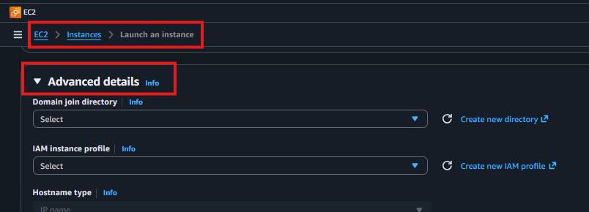
Step 2 – Expand Advanced Details
Click to expand the 'Advanced Details' section. Scroll to the very bottom to find the 'User Data' text box where you will enter your setup script.
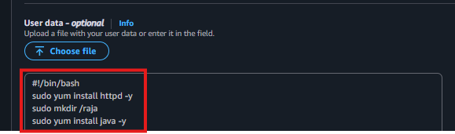
Step 3 – Enter the User Data Script
Type or paste your Bash script into the User Data field. The script must begin with #!/bin/bash. Everything below it runs as root automatically on first boot.
#!/bin/bash
sudo yum install httpd -y # Install Apache web server
sudo mkdir /rajini # Create a custom directory
sudo yum install java -y # Install Java
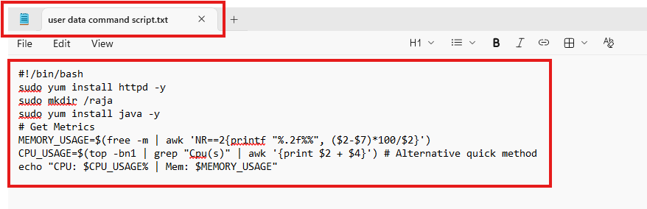
Step 4 – Launch and Verify
Complete the launch. Once the instance is running, SSH into it and verify the software was installed automatically.
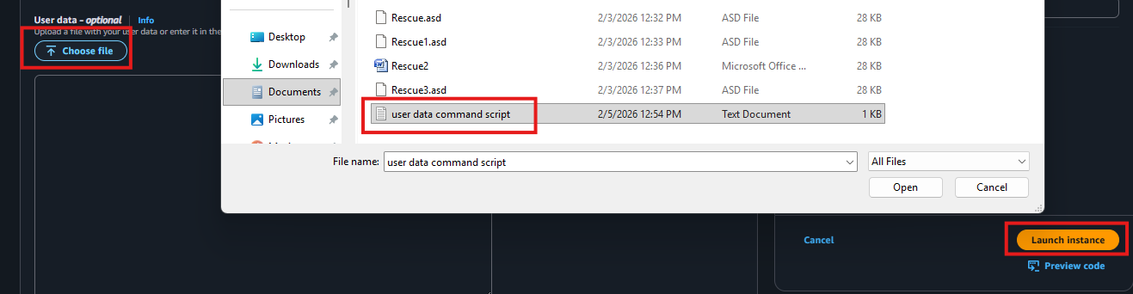
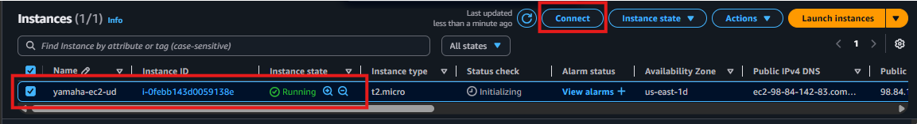
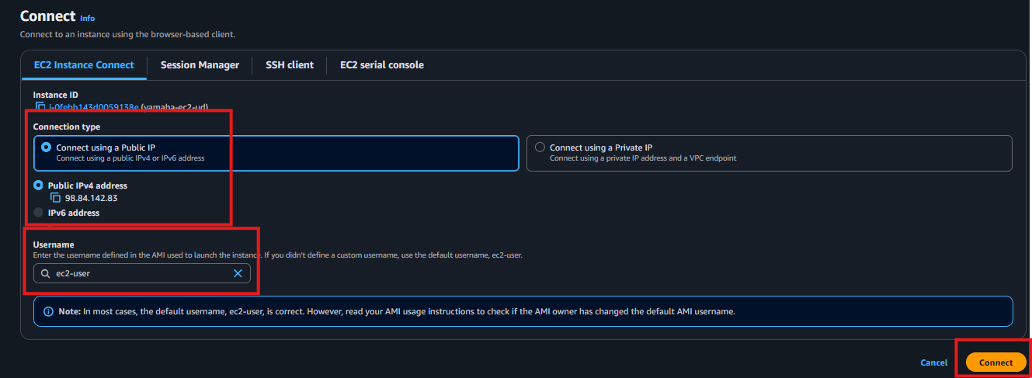
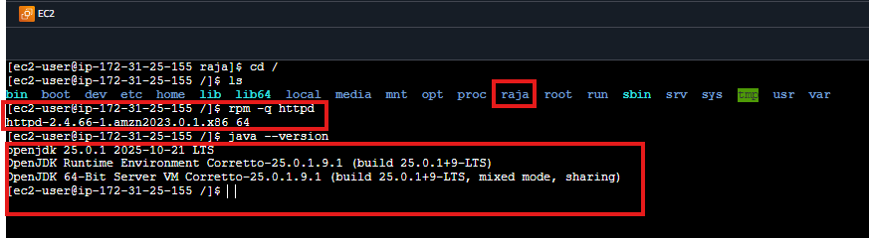
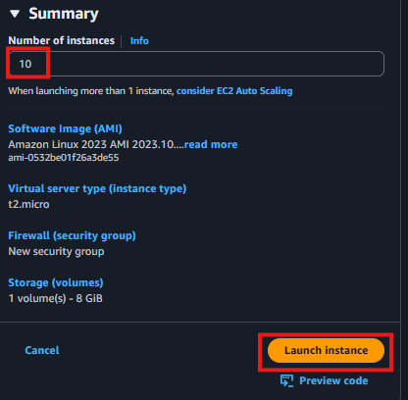
Section 2 – EC2 Instance Purchasing Options
AWS offers four purchasing models for EC2 instances. Choosing the right one can significantly reduce your cloud costs.
On-Demand Instances
Pay by the hour or second with no long-term commitment. Billing stops when you terminate the instance.
Best for: Development, testing, short-term or unpredictable workloads
Cost: Highest per-hour rate but no upfront commitment
Reserved Instances
Commit to using EC2 for 1 or 3 years in exchange for a significant discount.
Best for: Stable, predictable production workloads running 24/7
Savings: Up to 72% cheaper than On-Demand
Spot Instances
Use spare AWS capacity at up to 90% discount. AWS can reclaim the instance with a 2-minute warning.
Best for: Batch jobs, data processing, auto-scaling, non-critical testing
Warning: Not suitable for applications that cannot handle sudden interruptions
Dedicated Hosts
A physical server fully dedicated to your use. Required for compliance with software licenses tied to physical hardware.
Best for: Regulatory compliance, license-bound software
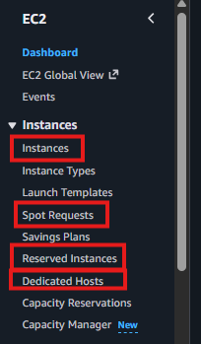
Section 3 – EC2 Instance Types
EC2 instance types define the hardware profile of your virtual server — CPU, RAM, and storage. AWS groups them into families based on purpose.
Reference: https://aws.amazon.com/ec2/instance-types/
Instance Type Categories
General Purpose (t, m): Balanced CPU and memory — web servers, everyday workloads
Compute Optimized (c): High CPU — batch processing, gaming, scientific modeling
Memory Optimized (r, x, z): Large RAM — databases, in-memory caching, big data
Accelerated Computing (g, p): GPU-powered — AI/ML training, graphics rendering
Storage Optimized (i, d, h): Fast or large disk I/O — data warehouses, log processing
HPC Optimized: High Performance Computing — scientific simulations
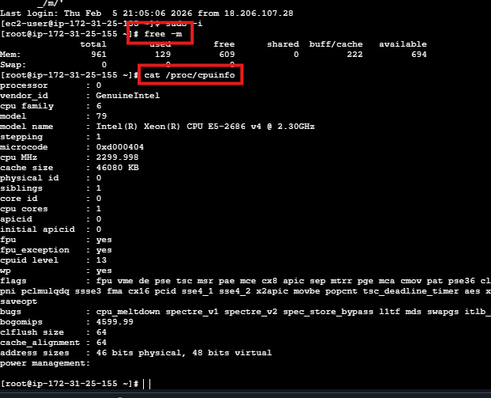
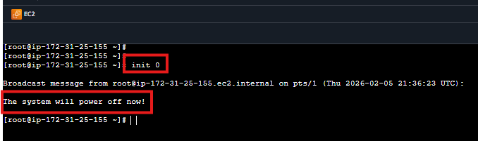
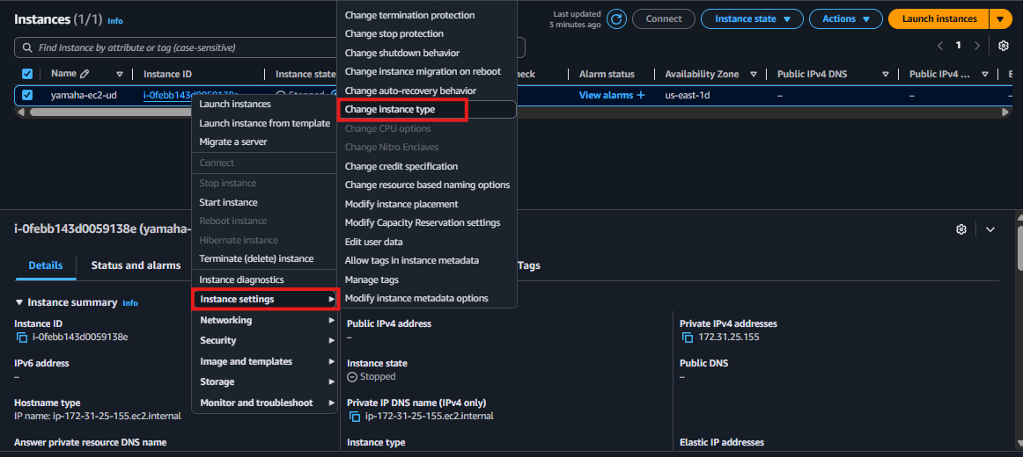
Section 4 – How to Change RAM and CPU (Instance Type)
In AWS, you change the instance type to upgrade RAM or CPU. The instance must be stopped first — you cannot change the type while it is running.
Step 1 – Check Current Resources
free -m # Check RAM in megabytes
cat /proc/cpuinfo # Check CPU details and core count
Step 2 – Stop the Instance
init 0 # Gracefully shut down from inside the OS
Or go to EC2 Console → select instance → Instance State → Stop.
Step 3 – Change Instance Type
Once stopped, go to Actions → Instance Settings → Change Instance Type. Select the new type and click Apply.

Step 4 – Start and Verify
Start the instance again. SSH back in and run free -m to confirm the new RAM is applied.
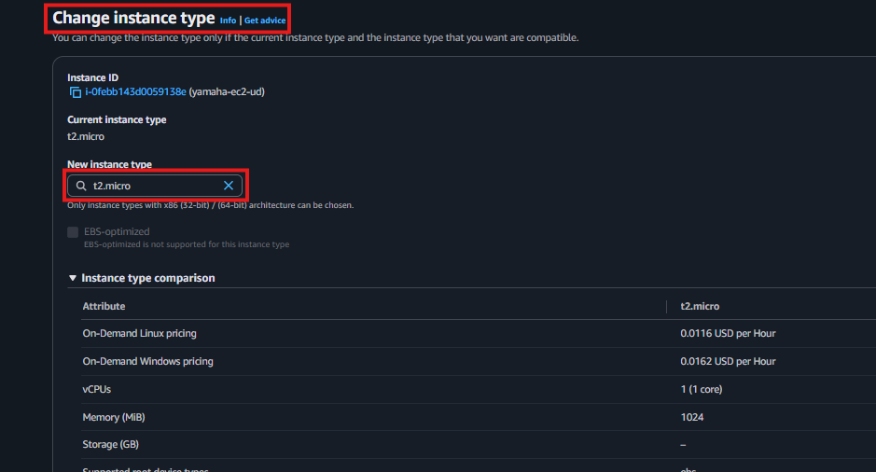
Important: Changing instance type assigns a new public IP — update DNS or firewall rules accordingly
Summary
✅ Used User Data to automatically install software at EC2 launch
✅ Understood all four EC2 purchasing options and when to use each
✅ Learned EC2 instance type families and naming conventions
✅ Changed instance RAM and CPU by stopping and modifying the instance type
Interview Questions & Answers

Q1: What is User Data in EC2 and how does it work?
User Data is a script you provide when launching an EC2 instance that runs automatically on the first boot. On Linux it is a Bash script starting with #!/bin/bash. I used it to automatically install Apache and Java the moment an instance launched — no manual login required.

Q2: How do you change the RAM and CPU of an EC2 instance?
In AWS you change the instance type to get more RAM or CPU. First I check current resources with free -m, then stop the instance. Once stopped I go to Actions → Instance Settings → Change Instance Type, select the new type, and start it again.

Q3: What EC2 purchasing option would you recommend for a production database?
For a production database running 24/7 I would recommend a Reserved Instance with a 1 or 3-year commitment. It saves up to 72% compared to On-Demand. On-Demand is better for development environments where the server is not always running.

Q4: What is the difference between Spot and On-Demand instances?
On-Demand is pay-as-you-go with no commitment — you pay the full price but the instance runs until you stop it. Spot uses spare AWS capacity at up to 90% discount but AWS can reclaim it with only a 2-minute warning. Spot is great for batch jobs and testing but not for critical production workloads.

