AWS EC2 – Part 2
AMI & Region Migration | Launch Templates | SSM Systems Manager
Hands-On Project Documentation

Section 1 – AMI (Amazon Machine Image)
An AMI is a complete snapshot of an EC2 instance — it captures the OS, installed software, configurations, and data. From one AMI you can launch identical instances instantly, migrate servers across regions, and create backups.
Step 1 – Verify Existing Instance and Website
Before creating the AMI, confirm the source instance is running correctly and the website is accessible.
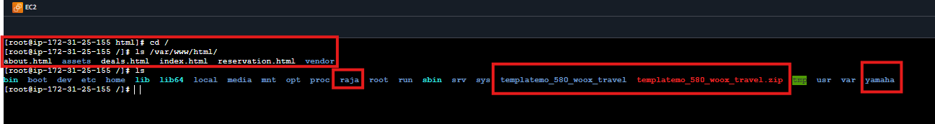


Step 2 – Create the AMI Image
In EC2 Console, select the instance, then go to Actions → Image and Templates → Create Image. This snapshots the entire instance.
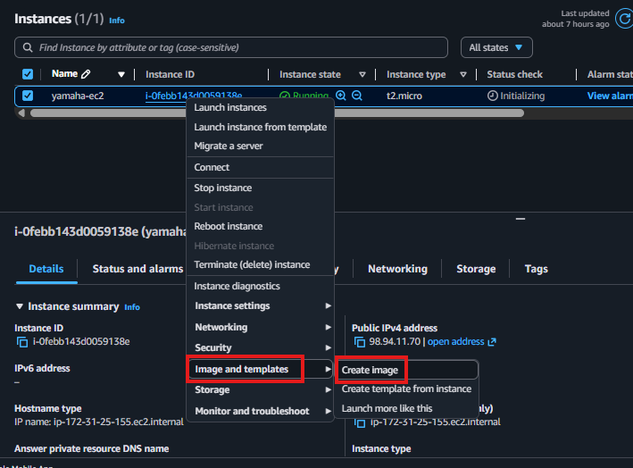
Step 3 – Configure AMI Settings
Give the AMI a clear name. Uncheck 'Reboot instance' to avoid downtime during creation. Click Create Image.
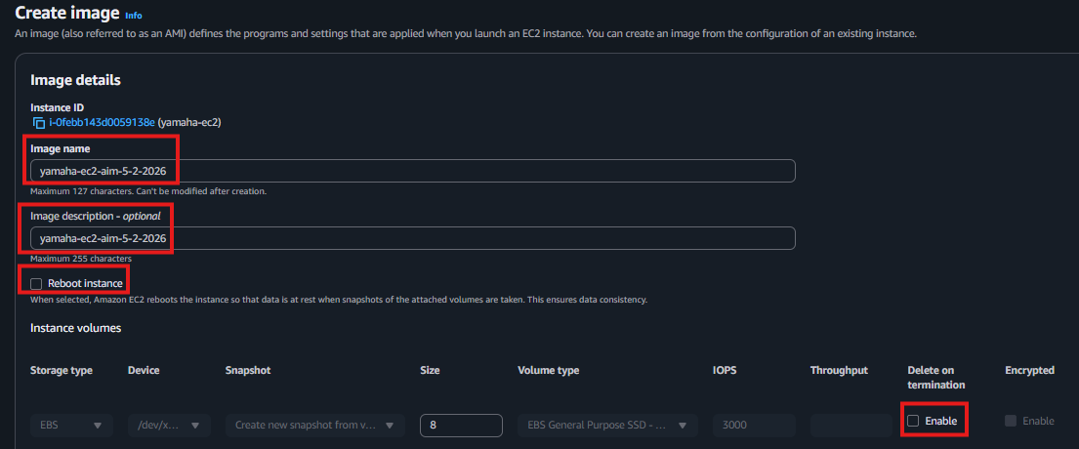
Best Practice: Name AMIs clearly with date and purpose e.g. 'web-server-apache-2026-02'
Step 4 – Launch New Instance from the AMI
Go to AMIs in EC2 Console, select your AMI, and click Launch Instance. The new instance is an exact copy — same OS, same software, same config.
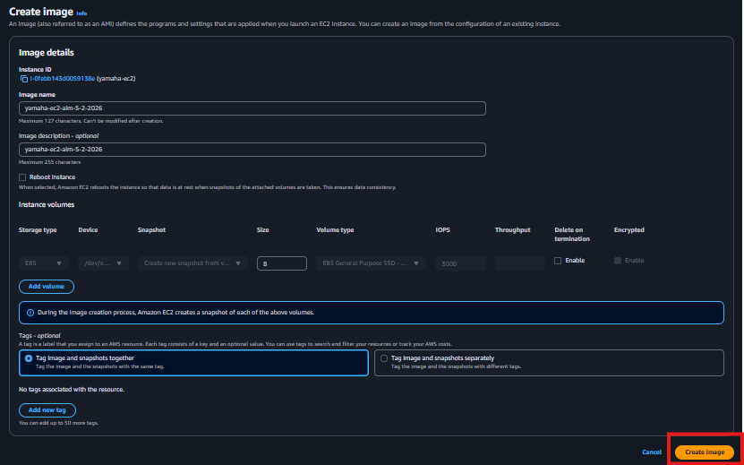
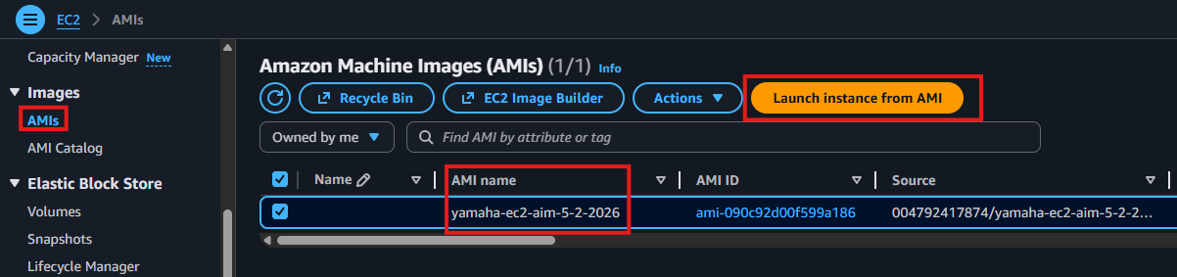
Step 5 – Verify Configuration and Launch
Confirm the key pair, security group, and instance name are correct before launching.
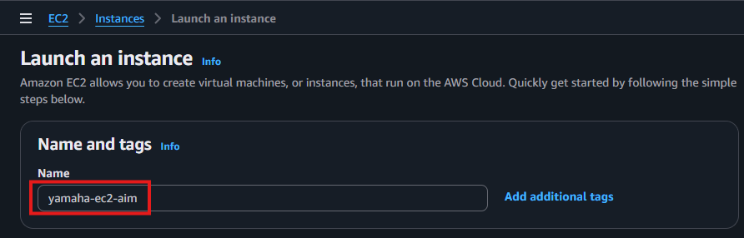
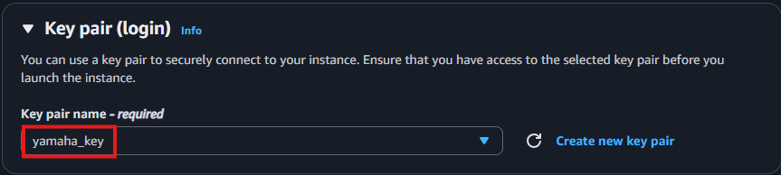
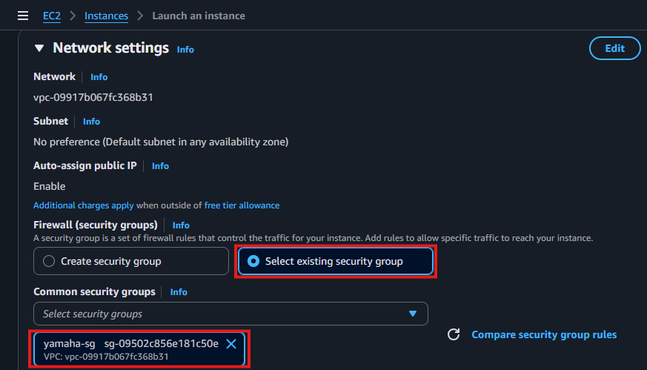
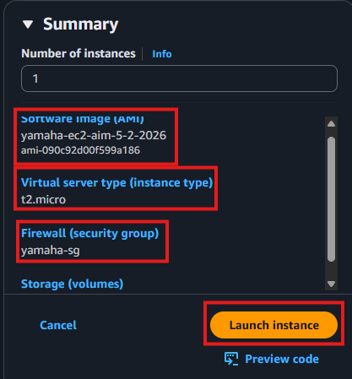
Step 6 – Confirm Instance is Running
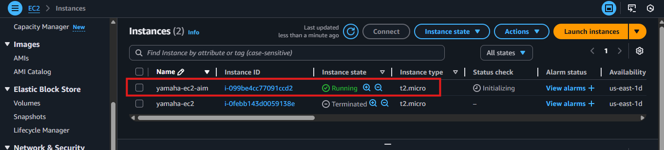
Step 7 – Verify Website on New Instance
Copy the new instance's public IP and open in a browser. The website loads immediately — no setup required as everything was baked into the AMI.
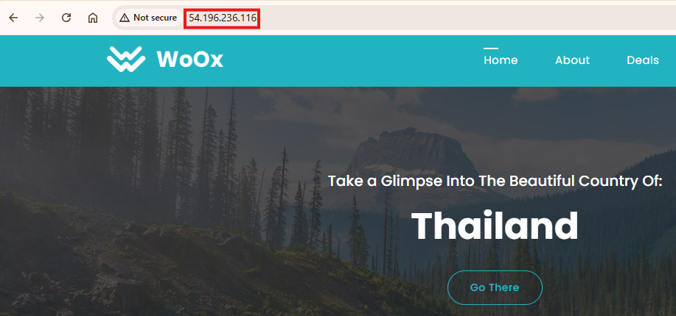
Section 2 – AMI Migration Across Regions
AMIs can be copied to any AWS region — useful for moving your server to a different geographic location for lower latency, disaster recovery, or compliance.
Step 1 – Select AMI and Copy to Another Region
In EC2 Console → AMIs, select your AMI, then click Actions → Copy AMI. Choose the destination region.
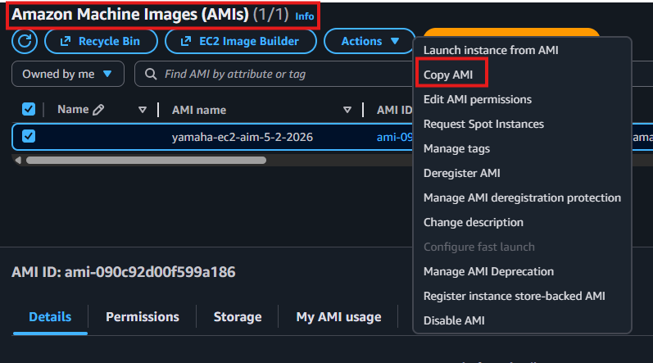
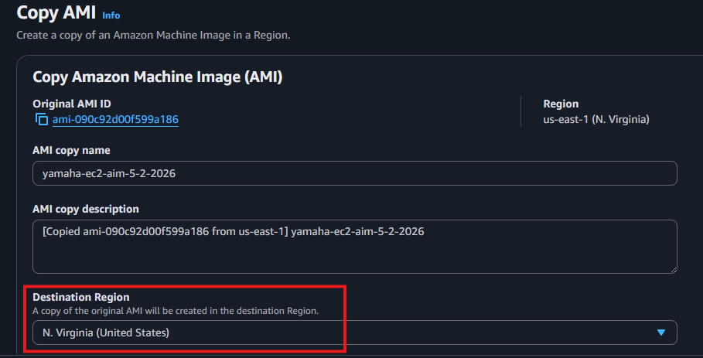
Step 2 – Choose Destination Region
Select the target AWS region, add a name for the copied AMI, and click Copy AMI.
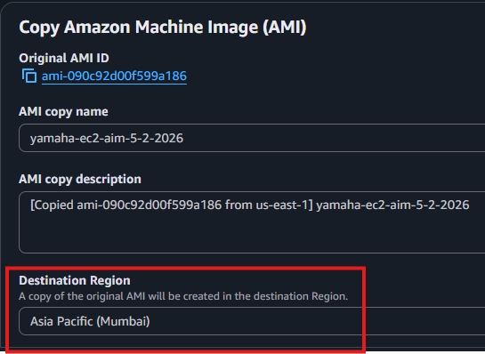
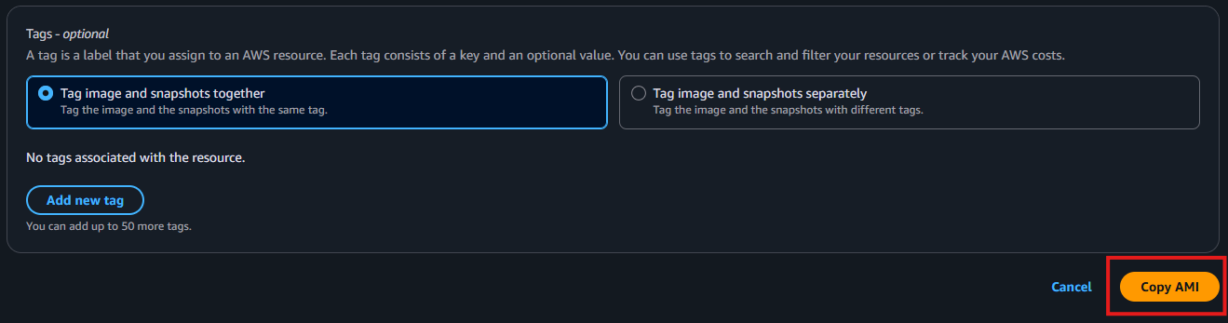
Step 3 – Switch to New Region and Launch
Switch to the destination region in the AWS Console. Navigate to AMIs — your copied AMI appears there. Launch an instance from it.
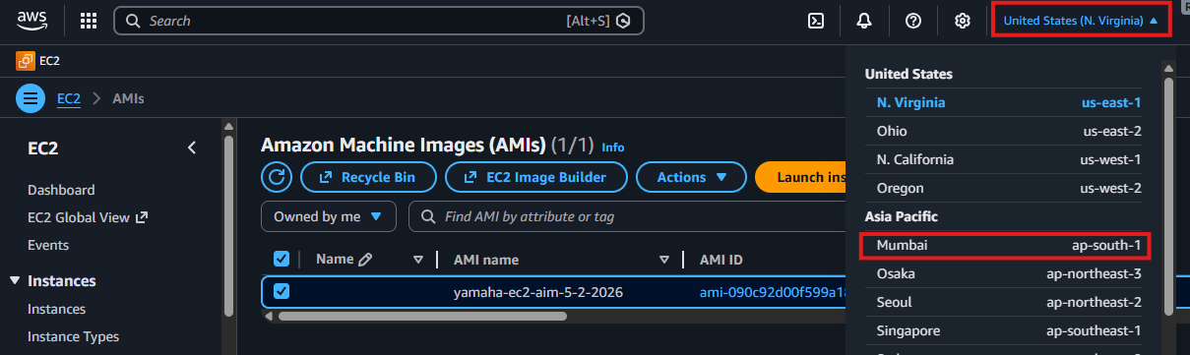
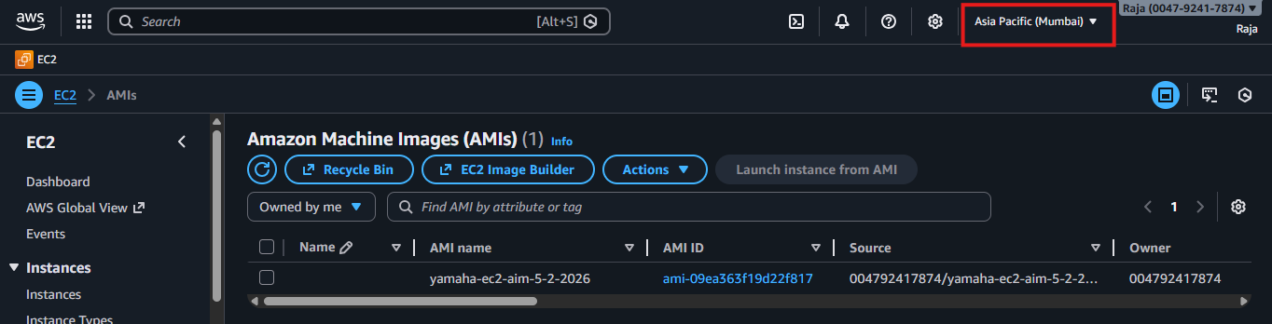
Section 3 – EC2 Launch Templates
A Launch Template saves all your EC2 configuration settings into a reusable template — AMI, instance type, key pair, security group, tags. Launch identical instances with one click, consistently and error-free.
Best for: Auto-scaling groups, repeated launches, team environments, automation
Step 1 – Navigate to Launch Templates
In EC2 Console → Instances → Launch Templates, click 'Create Launch Template'.
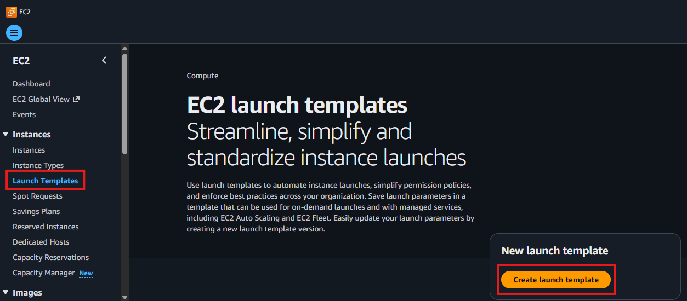
Step 2 – Name and Describe the Template
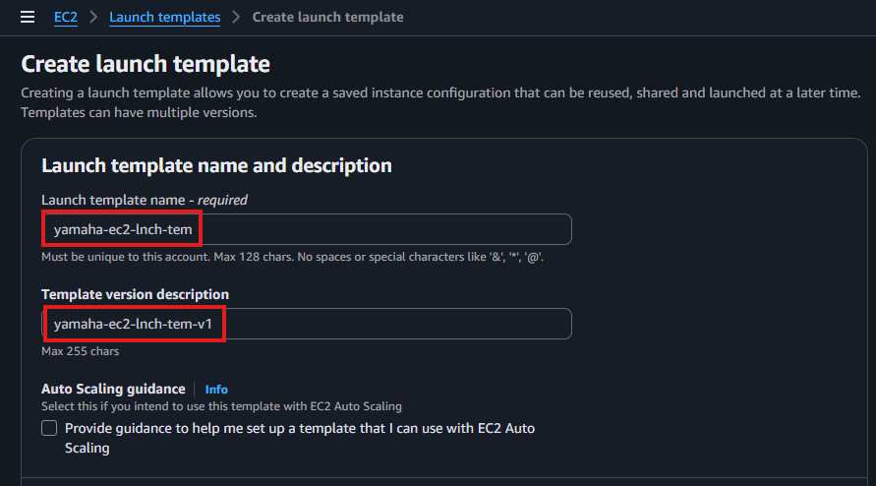
Step 3 – Select Your AMI
Under 'Application and OS Images', click 'My AMIs' and select your owned AMI — instances launched from this template will have everything pre-installed.
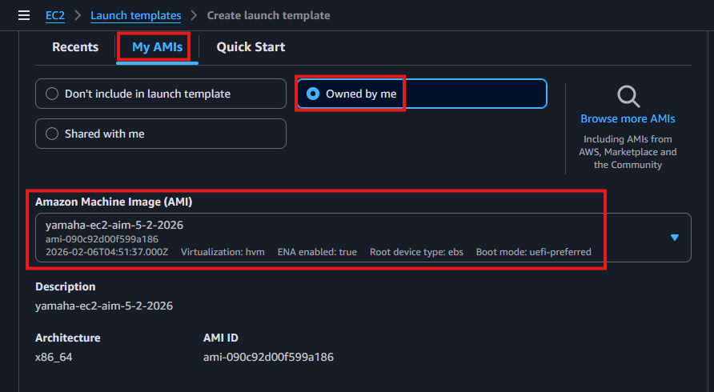
Step 4 – Select Instance Type and Key Pair
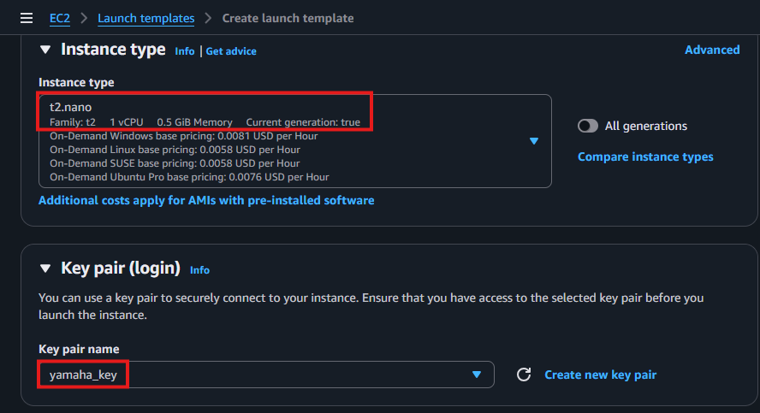
Step 5 – Select Security Group
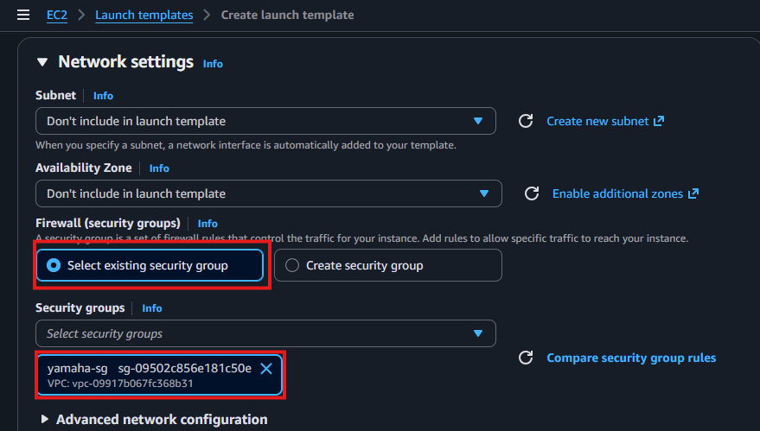
Step 6 – Add Resource Tags
Tags are key-value labels that help identify and organize resources. Common tags: Name, Environment, Project, Owner.
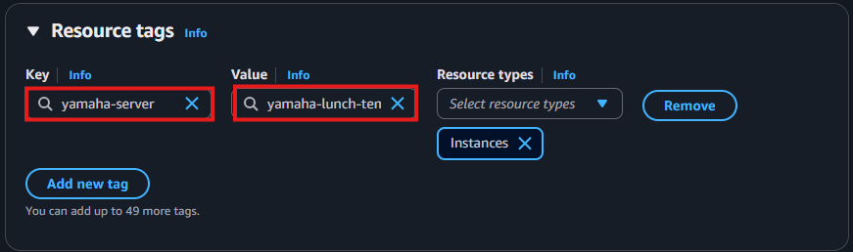
Step 7 – Review and Create Template
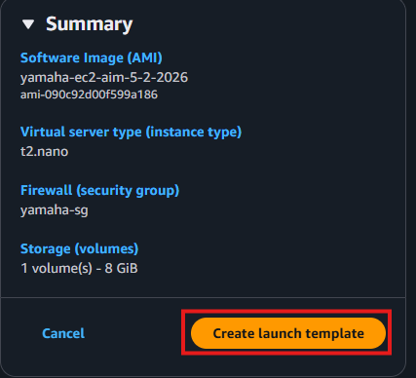
Step 8 – Launch Instance from Template
Select your template and click Actions → Launch Instance from Template. All settings are pre-filled — just confirm and launch.
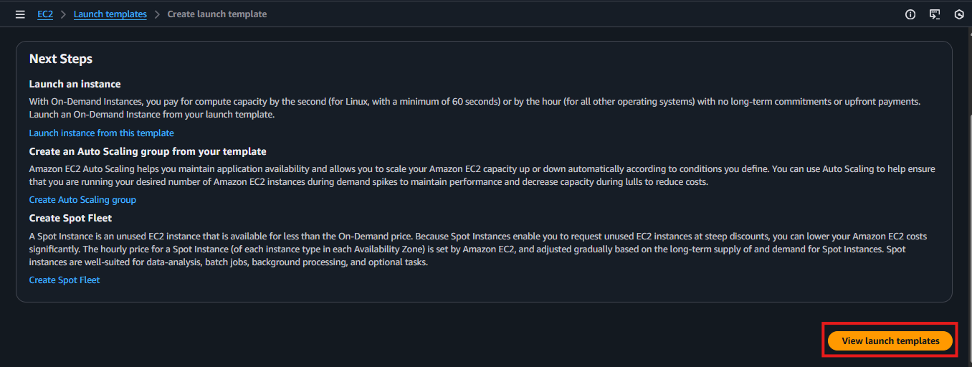
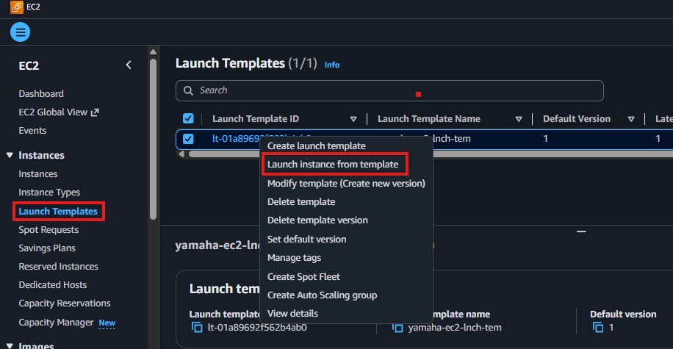
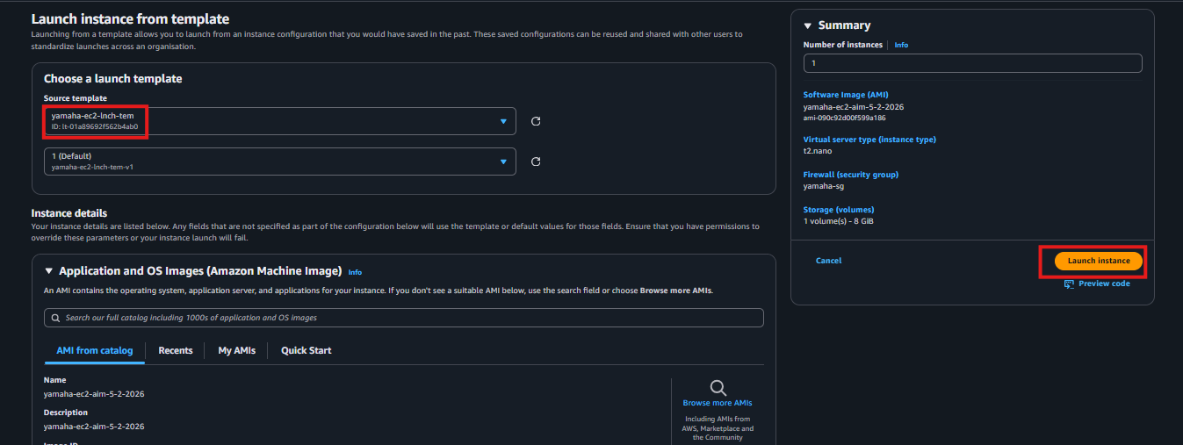
Step 9 – Verify Instance and Website
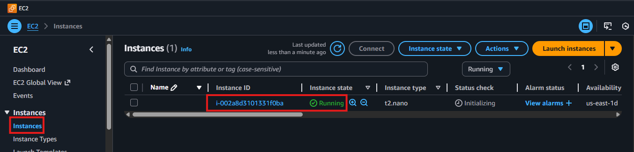
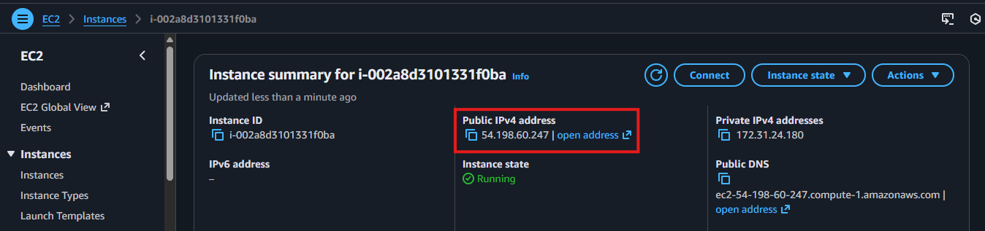
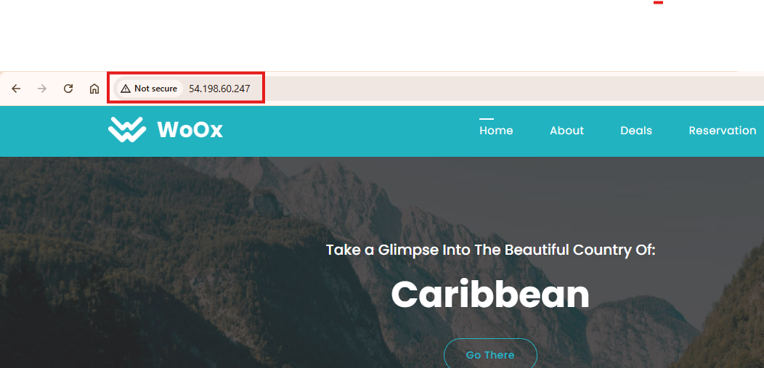
Section 4 – SSM Systems Manager
SSM lets you manage, patch, and run commands on EC2 instances without SSH or RDP. Install a lightweight agent, attach an IAM permission, and control all instances from the AWS Console.
Key benefit: Manage servers remotely without logging in — no PEM key or open SSH port required
Step 1 – Launch Two EC2 Instances
Create two instances to demonstrate SSM managing multiple servers simultaneously.
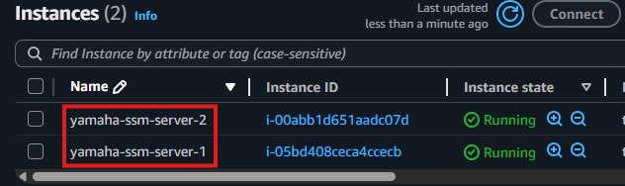
Step 2 – Check Fleet Manager (Before IAM Role)
Open SSM → Fleet Manager. The instances are NOT visible yet — SSM cannot manage them without the required IAM permission attached.
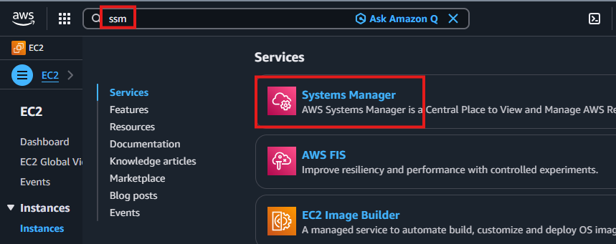
Why: AWS requires explicit IAM permission for SSM to communicate with EC2 — security by default
Step 3 – Create IAM Role for SSM
Go to IAM → Roles → Create Role. Select EC2 as the trusted service.
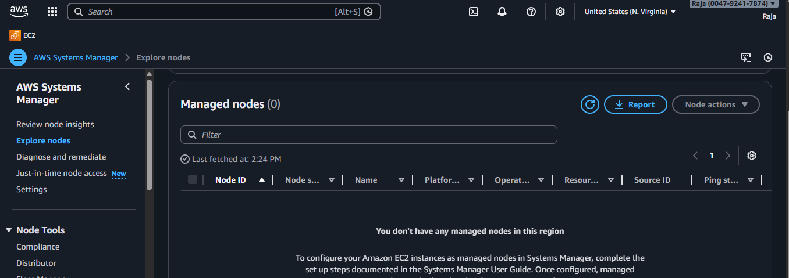
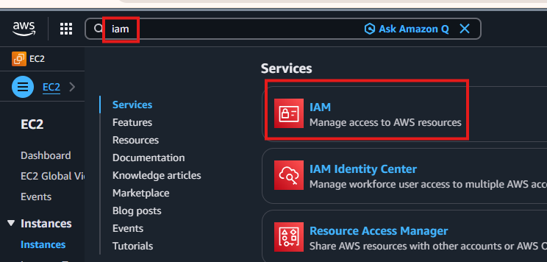
Step 4 – Attach the SSM Policy
Search for and attach the 'AmazonSSMManagedInstanceCore' policy — this grants SSM permission to manage EC2 instances.
Policy name: AmazonSSMManagedInstanceCore
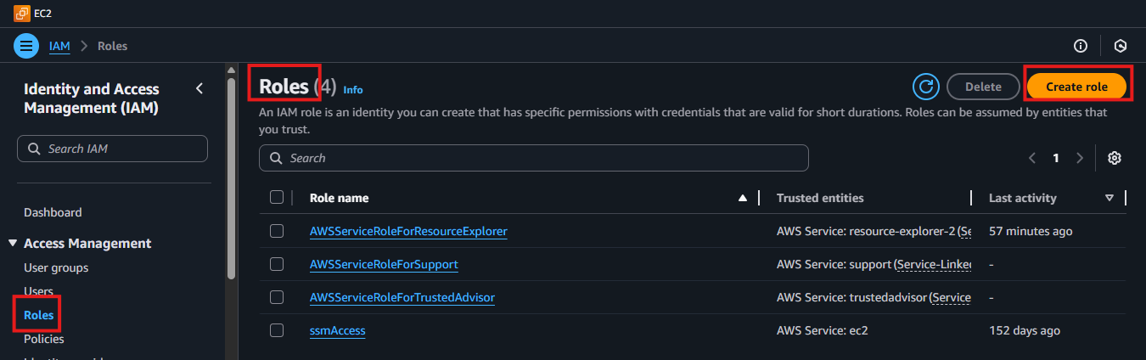
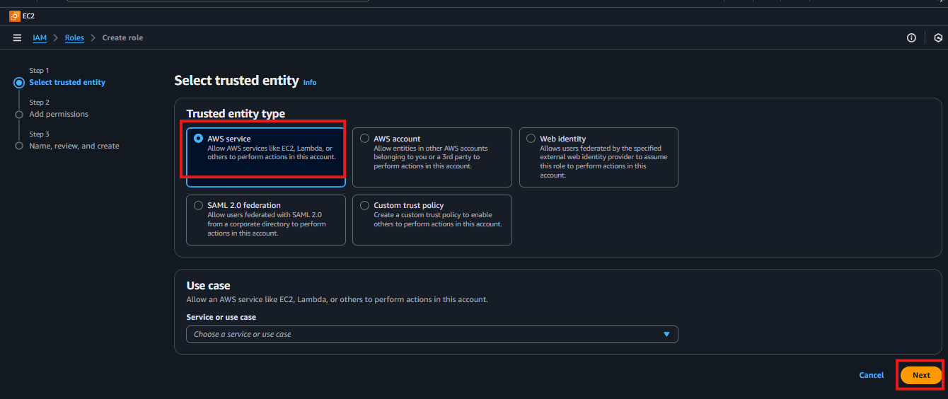
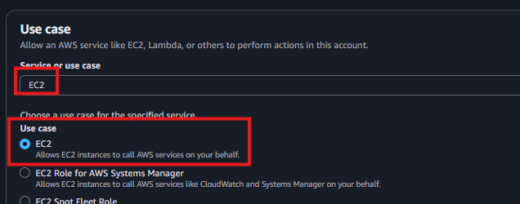
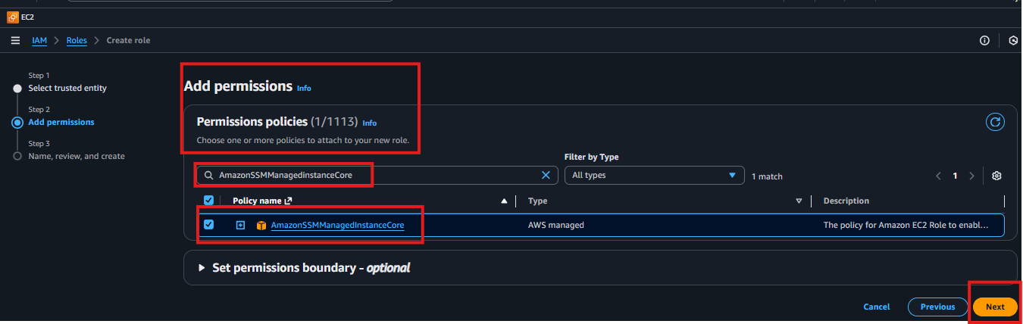
Step 5 – Name and Create the IAM Role
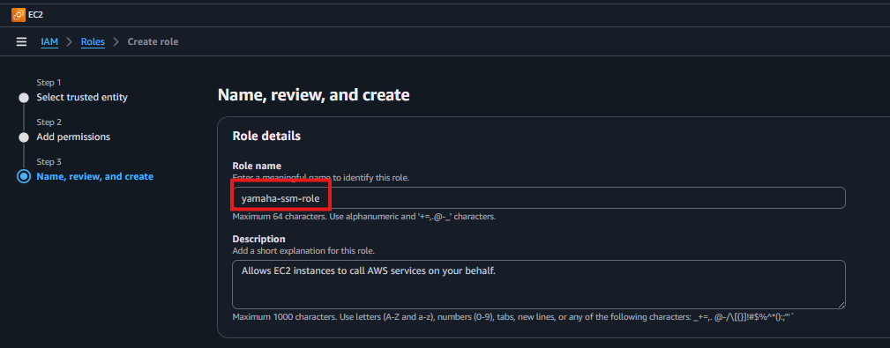
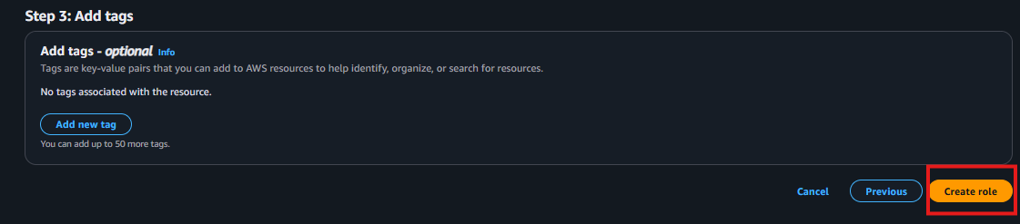
Step 6 – Attach IAM Role to Both EC2 Instances
Go to EC2 → select instance → Actions → Security → Modify IAM Role. Select the SSM role and click Update. Repeat for both instances.
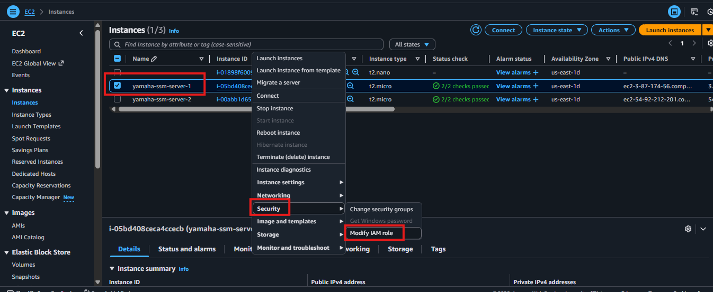
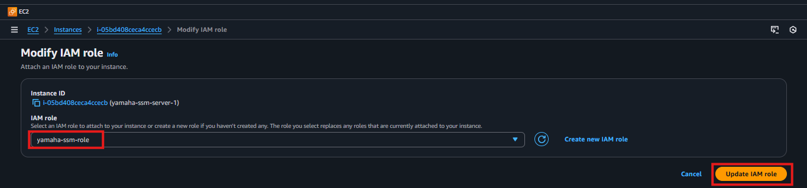
Step 7 – Install SSM Agent on Both Instances
SSH into each instance and install the SSM Agent.
sudo yum install -y https://s3.amazonaws.com/ec2-downloads-windows/SSMAgent/latest/linux_amd64/amazon-ssm-agent.rpm
systemctl start amazon-ssm-agent # Start the agent
systemctl status amazon-ssm-agent # Verify it is running
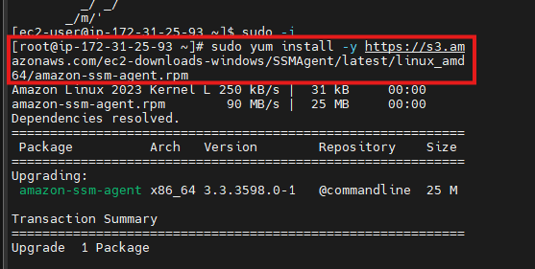
Step 8 – Verify Instances in Fleet Manager
Go back to SSM → Fleet Manager. Both instances now appear as 'Online' and ready to manage.
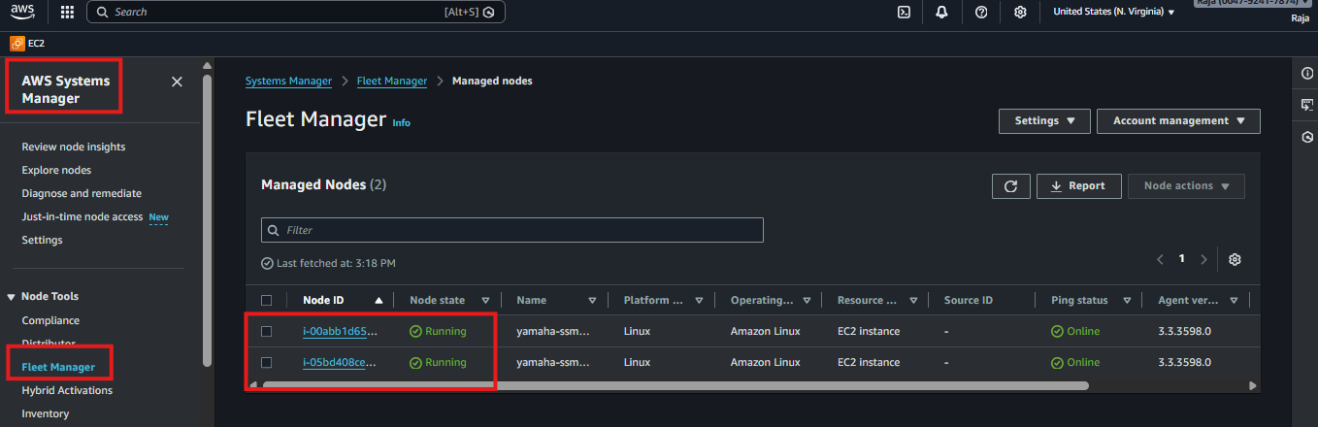
Step 9 – Run Commands via SSM Run Command
Go to SSM → Run Command. Search for 'AWS-RunShellScript' to run Bash scripts across multiple instances at once.
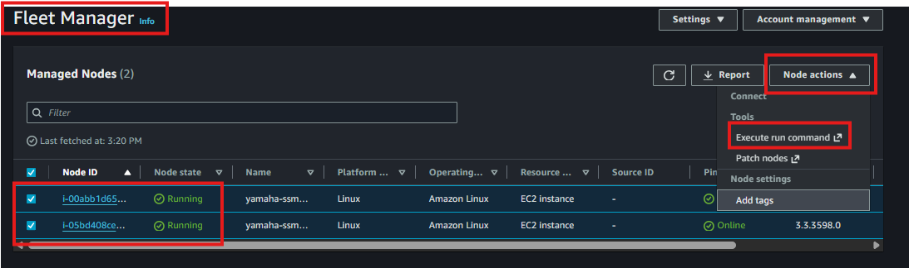
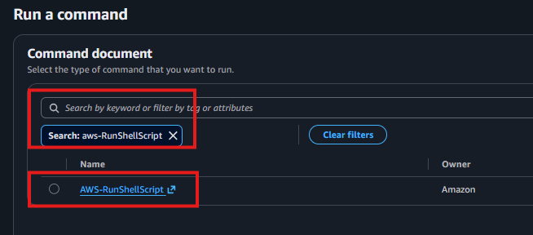
Step 10 – Write and Execute the Script
Enter your script, select both instances as targets, and click Run.
#!/bin/bash
sudo yum install httpd -y # Install Apache
sudo yum install java -y # Install Java
sudo yum install mariadb* -y # Install MariaDB
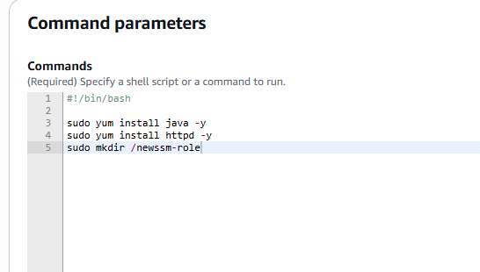
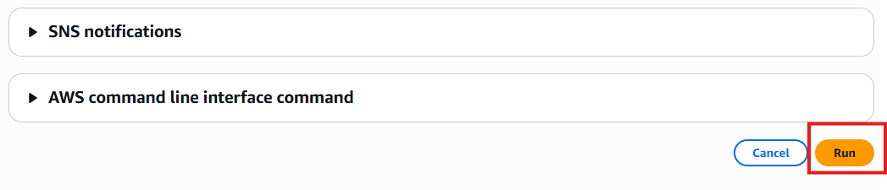
Step 11 – Verify Execution Result
SSM shows execution status for each instance — Success or Failed. Click an instance to see the detailed output log.
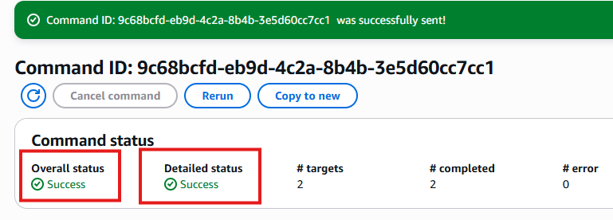
Step 12 – Confirm Packages Installed on Instance
rpm -qa | grep maria # Verify MariaDB was installed by SSM
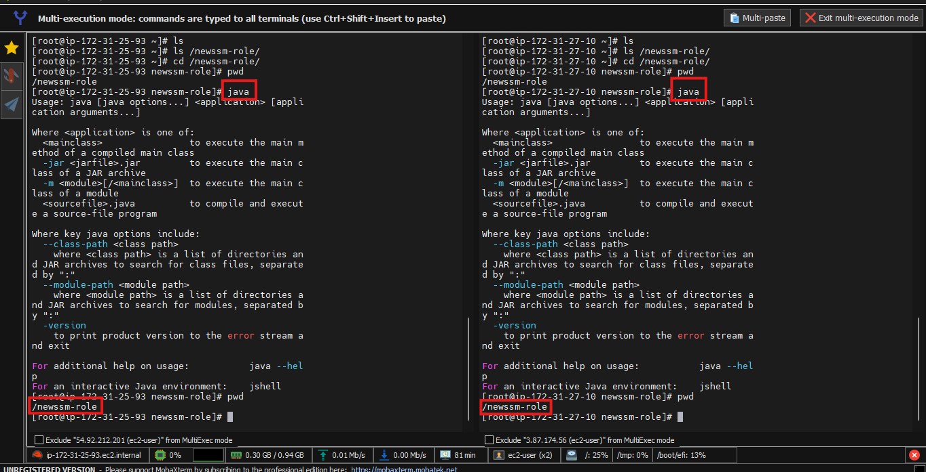
Summary
✅ Created an AMI from a running instance and launched identical copies from it
✅ Copied an AMI across AWS regions to migrate the server geographically
✅ Created a Launch Template for consistent, repeatable one-click EC2 deployments
✅ Set up SSM Systems Manager with IAM role and SSM agent on multiple instances
✅ Ran shell scripts across multiple EC2 instances simultaneously using SSM Run Command
Interview Questions & Answers

Q1: What is an AMI and why is it important?
An AMI is a complete snapshot of an EC2 instance — it captures the OS, installed software, configurations, and data. It lets you launch identical servers in seconds instead of setting them up from scratch. I use AMIs for backups before releases, for scaling by launching multiple copies, and for migrating servers to other regions.

Q2: What is a Launch Template and how is it different from an AMI?
An AMI is the server image — the OS and software. A Launch Template is the full configuration wrapper — it defines which AMI to use plus the instance type, key pair, security group, and tags. You can launch instances from an AMI manually each time, but a Launch Template saves all those settings so you launch consistently with one click.

Q3: How do you migrate an EC2 instance to another region?
I create an AMI from the running instance, then go to AMIs and click Actions → Copy AMI. I select the destination region, confirm the copy, then switch to that region in the console. Once the AMI copy is complete I launch a new instance from it — the server is now running in the new region with everything intact.

Q4: What is SSM and why would you use it instead of SSH?
SSM lets you manage EC2 instances without opening SSH port 22 or using a PEM key. You install the SSM agent, attach the AmazonSSMManagedInstanceCore IAM policy, and control instances from the AWS Console. The biggest advantage is running commands on multiple servers simultaneously using Run Command — much faster than SSHing into each one individually.

Q5: How would you quickly deploy 10 identical servers?
I configure one server with all required software, create an AMI from it, then create a Launch Template using that AMI with the correct instance type, key pair, and security group. From the template I can launch 10 identical instances in one action — ensuring consistency and eliminating manual configuration errors.

