AWS Storage Services
EBS | EFS | S3 | Glacier | Volume Resize | Snapshots
Hands-On Project Documentation

Project Overview
AWS provides different types of storage services to handle different kinds of data and workloads. This document covers the four main AWS storage services — EBS, EFS, S3, and Glacier — along with hands-on practice attaching EBS volumes to EC2 instances, resizing volumes, and creating and restoring snapshots for disaster recovery.

EBS: Block storage — like a hard disk attached to one EC2 instance
EFS: Shared file storage — multiple EC2 instances access the same files
S3: Object storage — files stored over the internet, highly durable
Glacier: Archival storage — lowest cost, for rarely accessed old data

Section 1 – AWS Storage Services Explained
1.1 EBS – Elastic Block Storage
EBS is block-level storage that is attached to a single EC2 instance. It works like a hard disk for the server and is used to store the operating system, applications, and databases.
Storage Type: Block storage
Scope: Single Availability Zone — must be in the same AZ as the EC2 instance
Performance: Low latency, high speed — ideal for databases and OS volumes
Persistence: Data remains even if the EC2 instance is stopped or rebooted
Use case: EC2 root volumes, databases, applications needing fast read/write
1.2 EFS – Elastic File System
EFS is a shared file storage service. Multiple EC2 instances can access the same EFS file system at the same time — similar to a shared network folder in an office.
Storage Type: File storage
Scope: Multi-AZ within a region — accessible from multiple instances
Scaling: Automatically grows and shrinks as files are added or removed
Use case: Shared application uploads, shared configuration files, CMS platforms
1.3 S3 – Simple Storage Service
S3 is an object storage service used to store files like images, videos, backups, and logs. It is highly durable and accessible over the internet via HTTP/HTTPS from anywhere in the world.
Storage Type: Object storage
Scope: Multi-AZ (Internet) — accessible globally
Durability: 99.999999999% (11 nines) — data is replicated across multiple AZs
Use case: Application backups, static website files, logs, media files
1.4 Glacier – Archival Storage
Glacier is designed for long-term archival storage of data that is rarely accessed. It is the lowest cost storage option but retrieval can take minutes to hours depending on the retrieval tier.
Storage Type: Archive storage
Cost: Lowest cost of all AWS storage options
Retrieval time: Minutes to hours depending on retrieval speed selected
Use case: Old backups, compliance data, logs that must be retained but rarely read

Quick Memory Trick
EBS: Disk — attached directly to one EC2 server
EFS: Shared Folder — many servers access the same files
S3: Internet Storage — store and access from anywhere
Glacier: Cold Storage — archive and forget until needed

Comparison Summary
EBS vs EFS: EBS is for one instance only. EFS is shared across many instances.
EBS vs S3: EBS is a disk (block), S3 is file storage over the internet (object).
S3 vs Glacier: S3 is for active data. Glacier is for archival — much cheaper but slow retrieval.
Section 2 – Attaching an EBS Volume to EC2
In this hands-on practice, we attach a new EBS volume to a running EC2 instance, format it with a filesystem, mount it, and make it persistent across reboots using /etc/fstab.

Step 1 – Check Current Disks on the Instance
Before adding a new disk, check what storage is currently available on the EC2 instance using the lsblk command. This lists all block devices attached to the server.
lsblk # List all attached block devices
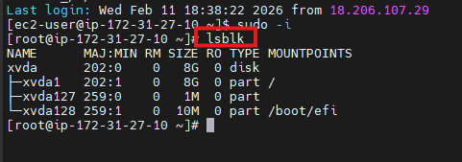
Step 2 – Create a New EBS Volume in AWS Console
Go to EC2 Console → Elastic Block Store → Volumes → Create Volume. Choose the size, volume type, and — most importantly — select the same Availability Zone as your EC2 instance.
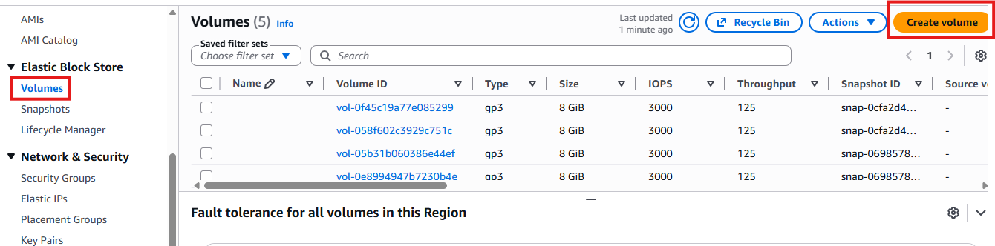
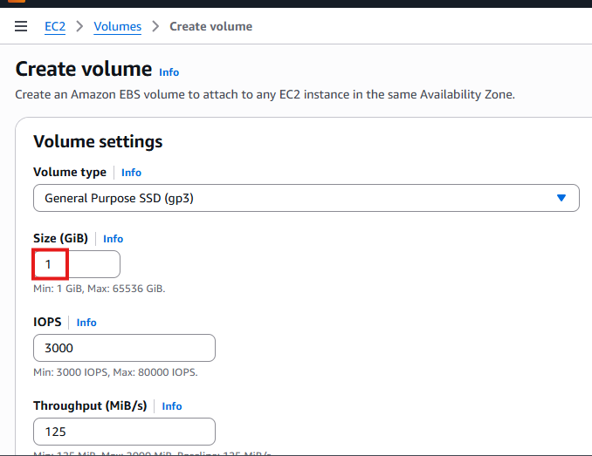
Critical Rule: The EBS volume MUST be in the same Availability Zone as the EC2 instance — volumes from other AZs will NOT appear when attaching
Step 3 – Region Matters: Same AZ vs Different AZ Test
To demonstrate the AZ restriction, two volumes were created — one in the same region as the instance and one in a different region. This test proves that only same-AZ volumes can be attached.
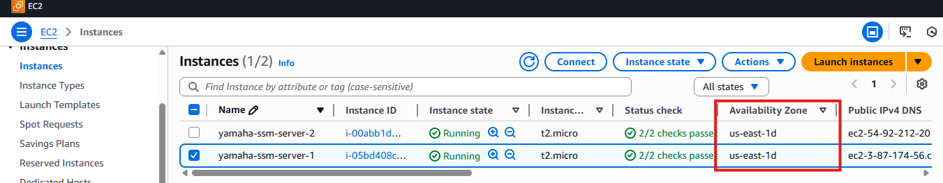
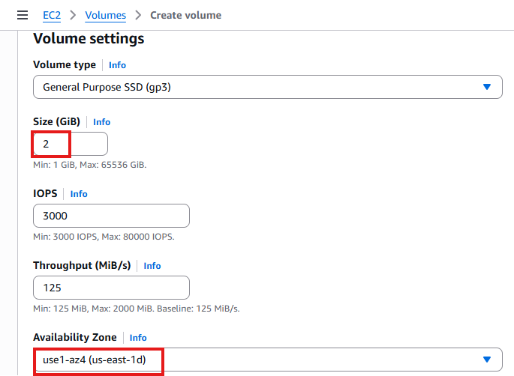
Step 4 – Add Name Tag and Create Volume
Add a Name tag to easily identify the volume. Then click Create Volume to finalize.
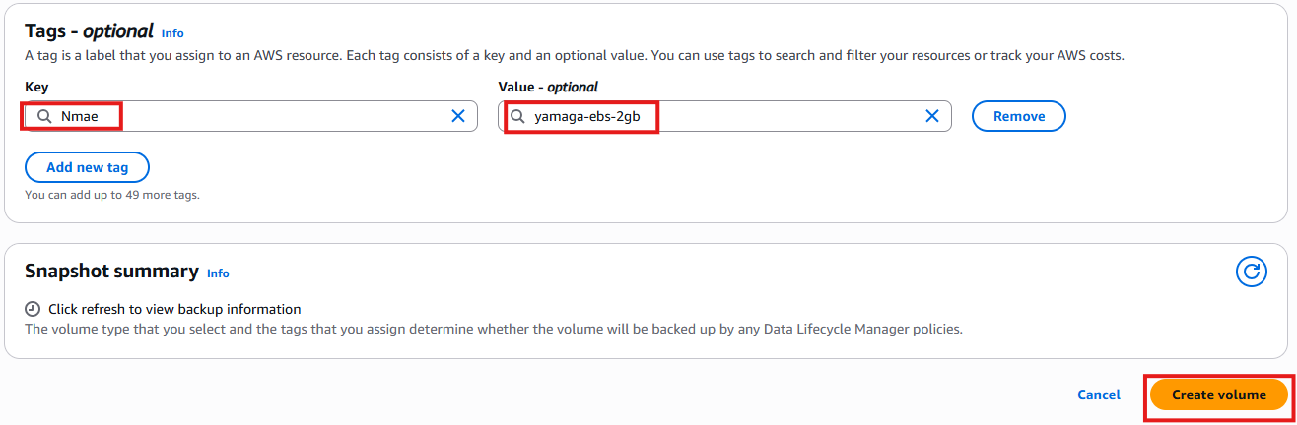
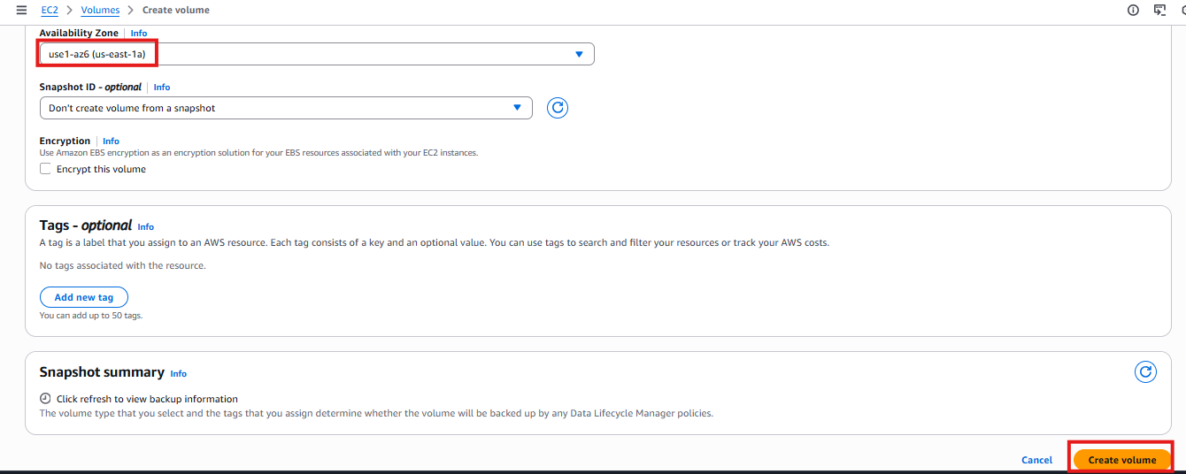
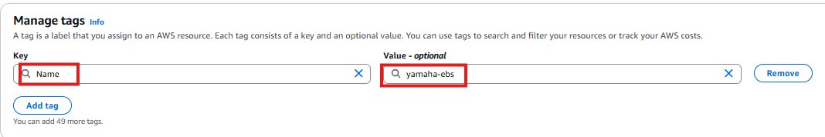
Step 5 – Confirm Volume Created
The new volume appears in the Volumes list with status 'Available', confirming it was successfully created and is ready to attach.
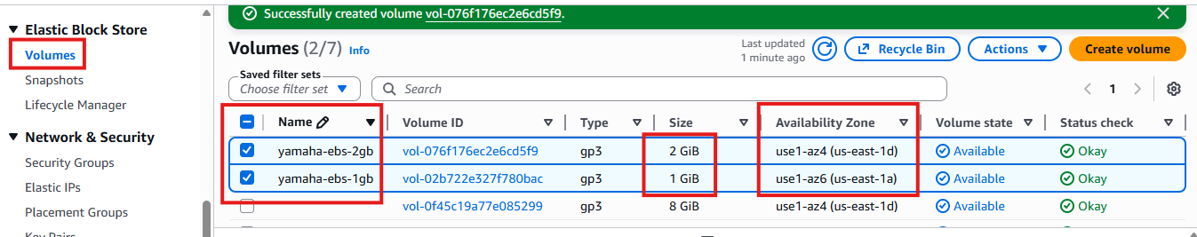
Step 6 – Attempt to Attach Different Region Volume (Fails)
When trying to attach a volume from a different region, the instance does not appear in the attachment dropdown — proving volumes cannot be attached across regions or AZs.
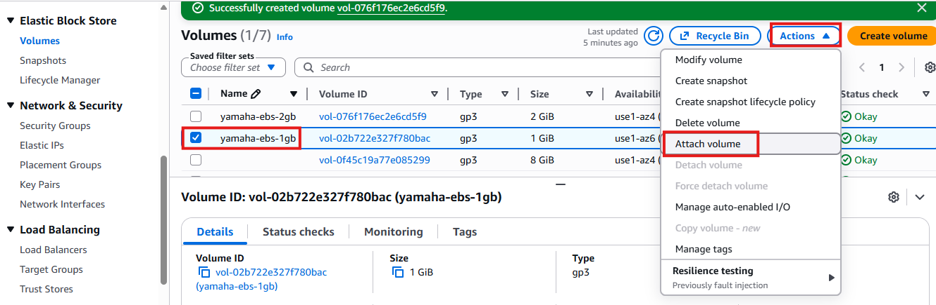
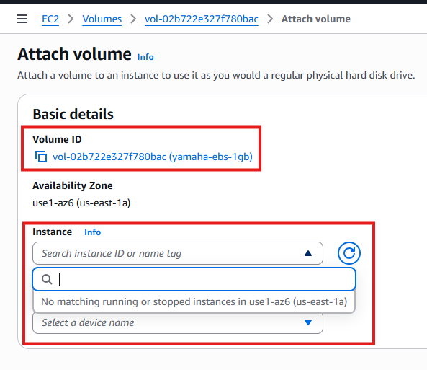
Step 7 – Attach Same Region Volume (Succeeds)
When attaching a volume from the same AZ, all running instances in that AZ appear in the dropdown. Select the instance and confirm the attachment.
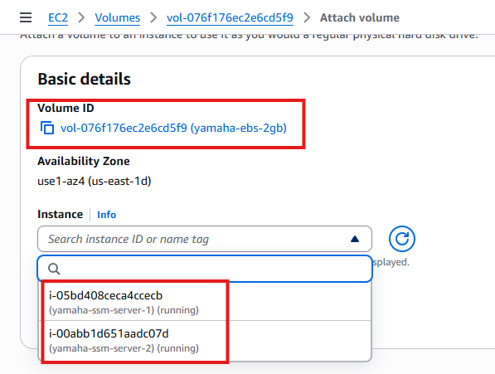
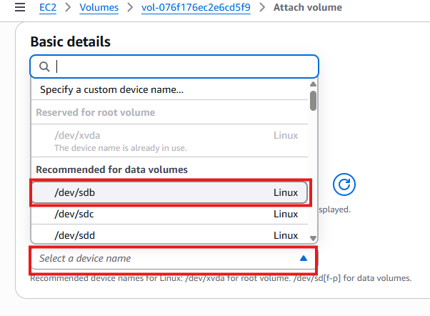
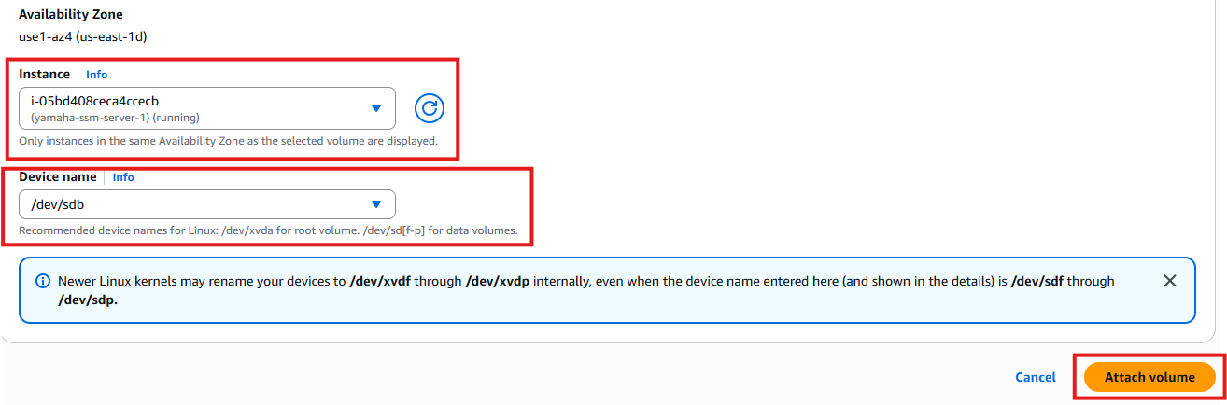
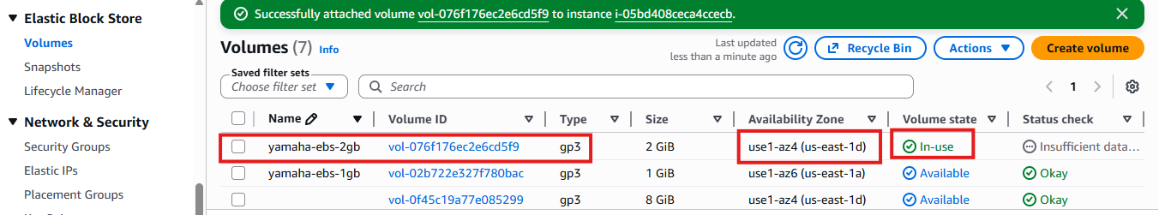
Step 8 – Verify Disk Appears on the Instance
SSH into the EC2 instance and run lsblk again to confirm the new volume is visible as a new block device (e.g., xvdb or nvme1n1).
lsblk # New disk should now appear in the list
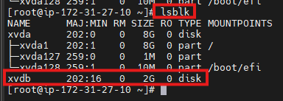
Step 9 – Format the Disk with a Filesystem
A new EBS volume is raw — it has no filesystem. Format it with ext4 (the standard Linux filesystem) before it can be used to store files.
mkfs.ext4 /dev/xvdb # Format the new disk with ext4 filesystem
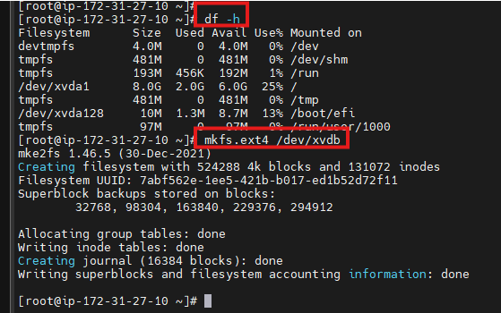
Important: This step is only done ONCE on a new disk — formatting erases all data on the volume
Step 10 – Create a Mount Point and Mount the Disk
Create a directory where the disk will be accessible, then mount the volume to that directory. After mounting, the disk is ready to store files.
mkdir /yamaha # Create the mount point directory
mount /dev/xvdb /yamaha # Mount the volume to the directory
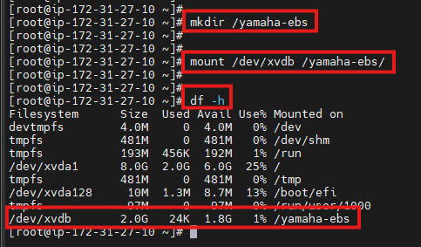
Step 11 – Make the Mount Permanent (fstab)
By default, mounts are lost after a reboot. Add an entry to /etc/fstab to ensure the volume auto-mounts every time the server restarts.
vi /etc/fstab # Edit the filesystem table
Add a line like: /dev/xvdb /yamaha ext4 defaults 0 0
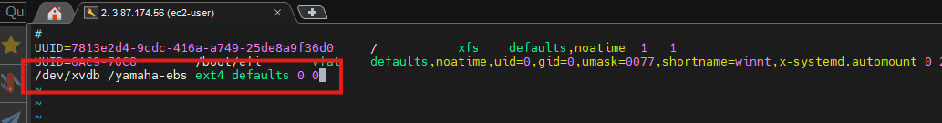
Warning: Always run 'mount -a' after editing fstab to test for errors — a bad fstab entry can prevent the server from booting
mount -a # Test fstab entries — no output means no errors
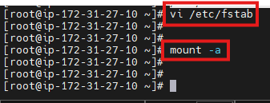
Step 12 – Create Files and Verify Persistence
Create test files on the mounted volume. After rebooting the server, confirm the files are still present — proving the mount is permanent and data persists.
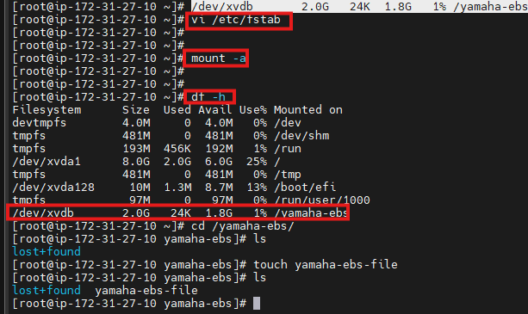
Important: You Can Only Increase EBS Volume Size — Never Decrease
AWS EBS volumes can only be expanded in size, never reduced. Always plan your storage requirements carefully before creating volumes.
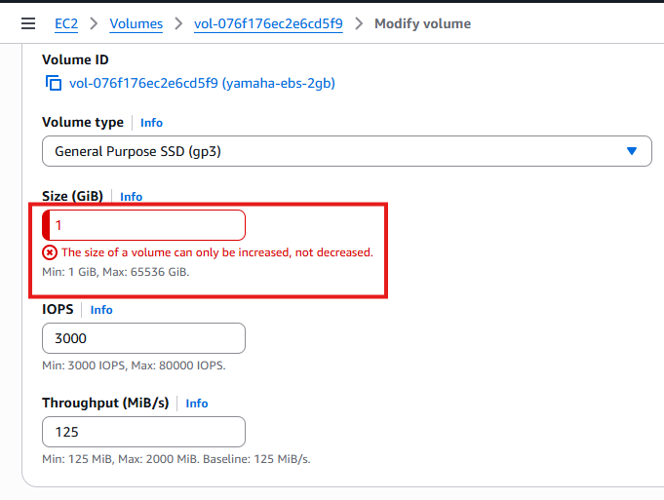
Rule: NEVER attempt to reduce the size of an EBS volume — AWS does not support size reduction
Section 3 – Resizing an EBS Volume
When an EBS volume runs low on space, you can increase its size without stopping the EC2 instance or losing any data. After resizing in AWS, you must also extend the filesystem inside the OS to use the new space.

Step 1 – Check Current Filesystem Size
Before resizing, check the current disk usage and filesystem size using df -h.
df -h # Show disk usage in human-readable format
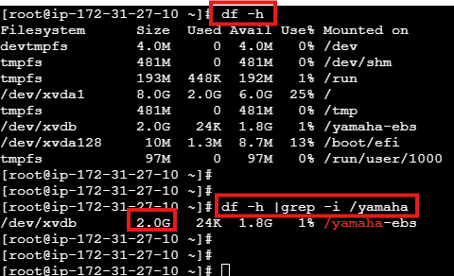
Step 2 – Modify the Volume Size in AWS Console
Go to EC2 → Volumes, select the volume, then click Actions → Modify Volume. Increase the size (e.g., from 2GB to 3GB) and click Modify.
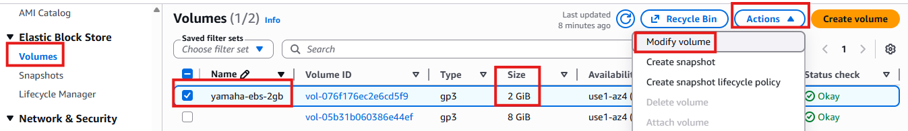
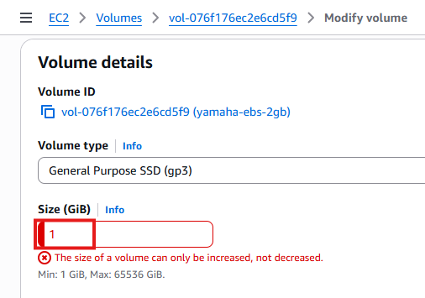
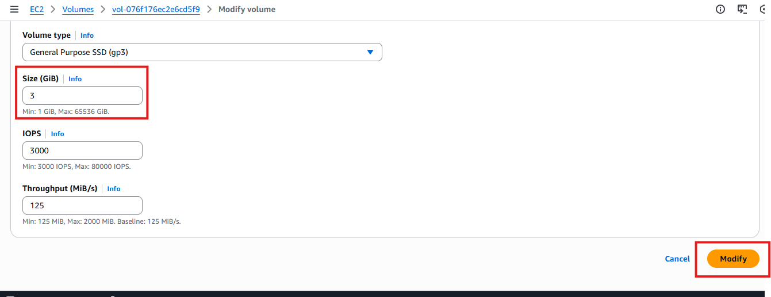
Step 3 – Confirm Volume Size Increased in AWS
The volume list now shows the updated size. However, the OS inside the EC2 instance does not automatically see the new space yet — the filesystem must be extended.
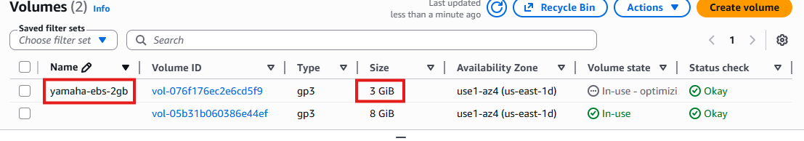
Step 4 – Extend the Filesystem Inside the Instance
SSH into the instance and run resize2fs to expand the filesystem to use the newly added space. Then verify with df -h.
resize2fs /dev/xvdb # Extend filesystem to use new volume size
df -h # Verify the new size is reflected
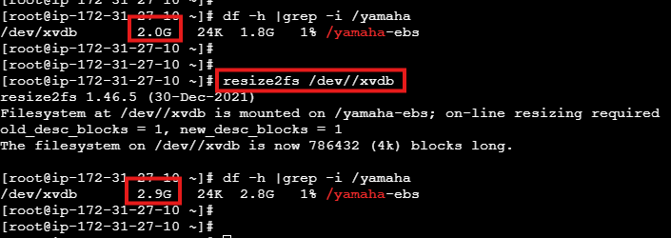
Remember: AWS expands the volume but resize2fs expands the filesystem inside — both steps are required
Section 4 – EBS Snapshots (Backup and Restore)
An EBS Snapshot is a point-in-time backup of an EBS volume stored in S3. If data is accidentally deleted or a volume fails, you can create a new volume from the snapshot and restore all data exactly as it was.

Use case: Disaster recovery, data backup before risky changes, volume migration
Storage location: Snapshots are stored in S3 automatically — you don't manage this

Step 1 – Create Test Files Before Snapshot
Create test files in the mounted directory. These files will be included in the snapshot and used to verify the restore later.
mount -a # Ensure volume is mounted
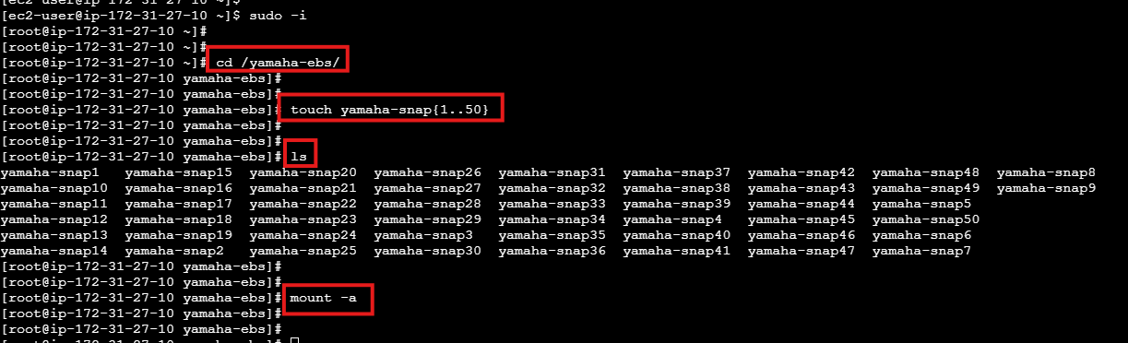
Step 2 – Create a Snapshot of the Volume
In EC2 Console → Volumes, select the volume, then click Actions → Create Snapshot. Add a description and tags to identify the snapshot.
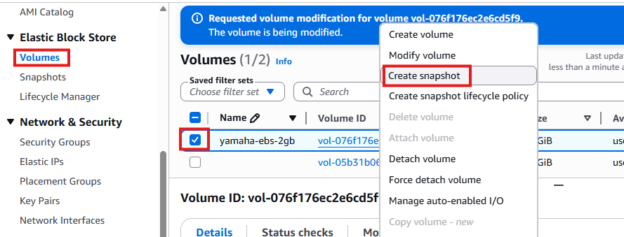
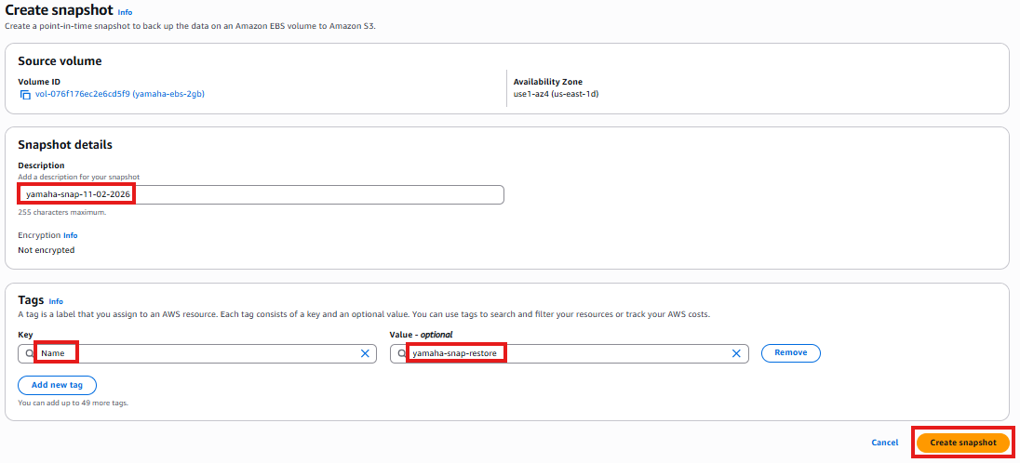
Step 3 – Confirm Snapshot Created
Go to EC2 → Snapshots to confirm the snapshot appears with status 'Completed'. It is now safely stored in S3.
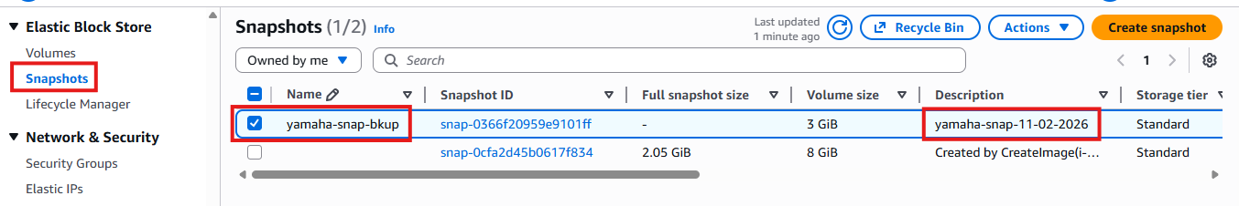
Step 4 – Simulate Data Loss (Delete Files)
To test the restore process, delete the files from the mounted directory — simulating accidental data deletion.
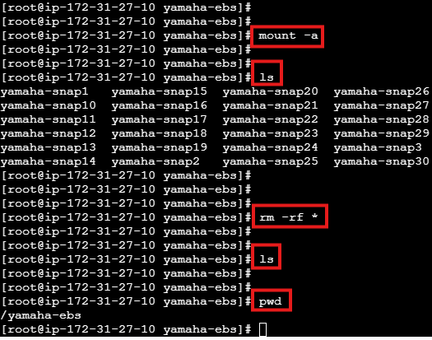
Step 5 – Detach the Volume from the Instance
Detach the original volume from the EC2 instance so we can replace it with a volume restored from the snapshot.
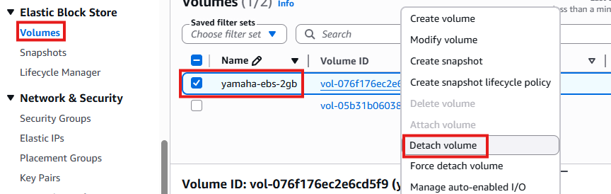
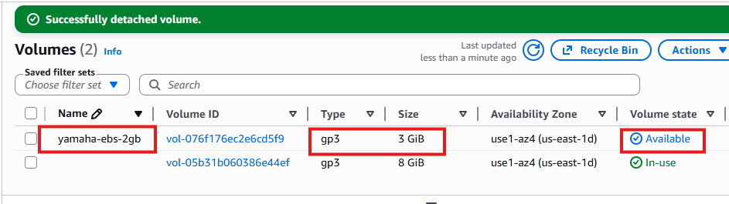
Step 6 – Verify Volume is Detached
Confirm the filesystem is no longer available on the instance by trying to access the mount point.
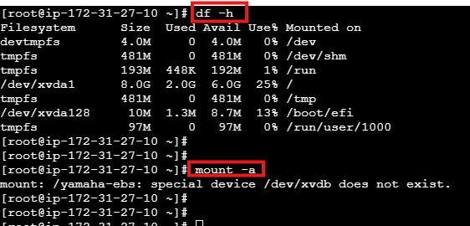
Step 7 – Create a New Volume from the Snapshot
In EC2 → Snapshots, select the snapshot, then click Actions → Create Volume from Snapshot. This creates a new EBS volume with all the data from the snapshot intact.
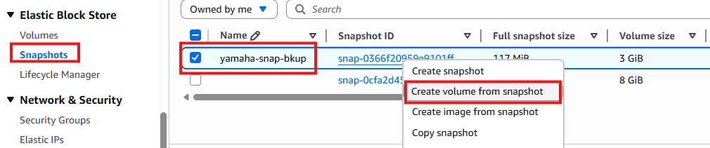
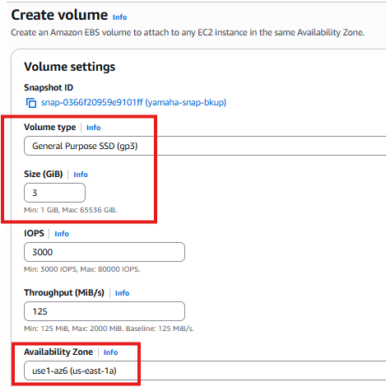
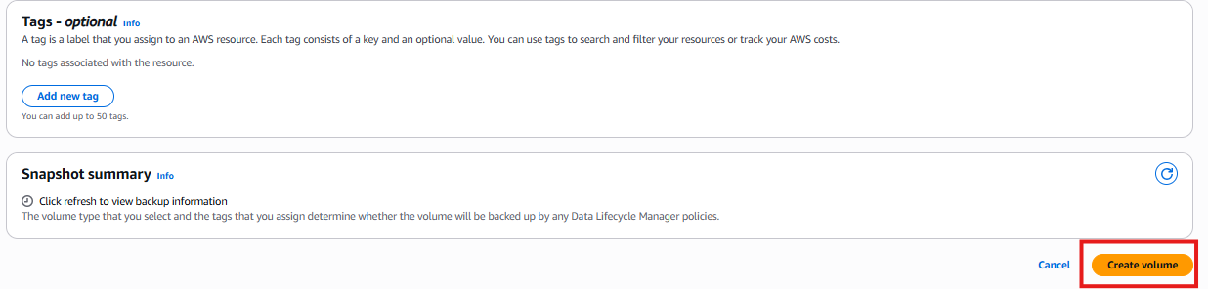
Step 8 – Attach the Restored Volume to the Instance
Attach the newly created volume (restored from snapshot) to the EC2 instance, just like attaching any new volume.
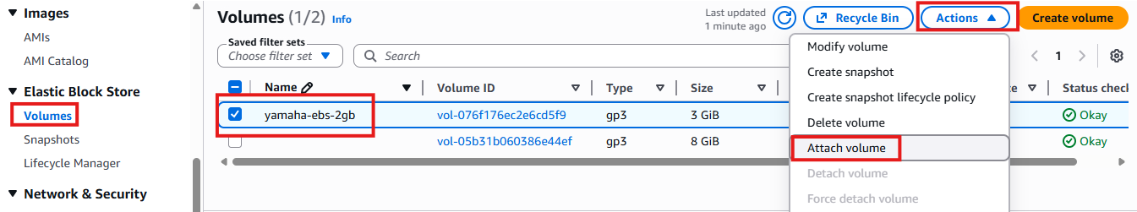
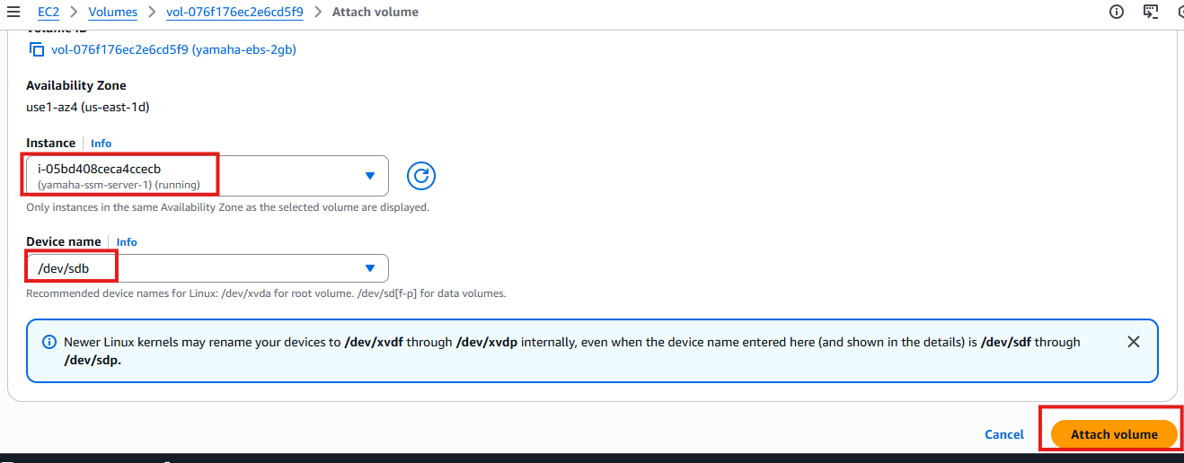
Step 9 – Verify Volume is Attached
Confirm the restored volume appears as available in the AWS Console and as a block device on the instance.
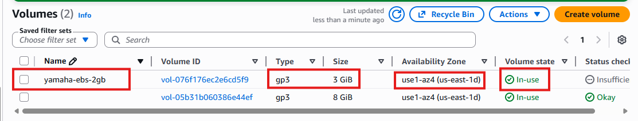
lsblk # Confirm restored volume appears
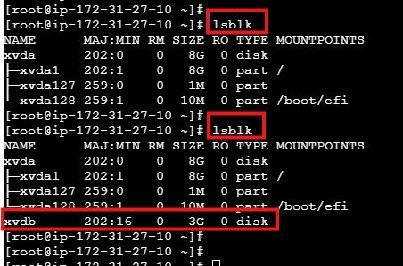
Step 10 – Mount and Verify Data Restored
Mount the restored volume and confirm the files that were deleted are back — exactly as they were at the time the snapshot was taken.
mount /dev/xvdb /yamaha # Mount the restored volume
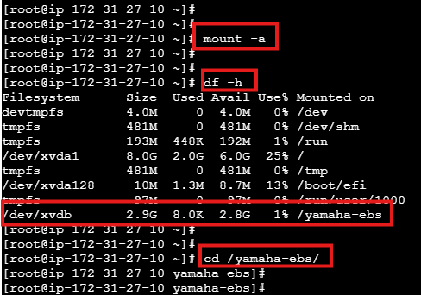
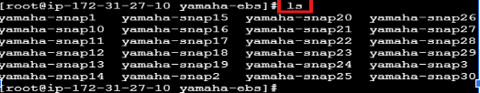
All files are restored successfully — confirming the snapshot backup and restore process works correctly!
Project Summary
✅ Understood the four AWS storage types: EBS, EFS, S3, and Glacier and when to use each
✅ Created an EBS volume and proved same-AZ requirement by testing cross-region attachment
✅ Formatted, mounted, and made an EBS volume persistent using /etc/fstab
✅ Increased EBS volume size from AWS Console and extended the filesystem with resize2fs
✅ Created an EBS snapshot as a point-in-time backup stored in S3
✅ Simulated data loss by deleting files and detaching the volume
✅ Restored all data by creating a new volume from the snapshot and remounting it
Interview Questions & Answers

Q1: What are the different AWS storage types and when would you use each?
AWS has four main storage types. EBS is block storage attached to a single EC2 instance — I use it for OS volumes and databases. EFS is shared file storage accessible by multiple EC2 instances at the same time — I use it for shared application data. S3 is object storage accessible over the internet — I use it for backups, static files, and logs. Glacier is archival storage for data that is rarely accessed — I use it to store old backups and compliance data at the lowest cost.

Q2: Can you attach an EBS volume to an EC2 instance in a different region?
No. EBS volumes must be in the same Availability Zone as the EC2 instance. I actually tested this — I created a volume in a different AZ and when I tried to attach it, the instance did not appear in the dropdown at all. To move data across regions you would need to create a snapshot of the volume and copy it to the target region, then create a new volume from that snapshot.

Q3: How do you resize an EBS volume without losing data?
First I modify the volume size in the AWS Console by selecting the volume and clicking Actions → Modify Volume. This expands the volume at the AWS level. But the OS still sees the old size until I run resize2fs inside the instance, which extends the filesystem to use the new space. Both steps are required — AWS expands the volume and resize2fs expands the filesystem. And importantly, EBS volumes can only be increased in size — never decreased.

Q4: What is an EBS Snapshot and how do you use it for disaster recovery?
A snapshot is a point-in-time backup of an EBS volume that is automatically stored in S3. To demonstrate disaster recovery, I created files on a volume, took a snapshot, then deleted those files and detached the volume. I then created a new volume from the snapshot, attached it to the instance, mounted it, and confirmed all the deleted files were restored exactly as they were. This is the standard approach for recovering from accidental data loss.

Q5: What is the difference between EBS and EFS?
EBS is block storage that can only be attached to one EC2 instance at a time and must be in the same Availability Zone. EFS is file storage that can be shared across multiple EC2 instances simultaneously and spans multiple AZs within a region. EBS is like a personal hard drive for one server, while EFS is like a shared network folder that many servers can access at the same time.

Q6: What happens to data on an EBS volume when the EC2 instance is terminated?
It depends on the configuration. The root EBS volume is set to 'Delete on Termination' by default — so it gets deleted when the instance is terminated. Additional EBS volumes attached to the instance are NOT deleted by default — they remain as independent volumes. This is important to manage carefully to avoid paying for unused volumes after instance termination.

