AWS EFS – Elastic File System
Shared Storage Across Multiple EC2 Instances in Different Availability Zones
Hands-On Project Documentation

Project Overview
This project demonstrates how to set up AWS EFS (Elastic File System) — a shared file storage service that allows multiple EC2 instances in different Availability Zones to access and share the same files simultaneously.
Unlike EBS which can only be attached to a single EC2 instance in one Availability Zone, EFS works across the entire region and can be mounted on many instances at the same time. Any file created on one server is instantly visible on all other servers sharing the same EFS.
Key difference from EBS: EBS = one disk for one server. EFS = one shared folder for many servers
Port required: NFS port 2049 must be open in the Security Group
Use case: Shared application uploads, configuration files, content management systems
Project Steps Overview
- Step 1 – Add NFS port 2049 to the Security Group
- Step 2 – Launch 2 EC2 instances in 2 different Availability Zones
- Step 3 – Create the EFS file system
- Step 4 – Install EFS utils and mount EFS on both instances
- Step 5 – Verify shared storage — files created on one server appear on the other
- Step 6 – Make the mount permanent using /etc/fstab

Step 1 – Add NFS Port to Security Group
Before creating EFS, the Security Group attached to both EC2 instances must allow NFS (Network File System) traffic on port 2049. This is the port EFS uses to communicate with EC2 instances. Without this rule, the instances cannot connect to EFS.
Protocol: NFS (Network File System)
Port: 2049
Why: EFS uses the NFS protocol to share files over the network — port 2049 must be open inbound
Go to EC2 → Security Groups → select the security group → Edit inbound rules → Add Rule → Type: NFS → Port: 2049 → Source: your VPC CIDR or 0.0.0.0/0 for testing.
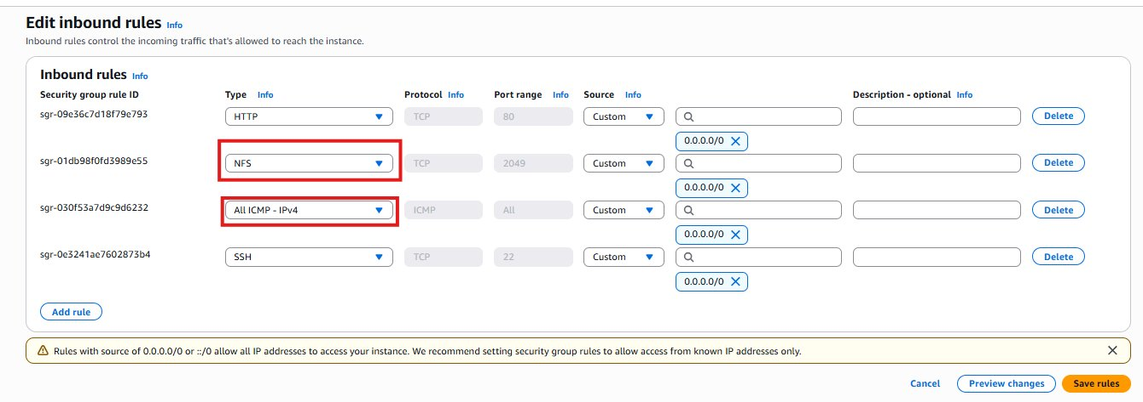

Step 2 – Launch 2 EC2 Instances in Different Availability Zones
To demonstrate that EFS works across Availability Zones (unlike EBS which is restricted to one AZ), we launch two EC2 instances in two different AZs within the same region. Both instances will mount the same EFS and share the same files.
Instance 1: Launched in Availability Zone A (e.g., us-east-1a)
Instance 2: Launched in Availability Zone B (e.g., us-east-1b)
Key point: EFS works across multiple AZs — this is what makes it fundamentally different from EBS
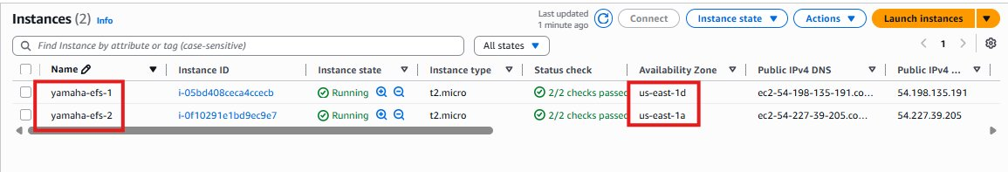

Step 3 – Create the EFS File System
Go to AWS Console → Services → EFS → Create File System. The EFS wizard will walk you through configuring the file system settings, network access, and security groups.
Step 3.1 – Customize EFS Settings
In the EFS creation wizard, select 'Customize' to configure detailed settings such as storage class, performance mode, and throughput mode.
Storage Class: Standard — data stored across multiple AZs for high availability
Performance Mode: General Purpose — suitable for most workloads
Throughput Mode: Bursting — scales throughput with the amount of data stored
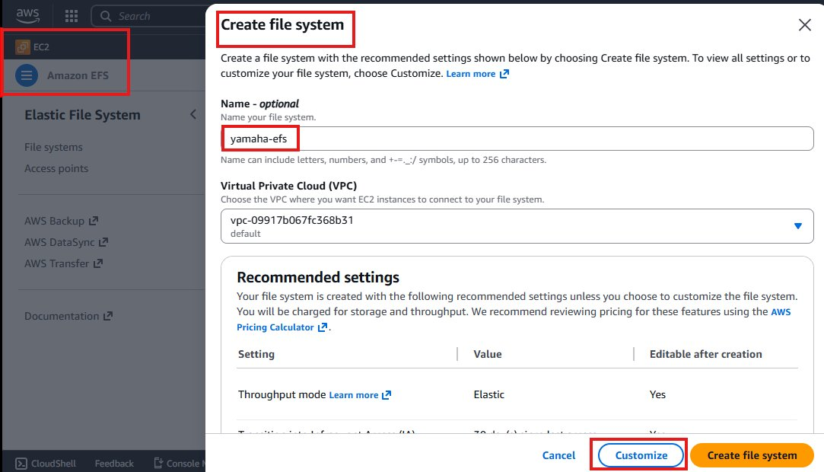
Step 3.2 – Configure General Settings
Set the file system name, choose Regional for high availability across multiple AZs, configure lifecycle management, and optionally enable encryption.
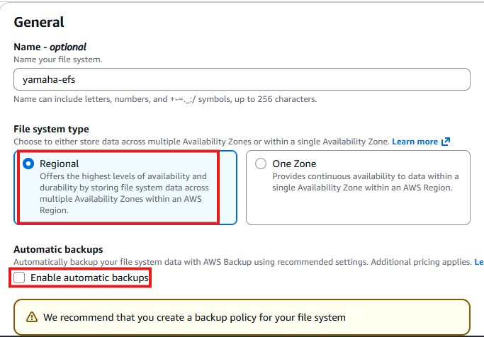
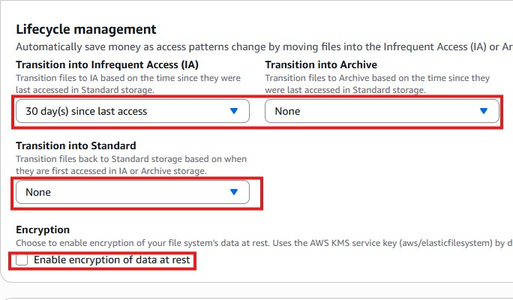
Step 3.3 – Configure Performance Settings
Select Bursting for throughput mode and General Purpose for performance mode — these are the recommended settings for most use cases.
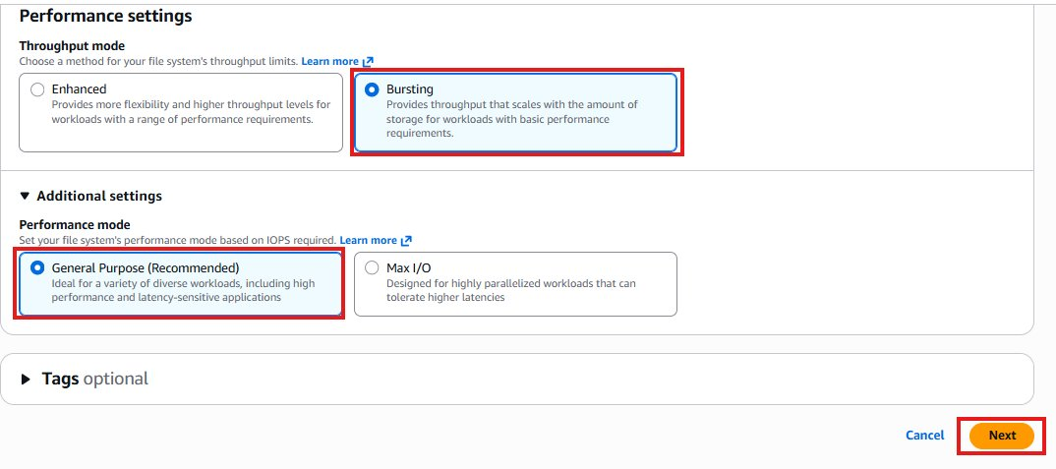
Step 3.3 – Attach Security Group to EFS
In the network step, select the VPC and configure mount targets for each Availability Zone. A mount target is the network endpoint that EC2 instances connect to when mounting EFS. Create one mount target per AZ where you have EC2 instances.
Attach the security group (with NFS port 2049 open) to the EFS mount targets. This allows the EC2 instances to communicate with the EFS over port 2049.
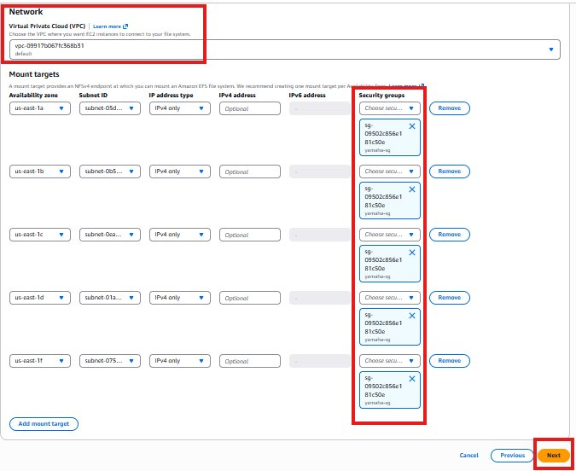
Step 3.4 – Review and Create
Review all the EFS configuration settings and click Create to finalize.
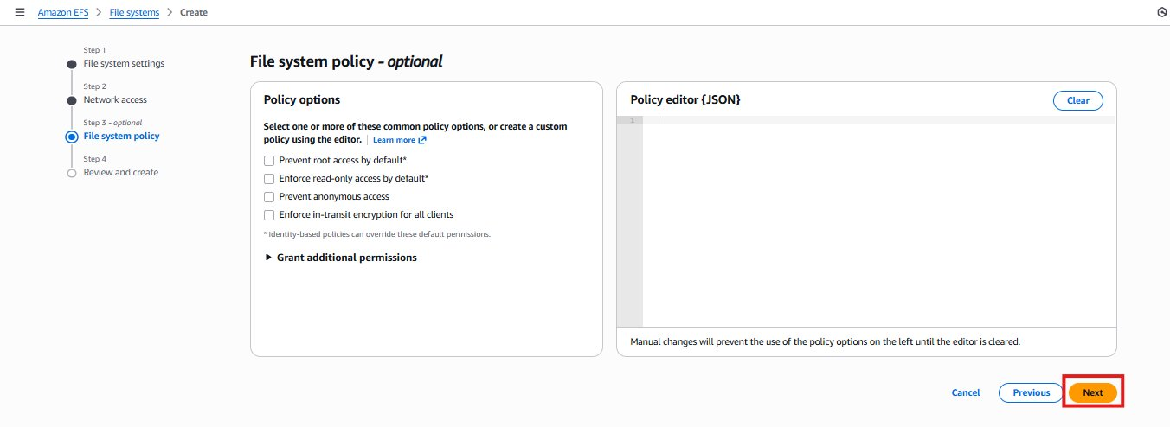
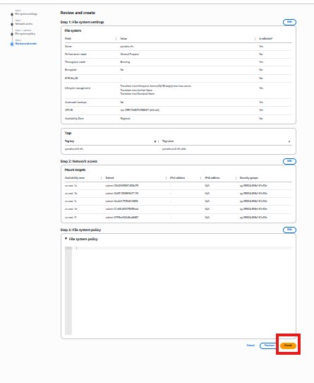
Step 3.5 – Confirm EFS Created and Ready
The EFS file system now appears in the EFS console with a status of 'Available'. It is ready to be mounted on EC2 instances.
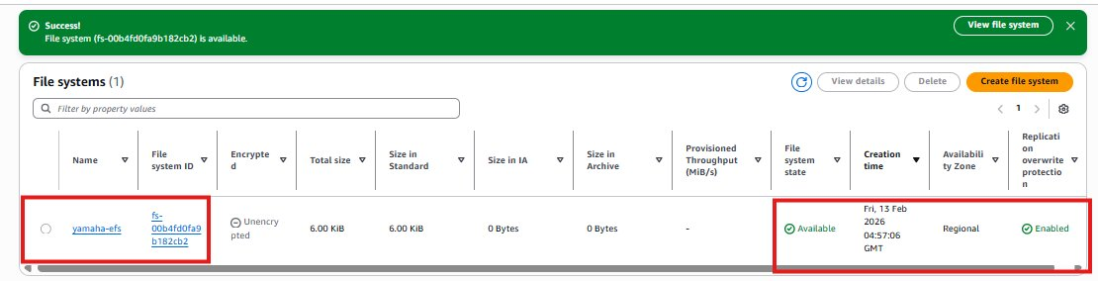

Step 4 – Install EFS Utils and Mount on Both Instances
To mount EFS on EC2 instances, the amazon-efs-utils package must be installed. This package provides the mount helper tool that simplifies the EFS mounting process.
Step 4.1 – Install amazon-efs-utils on Both Servers
SSH into each EC2 instance and install the EFS utilities package. This must be done on both servers.
sudo yum install -y amazon-efs-utils # Install EFS mount helper
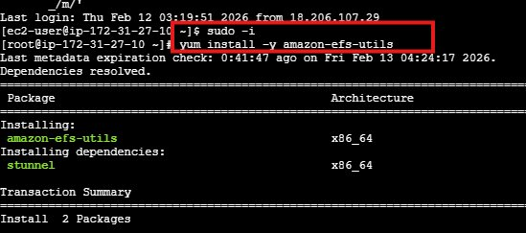
Step 4.2 – Create Mount Point on Both Servers
Create a directory on each server that will serve as the mount point for the EFS. Use the same directory name on both servers for consistency.
mkdir /shared-efs # Create mount point directory on both servers
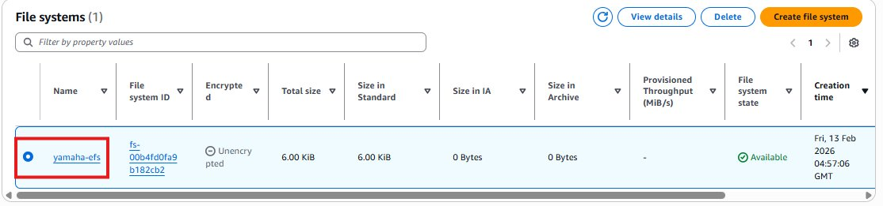
Step 4.3 – Get the EFS Mount Command
In the EFS Console, select your EFS file system and click 'Attach'. AWS provides the exact mount command with your EFS DNS name. Copy this command — you will run it on both instances.
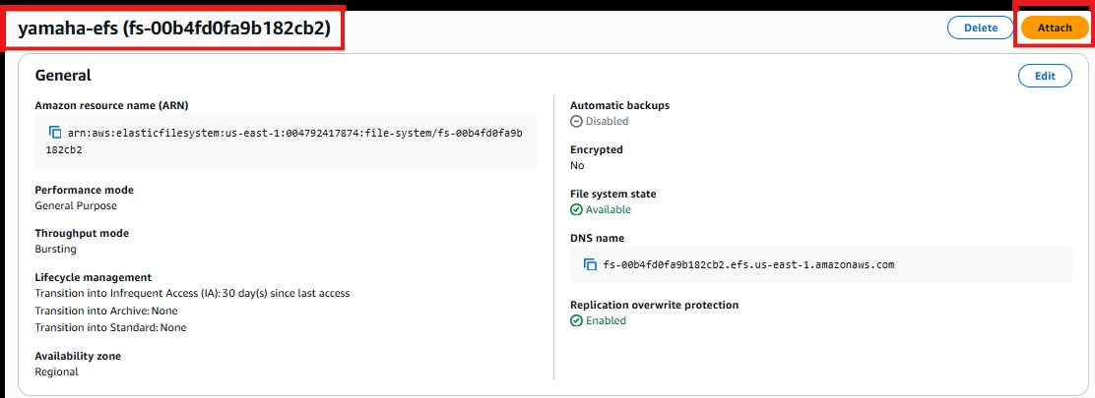
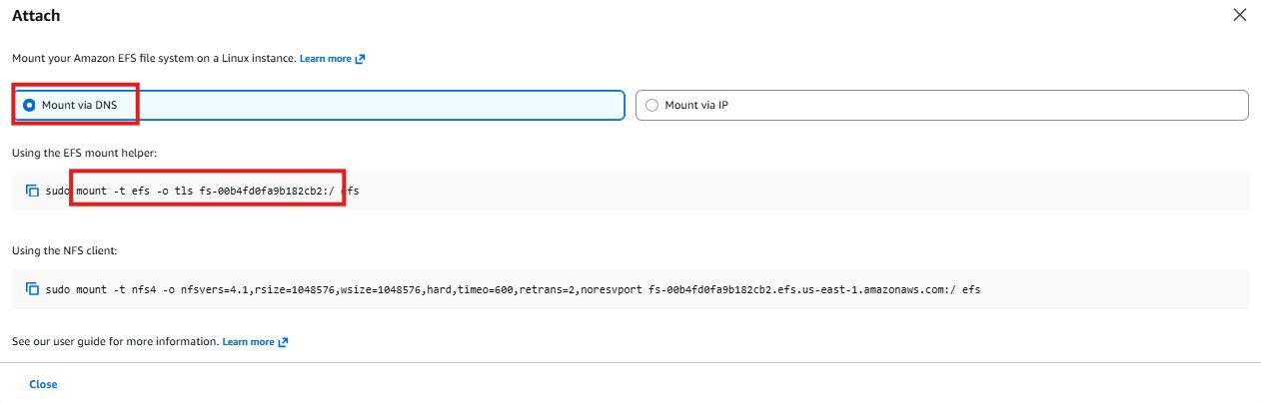
Step 4.4 – Run the Mount Command on Both Instances
Run the mount command copied from the EFS console on both EC2 instances. This connects each instance to the shared EFS file system.
sudo mount -t efs -o tls fs-xxxxxxxx:/ /shared-efs # Mount EFS (use your EFS ID)
Step 4.5 – Verify EFS is Mounted
Run df -h on both instances to confirm the EFS is mounted and showing as an available filesystem.
df -h # Confirm EFS appears in the mounted filesystems list
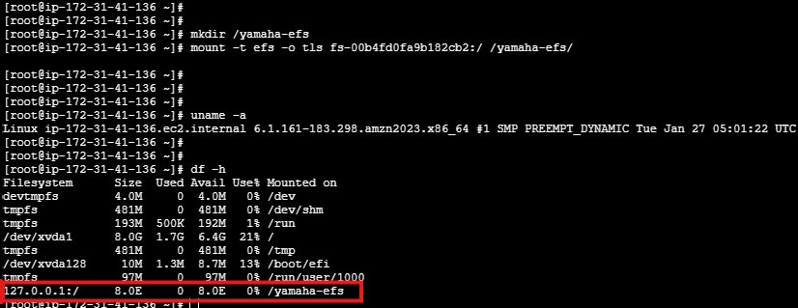
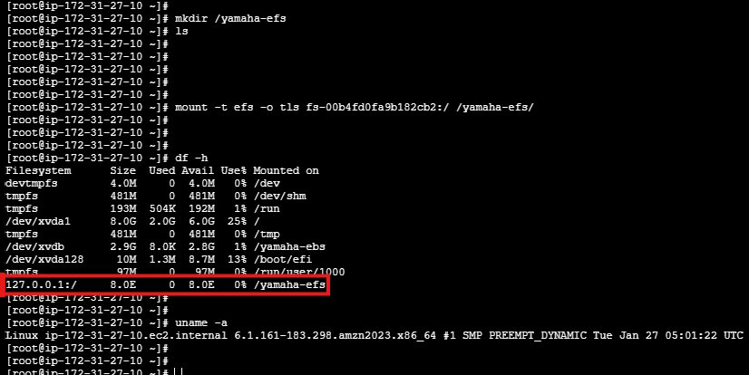

Step 5 – Verify Shared Storage Works
This is the key test that proves EFS works as shared storage. A file created on Server 1 should instantly appear on Server 2 — without any copying or syncing required.
Step 5.1 – Create a File on Server 1
On the first EC2 instance, create a new file inside the EFS mount point directory.
touch /shared-efs/testfile.txt # Create file on Server 1
echo 'Hello from Server 1' > /shared-efs/testfile.txt
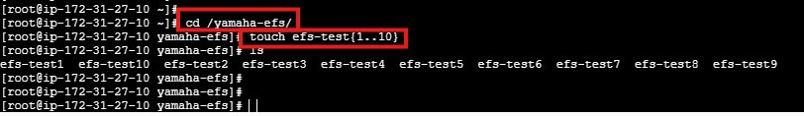
Step 5.2 – Verify File Appears on Server 2
Without doing anything on Server 2, list the contents of the EFS mount point. The file created on Server 1 should be immediately visible — confirming EFS shared storage is working correctly.
ls /shared-efs # File from Server 1 should appear here on Server 2
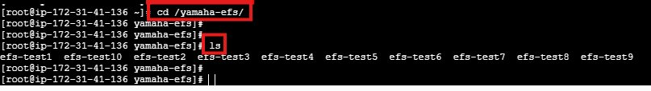
Result: The file created on Server 1 is instantly visible on Server 2 — this is the power of EFS shared storage

Step 6 – Make EFS Mount Permanent Using /etc/fstab
Just like EBS volumes, EFS mounts are lost after a server reboot unless an entry is added to /etc/fstab. Add the EFS mount entry to /etc/fstab on both servers to ensure EFS auto-mounts on every reboot.
vi /etc/fstab # Edit filesystem table on both servers
Add a line like: fs-xxxxxxxx:/ /shared-efs efs defaults,_netdev 0 0
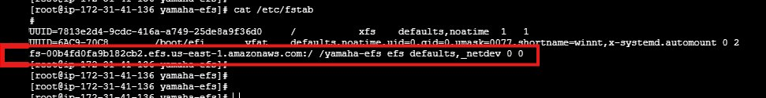
Important: Use the _netdev option in fstab for EFS — this ensures the network is ready before mounting on boot
mount -a # Test fstab — no errors means the entry is correct

Project Summary
- Added NFS port 2049 to Security Group to allow EFS communication
- Launched 2 EC2 instances in 2 different Availability Zones
- Created an EFS file system with mount targets in each AZ
- Installed amazon-efs-utils and mounted EFS on both instances
- Proved shared storage — file created on Server 1 instantly appeared on Server 2
- Made EFS mount permanent on both servers using /etc/fstab

Interview Questions & Answers
Q1: What is EFS and how is it different from EBS?
EFS is a shared file storage service that multiple EC2 instances can access simultaneously across different Availability Zones. EBS is block storage that can only be attached to one EC2 instance in one AZ at a time. Think of EBS as a personal hard drive for one server, and EFS as a shared network folder that many servers access together. EFS automatically scales as data grows while EBS requires manual resizing.
Q2: What port does EFS use and why must it be open?
EFS uses NFS (Network File System) on port 2049. This port must be open in the Security Group attached to both the EC2 instances and the EFS mount targets, otherwise the instances cannot connect to EFS and the mount command will fail or time out.
Q3: How do you mount EFS on an EC2 instance?
First I install the amazon-efs-utils package using yum install amazon-efs-utils. Then I create a mount point directory like mkdir /shared-efs. I get the mount command from the EFS Console by clicking Attach on the file system, then run that command on the instance. To make it permanent across reboots I add the EFS entry to /etc/fstab using the _netdev option which ensures the network is available before mounting.
Q4: How did you prove that EFS works as shared storage?
I launched two EC2 instances in two different Availability Zones and mounted the same EFS on both. Then I created a file on Server 1 inside the EFS mount directory. Without doing anything on Server 2, I listed the same directory there and the file appeared immediately. This proves that EFS is truly shared — any write on one instance is instantly visible on all other instances that have the same EFS mounted.
Q5: When would you use EFS over EBS in a real project?
I would use EFS when multiple servers need to share the same files — for example in a web application where multiple EC2 instances behind a load balancer all need to access the same uploaded user files or shared configuration. With EBS I would need to copy files across servers manually or use S3. EFS solves this automatically since all instances see the same filesystem in real time.

