AWS Networking
IP Addressing | Subnetting | VPC | Subnets | Internet Gateway | Route Tables | NAT Gateway | VPC Endpoints
Concept & Hands-On Project Documentation

Project Overview
Networking is the foundation of everything in AWS. Before building anything in the cloud, you need to understand how devices communicate, how IP addresses work, and how AWS VPC (Virtual Private Cloud) isolates and connects your resources securely.
This document covers three areas: networking fundamentals (IP addressing, subnetting, CIDR), hands-on VPC creation with public and private subnets, and NAT Gateway + VPC Endpoints to control internet access for private instances.

Doc 1 - Networking Theory: IP classes, subnetting, CIDR, switches, routers, public vs private IP
Doc 2 - VPC Practical: Create VPC, subnets, IGW, route tables, launch instances, bastion host
Doc 3 - NAT Gateway & Endpoints: Allow private instances to access internet and S3 securely

PART 1 – Networking Fundamentals

Section 1.1 – What is Networking & IP Addressing?
Networking is simply about connecting computers or devices so they can communicate and share resources like data, applications, or internet access. Every device on a network needs a unique IP address — like a home address — so data knows where to go.
IPv4: 32-bit address written as four octets — e.g., 192.168.1.1 (most common today)
IPv6: 128-bit address in hexadecimal — e.g., 2001:db8::1 (newer, solves IPv4 exhaustion)
Why IPv6: IPv4 only supports ~4.3 billion addresses which are running out. IPv6 has 340 undecillion addresses

Section 1.2 – IP Address Classes (Classful Addressing)
In classful addressing, IP addresses are divided into classes A, B, C, D, and E based on the first octet value. Each class determines how many networks and hosts are supported.

Class A – Very Large Networks (Range: 1–126)
Format: N.H.H.H (1 network octet, 3 host octets)
Subnet Mask: 255.0.0.0 | CIDR: /8
Example: 10.0.0.1/8
Available Hosts: ~16 million hosts per network
Used for: Very large organizations, ISPs, governments
Class B – Medium Networks (Range: 128–191)
Format: N.N.H.H (2 network octets, 2 host octets)
Subnet Mask: 255.255.0.0 | CIDR: /16
Example: 172.16.0.0/16
Available Hosts: ~65,000 hosts per network
Used for: Universities, medium-sized organizations
Class C – Small Networks (Range: 192–223)
Format: N.N.N.H (3 network octets, 1 host octet)
Subnet Mask: 255.255.255.0 | CIDR: /24
Example: 192.168.1.0/24
Available Hosts: 254 hosts per network
Used for: Home networks, small offices
Class D & E – Special Use
Class D (224–239): Multicast — sending data to multiple recipients simultaneously
Class E (240–254): Experimental — not used in real networks

How to Identify IP Class — Quick Rule
52.36.65.90: First octet 52 → Class A
182.168.1.2: First octet 182 → Class B
192.168.1.1: First octet 192 → Class C

Reserved IP Addresses
0 — Network Address: Represents the network itself — e.g., 192.168.1.0
127.0.0.1 — Loopback: Points back to your own machine — used for self-testing
255 — Broadcast: Sends a message to ALL devices on the network simultaneously

Why is 255 the maximum? Each IP octet is 8 binary bits. When all bits are ON the max value is:
128 + 64 + 32 + 16 + 8 + 4 + 2 + 1 = 255

Section 1.3 – Subnetting
Subnetting divides a large network into smaller sub-networks to avoid IP wastage and improve security and management. Instead of using an entire Class B network (65,000 IPs) when you only need 2,000, you subnet it.
Before subnetting: 172.16.0.0/16 → 65,000 IP addresses (wasteful)
After subnetting: 172.16.0.0/21 → 2,046 IP addresses (efficient)
Subnet Calculator: https://www.subnet-calculator.com/subnet.php?net_class=B

Subnet Mask — N and H Explained
N = Network part: Fixed — same for all devices on that network
H = Host part: Variable — different for each device on the network
The subnet mask tells devices which part of the IP is the network and which part is the host. For example in 192.168.1.0/24, the first three octets (192.168.1) are the network and the last octet (.1 to .254) are the hosts.

Section 1.4 – CIDR (Classless Addressing)
CIDR (Classless Inter-Domain Routing) removes the fixed class system and allows flexible IP allocation using any subnet mask. You can allocate exactly the number of IPs you need — not locked into Class A/B/C sizes.
Example: 192.168.1.0/25 → 126 hosts | 192.168.1.0/24 → 254 hosts
Used in: AWS VPC, all modern networks, internet routing
CIDR Calculator: https://www.subnet-calculator.com/cidr.php

Section 1.5 – Networking Devices & IP Types
Switch
A switch connects devices within the same network. It operates at Layer 2 (Data Link) and forwards data based on MAC addresses. Think of it as a traffic controller inside one office building.
Connects: Devices within the same network
Works with: MAC addresses (hardware addresses)
Router
A router connects different networks together. It operates at Layer 3 (Network) and routes traffic based on IP addresses. Think of it as a post office that routes mail between cities.
Connects: Different networks together
Works with: IP addresses
Public vs Private IP Addresses
Public IP: Internet-facing, globally unique, used for internet-accessible services — e.g., 52.x.x.x
Private IP: Internal use only, not routable on internet, can be reused in different private networks — e.g., 10.x.x.x, 192.168.x.x

PART 2 – VPC Hands-On Project

Section 2.1 – AWS VPC Core Concepts
A VPC (Virtual Private Cloud) is your own private network inside AWS. It is completely isolated from other AWS customers and gives you full control over IP ranges, subnets, routing, and security.

VPC: Your private AWS network — you define the IP range using CIDR
Subnet: A subdivision of your VPC. Public subnets have internet access, private subnets don't
Internet Gateway (IGW): Connects your VPC to the internet — required for public subnet internet access
Route Table: A set of rules that directs where network traffic goes — to IGW, NAT, or other VPCs
Security Group: Virtual firewall controlling inbound and outbound traffic for instances

AWS Reserved IPs: In every subnet, AWS reserves 5 IPs: .0 (network), .1 (router), .2 (DNS), .3 (future use), .255 (broadcast)

Section 2.2 – Step-by-Step VPC Creation
In this hands-on project we create a complete VPC with a public subnet (for web/dev servers) and a private subnet (for database servers), connect them to the internet via an Internet Gateway, configure routing, and test connectivity using a Bastion Host.

Step 1 – Create the VPC
Go to AWS Console → VPC → Your VPCs → Create VPC. Define the VPC name and CIDR block. We use 10.0.0.0/16 which gives 65,536 IP addresses for our entire VPC.
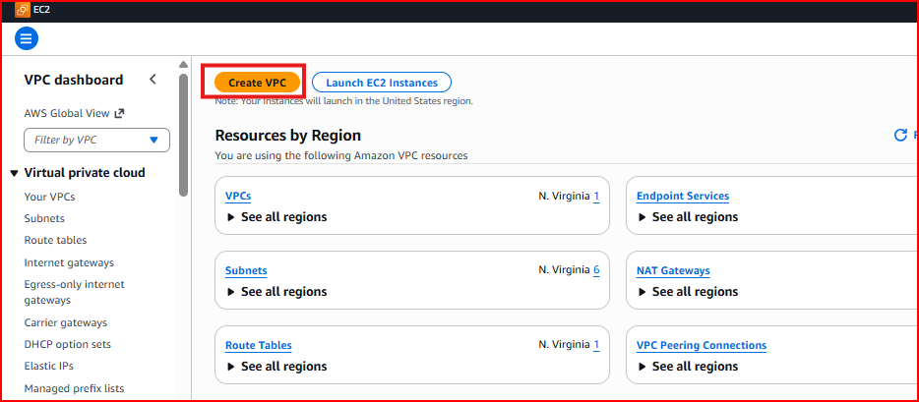
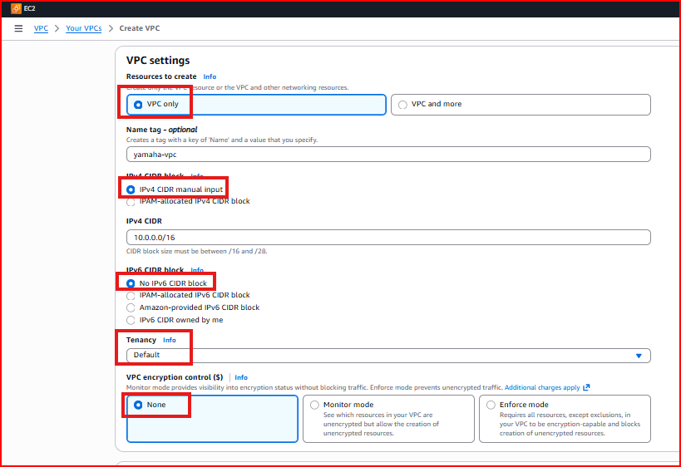
VPC Name: Insta-VPC
IPv4 CIDR: 10.0.0.0/16
Tenancy: Default
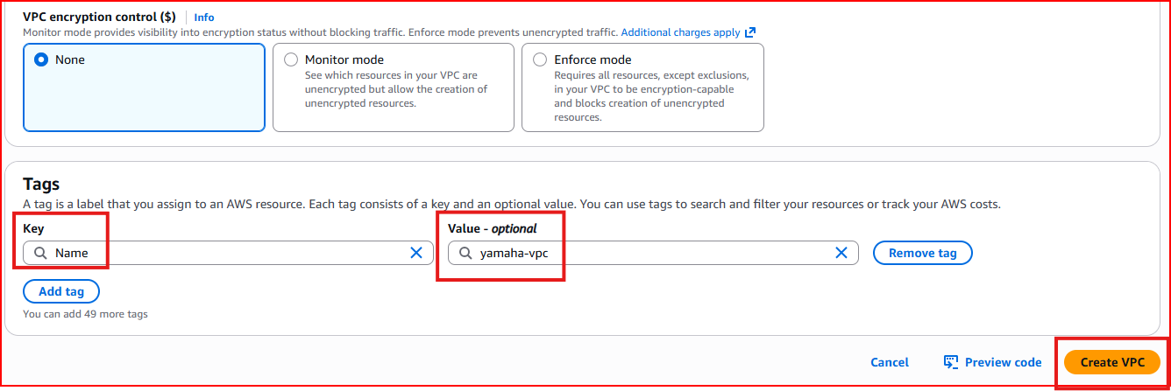
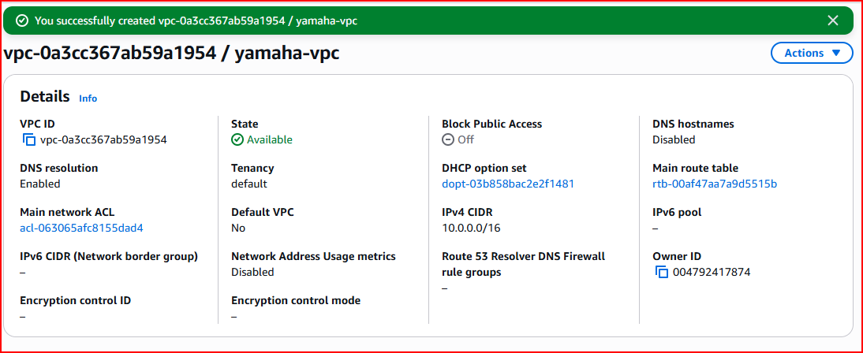
Step 2 – Create Public Subnet (Dev/Web Subnet)
Create the first subnet inside the VPC for public-facing resources like web servers and development instances. This subnet will have a route to the Internet Gateway so instances can have public IPs.
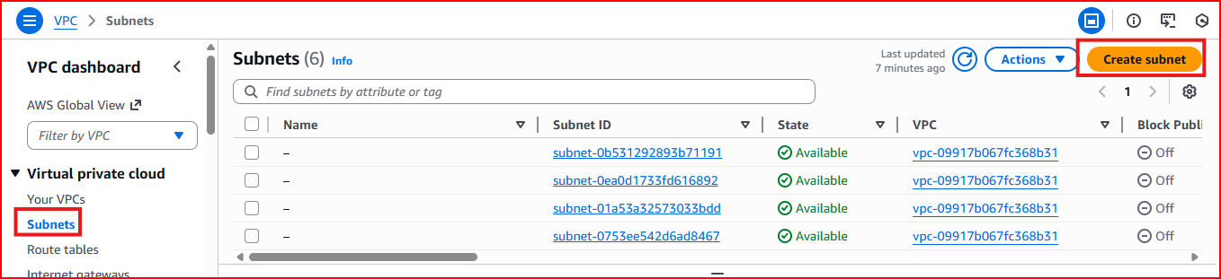
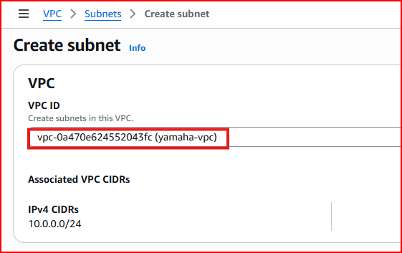
Subnet Name: Dev-Subnet
Availability Zone: e.g., us-west-2a
IPv4 CIDR: 10.0.1.0/24 — gives 254 usable IP addresses
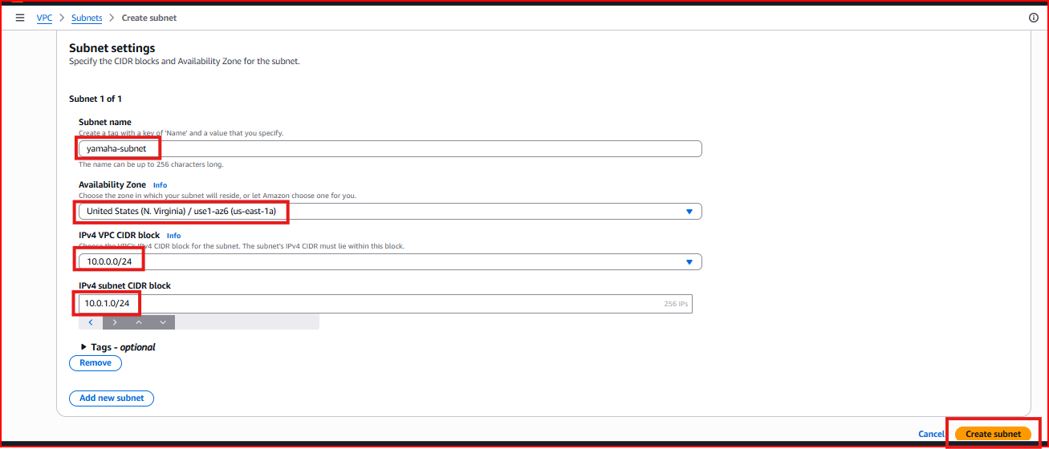
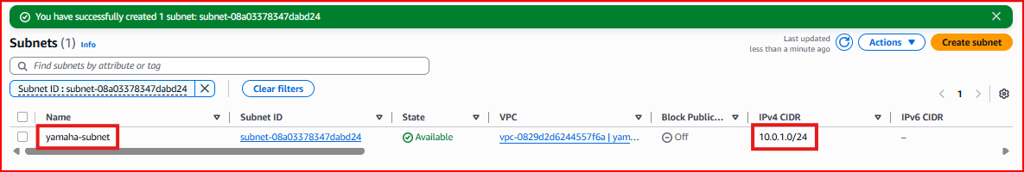
Step 3 – Enable Auto-Assign Public IP for Public Subnet
By default, instances launched in a subnet don't get a public IP automatically. Enable auto-assign public IP on the Dev subnet so any EC2 instance launched there automatically receives a public IP address for internet access.
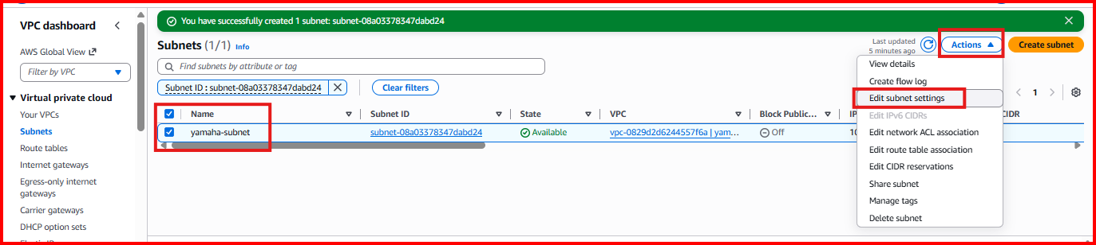
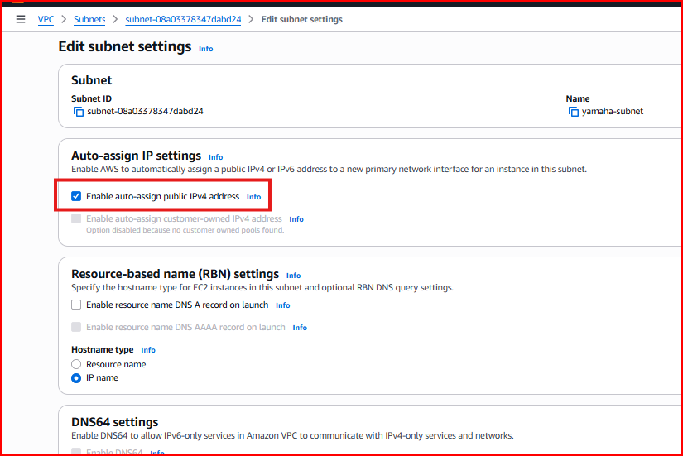
Important: Only enable this on the PUBLIC subnet — never on the private DB subnet
Step 4 – Create Private Subnet (DB Subnet)
Create a second subnet for database servers. This subnet will NOT have a route to the Internet Gateway, making it completely inaccessible from the internet — keeping your database secure.
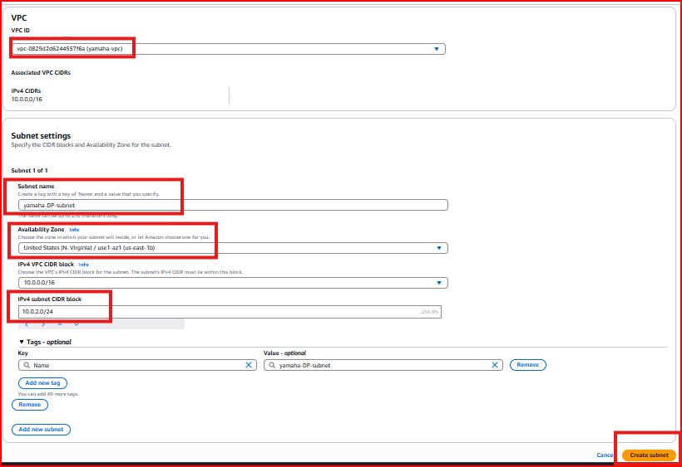
Subnet Name: DB-Subnet
Availability Zone: e.g., us-west-2b (different AZ for high availability)
IPv4 CIDR: 10.0.2.0/24
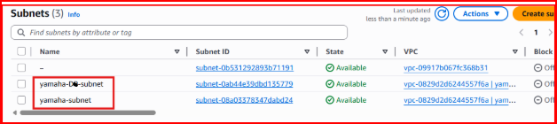
Security rule: Do NOT enable auto-assign public IP for DB-Subnet — database servers must remain private
Step 5 – Create Internet Gateway (IGW)
An Internet Gateway is the door between your VPC and the internet. Without it, nothing in your VPC can communicate with the outside world. Create the IGW and then attach it to your VPC.
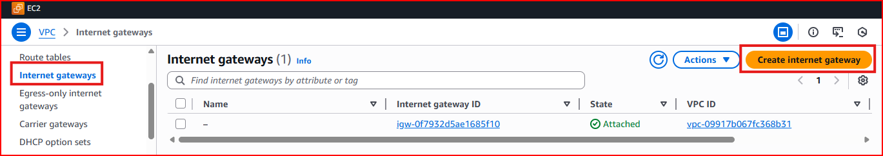
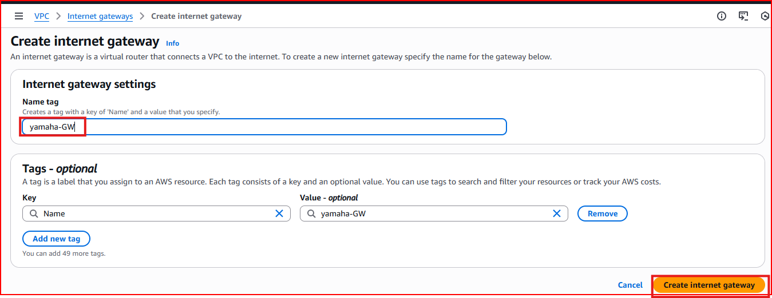
IGW Name: Insta-IGW
After creation the IGW shows as 'Detached' — you must attach it to the VPC to activate it.
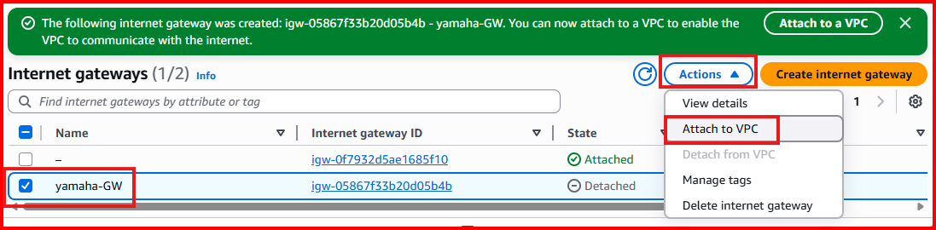
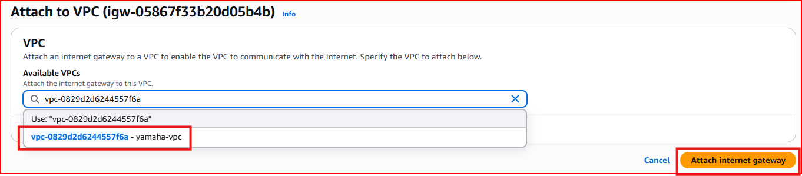
Step 6 – Configure Route Table
A Route Table defines where traffic goes. AWS creates a default route table with your VPC. We add a route sending all internet traffic (0.0.0.0/0) to the Internet Gateway, then associate the public Dev subnet with this route table.
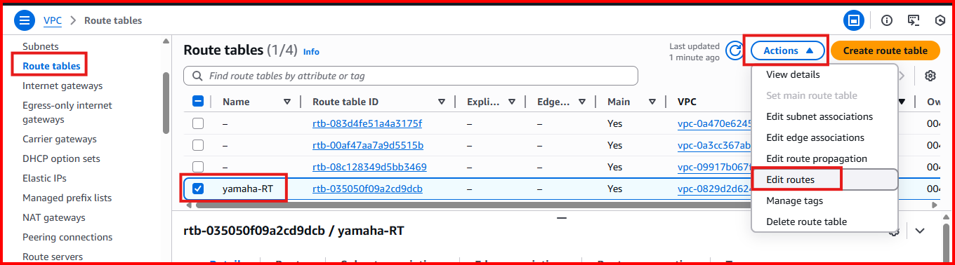
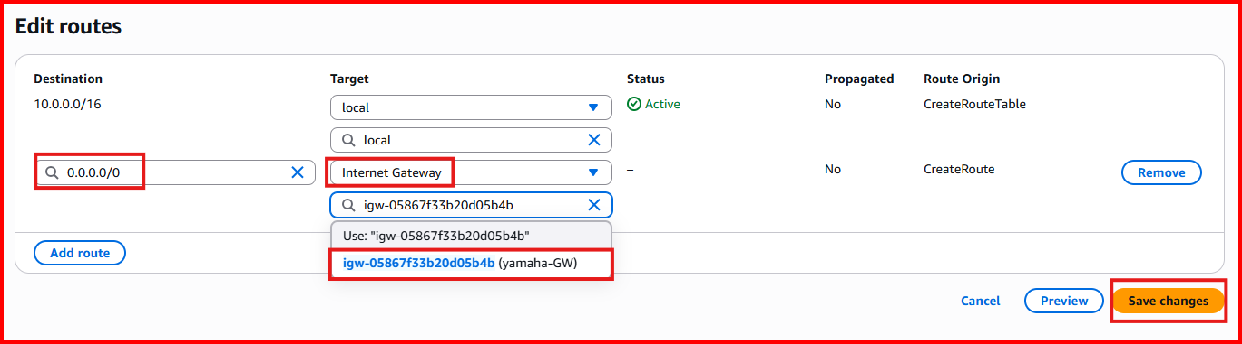
Route added: Destination: 0.0.0.0/0 → Target: Insta-IGW
Subnet associated: Dev-Subnet only — NOT DB-Subnet
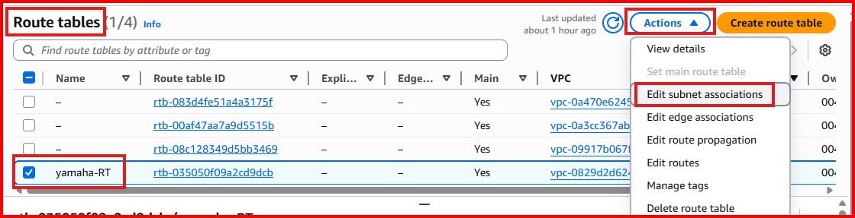
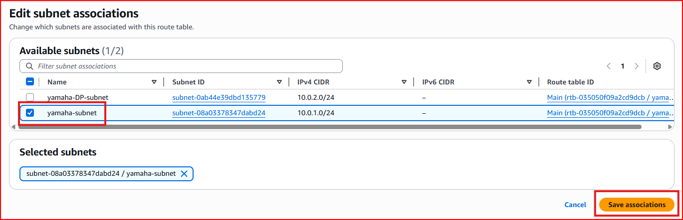
Critical: Only associate the PUBLIC subnet with this route table. The DB subnet should NOT have a route to IGW
Step 7 – Create Security Group
Create a security group inside the VPC with SSH (port 22) and ICMP (ping) rules. SSH allows remote login and ICMP allows connectivity testing between instances.
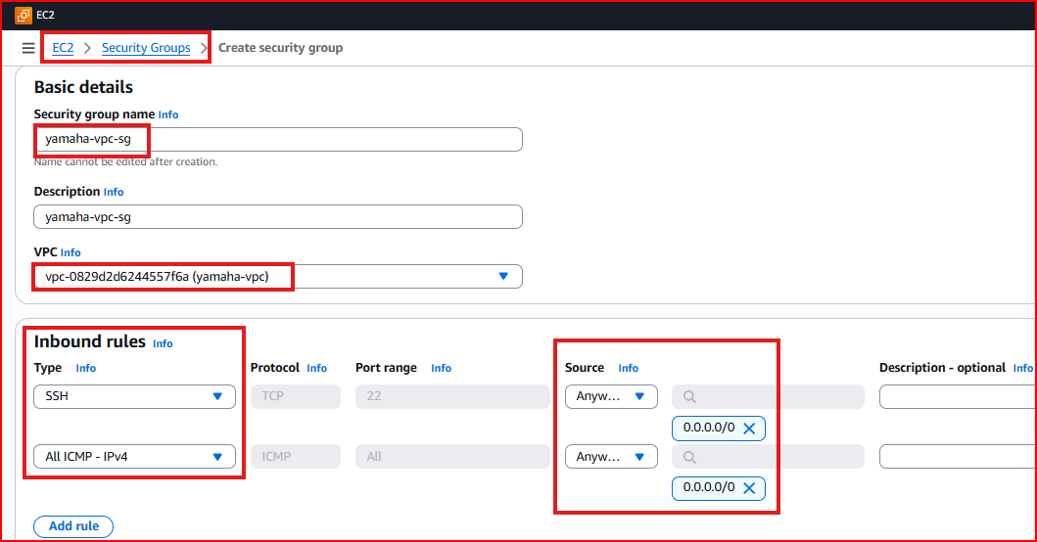
SG Name: Insta-SG
Inbound rules: SSH port 22 (login) + ICMP (ping testing between instances)
Step 8 – Launch Dev Instance in Public Subnet
Launch an EC2 instance in the Dev-Subnet (public). Select the Insta-VPC network, Dev-Subnet, and the Insta-SG security group. This instance will have a public IP for internet access.
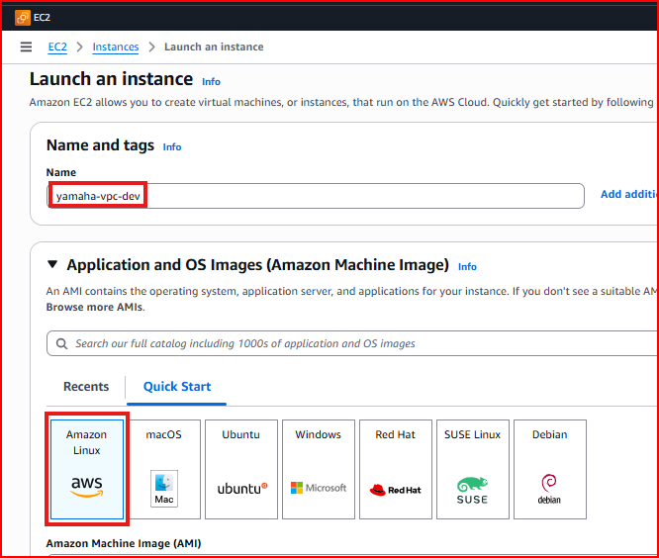
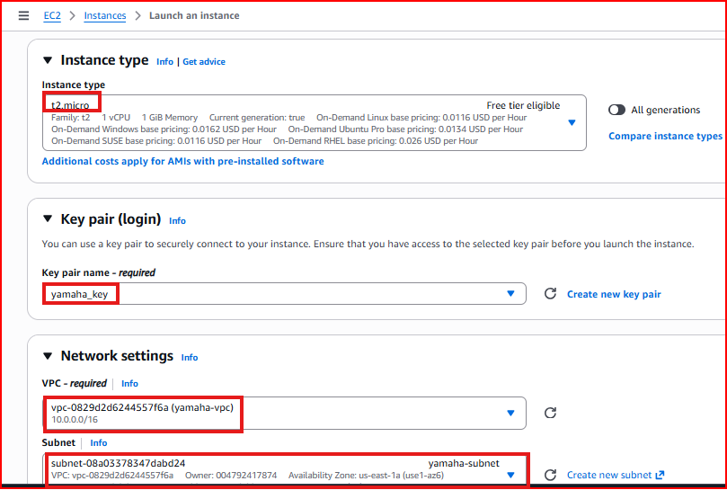
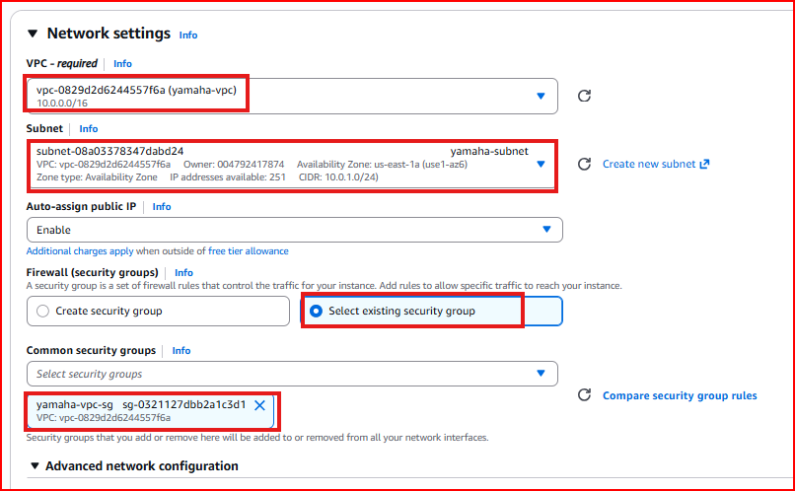
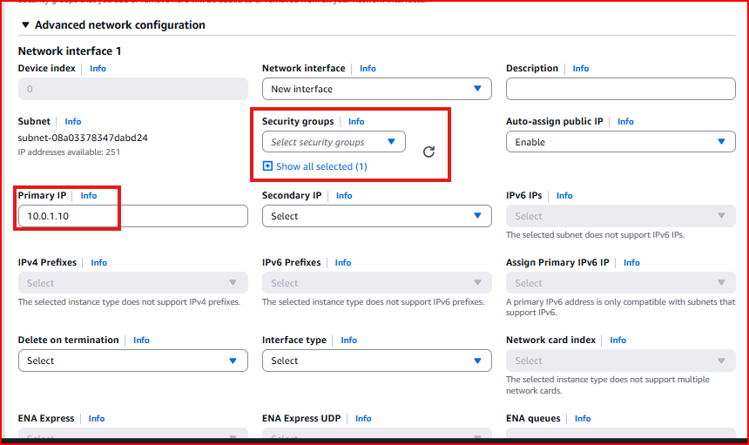
Step 9 – Launch DB Instance in Private Subnet
Launch a second EC2 instance in the DB-Subnet (private). This instance will have NO public IP — it is only accessible from within the VPC via private IP. This is the correct setup for database servers.
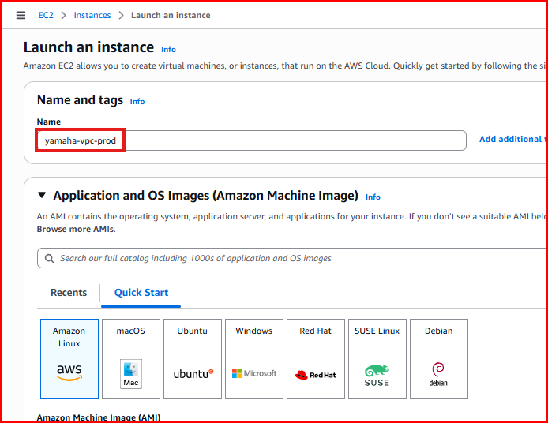
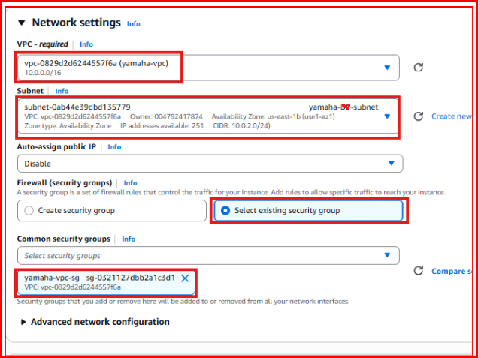
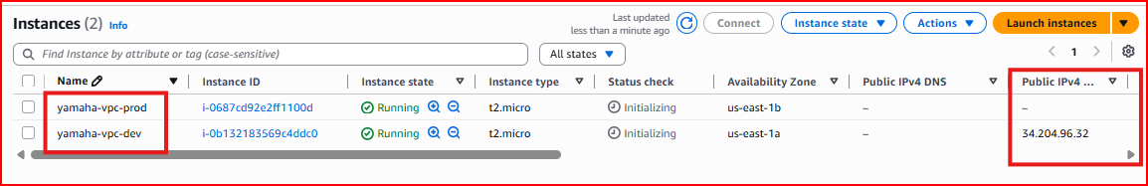
Step 10 – Test Connectivity: Ping Dev and DB Instances
Login to the Dev instance via SSH and test internet connectivity. Then ping the DB instance using its private IP to confirm both instances can communicate within the VPC.
ping google.com # Test internet access from Dev instance
ping <db-private-ip> # Test internal VPC communication to DB instance
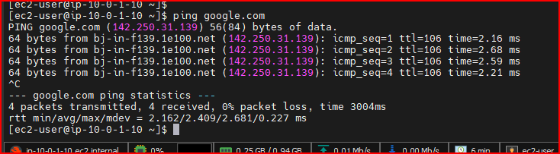
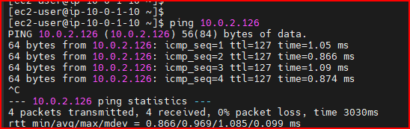
Step 11 – Bastion Host: Connect to Private DB Instance
Since the DB instance has no public IP, you cannot SSH into it directly from the internet. The solution is to use the Dev instance as a Bastion Host (Jump Server) — you SSH into Dev first, then SSH from Dev into DB using the private IP.
Why Bastion Host: DB servers must stay private. The Bastion Host in the public subnet acts as a secure gateway to reach private instances
Step 1: Upload your .pem key file to the Dev instance
Step 2: From Dev instance, SSH into DB instance using its private IP
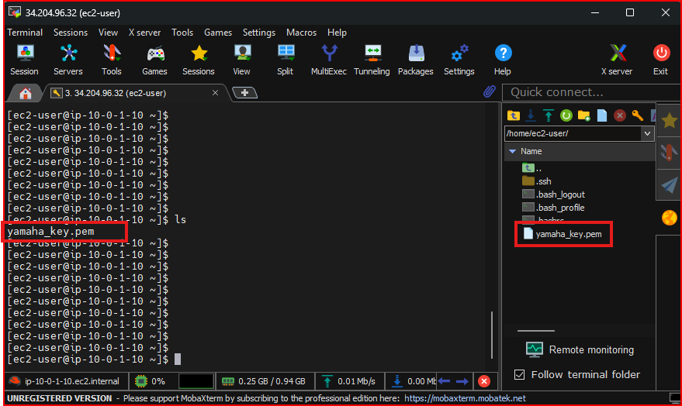
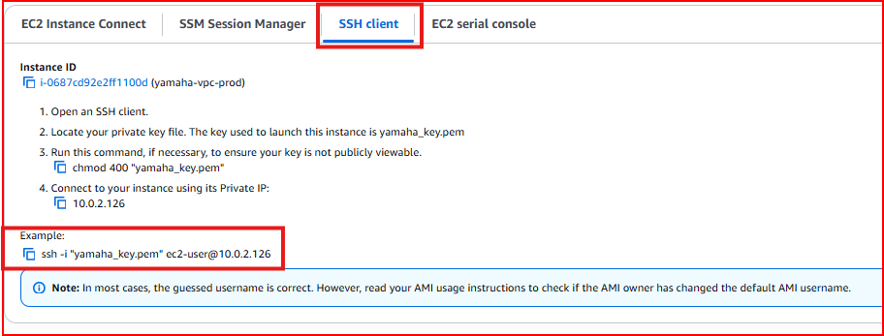
ssh -i ~/.ssh/your-key.pem ec2-user@<db-private-ip> # Run this FROM Dev instance
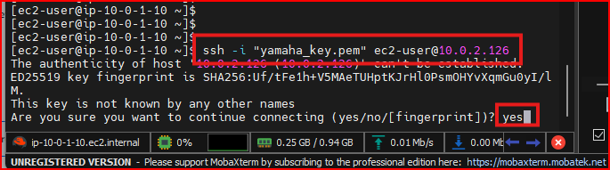
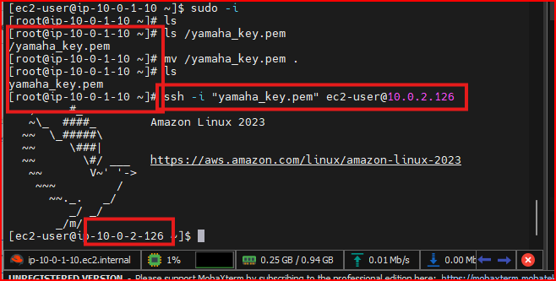
PART 3 – NAT Gateway & VPC Endpoints

Section 3.1 – NAT Gateway
A NAT (Network Address Translation) Gateway allows instances in a PRIVATE subnet to access the internet for outbound requests like software updates and package downloads — while keeping them completely inaccessible from the internet inbound.

Key feature: Outbound internet access for private instances — no inbound access from internet
Hides internal IPs: External services only see the NAT Gateway's IP, not the private instance IP
Managed by AWS: Highly available, scales automatically up to 45 Gbps, no maintenance required
Placement: NAT Gateway must be created in the PUBLIC subnet

Step 1 – Verify Current Setup
Confirm you have a Dev instance in the public subnet and a DB instance in the private subnet. The DB instance currently has no internet access at all.
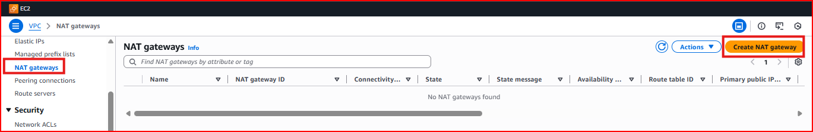
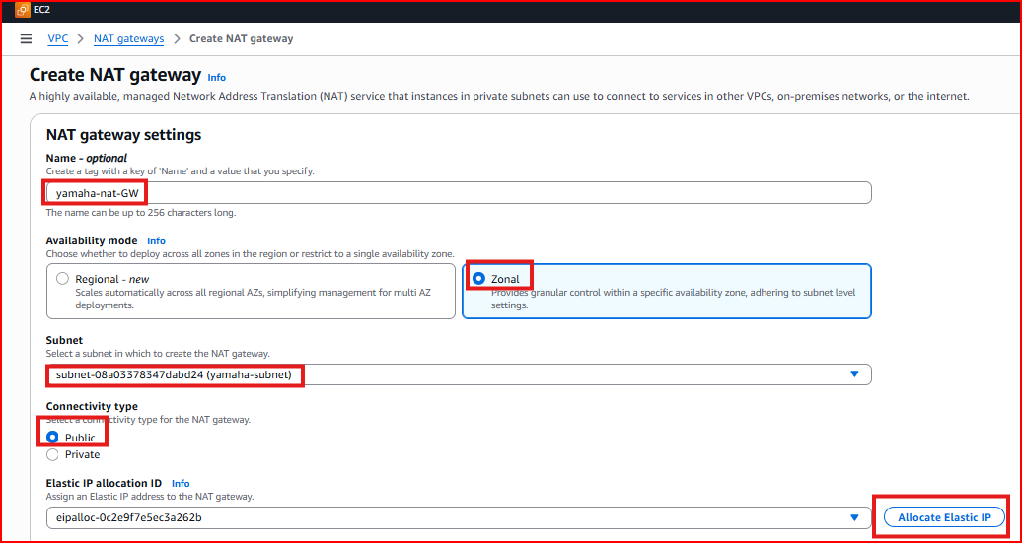
Step 2 – Create the NAT Gateway
Go to VPC → NAT Gateways → Create NAT Gateway. Place it in the PUBLIC Dev-Subnet and allocate an Elastic IP address (a fixed public IP that the NAT Gateway will use for outbound traffic).
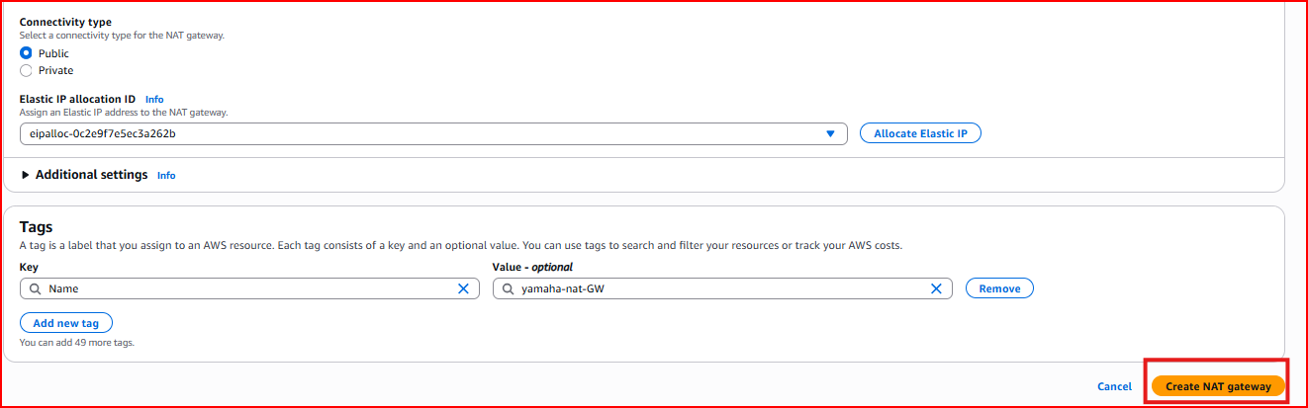
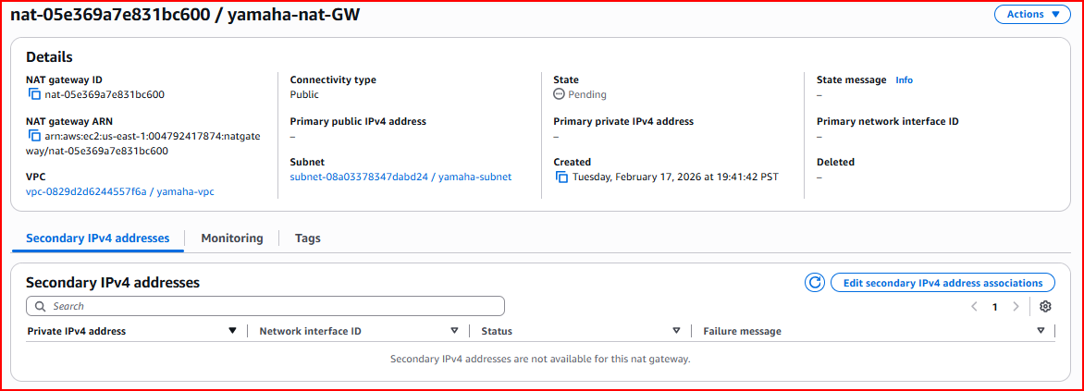
NAT GW Name: Insta-NAT-GW
Subnet: Dev-Subnet (must be PUBLIC)
Elastic IP: Click 'Allocate Elastic IP' to assign a fixed public IP
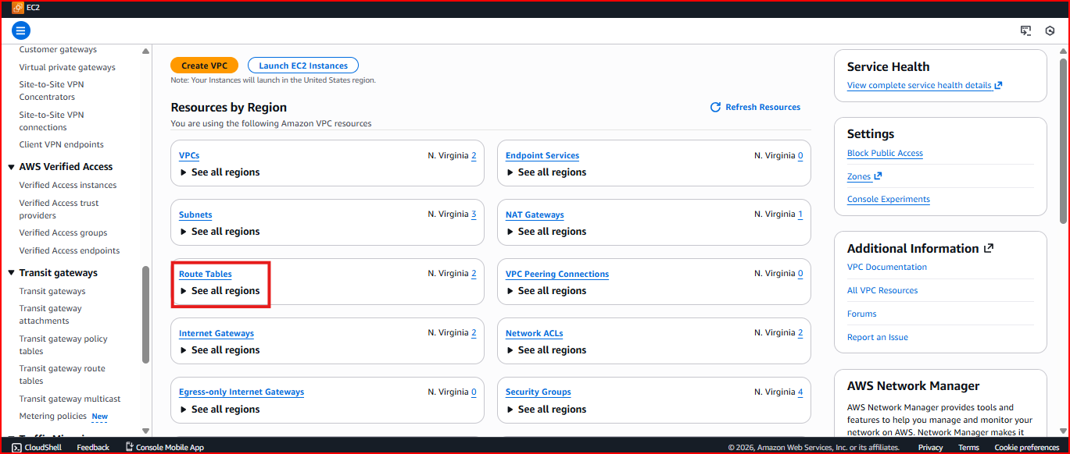
Wait: NAT Gateway takes 2-3 minutes to become Available after creation
Step 3 – Create a Private Route Table
Create a separate route table specifically for the private subnet. This route table will send all outbound internet traffic (0.0.0.0/0) through the NAT Gateway instead of the Internet Gateway.
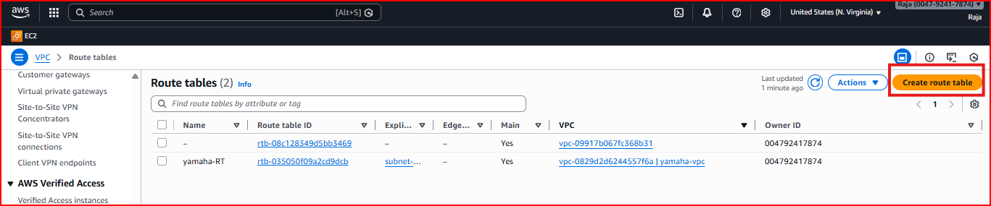
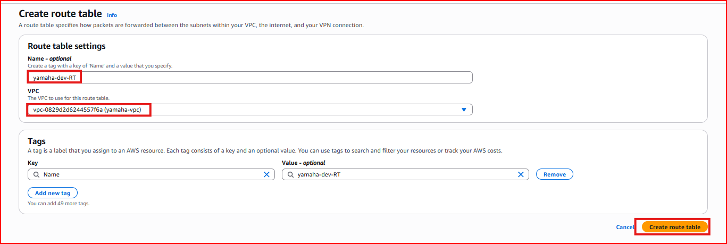
Route Table Name: Private-RT
Route added: Destination: 0.0.0.0/0 → Target: Insta-NAT-GW
Step 4 – Add NAT Gateway Route and Associate DB Subnet
Add the 0.0.0.0/0 route pointing to the NAT Gateway in the Private-RT, then associate the DB-Subnet with this private route table.
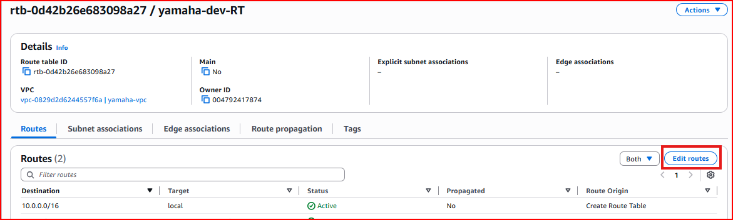
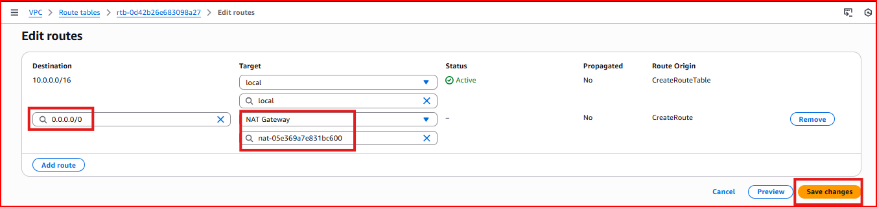
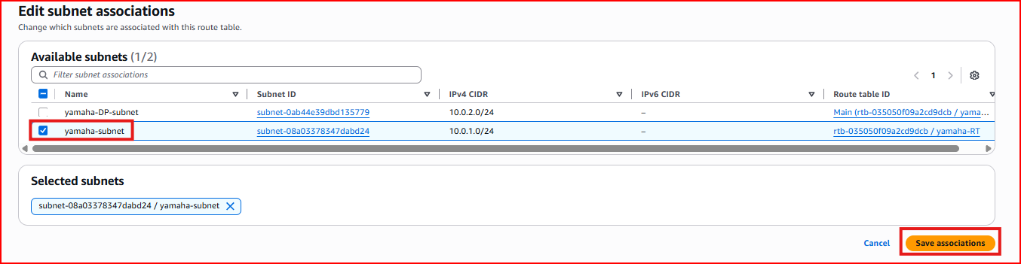
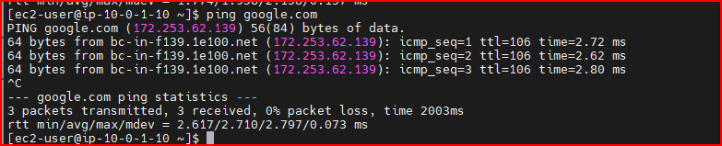
Step 5 – Test Internet Access from DB Instance
SSH into the DB instance via the Bastion Host and test internet connectivity. The DB instance can now access the internet outbound through the NAT Gateway.
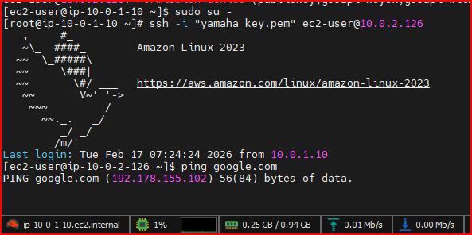
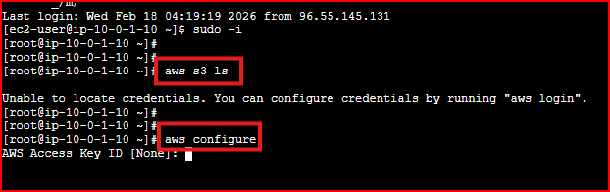
ping google.com # Should now work from DB instance via NAT Gateway
sudo yum update -y # Package updates now work on private instances
Section 3.2 – VPC Endpoints
A VPC Endpoint allows private instances to access specific AWS services (like S3) directly through the AWS private network — without going through the internet at all, even through NAT Gateway. This is more secure and often faster.

Use case: DB instance needs to access S3 (e.g., for backups) but should not have general internet access
Types: Gateway Endpoint (for S3 and DynamoDB) and Interface Endpoint (for other AWS services)
Benefit: Traffic stays within AWS network — more secure, no data transfer costs through NAT

Step 1 – Test S3 Access (Before Endpoint)
First verify the DB instance cannot access S3 or configure AWS CLI without going through the internet. Set up AWS credentials on the DB instance for testing.
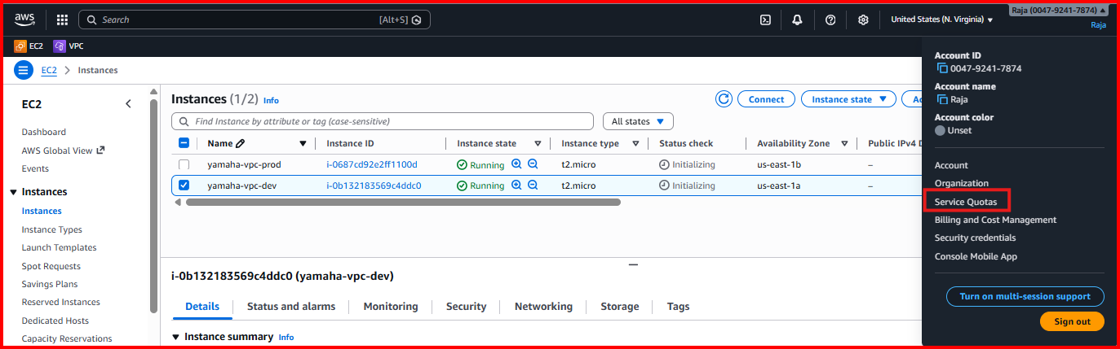
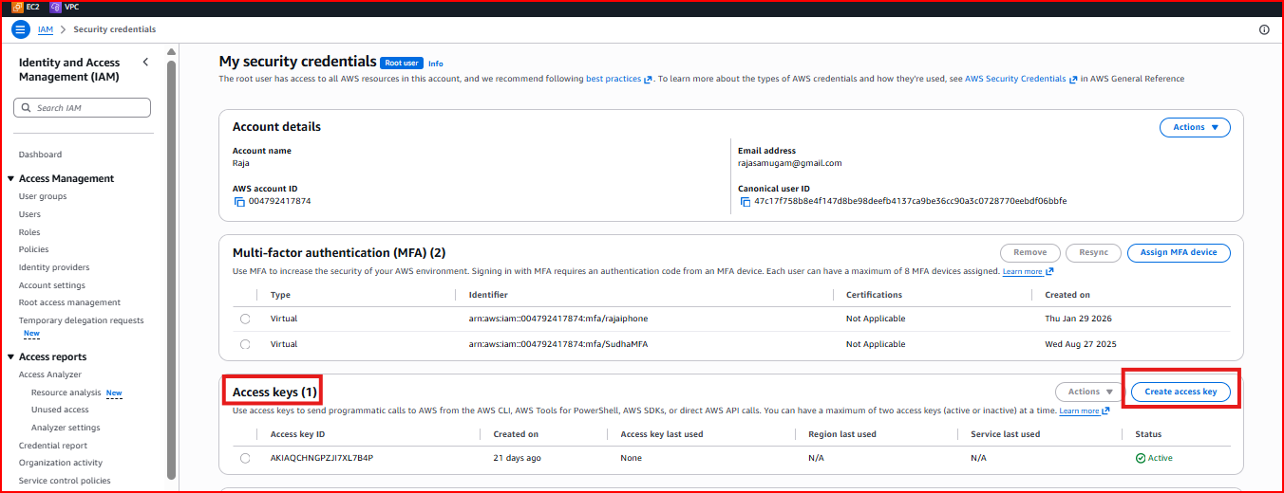
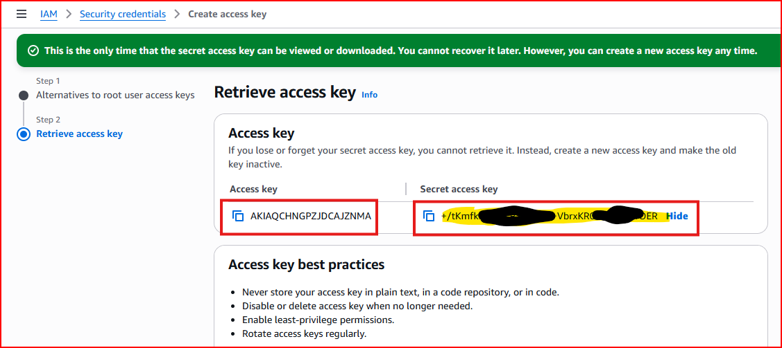
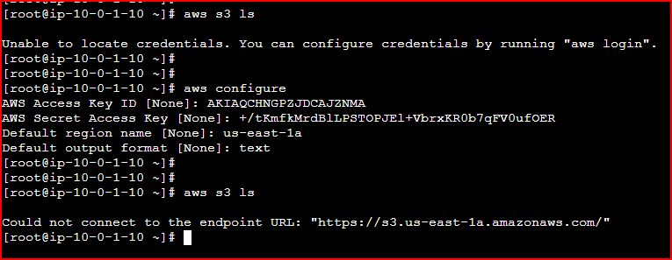
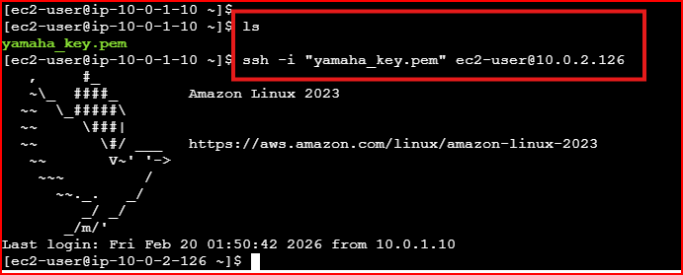
Step 2 – Create VPC Endpoint for S3
Go to VPC → Endpoints → Create Endpoint. Select 'AWS Services' as the service category, search for S3, and select the Gateway type endpoint. Associate it with your VPC and the private route table.
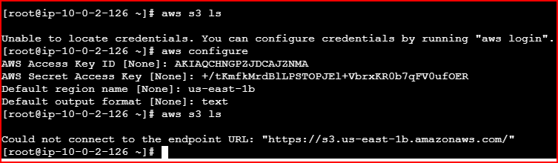
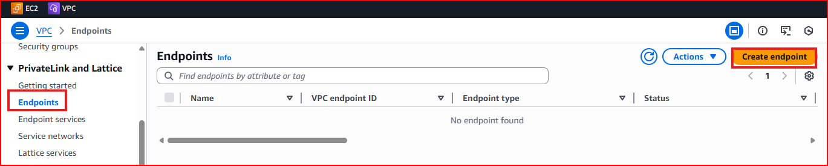
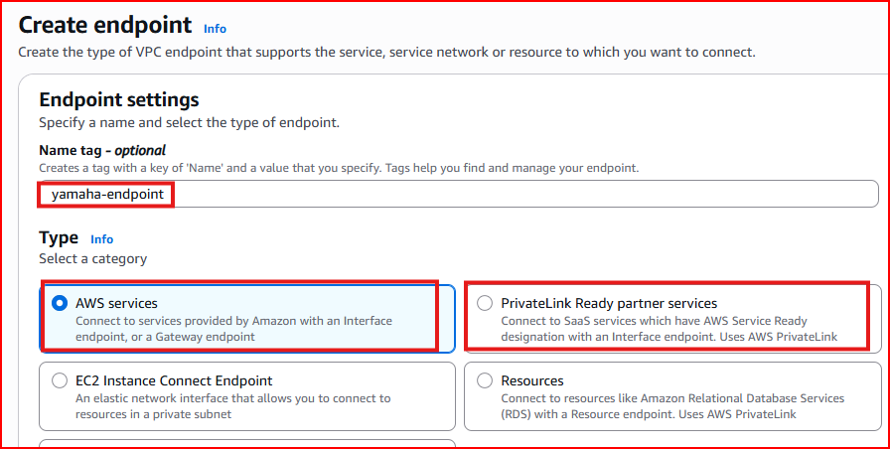
Service: com.amazonaws.<region>.s3
Type: Gateway (free — recommended for S3)
Route table: Select Private-RT so DB subnet traffic routes through the endpoint
Important: Do NOT select 'Express' option — select the standard AWS Services option
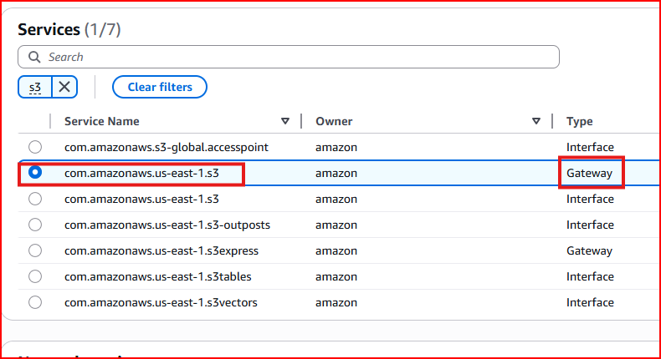
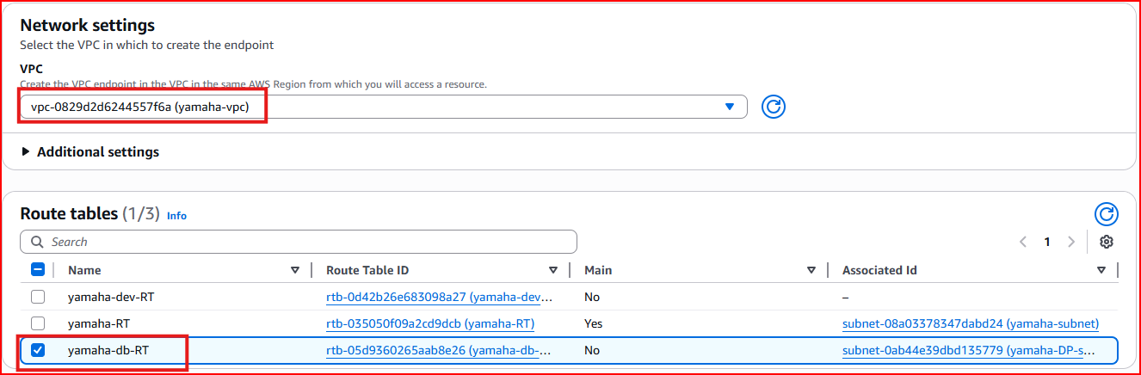
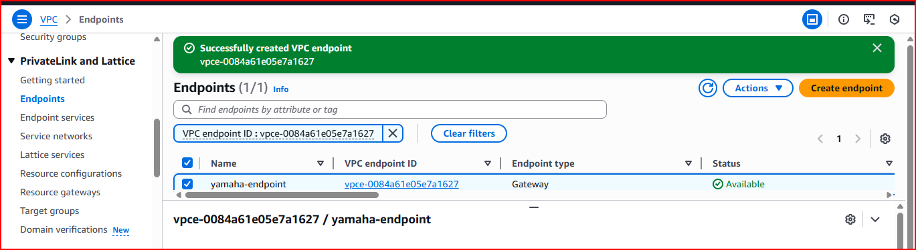
Step 3 – Verify S3 Access from DB Instance
After the endpoint is created, the DB instance can now access S3 directly through the AWS private network without internet access. Test by listing S3 buckets from the DB instance.
aws s3 ls # This should now work from the private DB instance
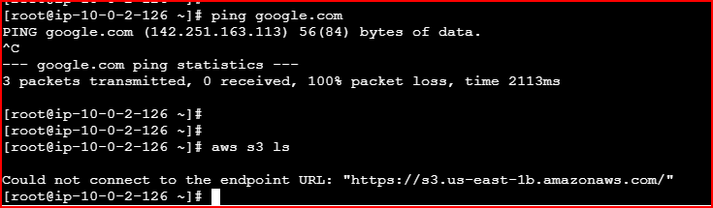
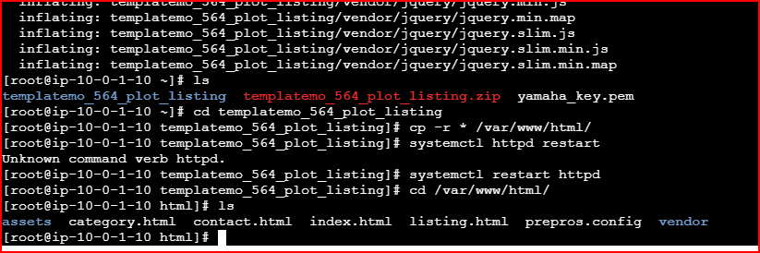
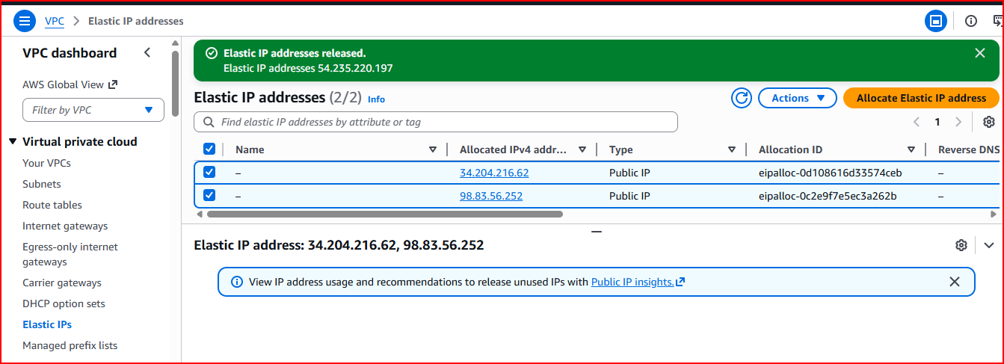
Result: DB instance can now access S3 only — other internet services remain blocked. This is the correct security posture for database servers
Project Summary
✅ Understood IP classes (A, B, C), subnetting, CIDR and reserved IP addresses
✅ Created a VPC with CIDR 10.0.0.0/16 with full isolation from other AWS customers
✅ Created a public subnet (Dev) with auto-assign public IP and internet access via IGW
✅ Created a private subnet (DB) with no internet access — secure for database servers
✅ Created an Internet Gateway and attached it to the VPC for public subnet internet access
✅ Configured Route Tables — public subnet routes to IGW, private subnet has no IGW route
✅ Launched Dev and DB instances in correct subnets and tested VPC connectivity with ping
✅ Used Bastion Host (Dev instance) to SSH into the private DB instance
✅ Created NAT Gateway in public subnet to allow private instances outbound internet access
✅ Created VPC Endpoint for S3 so DB instance can access S3 without going through internet
Interview Questions & Answers

Q1: What is a VPC and why is it important?
A VPC (Virtual Private Cloud) is your own isolated private network inside AWS. It is important because it gives you complete control over your network — you define the IP range, create subnets, control routing, and set firewall rules. Without a VPC, your resources would be exposed on a shared network. Every AWS account gets a default VPC but in production we always create custom VPCs for proper isolation and security.

Q2: What is the difference between a public and private subnet?
A public subnet has a route to an Internet Gateway, so instances launched there can have public IP addresses and communicate with the internet directly. A private subnet has no route to an Internet Gateway, so instances there have no public IP and cannot be reached from the internet — making them ideal for databases and backend servers that should never be publicly accessible.

Q3: What is an Internet Gateway and what is a NAT Gateway — how are they different?
An Internet Gateway allows two-way communication between your VPC and the internet — instances in public subnets can receive inbound connections and make outbound connections. A NAT Gateway only allows outbound connections from private instances — private servers can reach the internet for updates and downloads, but nobody from the internet can initiate a connection to them. NAT Gateway is placed in the public subnet and used by the private subnet.

Q4: What is a Bastion Host and why do you need it?
A Bastion Host is an EC2 instance in the public subnet that acts as a secure jump server to access private instances. Since DB instances in private subnets have no public IP, you cannot SSH into them directly from the internet. Instead you SSH into the Bastion Host (public instance) first, then from there SSH into the private DB instance using its private IP. This keeps the DB completely hidden from the internet while still allowing authorized access.

Q5: What is a VPC Endpoint and when would you use it?
A VPC Endpoint allows private instances to access AWS services like S3 directly through the AWS private network without going through the internet or NAT Gateway. I use it when a private database server needs to access S3 for backups but should not have general internet access. Traffic through a VPC Endpoint stays entirely within the AWS network — it is more secure and avoids NAT Gateway data transfer costs.

Q6: What is subnetting and why is it important in AWS?
Subnetting is dividing a large IP network into smaller sub-networks. In AWS it is important because it lets you isolate different tiers of your application — web servers in a public subnet, application servers in a private subnet, and databases in another private subnet. Each subnet has its own CIDR block, route table, and security controls. This gives you fine-grained control over which resources can communicate with each other and with the internet.

