AWS Advanced Networking & Load Balancing
VPC Peering | Network Interfaces | Flow Logs | Transit Gateway | VPN | Classic Load Balancer | ALB
Hands-On Project Documentation

What This Document Covers
This document covers advanced AWS networking features and load balancing services across three hands-on projects:
📌 Part 1 – VPC Peering, Network Interfaces, VPC Flow Logs & Transit Gateway
📌 Part 2 – VPN (OpenVPN) Setup & Classic Load Balancer
📌 Part 3 – Application Load Balancer (ALB) with Path-Based Routing

PART 1 – VPC Peering, Interfaces, Flow Logs & Transit Gateway

Section 1.1 – VPC Peering
VPC Peering is a private network connection between two VPCs that allows them to communicate using private IP addresses — as if they were in the same network. The VPCs can be in the same region, different regions, or even different AWS accounts.

Use case: Connect a development VPC in the US with a production VPC in India using private IPs
Traffic: Travels through AWS private backbone — never goes over the public internet
No transitive peering: If VPC-A peers with VPC-B and VPC-B peers with VPC-C, VPC-A cannot talk to VPC-C
Key rule: VPC CIDR ranges must NOT overlap — e.g., US VPC: 10.0.0.0/16 and India VPC: 172.16.0.0/16

Step 1 – Create Two VPCs in Different Regions
Create one VPC in the US region and another in the India (Mumbai) region. Each VPC needs its own unique CIDR block that does not overlap with the other.
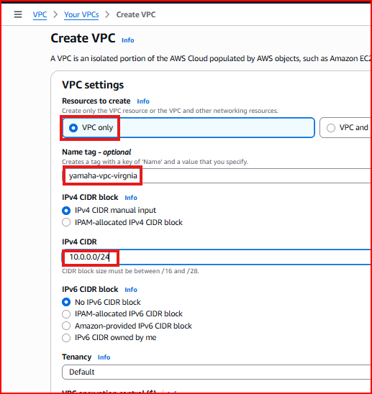
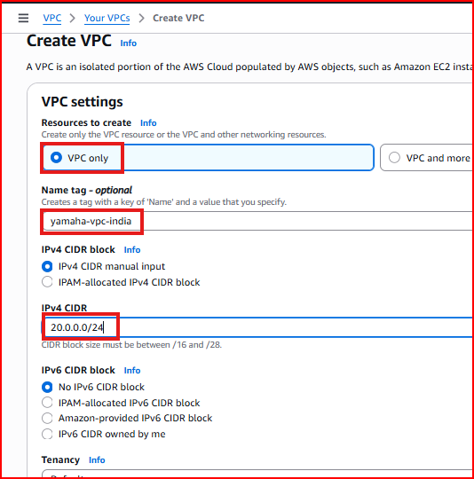
Step 2 – Create Subnets in Each VPC
Create subnets inside each VPC. The subnet CIDRs must also be non-overlapping between the two VPCs.
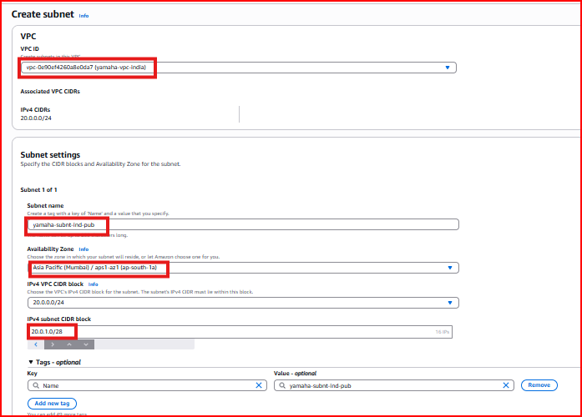
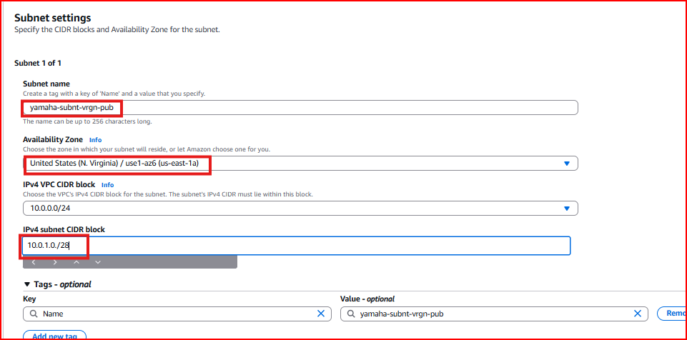
Step 3 – Enable Public IP and Configure IGW
Enable auto-assign public IP for testing purposes. Create and attach an Internet Gateway to both VPCs so instances can be accessed via SSH for testing.
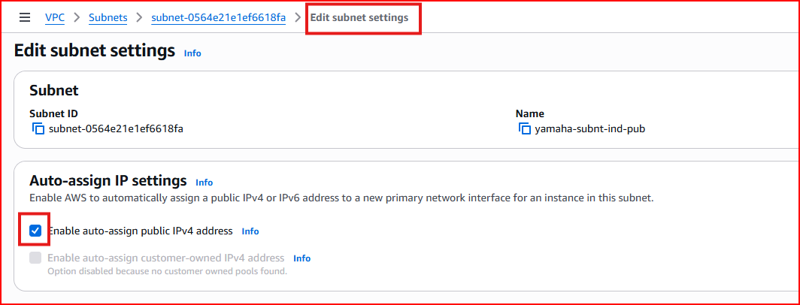
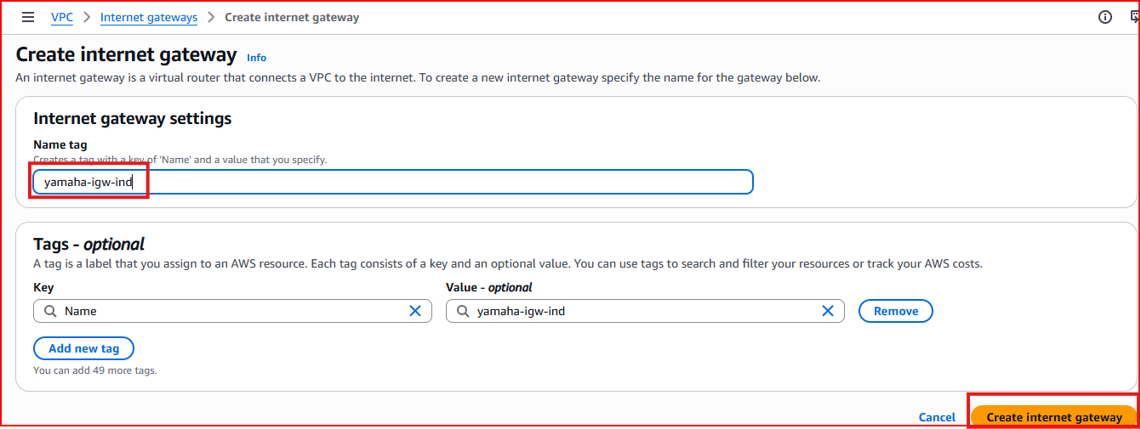
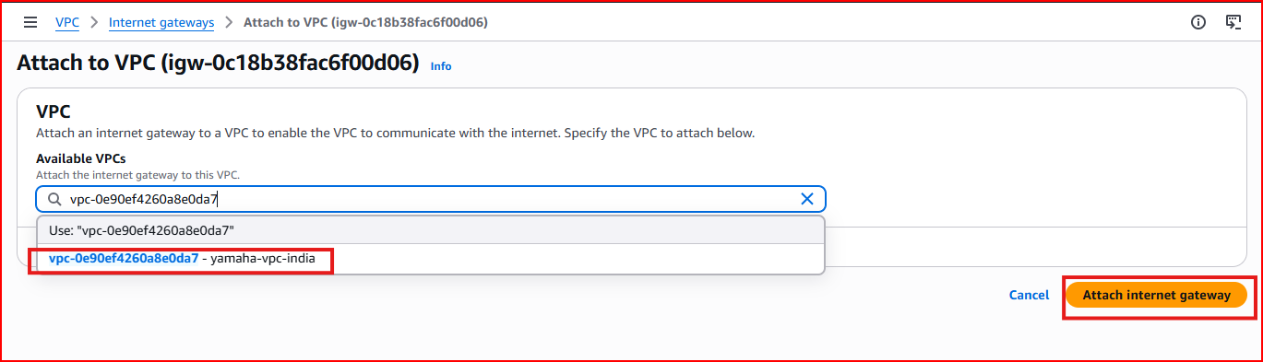
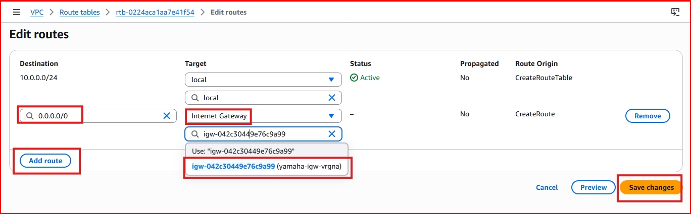
Step 4 – Launch EC2 Instances in Both Regions
Launch one EC2 instance in the US VPC and one in the India VPC. Note the private IP addresses of both instances — these will be used to test connectivity after peering is established.
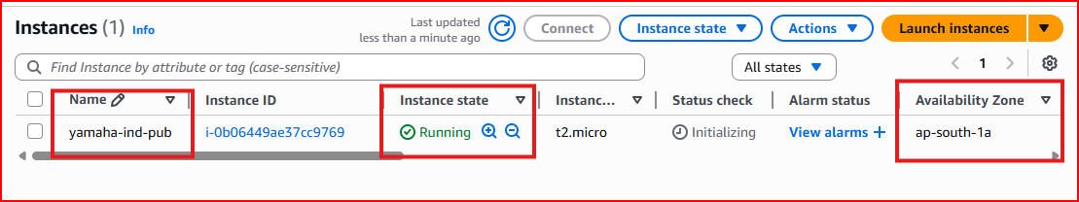
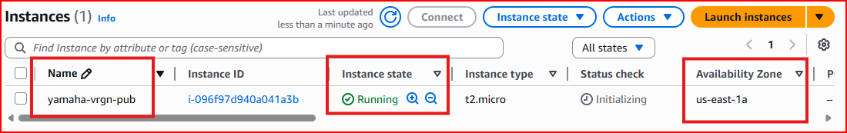
Step 5 – Test Connectivity Before Peering
Before peering, ping both instances. Only the public IPs respond — private IPs are unreachable across different VPCs without peering.
ping <public-ip> # Works — public internet routing
ping <private-ip> # Fails — no connection between VPCs yet
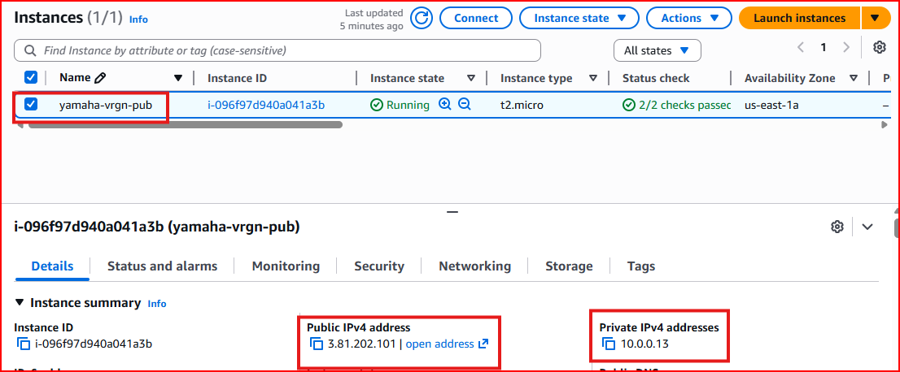
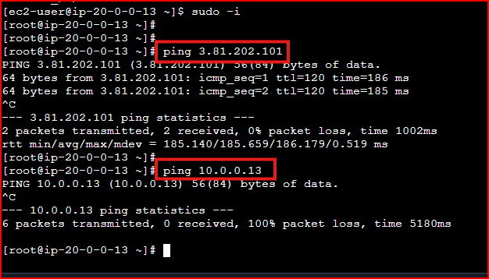
Step 6 – Create VPC Peering Connection
In the US VPC, go to VPC → Peering Connections → Create Peering Connection. Select the local VPC (US) as the requester and enter the India VPC ID as the accepter. Select the India region from the dropdown.
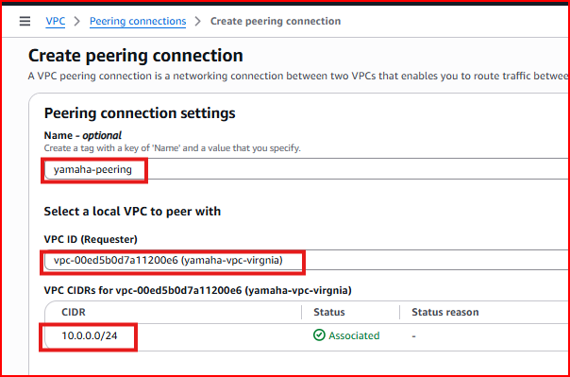
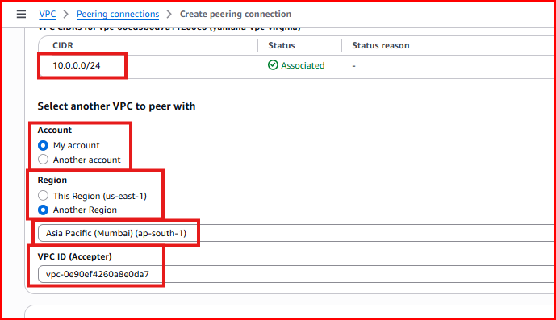
Step 7 – Accept the Peering Request from India
Switch to the India region in the AWS Console. Go to VPC → Peering Connections — the pending request from the US will appear. Click Actions → Accept Request to establish the peering connection.
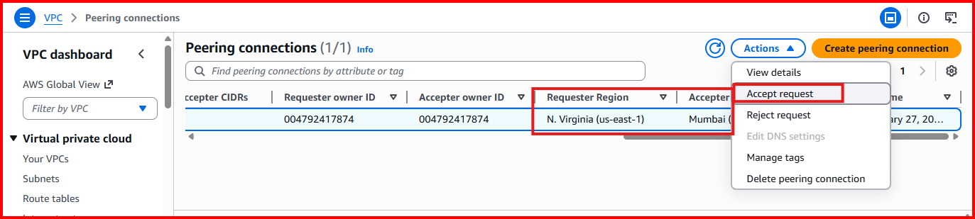
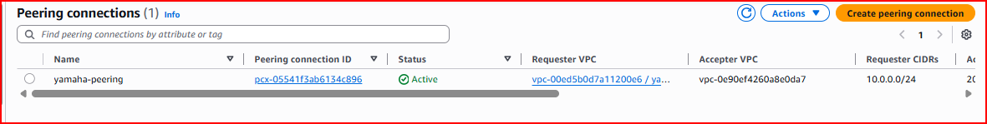
Important: Both sides must also update their Route Tables to route traffic for the other VPC's CIDR through the peering connection
Step 8 – Verify Private IP Connectivity
After peering is accepted and route tables are updated, ping the India instance from the US instance using its private IP. The ping now succeeds — confirming VPC peering is working.
ping <india-private-ip> # Now works through VPC peering!
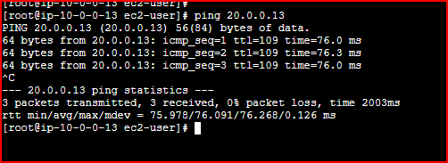

Section 1.2 – Transit Gateway (Multi-VPC Hub)
A Transit Gateway is a central hub that connects multiple VPCs and on-premises networks through a single gateway. Instead of creating individual peering connections between every pair of VPCs (which gets complex fast), all VPCs connect to the Transit Gateway and can communicate through it.

Problem it solves: With 5 VPCs, peering requires 10 individual connections. Transit Gateway needs only 5 connections (one per VPC)
Centralized connectivity: All VPCs connect to one hub — much simpler to manage
Supports: Thousands of VPCs, inter-region peering, on-premises connections via VPN
Who configures it: Typically the Network/Infrastructure team — not individual developers

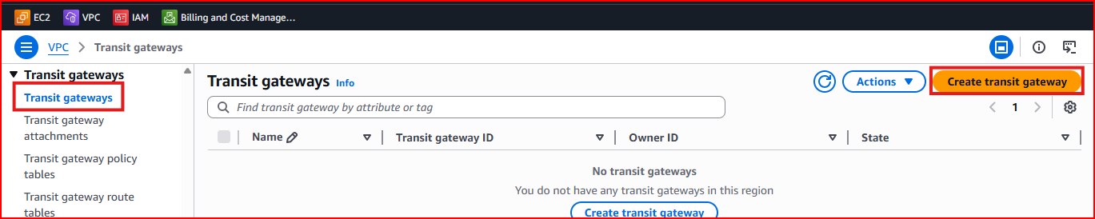
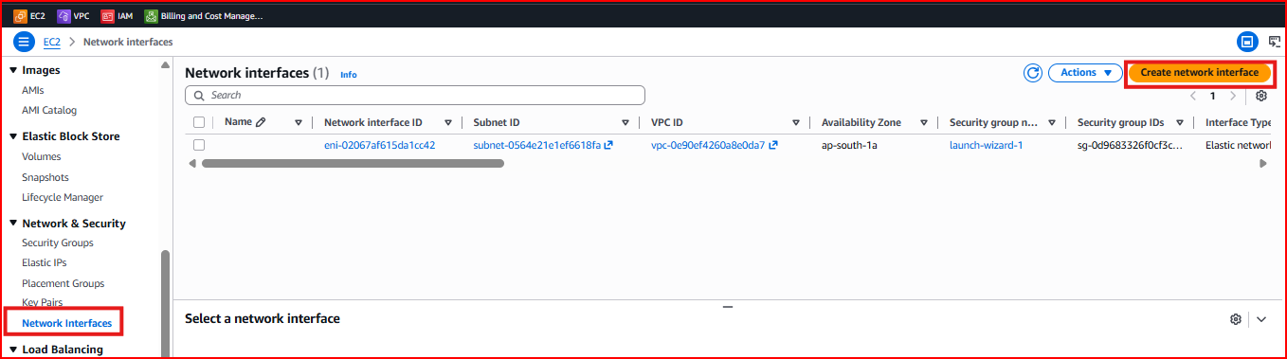
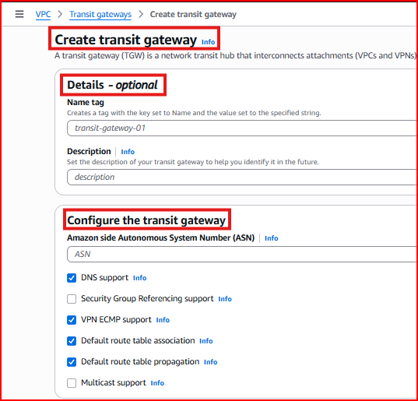
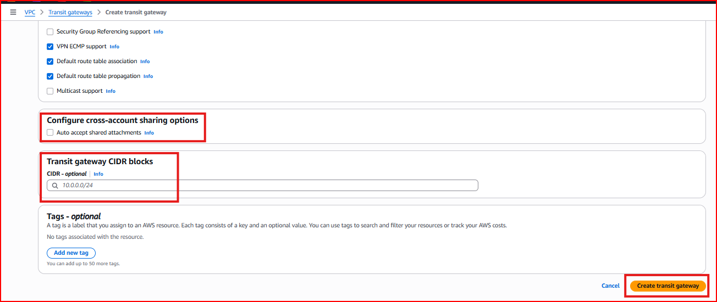

Section 1.3 – Network Interfaces (Multiple IPs on One Instance)
A Network Interface (ENI — Elastic Network Interface) is a virtual network card attached to an EC2 instance. By default every instance has one ENI with one private IP. You can add additional ENIs to give an instance multiple network interfaces and multiple private IP addresses.

Use case: A server that needs to be on two different subnets or VPCs simultaneously
Use case: High availability — if one interface fails, traffic can failover to another
Use case: Separating management traffic from application traffic

Step 1 – Create an Additional Network Interface
Go to EC2 → Network & Security → Network Interfaces → Create Network Interface. Select the subnet and security group for the new interface.
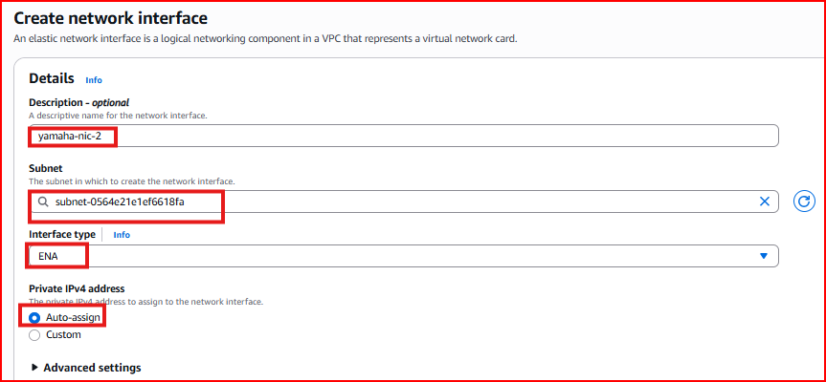
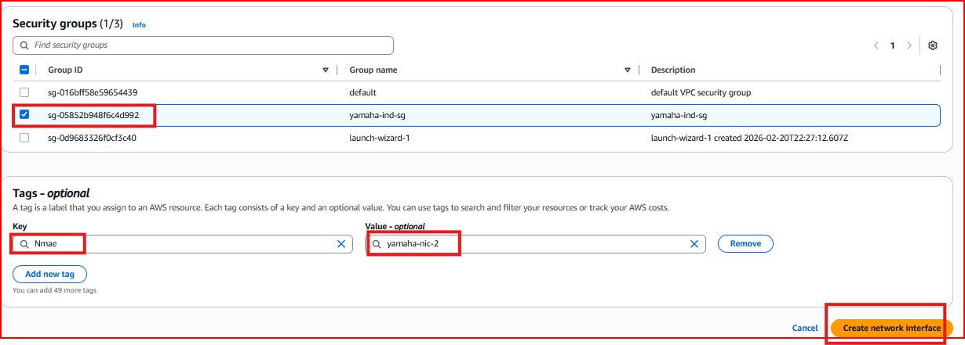
Step 2 – Attach the Interface to an Instance
Select the new network interface, click Actions → Attach, and select the EC2 instance to attach it to. The instance must be in the same VPC.
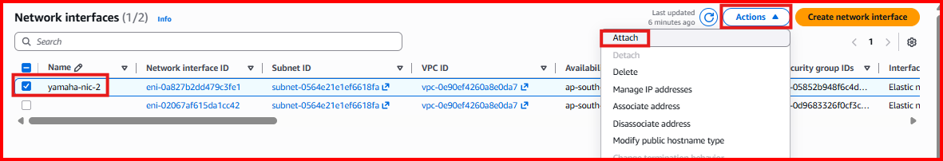
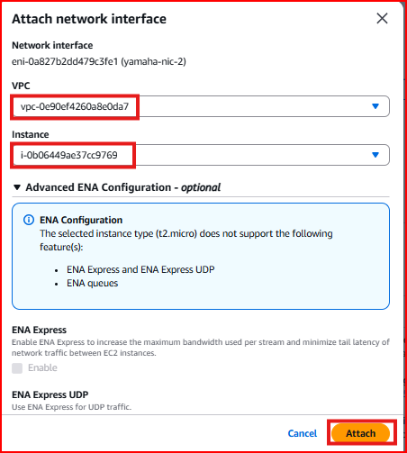
Step 3 – Verify Two IPs on the Instance
After attaching, the instance now has two network interfaces and two private IP addresses. You can verify this in the EC2 Console under the instance details or by running ifconfig inside the instance.
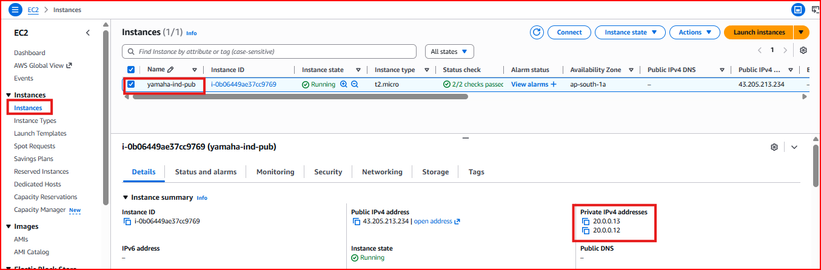

Section 1.4 – VPC Flow Logs (Network Traffic Capture)
VPC Flow Logs capture information about all IP traffic going to and from network interfaces in your VPC. This is essential for security monitoring, troubleshooting connectivity issues, and compliance auditing. Flow Logs can be enabled at three levels: VPC, Subnet, or individual Network Interface.

VPC level: Captures all traffic for every resource in the entire VPC
Subnet level: Captures all traffic within a specific subnet
Interface level: Captures traffic for one specific EC2 instance's network interface
Destination: Logs are sent to CloudWatch Logs for analysis

Step 1 – Create Flow Log for VPC
Go to VPC → Your VPCs → select your VPC → Flow Logs tab → Create Flow Log. Choose to capture all traffic (Accept, Reject, or All).
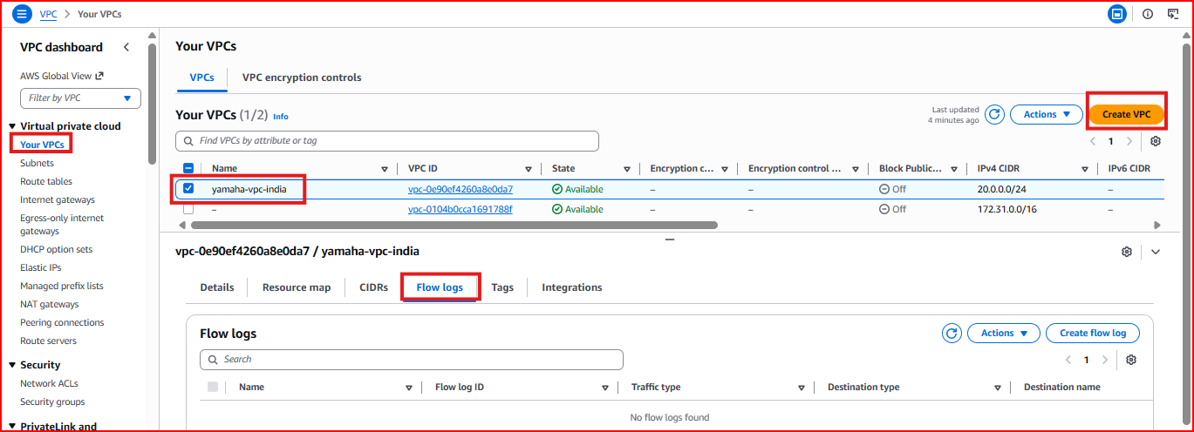
Step 2 – Create Flow Log for Subnet
Go to VPC → Subnets → select a subnet → Flow Logs tab → Create Flow Log to capture traffic at subnet level.
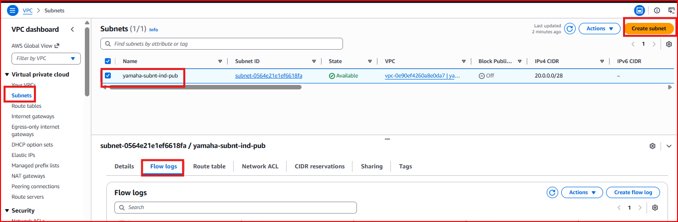
Step 3 – Create Flow Log for Instance (Network Interface)
Go to EC2 → select instance → Networking tab → Network Interface → select the interface. Scroll to the bottom to find the Flow Logs section.
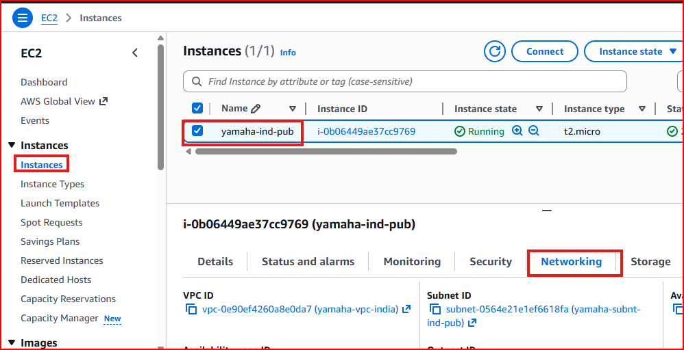
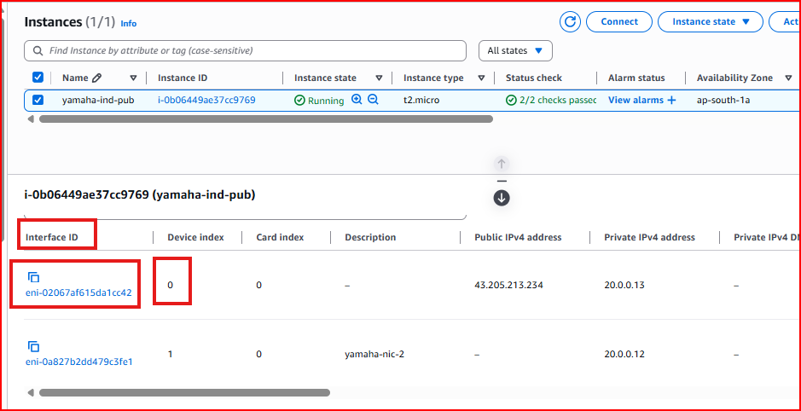
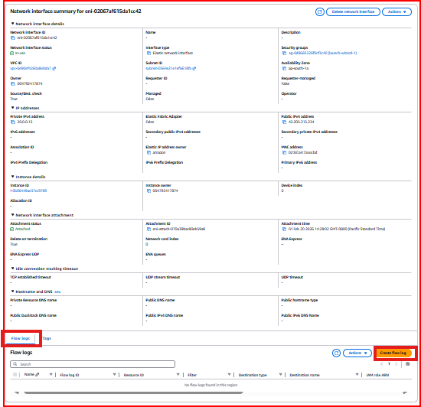
Step 4 – Create CloudWatch Log Group
Create a CloudWatch Log Group to store the flow log data. When creating the flow log, select CloudWatch Logs as the destination and choose or create a log group and IAM role that allows VPC to write to CloudWatch.
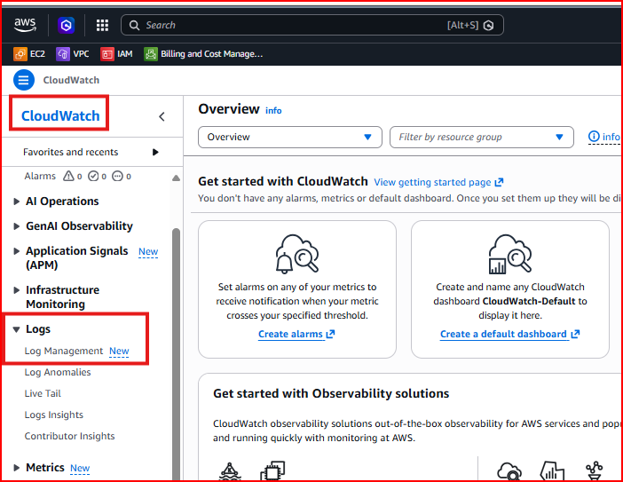
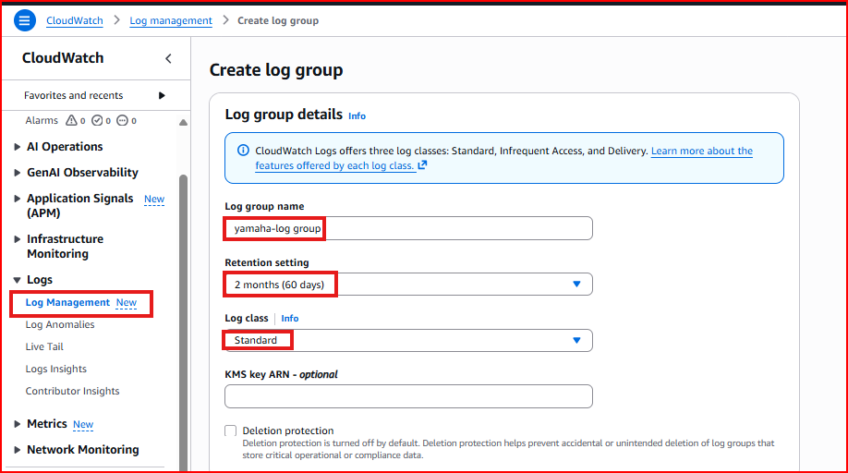
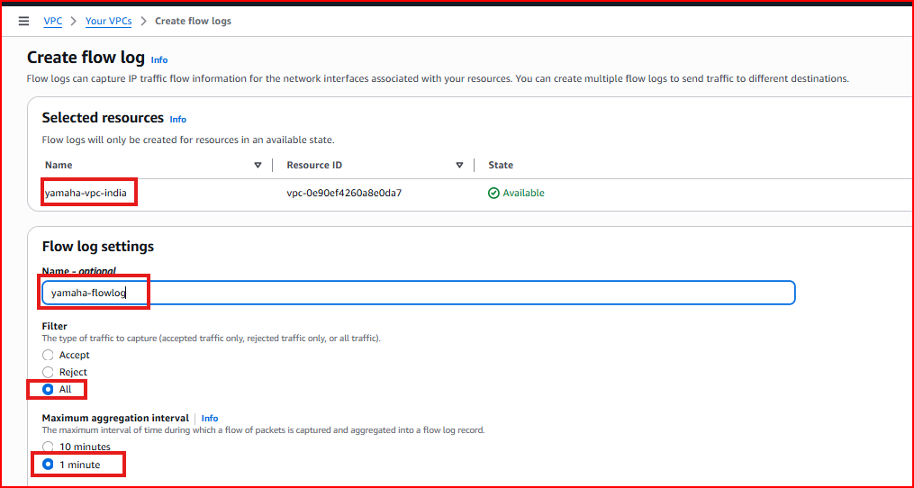
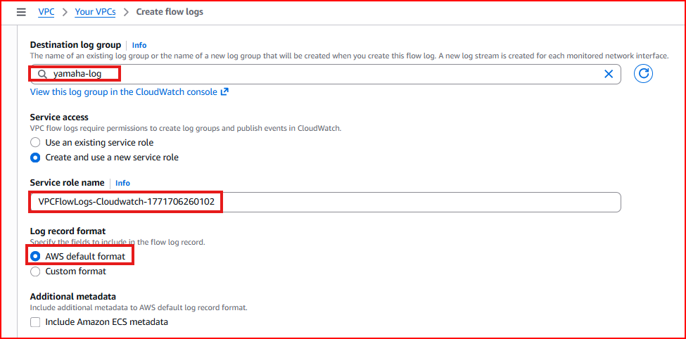
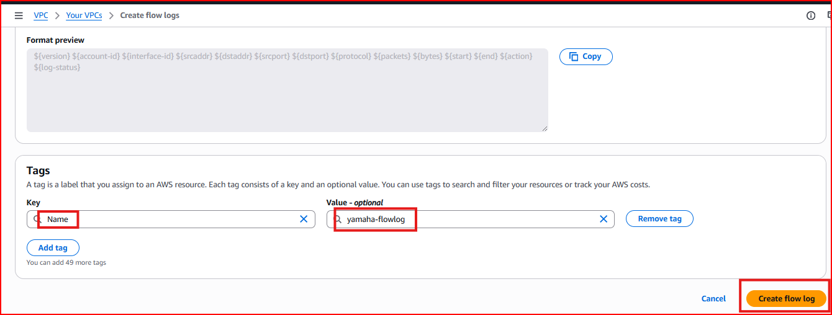
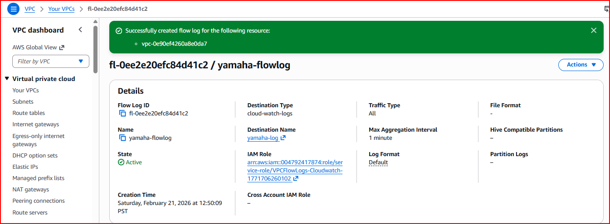
Step 5 – View the Captured Flow Logs
Go to CloudWatch → Log Groups → select your flow log group. You will see log streams for each network interface. Each log entry shows source IP, destination IP, port, protocol, bytes transferred, and whether traffic was ACCEPTED or REJECTED.
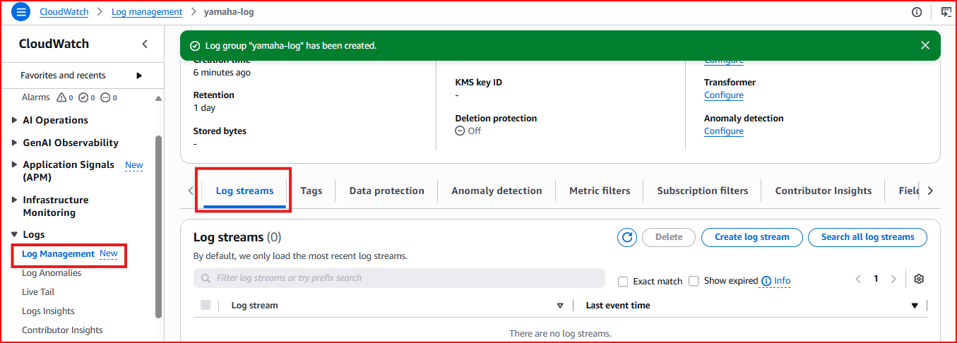
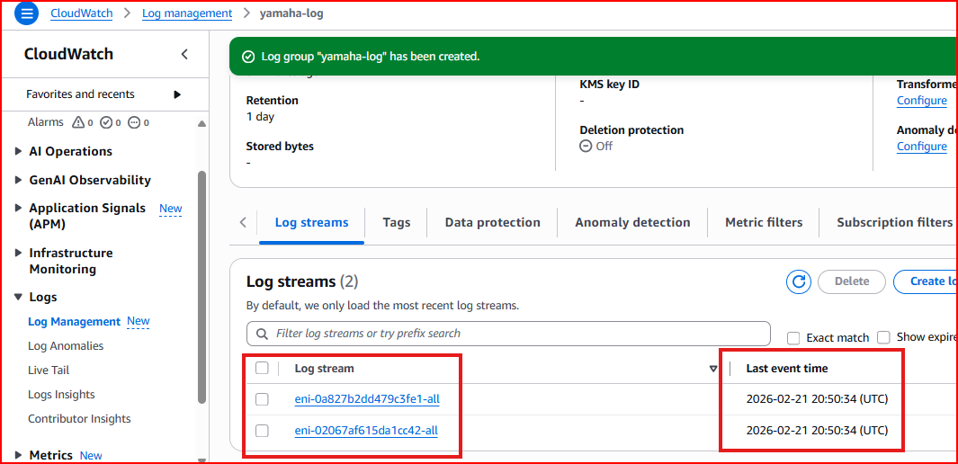
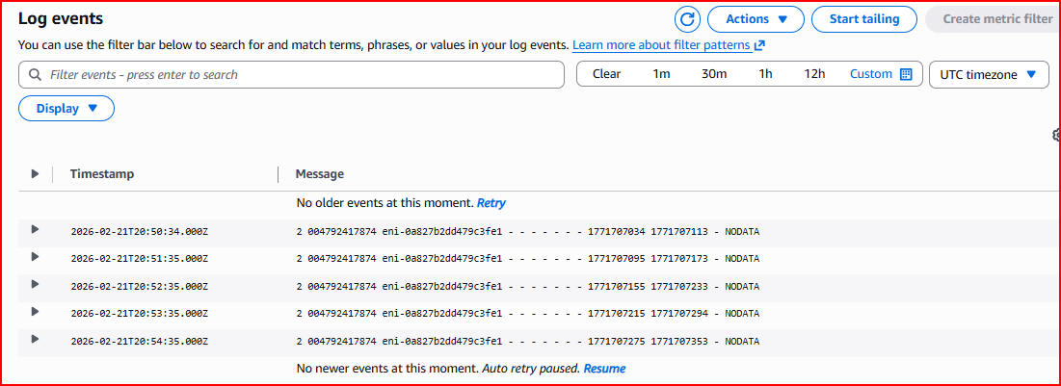

PART 2 – VPN & Classic Load Balancer

Section 2.1 – VPN (Virtual Private Network)
A VPN creates a secure, encrypted tunnel between your on-premises network (or remote users) and your AWS VPC. All traffic through this tunnel is encrypted, making it safe to transmit sensitive data over the public internet.

OpenVPN: Software-based VPN — easy to set up, allows remote users to connect to AWS VPC securely
Site-to-Site VPN: Connects an entire office network to AWS VPC — always-on encrypted tunnel
Direct Connect: Physical dedicated connection from your data center to AWS — highest speed and security, no internet

Step 1 – Launch OpenVPN Instance from AWS Marketplace
Instead of setting up VPN software manually, AWS Marketplace provides a ready-made OpenVPN AMI. Search for 'OpenVPN' in the EC2 launch wizard under AWS Marketplace and select the BYOL (Bring Your Own License) option.
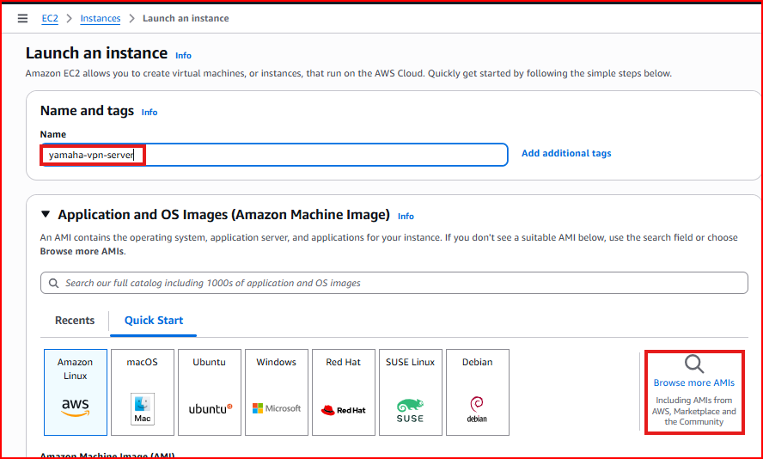
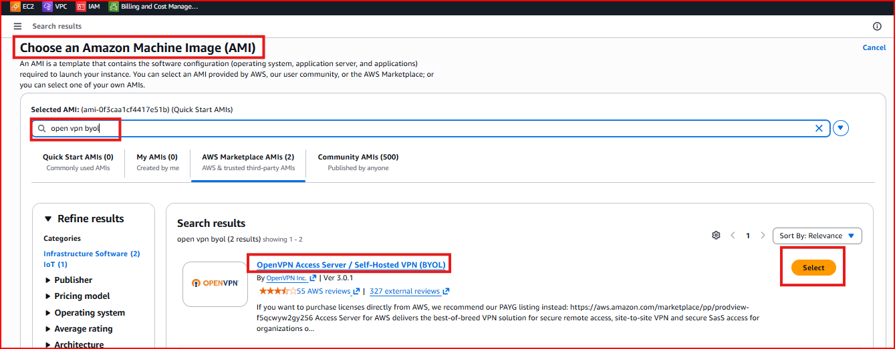
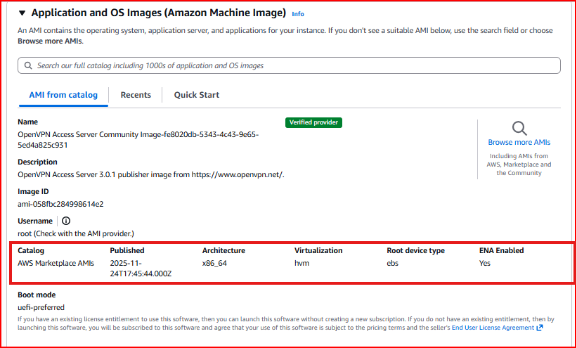
Step 2 – Configure the OpenVPN Instance
Complete the EC2 launch configuration — select instance type, key pair, and security group. The OpenVPN AMI requires specific ports to be open: UDP 1194 (VPN traffic) and TCP 943 (admin UI).
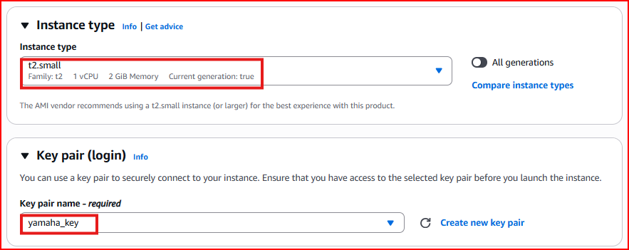
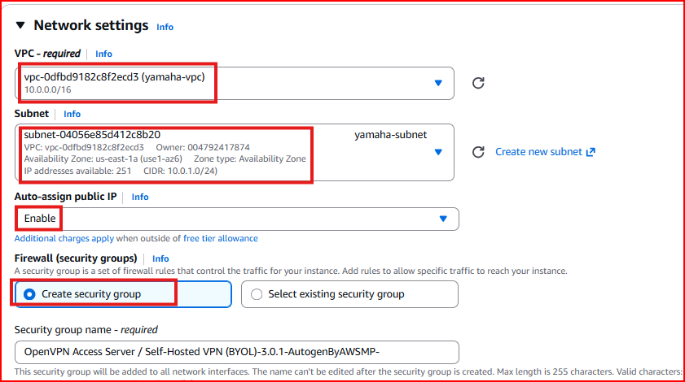
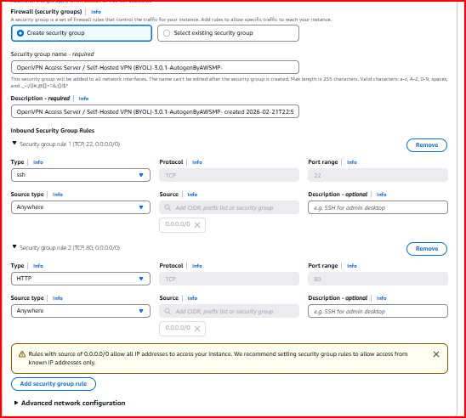
Step 3 – Initial OpenVPN Setup via SSH
SSH into the OpenVPN instance. On first login it will run a setup wizard. Accept all default options EXCEPT the Admin UI — answer Yes to everything and configure your admin username and password.
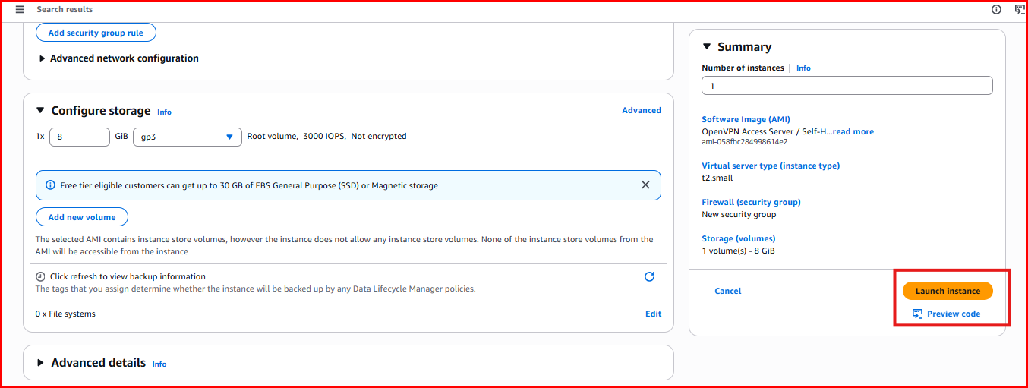
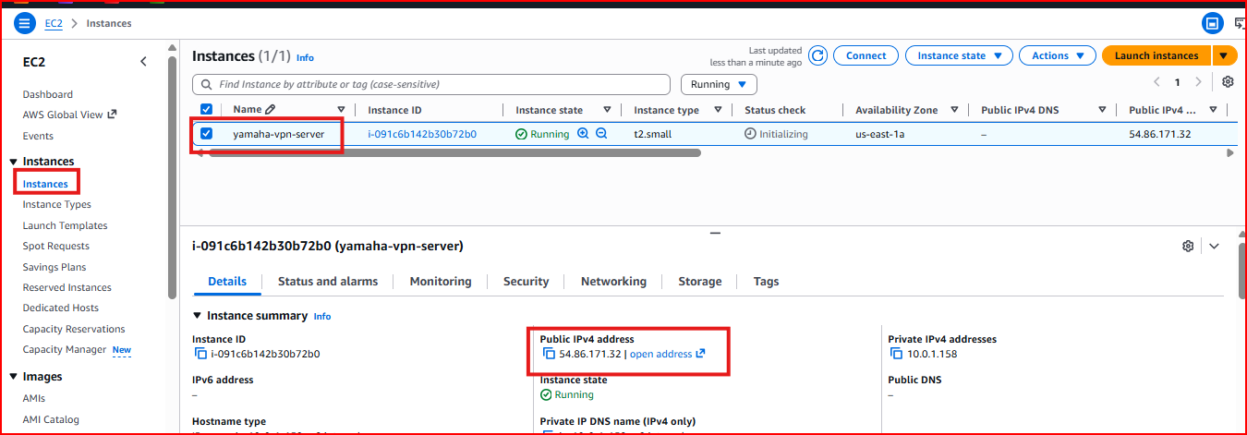
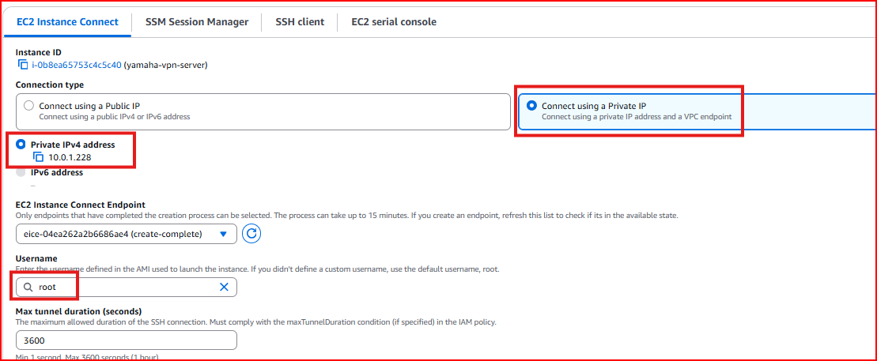
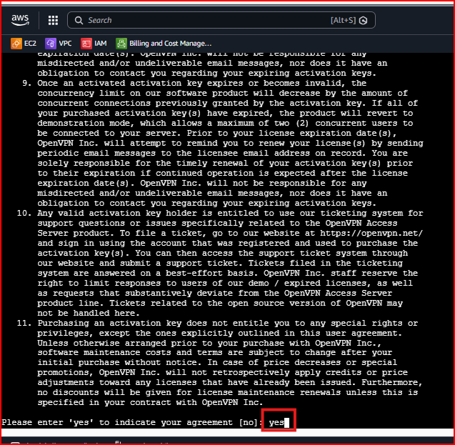
When prompted: Accept all defaults EXCEPT Admin UI — answer Yes to everything else
Step 4 – Configure Admin Settings
Set up your VPN admin credentials during the wizard.
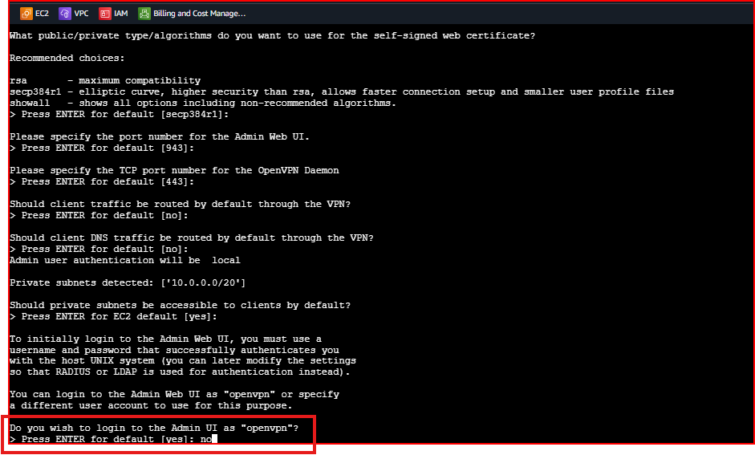
Step 5 – Access OpenVPN Admin UI
Open a browser and navigate to the OpenVPN Admin UI. Log in with your admin credentials to manage VPN users and settings.
https://<public-ip>:943/admin
Username: yamahavpn
Password: Yamaha@123 (or your configured password)
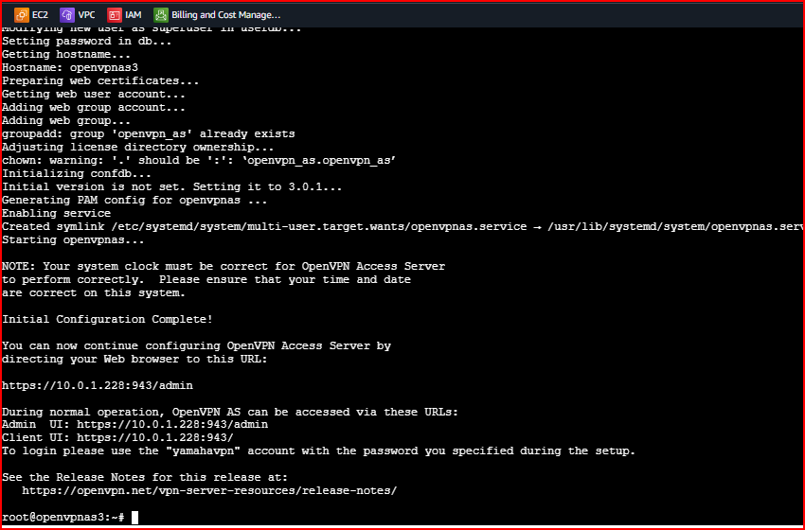
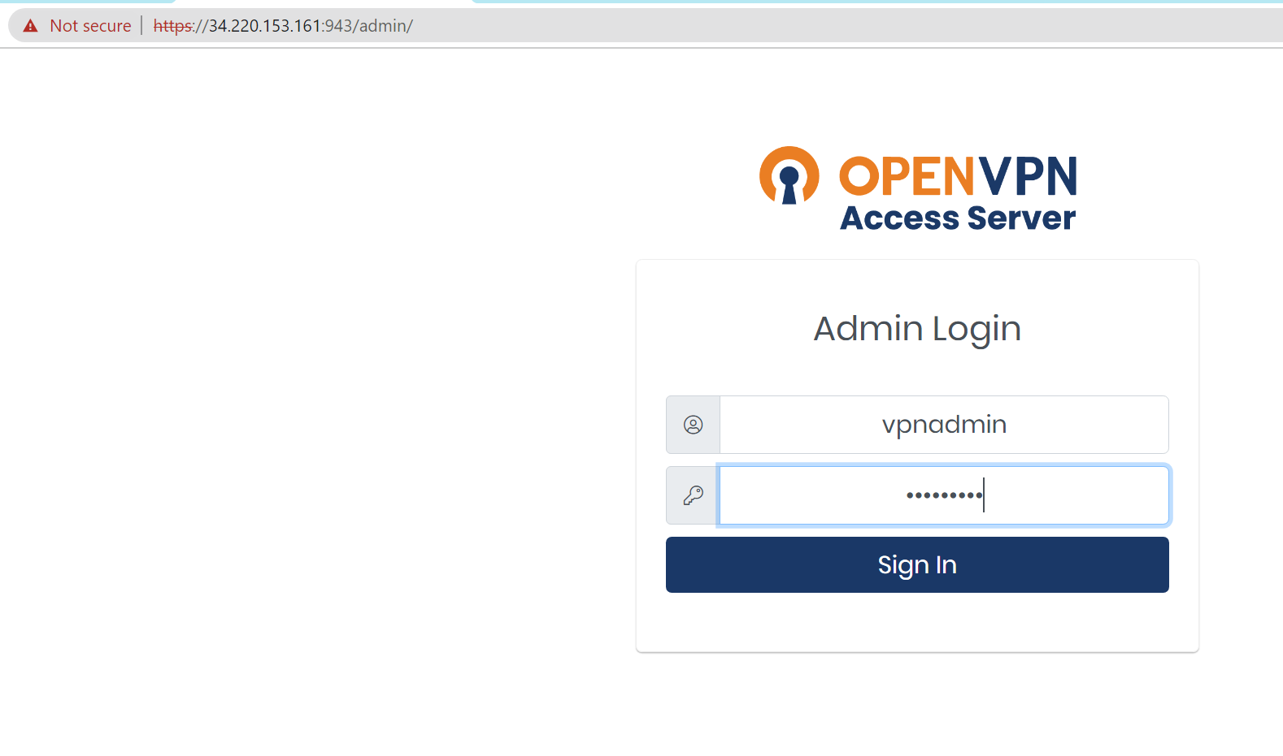

Section 2.2 – Classic Load Balancer Setup
A Load Balancer distributes incoming traffic across multiple EC2 instances so no single server gets overloaded. It also provides high availability — if one server fails, the Load Balancer automatically routes traffic to healthy servers only.

Classic LB: Legacy load balancer — works at both Layer 4 (TCP) and Layer 7 (HTTP)
How it works: Users connect to the LB DNS name — the LB distributes each request to one of the backend servers
Health checks: LB continuously monitors instances and removes unhealthy ones from rotation

Step 1 – Launch Two EC2 Instances in Different AZs
Create two EC2 instances in different Availability Zones. Having servers in different AZs ensures your application stays available even if one entire AZ has an outage.
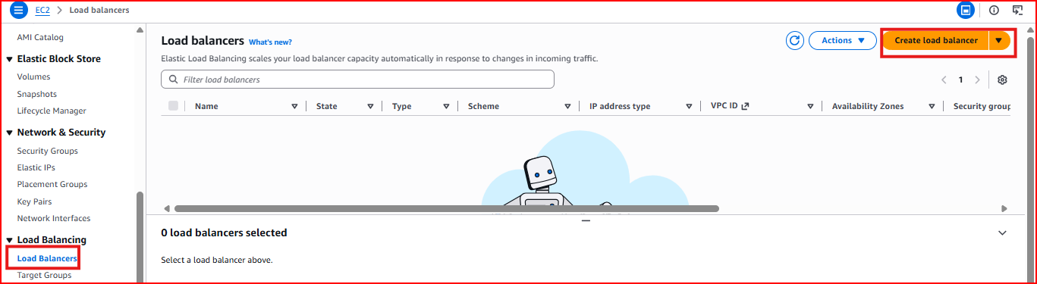
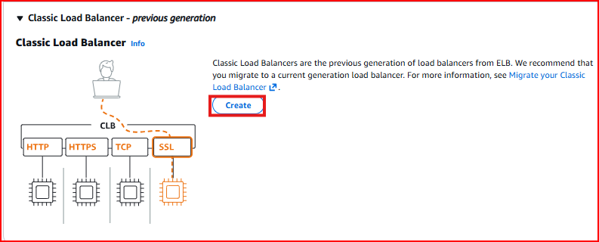
Step 2 – Install Apache and Create Different Coloured Web Pages
Install Apache on both servers and create distinct HTML pages so you can visually confirm which server the Load Balancer is sending you to. Use different background colours on each server.
sudo yum install httpd -y && sudo systemctl start httpd && sudo systemctl enable httpd
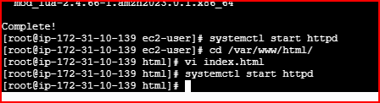

Web Server 1 page: Blue background — confirms request went to Server 1
Web Server 2 page: Green background — confirms request went to Server 2
cd /var/www/html
sudo vi index.html
Server 1 HTML content:
<h1 style="background-color:DodgerBlue;">Hello World</h1>
Server 2 HTML content:
<h1 style="background-color:green;">Hello World</h1>
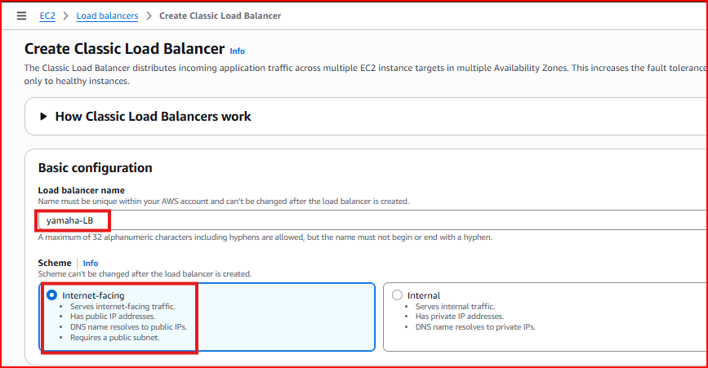
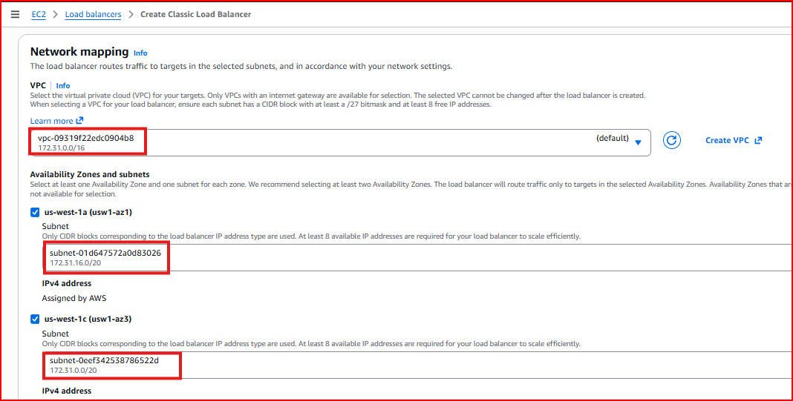
Step 3 – Create the Load Balancer
Go to EC2 → Load Balancers → Create Load Balancer → Classic Load Balancer. Configure the listener on port 80 (HTTP), select both Availability Zones, and add both EC2 instances as targets.
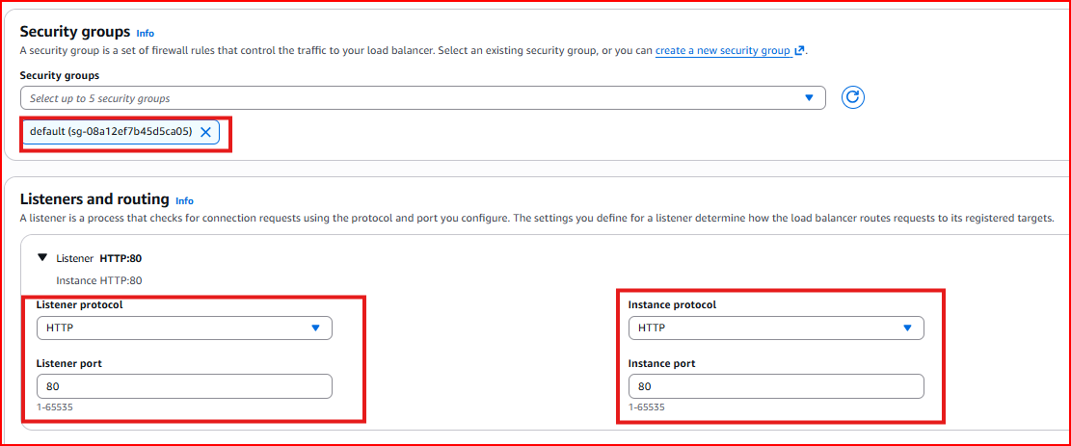
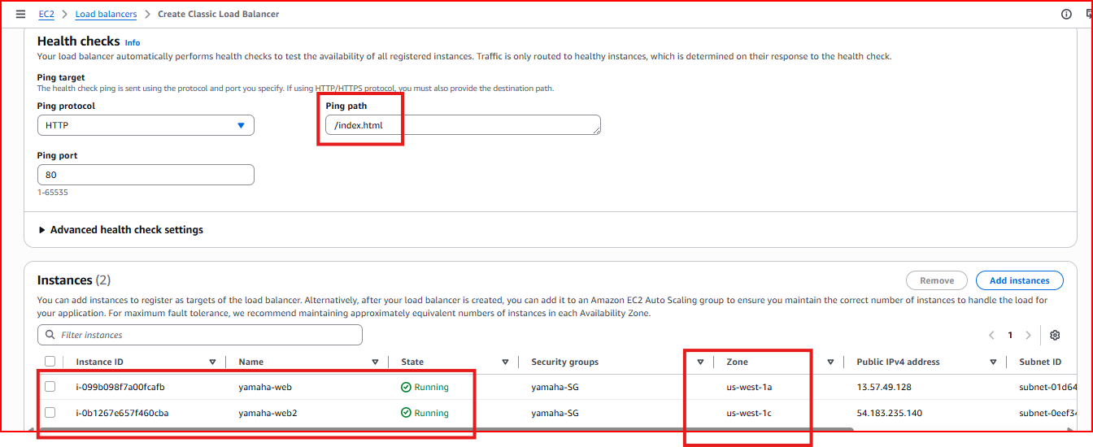
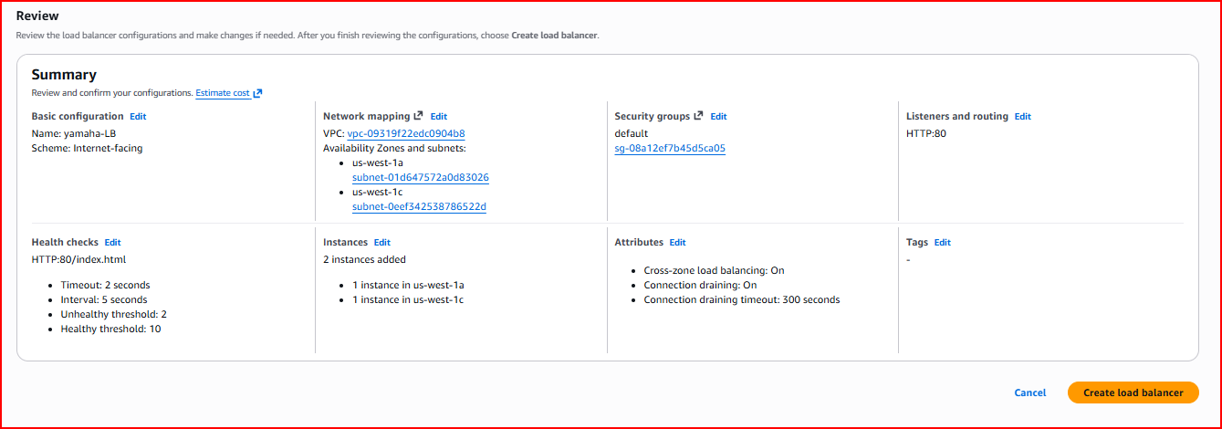
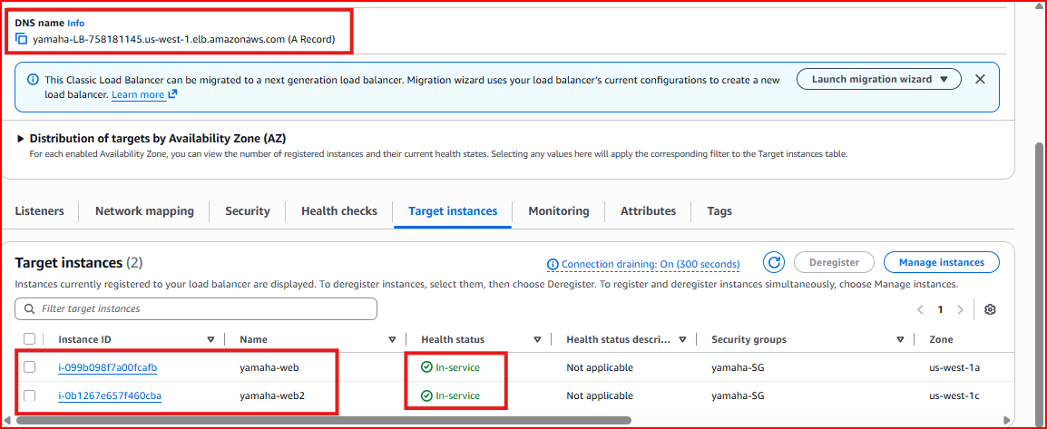
Step 4 – Verify Load Balancer is Active
Wait for the Load Balancer state to become 'Active'. Copy the Load Balancer DNS name and open it in a browser. Refresh the page multiple times — you will see the page alternate between blue and green, confirming the LB is distributing traffic between both servers.
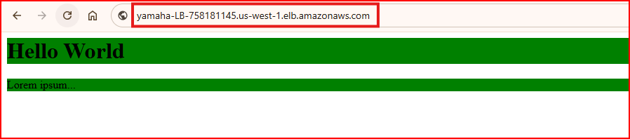
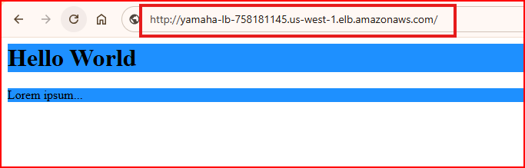
Test result: Each page refresh may show a different colour — proving traffic is being distributed across both servers

PART 3 – Application Load Balancer (ALB) with Path-Based Routing

Section 3.1 – What is an Application Load Balancer?
An Application Load Balancer (ALB) operates at Layer 7 (Application Layer) and can make intelligent routing decisions based on the content of the HTTP request — specifically the URL path, hostname, or HTTP headers. This makes it far more powerful than a Classic Load Balancer.

Layer 7 routing: Routes based on URL path, not just TCP port
Path-based routing: / → Main servers | /videos/* → Video servers | /images/* → Image servers
Target Groups: Groups of servers that handle specific types of requests
Use case: Microservices architecture where different services handle different URL paths

Project Architecture
This project sets up a social media platform with three separate services, each handled by dedicated servers in two Availability Zones:
Main Application: Web1 (AZ-2a) + Web2 (AZ-2b) — handles all traffic at /
Video Service: Web3 (AZ-2a) + Web4 (AZ-2b) — handles traffic at /videos/*
Image Service: Web5 (AZ-2a) + Web6 (AZ-2b) — handles traffic at /images/*
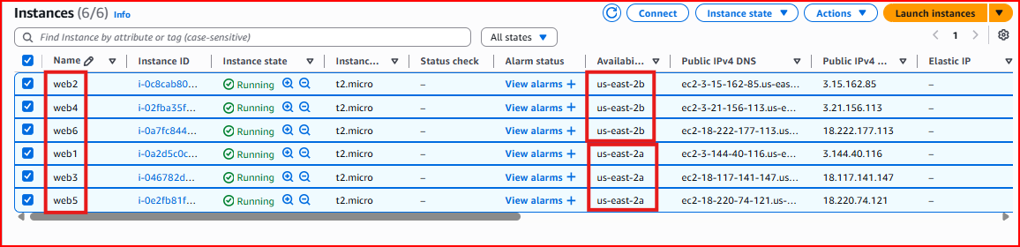
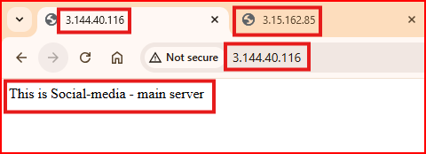
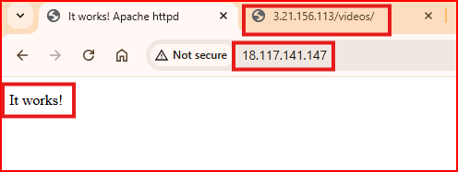
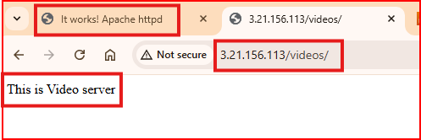
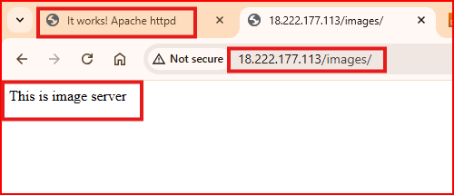

Section 3.2 – Creating the Application Load Balancer
Step 1 – Create the ALB
Go to EC2 → Load Balancers → Create Load Balancer → Application Load Balancer. Set it as internet-facing, select both Availability Zones, and configure the listener on port 80.
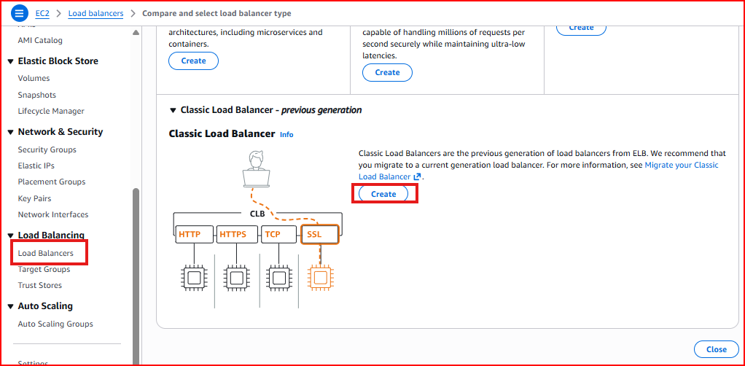
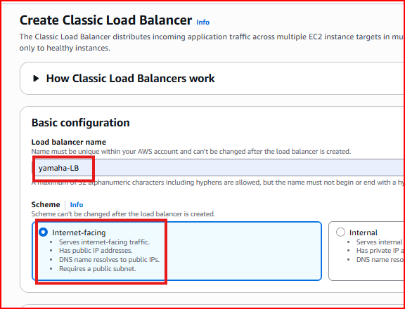
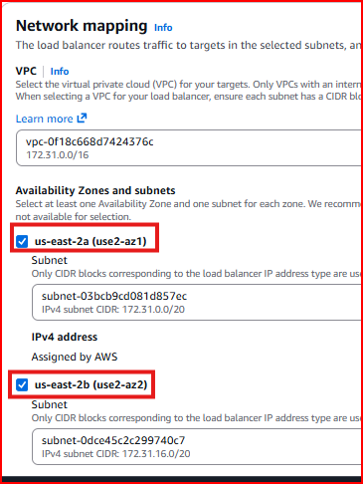
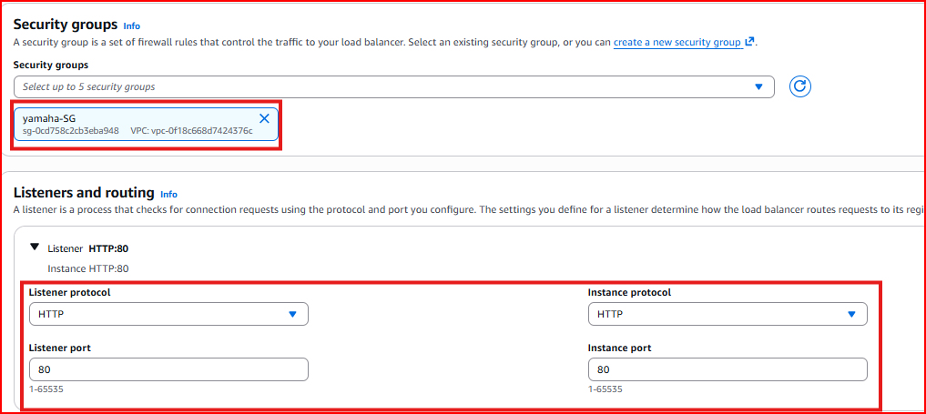
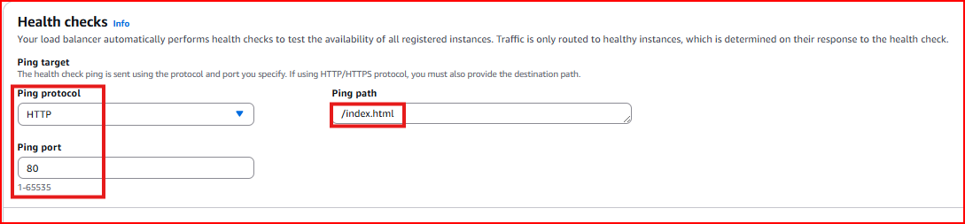
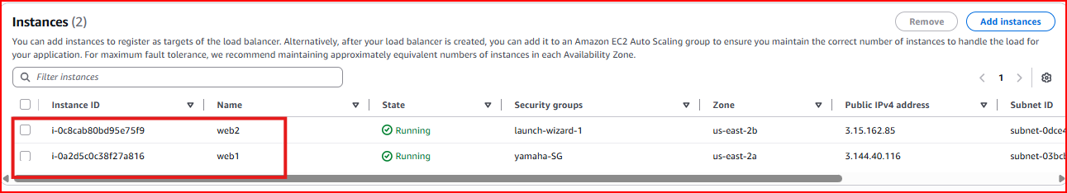
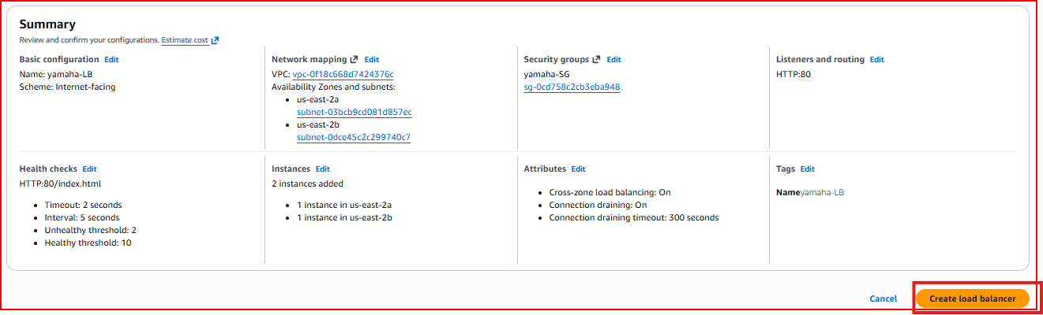
Step 2 – Create Target Group 1 (Main Application)
Create the first target group for the main application. A Target Group is a collection of servers that will receive a specific type of traffic. Configure health check path as / so the ALB knows these servers are healthy.
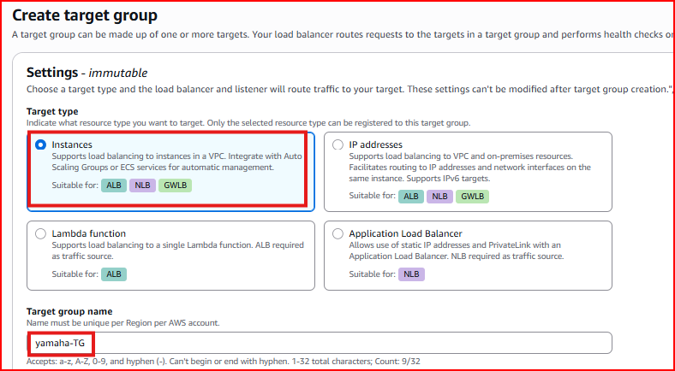
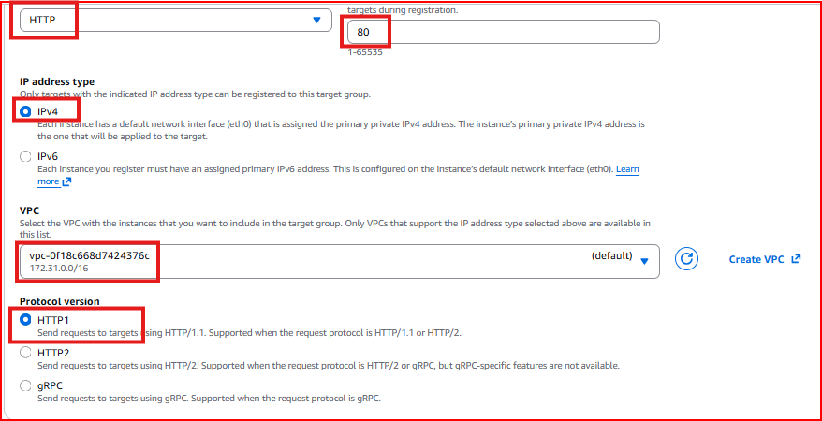
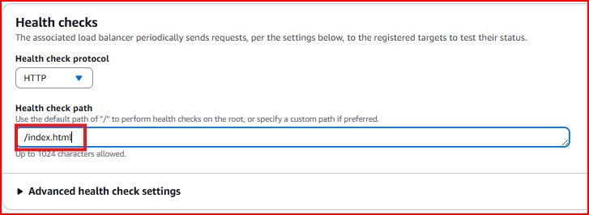
Step 3 – Register Targets (Add Instances to Target Group)
Register Web1 and Web2 into the main application target group. Repeat this process to create target groups for the video service (Web3, Web4) and image service (Web5, Web6).
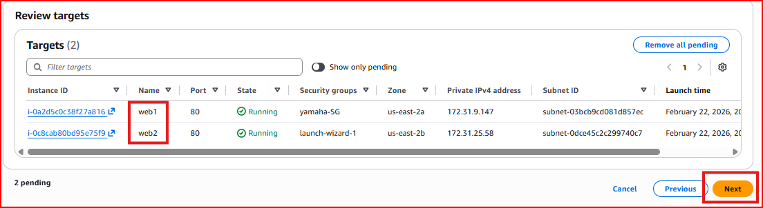
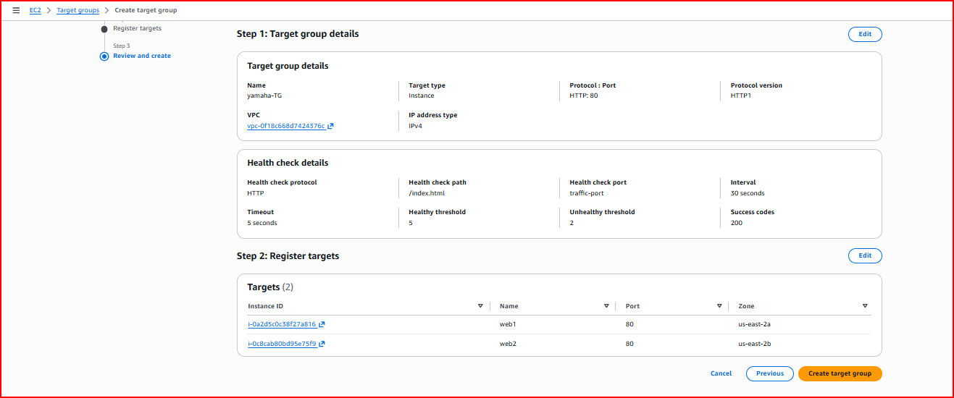
Step 4 – Copy ALB DNS Name and Test
Once the ALB is active, copy its DNS name. Open it in a browser to access the main application. The ALB will automatically distribute traffic between Web1 and Web2.
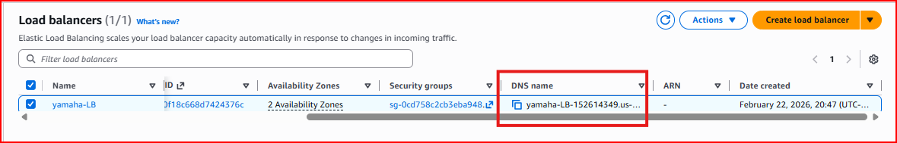
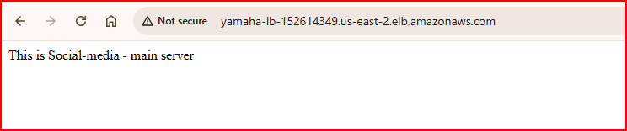
Step 5 – Create Navigation Page with Path-Based Links
Create an enhanced HTML page on Web1 and Web2 with clickable navigation links that route to /videos/ and /images/ paths. This demonstrates path-based routing in action.
sudo vi /var/www/html/index.html
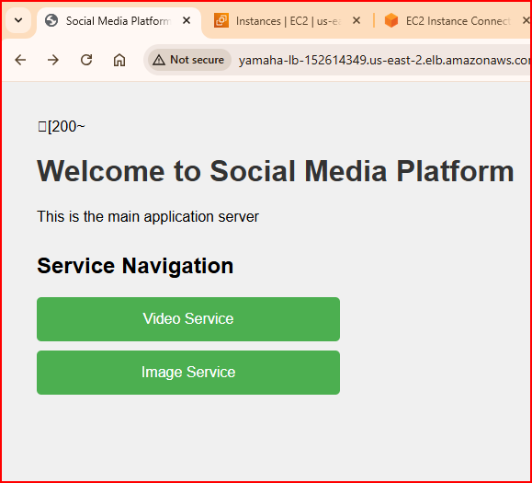

Main page /: Shows main social media content with navigation links
Click Video Service link: ALB routes to /videos/* — served by Web3 and Web4
Click Image Service link: ALB routes to /images/* — served by Web5 and Web6
Result: One ALB DNS name serves three different services — routing is based entirely on the URL path

Project Summary
✅ Created VPC Peering between US and India regions — private IP communication across regions
✅ Understood Transit Gateway as a hub for connecting multiple VPCs at scale
✅ Added additional Network Interfaces to an EC2 instance for multiple IPs
✅ Enabled VPC Flow Logs at VPC, Subnet, and Instance level — sent to CloudWatch
✅ Set up OpenVPN on EC2 using AWS Marketplace for secure encrypted remote access
✅ Created Classic Load Balancer distributing HTTP traffic across two web servers in different AZs
✅ Built Application Load Balancer with path-based routing for three separate services
✅ Verified routing — /videos/* and /images/* routes to dedicated server groups
Interview Questions & Answers

Q1: What is VPC Peering and what are its limitations?
VPC Peering is a private network connection between two VPCs that allows them to communicate using private IP addresses through the AWS backbone — never over the internet. The key limitations are: the CIDR ranges must not overlap, peering is not transitive (if A peers with B and B peers with C, A cannot reach C without a direct peering), and you need to update route tables on both sides. For connecting many VPCs, Transit Gateway is a better solution.

Q2: What is the difference between a Classic Load Balancer and an Application Load Balancer?
A Classic Load Balancer operates at Layer 4 (TCP) and Layer 7 (HTTP) and simply distributes traffic across servers based on round-robin or least connections. An Application Load Balancer operates at Layer 7 only but provides much smarter routing — it can route traffic based on URL paths, hostnames, or HTTP headers. For example, ALB can send /api/* to API servers and /videos/* to video servers. ALB is recommended for all modern applications.

Q3: What is path-based routing in ALB and when would you use it?
Path-based routing in ALB directs traffic to different target groups based on the URL path in the request. For example, requests to /videos/* go to video processing servers and requests to /images/* go to image servers — all behind the same single ALB DNS name. I use it in microservices architectures where different services handle different parts of the application, saving cost by using one load balancer instead of multiple.

Q4: What are VPC Flow Logs and what do they capture?
VPC Flow Logs capture metadata about all IP traffic going through network interfaces in a VPC — source and destination IP, port, protocol, bytes transferred, and whether the traffic was ACCEPTED or REJECTED by security groups. They are essential for security auditing, troubleshooting connectivity issues, and compliance. Flow Logs can be enabled at three levels: VPC (all traffic), Subnet (specific subnet), or Network Interface (specific instance). Logs are stored in CloudWatch or S3.

Q5: What is a Transit Gateway and how is it different from VPC Peering?
Transit Gateway is a central hub that connects multiple VPCs and on-premises networks through a single gateway. With VPC Peering, connecting 5 VPCs requires 10 individual peering connections. With Transit Gateway, each VPC connects to the hub once — just 5 connections total. Transit Gateway also supports transitive routing, inter-region peering, and VPN connections. It is managed and configured by the network team and is the preferred solution for large-scale multi-VPC architectures.

Q6: What is VPN and when would you use it in AWS?
VPN (Virtual Private Network) creates a secure encrypted tunnel between a remote network or user and an AWS VPC. I use OpenVPN when individual remote developers or team members need secure access to AWS private resources without exposing those resources to the internet. Site-to-Site VPN is used when an entire office network needs a permanent encrypted connection to AWS. For highest performance and reliability, Direct Connect provides a dedicated physical connection to AWS — no internet involved at all.

