AWS Auto Scaling & CloudFront
Auto Scaling Group | Launch Template | SNS | Load Balancer | CPU Stress Test | CloudFront CDN
Hands-On Project Documentation

Project Overview
This project demonstrates AWS Auto Scaling — the ability to automatically add or remove EC2 instances based on real-time demand. When CPU usage spikes, new instances are launched automatically. When load drops, extra instances are terminated to save cost. A Load Balancer distributes traffic across all running instances at all times.
The project also covers CloudFront CDN — how caching content at global edge locations reduces latency from ~1 second to ~157ms for users accessing your application from distant regions.

Prerequisites built: AMI (server snapshot) → Launch Template → SNS Topic → Auto Scaling Group → Load Balancer
Test method: CPU stress script triggers scaling — watch new instances launch automatically
CloudFront test: Pingdom performance test before vs after CloudFront — 84% improvement

Section 1 – Auto Scaling Concepts
AWS Auto Scaling automatically increases or decreases the number of EC2 instances behind a load balancer based on defined rules. For example, if average CPU usage goes above 70%, it adds more instances to handle the traffic. When load drops, it terminates the extra instances so you only pay for what you use.

Desired Capacity: Number of instances Auto Scaling tries to maintain under normal conditions
Minimum Capacity: Auto Scaling will never go below this number — guarantees minimum availability
Maximum Capacity: Auto Scaling will never exceed this number — prevents runaway costs
Scaling Policy: The rule that triggers scaling — e.g., add instances when CPU > 70%
Target Tracking: Most common policy — keeps a metric (like CPU) at a target value automatically

Cost benefit: You only pay for instances that are actually running — Auto Scaling removes them when no longer needed

Step 1 – Create an AMI (Base Server Image)
Before creating an Auto Scaling Group, you need a base AMI — a snapshot of a fully configured EC2 instance with your application installed. Auto Scaling uses this AMI to launch all new instances, ensuring every server is identical.

Why AMI first: Ensures all auto-scaled instances are identical — same OS, same software, same config
How: EC2 → select running instance → Actions → Image and Templates → Create Image
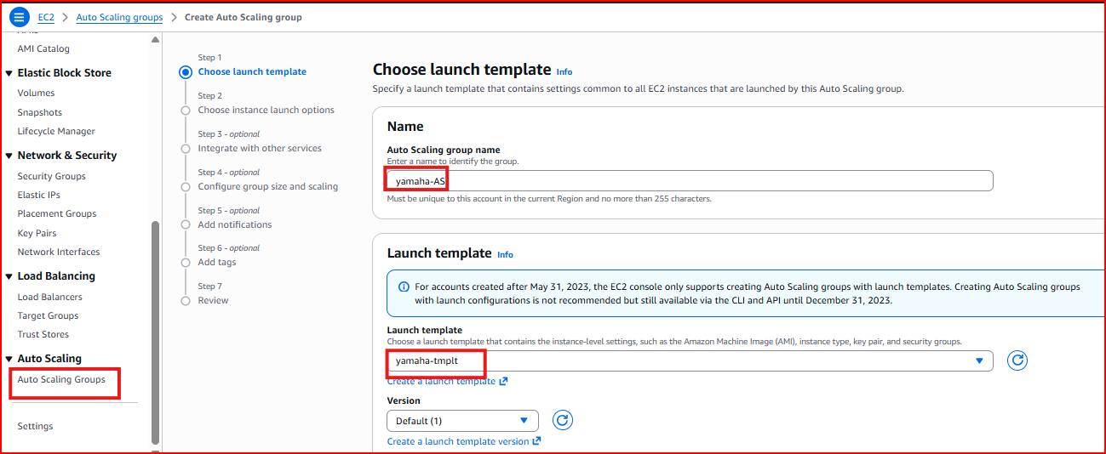
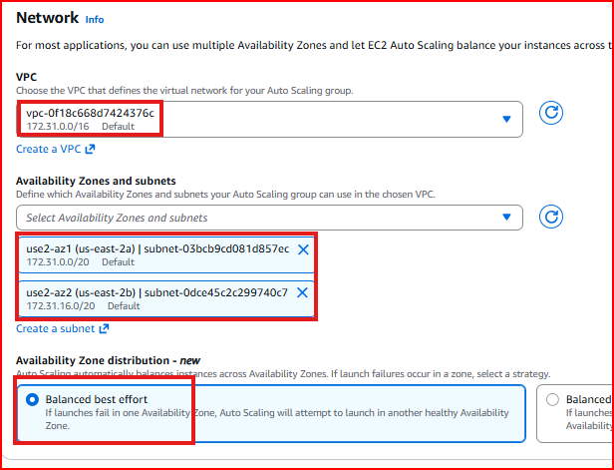

Step 2 – Create a Launch Template
A Launch Template is a reusable configuration that Auto Scaling uses every time it needs to launch a new instance. It defines the AMI, instance type, key pair, security group, and any other settings. Without a Launch Template, Auto Scaling doesn't know what kind of server to create.

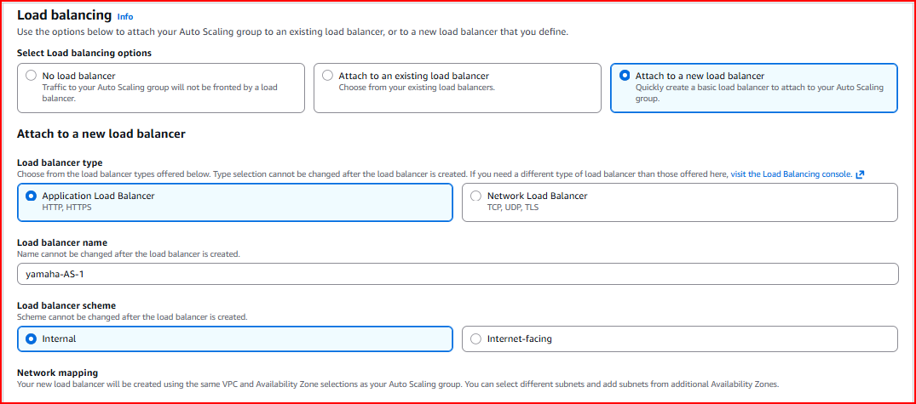
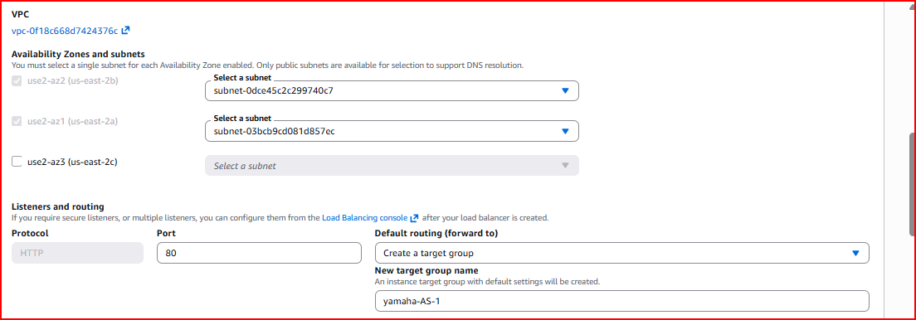
Template name: Give a clear descriptive name
AMI: Select 'My AMIs' and choose the AMI created in Step 1
Instance type: t2.micro for testing, t3.medium or larger for production
Key pair: Select your existing .pem key pair
Security group: Select the group that allows HTTP port 80 and SSH port 22
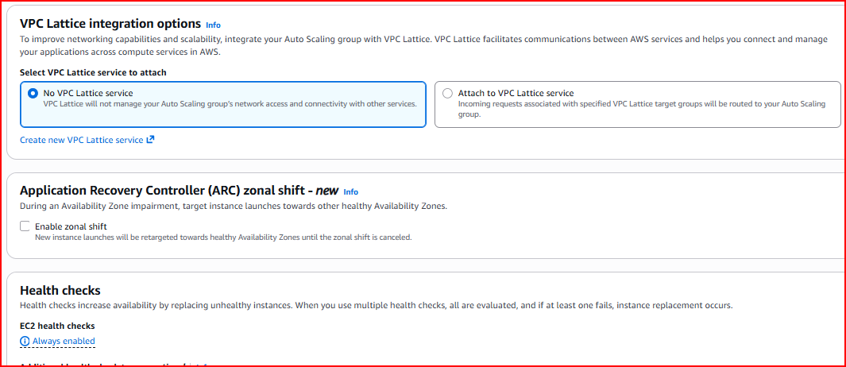
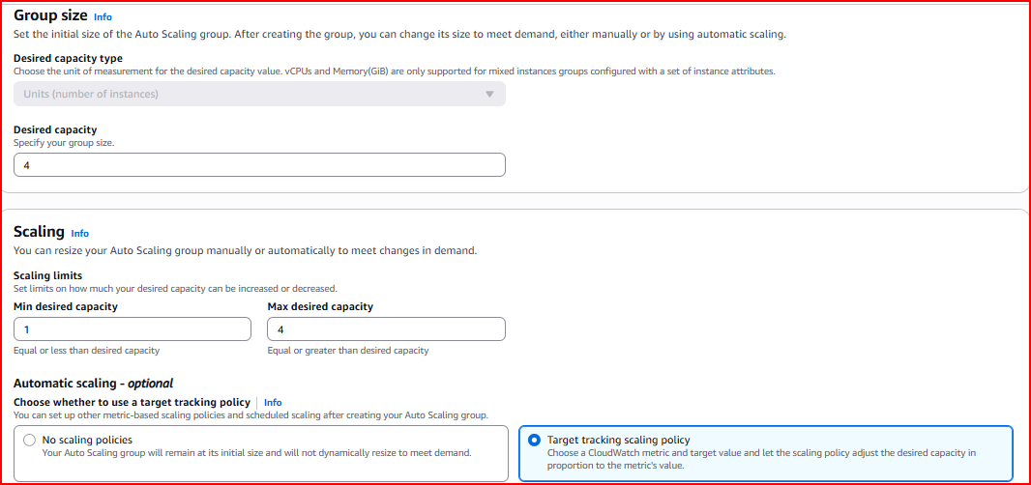

Step 3 – Create SNS Topic for Notifications
SNS (Simple Notification Service) sends you email alerts whenever Auto Scaling launches or terminates instances. This keeps you informed about all scaling activity without having to watch the AWS Console constantly.

Events notified: Instance Launch, Instance Terminate, Fail to Launch, Fail to Terminate
Protocol: Email — you receive an alert at your inbox for every scaling event

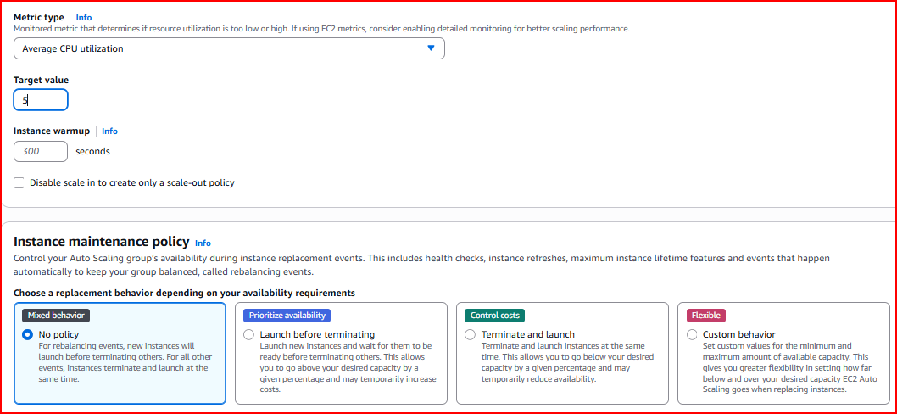
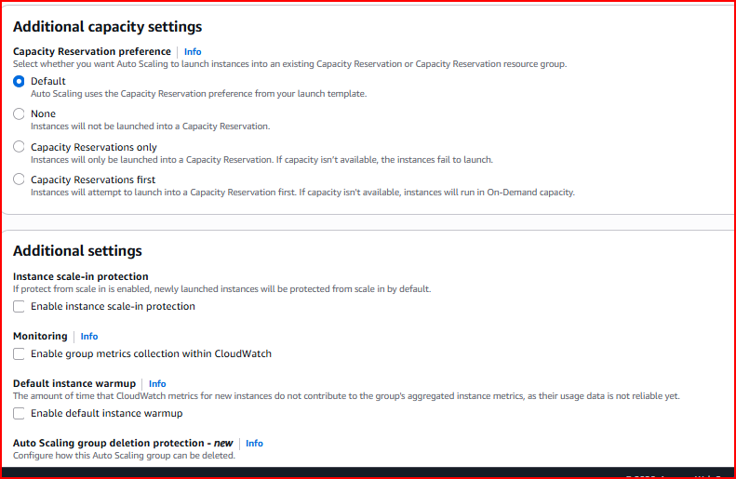
After creating the SNS topic and subscription, AWS sends a confirmation email. You MUST click the confirmation link in that email — otherwise the subscription stays 'Pending' and you won't receive any alerts.
Important: Check your inbox and confirm the subscription before proceeding — unconfirmed subscriptions receive no notifications

Step 4 – Create the Auto Scaling Group
The Auto Scaling Group (ASG) is the core component. It manages the fleet of EC2 instances — launching new ones when demand increases and terminating them when demand drops. It uses the Launch Template to know what kind of instances to create.

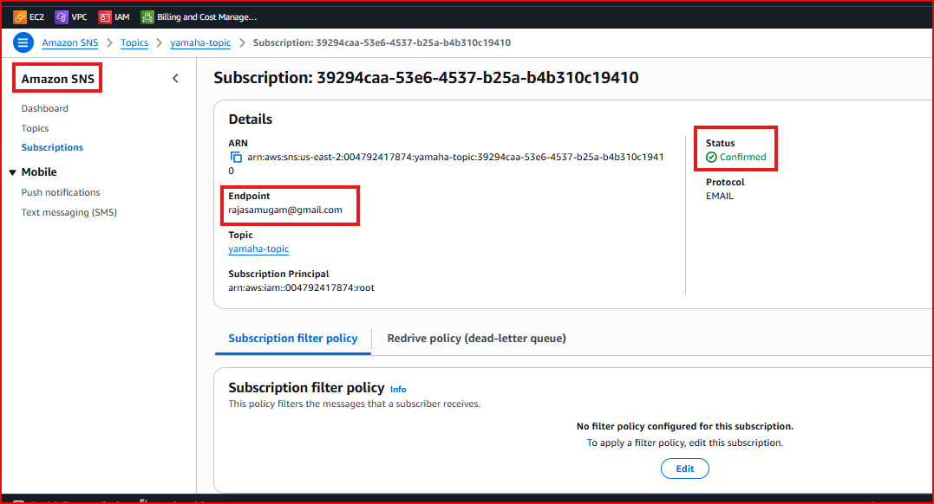
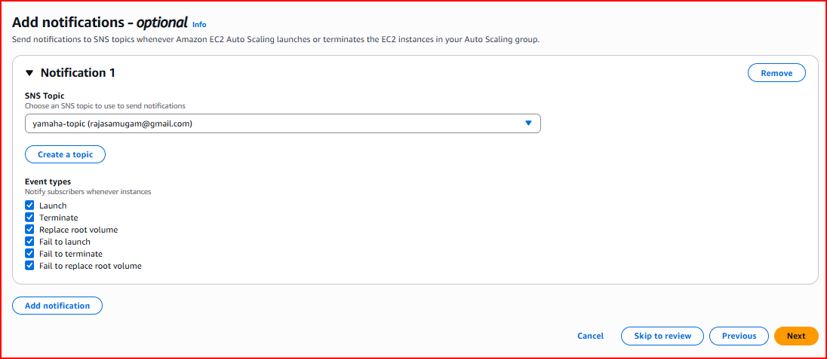
Step 4.1 – Configure Group Name and Launch Template
Give the Auto Scaling Group a name and select the Launch Template created in Step 2. Choose 'Latest' version so any future template updates are automatically used.
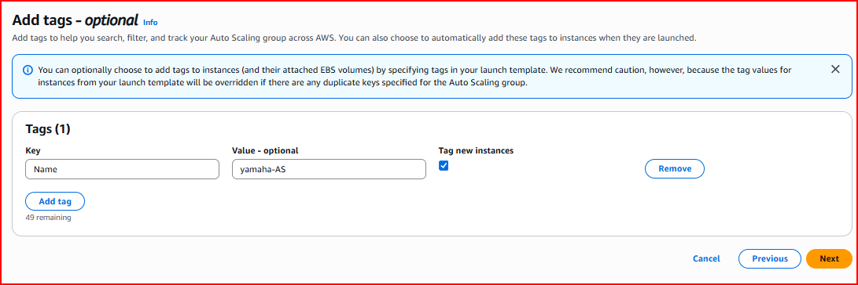
Step 4.2 – Select VPC and Availability Zones
Select your VPC and choose at least two Availability Zones. Spreading instances across multiple AZs ensures your application stays available even if one entire AZ has an outage.
Best practice: Always select 2+ Availability Zones for high availability
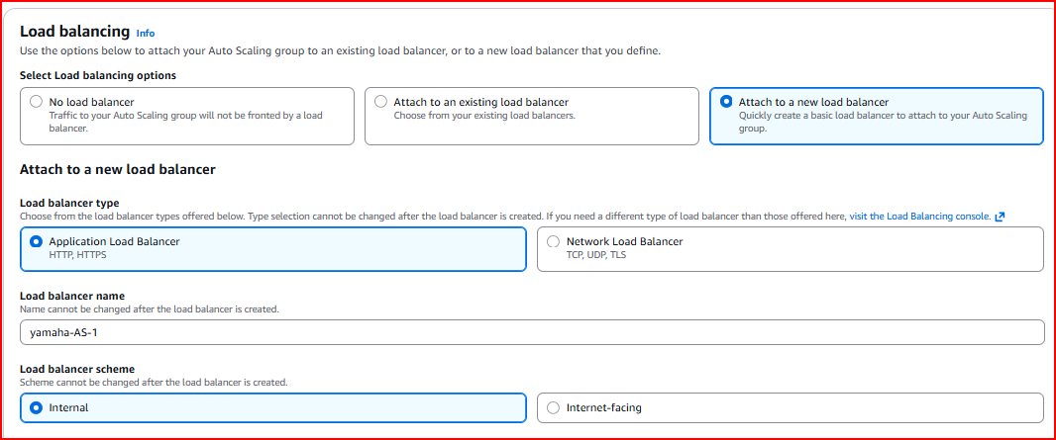
Step 4.3 – Configure Group Size and Scaling Policy
Set the desired, minimum, and maximum instance counts. Then configure the Target Tracking Scaling Policy — this automatically adjusts the number of instances to keep CPU at the target value.

Desired Capacity: 2 — ASG maintains 2 instances under normal conditions
Minimum Capacity: 2 — never scale below 2 instances
Maximum Capacity: 4 — never scale above 4 instances
Metric: Average CPU Utilization
Target value: 5% for testing (use 70-80% in production)
Instance warmup: 300 seconds — prevents premature scaling during instance startup
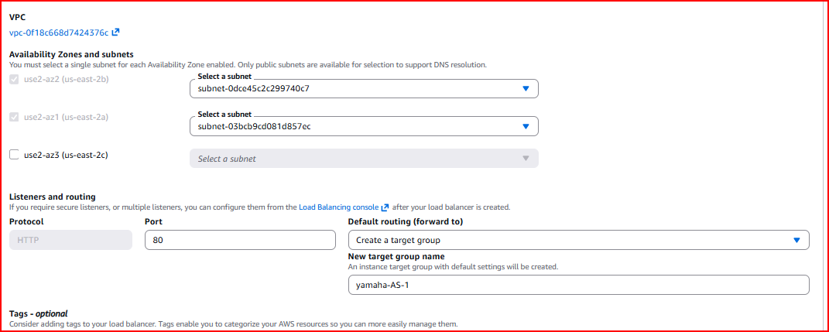
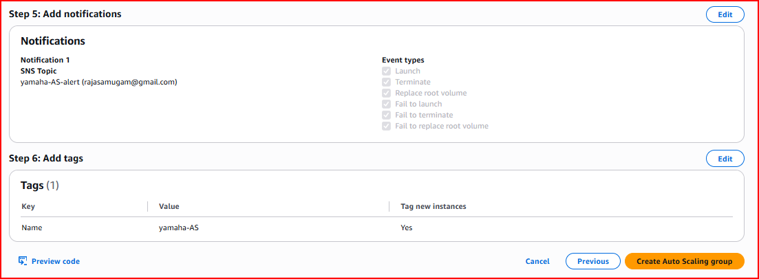
Testing tip: A 5% CPU threshold makes it very easy to trigger auto scaling during testing — in production use 70-80%
Step 4.4 – Add SNS Notification
Connect the SNS topic created in Step 3 to the Auto Scaling Group. Select all event types — Launch, Terminate, Fail to Launch, Fail to Terminate — so you receive email alerts for all scaling activity.
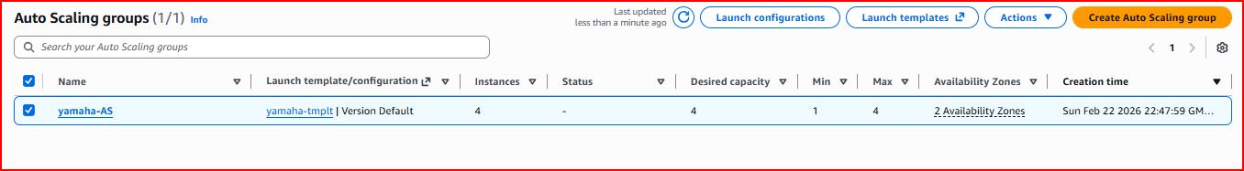
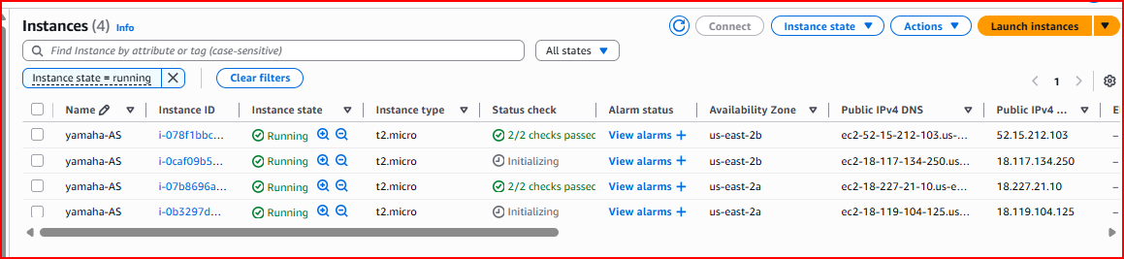

Step 5 – Create Load Balancer and Attach to ASG
Create a Classic Load Balancer that distributes incoming HTTP traffic across all instances in the Auto Scaling Group. When Auto Scaling launches new instances, they are automatically registered with the Load Balancer. When instances are terminated, they are automatically deregistered.

Listener: HTTP port 80
Health check path: /index.html — LB checks this URL to confirm instance is healthy
Health check interval: 30 seconds
Cross-Zone LB: Enable — distributes traffic evenly across all AZs

After creating the Load Balancer, attach it to the Auto Scaling Group: ASG → Actions → Edit → Load Balancing → select your Load Balancer → Update.
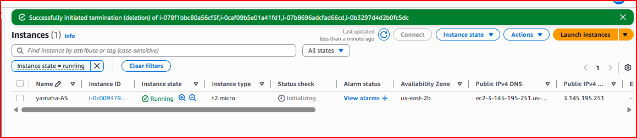

Step 6 – Trigger Auto Scaling with CPU Stress Test
Now we test that Auto Scaling actually works by artificially spiking the CPU on one instance. When CPU exceeds the 5% threshold, the Auto Scaling Group should automatically launch additional instances.

Step 6.1 – Create the CPU Load Script
SSH into one of the running instances in the Auto Scaling Group and create a Bash script that generates heavy CPU load using the 'dd' command. This simulates a real traffic spike.
vi load.sh
#!/bin/bash
dd if=/dev/zero of=/dev/null bs=50000 count=1000000
dd if=/dev/zero of=/dev/null bs=50000 count=1000000
dd if=/dev/zero of=/dev/null bs=50000 count=1000000
Tip: In vi, press Esc, type 'yy' to copy a line, then '300p' to paste it 300 times quickly.

Then create a wrapper script that runs load.sh in a loop:
vi for.sh
#!/bin/bash
for i in {1..10}
do
sh load.sh
done

Step 6.2 – Alternative: Use Stress Tool
A simpler and more reliable method is the 'stress' utility which directly pins CPU cores:
yum install stress -y # Install stress tool
stress --cpu 8 --timeout 800 # Spike 8 CPU cores for 800 seconds
Step 6.3 – Make Scripts Executable and Run
chmod a+x for.sh load.sh # Make scripts executable
./for.sh & # Run in background so terminal stays free
top # Monitor CPU usage in real time
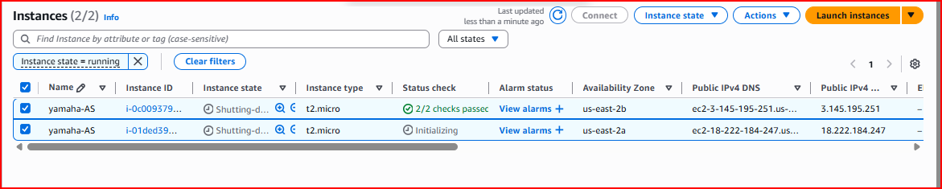
Step 6.4 – Watch Auto Scaling in Action
As CPU climbs above the 5% threshold, observe the following in AWS Console:
EC2 Instances: New instances appear with status 'Initializing' then 'Running'
ASG Activity tab: Shows scaling events with timestamps and reasons
CloudWatch: CPU utilization graph shows the spike that triggered scaling
Email inbox: SNS notifications arrive for each instance that launches
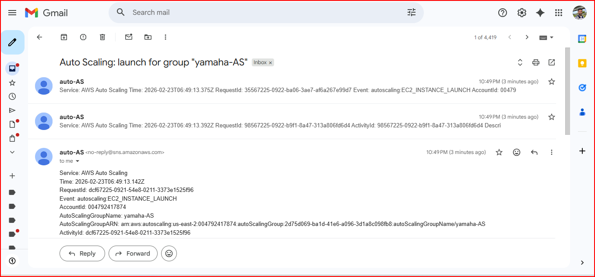
Scale down: When the stress script finishes and CPU drops below threshold, Auto Scaling automatically terminates extra instances — you receive Terminate notifications via SNS

PART 2 – CloudFront CDN

Section 2.1 – What is CloudFront?
Amazon CloudFront is a Content Delivery Network (CDN) that improves website performance by caching your content at edge locations around the world. Instead of every user connecting to your origin server in a single region, they connect to the nearest CloudFront edge location which serves cached content at much lower latency.

Without CloudFront: User in India → AWS server in US-East → ~1,000ms latency
With CloudFront: User in India → CloudFront edge in Mumbai → ~157ms latency (84% faster)
Edge locations: 400+ locations worldwide — content served from the one closest to the user
Cache: Static content (HTML, images, CSS, JS) is cached at the edge — less load on origin

Section 2.2 – CloudFront Setup and Performance Test
Step 1 – Baseline Performance Test (Before CloudFront)
Before setting up CloudFront, measure the current performance of your Load Balancer URL using Pingdom. Test from a distant location like Sydney, Australia to simulate a geographically remote user.
Tool: https://tools.pingdom.com/
Test location: Pacific — Australia — Sydney
Result before CloudFront: Load time: ~997ms (nearly 1 full second)

Step 2 – Create CloudFront Distribution
Go to AWS Console → CloudFront → Create Distribution. Select your Load Balancer as the origin — CloudFront will fetch content from the LB and cache it at all edge locations globally.
Origin Domain: Select your Application Load Balancer from the dropdown
Origin Protocol: HTTP Only (or Match Viewer if using HTTPS)
Viewer Protocol Policy: HTTP and HTTPS (recommended for testing)
Cache Policy: Caching Optimized — best for static websites
Price Class: Use North America, Europe, Asia, Middle East, and Africa
Wait time: CloudFront takes 10-15 minutes to deploy — wait for status 'Deployed' before testing

Step 3 – Performance Test After CloudFront
Once the distribution is deployed, copy the CloudFront domain name (e.g., d1234abcd.cloudfront.net) and run the same Pingdom test again from Sydney.
Result after CloudFront: Load time: ~157ms
Improvement: 84% faster — from 997ms down to 157ms

Performance Comparison
Before CloudFront: 997ms load time | 253.4KB page size | High latency (origin-based)
After CloudFront: 157ms load time | 206.8KB page size | Very low latency (edge cached)
Overall improvement: ~84% faster page load, ~18% smaller page size due to compression

Project Summary
✅ Created an AMI from a running web server as the base image for Auto Scaling
✅ Created a Launch Template defining the instance configuration for Auto Scaling
✅ Set up SNS topic with email subscription for Auto Scaling event notifications
✅ Created Auto Scaling Group with Desired: 2, Min: 2, Max: 4 and Target Tracking policy
✅ Created Load Balancer and attached it to the Auto Scaling Group
✅ Ran CPU stress test — watched new instances launch automatically when CPU exceeded threshold
✅ Confirmed SNS email notifications received for each scaling event
✅ Configured CloudFront distribution using Load Balancer as origin
✅ Proved 84% performance improvement — 997ms reduced to 157ms for remote users
Interview Questions & Answers

Q1: What is Auto Scaling and how does it work?
AWS Auto Scaling automatically adds or removes EC2 instances based on demand. You define a minimum, desired, and maximum instance count, then create a scaling policy — for example, add instances when average CPU exceeds 70% and remove them when it drops below 30%. A Launch Template tells Auto Scaling what kind of instance to create, and the instances are automatically registered with the Load Balancer so traffic is immediately distributed to them.

Q2: What are the prerequisites for setting up Auto Scaling?
You need four things in order. First an AMI — a snapshot of a fully configured server so all auto-scaled instances are identical. Second a Launch Template — defining the AMI, instance type, key pair and security group. Third an SNS topic for email notifications on scaling events. Fourth the Auto Scaling Group itself configured with the scaling policy and capacity limits. Finally a Load Balancer to distribute traffic across all running instances.

Q3: What is Target Tracking scaling policy and when would you use it?
Target Tracking is the most common Auto Scaling policy. You set a target value for a metric — for example keep average CPU at 70%. Auto Scaling then automatically adds or removes instances to maintain that target. If CPU goes above 70% it adds instances. If it drops well below 70% it removes instances. I use it for web applications where traffic patterns are variable and unpredictable. For testing I set the target to 5% CPU so it is easy to trigger.

Q4: How did you test that Auto Scaling was actually working?
I created a Bash script using the 'dd' command that generates heavy CPU load by reading from /dev/zero and writing to /dev/null in a loop. I made the script run multiple parallel processes to spike CPU well above the 5% threshold I set. Within a few minutes I could see new instances launching in the EC2 Console with status 'Initializing', SNS emails arriving for each launch, and the Activity tab in the Auto Scaling Group showing the scaling events with timestamps and reasons.

Q5: What is CloudFront and what problem does it solve?
CloudFront is a Content Delivery Network that caches your website content at over 400 edge locations worldwide. It solves the latency problem for users who are geographically far from your origin server. I tested this with Pingdom — before CloudFront, a user in Sydney accessing my Load Balancer in the US had a load time of 997ms. After setting up CloudFront, the same test from Sydney showed 157ms — an 84% improvement. CloudFront also reduces load on the origin server and can compress content to reduce page size.

Q6: What is the difference between Auto Scaling and a Load Balancer?
A Load Balancer distributes incoming traffic across a fixed set of servers that are already running — it doesn't create or remove instances. Auto Scaling manages the number of instances dynamically — it creates new instances when demand is high and terminates them when demand drops. They work together: Auto Scaling controls how many instances exist, and the Load Balancer distributes traffic across all of them. Auto Scaling automatically registers new instances with the Load Balancer and deregisters terminated ones.

