Feb 3rd Lab Assignment Steps

Database: “miRWalk: An online resource for prediction of microRNA binding sites.” Sticht, Torre, Parveen and Gretz (2018) PLOS One. (Vijayam [StichtEtAl_miRWalk_PLOSone2018.pdf](https://uncc.instructure.com/courses/146088/files/11428842?wrap=1)[Preview the document](https://uncc.instructure.com/courses/146088/files/11428842?wrap=1)  ) [doi.org/10.1371/journal.pone.0206239 (Links to an external site.)](https://doi.org/10.1371/journal.pone.0206239) ;  [http://mirwalk.umm.uni-heidelberg.de/ (Links to an external site.)](http://mirwalk.umm.uni-heidelberg.de/)

1. Get into mirWalk Url:

<http://mirwalk.umm.uni-heidelberg.de/>

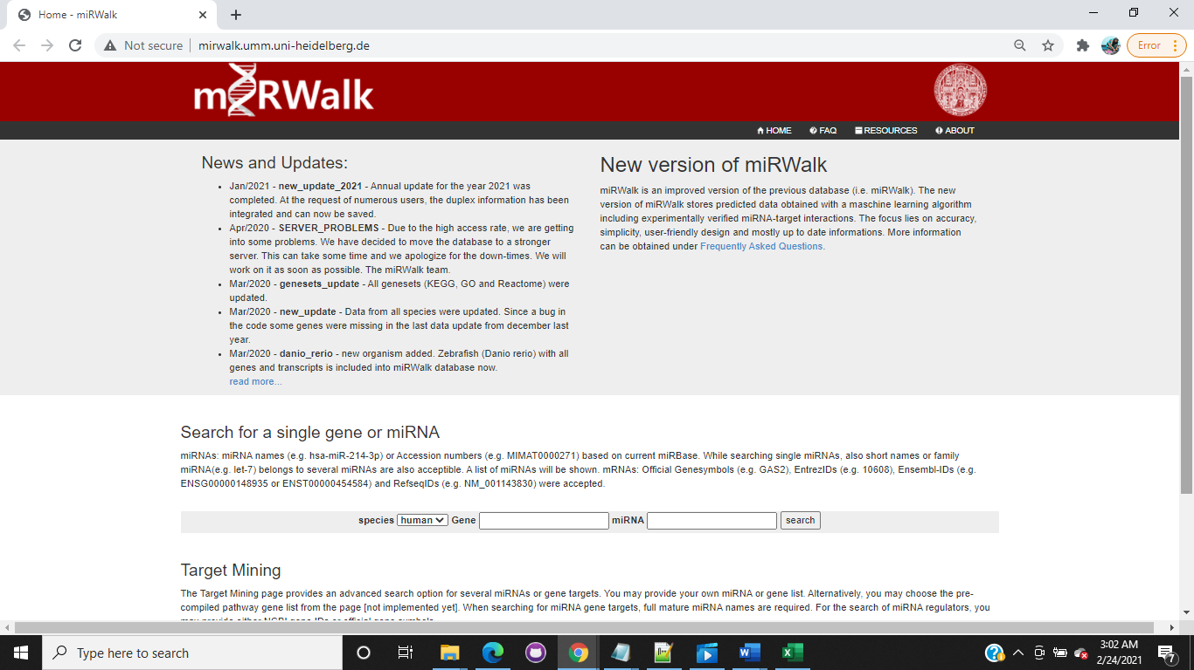

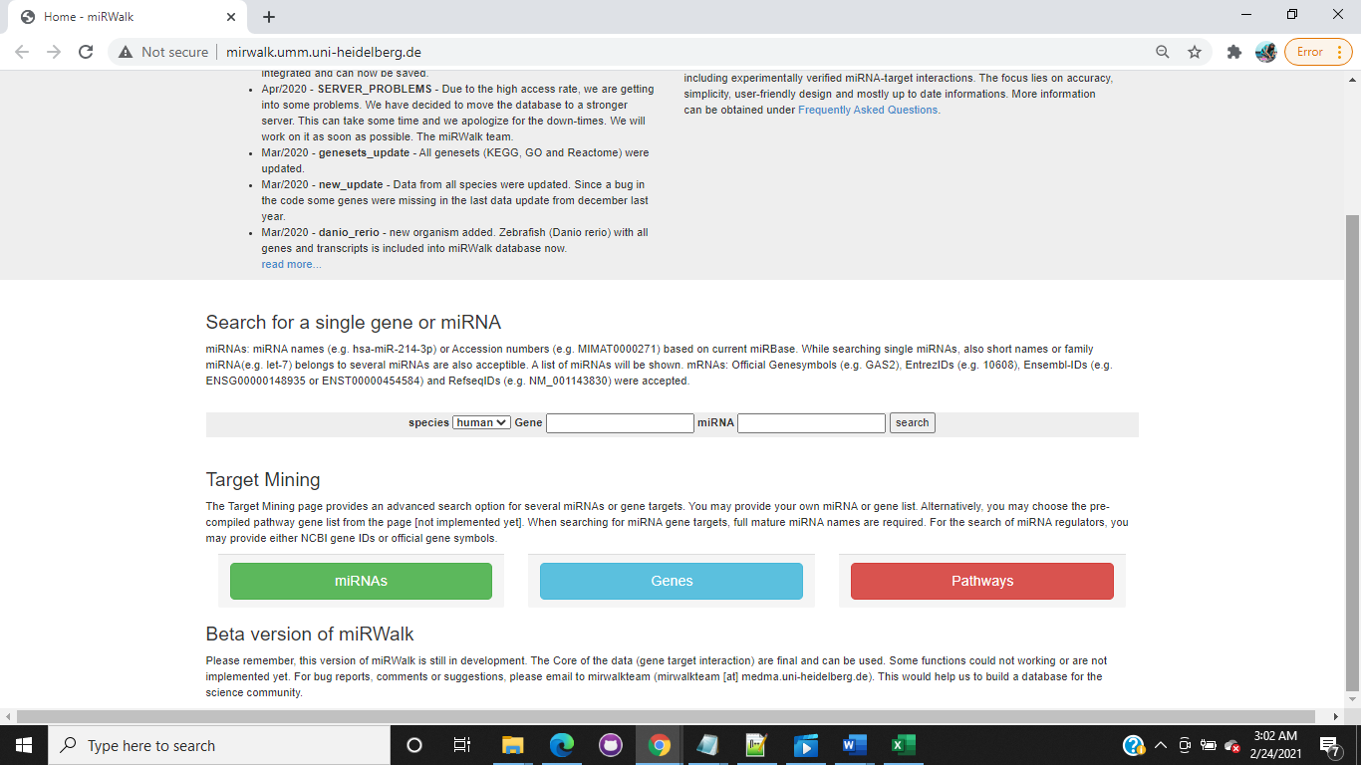

1. Click Pathways

Select any one of the path way

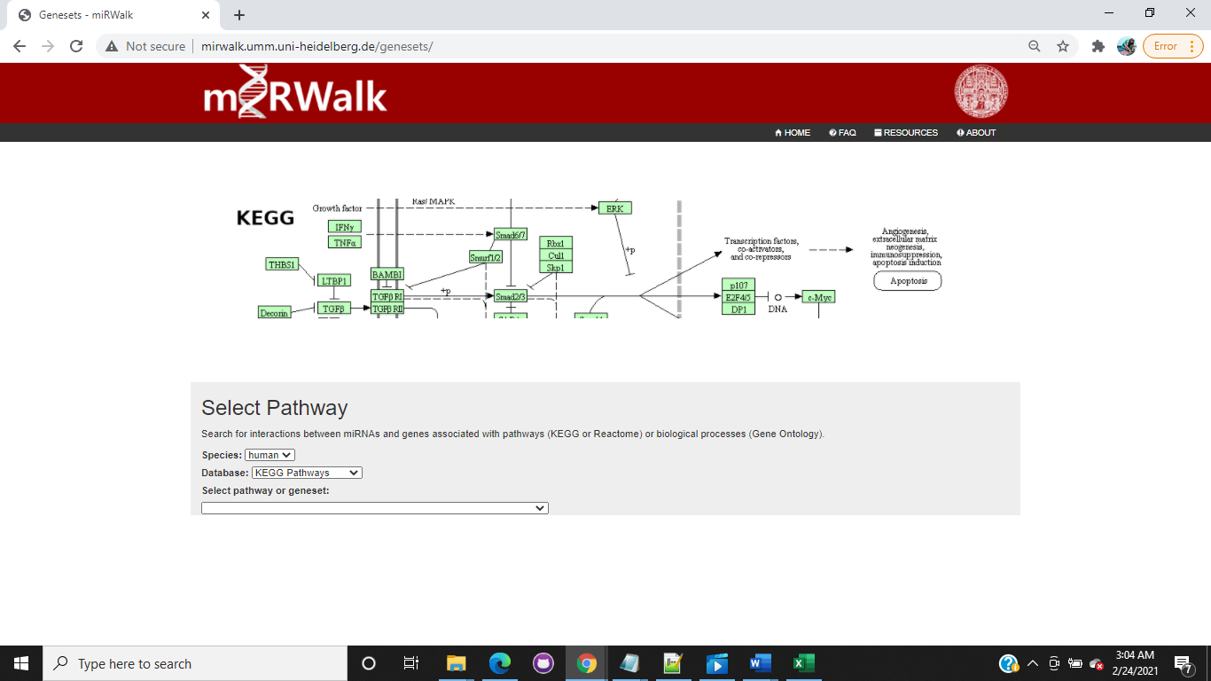

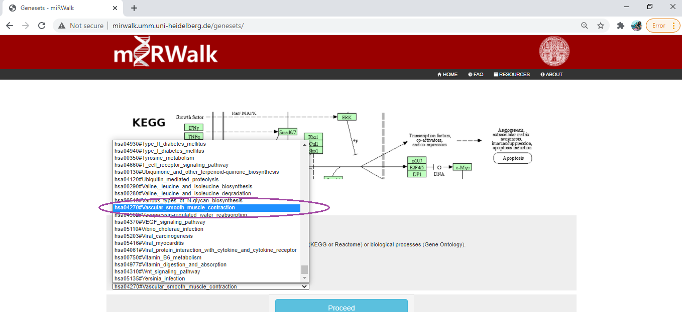

Click proceed

1. Set Filters

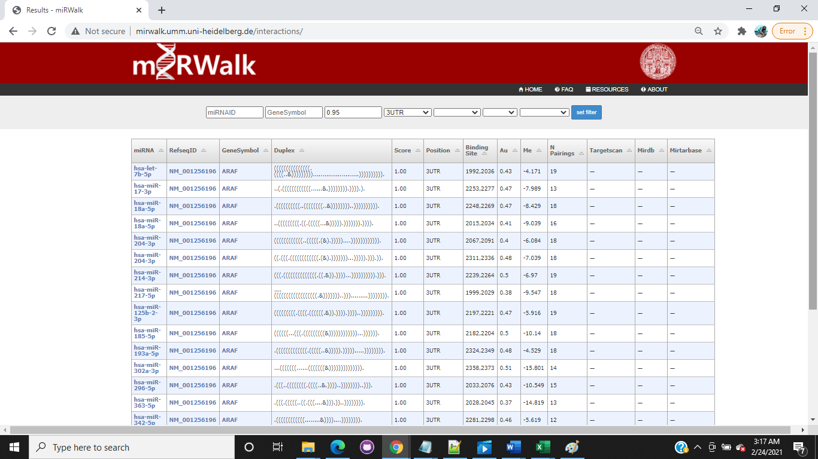

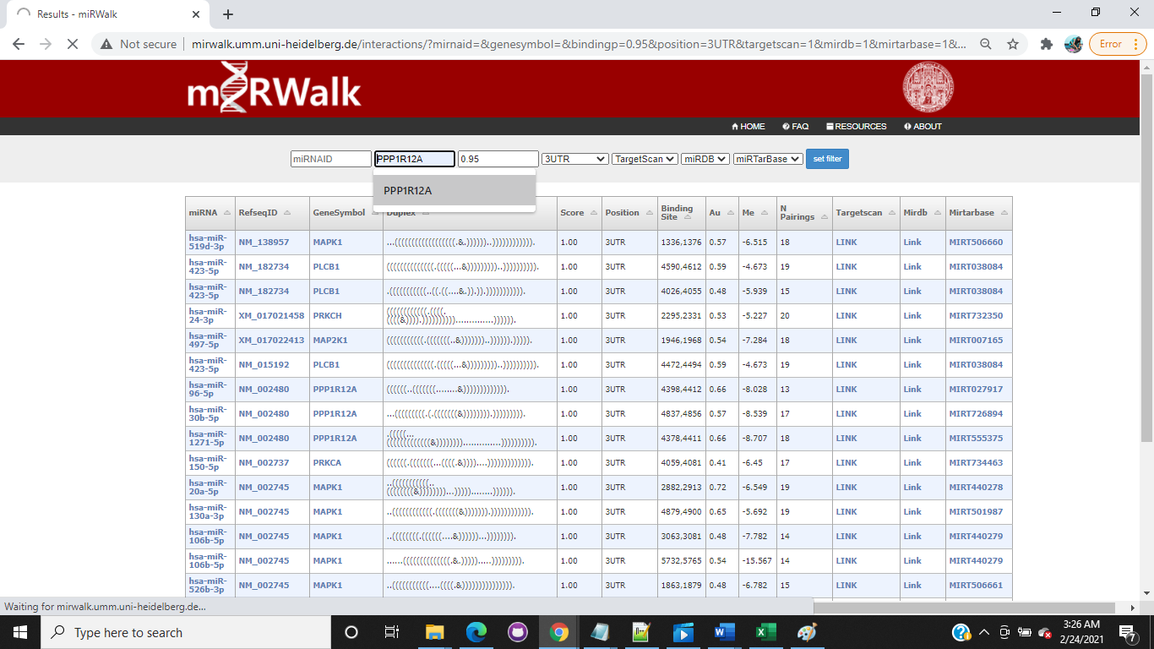

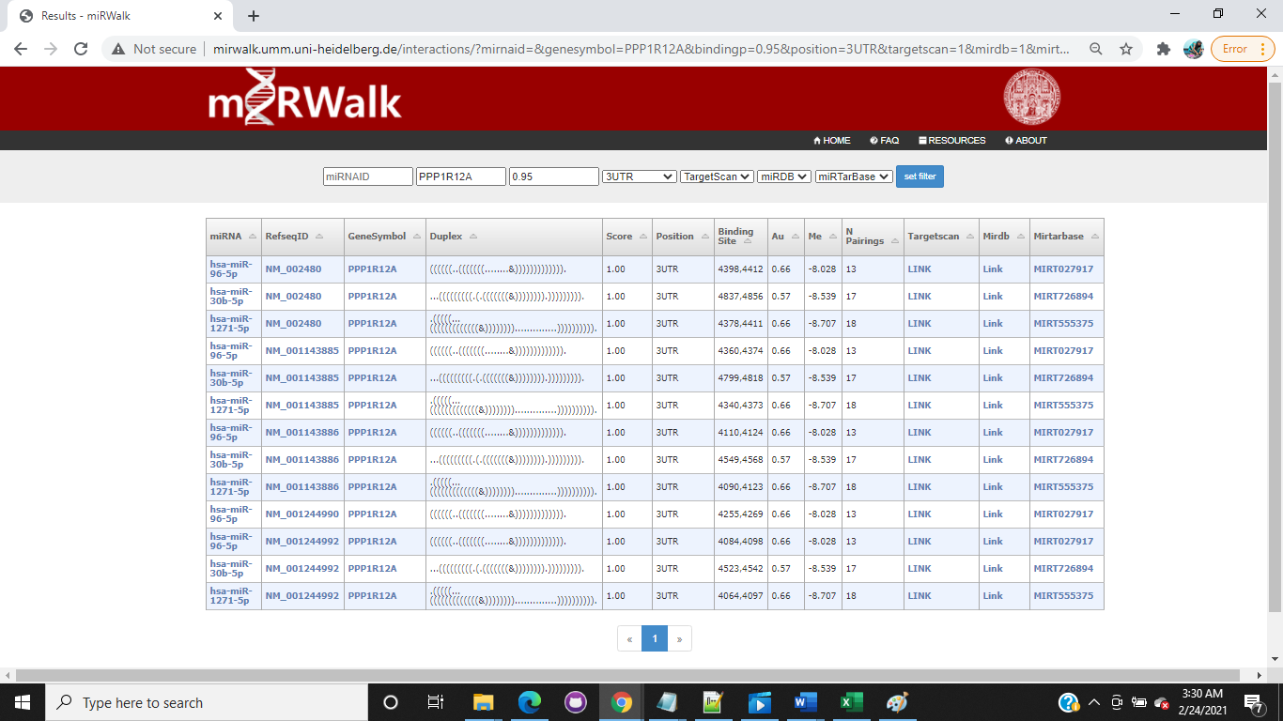

1. Choose = [**hsa-miR-1271-5p**](http://www.mirbase.org/cgi-bin/query.pl?terms=hsa-miR-1271-5p)

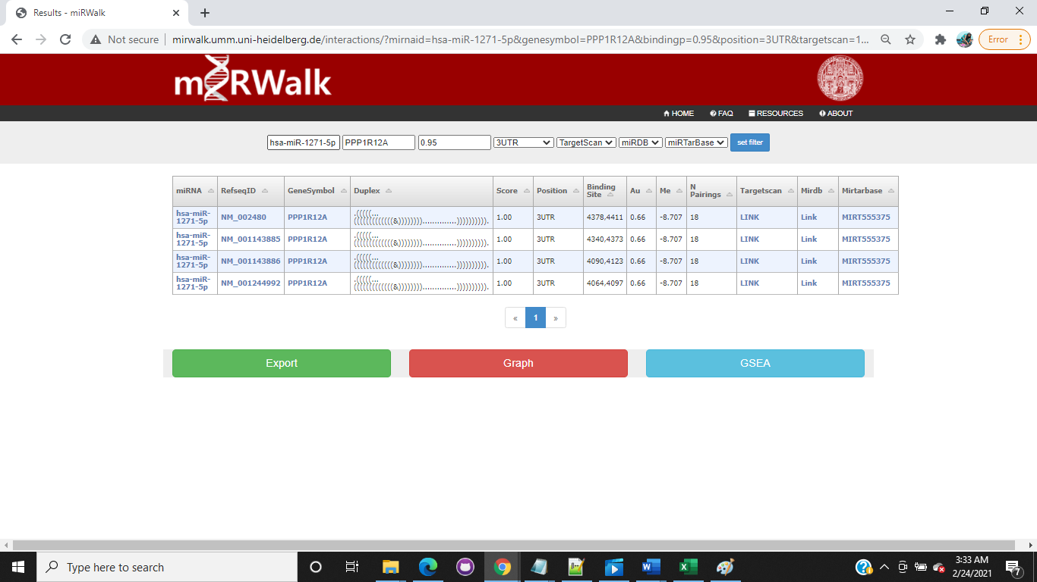

1. Collect data points from different links

mirDB:

http://mirdb.org/cgi-bin/search.cgi?searchType=miRNA&searchBox=hsa-miR-1271-5p&full=1

Target Miner:

<https://www.isical.ac.in/~bioinfo_miu/final_html_targetminer/hsa-miR-1271-5p.html>

Target Scan:

<http://www.targetscan.org/cgi-bin/targetscan/vert_71/view_gene.cgi?rs=ENST00000261207.5&taxid=9606&members=miR-96-5p/1271-5p&showcnc=0&shownc=0&shownc_nc=&showncf1=&showncf2=&subset=1>

Get Transcript and Gene:

http://useast.ensembl.org/Homo_sapiens/Gene/Summary?db=core;g=ENSG00000058272;r=12:79773563-79935455;t=ENST00000261207

http://useast.ensembl.org/Homo_sapiens/Transcript/Summary?db=core;g=ENSG00000058272;r=12:79773563-79935455;t=ENST00000261207

https://www.ncbi.nlm.nih.gov/nuccore/NM_001143886

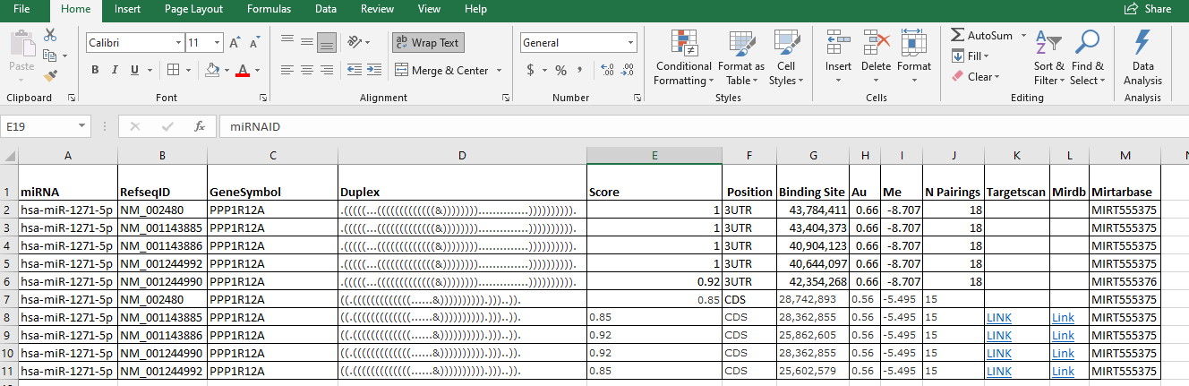

1. Create Entities

|  |  |  |  |  |  |  |  |  |
| --- | --- | --- | --- | --- | --- | --- | --- | --- |
| **miRNA** |  | **mRNA** |  | **Gene** |  | **Transcript** |  | **Pathway** |
| **miRNAID** |  | **refseqid ()** |  | Gene Symbol |  | Transcript Name |  | Pathway ID |
| Accession |  | Chromosome |  | Description |  | Transcript ID |  | Pathway Name |
| Sequence |  | 6mer (count) |  | Gene ID |  |  |  | **miRNAID** |
| stem loop |  | 6mer (position) |  | Gene type |  |  |  | **refSeqId** |
| **refseqid (mRNA)** |  | 7mer-A1 (count) |  | Location |  |  |  | GeneSymbol |
|  |  | 7mer-A1 (position) |  | **Transcript ID** |  |  |  |  |
|  |  | 7mer-m8 (count) |  |  |  |  |  |  |
|  |  | 7mer-m8 (position) |  |  |  |  |  |  |
|  |  | 8mer (count) |  |  |  |  |  |  |
|  |  | 8mer (position) |  |  |  |  |  |  |
|  |  | sequence file or Sequence?? |  |  |  |  |  |  |

