|  |  |
| --- | --- |
| **Name** | Rajas Baadkar |
| **UID** | 2021300007 |
| **Experiment** | 5 |

**Aim :** Create advance charts using the R programming language on housing dataset.

* Advance- Word Cloud, Box plot, Violin plot, Jitter plot
* Write observations from each chart

**Objectives:**

* To understand and apply advance data visualization techniques in R.
* To create various types of charts using a housing-related dataset.
* To interpret and analyze the data through visual representations.

**Theory:**

Data visualization is an essential skill in data analysis that helps in understanding trends,

patterns, and relationships within a dataset. R, a powerful statistical programming language,

provides a wide range of tools for creating visually appealing and informative charts. In this

experiment, we will use advance chart types to analyze housing data and derive insights.

**Dataset link :** [**https://www.kaggle.com/datasets/vijayjoshi17/housing-dataset-in-metropolitan-combined-dataset**](https://www.kaggle.com/datasets/vijayjoshi17/housing-dataset-in-metropolitan-combined-dataset)

**1. Word Cloud :**

options(repr.plot.width = 15, repr.plot.height = 7)

location_count = housing_data %>% group_by(Location) %>% summarise(count = n(), .groups = 'drop')

wordcloud(words = location_count$Location, freq = location_count$count, min.freq = 5,

max.words=75, random.order=FALSE, rot.per=0.35,

colors=brewer.pal(8, "Dark2"))

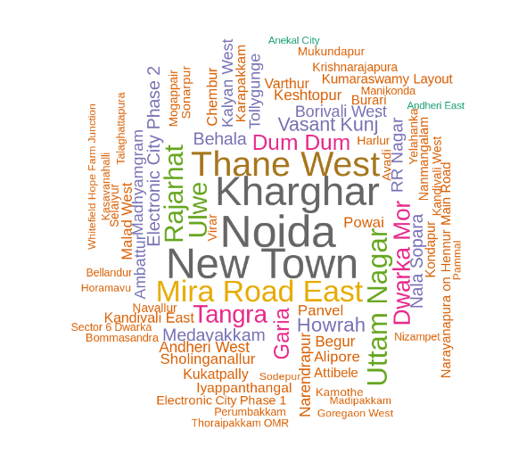

**Observation :** Popular living areas are Noida, Kharghar, New Town and Thane West.

**2. Box Plot:**

ggplot(housing_data, aes(x = City, y = Area, fill = City)) +

geom_boxplot()

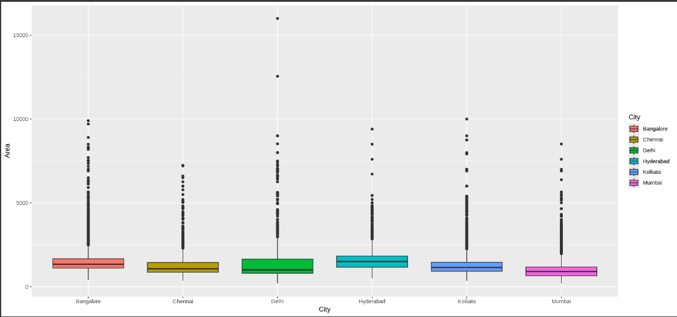

**Observation :** Hyderabad and Bangalore have the highest price median while the median of Delhi is lowest and most of the prices are above median.

**3. Violin Plot:**

ggplot(housing_data, aes(x = City, y = Price, fill = City)) +

geom_violin(bounds = c(0, 5e7))

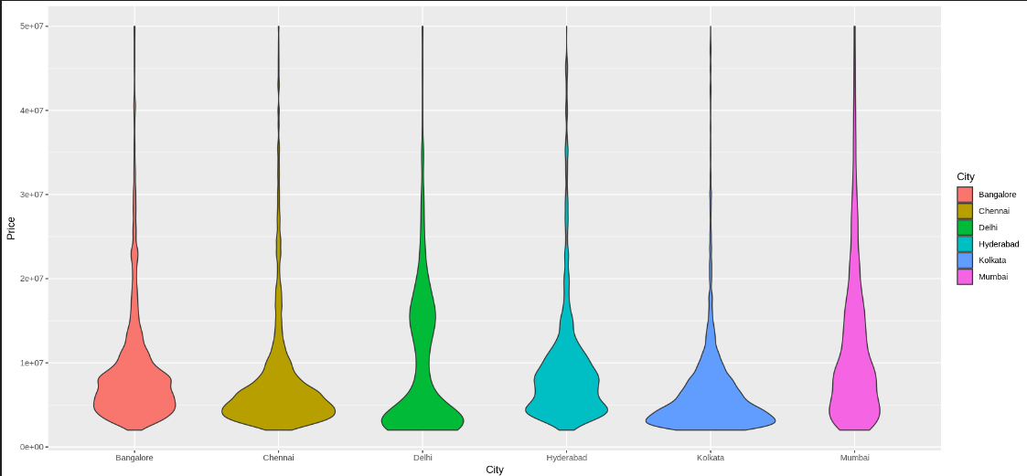

**Observation :** The plot for Bangalore and Hyderabad seems to be quite uniform indicating that prices may change depending on the area in both cities.

**4. Regression Plot:**

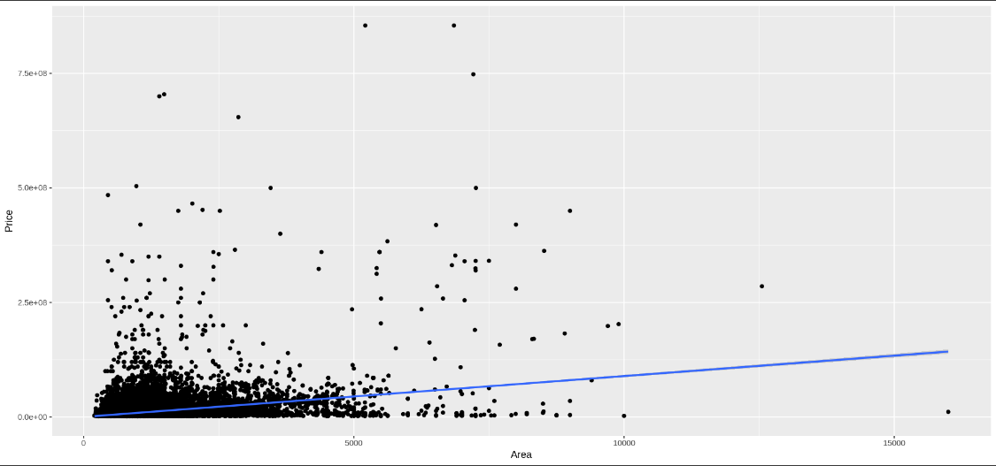

**Conclusion :**

From this experiment I was able to plot advance plots in R which can be used to provide more detailed insights about the data.