**Name : Rajas Baadkar**

**UID : 2021300007**

**Exp: 1**

**Batch : G**

**Aim:** To demonstrate the product-wise sales in various States of America.

**Dataset Link :** https://www.kaggle.com/datasets/kushagra1211/usa-sales-product-datasetcleaned **Graphical Analysis:**

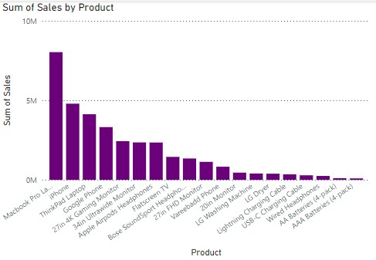

The bar graph highlights the sales figures for different products. Among all the products, the **MacBook Pro Laptop** has the highest sales, with its bar towering significantly above the others. Following this, other popular products include the **iPhone**, **ThinkPad Laptop**, **Google Phone**, and **27in 4K Gaming Monitor**. The middle tier comprises products like the **Apple AirPods**, **Flatscreen TV**, and **27in HD Monitor**. The products with the lowest sales, indicated by shorter bars, include **AA Batteries (4-pack)**, **Vareebadd Phone**, and **USB Charging Cable**.

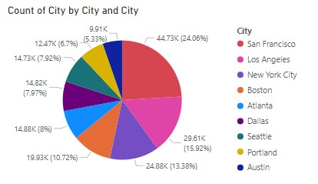

The pie chart represents the distribution of sales across various cities. **San Francisco** takes up the largest portion of the pie, accounting for **44.73%** of the total sales. This suggests that a substantial amount of sales activity is concentrated in this city compared to other locations.

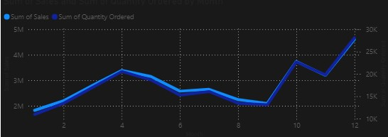

The line graph likely represents the trend of sales for various products over time. It shows how the sales figures change month by month or quarter by quarter. Peaks in the graph may indicate promotional periods or seasonal demands for certain products, while troughs might suggest periods of lower sales activity.

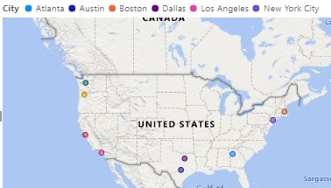

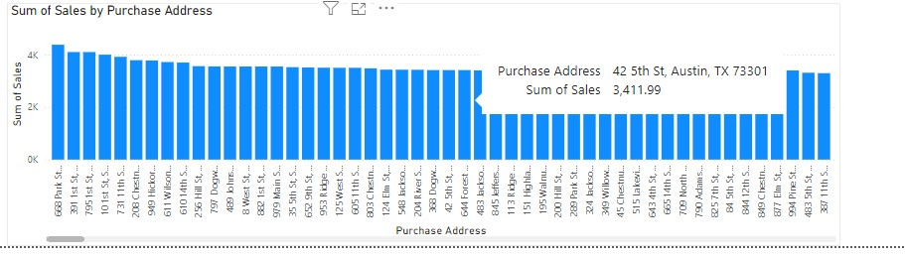

This chart depicts the distribution of sales for various addresses. Each bar is divided into segments representing different products, allowing for a comparison of how well each product performs in different locations. The height of the stacked segments provides a quick visual reference for the total sales in each state.

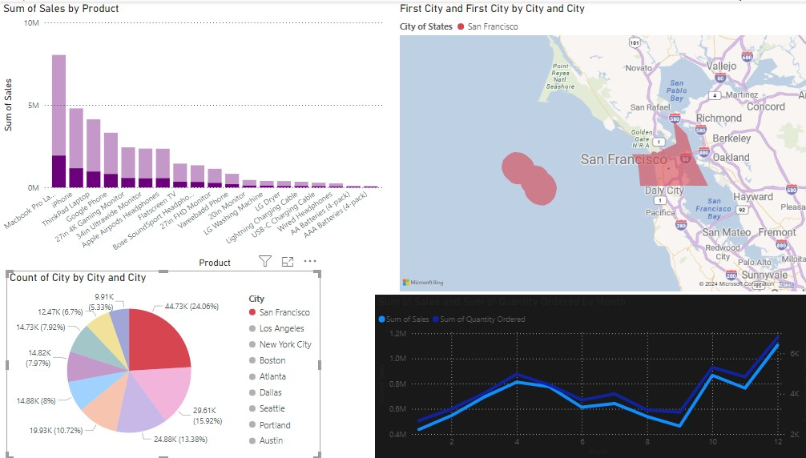

The map plot visually represents the sales distribution across various regions in the United States. Different states or regions are shaded in varying intensities to indicate the volume of sales—darker shades typically represent higher sales figures, while lighter shades indicate lower sales.

The map highlights which regions recorded the maximum sales, likely showing the dominance of urban or economically vibrant areas such as **California**, **New York**, or **Texas**. These regions are shaded the darkest, indicating the highest sales volumes. Conversely, regions with lighter shades represent areas with comparatively lower sales. This kind of plot provides a geographical overview, making it easy to spot where the products are most and least popular.

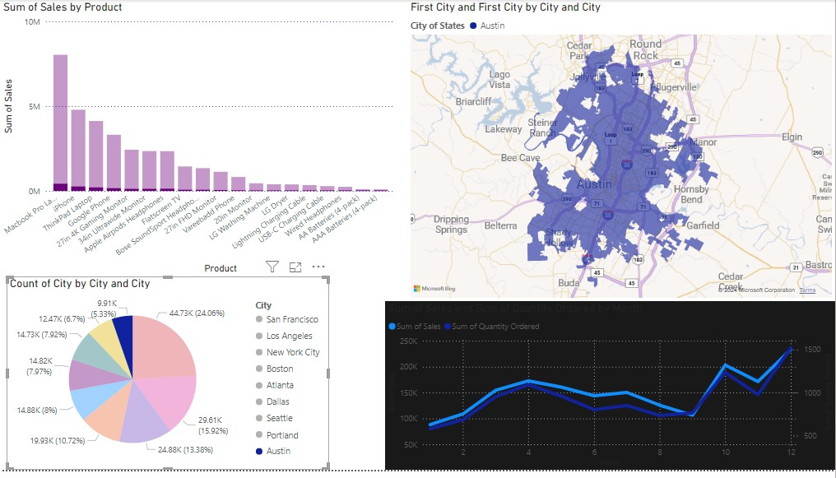

The above dashboard represents the status of Austin. It shows that Austin contributes to over 9% of total sales. The map shows the areas in Austin where the sales are concentrated. The bar graph shows the product wise sales in Austin.