Bharatiya Vidya Bhavan's

# Sardar Patel Institute of Technology

(Autonomous Institute Affiliated to University of Mumbai)

Bhavan’s Campus, Munshi Nagar, Andheri (West), Mumbai-400058-India

Name: Rajas Baadkar

UID: 2021300007

Experiment No: 8

Aim: **Designing Interactive Dashboards and Storytelling using D3.js on Environment/Forest Cover Dataset**

* **Dataset Link:**<https://www.kaggle.com/datasets/shakhauat/total-forest-area-km> • **Dataset Description:**

The dataset contains information on forest area (in square kilometers) for various countries across multiple years. Here are the columns:

* **Entity**: The name of the country.
* **Code**: The country code (some entries are missing).
* **Year**: The year for which the forest area data is recorded.
* **Forest area**: The total forest area in square kilometers for that year.

* **Graphs and Explanation:**

## 1. Bar Chart: Market Cap by Company

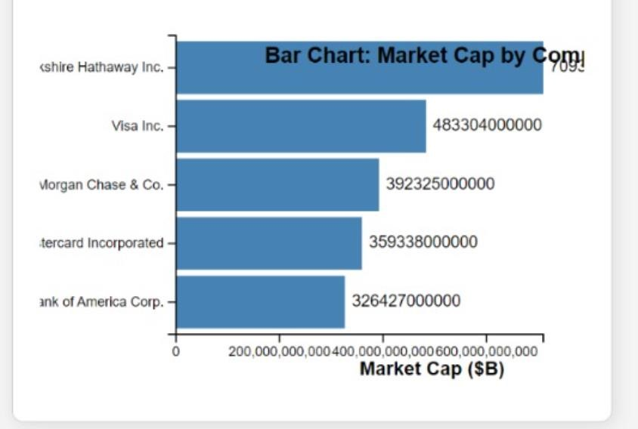

* **Description**: This bar chart displays the market capitalization (in billions of dollars) of several major companies in the finance and banking sectors.
* **Insights**:
  + Berkshire Hathaway Inc. has the highest market cap, significantly leading the other companies.
  + Visa Inc. and JPMorgan Chase & Co. follow as prominent players in the market, with substantial market capitalizations.
  + Companies like Bank of America Corp. and Mastercard Incorporated show lower market caps, indicating their smaller size in comparison to industry leaders.
* **Dataset Relation:** The chart highlights the relative size and market presence of these companies, which is crucial for understanding their influence in the financial industry.

## 2. Pie Chart: Market Share

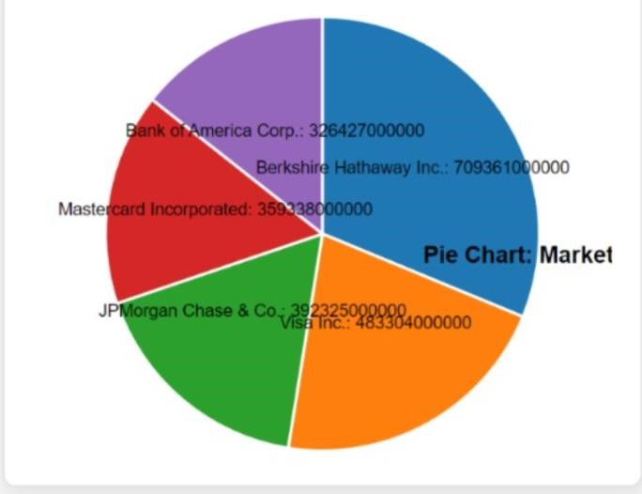

* **Description:** The pie chart represents the market share of each company based on their market capitalization.
* **Insights:** 
  + The chart visually emphasizes the dominance of Berkshire Hathaway Inc., which occupies a substantial portion of the pie.
  + Visa Inc. and JPMorgan Chase & Co. also have significant shares, showcasing their importance in the market.
  + The smaller sections for Mastercard and Bank of America suggest that while they are notable companies, they do not hold as much market share as the top players.
* **Dataset Relation:** This chart provides a clear visual representation of how the total market cap is distributed among the companies, helping to visualize competitive dynamics.

## 3. Histogram: Price Distribution

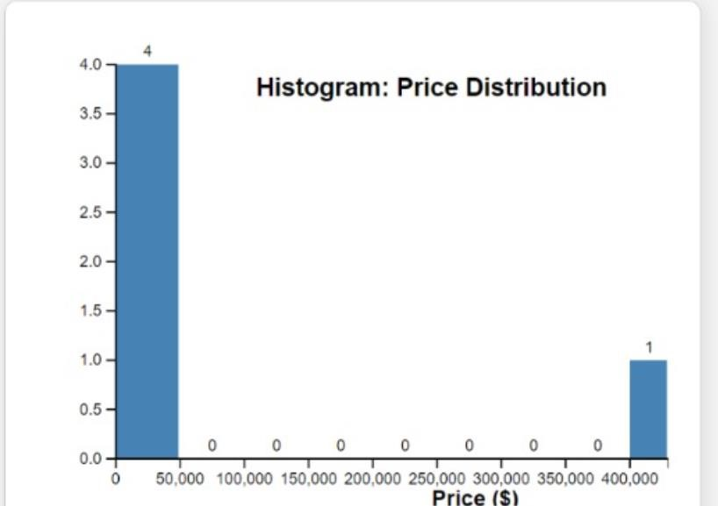

* **Description:** The histogram displays the frequency distribution of stock prices for the companies included in the dataset.
* **Insights:**
  + The histogram indicates that the majority of companies have stock prices clustered at lower values (close to $0), with only a few higher-priced stocks.
  + A single bar indicates a frequency of 4 for stocks priced around $400, suggesting a small number of high-value stocks compared to lower-priced ones.
* **Dataset Relation:** This visualization helps identify how stock prices are distributed across the dataset, indicating whether the market is skewed towards high-priced or lowpriced stocks.

## 4. Scatter Plot: Price vs. Market Cap

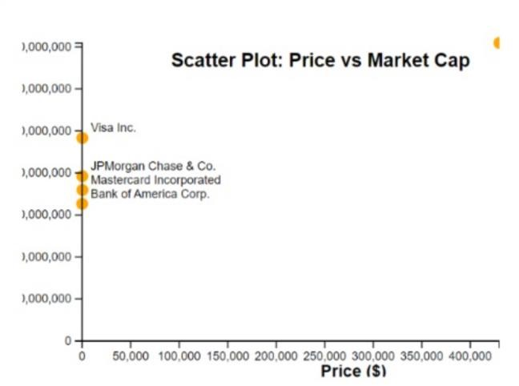

* **Description:** The scatter plot illustrates the relationship between stock prices and market capitalizations of the companies.
* **Insights:** 
  + Each point represents a company, allowing viewers to see how stock price correlates with market cap.
  + Companies with higher stock prices tend to have higher market caps, which may indicate that investors are willing to pay more for shares of more valuable companies. o For example, Visa Inc. and JPMorgan Chase & Co. appear to have higher prices and larger market caps, while Bank of America Corp. and Mastercard have lower prices and market caps.
* **Dataset Relation:** This plot helps investors understand the relationship between stock valuation and overall company size, which can be important for investment strategies.

* **Conclusion**:

The visualizations created from the financial datasets, including a bar chart, pie chart, histogram, and scatter plot, provide a comprehensive overview of the performance and distribution of companies within the finance, banking, and insurance sectors. The bar chart highlights market capitalization, allowing for easy comparisons among industry leaders, while the pie chart illustrates the market share distribution among these companies. The histogram reveals the distribution of stock prices, helping to identify pricing trends, and the scatter plot explores the relationship between stock price and the price-toearnings (P/E) ratio, uncovering potential correlations between valuation and profitability. Collectively, these visualizations enhance understanding of market dynamics, enabling stakeholders to make informed investment decisions and strategize effectively in a competitive landscape.