**Particle Packing in Biomanufacturing**

**CSL Behring for BIG Q Hackathon**

**Chicago, Sept. 29 – Oct. 2, 2023**

1. **Introduction**

CSL Behring is a global biotherapeutics leader driven by our promise to save lives. Focused on serving patients’ needs by using the latest technologies, we discover, develop, and deliver innovative therapies for people living with conditions in the immunology, hematology, cardiovascular and metabolic, respiratory, and transplant therapeutic areas. We use three strategic scientific platforms of plasma fractionation, recombinant protein technology, and cell and gene therapy to support continued innovation and continually refine ways in which products can address unmet medical needs and help patients lead full lives [1].

The biopharmaceutical manufacturing market is forecast to grow at a compound annual growth rate of 15% for the next decade, from $ 21 billion in 2021 to $ 85 billion in 2031. [2] Some projected growth drivers are increasing biologics and biosimilars approvals, automation technology integration and an increase in bioproduction workflow coupled with a reduction in cost, time, and labor. Typical biopharmaceutical manufacturing workflows are divided into two segments, upstream biomanufacturing and downstream biomanufacturing.

For downstream biopharmaceutical manufacturing a thorough understanding of the phenomena of particle packing from a suspension is necessary in optimizing efficiency and yield. The filtration of protein suspensions is an important step in isolating target proteins when purifying proteins in blood plasma for therapeutic use. These proteins may also be further processed using chromatography to further isolate the target protein with high purity and homogeneity. Modeling the interactions of the suspension mixtures and their packing behavior across a variety of pressure and flow systems provides an ideal methodology to optimize the separation of suspension mixtures and therefore ensure efficiency in the transformation of valuable blood plasma to life-saving therapies.

The modeling of the interactions in protein suspensions as well as their separations is computationally cost prohibitive today. Quantum computing provides an opportunity to provide insight and evaluate the separation process on a molecular level. The ability to both optimize the particle packing and model the interactions inherent in the separation could enable improved product yield and purity. However, given the limited capacity of today’s quantum computers, both these goals may not be possible especially in modeling the interactions inherent in the separation. Therefore, an algorithm that can evolve and utilize a variety of quantum computer capacity and enable increased utility in the future would be ideal.

In addition to optimizing packing as well as modeling interactions, the scale of the process is an additional complexity. While it may be less computationally intensive to model smaller scale processes, it is commercially more valuable to understand how the interactions and packing dynamics change as the scale is increased. Economies of scale become increasingly important and ensuring that the efficiency can be achieved at larger and smaller scales is an important aspect of a wholistic understanding of the process. Therefore, approaches to increasing understanding of the systems requires an ability to consider the scale of the system as well as potentially identify pitfalls when moving from small scales to larger ones.

The application of the system is also crucial with an ability to either maximize flux through the packed bed or increase opportunities for interaction with the bed being of importance. During filtrations, a desire to maximize the flux and throughput though the facility is required while for chromatography applications the primary goal is maximize interactions with the packed bed to maximize the capture capacity of the bed. A solution that enables an understanding of the primary consideration or allows the setting of importance of various considerations during optimization is desirable and would provide the utmost utility in the biomanufacturing space.

The ability to also provide a size distribution profile of the various components of the suspension mixture is also key and would be an important determination in any implementation of the algorithm. It would enable the solution to be utilized across various implementations as well as provide a methodology to understand how particle size could affect the performance of the packed bed for either separations or chromatography.

1. **Classical Approach**

Classical approaches to the phenomena of particle packing are historically focused on spherical particles [3] with event-driven or time-driven molecular dynamics approaches employed for soft or hard particles [4]. Algorithms that extend the particle packing problem to non-spherical particles and arbitrary geometry containers by digitization of the particles and containers [5]. These approaches require complex data intensive algorithms that model the problem in 3 dimensions and consider the dynamics of the particle environment (including any surrounding fluid). Additionally, the algorithms are optimized for classical computation and are not of a nature that can be easily extended to quantum computing.

We can then simplify the problem even further and look at an even more fundamental formulation of the problem bin packing. In bin packing problems, one is trying to pack items of various sizes into bins whilst optimizing some given objective function [6]. The algorithms that arise can easily be modified to provide utility in the original problem, while increasing the complexity and including external driving forces.

1. **Case Study**

Recently, quantum computing applicable algorithms for the bin packing problem have been advanced [7], [8], [9], [10]. These algorithms consider static 1-, 2-, and 3-dimensional bin packing problems and focus on packing packages in various bins. Considering more than one dimensional packing in the quantum domain is challenging due to its complexity and the limited capacity of contemporary quantum computers [7]. Therefore, we consider the static 2-dimensional packing of spherical particles in containers of varying geometries (Rectangular or cylindrical). The effect of particle size and size distribution on the packing of particles has been extensively investing based on the packing of spheres [11]. The particle size distribution of the particles as well as the container size should be considered and adjustable. If time and resources allow, we may also consider the 3-dimensional case or the dynamic case.

A normal distribution of particle size may be considered with the packing such that no particle overlap is allowed. Mathematically, the input parameters for the problem may be defined as follows:

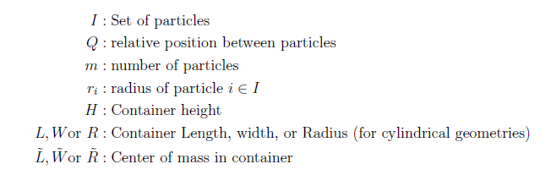

The variables that may be used to compose the problem are as follows:

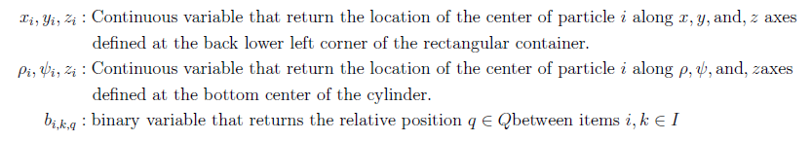

The packing can be solved as an optimization problem with the cost function to minimize as the sum of two objectives, i.e. min . The first objective minimizes the average height of all the particles and the second objective distributes the particles around a desired center of mass for the container.

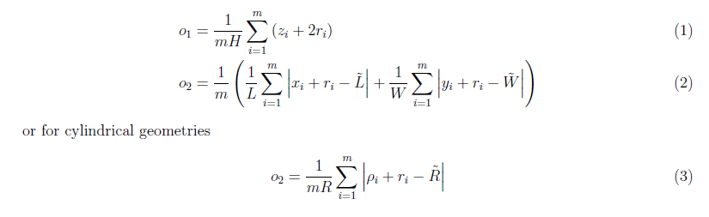

1. **References**

|  |  |
| --- | --- |
| [1] | CSL Behring, "Our Businesses and Products/CSL Behring," 2023. [Online]. |
| [2] | BIS Research, "Next-Generation Biomanufacturing Market - A Global Analysis: Focus on Single-Use and Digital Platform and Segment Analysis for Workflow, Products, Medical Application, End User, Country Data (16 Countries), and Competitive Landscape - Analysis and Forecas," 2021. |
| [3] | S. Torquato and Y. Jiao, "[Dense packings of the Platonic and Archimedean Solids](https://doi.org/10.48550/arXiv.0908.4107)," *Nature,* vol. 460, pp. 876-879, 2009. |
| [4] | A. Donev, S. Torquato and F. H. Stillinger, "[Neighbor List Collison-Driven Molecular Dynamics Simulation for Nonspherical Hard Particles.](https://www.sciencedirect.com/science/article/pii/S0021999104003146/pdfft?md5=3e49aaeddc0e9a3ba44ad6183f032b77&pid=1-s2.0-S0021999104003146-main.pdf)," *Journal of Computational Physics,* vol. 202, no. 2, pp. 737-764, 2004. |
| [5] | X. Jia, M. Gan, R. A. Williams and D. Rhodes, "[Validation of a digital packing algorithm in predicting powder packing densities](https://www.sciencedirect.com/science/article/pii/S003259100600444X/pdfft?md5=bf64b1d353686bbbfd4f23282db88de8&pid=1-s2.0-S003259100600444X-main.pdf)," *Powder Technology,* vol. 174, no. 1-2, pp. 10-13, 2007. |
| [6] | M. R. Garey and D. S. Johnson, "Approximation Algorithms for Bin Packing Problems: A Survey," in *Analysis and Design of Algorithms in Combinatorial Optimization*, G. Ausiello and M. Lucertini, Eds., Vienna, Springer, 1981, pp. 147-172. |
| [7] | S. V. Romero, E. Osaba, E. Villar-Rodriguez, I. Oregi and Y. Ban, "[Hybrid Approach for solving real-world bin packing problem instances using quantum annealers](https://www.nature.com/articles/s41598-023-39013-9)," *Scientific Reports,* vol. 13, no. 1, p. 11777, 2023. |
| [8] | S. V. Romero, E. Osaba, E. Villar-Rodriguez and A. Anton, "[Solving Logistic-Oriented Bin Packing Problems Through a Hybrid Quantum-Classical Approach](https://doi.org/10.48550/arXiv.2308.02787)," 2023. |
| [9] | M. G. de Andoin, E. Osaba, I. Oregi, E. Villar-Rodriguez and M. Sanz, "[Hybrid Quantum-Classical Heuristic for the Bin Packing Problem](https://doi.org/10.48550/arXiv.2204.05637)," in *Proceedings of the Genetic and Evolutionary Computation Conference Companion*, Boston, Massachusetts, 2022. |
| [10] | A. A. Bozhedarov, A. S. Boev, S. R. Usmanov, G. V. Salahov, E. O. Kiktenko and A. K. Fedorov, "[Quantum and quantum-inspired optimization for solving the minimum bin packing problem](https://doi.org/10.48550/arXiv.2301.11265)". |
| [11] | C. M. Kong and J. J. Lannutti, "Effect of Agglomerate Size Distribution on Loose Packing Fraction," *Journal of the American Ceramic Society,* vol. 83, no. 9, pp. 2183-2188, 2000. |