**DevOps**

**Question: Sonar Cloud**

**Steps:**

1. **Login to your GitHub Account**
2. **Login to Sonar Cloud Account**
3. **Link your GitHub Account with your Sonar Cloud Account**
4. **Create Python File/Project and uploaded it to GitHub**
5. **Click on Analyze new Project and add your project**
6. **Choose Option “With GitHub Actions”**

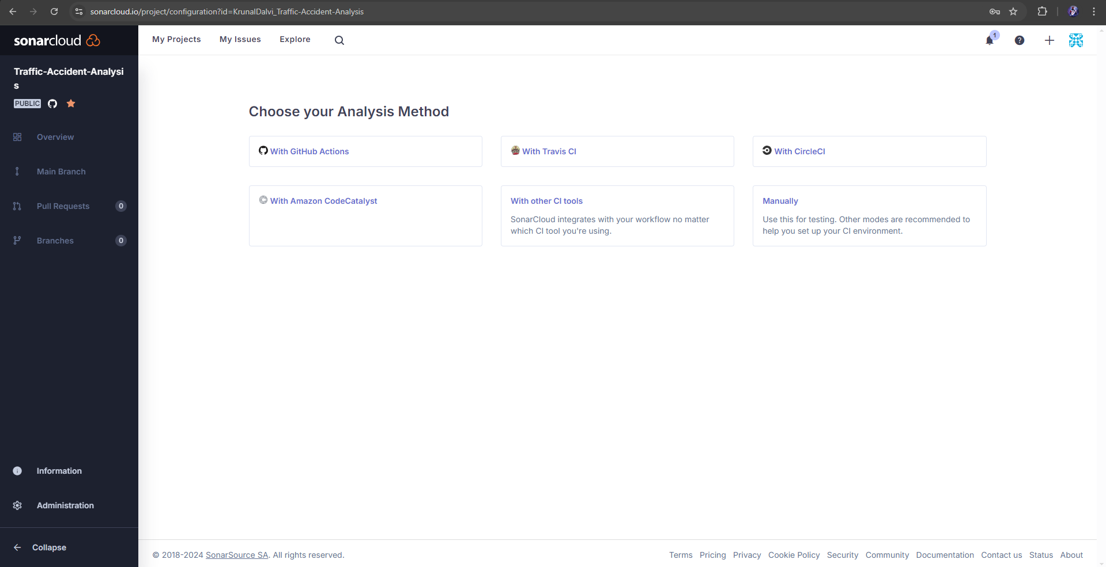

1. **Create a GitHub Secret**

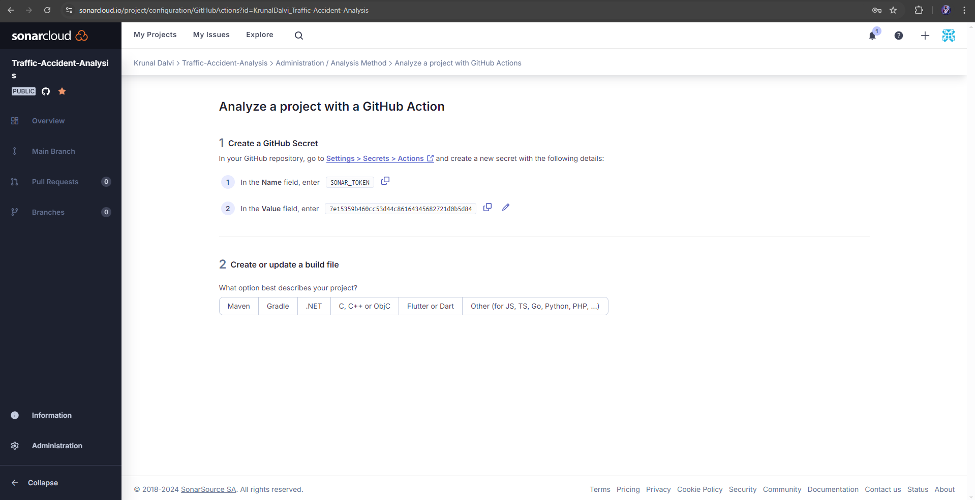

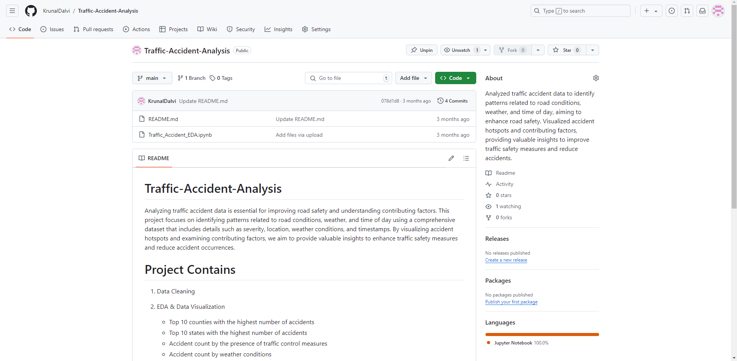

1. **Click on Settings and select “Actions” under “Secrets and Variables” options and click on New Repository Secret**

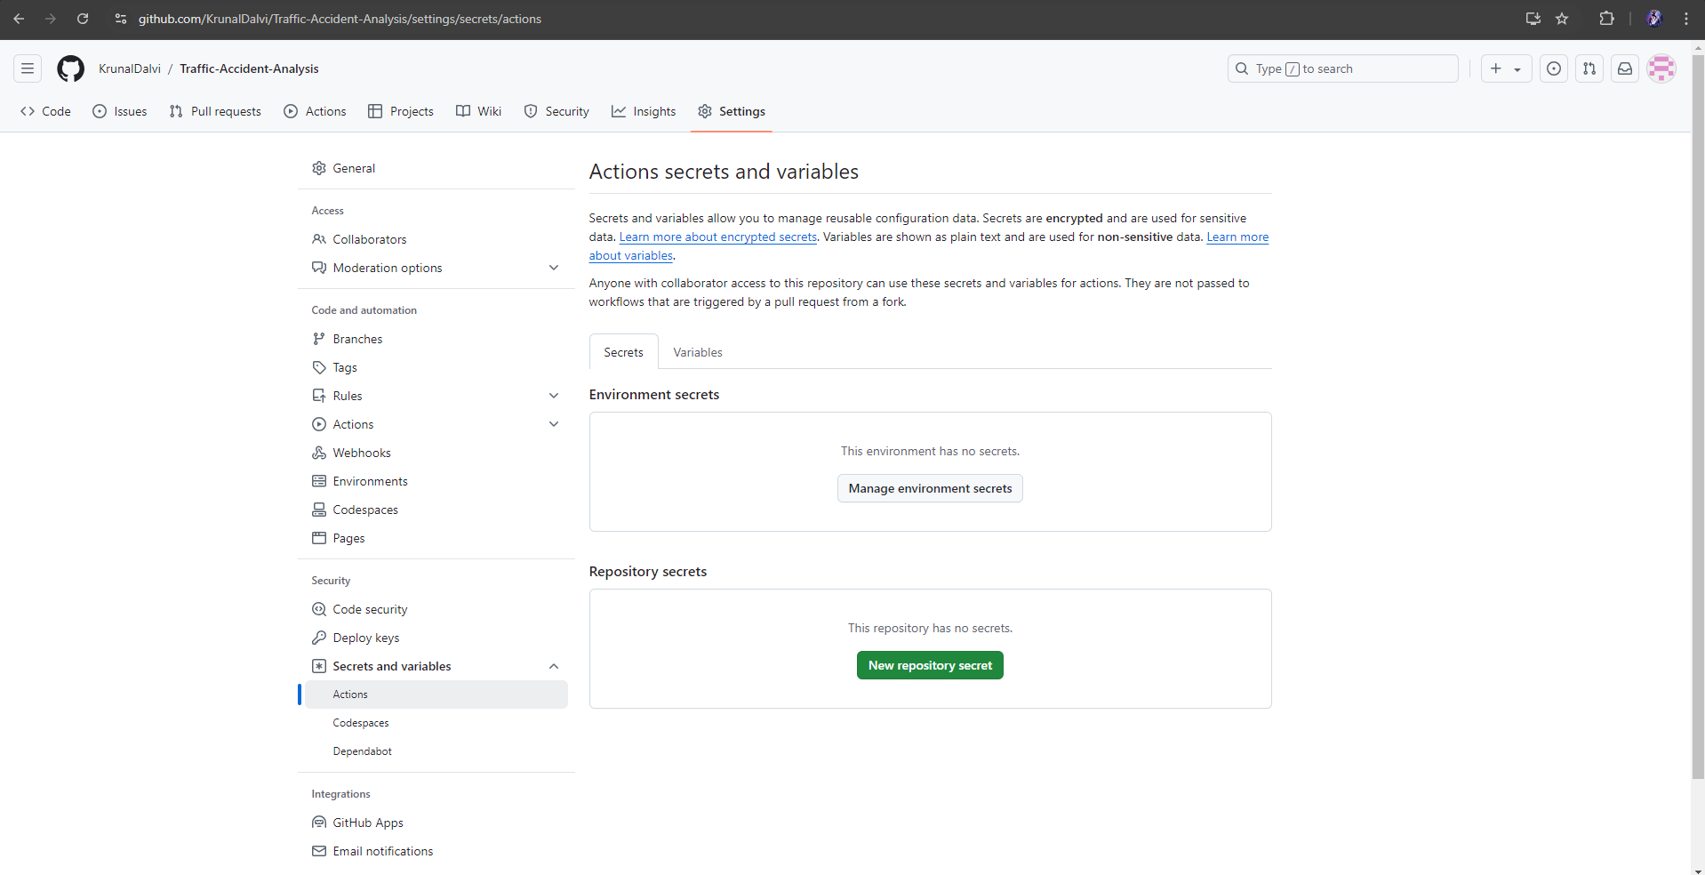

1. **From Step 7 copy the Name, Value and paste it below and click on Add Secret Button.**

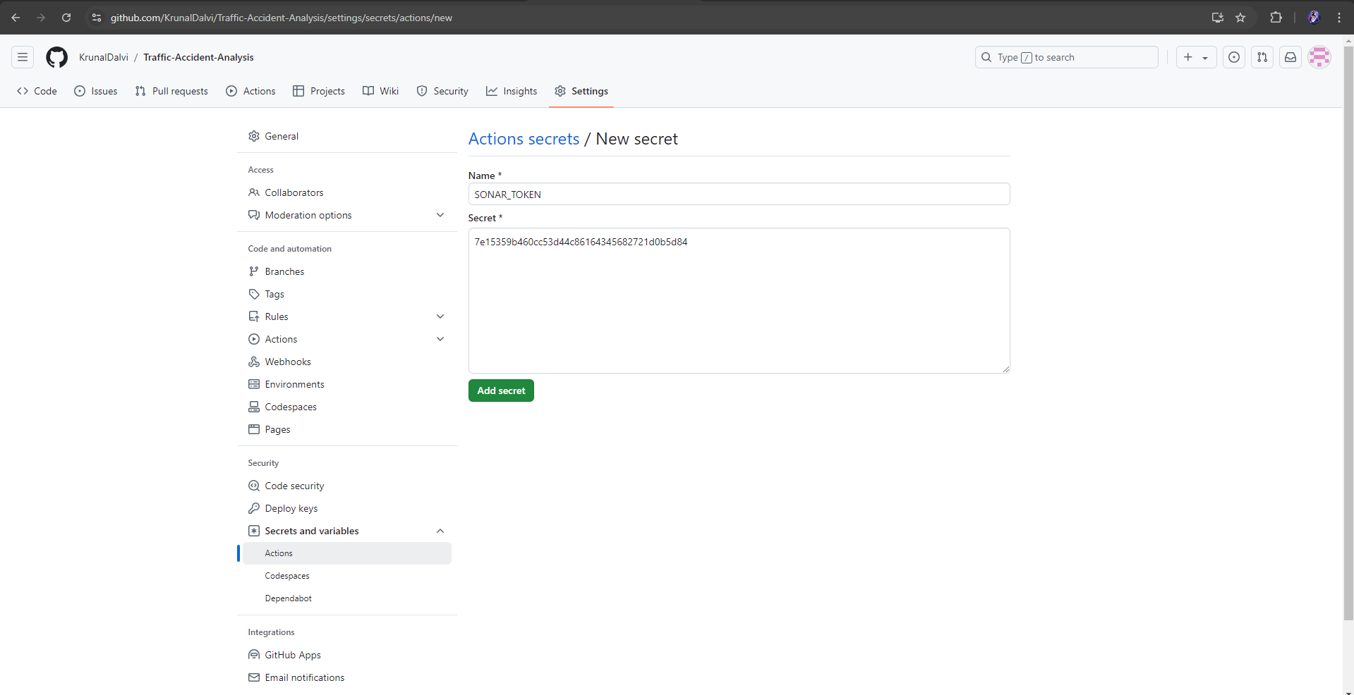

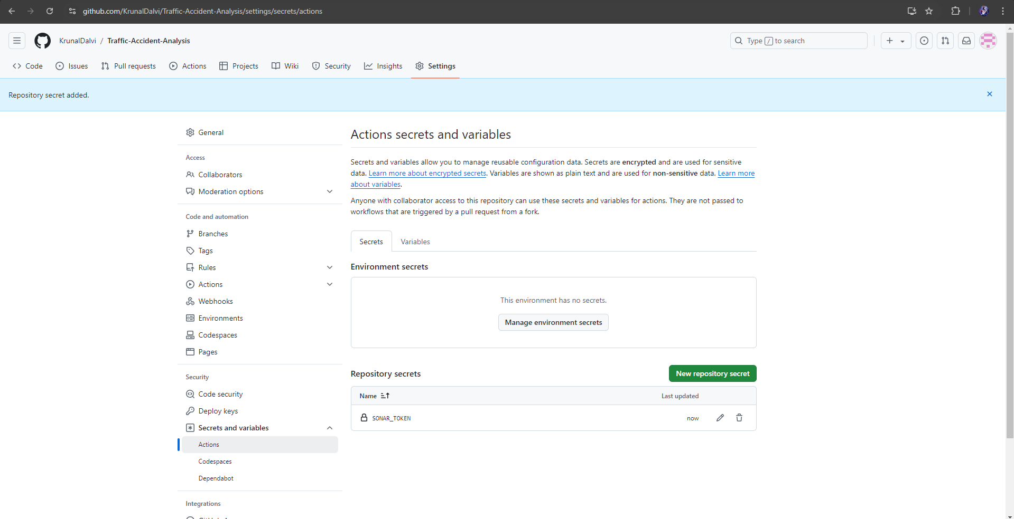

1. **In Sonar Cloud Select Account -> Security, write Token Name and Click on Generate Token.**

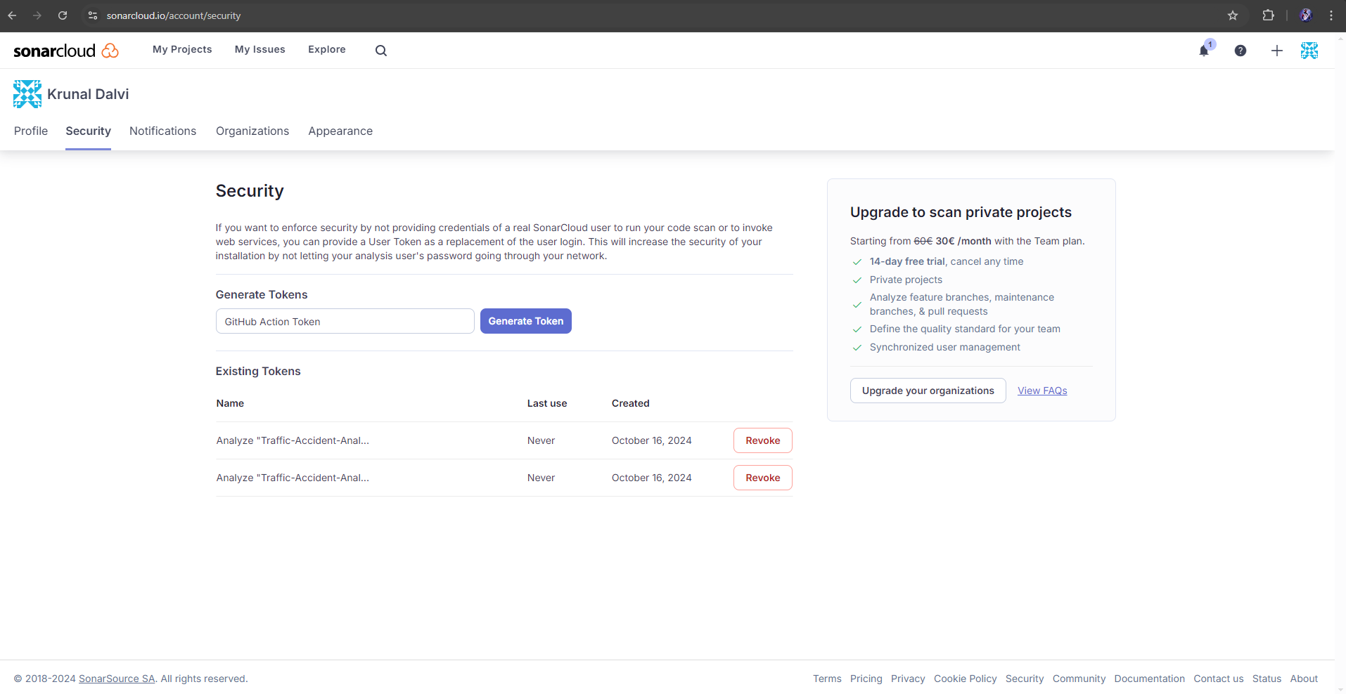

1. **Create a new file into your repository and create new file sonar-project.properties and paste the below code**

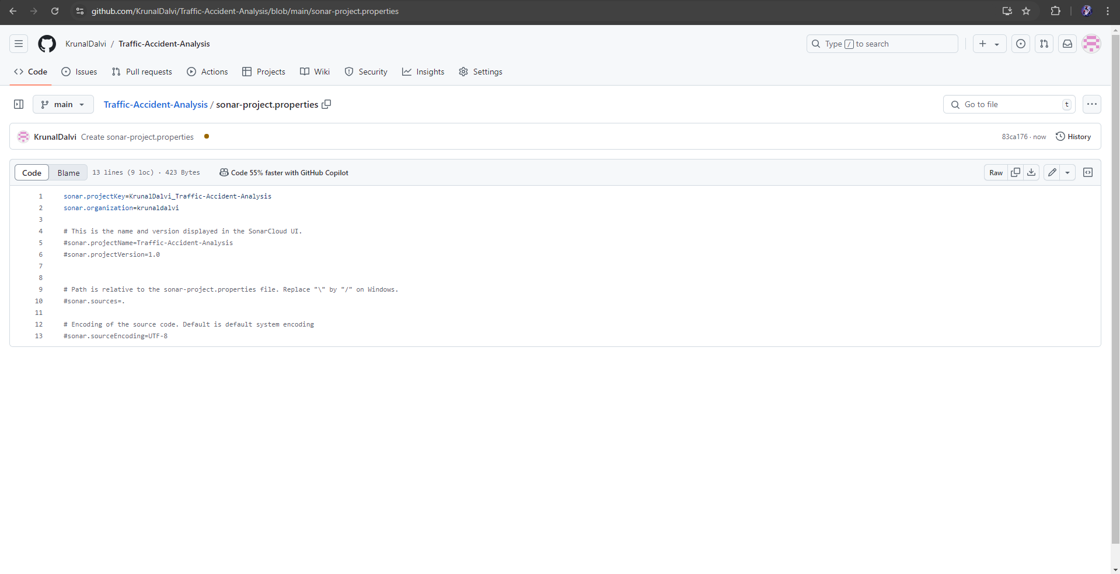

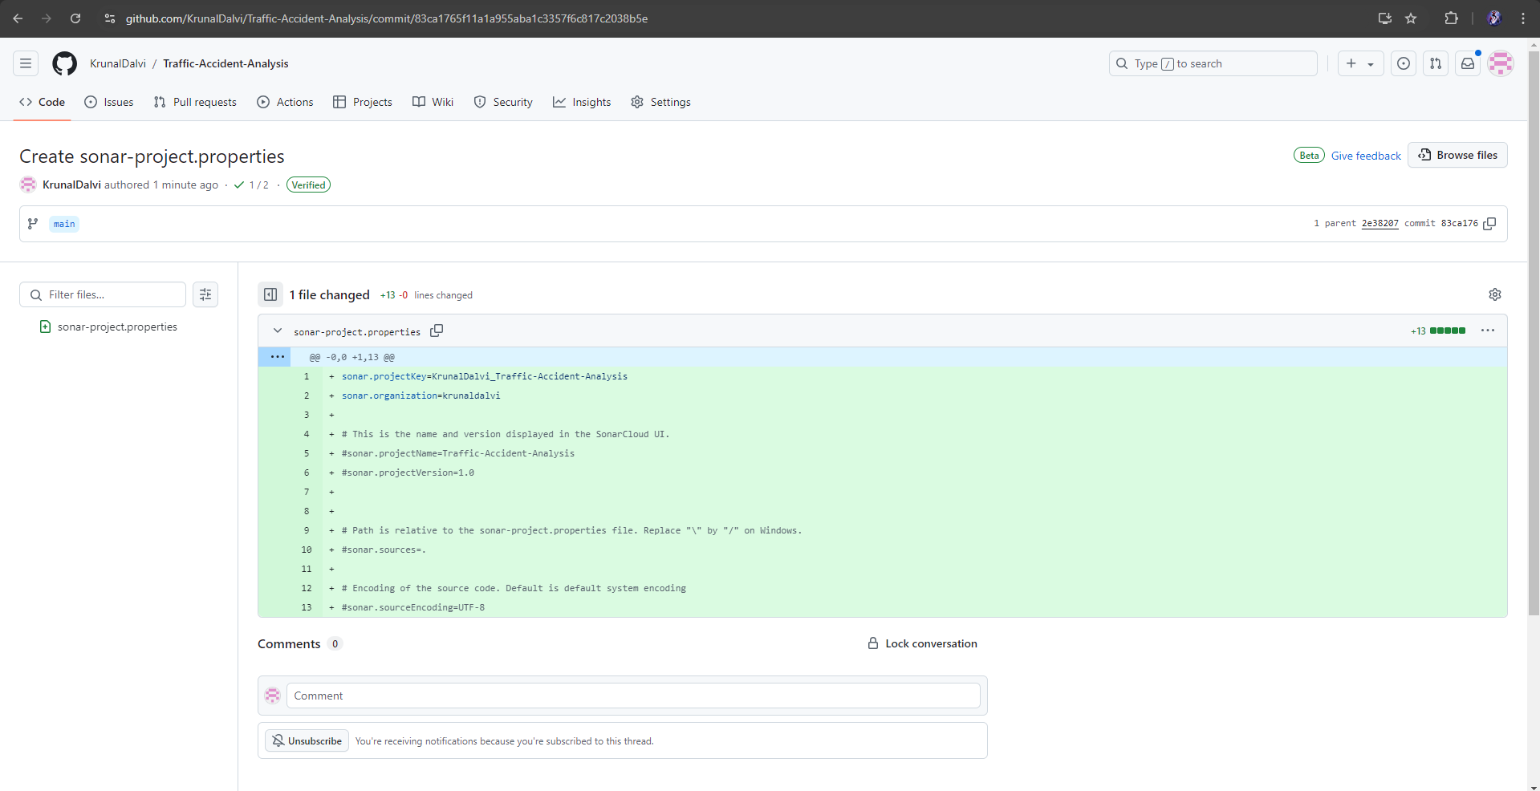

1. **Go Back to Sonar Cloud and view the Summary of your Project**



